*PACKET # 22*

**AEROBICS**

**INSTRUCTIONS**

This Learning Packet has two parts: (1) text to read and (2) questions to answer.

The text describes a particular sport or physical activity, and relates its history, rules, playing techniques, scoring, notes and news.

The Response Forms (questions and puzzles) check your understanding and appreciation of the sport or physical activity.

**INTRODUCTION**

Aerobic exercise conditions the cardiovascular system and improves performance in sports that require endurance, such as running and jogging. By conditioning the cardiovascular system, aerobics contributes to overall health and enhances the ability to use oxygen.

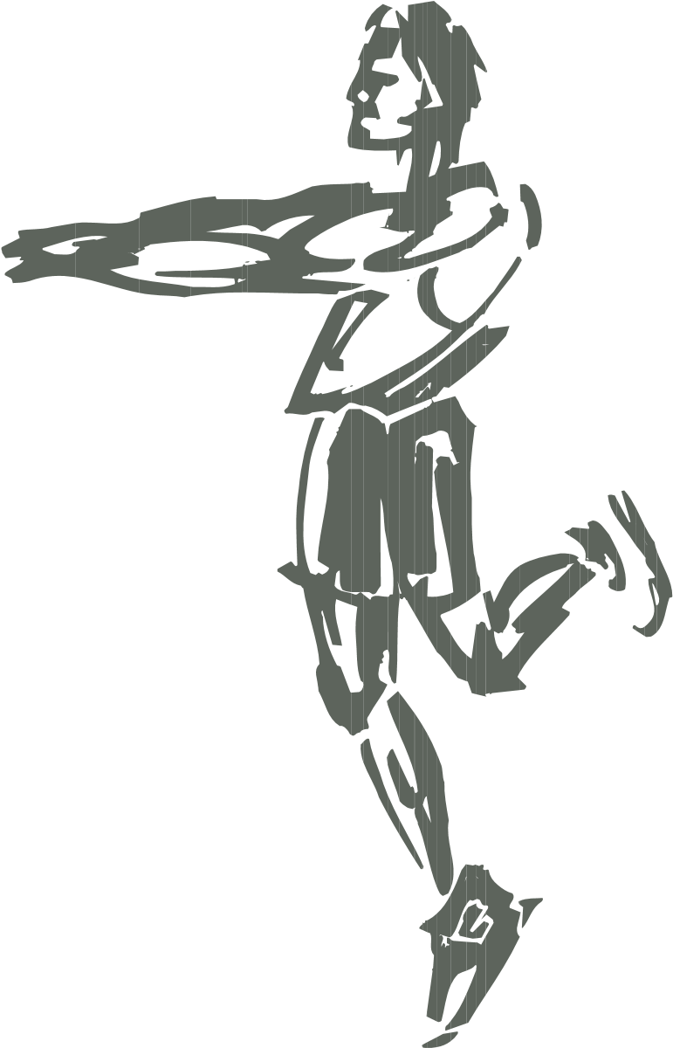Perhaps the best way to describe how aerobics works is to explain how exercise improves the body’s ability to perform. Depending on which exercises you do, you may develop strength, endurance, stamina or power. However, as all sports trainers know, exercise is “specific,” which means that specific exercises produce specific results.

For example, exercises designed strictly to improve strength will not do much to improve your endurance. On the other hand, if you train for endurance alone (for example, by doing only long-distance running), you will not improve your strength significantly. This is why you often see runners who couldn’t bench press 200 pounds if their lives depended on it, and champion powerlifters who get out of breath just running across the street.

**HISTORY OF AEROBICS**

Aerobic activity has been around since warm-blooded animals first started running from predators. But “aerobics” as a popular type of exercise activity came into international popularity in the 1970s and 80s as part of the fitness movement in the United States. People wanted to lose weight, slim down, be healthy, and improve the quality of their lives. Aerobic training provided a means of accomplishing some of these goals.

At first jogging and running were the most popular forms of aerobic activity. Dr. Kenneth Cooper, James Fixx, and others wrote books on aerobics, running and the benefits of cardiovascular conditioning. Later, as trainers became more experienced in the ways in which aerobic benefits could be achieved and as more and more people were caught up in the fitness movement and began to join health clubs, different forms of aerobic training evolved.

One of the most popular forms of aerobic training is aerobic dance. Aerobic dance involves stepping, jumping, spinning and twisting motions that follow the beat of music played on a sound system. The intensity of this form of exercise can be increased either by increasing the tempo of the music, or by increasing the number or difficulty of the dance movements.

Aerobic dance is usually done in large groups, but can be done alone if desired. One can dance aerobically regardless of the type of music. However, the most popular aerobic dance music is rock, because of the fast rhythms and heavy beat.

Another form of aerobic training is called “circuit training.” Exercise machines by Universal, Nautilus, Cybex, Hydragym, Soloflex and other manufacturers enable a person to move rapidly from one machine to another with only a brief rest period between sets. Thus by

using light weights and high repetitions on all the movements, these resistance-exercise machines can become aerobic-exercise machines.

**HOW AEROBIC TRAINING WORKS**

Depending on whether you are training for endurance and aerobic benefits or for strength, you will work different types of muscle fibers. Muscles are made up chiefly of two types of fibers: (1) slow-twitch red fibers and (2) fast-twitch white fibers. The red fibers contract more slowly than the white fibers, but demand a grater amount of oxygen to do their work. White fibers contract faster than the reds, but demand less oxygen.

Aerobic exercise is a type of endurance training, and chiefly works the red muscle fibers, thus increasing the demand for oxygen. As the oxygen demand is increased, the cardiovascular system (the heart and lungs) is forced to work harder. In normal persons who have no cardiovascular disease, aerobic exercise increases muscular endurance and improves the ability of the cardiovascular system to meet greater oxygen demands.

By contrast, strength training chiefly works the white muscle fibers. The most effective method of strength training is done with what is called “progressive resistance” exercises in which both the resistance and the number of repetitions of the exercise movements are increased over a specified period of time. In short, working the white muscle fibers with progressive resistance exercises makes you stronger.

So if you want to improve your muscular strength (lifting heavier weights, etc.), you must do progressive resistance exercises in which you do a small number of repetitions with increasing resistance over a short period of time. If you want to improve the action of your heart and lungs while developing muscular endurance (running, etc.), you must do aerobic exercises with many repetitions with less resistance over a long period of time.

But remember that the best training program is one that includes both aerobic and strength training.

The “aerobic effect” of cardiovascular conditioning is achieved by reaching a target pulse rate. Trainers disagree about which pulse rate is an appropriate target and how long that pulse rate must be maintained. For example, Dr. Gabe Mirkin, who does the radio mini-programs called “Dr. Gabe Mirkin on Fitness,” says that to achieve cardiovascular fitness, you must push your heartbeat to more than 60 per cent of its maximum for at least 30 minutes three times a week.

On the other hand, Dr. Paul DeVore, in an article, “Cardiovascular Benefits of Strength Training Exercises” (Iron Man Magazine, July, 1979) holds that the correct target pulse rate is between 70 and 85 per cent of the maximum heart rate as figured according to age-adjusted maximal heart rate charts. According to DeVore, these heart rates need be sustained for only 10 to 12 minutes for aerobic conditioning.

Dr. Kenneth Cooper, in his book, Aerobics, claims that a target pulse rate of 60 to 85 per cent of maximum should be maintained for between 12 to 30 minutes, and repeated at least several times a week.

Opinions thus vary about the number of beats per minute, the length of the workout at the target rate, and the number of workouts needed per week to achieve cardiovascular fitness. So don’t be surprised if you find contradictory figures from the many people who write about aerobics and cardiovascular conditioning.

**SAMPLE AEROBIC EXERCISES**

Aerobic exercises are sometimes categorized as “high impact” and “low impact.”

High-impact exercises involve movements that compress the ankle, knee and hip joints. Examples would include jogging on pavement or fast aerobic dancing with repeated jumps, done to a fast tempo on a hard gym floor.

Low-impact exercises are those which do not involve compressing the joints. An example would be circuit training with exercise machines, in which movements are done smoothly with no jumping or sudden pushing motions, or aerobic dancing that does not involve repeated jumping.

*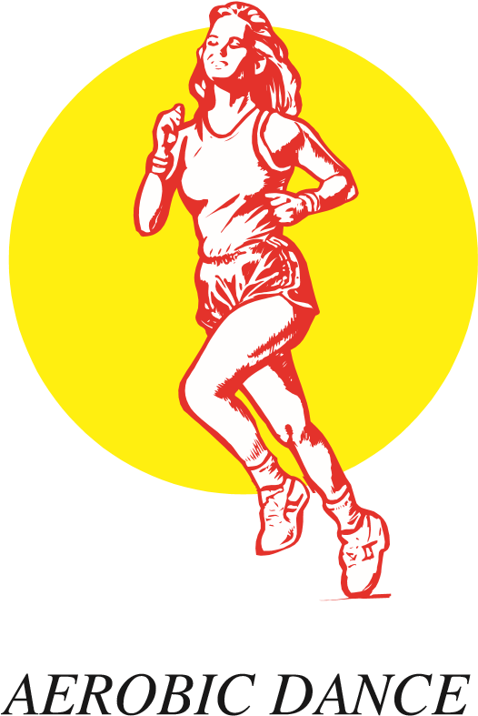JOGGING*

After a few minutes of stretching exercises, start to jog slowly, gradually increasing your speed. Don’t run (don’t have both feet off the ground at the same time) and don’t shuffle (don’t slide your feet). After a few minutes, look at your watch or pulse meter and increase or decrease your speed until you reach your target pulse rate. Sustain that rate for the duration of the session.

Put a fairly fast number on your hi-fi, CD player or radio. Turn the volume up so you can hear the beat. Warm up, then start slowly with dance movements or familiar floor exercises to the rhythm of the music. Make jumping jacks a dance movement by varying the direction of the jumps. Make twisting movements an aerobic exercise by doing them to fast music. Check your pulse, achieve the target rate, and sustain that rate for the duration of the session.

*CIRCUIT TRAINING*

Circuit training involves moving from one exercise machine to another with little or no rest between machines, until you have completed a circuit through a specified number of machines. Machines are better than free weights for circuit training, since you can change the amount of resistance quickly and easily by placing a pin or turning a dial, instead of having to load or unload plates and tighten barbell collars. If you belong to a health club that has a complete line of exercise machines, do the following:

1. Achieve your target pulse rate by varying the:

amount of weight or resistance number of repetitions speed with which the repetitions are done duration of each set on a specific machine duration of the rest period between machines

1. Use the machines that accomplish the following exercises. Be sure to do the exercises in the order listed so that you can pace yourself. You will alternate between large and small muscle mass exercises. Also, you need to learn two terms that are used in all sports training: “extend” and “flex.” When you straighten your arm or leg (as in a pushing movement), you EXTEND the arm or leg. When you bend your arm at the elbow or your leg at the knee, you FLEX the arm at the elbow and flex the leg at the knee. These handy terms will help you understand the exercises.

Don’t forget to warm up before starting the circuit.

Here are the exercises by their common names, with the movements described in terms of extending or flexing the limb at the joint. Find a machine that will enable you to do these movements:

|  |  |
| --- | --- |
| EXERCISE | MOVEMENT |
| Leg press | Extend the legs at the knees. |
| Arm curl | Flex the arms at the elbows. |
| Leg extension | Extend the legs at the knees, swinging the feet in an arc while keeping the upper legs in the same position. |
| Bench press | Lie on your back and vertically extend your arms at the elbows. |
| Leg curl | Flex the legs at the knees, keeping the upper leg stationary. |
| Shoulder shrug | Raise the shoulders vertically while holding a weight or bottom-pulley machine bar in front of you, starting with the shoulders down and the arms straight down |
| Cal raise | Lift your heels and rise up on the balls of your feet. Then slowly let your heel come back down. |
| Wide-grip pull-downs | Using a wide grip, grasp a top-pulley machine bar and slowly pull it down to the top of your chest. Then slowly let the bar return to the starting position. |
| Spinal hyperextensions | Lie face down on the floor. Place your hands together at the small of your back. Contract the back muscles and arch your body by lifting the chest and the feet off the |

floor. Keep the knees straight.

Abdominal crunches Put your hands across your chest, bend your knees, and flex the abdominal muscles without raising the small of your back off the floor. Hold at peak contraction for a count of 5 before lowering your back to the floor.

These and many other machine exercises can be incorporated into an aerobics training program. Just remember that the goal is not to lift heavy weights, but to reach your target pulse rate and sustain that pulse rate until you have completed the circuit of machines. Pace yourself. This can be an extremely exhausting exercise routine, especially if you are not in good shape and try to do too much.

**EQUIPMENT AND CLOTHING**

*FOR JOGGING OR RUNNING*

Wear light clothing that is suitable to the temperature, and which gives you a full range of movement. For example, wear shorts and a tank top indoors or during the summer; wear a jogging suit or sweats during the winter. Don’t allow yourself to get either too hot or too cold for comfort. Overheating can bring on heat stroke. Overcooling can result in pulled muscles and cramps. Be sure to wear good running or jogging shoes.

*FOR AEROBIC DANCE*

Wear a jogging suit or a leotard, and a good pair of gym shoes. Be sure you have a complete range of motion so you can do all the moves. Don’t skimp on footwear. Aerobic dance should NOT be done in ballet slippers.

*FOR CIRCUIT TRAINING*

Most gyms require workout suits that cover the arms and legs. This is to save the machines’ cushions and pads from deteriorating because of perspiration. Also, there is nothing more disgusting than having to do an exercise while sliding on someone else’s sweat. Wear a workout suit that fits the environment. If your gym is hot, wear something light. If it’s cold, wear a sweatsuit. Make sure that you have a good pair of gym shoes. You will be moving rapidly from machine to machine, and you will need a firm foundation for exercises such as leg presses and heel-raises.

**NOTES AND NEWS**

Aerobics is primarily a form of exercise: namely, an exercise that conditions the cardiovascular system by increasing the ability to use oxygen. But human beings have never been satisfied with merely exercising. Hence, the invention of aerobic dance: a way to do aerobics and have fun at the same time.

The intensity of this form of exercise can be increased either by increasing the tempo of the music, or by increasing the number and difficulty of the dance movements. Aerobic dance is usually done in large groups, but can be done alone if desired. Watch out for the group you join: the fitter the group, the more intense the exercise. If you are a beginner, you may want to start out on your own and get in shape; or better yet, find a beginners group made up of other people who are just starting out.

Most health club aerobic classes involve some form of aerobic dancing. it may not be called dancing, but it involves all the bodily movements of dancing, except that it is faster and more vigorous.

Here’s a typical aerobic dance

routine:

Put a fairly fast num-

1.

ber on your stereo, CD

player or radio. Turn

the volume up so you

can hear the beat.

1. Warm up, then start slowly with dance movements or familiar floor exercises to the rhythm of the music.
2. Make jumping jacks a dance movement by varying the direction of the jumps.
3. Make twisting movements an aerobic movement by doing them to fast music.

Check your pulse, achieve the target rate, and sustain that rate for the duration of the dance session.

If you are interested in learning more about Aerobics, you might take a look on the internet at these websites:

http://www.fitnesszone.co.za/aerobics.htm http://www.turnstep.com http://www.aerobics.com

Here you will not only learn about the latest formats and steps in aerobics but also get an up-date on competitions.

Aerobics is an excellent form of exercise and can be done almost anywhere. Give this conditioning technique a try if you haven’t already tried it.

STUDENT RESPONSE PACKET **AEROBICS**

NAME _____________________________

DATE______________________________

WHAT TO DO

The following questions will help you to have a greater appreciation and understanding of aerobics. Write your answers in the spaces below the questions. If there is not enough room, write on the backs of these sheets. Be neat, spell correctly, and write in complete sentences.

1. What are some of the physical benefits to be derived from aerobics?
2. What type of muscle fibers does aerobic training chiefly work?
3. What does it mean to say that exercise is “specific”?
4. What is a target pulse rate? Explain.
5. Describe how dancing can be done as an aerobic exercise.
6. Explain the difference between extending and flexing your arm at the elbow.
7. Why is running or jogging a good aerobic exercise? Explain.
8. What is the difference between high-impact and low-impact aerobics?
9. What is circuit training and how can it be aerobic?
10. Explain why a good exercise program should include both aerobic and resistance training.

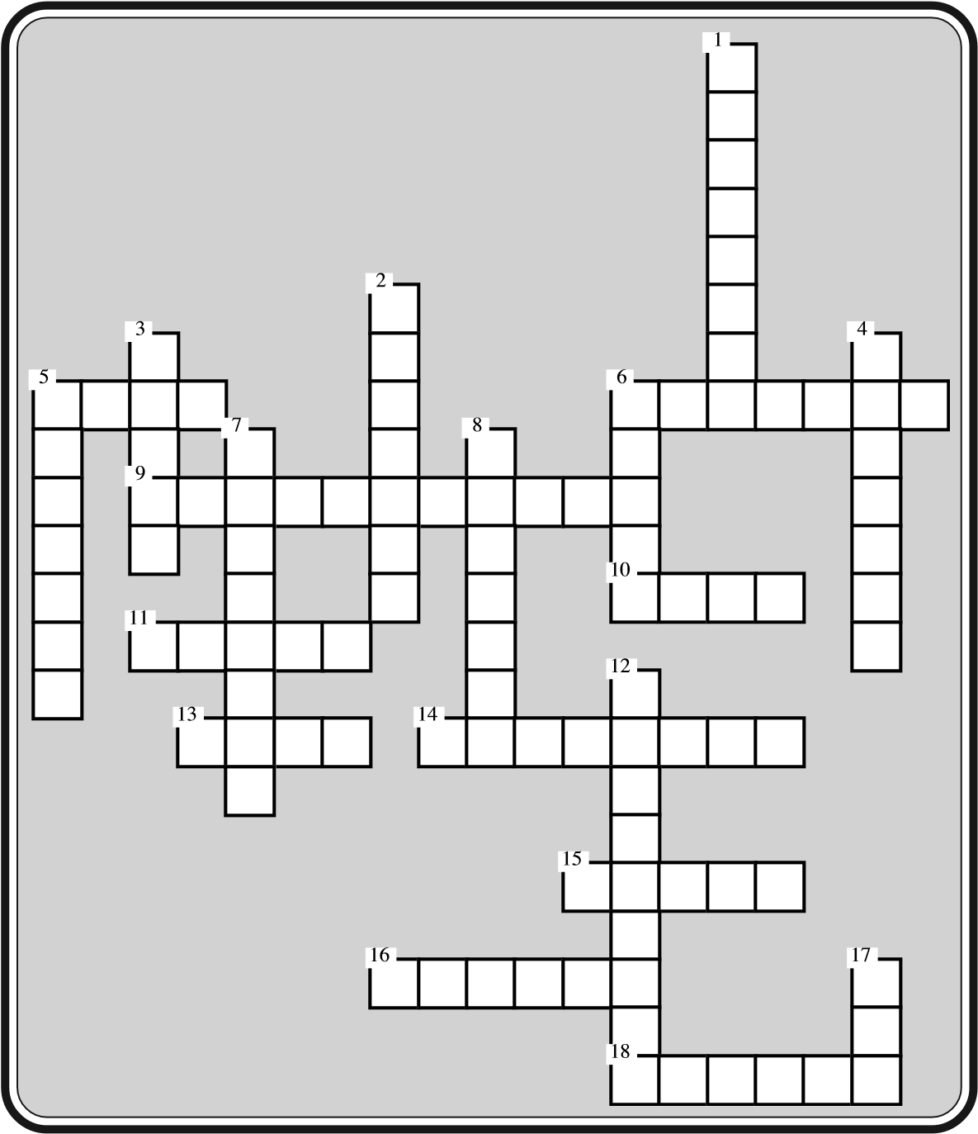 Name: ___________________ Date: __________

Physical Education 22 Crossword

**Across:**

1. The term used for describing the bending of an arm or a leg
2. They are made of two types of fibers
3. You can achieve your target pulse rate by varying the number of these
4. The arm _______ flexes the arms at the elbows
5. These muscle fibers do not require as much oxygen
6. He wrote a book on aerobics
7. This type of training works primarily with the white muscle fibers
8. The leg ______ extends the legs at the knees
9. Aerobic exercises help the body’s ability to use this element

18. The term used to describe the straightening of your arm or leg

**Down:**

1. This is one popular brand of exercise machine
2. This was the most popular form of aerobic exercise in the early years of aerobics
3. This organ is one part of the cardiovascular system
4. This exercise conditions the cardiovascular system
5. Aerobic exercise became part of this movement in the 1970s
6. This accompanies aerobic dance
7. A specific exercise produces this type of result
8. This type of training involves moving from one exercise machine to another with

little rest

12. If you just train for strength, you will not improve this

17. These muscle fibers contract more slowly

Name: ___________________ Date: __________

MHXBMOADWLGNENIECNMOXYGENUTCUT

CNSETEELTTEHXCPRMNGECISPAIRIEN

RERNXGRSTDCBTNNNISTSGGSNSXSRXU

RUFRCIGIREDFEEIXDWHITEXRNUUCGY

IAEROBICTSTENSNFASLXSPEECLNUIX

DIRIIRBEINLEDECPJDYRDFLEXREIDS

HGTLDEURALSTXRCFSPCYONERCTITUT

OPSTSPECIFICLNAUTILUSRNCUUCFRR

EEXTSNJXCCOEUMECFYTMUSICRTTUGE

MSBUAAUCNTLNXCPNXNGUFTPTLUXCIN

PRESSCSOPAUENDURANCEIJRLSESDIG

DDJOGGINGTUFETSAHRAMTIISIPISCT

IEEAFNNFNCISCSDDTIXENXTTIBMFTH

EUILNCMUFREPETITIONSEUXEDRGHTR

CRANLNCOIEOLENEHHNPCSRIUSDISNI

RWDSXSHCXFEFHUTHRECFSERUUSNPRI

TNAAEGGMXBYMUSCLESARCNSCEUUERC

EMTRMCSOGTNDNTNGLAERHUEHISLFSI

DIOFEBIEXCRRMGSXXPEUTCHRIIATLE

GEIAONATGFLIBXUEIEASRNDEEESTSF

Physical Education 22 Word Search

Use the clues below to discover words in the above puzzle. Circle the words.

1. He wrote a book on aerobics
2. The leg ______ extends the legs at the knees
3. Aerobic exercises help the body’s ability to use this element
4. These muscle fibers contract more slowly
5. If you just train for strength, you will not improve this
6. A specific exercise produces this type of result
7. They are made of two types of fibers
8. You can achieve your target pulse rate by varying the number of these
9. Aerobic exercise became part of this movement in the 1970s
10. The term used for describing the bending of an arm or a leg
11. This type of training involves moving from one exercise machine to another with little rest
12. This organ is one part of the cardiovascular system
13. This exercise conditions the cardiovascular system
14. The arm _______ flexes the arms at the elbows
15. The term used to describe the straightening of your arm or leg
16. These muscle fibers do not require as much oxygen
17. This type of training works primarily with the white muscle fibers
18. This accompanies aerobic dance
19. This is one popular brand of exercise machine
20. This was the most popular form of aerobic exercise in the early years of aerobics