Fairview Elementary School

**Free Academic Resources**

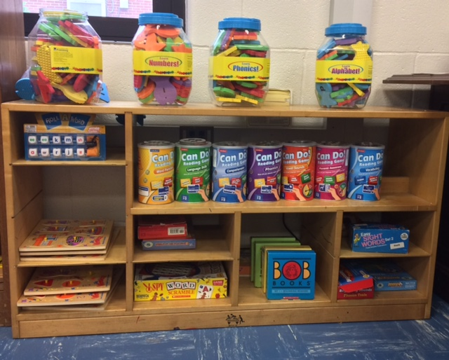

Fairview Elementary Family Resource Center

Located in Room 402

Hours: Monday – Friday

8:00 am – 2:00 pm*

Do you want to know more about how to help your child

in a specific area?

Homework, Test Taking, Reading, Math, Science, Social Studies or Writing?

Visit the Family Resource Center (Room 402) for tips, family workshops, academic resources (available for checkout) and much more.

*To visit during extended hours, please contact **Channell Campbell, Parent Involvement Professional**

770-474-8265 or [channell.campbell@henry.k12.ga.us](mailto:channell.campbell@henry.k12.ga.us)