**Social Studies**



* Explore the concept of patriotism through the words in the songs America and America the Beautiful (for example: brotherhood, liberty, freedom, pride, etc.).
* Identify goods that people make and services that people provide for each other.
* Explain that scarcity is when unlimited wants are greater than limited resources.

**Science**

Light & Sound





**January 10th- 2nd Semester Begins**

**January 17th- MLK Holiday (no school)**

**February 3rd- Parent Meeting w/ Dr. Akbar**

**February 7th-February 16th- Candy Grams Sell**

**February 21st-25th- Winter Break (no school)**

***Please sign up for Accelerated Reader Home Connect***

***(Letters were sent home on February 3rd)***



**Birthdays**



**Gaibriel 1/22**

**Reading **

* Sensory Details
* Character Traits
* Making Connections
* Information from pictures & text

***Don’t forget to read daily to meet monthly reading goal.***

**Writing**

Write opinion pieces in which they introduce the topic or the name of the book they are writing about, state an opinion, supply a reason for the opinion, and provide some sense of closure

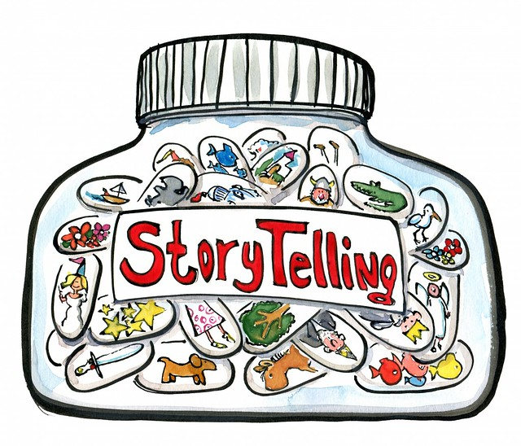

**Language**

* Using conjunctions
* Root words
* capitalization
* punctuation
* adjectives
* Multiple meaning words

**Math**

* Addition and subtraction strategies
* Measuring Length
* Time (hour & half)

