**Social Studies**

* Identify and locate the student’s city, county, state, nation (country), and continent on a simple map or a globe.
* Locate major topographical features of the earth’s surface.



**Science**

* Represent data in tables and/or graphs to identify and describe different types of weather and the characteristics of each type.
* Ask questions to identify forms of precipitation such as rain, snow, sleet, and hailstones as either solid (ice) or liquid (water).



**September 6th Labor Day- No School**

**September8th Progress Reports**

**September 10th Club Day/ Book Fair Begins**

**September 13th-17th Parent Teacher Conferences**

**September 16th Curriculum Night**

**September 20th-24th Fall Break (No School)**



**Birthdays**



Kennadie-5th

Mrs. Hicks-23rd

**Reading **

* Ask and answer questions about key details in the text.
* Explain the major difference between texts that tell stories and texts that give information.
* Ask and answer questions to help determine or clarify the meaning of words and phrases in a text.

**Writing**

Write narratives in which they recount two or more appropriately sequenced events, include some details regarding what happened, use words to signal event order, and provide some sense of closure.

Beginning, Middle, and End

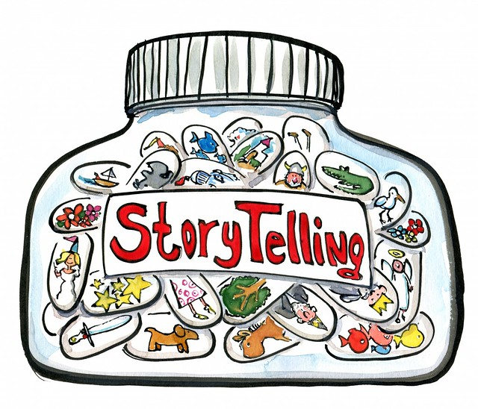

**Language**

* Produce and expand (declarative, interrogative, imperative, and exclamatory)
* Capitalization
* Punctuation
* Verbs

Nouns

**Math**

* Count to 120
* Developing base 10 number sense
* Organize, represent and interpret data

