

***STOCKBRIDGE MIDDLE SCHOOL***

 **Vision**

**SMS Vision**  
***Stockbridge Middle School will be a culturally responsive, community engaged environment that provides rigorous instruction which advances learning opportunities, equitable access and positive outcomes for all scholars.***

**GRADE 6 SOCIAL STUDIES**

**COURSE SYLLABUS**

**COURSE DESCRIPTION**

This year students will begin this course exploring several major geographical regions around the world. Our regions of study will include Europe, Latin America, Canada, and Australia. Students will also study Personal Finance and Economics. During this course, learners will participate in an inquiry-based service learning project-National History Day. Please refer to the Henry Teaching and Learning Standards for detailed listings of standards.

**Office Hours:**

Tuesday 2:40pm- 3:55pm

**Tutoring Schedule: TBA**

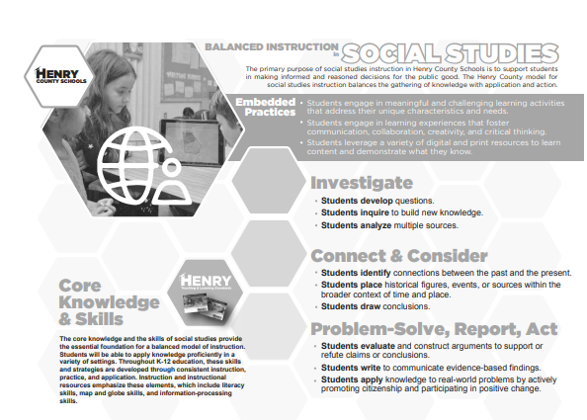

**Units of Study for 6th grade**

**Unit 1 Economics and Government Fundamentals**

**Unit 2 Geography of Europe**

**Unit 3 The Historical and Political Development of Europe**

**Unit 4 Economic Developments in Europe**

**Unit 5 Geography of Latin America**

**Unit 6 The Historical and Political Developments of Latin America**

**Unit 7 Economic Developments in Latin America**

**Unit 8 Geography of Canada**

**Unit 9 The Historical and Political Developments of Canada**

**Unit 10 Economic Developments of Canada**

**Unit 11 Geography of Australia**

**Unit 12 The Historical and Political Developments of Australia**

**Unit 13 Economic Developments of Australia**

**Unit 14 Personal Money Management**

|  |  |
| --- | --- |
| Suggested Materials for Student Success:  **Below are the items that will be utilized for my class**.   * 3 Ring Binder * Pocket/Prong Folders - Qty 1 * Colored Pencils * Glue Stick * College Ruled paper * Pencils * Highlighters   **Wishlist**   * Hand sanitizer * Facial tissue * Copy Paper * Extra Pencils | **GRADING SCALE**  90 – 100% = A  80 – 89% = B  74 – 79% = C  73 – 70% = D  69% and below = F  **GRADING WEIGHTS**  The grading percentages are as follows:   * Practice ~ 35%   + Classwork/ Lab (20%)   + Homework (10%)   + Notebook (10%) * Assessments-50%   + Tests/ Projects (20%)   + Quizzes (10%)   + Common Summative Assessments (10%) * Final Exams~ 15% |

**LATE WORK: Please carefully review the school’s policy.**

**IMPORTANT CLASSROOM RULES:**

* Be respectful of your peers, teachers, yourself and your classroom environment.
* Come to class on time
* Bring required materials/ assignments everyday
* Talk only when permitted
* Remain in your assigned seat unless you have permission to get up
* Use polite speech and body language.
* No gum, food, or drink in the classroom unless permitted.
* Attend to personal needs before coming to class. Use the restroom or take care of any issues before class.
* Your responsibility is to follow all classroom rules.

***Students who do not follow these classroom rules will be assigned a consequence, depending on the situation.

|  |  |
| --- | --- |
| **Rewards** | **Consequences**  **(May be adjusted based on circumstances)** |
| * Verbal Praise * Reward * Phone Call/ Note Home | * Citation 1/ Warning/ Teacher Conference * Citation 2/Parent Contact/ Silent Lunch/ Detention * Citation 3/ Parent Contact/ Team Conference * Citation 4/ Parent Contact/ Office Referral |

The requirements and information on this syllabus are all designed with a successful year in mind. I am confident that learners will gain the necessary tools to *be exceptional!* This year will begin many changes in your academic life and it is my goal to prepare you for the road ahead, high school, which for many of you will lead to college and/or career. I want all of you to know my door is open any time for advice and help. I look forward to learning from all of you, along with teaching and guiding you. It is important to be aware that this syllabus may be adjusted at any time during the school year to better meet the needs of the classroom and you as learners.

**Good Luck and Welcome to 6th Grade!**

Your efforts are greatly appreciated for the time dedicated to reading and discussing the information printed above. I look forward to working with each of you this year. Please complete the information on this form, and then sign below and return it. If you have any questions, please do not hesitate to contact me via email.

|  |  |
| --- | --- |
| **Parent Name:** | **Student Name:** |
| **Parent’s Phone:** | **Parent’s Email:** |

|  |  |
| --- | --- |
| **I have read and discussed all expectations and policies with my child.** | |
|  | **Date:** |
| **Student Signature** | **Date:** |

|  |  |  |
| --- | --- | --- |
| **I have signed up for Remind 101.** | |  |
| **Parent Signature** | **Date:** | |

**PLEASE RETURN THIS SIGNED PAGE TO YOUR SOCIAL STUDIES TEACHER**