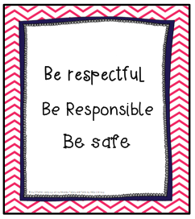

**Mission Statement:**

*"To create a safe, caring and friendly learning community that enables the students we serve to achieve their highest social, behavioral, and academic potential."*

***Purpose:***

*The primary goal of Positive Behavioral Interventions and supports or PBIS is to help schools design effective environments that will increase teaching and learning for all students. (gadoe.org/gapbis)*

