**Social Studies**

Read about and describe the life of historical figures in American history.

Continue to work on topographical features.



**Science**

Magnets

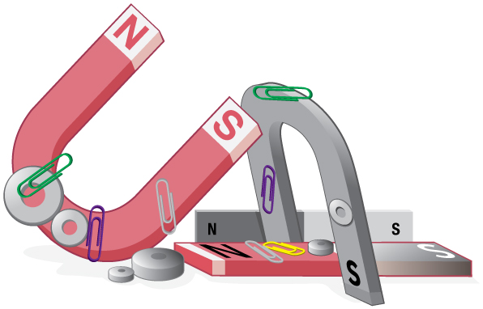



**October 8th-13th Early Release Days**





**Birthdays**



**Journee’ 10/1**

**Jordyn 10/14**

**Reading** 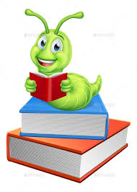

* Retelling
* Use text features to locate key information
* Ask and answer questions to help determine or clarify the meaning of words and phrases in a text.

**Writing**

Write informative/ explanatory texts in which they name a topic, supply some facts about the topic, and provide some sense of closure.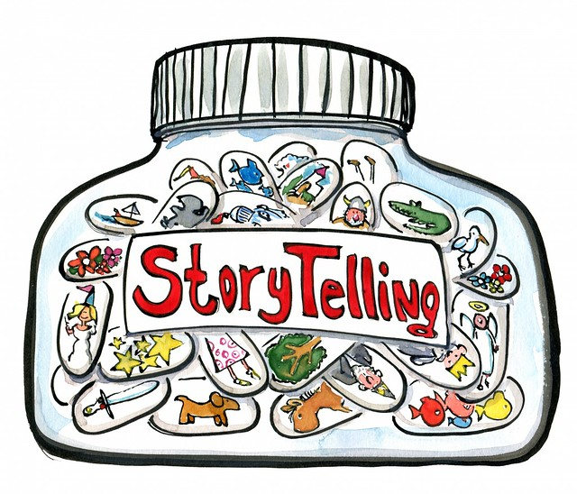

**Language**

* Common, proper, and possessive nouns
* Singular and plural nouns
* Extending sentences
* Sentence structure

**Math**

* Money
* Developing base 10 number sense
* Organize, represent and interpret data

