SS8G1: The student will describe Georgia with regard to physical features and location.

a. Locate Georgia in relation to region, nation, continent, and hemispheres.

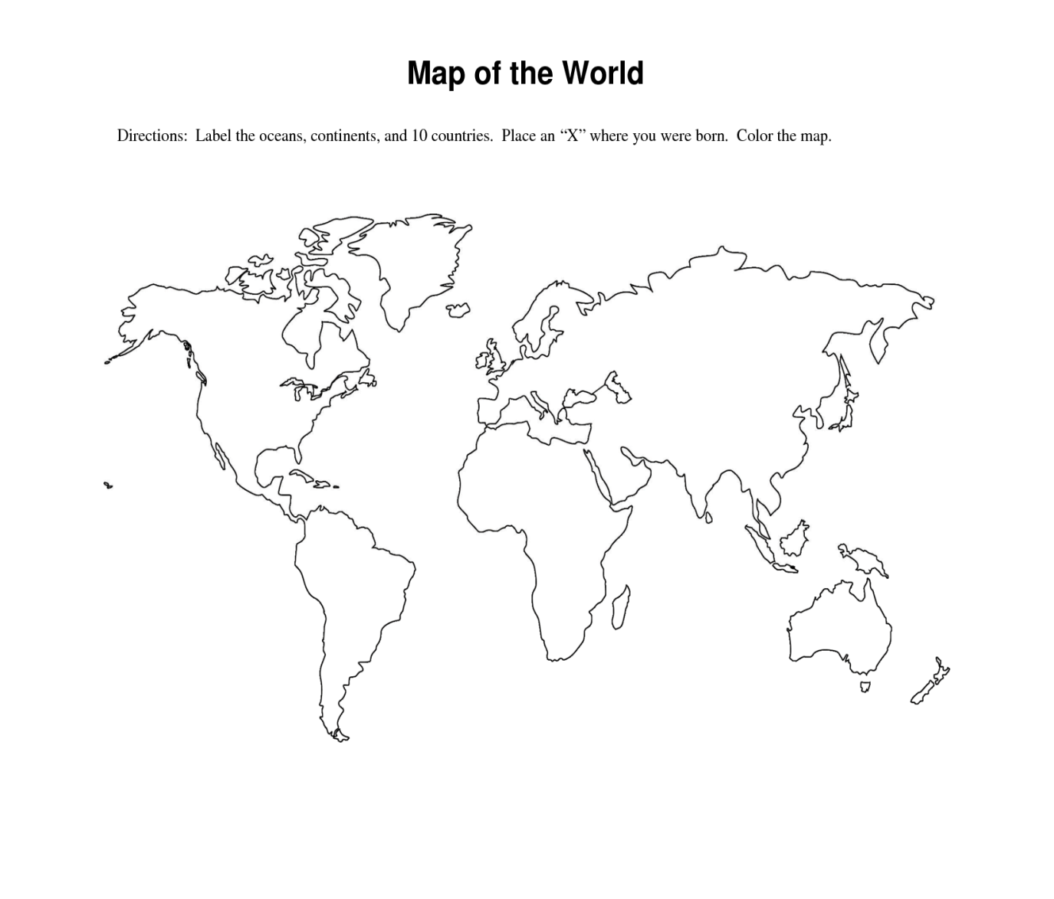

Name:

* Use the map above to complete this assignment:

1. Draw a vertical and horizontal line across the center of the map to represent the Hemispheres.
2. Label the hemispheres Northern, Southern, Eastern, and Western.
3. Georgia is located in the __________________________Hemisphere and/or the __________________________Hemisphere.
4. Draw a blue square around the Continent in which you would find Georgia.
5. The name of this Continent is _______________________________.
6. Draw a red rectangle around the Nation or Country in which you would find Georgia.
7. The name of this nation/country is ___________________________.
8. Draw a yellow star where Georgia is located.
9. What region(s) of this nation or country would you find Georgia?

(north, south, east, west, northeast, northwest, southeast, southwest)

SS8G1: The student will describe Georgia with regard to physical features and location.

a. Locate Georgia in relation to region, nation, continent, and hemispheres.



Name:

* Use the map above to complete this assignment:

1. Draw a vertical and horizontal line across the center of the map to represent the Hemispheres.
2. Label the hemispheres Northern, Southern, Eastern, and Western.
3. Georgia is located in the __________________________Hemisphere and/or the __________________________Hemisphere.
4. Draw a blue square around the Continent in which you would find Georgia.
5. The name of this Continent is _______________________________.
6. Draw a red rectangle around the Nation or Country in which you would find Georgia.
7. The name of this nation/country is ___________________________.
8. Draw a yellow star where Georgia is located.
9. What region(s) of this nation or country would you find Georgia?

(north, south, east, west, northeast, northwest, southeast, southwest)