**Social Studies**

Read bout and describe the life of historical figures in American history. 

* Benjamin Franklin
* Thomas Jefferson
* Lewis and Clark
* Sacagawea
* George Washington Carver

**Science**

Magnets

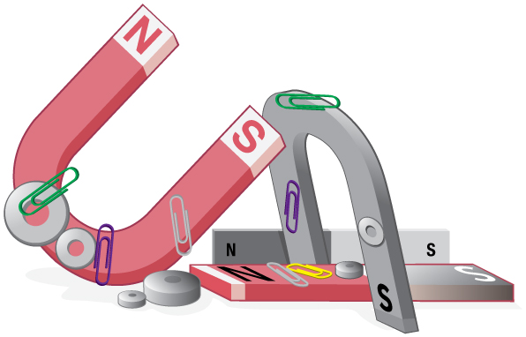



**November 2th -Teacher Work Day/Election Day**

**November 4th- School Poetry Recitation Contest**

**November 6th- Fall Festival**

**November 22nd-26th Thanksgiving Break**

**December 2nd- Kona Ice Day**

**December 22nd- Early Release Day**

**December 23rd-January 10th- Semester Break**



**Birthdays**



**Sir-Zayvion 11/18**

**Mason 11/24**

**Aaron 12/10**

**Lyrical 12/23**

**Jasmine 12/31**

**Reading** 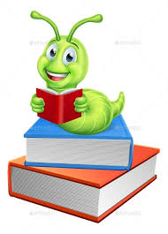

* Theme
* Main Idea
* Supporting Details

***Don’t forget to read daily to meet monthly reading goal.***

**Writing**

Write informative/ explanatory texts in which they name a topic, supply some facts about the topic, and provide some sense of closure.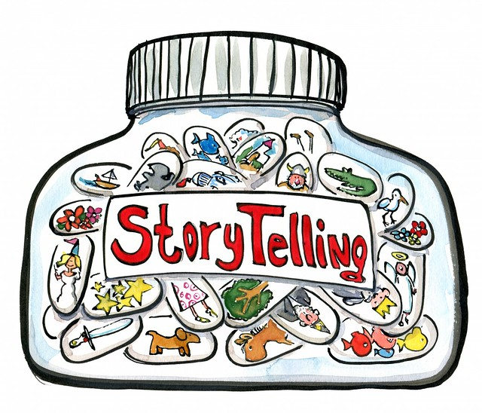

**Language**

* Using commas
* Extending sentences
* Sentence structure
* Contractions
* Multiple meaning words

**Math**

* Solving story problems
* Addition and subtraction strategies
* Solving for the unknown
* Fact Families

