Name: _______________________________________________
Milestones REVIEW #2 – Write FINAL ANSWER in box but MUST attach all scratch work as PROOF!! No work = No Credit
#1  What is the value of -12 + 4? | #2  Write three equivalent ratios for 2/3. | #3  Mike is m years old. His mother's age is three years more than twice Mike's age. Write an expression to represent the age of Mike's mother. | #4  Angle G and angle H are supplementary angles. If angle G measures 123 degrees, what is the measure of angle H? | #5  What is the absolute value of 45?
#6  The temperature one morning was -12 degrees. By the afternoon, the temperature had risen 8 degrees. What was the temperature in the afternoon? | #7  Find the product of -8 and -6. | #8  Solve for x:  1 x = 7  6 | #9  Expand and Simplify: 6³ = ______ | #10  Write 26% as a fraction in simplest form.
#11  A fast food restaurant offers delivery service anywhere within a 6 mile radius. What AREA does the restaurant delivery service cover? | #12  Write 0.12 as a fraction in simplest form. | #13  Lindsey walked 48 blocks in 3 hours. How many blocks can she walk in 1 hour? | #14  Solve and graph:  x + 5 > -3 | #15  What is the value of the missing angles?  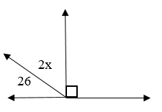
#16  Solve for x:  3x + 15 = 27 | #17  A football team gains 11 yards, loses 4 yards, gains 7 yards, and then loses 10 yards. What was the total gain or loss? | #18  -4 x 3 x -2 = | #19  What are the values of the missing angles?  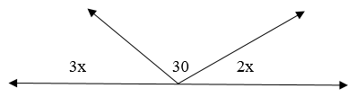 | #20  Write “ten less than twice a number” as an algebraic expression.
#21  If x = -3, what is the value of 2x + 8? | #22  Combine like terms:  4a – 3ab – 2a + 12ab | #23  Zach earns $5.50 per hour. Last week he worked 17 hours. How much did he earn? | #24  (12x + 4y – 5) – (6x + 2y + 20) | #25  Angle C and angle D are complementary angles. If angle C measures 64 degrees, what is the measure of angle D?
#26  Are the ratios equivalent?  1 to 4 and 3 to 20  Yes No | #27  What is the opposite of  -18? | #28  Solve for m:  -4m – 7 = 17 | #29  65 – 20 ÷ (2 + 3) = | #30  Write 0.16 as a percent.

REMEMBER…
Write FINAL ANSWER in box but MUST attach all scratch work as PROOF!!
No work = No Credit

