**Project Based Learning**

**Entry Event**

Have you ever thought about what it takes to be on the other side of the ball – to be the coach – to be the one making the decisions? Well, here is your chance. Your Coaches are hiring you to assist them throughout the year.

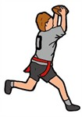

Your first task is to teach a sport and then set up a sports tournament for your peers. You will work in groups of 3 or 4, and as a group, you will select a sport. After selecting the sport, your group will spend time researching the sport and how to best teach the skills to other students.

Once you have taught the rules and skills, you will coach your peers during a tournament that you have organized for them. **You will have 2 days for your games/tournament.**

**Standards**

**PEHS.1:** Demonstrates competency in motor skills and movement patterns needed to perform a variety of physical activities.

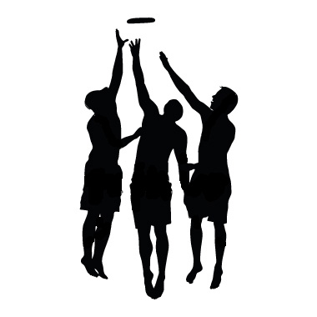**PEHS.2:** Demonstrates understanding of movement concepts, principles, strategies, and tactics as they apply to the learning and performance of physical activities.

**PEHS.3:** Participates regularly in physical activity.

**PEHS.4:** Achieves and maintains a health-enhancing level of physical fitness.

**PEHE.5:** Exhibits responsible personal and social behavior that respects self and others in physical activity settings.

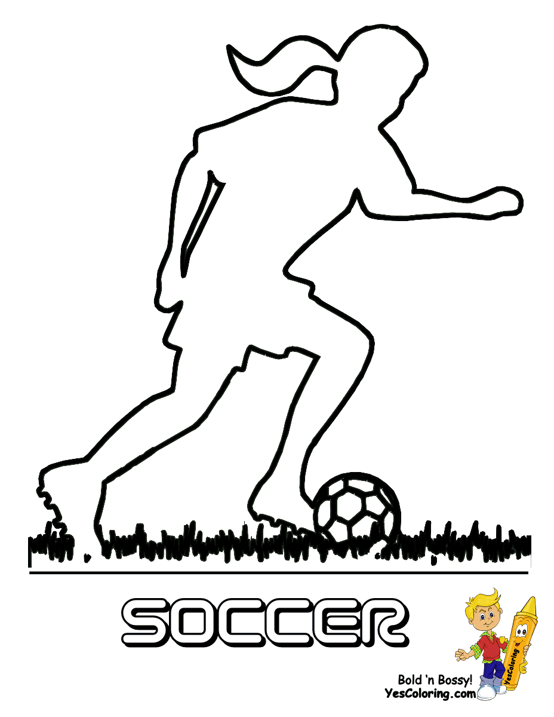

**Driving Question**

As a coach, how do you ensure that your participants understand the sport and are capable of competing in that sport?

**Possible Sports [I = indoor/O=outdoor]**

* flag football [O]
* outdoor soccer [O]
* ultimate frisbee [O]
* volleyball [I]
* whiffle ball [I]
* team handball [I]
* badminton [O]
* tennis [O]
* Basketball
* kickball [I]
* softball [O]
* lacrosse [O]
* frisbee golf [O]
* floor hockey [I]

**Group Research/Notes Pages**

|  |  |
| --- | --- |
| ***Group Members***  *Who are the members of your group? Write their first and last names.* | 1. __________________________________________________ 2. __________________________________________________ 3. __________________________________________________ 4. __________________________________________________ |
| ***Sport***  *Which sport is your group choosing?* |  |
| ***Pre-Reflection***  *Think about what you need to do. Then answer the questions.*   1. *What information does your group need to find when you begin your research?* 2. *Where do you think you will find this information?* |  |
| ***Rules***  *What are the rules of your sport that you will need to teach to your peers?* |  |

|  |  |
| --- | --- |
| ***Skills***  ***What skills will your peers need to learn to play this sport well?*** |  |
| ***Equipment Needed:***  ***(This may include but, not limited to Audio/Visual, handouts or other items needed to assist in teaching)***  ***Please remember – this is limited to the equipment we have at LGHS.*** |  |
| ***Tournament Rules and Information***  *What you have a single or double elimination system?* |  |
| *Will you have brackets? Double or Single Elimination* |  |
| *When students are eliminated, what will they do?* |  |

**Group Planning Pages**

**As you are planning, remember that everyone in your group must teach at least 1 skill.**

|  |  |  |
| --- | --- | --- |
| ***What do I want the students to know?*** | ***How will I assist in their learning?*** | ***How will I know they have learned?*** |
|  |  |  |
| ***Which GaDOE Standards apply in these skill?*** | ***How will I assist those who have lower level skills?*** | ***Are there rule modifications I am using?*** |
|  |  |  |
| ***Skills To Be Taught***  ***Example:***  *Basketball Shooting* | ***Teaching Cues***  ***Example:***   1. *L-Shaped Arms* 2. *Wave Bye Bye* | ***Who will teach it?***  ***Example:***  *Coach Shook* |
|  |  |  |

**Grading Rubric**

**Name: __________________________ Class Period: __________________**

**Sport: _____________________**

|  |  |  |  |  |
| --- | --- | --- | --- | --- |
| **Grade** | **Developing 0 – 5** | **Effective**  **6 - 10** | **Proficient**  **11 - 15** | **Exemplary**  **16 - 20** |
| **Knowledge of concepts and rules** | **Poor knowledge of game rules, boundaries, scoring, game concepts, and tactical strategies.** | **Fair knowledge of game rules, boundaries, scoring, game concepts, and tactical strategies.** | **Good knowledge of game rules, boundaries, scoring, game concepts, and tactical strategies** | **Excellent knowledge of game rules, boundaries, scoring, game concepts, and tactical strategies.** |
| **Skills** | **Demonstrates inadequate skills with little/no understanding.** | **Demonstrates skills at a minimum understanding level** | **Demonstrates proficient of skills and growth at a competitive level.** | **Demonstrates excellent skills at a competitive level.** |
| **Preparation** | **Unprepared for unit each day** | **Inconsistently prepared** | **Presentation prepared but equipment not** | **Prepared for class and ready to teach** |
| **Participation** | **Minimal/poor effort during activity, little/no movement with numerous excuses for inactivity, socialization interferes with participation** | **Displays some effort, contributes little to team in teaching and demonstrating, need reminders to stay on task** | **Consistent daily effort, good level of participation within group, displays quality movement during activity, stays on task** | **Gives maximum effort daily, models a high level of participation, self-motivated, encourages others.** |
| **Attitude/Behavior** | **Rarely, demonstrates sportsmanship and responsible personal and social behavior. Student has a negative attitude within group, peers and instructor** | **Occasionally, demonstrates sportsmanship and responsible personal and social behavior. Student is occasionally negative or uncooperative within group.** | **Frequently, demonstrates sportsmanship and responsible personal and social behavior. Student has a positive attitude with peers and instructor.** | **Demonstrates outstanding sportsmanship and responsible personal and social behavior. Student has a positive attitude with peers and instructor.** |
| **Total:** |  |  |  |  |

**Total possible points is 80.**

**80 – 78 is A+; 77 – 75 is A; 74 – 72 is A-**

**71 -69 is B+; 68 – 66 is B; 65 - 63 is B-**

**62 – 59 is C+; 58 – 55 is C; 54 – 51 is C-**

**50 – 47 is D+; 46 – 43 is D; 42 – 39 is D-**

**38 and below is F.**