September 2021

Parent & FAMILY ENGAGEMEN CALENDAR
‘’’’’’
Eagle’s Landing Middle School
 | Monday | Tuesday | Wednesday | Thursday | 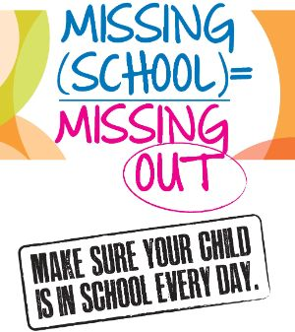  Friday | Saturday
 |  |  | 1 | 2 | 3 | 4
 |  | ELMS Family Resource Center is open to all Monday-Friday 8:30-3:30 Room 121 by appointment. Mask required |  |  | 
 | 6 | 7 | 8 | 9 | 10 | 11
 |   School Closed | Need resources to assist your student at home? Schedule an appointment with your PIP  School Council Elections Rm121 | Parent Power Hour:  Need help with Infinite Campus? Start Here:  https://schoolwires.henry.k12.ga.us/domain/2747  School Council Elections Rm121 | PRC closed for Professional Training  8:00am – 1:00pm  School Council Elections Rm121 | Extra Help  Fall Break is coming up. Make an appointment in the FRC for resources to help your student study over the break  School Council Elections  Rm121
 | 13 | 14 | 15 | 16 | 17 | 18
 | School Hours  8:45a-3:55p  NO check outs after 3:15p  Please have your ID to check your student out | Did You Know?  Reading just 15+ minutes daily accelerates reading growth. | Use the QR code to the right to check out family resources to help your student thrive at school as well as at home. |  | Extra Help  Fall Break is coming up. Make an appointment in the FRC for resources to help your student study over the break
  No School……See you September 27th!!! | 20 | 21 | 22 | 23 | 24 | 25
 | 27 | 28 | 29 | 30 | Game Times @ ELMS!! | Upcoming:
 |  | Infinite Campus:  It’s never too late to sign up for Infinite Campus where you can check your child’s grades and more from home | Wrap it Up Wednesday  How can the FRC assist you and your student? Schedule an appointment to see the many resources available to you at no cost! | Parenting Tip of the Day  Discuss ideas and feelings about school, studies and activities with your student | Sept 1st - 8th grade football @ LGMS  Sept 2nd - Softball ELMS vs. HMS (home)  Sept 7th-10th - School Council Elections  Rm 121 | Look for updates and information on PTO and Student Council Meetings
For more information contact: Sharon Murray@ sharon.murray@henry.k12.ga.us, Parent Involvement Professional
rrr

