October 2021

Parent & FAMILY ENGAGEMENT CALENDAR

Eagle’s Landing Middle School
 | Monday | Tuesday | Wednesday | Thursday | Friday | 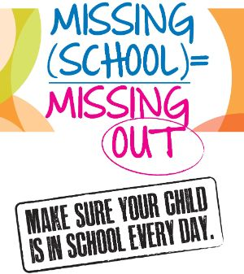  Saturday
 |  |  |  |  | 1 | 4
 | ELMS Family Resource Center is open to all Monday-Friday 8:30-3:30 Room 121 by appointment only. Mask Required |  |  | In support of Hispanic Heritage Month Find a Hispanic recipe, cook the meal with your family and post on our school twitter @ELM_HCS | 
 | 4 | 5 | 6 | 7 | 8 | 11
 | Hispanic Heritage Month thru 10/15  Learn a new language by using Hispanic greetings and language at home | Need Resources to assist your student at home? Make an appointment to visit the FRC to see what’s available | Infinite Campus  Take some time to become familiar with all you can do within Infinite Campus  https://schoolwires.henry.k12.ga.us/Page/15264  How to set up and use Infinite Campus | Check out a game from the FRC. Have a family game night. Unplug the video games and connect with family! | Early Release @ 12:55
 | 11 | 12 | 13 | 14 | 15 | 18
 | Parent-Teacher Conference  Early Release @ 12:55 | Parent-Teacher Conference  Early Release @12:55 | Parent-Teacher Conference  Early Release @12:55 | Progress Reports  Progress Reports Available via Parent Portal & Print |  | 
 | 18 | 19 | 20 | 21 | 22 | 25
 | Does your child need help with homework, tutoring or test prep? Check out tutor.com sponsored by Henry County Public Library |  | Have you Joined the PTO?  Stop by the Parent and Family Resource Center in Room 121 for more Information | ELMS is here when you need  | 
 | 25 | 26 | 27 | 28 | 29 | 1
 | How can the Family Resource Center be beneficial to me and my child? | Infinite Campus:  It’s never too late to sign up for Infinite Campus | Wrap it Up Wednesday  Make an appointment with Abundant Life Church to visit their Food & Pantry and Clothing Closet  770-775-4838 | School Council  Meeting | Visit the Virtual FRC https://schoolwires.henry.k12.ga.us/Page/150169  Check out and take home FREE academic resources | cONNECT WO
For more information contact your Parent Involvement Professional @ Sharon.murray@henry.k12.ga.us

