November 2021

Parent & Family engagement calendar

Eagle’s Landing Middle School
 | Monday | Tuesday | Wednesday | Thursday | Friday | 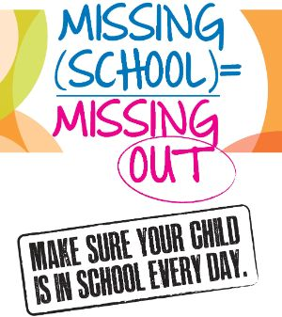  Saturday
 | 1 | 2 | 3 | 4 | 5 | 4
 |  | Teacher’s Workday  Students Out!!  GO VOTE!!!!!! |  | Parent University: Navigating Middle School  Session 1 - 11:00am
 | 8 | 9 | 10 | 11 | 12 | 11
 | Schedule an Appointment  with the PIP to see resources available at no cost to you | Parent University: Navigating Middle School  Session 2 - 1:00pm | Parent Power Hour:   |  | Parent Power Hour  8:30am and 11:30am  What can we help you with? Do you have questions? Get answers, support & materials you need ☺
 | 15 | 16 | 17 | 18 | 19 | 18
 | Title I Parent Input Meeting  3p-4p  Pop in to give your input |  | GRADES POSTED  MAKE SURE YOU CHECK INFINITE CAMPUS TO SEE YOUR CHILDS GRADES | What are you thankful for?  I am thankful for family  Ask your kids what they are thankful for. | Get connected!  Drop in the Family Resource Center to find out all the ways we can stay connected to you! | 
 | 22 | 23 | 24 | 25 | 26 | 25
Thanksgiving Break
We will see you November 29th

 | 29 | 30 |  |  |  | 1
 | HAPPY FAMILY ENGAGEMENT MONTH!! |  |  |  |  | cONNECT WO
For more information please contact the PIP – Sharon Murray

