August 2021

PARENT & FAMILY ENGAGEMENT CALENDAR

Eagle’s Landing Middle School
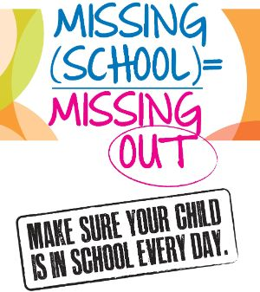
 | Monday | Tuesday | Wednesday | Thursday | Friday | Saturday
 | 2 | 3 | 4 | 5 | 6 | 4
 | The Family Resource Center is open daily from 8:30am to 3:30pm. Please contact Ms. Murray at  770-914-8189 or Sharon.murray@henry.k12.ga.us to set up an appointment or if you have any questions or need additional information. |  |  | Get Connected!  Familiarize yourself with your child’s school – teachers, front office, clinic aid, administrators, cafeteria workers, bus drivers and/or after-school staff  (if applicable) | Get Connected!  Take a moment to discuss with your child their first week of school.
 | 9 | 10 | 11 | 12 | 13 | 11
 | Henry County Board Meeting  7:00pm | FRC closed for Professional Training  8:00am – 1:00pm | Family Resource Center  Make an appointment to see what the FRC has to offer you and your child for this school year. Contact: Sharon.murray@henry.k12.ga.us or call 770-914-8189 | FRC closed for Professional Training  8:00am – 1:00pm
 | 16 | 17 | 18 | 19 | 20 | 18
 |  | MAP TESTING  (Measures of academic progress) | MAP TESTING  (Measures of academic progress) | MAP TESTING  (Measures of academic progress) | Community Night  Eagle’s Landing vs. Meadowcreek  Come out and join us for:  Music, face painting, games, food @6:00pm  Game Time @7:30pm  😊END OF MAP TESTING! 😊
 | 23 | 24 | 25 | 26 | 27 | 25
 | PARENT HOUR OF POWER  Starting the year strong!  Establishing a routine with your kids for a successful school year. See our Title 1 website to learn tips from experts | Get Connected!  Take a moment to discuss with your child how you can work together as a team to ensure a successful in-person learning experience for ALL! | Family Resource Center  Make an appointment to see what the FRC has to offer you and your child for this school year. Contact: Sharon.murray@henry.k12.ga.us or call 770-914-8189 | PARENT HOUR OF POWER  HOMEWORK TIPS  Learn tips from experts on establishing a homework routine with your kids.  See our Title 1 website for more information. | 
 | 30 | 31 |  |  |  | 1
 |  | ADDITIONAL ACTIVITES:  Aug. 23 Softball game ELMS vs UGMS (home  Aug. 24 7th grade football game at Austin Road Middle  Aug. 25 8th grade football game ELMS at ARMS (home)  Aug. 26 Softball game ELMS vs. ARMS (home)  Aug. 30 Softball game at Luella Middle School  Aug. 31 7th grade football game ELMS vs. LGMS (home) |  |  |  | cONNECT WO

