December 2021

Parent & FAMILY ENGAGEMENT CALENDAR

Eagle’s Landing Middle School
 | Monday | Tuesday | Wednesday | Thursday | Friday | 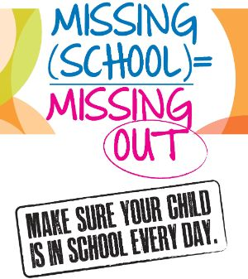  Saturday
 |  |  | 1 | 2 | 3 | 4
 | Hey Parents! The semester is coming to an end, and finals are approaching. Stop by the FRC for resources to help your student prepare. |  | Tech Time  Come in for computer resources, to help your student at home. | Parent Resource Center  Room 121  8:30-3:30 Monday-Friday | Infinite Campus  Are you checking Infinite Campus for your students’ grades?
 | 6 | 7 | 8 | 9 | 10 | 11
 | New parent Orientation/ School Tours  9am  12pm  1pm | Your Voice Matters    POP in and see the PIP and give us your input | Parent Power Hour:  “There are two great things you can give your children: one is roots, the other is wings.” ~ H. Carter | Parent Resource Center  POP in with the PIP and see what the FRC has to offer families and students | Weekend Warrior  Parents…Finals are next week. Make sure your student has their student guide. Contact us if you need assistance.
 | 13 | 14 | 15 | 16 | 17 | 18
 | Parent Power Hour  12:30-2:30  POP in with the PIP and check out our resources |  |  | Don’t Forget  Christmas Break is next week. If your child has medicine in the clinic that they will need, be sure to come pick it up. | Semester Final Exams | 
 | 20 | 21 | 22 | 23 | 24 | 25
 | Semester Final Exams  Christmas Break (Dec. 23 - Jan. 7) See You Next Semester!! |  | Early Release
 | 27 | 28 | 29 | 30 | 31 | 1
 | Christmas Break, Students Return January 7th |  |  |  |  | cONNECT WO
For more information please contact the PIP – Sharon Murray

