Name: ______________________________________ Date: ________________________

Student Exploration: Solubility and Temperature

Vocabulary: concentration, dissolve, homogeneous mixture, solubility, solubility curve, solute, solution, solvent

Prior Knowledge Questions (Do these BEFORE using the Gizmo.)

- What happens when you stir a spoonful of sugar into hot water? ______________________

_________________________________________________________________________

- When sugar or another substance is dissolved in water, it disappears from view and forms a homogeneous mixture with the water, also called a solution.

If you can’t see the sugar, how can you tell that it is there? __________________________

_________________________________________________________________________

- Does sugar dissolve more easily in hot water or cold water? _________________________

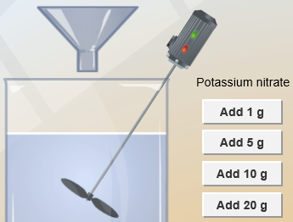
Gizmo Warm-up
A solution generally consists of two parts, a solute that is dissolved and a solvent that the solute is dissolved into. For example, sugar is a solute that is dissolved into the solvent water. In the Solubility and Temperature Gizmo™, you will study how temperature affects how much solute will dissolve in a solution.

To begin, check that Potassium nitrate is selected and the Temp. of the water is 20 °C. Click OK.

- In this solution, what is the solute? ________________ What is the solvent? ___________

- Click Add 10 g to mix 10 g of potassium nitrate into the water.

  - Did all of the potassium nitrate dissolve? ___________

  - How can you tell? ____________________________________________________

___________________________________________________________________

Activity A:  Solubility | Get the Gizmo ready:  - Click Reset.  - Check that the Temp. is 20 °C and that Potassium nitrate is selected. | 

Question: How do we find how much solute can be dissolved in a solvent?

- Observe: Click OK. Click Add 20 g, and observe the potassium nitrate being mixed into the solution. On the right, select the BAR CHART tab and turn on Show numerical value. The bars show how much solute has been added and how much has piled up on the bottom.

Did all of the solute dissolve? _________________________________________________

- Calculate: The concentration of a solution is equal to the mass of solute divided by the volume of solvent. Units of concentration are grams per 100 milliliters (g/100 mL, or g/dL).

What is the concentration of this solution? _______________________________________

- Experiment: Click Add 20 g again.

    - Did all of the solute dissolve? Explain how you can tell. _______________________

___________________________________________________________________

    - Based on the amount of solute added and the amount piled up on the bottom, how many grams of solute dissolved in the water? _______________________________
    - The solubility of the solution is equal to the maximum concentration of the solute.

What is the solubility of potassium nitrate in 20 °C water? _____________________

- Experiment: Click Reset, and select Sodium chloride. With the Temp. still set to 20 °C, click OK. Add sodium chloride to the beaker until it starts piling up at the bottom.

    - How much sodium chloride did you add? __________________________________

    - How much sodium chloride piled up at the bottom? __________________________

    - How much sodium chloride dissolved in the water? __________________________

    - What is the solubility of sodium chloride in 20 °C water? ______________________

- Apply: At 20 °C, how much sodium chloride could be dissolved into 2 L of water? ________
How much potassium nitrate could be dissolved into the same amount of water? _________

Activity B:  Solubility and temperature | Get the Gizmo ready:  - Click Reset.  - Set the Temp. to 10 °C.  - Select Potassium nitrate, and click OK. | 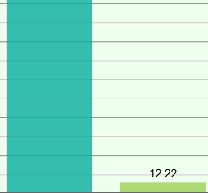

Question: How does temperature of the solvent affect solubility?

- Predict: Based on your own experience, how do you expect temperature to affect solubility?

_________________________________________________________________________

_________________________________________________________________________

- Gather data: Use the Gizmo to measure the solubility of potassium nitrate at each temperature given in the table below. Then, graph the resulting solubility curve at right.
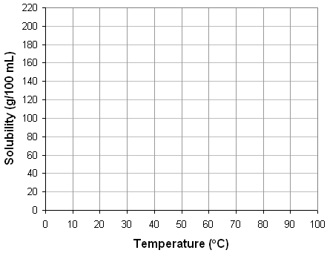
Temperature | Solubility  (g/100 mL)
10 °C
20 °C
30 °C
40 °C
50 °C
60 °C
70 °C
80 °C
90 °C

- Infer: Based on your graph, what would you predict is the solubility of potassium nitrate at a temperature of 5 °C? 95 °C? Check your 5 °C prediction with the Gizmo.

5 °C predicted solubility: ____________ 5 °C actual solubility: ____________

95 °C predicted solubility: __________ (Impossible to find actual solubility using Gizmo.)

- Explain: Potassium nitrate absorbs a large amount of heat energy from the water as it dissolves. How does this explain the solubility curve you graphed for potassium nitrate?

_________________________________________________________________________

_________________________________________________________________________
(Activity B continued on next page)
Activity B (continued from previous page)

- Gather data: Now use the Gizmo to measure the solubility of sodium chloride at each temperature given in the table below. Then, graph the solubility curve of sodium chloride.
Temperature | Solubility  (g/100 mL)
10 °C
20 °C
30 °C
40 °C
50 °C
60 °C
70 °C
80 °C
90 °C

- Infer: Based on your graph, what would you predict is the solubility of sodium chloride at a temperature of 5 °C? 95 °C? Check your predictions with the Gizmo.

5 °C predicted solubility: ____________ 5 °C actual solubility: ______________

95 °C predicted solubility: ____________ 95 °C actual solubility: _____________

- Compare: How does the solubility curve for sodium chloride compare with the solubility curve for potassium nitrate?

_________________________________________________________________________

_________________________________________________________________________

- Infer: Potassium nitrate absorbs a lot of heat from water as it dissolves. Based on its solubility curve, what can you infer about how much heat sodium chloride absorbs?

_________________________________________________________________________

_________________________________________________________________________

- Think and discuss: What do you think the solubility curve would look like for sugar? Explain.

_________________________________________________________________________

_________________________________________________________________________

