Rekenreks – Number Talks

Use the following resource to complete the Number Strings.

<http://www.ronblond.com/MathGlossary/Division01/Rekenrek/REKENREK/>

Click “hide amount” to only see the beads.

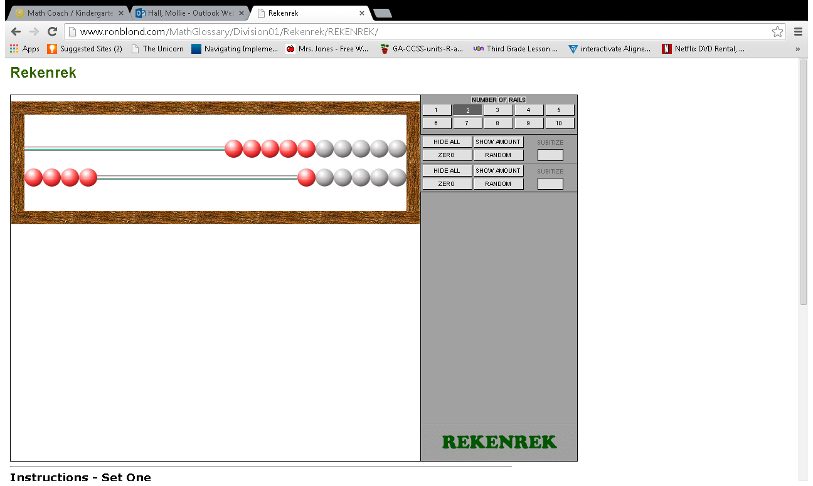

The Following Number Strings are from Number Talks: Helping Children Build Mental Math and Computation Strategies by Sherry Parrish.

“The problems within each string should be presented in sequential order (A, B, C, and so on).”

Number 3

1. 0 on top A. 1 on top A. 3 on top

2 on bottom 1 on bottom 0 on bottom

1. 1 on top B. 2 on top B. 2 on top

2 on bottom 1 bottom 1 on bottom

1. 3 on top C. 1 on top C. 0 on top

0 on bottom 2 on bottom 3 on bottom

1. 2 on top D. 0 on top

3 on bottom 3 on bottom

Number 4

1. 2 on top A. 3 on top A. 1 on top

2 on bottom 1 on bottom 3 on bottom

1. 4 on top B. 1 on top B. 2 on top

0 on bottom 3 bottom 2 on bottom

1. 3 on top C. 2 on top C. 4 on top

1 on bottom 2 on bottom 0 on bottom

Number 5

1. 2 on top A. 2 on top A. 1 on top

3 on bottom 3 on bottom 4 on bottom

1. 2 on top B. 3 on top B. 0 on top

3 on bottom 2 bottom 5 on bottom

1. 1 on top C. 4 on top C. 3 on top

4 on bottom 1 on bottom 2 on bottom

1. 0 on top D. 5 on top D. 4 on top

5 on bottom 0 on bottom 1 on bottom

Number 6

1. 3 on top A. 6 on top A. 1 on top

3 on bottom 0 on bottom 5 on bottom

1. 4 on top B. 5 on top B. 2 on top

2 on bottom 1 bottom 4 on bottom

1. 3 on top C. 4 on top C. 3 on top

3 on bottom 2 on bottom 3 on bottom

1. 2 on top D. 3 on top D. 0 on top

4 on bottom 3 on bottom 6 on bottom

Number 7 – Includes numbers other than 7.

1. 3 on top A. 4 on top A. 5 on top

3 on bottom 4 on bottom 0 on bottom

1. 3 on top B. 3 on top B. 5 on top

4 on bottom 4 bottom 2 on bottom

1. 4 on top C. 3 on top C. 4 on top

3 on bottom 3 on bottom 3 on bottom

1. 7 on top D. 3 on top D. 2 on top

0 on bottom 4 on bottom 5 on bottom

1. 3 on top A. 3 on top A. 0 on top

3 on bottom 3 on bottom 7 on bottom

1. 6 on top B. 2 on top B. 1 on top

1 on bottom 5 bottom 6 on bottom

1. 5 on top C. 4 on top C. 2 on top

2 on bottom 4 on bottom 5 on bottom

1. 7 on top D. 3 on top D. 3 on top

0 on bottom 4 on bottom 4 on bottom

Number 8 – Includes numbers other than 8.

1. 4 on top A. 3 on top A. 2 on top

5 on bottom 3 on bottom 4 on bottom

1. 3 on top B. 3 on top B. 2 on top

5 on bottom 5 bottom 5 on bottom

1. 4 on top C. 4 on top C. 4 on top

4 on bottom 4 on bottom 4 on bottom

1. 5 on top D. 5 on top D. 6 on top

0 on bottom 3 on bottom 2 on bottom

1. 8 on top A. 5 on top A. 3 on top

0 on bottom 5 on bottom 5 on bottom

1. 7 on top B. 5 on top B. 4 on top

1 on bottom 3 bottom 4 on bottom

1. 6 on top C. 6 on top C. 2 on top

2 on bottom 2 on bottom 6 on bottom

1. 5 on top D. 7 on top D. 1 on top

0 on bottom 1 on bottom 7 on bottom

Number 9 – Includes numbers other than 9.

1. 4 on top A. 9 on top A. 4 on top

4 on bottom 0 on bottom 5 on bottom

1. 4 on top B. 8 on top B. 3 on top

5 on bottom 1 bottom 6 on bottom

1. 5 on top C. 7 on top C. 2 on top

5 on bottom 2 on bottom 7 on bottom

1. 5 on top D. 6 on top D. 1 on top

4 on bottom 3 on bottom 8 on bottom

1. 5 on top A. 3 on top A. 2 on top

5 on bottom 6 on bottom 7 on bottom

1. 4 on top B. 6 on top B. 7 on top

5 on bottom 3 bottom 2 on bottom

1. 5 on top C. 5 on top C. 4 on top

4 on bottom 4 on bottom 5 on bottom

1. 4 on top D. 8 on top D. 3 on top

4 on bottom 0 on bottom 6 on bottom

Number 10

1. 5 on top A. 6 on top A. 7 on top

5 on bottom 4 on bottom 3 on bottom

1. 4 on top B. 5 on top B. 5 on top

6 on bottom 5 bottom 5 on bottom

1. 3 on top C. 4 on top C. 6 on top

7 on bottom 6 on bottom 4 on bottom

1. 2 on top D. 5 on top D. 7 on top

8 on bottom 5 on bottom 3 on bottom

1. 5 on top A. 2 on top A. 10 on top

5 on bottom 8 on bottom 0 on bottom

1. 4 on top B. 1 on top B. 9 on top

6 on bottom 9 bottom 1 on bottom

1. 3 on top C. 0 on top C. 8 on top

7 on bottom 10 on bottom 2 on bottom

1. 2 on top D. 2 on top D. 7 on top

8 on bottom 8 on bottom 3 on bottom