**Georgia**

**Standards of Excellence**

**Frameworks**

**Mathematics**

GSE Fifth Grade

Unit 5: 2D Figures



**Unit 5: 2D Figures**

**TABLE OF CONTENTS**

Overview 3

Standards for Mathematical Practice .3

Standards for Mathematical Content ……………………………………………………...4

Big Ideas 4

Essential Questions 5

Concepts & Skills to Maintain 5

Strategies for Teaching and Learning 5

Selected Terms and Symbols 7

Tasks 8

* Polygon Capture 11
* My Many Triangles 20
* Tangling With Triangles 26
* Triangle Hierarchy Diagram 37
* Rectangles & Parallelograms 41
* Property List of Quadrilaterals 48
* Investigating Quadrilaterals 51
* Quadrilateral Hierarchy Diagram........................................................................... 64
* Constructing Hierarchies 68
* Shapely Pairs CULMINATING TASK…………………………….…………… 77

***Please note that all changes made to standards will appear in red bold type. Additional changes will appear in green.

**OVERVIEW**

In this unit students will:

* Identify similarities and differences among two-dimensional figures.
* Reason about attributes (properties) of two-dimensional figures.
* Have experiences discussing properties of two-dimensional figures.
* Build upon their fourth grade knowledge and create a hierarchy diagram.
* Understand that attributes belonging to a category of two-dimensional figures also belong to all subcategories of that category.

**Classify two-dimensional figures into categories based on their properties.**

Mathematically proficient students communicate precisely by engaging in discussion about their reasoning using appropriate mathematical language. The terms students should learn to use with increasing precision with this cluster are: **attribute, category, subcategory, hierarchy, (properties)-rules about how numbers work, two dimensional**. From previous grades: polygon, rhombus/rhombi, rectangle, square, triangle, quadrilateral, pentagon, hexagon, cube and trapezoid.

*From Teaching Student Centered Mathematics, page 186, Van de Walle & Lovin, 2006*

1. Shapes exist in great variety. There are many different ways to describe attributes of shapes. The more ways one can classify and discriminate shapes, the better one understands them.
2. Shapes have properties that can be used when describing and analyzing them. Awareness of these properties helps us appreciate shapes in our world. Properties can be explored and analyzed in a variety of ways.
3. An analysis of geometric properties leads to deductive reasoning in a geometric environment.

For more detailed information about unpacking the content standards, unpacking a task, math routines and rituals, maintenance activities and more, please refer to the Grade Level Overview.

# STANDARDS FOR MATHEMATICAL PRACTICE

This section provides examples of learning experiences for this unit that support the development of the proficiencies described in the Standards for Mathematical Practice. These proficiencies correspond to those developed through the Literacy Standards. The statements provided offer a few examples of connections between the Standards for Mathematical Practice and the Content Standards of this unit. The list is not exhaustive and will hopefully prompt further reflection and discussion.

1. **Make sense of problems and persevere in solving them.** Students make sense of problems involving two-dimensional figures based on their geometric properties.
2. **Reason abstractly and quantitatively.**Students demonstrate abstract reasoning about rational relationships among geometric properties. Students go beyond simple recognition to an analysis of the properties and how they interrelate.
3. **Construct viable arguments and critique the reasoning of others.**Students construct and critiques arguments regarding their knowledge of triangles and the ability to belong to one or more of the categories and sub-categories.
4. **Model with mathematics.**Students use tables to identify and draw all three types of triangles comparing their attributes in mathematical and real-world contexts.
5. **Use appropriate tools strategically.**Students select and use tools such as tables and the quadrilateral hierarchy to represent situations involving the categories and sub-categories of two-dimensional figures.
6. **Attend to precision.**Students attend to the geometric precision when classifying two-dimensional figures in the hierarchy.
7. **Look for and make use of structure.**Students relate the attributes belonging to a category of two-dimensional figures also belong to all subcategories of that category.
8. **Look for and express regularity in repeated reasoning.**Students relate new experiences to experiences with similar contexts when studying the hierarchy of polygons based on properties.

**\*\*\*Mathematical practices 1 and 6 should be evident in EVERY lesson\*\*\***

**STANDARDS FOR MATHEMATICAL CONTENT**

**Classify two-dimensional figures into categories based on their properties**

**MGSE5.G.3 Understand that attributes belonging to a category of two-dimensional figures also belong to all subcategories of that category.** For example, all rectangles have four right angles and squares are rectangles, so all squares have four right angles.

**MGSE5.G.4 Classify two-dimensional figures in a hierarchy based on properties (polygons, triangles and quadrilaterals).**

**Big Ideas**

* Two-Dimensional figures are classified by their properties.
* Two-Dimensional figures can fit into more than one category.
* Identify and describe properties of two-dimensional figures more precisely

**ESSENTIAL QUESTIONS**

* How can plane figures be categorized and classified?
* What is a quadrilateral?
* What are the properties of quadrilaterals?
* How can you classify different types of quadrilaterals?
* How are quadrilaterals alike and different?
* How can angle and side measures help us to create and classify triangles?
* Where is geometry found in your everyday world?
* What careers involve the use of geometry?
* Why are some quadrilaterals classified as parallelograms?
* Why are kites not classified as parallelograms?
* Why is a square always a rectangle?
* What are ways to classify triangles?

**CONCEPTS/SKILLS TO MAINTAIN**

It is expected that students will have prior knowledge experience related to the concepts and skills identified below. It may be necessary to pre-assess to determine if time needs to be spent on conceptual activities that help students develop a deeper understanding of these ideas. Details learned in earlier grades need to be used in the descriptions of the attributes of shapes. The more the students can classify and discriminate shapes, the better they can understand them.

* describe, analyze, create, and compare properties of two-dimensional figures
* compare and classify figures by their sides and angles
* examine the presence or absence of parallel and perpendicular lines
* examine the presence or absence of angles of a specified size to classify two-dimensional shapes
* classify two-dimensional shapes in a hierarchy based on properties

**Fluency**: Procedural fluency is defined as skill in carrying out procedures flexibly, accurately, efficiently, and appropriately. Fluent problem solving does not necessarily mean solving problems within a certain time limit, though there are reasonable limits on how long computation should take. Fluency is based on a deep understanding of quantity and number.

**Deep Understanding**: Teachers teach more than simply “how to get the answer” and instead support students’ ability to access concepts from a number of perspectives. Therefore students are able to see math as more than a set of mnemonics or discrete procedures. Students demonstrate deep conceptual understanding of foundational mathematics concepts by applying them to new situations, as well as writing and speaking about their understanding.

**Memorization**: The rapid recall of arithmetic facts or mathematical procedures. Memorization is often confused with fluency. Fluency implies a much richer kind of mathematical knowledge and experience.

**Number Sense:** Students consider the context of a problem, look at the numbers in a problem, make a decision about which strategy would be most efficient in each particular problem. Number sense is not a deep understanding of a single strategy, but rather the ability to think flexibly between a variety of strategies in context.

**Fluent students**:

* flexibly use a combination of deep understanding, number sense, and memorization.
* are fluent in the necessary baseline functions in mathematics so that they are able to spend their thinking and processing time unpacking problems and making meaning from them.
* are able to articulate their reasoning.
* find solutions through a number of different paths.

For more about fluency, see: <http://www.youcubed.org/wp-content/uploads/2015/03/FluencyWithoutFear-2015.pdf>  and: <http://joboaler.com/timed-tests-and-the-development-of-math-anxiety/>

**STRATEGIES FOR TEACHING AND LEARNING**

**Classify two-dimensional figures into categories based on their properties.**

**MGSE5.G.3**

This standard calls for student to reason about the attributes (properties) of shapes. Student should have experiences discussing the property of shapes and explaining their reasoning.

For example, examine whether all quadrilaterals have right angles. Justify your answer by giving examples and non-examples.

**MGSE5.G.4**

This standard builds on what was done in 4th grade. Figures from previous grades: polygon, rhombus/rhombi, rectangle, square, triangle, quadrilateral, pentagon, hexagon, cube and trapezoid.

For example, explain how a right triangle can be both scalene and isosceles, but not equilateral.

**SELECTED TERMS AND SYMBOLS**

The following terms are often misunderstood. These concepts are not an inclusive list and should not be taught in isolation. However, due to evidence of frequent difficulty and misunderstanding associated with these concepts, instructors should pay particular attention to them and how their students are able to explain and apply them.

**The terms below are for teacher reference only and are not to be memorized by the students.** Teachers should present these concepts to students with models and real life examples. Students should understand the concepts involved and be able to recognize and/or demonstrate them with words, models, pictures, or numbers. Due to the preponderance of advantages, inclusive definitions are used. For example, the inclusive definition of trapezoid specifies that it is a quadrilateral with at least one pair of parallel sides.

* **acute angle**
* **acute triangle**
* **congruence/congruent**
* **equilateral triangle**
* **hexagon**
* **irregular polygon**
* **isosceles triangle**
* **kite**
* **obtuse angle**
* **parallel lines**
* **parallelogram**
* **pentagon**
* **perpendicular lines**
* **plane figure**
* **polygon**
* **quadrilateral**
* **rectangle**
* **regular polygon**
* **right angle**
* **right triangle**
* **rhombus/rhombi**
* **scalene triangle**
* **square**
* **triangle**
* **trapezoid**
* **two-dimensional**
* **vertex**

**Common Core Glossary**

<http://www.corestandards.org/Math/Content/mathematics-glossary/glossary>

**TASKS**

The following tasks represent the level of depth, rigor, and complexity expected of all fourth grade students. These tasks or tasks of similar depth and rigor should be used to demonstrate evidence of learning. It is important that all elements of a task be addressed throughout the learning process so that students understand what is expected of them. While some tasks are identified as a

performance task, they also may be used for teaching and learning (learning task).

|  |  |
| --- | --- |
| **Scaffolding Task** | Tasks that build up to the learning task. |
| **Constructing Task** | Constructing understanding through deep/rich contextualized problem solving tasks. |
| **Practice Task** | Tasks that provide students opportunities to practice skills and concepts. |
| **Performance Task** | Tasks which may be a formative or summative assessment that checks for student understanding/misunderstanding and or progress toward the standard/learning goals at different points during a unit of instruction. |
| **Culminating Task** | Designed to require students to use several concepts learned during the unit to answer a new or unique situation. Allows students to give evidence of their own understanding toward the mastery of the standard and requires them to extend their chain of mathematical reasoning. |
| **Formative Assessment Lesson (FAL)** | Lessons that support teachers in formative assessment which both reveal and develop students’ understanding of key mathematical ideas and applications. These lessons enable teachers and students to monitor in more detail their progress towards the targets of the standards. |
| **CTE Classroom Tasks** | Designed to demonstrate how the Common Core and Career and Technical Education knowledge and skills can be integrated. The tasks provide teachers with realistic applications that combine mathematics and CTE content. |
| **3-Act Task** | A Three-Act Task is a whole-group mathematics task consisting of 3 distinct parts: an engaging and perplexing Act One, an information and solution seeking Act Two, and a solution discussion and solution revealing Act Three. More information along with guidelines for 3-Act Tasks may be found in the ***Guide to Three-Act Tasks*** on georgiastandards.org and the K-5 CCGPS Mathematics Wiki. |

|  |  |  |  |  |
| --- | --- | --- | --- | --- |
| **Task Name** | **Task Type**  ***Grouping Strategy*** | **Content Addressed** | **Standard(s)** | **Task Description** |
| Polygon Capture | *Scaffolding Task*  *Partner Task* | Classify polygons by properties | MGSE5.G.3 | Examining relationships among geometric properties |
| My Many Triangles | *Constructing Task*  *Partner/Small Group Task* | Classify triangles by sides and angles | MGSE5.G.3 | Sorting triangles according to their attributes |
| Tangling with Triangles | Practice Task  *Small Group/Individual Task* | Create and explain the attributes of each  type of triangle | MGSE5.G.3 | Making/drawing angles/triangles with straws |
| Triangle Hierarchy Diagram | *Performance Task*  *Individual Task* | Constructing a triangle hierarchy  diagram | MGSE5.G.3  MGSE5.G.4 | Creating a hierarchy with shapes |
| Rectangles and Parallelograms | *Scaffolding Task*  *Individual Task* | Identify, compare, and analyze attributes  of rectangles and parallelograms | MGSE5.G.3  MGSE5.G.4 | Classifying 2-D shapes into a hierarchy based on properties |
| Property list of Quadrilaterals | *Constructing Task*  *Partner/Small Group Task* | Create and compare quadrilaterals | MGSE5.G.3 | Becoming familiar with properties of quadrilaterals |
| Investigating Quadrilaterals | *Practice Task*  Individual/Pair/Whole Group | Compare and analyze attributes  of quadrilaterals | MGSE5.G.3  MGSE5.G.4 | Investigating attributes of quadrilaterals |
| Quadrilateral Hierarchy  Diagram | *Performance Task*  *Individual Task* | Constructing a quadrilateral hierarchy  Diagram | MGSE5.G.3  MGSE5.G.4 | Creating a hierarchy of 2-D shapes |
| Constructing Hierarchies | *Practice Task*  Partner/Small Group | Compare and analyze attributes of 2D figures to construct a hierarchy | MGSE5.G.3  MGSE5.G.4 | Wonderings about angles and polygons |
| Shapely Pairs | *Culminating Task*  *Partner/Individual Task* | Review all properties of polygons and show true understanding of knowledge | MGSE5.G.3  MGSE5.G.4 | Identifying relationships between various shapes |

If you need further information about this unit, visit the GaDOE website and reference the unit webinars.

<https://www.georgiastandards.org/Common-Core/Pages/Math-PL-Sessions.aspx>

**Scaffolding Task:** Polygon Capture

*Adapted from NCTM Illuminations*

*Approximately 1 day*

**STANDARDS FOR MATHEMATICAL PRACTICE**

1. Make sense of problems and persevere in solving them.

2. Reason abstractly and quantitatively.

6. Attend to precision.

7. Look for and make use of structure.

**STANDARDS FOR MATHEMATICAL CONTENT**

**MGSE5.G.3** Understanding that attributes belonging to a category of two-dimensional figures also belong to all subcategories.

**BACKGROUND KNOWLEDGE**

The students will need to know the meaning of parallel, perpendicular, quadrilateral, acute, obtuse, and right.

**COMMON MISCONCEPTIONS**

Students think that when describing geometric shapes and placing them in subcategories, the last category is the only classification that can be used.

**ESSENTIAL QUESTIONS**

* How can I classify and understand relationships among 2D figures using their attributes?
* What strategy will you use to capture the most polygons?

**MATERIALS**

* Polygon Capture Game Rules
* Polygon Capture Game Cards, **(Copied onto cardstock)**
* Polygon Capture Game Polygons, **(Copied onto cardstock)**

**GROUPING**

Pairs**/**small group task

**TASK DESCRIPTION, DEVELOPMENT AND DISCUSSION**

The purpose of this task is to motivate students to examine relationships among geometric properties. In this activity, students must choose figures according to a pair of properties, players go beyond simple recognition to an analysis of the properties and how they interrelate.

Comments: The purpose of this task is to motivate students to examine relationships among geometric properties. According to Van Heile, the students move from recognition or description to analysis. When asked to describe geometric figures, students rarely mention more than one property or describe how two properties are related. In this activity, by having to choose figures according to a pair of properties, players go beyond simple recognition to an analysis of the properties and how they interrelate.

**Task**

Prior to beginning the game, assess the students’ familiarity with the vocabulary used in this game by engaging students in a class discussion in which they find examples, define, and/or illustrate the geometric terms.

1. Distribute copies of Polygon Capture Game Rules, Polygon Capture Game Cards, and Polygon Capture Game Polygons to each pair of students.

2. BEFORE CUTTING: The students should label each game card on the back to designate it as an “angle” or “side” card. The first eight game cards, or the top sheet, should be labeled “A” for angle property; the last eight game cards, or the bottom sheet, should be labeled “S” for side property. After labeling the game cards, the students may cut out the polygons and all game cards.

3. Basic Rules: Have the students read the rules on the Polygon Capture Game Rules sheet. Teachers have found it helpful to begin by playing the game together. Teacher vs class. For the first game, remove the Steal Card to simplify the game.

To introduce the game as a whole-class activity, lay all twenty polygons in the center of the overhead projector. Students may lay out their shapes and follow along. An introductory game observed in one of the classroom proceeded as follows.

1. The teacher draws the cards, *All angles have the same measure* and *All sides have the same measure*. She takes figures D, G, Q, and S, placing them in her pile and out of play.

2. Students then pick the cards *At least two angles are acute* and *It is a quadrilateral*. They choose figures I, J, K, M, N, O, and R.

3. On her second turn, the teacher picks the cards *There is at least one right angle* and *No sides are parallel*. She chooses figures A and C and then asks students to find a figure that she could have taken but forgot. One student points out that figure H has a right angle and no parallel sides. Other students are not sure that this polygon has a right angle, which leads to a discussion of how they might check.

4. The students then proceed to take two new cards.

*When no polygons remain in play that matches the two cards chosen, the player may turn over one additional card-either an angle or a side card. This move calls for some planning and analysis to determine whether an angle card or a side card is most likely to be useful in capturing the most polygons. If the player still cannot capture any polygons, the play moves to the opponent. When all cards in a deck are used up before the end of the game, they are reshuffled. Play continues until two or fewer polygons remain. **The player with the most polygons is the winner**.

WILD CARD: When the “Wild Card” is selected, the player may name whatever side property he or she wishes; it need not be one of the properties listed on the cards. Again, a good strategy to capture the largest number of polygons requires an analysis of the figures that are still in play.

STEAL CARD: When the “Steal Card” comes up, a card from the deck is not drawn. Instead, the player has the opportunity to capture some of the opponent’s polygons. The person who has chosen the Steal Card names two properties (one side and one angle) and “steals” the polygons with those properties from the opponent. The students may select their own properties, not necessarily those on the game cards. If the opponent has no polygons yet, the Steal Card is put back in the deck and a new card chosen.

NOTES: The various strategies that the students use will be interesting. Some students go through the figures one at a time, using a trial and error method. Some students perform two sorts; they find the polygons that match the first card and then the second. Others may mentally visualize the polygons that are possible.

**FORMATIVE ASSESSMENT QUESTIONS**

* How did decide which card to play?
* How did you decide which property to select?
* How did you sort your cards?
* How can you capture the most cards?

**DIFFERENTIATION**

**Extension**

* Some teachers have found that coordinating two properties is initially too difficult for their students and have simplified the game by placing all cards into a single pile. For this simpler version only one card is turned over, and students choose all polygons with that property. It is probably best to remove the WILD CARD and the STEAL CARD. The other rules are the same.
* The polygons figures on the Polygon Capture Game Polygons sheet can also be used for various sorting games and activities. For example, students may work in pairs, with one student separating the shapes into groups based on some rule or set of rules, and the other student trying to decide the rules.
* More polygons can be added by the students or teacher. These might include figures that are more complex to capture, such as a kite or nonconvex hexagon. Nonpolygons, such as figures with curves, can be added to the basic deck.

**Intervention**

* Use the polygon figures on the Polygon Capture Game Polygon sheet to review geometry vocabulary prior to playing the game.
* The Polygon Capture game cards can also be used to generate figures. As in the game, students turn over two cards. Instead of capturing polygons, they use a garboard or dot paper to make a figure that has the two properties. Rather than a game, this is simply an activity to help students learn to coordinate the features of a polygon.

**TECHNOLOGY CONNECTION**

* <http://www.crickweb.co.uk/ks2numeracy-shape-and-weight.html#quad> Play the Polygon Capture game
* <http://www.nctm.org/standards/content.aspx?id=25040> This interactive activity explores geometric relationships and make and test conjectures.
* <http://illuminations.nctm.org/LessonDetail.aspx?ID=L350>In this lesson, from Illuminations, students use dynamic software to examine the properties of rectangles and parallelograms and then identify what distinguishes a rectangle from a more general parallelogram. Using spatial relationships, they examine the properties of two- and three-dimensional shapes. The lesson links to a virtual manipulative that allows students to compare rectangles and parallelograms.

**Polygon Capture: RULES OF THE GAME**

**Preparation**

Before playing the game, cut out the cards on the Polygon Capture Game Cards sheet. Mark the

back of the top eight cards with "A" for angle. Mark the back of the bottom eight cards with "S" for side. Cut out the polygons on the Polygon Capture Game Polygons sheet. Place the twenty polygons in the center of the playing area. Put the cards in two decks: *angle* cards and *side* cards.

**Basic Play**

1. Player 1 turns over one card from the angle deck and then one card from the side deck. All

polygons that match *both* these properties may be captured. Captured polygons are removed from play.

2. If player 1 has missed any figures, player 2 may now capture them.

3. Player 2 chooses a card from each deck and tries to capture polygons.

If no polygons can be captured with the cards chosen, the player may choose one more card from

either deck. If no polygons can then be captured, that turn is over. A player may challenge the

opponent's capture. If the piece was incorrectly chosen, it is put back in play in the center. Play until two or fewer polygons remain. If you run out of cards, reshuffle the deck. The player with the most polygons wins.

**Wild Card**

If the Wild Card comes up, you may choose any side property. For example, if you have chosen *All angles are right angles and* the Wild Card, you may say, "All opposite sides are the same length" and capture all rectangles.

**Steal Card**

If you select the Steal Card, do not turn over a second card. This card allows you to steal polygons from your opponent. Without selecting another card, pick two properties, one for sides and one for angles, that will allow you to steal as many polygons from your opponent as possible. Make up these properties on your own. If your opponent has no cards to steal, put the Steal Card back in the angle deck and choose two new cards.

**Example**

Player 1 turns over the cards *All angles have the same measure* and *It is a quadrilateral.* Player 1

captures shapes D, E, and G.

Player 2 may now capture shape T, since it was missed by player 1.

Player 2 now turns over two cards.

**Polygon Capture Game Cards (Copy on Cardstock)**

|  |  |  |  |
| --- | --- | --- | --- |
| All angles are right angles.  (Angle) | At least one angle is obtuse.  (Angle) | No angle is a right angle.  (Angle) | At least one angle is less than 90 degrees.  (Angle) |
| At least one angle is a right angle.  (Angle) | At least two angles are acute.  (Angle) | All angles have the same measure.  (Angle) | **Steal Card**:  Select a pair of properties. Steal all those polygons from your opponent. |

**Polygon Capture Game Cards (Copy on Cardstock)**

|  |  |  |  |
| --- | --- | --- | --- |
| No pairs of sides are parallel.  (Sides) | All sides are of equal length.  (Sides) | Only one pair of sides is parallel.  (Sides) | At least one pair of sides is perpendicular.  (Sides) |
| All pairs of opposite sides are parallel.  (Sides) | It is a quadrilateral.  (Sides) | All pairs of opposite sides have equal length.  (Sides) | WILD CARD:  Pick your own side property.  (Sides) |



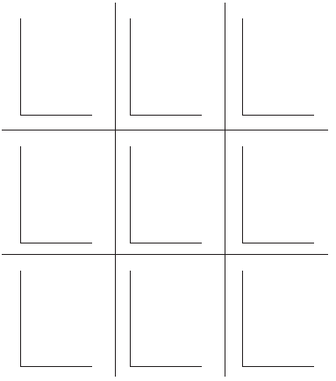This resource may be used with a variety of tasks as a guide for students. Copy onto cardstock and laminate for students as a guide to determine right, obtuse, and acute angles. (From Academy handbook)

**Constructing Task:** My Many Triangles

*Approximately 1 day*

**STANDARDS FOR MATHEMATICAL PRACTICE**

1. Make sense of problems and persevere in solving them.

2. Reason abstractly and quantitatively.

6. Attend to precision.

7. Look for and make use of structure.

**STANDARDS FOR MATHEMATICAL CONTENT**

**MGSE5.G3.** Understanding that attributes belonging to a category of two-dimensional figures also belonging to all subcategories of that category.

**BACKGROUND KNOWLEDGE**

Students should be able to identify triangles by the lengths of their sides (isosceles, equilateral, and scalene) as well as by the measure of their angles (right, obtuse, and acute). Students will need to be able measure the sides and the angles in order to create the required triangles. Also, they will need to know that the sum of the measures of the angles of a triangle is 180.

Of the nine triangles, two are not possible.

* An equilateral right triangle is not possible because an equilateral triangle also has equal angle measures (equiangular). A triangle can have no more than 180 however, $90°×3=270°$ which is more than 180.
* An equilateral obtuse triangle is not possible because an equilateral triangle has equal angle measures (equiangular). A triangle can have no more than 180 however, by definition an obtuse angle is greater than $90°$. Multiplying a number greater than $90°$ by 3 will be greater than 180.

**COMMON MISCONCEPTIONS**

Students think that when describing geometric shapes and placing them in subcategories, the last category is the only classification that can be used.

**ESSENTIAL QUESTIONS**

* How can angle and side measures help us to create and classify triangles?

**MATERIALS**

* “My Many Triangles” student recording sheet
* “My Many Triangles, Triangles to Cut and Sort” student sheet
* white construction paper (one sheet per student or per pair of students)
* colored construction paper cut into strips $\frac{1}{4}"$ wide (each student will need approximately 10 strips of paper)

**GROUPING**

Partner/Small Group Task

**TASK DESCRIPTION, DEVELOPMENT, AND DISCUSSION**

This task requires students to sort triangles according to common attributes and then create triangles according to two properties.

**Part 1**

Adapted from Van De Walle, J.A., Karp, K. S., & Bay-Williams, J. M. (2010). *Elementary and Middle School Mathematics: Teaching Developmentally* 7th Ed. Boston: Pearson Education, Inc., p. 413-414.

**Comments**

As an introduction to this task, students can be asked to fold different types of triangles. Using a piece of plain paper, ask students if they can fold to create any of the following triangles. (Small pieces of plain paper can be used, approximately 4” x 4”.)

* Equilateral
* Right
* Acute
* Obtuse

Discuss how students know their triangle belongs to one or more of the categories listed above.

(For some children paper folding can be a little challenging at first. Reassure children that it is okay to make mistakes when folding and to persevere until they are successful. It will be necessary to have several extra pieces of paper available for all students. This task helps students become more confident in their spatial abilities.)

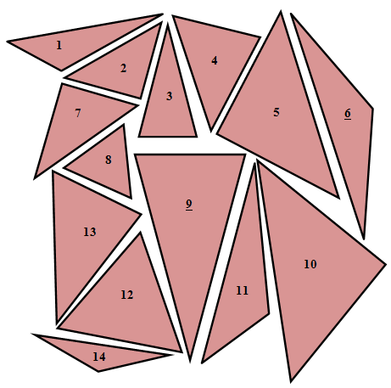The type of each triangle on the “My Many Triangles, Triangles to Cut and Sort” student sheet are shown below.

#1, #11 – obtuse scalene

#2, #7 – right scalene

#4, #13 – acute scalene

#5, #10 – right isosceles

#8, #12 – acute equilateral

#3, #9 – acute isosceles

#6, #14 – obtuse isosceles

Allow students struggle a little bit with this part of the task. Students may need to try out a few possibilities before finding that lengths of sides and measures of angles are two ways to sort these triangles so that each triangle belongs to exactly one group when sorted.

Sorted according to side lengths Sorted according to angle measures

Equilateral triangles: 8, 12 Acute triangles: 3, 4, 8, 9, 12, 13

**or**

Isosceles triangles: 2, 3, 5, 6, 9, 14 Right triangles: 2, 5, 7, 10

Scalene triangles: 1, 4, 7, 10, 11, 13 Obtuse triangles: 1, 6, 11, 14

**Task Directions**

Cut out the triangles below. Sort the triangles into groups where there are no triangles that do not fit into a group and there are no triangles that belong to more than one group. Then sort the triangles in a different way. Again, there should be no triangles that do not fit into a group and no triangles that belong to more than one group. Record how you sorted the triangles and the number of the triangles in each group. Be able to share how you sorted the triangles.

**FORMATIVE ASSESSMENT QUESTIONS**

* How do you know this is a(n) ______ (isosceles, right, equilateral, etc.) triangle?
* Are there any triangles that don’t belong in a group?
* Are there any triangles that belong to more than one group?
* Can you think of another way to sort the triangles?
* What are some properties of this triangle? Can you use one of those properties to think of a way to group all of your triangles?

**Part 2**

**Comments**

Students may need some assistance using the chart to identify the triangles they need to create. Be sure students understand they need to attempt to make nine different types of triangles, two of which are not possible to create. Encourage students to try to make an equilateral obtuse angle and an equilateral right triangle so that they can see that it is not possible to create a three-sided closed figure with two obtuse angles or two right angles. (See below.)

**Task Directions**

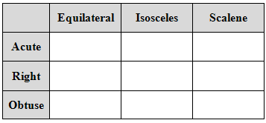Use the strips of construction paper to create the triangles described in each box below. Use the row label and the column label to identify the properties required for each triangle. For example, the box labeled “A” needs to be acute and isosceles because the row label is “Acute” and the column label is “Isosceles.”

**A**

Two triangles are not possible; for those, explain why each triangle is not possible on the lines below.

Glue each triangle onto the construction paper and label it.

**FORMATIVE ASSESSMENT QUESTIONS**

* Can you create an equilateral right triangle? An equilateral obtuse triangle? How do you know?
* Is there a scalene equilateral triangle? How do you know?
* How do you know this is a ___________ (i.e. scalene obtuse) triangle? Justify your answer.
* If it is a ___________ (i.e. scalene obtuse) triangle, what is true about the length of its sides? The measures of its angles? Prove that the triangle you created has those attributes.

**DIFFERENTIATION:**

**Extension**

Challenge students to write directions for a triangle that they chose so that someone else could follow their directions and create the same triangle. Allow a partner to try these directions with to see how successful they were at describing how to create their triangle.

**Intervention**

Allow students to use a picture glossary or the triangles from Part 1 of this task to help them create the triangles for Part 2.

**TECHNOLOGY CONNECTION:**

* <http://www.basic-mathematics.com/types-of-triangles.html> Gives basic definitions for the types of triangles. Note: this web site contains advertising.
* <http://www.k-5mathteachingresources.com/Geometry-Interactive-Whiteboard-Resources.html>This resource has a triangle sort activity in which can be used for additional practice or remediation purposes.

My Many Triangles

Triangles to Cut and Sort

Cut out the triangles below. Sort the triangles into groups where there are no triangles that do not fit into a group and there are no triangles that belong to more than one group. Then sort the triangles in a different way. Again, there should be no triangles that do not fit into a group and no triangles that belong to more than one group. Record how you sorted the triangles and the number of the triangles in each group. Be able to share how you sorted the triangles.

**1**

**4**

Name _________________________________________ Date __________________________

**9**

**14**

**11**

**12**

**6**

**10**

**13**

**5**

**8**

**7**

**3**

**2**



My Many Triangles

Use the strips of construction paper to create the triangles described in each box below. Use the row label and the column label to identify the properties required for

each triangle. For example, the box labeled “A” needs to be acute and isosceles because the row label is “Acute” and the column label is “Isosceles.”

Two triangles are not possible; for those, explain why each triangle is not possible on the lines below.

Glue each triangle onto the construction paper and label it.



**A**

____________________________________________________________________________________________________________________________________________________________________________________________________________________________________________________________________________________________________________________________________________________________________________________________________________________________________________________________________________________________________________________________________________________________________________________________________________________________________________________________________________________________________________________________________________________________________________________________________________

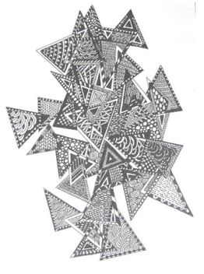**Practice Task:** Tangling with Triangles

*Adapted from Ohio Department of Education*

*Approximately 1 day*

**STANDARDS FOR MATHEMATICAL PRACTICE**

1. Make sense of problems and persevere in solving them.

2. Reason abstractly and quantitatively.

6. Attend to precision.

7. Look for and make use of structure.

**STANDARDS FOR MATHEMATICAL CONTENT**

**MGSE5.G.3** Understanding that attributes belonging to a category of two-dimensional figure also belong to all subcategories.

**BACKGROUND KNOWLEDGE**

Students should be able to identify and draw all three types of triangles.

**MISCONCEPTIONS**

Students may have misconceptions that the orientation of an angle or the length of the sides of an angle determines the measure of the angles (NRC, 2001).

**ESSENTIAL QUESTIONS**

* How can angle and side measures help us to create and classify triangles?
* What are ways to classify triangles?

**MATERIALS**

* status of the class sheet (pre-assessment)
* dry spaghetti noodles
* 7 triangle pictures
* index cards
* ruler
* 3 straws per student
* chart paper
* angles (optional)

**GROUPING**

Whole/Individual/Small Group

**TASK DESCRIPTION, DEVELOPMENT AND DISCUSSION**

Students will draw and use straws to make the three types of angles, within triangles.

Angles are difficult, complicated figures for students to understand because they must be understood as a rotation from one place to the next, as a geometric shape, and a combination of both when measuring (NRC, 2001). Be prepared to help students identify individual angles in a triangle and deal with misconceptions about those angles.

**TASK**

**Pre-Assessment**

* Distribute three straws of equal length to each student.
* Ask each student to make a right angle with the straws. Next ask them to make an acute angle with the straws. Finally, direct them to make an obtuse angle.
* You can use the Status of the class sheet to document if students understand right, obtuse, and acute.

**Part One**

Prepare for the post-assessment by making an assortment of seven large triangles (acute, obtuse, and right). Number the triangles from 1-7 and display them around the room.

* Distribute *Triangle Measurements*, Attachment A, to each student. Explain the procedures of the activity. Small groups of students rotate around the room and view seven displayed triangles. Identify a non-verbal cue to signal rotation to the next triangle.
* Place the students into seven small groups. Assign each group to a triangle. Students analyze the angles of the triangles and identify the type of triangle.
* Instruct the students to write the type of triangle on the sheet and then raise their hands when ready to move to the next triangle.
* Rotate groups through the seven triangles and collect the sheets.

Instructional Procedure

1. Complete the pre-assessment.
2. Distribute Attachment B, *Triangle Angle Exploration* to each student.
3. Draw the following triangles on the board.

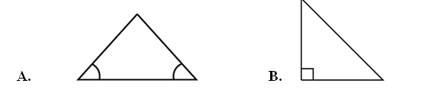

1. Ask students if they can classify the triangles on the board. Explain the use of the angle markings to indicate angles of equal or different measures. For example, Triangle A has two angles of equal measure (the two angles each with one curve) and one angle that is different (the top angle with no marking). Triangle B has a ninety degree measure (the square in the corner).
2. Ask students to individually classify the triangles of Attachment B, *Triangle Angle Exploration* into groups using characteristics of the angles. Do not suggest names for the categories prior to classifying. Ask students to explain their reasoning about classifying the triangles. Keep the conversation focused on the size of the angles (acute, right, obtuse) or angle relationship (equiangular) during this part of the lesson. Part Two of the lesson focuses on classifying triangles by sides within a triangle (scalene, isosceles, and equilateral). After 5 minutes, place students into groups of 3 or 4 to discuss how and why they classified the triangles the way that they did.
3. Ask students to suggest names for the categories. Use the names students suggest first and then give the mathematical name. For example, students might make a category for triangles whose angles are all equal and suggest “all equal angles” as the name. Write that name on the board and then write the mathematical name, equiangular.
4. Have students work in their groups to suggest triangles that can be moved into other categories. For example, the equiangular triangles are also acute triangles. Allow students a few minutes to examine the existing placements, then discuss different placements as a class.
5. Have each student use a straightedge to draw a triangle to represent an acute, obtuse, right, and equiangular triangle. Have each student share their triangles with their group to compare.
6. Create class definitions of acute, right, obtuse, and equiangular triangles. Record the generated definitions on chart paper and save them for Part Three of the lesson.
7. Collect the drawings the students created as they exit the room. Look for misconceptions and progress toward understanding types of triangles.

**Part Two**

* Using page 2 of *Triangle Measurements*, Attachment A, have students create each type of triangle by gluing uncooked spaghetti strands onto the paper.
* Students should mark congruent sides and angles if they draw the triangles.

Instructional Procedure

1. Distribute Attachment C, *Triangle Side Exploration,* to students. Ask students if they

know what the triangle below represents. Explain the use of the slash marks to indicate

sides of the same and different lengths. For example, explain to students that the

following triangle has two congruent sides (the sides with one slash mark) and one side

that is a different length (the side with two slash marks).

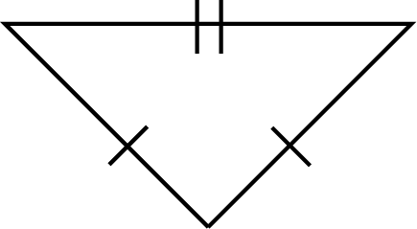

2. Have students work in small groups to discover the commonalities of the triangles in Group1 on Attachment C, *Triangle Side Exploration.* Also have groups discuss how the triangles in Group 1 are different from the triangles in the other groups. Allow groups to work for about five minutes and then ask groups to share their thoughts. (The triangles in Group 1 all have two sides that are equal.) Ask students to create a class name for the group and then introduce the formal name of isosceles.

3. Repeat step 1 with the triangles in Group 2 and Group 3. The Group 2 triangles have three equal sides (equilateral triangles). The triangles in Group 3 (scalene triangles) have no sides that are the same. Again, ask students to create a class name for Group 2 and Group 3 and then share the mathematical label.

4. As a class, create definitions for each of the groups of triangles on Attachment C, *Triangle Side Exploration.* Record the class-selected title, the mathematical title, and the class- created definitions on chart paper and save them for Part Three of the lesson.

5. Ask students to write a response to the following prompt and collect their responses to check for understanding:

*Describe the possible ways a triangle can be labeled if the measurements of the sides of a triangle are known.*

**Part Three**

* Use page 3 of *Triangle Measurements*, Attachment A. Ask the students to draw the triangles requested.
* Students should mark congruent sides and angles.

**Instructional Procedures**

Create a set of note cards by writing the class-created definitions of the seven triangles on individual note cards. Separate the note cards into two piles, by angle measurements (acute, right, obtuse, and equiangular) and by side length (scalene, isosceles, and equilateral). Prepare these before class.

1. Divide students into small groups of three to five students.

2. Have each group choose two note cards, one from each stack of note cards.

3. Explain that each group is in charge of finding an accurate mathematical definition and the type of triangle created when both note cards are combined. For example, a group may have an acute scalene triangle, or a right obtuse triangle. Provide mathematical dictionaries or Internet resources for student access.

4. On the chart paper, each group should provide the following:

* the mathematical term for the triangle;
* the class-created definition;
* an accurate mathematical definition pulled from a textbook or other reliable source; and
* three different examples of the type of triangle.

1. Give the groups 15-25 minutes to find the information and write the required information on chart paper. Assist groups with their examples as necessary.
2. Distribute Attachment D, *Study Guide*. Explain to the students that this is going to be their study guide for their post-assessment. The study guide is for students to record the mathematical terms and definitions for each type of triangle. Remind students to include examples of each type of triangle on their study guides.
3. Have each group make a presentation. Stress to each group the importance of staying under five minutes.
4. Ask students to go over Attachment D, *Study Guide,* in pairs when all groups are finished. Explain that each pair needs to make sure that both people filled out the study guide correctly.

**FORMATIVE ASSESSMENT QUESITONS**

* Name at least one positive thing about today’s lesson and one thing you will change.
* Can you create an equilateral right triangle? An equilateral obtuse triangle? How do you know?
* Is there a scalene equilateral triangle? How do you know?
* How do you know this is a ___________ (i.e. scalene obtuse) triangle? Justify your answer.
* If it is a ___________ (i.e. scalene obtuse) triangle, what is true about the length of its sides? The measures of its angles? Prove that the triangle you created has those attributes.

**DIFFERENTIATION**

**Extension**

* Have students research triangles. For example: How have triangles been used in architecture, science, engineering?
* Encourage students demonstrating understanding of classifying triangles to explore the relationship between angles and sides of a triangle in the real world. Provide research opportunities to allow students to explore why triangles are used and how different professional jobs use them.

**Intervention**

* Have students who are having difficulty categorize triangles with a student who is more familiar.
* Complete the Study Guide ahead of time for the students who have difficulty writing. Leave out key words to be filled in by those students.
* Allow students to use spaghetti noodles or angles to recreate the triangles. This will allow the student to physically compare angle measures and lengths of sides.

**TECHNOLOGY CONNECTION**

* <http://www.basic-mathematics.com/types-of-triangles.html> Gives basic definitions for the types of triangles. Note: this web site contains advertising.
* <http://www.k-5mathteachingresources.com/Geometry-Interactive-Whiteboard-Resources.html>This resource has a triangle sort activity in which can be used for additional practice or remediation purposes.

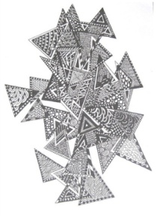Triangle Measurements

Attachment A

Name _________________________________ Date _____________________________

**Directions**: Look at each triangle displayed in the room. Draw and label the triangle in the correscponding box. Classify each of the triangles as acute, right, obtuse, or equilateral and explain your choices.

|  |  |
| --- | --- |
| Draw the triangle | Classify the triangle and explain your decision |
| Triangle 1 |  |
| Triangle 2 |  |
| Triangle 3 |  |
| Triangle 4 |  |
| Triangle 5 |  |
| Triangle 6 |  |
| Triangle 7 |  |

Triangle Measurements-page 2

Attachment A

**Directions**: Create or draw the following triangles to represent angle measurements and side lengths.

|  |
| --- |
| Isosceles triangle |
| Scalene triangle |
| Equilateral triangle |

Triangle Measurements-Page 3

Attachment A

**Directions**: Draw the following triangles to represent angle measurements and side length.

|  |
| --- |
| 1. Draw an acute, isosceles triangle: |
|  |
| 2. Draw a right, isosceles triangle: |
|  |
| 3. Draw an obtuse, scalene triangle: |
|  |
| 4. Draw an equilateral triangle: |
|  |

Triangle Angle Exploration

Triangle Side Exploration-Attachment C

Group 1

7 cm

7 cm

Group 2

5 cm

5 cm

5 cm

Group 3

3 cm

4 cm

6 cm

3

2

1

5

8

4

7

6

9

10

**Performance Task:** Triangle Hierarchy Diagram

*Adapted from K-5 Math Teaching Resources*

*Approximately 1 day*

**STANDARDS FOR MATHEMATICAL PRACTICE**

1. Make sense of problems and persevere in solving them.

2. Reason abstractly and quantitatively.

3. Construct viable arguments and critique the reasoning of others.

5. Use appropriate tools strategically.

6. Attend to precision.

7. Look for and make use of structure.

**STANDARDS FOR MATHEMATICAL CONTENT**

**MGSE5.G.3** Understanding that attributes belonging to a category of two-dimensional figures also belong to all subcategories.

**MGSE5.G.4** Classify two-dimensional figures in a hierarchy based on properties (polygons, triangles, and quadrilaterals).

**BACKGROUND KNOWLEDGE**

The students will use the knowledge that they have gained throughout this unit to perform this task. Students should be able to identify and draw all three types of triangles, based on angle measures and side lengths.

**COMMON MISCONCEPTIONS**

Students think that when describing geometric shapes and placing them in subcategories, the last category is the only classification that can be used.

**ESSENTIAL QUESTIONS**

* How can two-dimensional triangles be categorized and classified?
* How can angle and side measures help us to create and classify triangles?

**MATERIALS**

* Construction paper 9 X 11 or larger for hierarchy
* Glue sticks
* Markers
* Scissors
* One set of triangle shapes per student

**GROUPING**

Individual Task

**TASK DESCRIPTION, DEVELOPMENT AND DISCUSSION**

The students will create a Hierarchy Diagram using the terms: Polygons, Triangles, Acute Triangle, Obtuse Triangle, and Right Triangle.

1. The students will create a Hierarchy Diagram using the terms: Polygons, Triangles, Acute

Triangle, Obtuse Triangle, and Right Triangle. (Labels are provided for the students).

1. Measure the angles of each triangle to determine the angles and mark them.
2. Cut out the triangles and paste them in the appropriate place on the diagram.
3. Explain your reasoning using mathematical language.

**FORMATIVE ASSESSMENT QUESITONS**

* Name at least one positive thing about today’s lesson and one thing you will change.
* Can you create an equilateral right triangle? An equilateral obtuse triangle? How do you know?
* Is there a scalene equilateral triangle? How do you know?
* How do you know this is a ___________ (i.e. scalene obtuse) triangle? Justify your answer.
* If it is a ___________ (i.e. scalene obtuse) triangle, what is true about the length of its sides? The measures of its angles? Prove that the triangle you created has those attributes.

**DIFFERENTIATION**

**Extension**

* Allow the students to draw and/or add their own triangles to the diagram.
* Allow the students to present their mathematical reasoning as part of the task.

**Intervention**

* Allow students to work in pairs.
* Allow students to use their notes or the internet.

**TECHNOLOGY**

* <http://illuminations.nctm.org/Lesson.aspx?id=2917> This lesson from Illuminations discusses how to classify triangles..
* <https://www.schoology.com/resources/public/27010947/profile> This tutorial video discusses classifying triangles according to the measure of their sides; determining that the sum of the angles of a triangle equals 180 degrees; finding the perimeter of a triangle; and classifying triangles according to the measures of their angles.

|  |  |
| --- | --- |
| Polygons | Triangles |
| Acute  Triangle | Obtuse Triangle |
| Right  Triangle |  |

|  |  |
| --- | --- |
| Polygons | Triangles |
| Acute  Triangle | Obtuse Triangle |
| Right  Triangle |  |

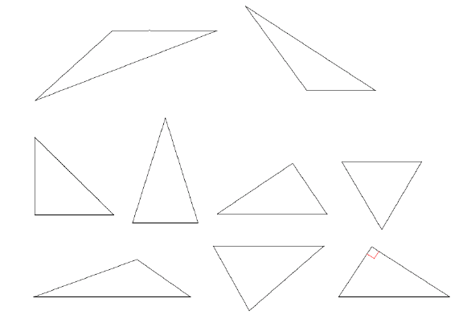**Triangle Hierarchy Diagram**

**Scaffolding Task:** Rectangles & Parallelograms

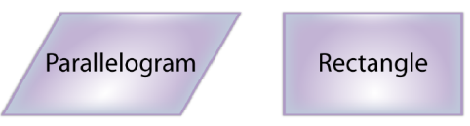*Adapted from Illuminations& Ohio Department of Ed.*

<http://illuminations.nctm.org/LessonDetail.aspx?id=L350>

*Approximately 1 day*

**STANDARDS FOR MATHEMATICAL PRACTICE**

1. Make sense of problems and persevere in solving them.

2. Reason abstractly and quantitatively.

3. Construct viable arguments and critique the reasoning of others.

5. Use appropriate tools strategically.

6. Attend to precision.

7. Look for and make use of structure.

**STANDARDS FOR MATHEMATICAL CONTENT**

**MGSE5.G.3** Understanding that attributes belonging to a category of two-dimensional figures also belong to all subcategories.

**MGSE5.G.4** Classify two-dimensional figures in a hierarchy based on properties (polygons, triangles, and quadrilaterals).

**BACKGROUND KNOWLEDGE**

This standard builds on what was done in 4th grade. Figures from previous grades: polygon, rhombus/rhombi, rectangle, square, triangle, quadrilateral, pentagon, hexagon, cube, and trapezoid.

**COMMON MISCONCEPTIONS**

Students think that when describing geometric shapes and placing them in subcategories, the last category is the only classification that can be used.

**ESSENTIAL QUESTIONS**

* What characteristics do parallelograms and rectangles share?
* Why is a square always a rectangle?

**MATERIALS:**

* Computer per student (Lab)
* Rectangle vs Parallelogram Activity Sheet
* Things are Shaping Up Activity Sheet
* Rectangles and Parallelograms Applet

**GROUPING**

Whole/individual/small group task

**TASK DESCRIPTION, DEVELOPMENT AND DISCUSSION**

In this task, students classify two-dimensional shapes into a hierarchy based on properties. Details learned in earlier grades need to be used in the descriptions of the attributes of shapes. The more ways that students can classify and discriminate shapes, the better they can understand them. The shapes are not limited to quadrilaterals.

This task builds on lessons from the third grade when students described, analyzed, and compared properties of two-dimensional shapes. They compared and classified shapes by their sides and angles, and connected these with definitions of shapes. In Grade 4 students built, drew and analyzed two dimensional shapes to deepen their understanding of the properties. They looked at the presence or absence of parallel and perpendicular lines or the presence or absence of angles of a specified size to classify two dimensional shapes. Now, students classify two-dimensional shapes into a hierarchy based on properties. Details learned in earlier grades need to be used in the descriptions of the attributes of shapes. The more ways that students can classify and discriminate shapes, the better they can understand them. The shapes are not limited to quadrilaterals.

**TASK**

Students use dynamic software to examine the properties of rectangles and parallelograms, and identify what distinguishes a rectangle from a more general parallelogram. Using spatial relationships, they will examine the properties of two-and three-dimensional shapes.

Introduction

Distribute the Rectangle & Parallelogram activity sheet to each member of the class. Ask students to carefully examine the two shapes on the handout and brainstorm their similarities and differences. Elicit oral responses about the attributes unique to both the rectangle and parallelogram. While the class-wide discussion is occurring, students should record the information in the corresponding boxes on the activity sheet.

After the students have recorded the similarities and differences brainstormed by the entire class, divide them into pairs or teams of three. They should work together to categorize the attributes listed on the activity handout into groups. For example: can they categorize or group the shapes’ attributes according to length of sides, number of sides, number of angles, measure of angles, etc?

Once the teams have categorized the information, distribute the Things are Shaping Up activity sheet to each student.

Explain that the students will manipulate the dynamic rectangles and parallelograms in the interactive applet by dragging the corners (vertices) and sides (edges). They should look at the shapes on the handout and mentally manipulate them before trying the activity online. In small groups, they should share their ideas surrounding this mental exercise.

Questions

* Do you think it will be possible to transform the shape?
* Will the rectangle retain its attributes?
* Will the parallelogram retain its attributes?

Once they have had the opportunity to think about the manipulation, students will go to Web site and use the activity sheet to recreate the shapes listed on the Things are Shaping Up activity sheet. Website: http://illuminations.nctm.org/Lesson.aspx?id=1323

As the students successfully re-create each shape, they should record a brief description describing the process they used to attain the goal. The teams can share their solutions and model their problem solving strategies throughout the activity. If students are having difficulty with specific shapes, they can also record the challenges being faced. The key element to this activity is for students to clearly describe the process they use to manipulate the shapes.

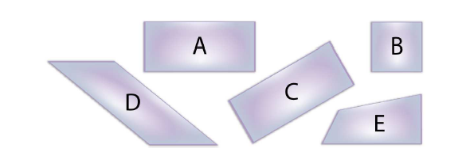

**FORMATIVE ASSESSMENT QUESTIONS**

* Explain how you categorized or grouped the figures based on their attributes.
* What was the first attribute you noticed that was similar between the two shapes?
* What was the first attribute you noticed that was different between the two shapes?
* What attributes stayed true to each shape even through the manipulation process?

**DIFFERENTIATION**

**Extension**

* Students use graphic organizers such as flow charts or T-charts to compare and contrast the attributes of geometric figures. Have students create a T-chart with a shape on each side. Have them list attributes of the shapes, such as number of sides, number of angles, types of lines, etc. They need to determine what’s alike or different about the two shapes to get a larger classification for the shape.

**Intervention**

* Students will classify figures by only one attribute (ie. The figure does have two pair of parallel sides, or it does not)
* The students may use a teacher-generated list of attributes found in rectangles and parallelograms, and they will match the attributes to the figure. Then, create a Venn Diagram to compare and contrast the attributes of the figures.

**TECHNOLOGY CONNECTION**

* <http://teams.lacoe.edu/documentation/classrooms/amy/geometry/6-8/activities/quad_quest/quad_quest.html> Quadrilateral Quest, testing properties of quadrilaterals

Name__________________________

Rectangles & Parallelograms

Use the table below to compare and contrast Rectangles and Parallelograms

Rectangle

Parallelogram

|  |  |
| --- | --- |
| How are these shapes similar? | How are these shapes different? |
|  |  |

Name_____________________

Things are Shaping Up

Use this applet to complete this task: <http://www.nctm.org/standards/content.aspx?id=25040>

B

A

D

C

E

* 1. Predict whether or not the rectangle tool can make each of the figures above. Record your predictions in the prediction space provided below. Then, use the rectangle tool to check your predictions (try to duplicate the shape). Record your work in the spaces below.
  2. Prediction _______________________________

Here is the process I used to try to create shape A:

* 1. Prediction _______________________________

Here is the process I used to try to create shape B:

* 1. Prediction _______________________________

Here is the process I used to try to create shape C:

* 1. Prediction _______________________________

Here is the process I used to try to create shape D:

* 1. Prediction _______________________________

Here is the process I used to try to create shape E:

* 1. Predict whether or not the parallelogram tool can make each of the figures above. Record your predictions in the prediction space provided below. Then, use the parallelogram tool to check your predictions (try to duplicate the shape). Record your work in the spaces below.
  2. Prediction _______________________________

Here is the process I used to try to create shape A:

* 1. Prediction _______________________________

Here is the process I used to try to create shape B:

* 1. Prediction _______________________________

Here is the process I used to try to create shape C:

* 1. Prediction _______________________________

Here is the process I used to try to create shape D:

* 1. Prediction _______________________________

Here is the process I used to try to create shape E:

**T-Chart**

|  |  |
| --- | --- |
|  |  |
|  |  |

Description: C:\Documents and Settings\Sharon Hooper\Local Settings\Temporary Internet Files\Content.IE5\P7IHK6WI\MCj02321040000[1].wmf**Constructing Task:** Property Lists of Quadrilaterals

*Adapted from Van De Walle, Teaching Student-Centered Math pg. 207*

*Approximately 1 day*

**STANDARDS FOR MATHEMATICAL PRACTICE**

1. Make sense of problems and persevere in solving them.

2. Reason abstractly and quantitatively.

6. Attend to precision.

7. Look for and make use of structure.

**STANDARDS FOR MATHEMATICAL PRACTICE**

**MGSE5.G.3** Understand that attributes belonging to a category of two-dimensional figures also belong to all subcategories of that categories.

**BACKGROUND KNOWLEDGE**

Students should have the following background knowledge.

* Be able to use a straight edge or ruler to draw a straight line.
* Know how to use a protractor, a ruler, and how to identify right angles (90 degrees), obtuse angles, and acute angles (using a protractor or the corner of an index card).
* Understand that opposite sides can not touch each other; they are on opposite sides of the quadrilateral.
* Know parallel means that lines will never intersect or cross over each other no matter how long they are extended. (Students may prove that lines are parallel by laying down 2 straight objects, such as rulers, on the parallel sides of the quadrilateral, extending those sides. This will show how the line segments do not intersect even if they are extended.)
* Understand that perpendicular means lines or segments intersect or cross forming a right angle. (Some students may use a protractor, while others may use the corner of an index card or the corner of a sheet of paper to show an angle is a right angle.)
* Know that a property is an attribute of a shape that is always going to be true. It describes the shape.
* Be able to use a ruler to measure sides to verify they are the same length.
* Be able to use a mirror to check lines of symmetry
* Be able to use tracing paper to check for angle congruence

Some properties of quadrilaterals that should be discussed are included below. As students draw conclusions about the relationships between different figures, be sure they are able to explain their thinking and defend their conclusions.

* A shape is a quadrilateral when it has exactly 4 sides and is a polygon. (To be a polygon the figure must be a closed plane figure with three or more straight sides.)
* A square is always a rectangle because a square will always have 4 right angles like a rectangle.
* A rectangle does not have to have 4 equal sides like a square. It can have 4 right angles without 4 equal sides. Therefore, rectangle is not always a square.
* A square is always a rhombus because it has 4 equal sides like a rhombus and it is also a rectangle because it has 4 right angles like a rectangle.
* A rhombus does not have to have right angles like a square. It can have 4 equal sides without having 4 right angles. Therefore a rhombus is not always a square.
* A parallelogram can be a rectangle if it has 4 right angles.

**COMMON MISCONCEPTIONS**

Students think that when describing geometric shapes and placing them in subcategories, the last category is the only classification that can be used.

**ESSENTIAL QUESTIONS**

* How can I use my knowledge of parallel and perpendicular lines to classify quadrilaterals?
* How can I use the attributes of quadrilaterals to sort and classify them into groups?

**MATERIALS**

* Rulers
* Protractors
* Index cards
* Mirror, pipe cleaners or tooth picks (choose one to check lines of symmetry)
* Copies of Property List Sheets Blackline Masters 37-40 found at

http://www.ablongman.com/vandewalleseries/Vol_1_BLM_PDFs/BLM37-40.pdf

* Chart Paper-(Class List) One chart per polygon for the students to record their answers after the presentations.

**GROUPING**

Partner/Small Group Task

**TASK DESCRIPTION, DEVELOPMENT, AND DISCUSSION**

The purpose of this task is for students to become familiar with the properties of quadrilaterals. They will identify the attributes of each quadrilateral, then compare and contrast the attributes of different quadrilaterals.

Assign students to work in groups of three or four to one type of quadrilateral. The task is for the students to list as many properties as they can for their quadrilateral. The list of properties must be applicable to all of the shapes on their sheet. Students may need an index card or protractor to check right angles. They will also need a ruler to compare lengths and draw straight lines. Mirrors can be provided for the students to check for symmetry. If you don’t have mirrors, the students can use pipe cleaners or toothpicks to place on top of the shapes to show lines of symmetry. Some students may also need to trace the shapes onto another piece of paper and cut it out to check for symmetry. They will then be able to fold the shape and manipulate it to decide if it is symmetrical. The words “at least” should highly be encouraged when the students are describing how many of something: for example, “rectangles have at least two lines of symmetry.”

The groups will be asked to present their list to the rest of the class and justify any answers. If the answers are correct, the list should then be added to a class list. It is recommended that the presentations go in order beginning with parallelograms, rhombi, rectangle, and finally square. A class list (chart paper per polygon) will need to be posted in the room for the students to record their correct findings. As one group presents their list, the other students who worked on the same shape should add to or subtract from it. The class must agree with everything placed on the class list. You may have to introduce proper vocabulary as the students discuss and present their shapes.

**FORMATIVE ASSESSMENT QUESTIONS**

* How do you know this quadrilateral is a ________ (square, rectangle, parallelogram, trapezoid, or rhombus)?
* What is meant by the term “opposite sides”?
* What does “parallel” mean? How can you show that those sides parallel?
* What does “perpendicular” mean? How can you show that those sides are perpendicular?
* How can you show that 2 sides are equal?
* What are some ways we can show an angle is a right angle?

**DIFFERENTIATION**

**Extension**

* Ask students to create a Venn diagram which contains a comparison of the properties of two quadrilaterals.

**Intervention**

* Play Shape Sorts by Van De Walle, Student Centered Mathematics pg. 194

**TECHNOLOGY CONNECTION**

* <http://teams.lacoe.edu/documentation/classrooms/amy/geometry/6-8/activities/quad_quest/quad_quest.html> Quadrilateral Quest, testing properties of quadrilaterals

**Practice Task:** Investigating Quadrilaterals

Approximately 2 days

**STANDARDS FOR MATHEMATICAL PRACTICE**

1. Make sense of problems and persevere in solving them.

2. Reason abstractly and quantitatively.

3. Construct viable arguments and critique the reasoning of others.

5. Use appropriate tools strategically.

6. Attend to precision.

7. Look for and make use of structure.

**STANDARDS FOR MATHEMATICAL CONTENT**

**MGSE5.G.3** Understanding that attributes belonging to a category of two-dimensional figures also belong to all subcategories.

**MGSE5.G.4** Classify two-dimensional figures in a hierarchy based on properties (polygons, triangles and quadrilaterals).

**BACKGROUND KNOWLEDGE**

Students should have the following background knowledge.

* Be able to use a straight edge or ruler to draw a straight line.
* Know how to use a protractor, a ruler, and how to identify right angles (90 degrees), obtuse angles, and acute angles (using a protractor or the corner of an index card).
* Understand that opposite sides can not touch each other; they are on opposite sides of the quadrilateral.
* Know parallel means that lines will never intersect or cross over each other no matter how long they are extended. (Students may prove that lines are parallel by laying down 2 straight objects, such as rulers, on the parallel sides of the quadrilateral, extending those sides. This will show how the line segments do not intersect even if they are extended.)
* Understand that perpendicular means lines or segments intersect or cross forming a right angle. (Some students may use a protractor, while others may use the corner of an index card or the corner of a sheet of paper to show an angle is a right angle.)
* Know that a property is an attribute of a shape that is always going to be true. It describes the shape.
* Be able to use a ruler to measure sides to verify they are the same length.
* Be able to use a mirror to check lines of symmetry
* Be able to use tracing paper to check for angle congruence

Some properties of quadrilaterals that should be discussed are included below. As students draw conclusions about the relationships between different figures, be sure they are able to explain their thinking and defend their conclusions.

* A shape is a quadrilateral when it has exactly 4 sides and is a polygon. (To be a polygon the figure must be a closed plane figure with three or more straight sides.)
* A square is always a rectangle because a square will always have 4 right angles like a rectangle.
* A rectangle does not have to have 4 equal sides like a square. It can have 4 right angles without 4 equal sides. Therefore, rectangle is not always a square.
* A square is always a rhombus because it has 4 equal sides like a rhombus and it is also a rectangle because it has 4 right angles like a rectangle.
* A rhombus does not have to have right angles like a square. It can have 4 equal sides without having 4 right angles. Therefore a rhombus is not always a square.
* A parallelogram can be a rectangle if it has 4 right angles.

**COMMON MISCONCEPTIONS**

Students think that when describing geometric shapes and placing them in subcategories, the last category is the only classification that can be used.

**ESSENTIAL QUESTIONS**

* How can I compare and contrast the different quadrilaterals?
* What is the rationale for grouping the quadrilaterals together?

**MATERIALS**

* Chart Paper
* Re-sealable plastic bag per student
* Attributes of Quadrilateral sheet per student
* Set of Quadrilateral Shapes per pair of students
* Overhead transparency

**GROUPING**

Whole/pairs/ individual task

**TASK DESCRIPTION, DEVELOPMENT AND DISCUSSION**

In this task, students will investigate the attributes of quadrilaterals.

Students typically enter fourth grade able to identify several shapes. Identifying shapes, however, does not provide sufficient foundations for the higher levels of reasoning required in later grades. Instruction in identifying specific classes of quadrilaterals and in understanding the hierarchy of quadrilaterals does help students move to a higher level of reasoning about two-dimensional figures. (*Adding It Up: Helping Children Learn Mathematics*) While this quote refers to fourth graders, it applies to fifth graders as well.

Pre-Assessment

* Have students complete a quick-write exercise in a journal explaining what they know about quadrilaterals.
* Select students to share what they know about quadrilaterals with the class and record the information on the board or chart paper.
* Ask students what questions they have about quadrilaterals and record those on chart paper.
* Use a K-W-L chart as an alternative

Scoring Guidelines for K-W-L or Quick Responses

Informally assess the students’ responses. Possible responses include:

* names of quadrilaterals (square, rectangle, rhombus, parallelogram and trapezoid) and if they know defining qualities
* quantitative descriptions such as the number of sides and vertices
* qualitative descriptions such as types of angles (acute, right, obtuse) and line relationships (parallel or perpendicular)

**Day One**

1. Distribute Attributes of Quadrilaterals, Attachment B and Quadrilateral Cards, Attachment C to pairs of students and have students cut out the twelve cards.
2. Use the information about quadrilaterals in the pre-assessment and observations students make using the cards to complete the first column, Quadrilaterals, on Attributes of Quadrilaterals, Attachment B. Depending on depth of prior knowledge, as revealed in pre-assessment, choose to have partners complete the column or complete the column as a class.
3. Have students sort the cards by the shapes at the top of Attributes of Quadrilaterals, Attachment B. Observe students as they sort the cards and provide assistance as needed.
4. Have students complete the chart together, using what they know about the shapes and the cards.
5. Complete a class chart on the overhead and allow students to make changes to their own charts. An example of a completed chart is provided on page two of Attributes of Quadrilaterals, Attachment B.
6. Have partners sort the shapes using different attributes. They may choose to use the attributes listed on Attributes of Quadrilaterals, Attachment B. Then, select students to share the attribute they used to sort the shapes and present the sorting to the class.
7. Have students store their shape cards in re-sealable bags for the next lesson.

**Day Two**

1. Have students take out the shape cards and Attributes of Quadrilaterals, Attachment B.
2. Have the students use the chart to compare the quadrilaterals. Have them create a list of attributes shapes share. For example: All sides of the square and rhombus are congruent.
3. Select students to share their comparison statements with the class.
4. Explain to students that by sorting shapes additional comparisons can be made and relationships among the shapes can be revealed.
5. Have the class sort the shapes into two categories, shapes with parallel sides and shapes without parallel sides.
6. Observe students as they sort the shapes and assist as necessary. Reinforce the concept of parallel lines.
7. Select students to present the sorting and allow other students to provide feedback.
8. Direct the students to the pile of shapes with parallel sides. Have pairs sort the shapes into two piles, shapes with one set of parallel sides and shapes with two sets of parallel sides. Observe students as they sort and provide assistance as necessary.
9. Select students to present the sorted shapes. Have students identify the names of the shapes in each pile.
10. Explain to the students that trapezoids have at least one set of parallel sides and that parallelograms have two sets of parallel sides. Ask students to identify the shapes in the parallelogram pile. Tell students that squares, rectangles and rhombi are special parallelograms.
11. Have partners sort the parallelograms by angle measure, shapes with right angles and shapes without right angles. Observe how pairs sort the shapes and provide assistance as needed.
12. Have students identify the shapes in each pile. Ask students questions about the relationships.

* What do squares and rectangles have in common? (four right angles)
* How are the rectangles and squares on the cards different? (lengths of sides)
* Can a square be described as a rectangle? Why? (A square is a special rectangle with four congruent sides.)

13. Have students compare a rhombus and a square. Ask questions and allow pairs to discuss before selecting students to respond. Questions for discussion include:

* How are the square and rhombus alike?
* How are the rhombi and squares on the cards different?
* Can a square be described as a rhombus? Why? (A square is a special rhombus with four right angles.)

14. Summarize the relationships visually using a graphic organizer. Quadrilateral Relationships, Attachment D is an example of an appropriate organizer. Distribute to the students and complete the organizer together. Encourage students to use the shape cards to re-sort the shapes with the attributes used during the lesson.

**Instructional Tips**

* In the following days, have students share the graphic organizer and write comparisons of the quadrilaterals.
* For morning work or problem of the day, present prompts for students to respond, about quadrilateral relationships. Prompts may include:

1. All squares are rectangles, but not all rectangles are squares. Why?

2. All squares are rhombi, but not all rhombi are squares. Why?

3. Squares, rectangles and rhombi are parallelograms. Why?

Post –Assessment

Use Attachment A, Quadrilateral Post-Assessment*.* Given a word bank of quadrilaterals, students select two figures to compare and contrast in a Venn diagram. Students then select two different quadrilaterals to compare and contrast in a table.

**FORMATIVE ASSESSMENT QUESITONS**

*The following questions are provided for teacher reflection since this task is already an assessment.*

* How do you know what attributes are important when comparing quadrilaterals?
* How did you decide to sort your shapes? What did you think about?
* How did you choose which quadrilaterals to compare?
* Can you compare two different quadrilaterals? What will change?

**DIFFERENTIATION**

**Extension**

* Make a class dictionary on the quadrilaterals and the vocabulary terms studied.
* Provide students with shapes that include polygons other than quadrilaterals such as pentagons, hexagons and different kinds of triangles. Place shapes in an envelope. Have students sort them into 2 groups and explain why some shapes fit in one group and why others are left out of that group. Have students sort two to three times.

**Intervention**

* Use two-dimensional manipulatives or geo-boards to investigate the properties, make conjectures and draw conclusions on quadrilaterals.
* Have students create a game board using the two-dimensional shapes with game cards asking questions identifying the shapes, and stating questions with answers on their similarities and differences. Such questions may be: How is a square similar to a rectangle? How is a rhombus like a parallelogram? Why do some trapezoids not fit in with the parallelogram, rectangle, rhombus, and square?

Home Connection:

* Assign an interdisciplinary activity. Assign homework where the student will draw a design or creature with the shapes: trapezoid, parallelogram, rectangle, rhombus, and a square. When the student returns his creative quadrilateral creature, provide them with an overhead transparency to draw a habitat for the creature. Place the overhead transparency over top of the creature or animal and share during Science class.
* Have the students communicate with their families the similarities and differences of quadrilaterals: trapezoid, parallelogram, rectangle, the rhombus and square.
* Have students build models of quadrilaterals out of household materials such as toothpicks, cotton swabs, spaghetti, and pieces of yarn or string. Include a writing portion of the assignment in which students describe the quadrilateral.

**TECHNOLOGY CONNECTION**

* <http://teams.lacoe.edu/documentation/classrooms/amy/geometry/6-8/activities/quad_quest/quad_quest.html> Quadrilateral Quest, classifying quadrilaterals

**Investigating Quadrilaterals**

**Attachment A**

**Quadrilateral Post-Assessment**

Name __________________________________ Date________________

Word Bank

parallelogram rectangle rhombus square trapezoid

**Directions**: From the list of quadrilaterals, select two. Use the Venn diagram to compare and contrast them. List at least two similarities and two differences for each.

Name of Quadrilateral 1_______________ Name of Quadrilateral 2______________

**Directions**: Complete this activity again using two different quadrilaterals. Use the table to compare and contrast them. List at least two similarities and two differences for each.

Name of Quadrilateral 3_______________ Name of Quadrilateral 4______________

|  |  |
| --- | --- |
| Common Characteristics | Different Characteristics |
|  |  |
|  |  |
|  |  |

**Investigating Quadrilaterals- Attachment B: Attributes of Quadrilaterals**

|  |  |  |  |  |  |  |
| --- | --- | --- | --- | --- | --- | --- |
| *Attributes of Shapes* | **Quadrilateral** | **Square** | **Rectangle** | **Rhombus** | **Trapezoid** | **Parallelogram** |
| *Number of sides* |  |  |  |  |  |  |
| *Number of angles* |  |  |  |  |  |  |
| *Congruent sides* |  |  |  |  |  |  |
| *Congruent angles* |  |  |  |  |  |  |
| *Right angles* |  |  |  |  |  |  |
| *Parallel sides* |  |  |  |  |  |  |
| *Symmetry* |  |  |  |  |  |  |
| *Congruent angles* |  |  |  |  |  |  |
|  |  |  |  |  |  |  |

**Attachment B (continued)**

**Attributes of Quadrilaterals**

|  |  |  |  |  |  |  |
| --- | --- | --- | --- | --- | --- | --- |
| *Attributes of Shapes* | **Quadrilateral** | **Square** | **Rectangle** | **Rhombus** | **Trapezoid** | **Parallelogram** |
| *Number of sides* | 4 | 4 | 4 | 4 | 4 | 4 |
| *Number of angles* | 4 | 4 | 4 | 4 | 4 | 4 |
| *Congruent sides* | Does not have to have congruent sides | All sides are congruent | Opposite sides are congruent | All sides are congruent | Does not have to have congruent sides | Opposite sides are congruent |
| *Congruent angles* | Does not have to have congruent angles | All angles are congruent | All angles are congruent | Opposite angles are congruent | Does not have to have congruent angles | Opposite angles are congruent |
| *Right angles* | Does not have to have a right angle | All angles are right angles | All angles are right angles | Does not have to have right angles | Does not have to have right angles | Does not have to have right angles |
| *Parallel sides* | Does not have to have parallel sides | Opposite sides are parallel | Opposite sides are parallel | Opposite sides are parallel | At least one set of opposite sides are parallel | Opposite sides are parallel |
| *Symmetry* | Does not have to have symmetry | Has four lines of symmetry | Has at least two lines of symmetry | Has at least two lines of symmetry | Does not have to have a line of symmetry | Does not have to have symmetry |
| *Congruent angles* | Does not have to have congruent angles | All angles are congruent | All angles are congruent | Opposite angles are congruent | Does not have to have congruent angles | Opposite angles are congruent |
|  |  |  |  |  |  |  |

**Attachment C: Quadrilateral Shapes**

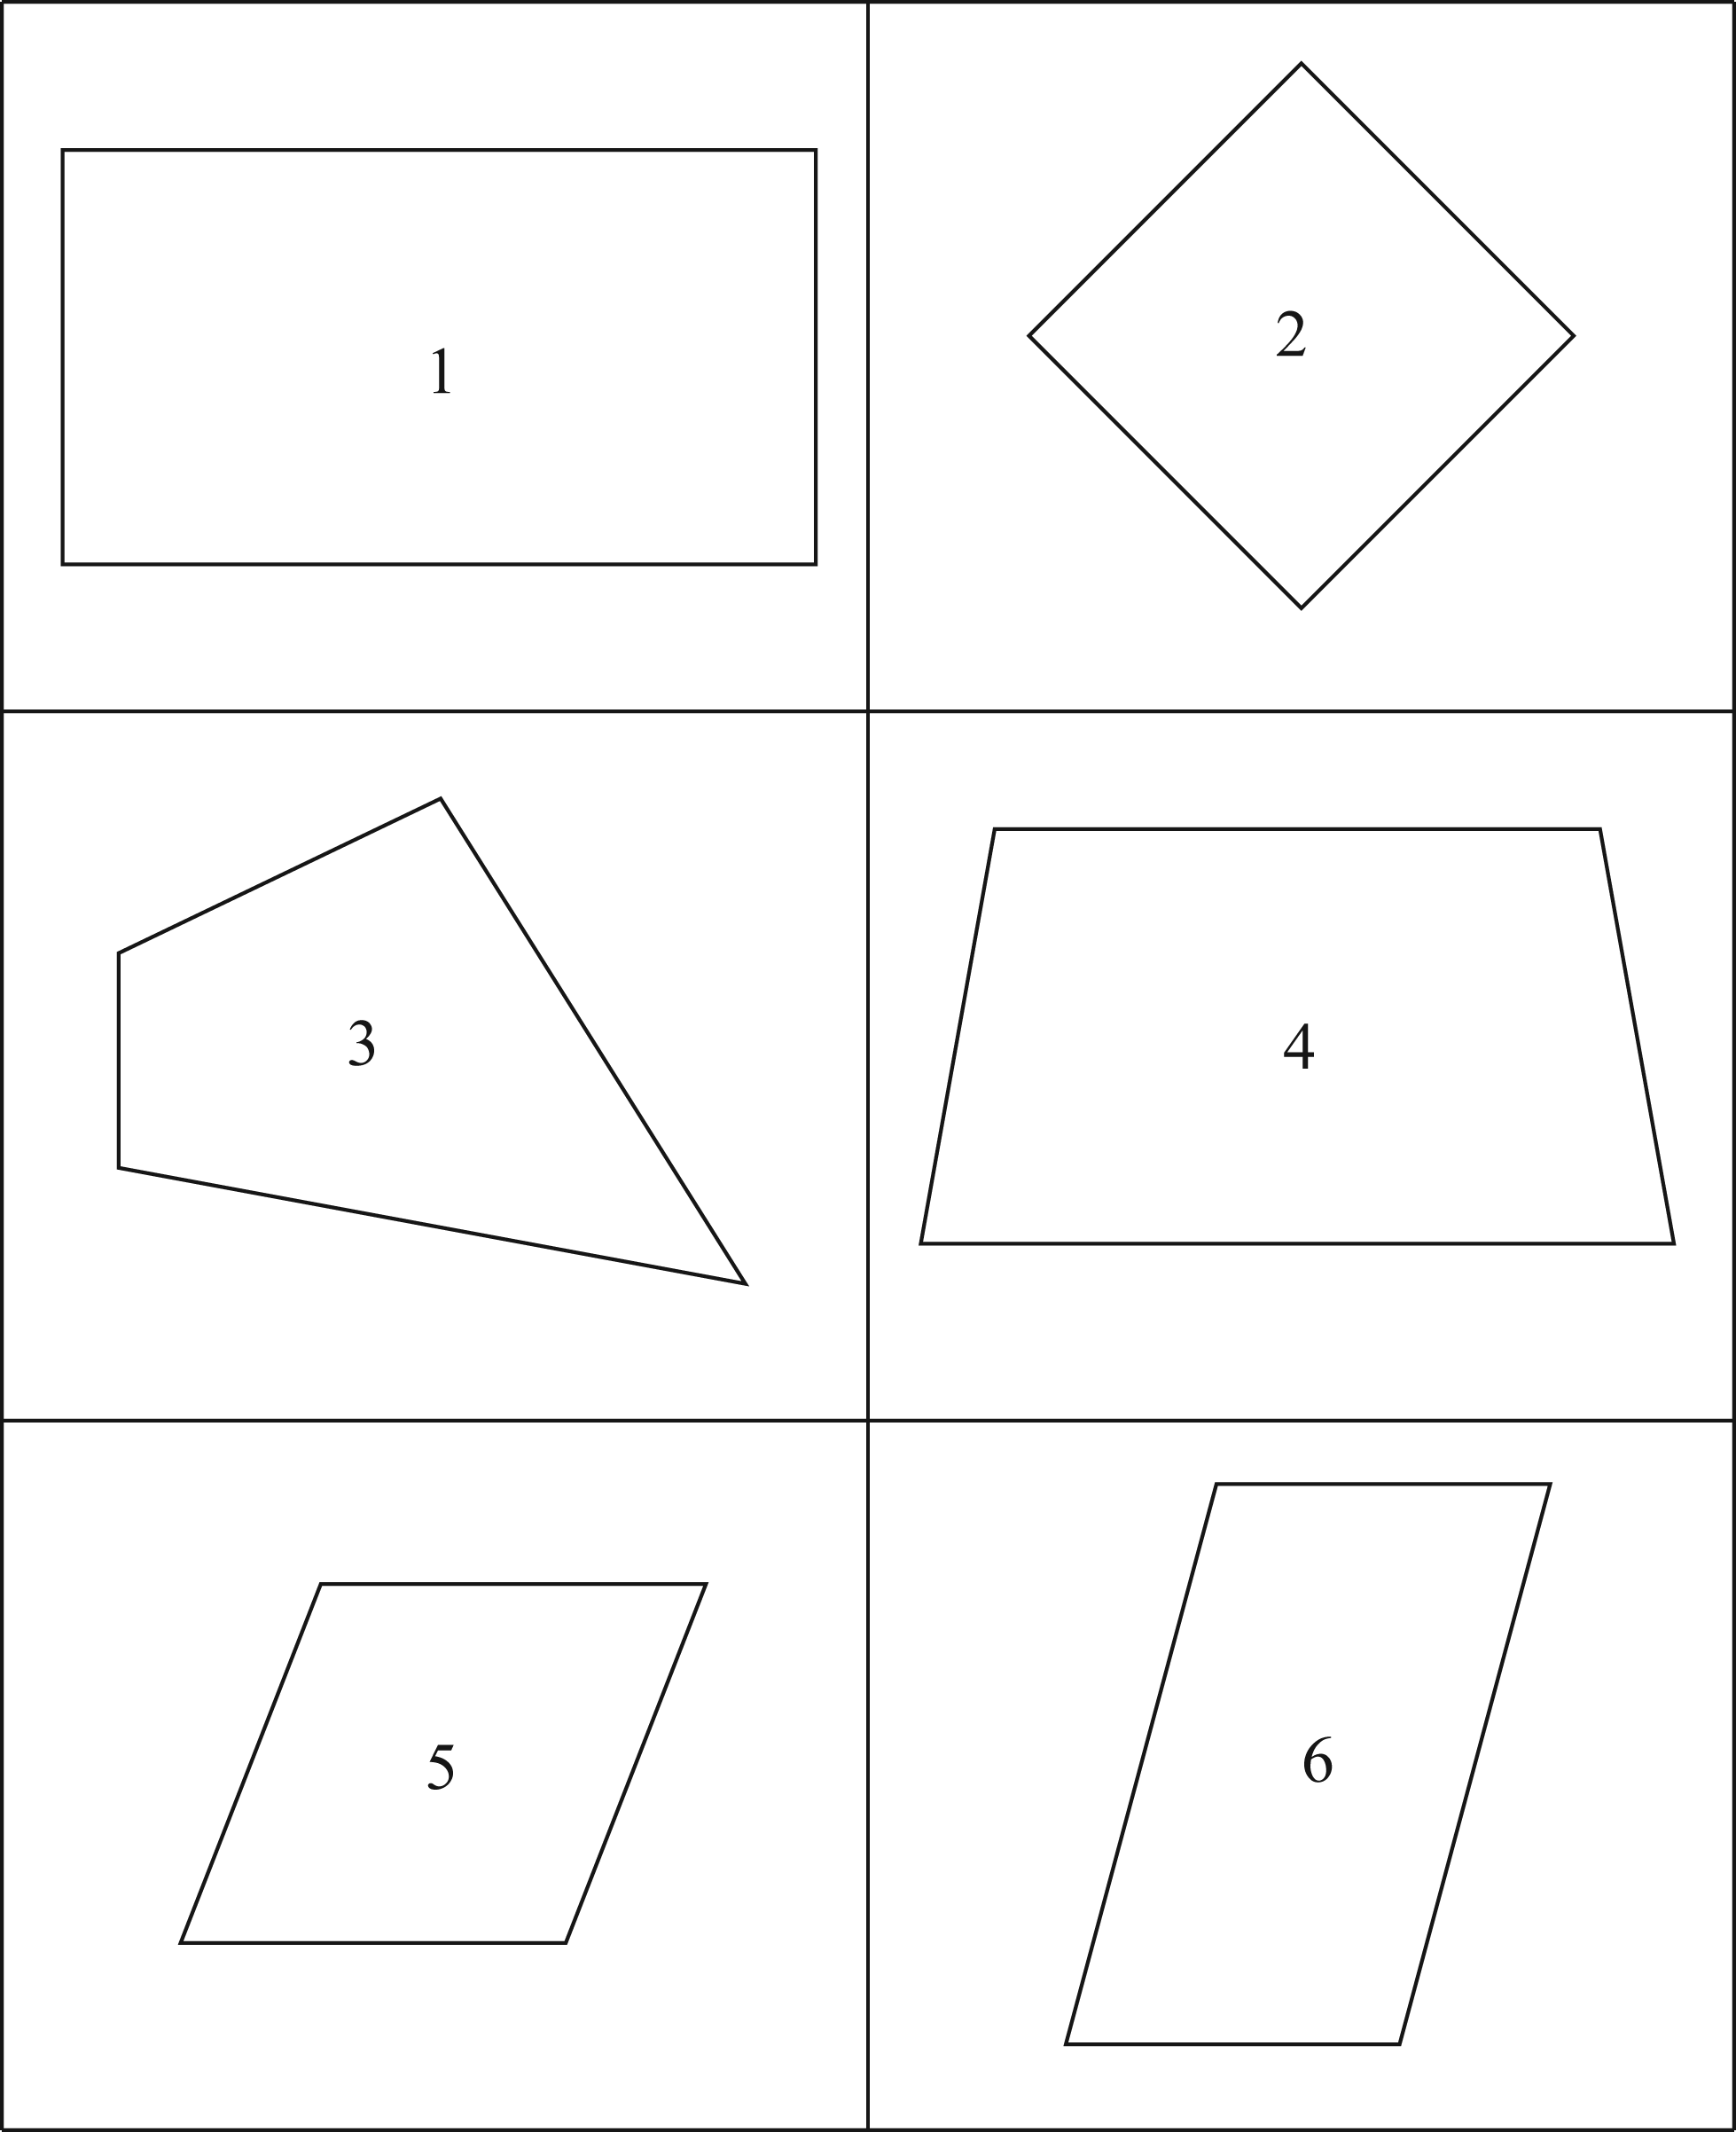

**Attachment C (continued): Quadrilateral Cards**

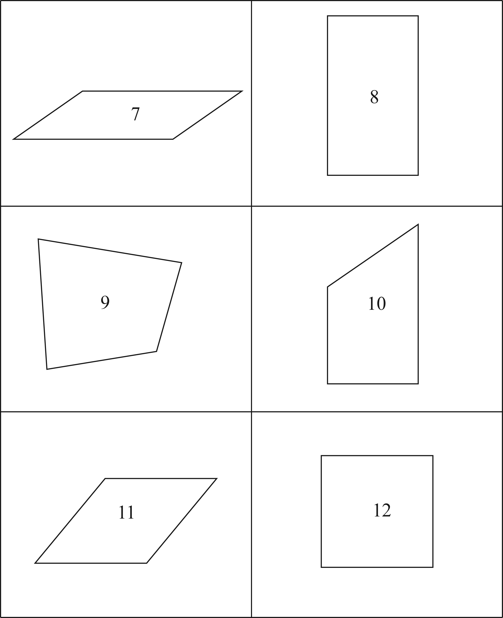

**Attachment D: Quadrilateral Relationships**

Note to teachers: you do not need to use the term trapezium. It is the same as trapezoid. You also do not need to introduce students to isosceles trapezoids at this point. For the purposes of this standard, use the general category of trapezoids.

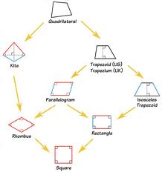

|  |  |  |  |
| --- | --- | --- | --- |
| **Quadrilateral- 4 sided figure** | | | |
| **Trapezoid**- 4 sided and at least 1 pair of parallel sides | | | **Kite**- 4 sided and pairs of congruent adjacent sides |
| **Parallelogram**- all of the attributes of a trapezoid, and 2 pairs of parallel sides (which results in congruent opposite angles) | | **Rhombus**- All of the attributes of a parallelogram and kite | |
| **Rectangle**- all of the attributes of the parallelogram, and 4 right angles |
| **Square**- all of the attributes of parallelogram, rhombus, and rectangle, and equal sides, equal angles | | |

.

This hierarchy with definitions is for teacher understanding only. Please use it as a guide for your thinking when questioning students or supporting development of student understanding through the tasks.

**Performance Task:** Quadrilateral Hierarchy Diagram

*Adapted from K-5 Math Teaching Resources*

*Approximately 1 day*

**STANDARDS FOR MATHEMATICAL PRACTICE**

1. Make sense of problems and persevere in solving them.

2. Reason abstractly and quantitatively.

3. Construct viable arguments and critique the reasoning of others.

5. Use appropriate tools strategically.

6. Attend to precision.

7. Look for and make use of structure.

**STANDARDS FOR MATHEMATICAL CONTENT**

**MGSE5.G.3** Understanding that attributes belonging to a category of two-dimensional figures also belong to all subcategories.

**MGSE5.G.4** Classify two-dimensional figures in a hierarchy based on properties (polygons, triangles and quadrilaterals).

**BACKGROUND KNOWLEDGE**

The students will use the knowledge that they have gained throughout this unit to perform this task.

**COMMON MISCONCEPTIONS**

Students think that when describing geometric shapes and placing them in subcategories, the last category is the only classification that can be used.

**ESSENTIAL QUESTIONS**

* How can you classify different types of shapes into a hierarchy?
* How can angle and side measures help us to create and classify shapes?

**MATERIALS**

* Construction paper 9 X 11 or larger for hierarchy
* Glue sticks
* Markers
* Scissors
* One set of shapes per student

**GROUPING**

Individual Task

**TASK DESCRIPTION, DEVELOPMENT AND DISCUSSION**

1. The students will create a Hierarchy Diagram using the terms: quadrilaterals, parallelogram, non-parallelograms, rectangle, square, rhombus, trapezoid, kite, and other. (Labels are provided for the students)

2. Cut out the quadrilaterals and place each figure in the appropriate place on the diagram and glue it down.

3. List the properties specific to each quadrilaterals.

**FORMATIVE ASSESSMENT QUESTIONS**

* How do you know this quadrilateral is a ________ (square, rectangle, parallelogram, trapezoid, or rhombus)?
* What is meant by the term “opposite sides”?
* What does “parallel” mean? How can you show that those sides parallel?
* What does “perpendicular” mean? How can you show that those sides are perpendicular?
* How can you show that 2 sides are equal?
* What are some ways we can show an angle is a right angle?

**DIFFERENTIATION**

**Extension**

* Allow the students to draw and/or add their own quadrilaterals to the diagram.
* Allow the students to present their mathematical reasoning as part of the task.

**Intervention**

* Allow students to work in pairs.
* Allow students to use their notes or the internet.

**TECHNOLOGY CONNECTION**

* <http://teams.lacoe.edu/documentation/classrooms/amy/geometry/6-8/activities/quad_quest/quad_quest.html> Quadrilateral Quest, classifying quadrilaterals
* <https://www.schoology.com/resources/public/27010947/profile> This tutorial video discusses classifying triangles according to the measure of their sides; determining that the sum of the angles of a triangle equals 180 degrees; finding the perimeter of a triangle; and classifying triangles according to the measures of their angles.

|  |  |  |
| --- | --- | --- |
| Quadrilaterals | Parallelograms | Square |
| Rhombus | Non Parallelograms | Rectangle |
| Trapezoid | Kite | Other |
| Quadrilaterals | Parallelograms | Square |
| Rhombus | Non Parallelograms | Rectangle |
| Trapezoid | Kite | Other |

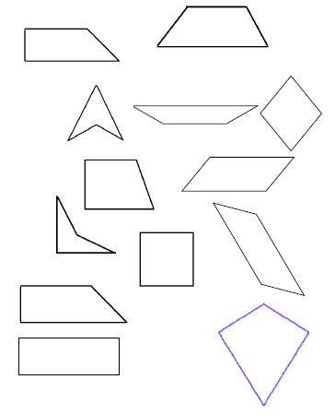

**3 ACT TASK:** Constructing Hierarchies

**Task adapted from Jenise Sexton’s “Investigating Quadrilaterals”**

*Approximately 1 day*

**STANDARDS FOR MATHEMATICAL CONTENT**

**MGSE5.G.3** Understand that attributes belonging to a category of two-dimensional figures also belong to all subcategories of that category.For example, all rectangles have four right angles and squares are rectangles, so all squares have four right angles.

**MGSE5.G.4** Classify two-dimensional figures in a hierarchy based on properties (polygons, triangles and quadrilaterals).

**STANDARDS FOR MATHEMATICAL PRACTICE**

**1. Make sense of problems and persevere in solving them.**  In the Act 1 video, students will watch a hierarchy being constructed using two dimensional geometry vocabulary and toothpicks. Students will analyze the relationship between the vocabulary words placed in the hierarchy to understand how the vocabulary has been organized according to rank. Understanding these relationships presented in the Act 1 video will help the students to complete the hierarchy in Act 2.

**3. Construct viable arguments and critique the reasoning of others.** As students work to place the remaining vocabulary words in the hierarchy during Act 2, they will need to construct arguments and defend their reasoning about why certain vocabulary words belong in certain rankings within the hierarchy. Students will also need to listen to others as they present their ideas and reasons. Students will base their conjectures on prior knowledge learned about two dimensional polygons and will communicate that knowledge as they defend their thinking during Act 2.

**6. Attend to precision.** As students communicate with one another, they will use precise language and vocabulary to justify their ideas and conjectures about two dimensional polygons. They will use accurate mathematics vocabulary and communicate precisely what the word means. For example, students might say, “I know that all squares are rectangles.” Students need to communicate precisely what attributes of a rectangle a square has that proves it can be also classified as a rectangle. A student might say, “I know a square is a rectangle because it has four right angles and two sets of parallel sides.”

**7. Look for and make use of structure.** When ranking the remaining polygons in the hierarchy during Act 2, students will need to think about what attributes make a polygon regular and what attributes make a polygon irregular. To be a regular polygon, it must be both equilateral (all sides are congruent) and equiangular (all angles are congruent). If a polygon is not both equilateral and equiangular, then it is an irregular polygon. Students will then use this pattern, or structure to help them determine which of the remaining polygons are regular triangles, irregular triangles, regular quadrilaterals or irregular quadrilaterals. Using this structure will allow students to investigate congruent sides and angles in polygons in order to rank them within the hierarchy.

**ESSENTIAL QUESTIONS**

During Act 1, students view a video of a hierarchy being created using toothpicks and vocabulary words involving two dimensional polygons. Students must infer how the information is being ranked in the hierarchy based on the words that are used to begin the hierarchy in Act 1. It is imperative that teachers allow students to ask questions of each other and participate in discussion that will lead the students to infer that information during Act 2. The essential questions below can be shared at the beginning of Act 2 to define the emphasis of the problem solving opportunity being presented.

* How can measures of angles and sides help classify polygons?
* What attributes can be used to classify quadrilaterals?
* What attributes can be used to classify triangles?
* What information can be inferred from a hierarchy?

**MATERIALS**

Act 1 video “Constructing Hierarchies” <https://vimeo.com/96079894>

Student recording sheet

Act 2 images (attached)

Act 3 video (Use the link above to locate the video.)

**GROUPING**

Whole group, partners or small groups

**TASK DESCRIPTION, DEVELOPMENT AND DISCUSSION**

Students will watch a video of a hierarchy being created using toothpicks and vocabulary words involving two dimensional polygons. Students must infer how the information is being ranked in the hierarchy based on the words that are used to begin the hierarchy in Act 1. Next, they will be asked to discuss what they wonder about mathematically or are curious about mathematically. These questions will be recorded on a class chart or on the board and on the student recording sheet. Students will then use mathematics to answer one of the questions generated on the chart. Students will be given information to solve the problem based on need. When they realize they don’t have the information they need, and ask for it, it will be given to them.

**BACKGROUND KNOWLEDGE:**

This task follows the 3-Act Math Task format originally developed by Dan Meyer. More information on this type of task may be found at <http://blog.mrmeyer.com/category/3acts/>. A Three-Act Task is a whole-group mathematics task consisting of 3 distinct parts: an engaging and perplexing Act One, an information and solution seeking Act Two, and a solution discussion and solution revealing Act Three. More information along with guidelines for 3-Act Tasks may be found in the ***Guide to Three-Act Tasks*** on georgiastandards.org and the K-5 CCGPS Mathematics Wiki.

At this point, students have quite a bit of background knowledge on two dimensional polygons from their learning in third and fourth grade. In third grade, students learned that rhombi, squares and rectangles are part of a larger group called quadrilaterals. Students learned that rhombi, squares and rectangles have an attribute that classify them as a quadrilateral. (They all have four sides.) In addition, students learned that there are other attributes that help classify shapes into categories – e.g., polygons/non-polygons; all right angles/some right angles/no right angles. In fourth grade, students learn to identify sets of parallel and perpendicular lines in two dimensional figures and classify two dimensional figures based on the number of sets of parallel or perpendicular sides, as well as the presence and absence of angles.

**COMMON MISCONCEPTIONS:**

In geometry, students that have limited experiences with constructing shapes and a limited amount of geometric images they have been exposed to often have many misconceptions about characteristics of shapes.

Students might believe that a shape’s position has an effect on its name. Students might look at the two figures below and say that figure 1 is a square, but figure 2 is a rhombus because it has been rotated.

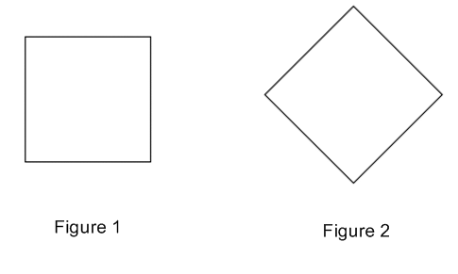

At this level, students must be aware that a shape’s position does not affect the attributes or the name of the shape.

Another common misconception occurs when students rely on the limited images they have seen to define characteristics of a particular shape. One example of this is a trapezoid. Students are often surprised to learn that other trapezoids exist in addition to the pattern block trapezoid they commonly see and work with. (Bamberger, Oberdorf and Schultz-Ferrell; Math Misconceptions; p.80-81) A trapezoid has one set of parallel sides. The other pair of opposite sides do not have to be congruent, which is true of the pattern block trapezoid. Varying the types of images students see and work with will help them classify shapes based on their characteristics and not their position or what they look like.

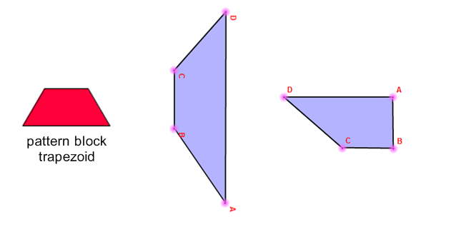

**TASK DIRECTIONS:**

**Act 1 – Whole Group** - Pose the conflict and introduce students to the scenario by showing Act I video or picture. **(Dan Meyer** <http://blog.mrmeyer.com/2011/the-three-acts-of-a-mathematical-story/>**)**

**“Introduce the central conflict of your story/task clearly, visually, viscerally, using as few words as possible.”**

* Show the Act 1 video “Constructing Hierarchies” to students. <https://vimeo.com/96079894>
* Ask students what they noticed mathematically in the video, what they wonder about mathematically, and what mathematical questions they have about what they saw in the video.
* Give each student a copy of the Student Recording Sheet. Have students record their questions and curiosities in the Act 1 section that asks “What questions come to your mind?” Consider doing a think-pair-share so that students have an opportunity to talk with each other before sharing questions with the whole group. Students may need to watch the video several times.
* Share and record students’ questions. The teacher may need to guide students so that the questions generated are math-related.
* Share the main question that will be investigated during today’s lesson. In the list below it is denoted with an asterisk. (*) Students will record the main question on their recording sheet.

**Anticipated questions students may ask and wish to answer:**

* How are the words being organized?
* What is a hierarchy?
* What is the relationship between the words in the hierarchy and the words that are not in the hierarchy?
* *How should the remaining words be placed in the hierarchy?

*\*Main question(s) to be investigated*

**Act 2** – **Student Exploration** - Provide additional information as students work toward solutions to their questions. **(Dan Meyer** <http://blog.mrmeyer.com/2011/the-three-acts-of-a-mathematical-story/>**)**

**“The protagonist/student overcomes obstacles, looks for resources, and develops new tools.”**

* During Act 2, students review the main question from Act 1 and decide on the facts, tools, and other information needed to answer the question. The main question for this task is “How should the remaining words be placed in the hierarchy?”
* Students can record information that they need to solve the problem, given information, estimates and work on the student recording sheet under Act 2.
* When students decide what they need to solve the problem, they should ask for those things. It is pivotal to the problem solving process that students decide what is needed without being given the information up front. Copies of the vocabulary words in the hierarchy are attached at the end of the lesson for student use. There are two copies per page. Students may wish to have toothpicks and the vocabulary words from the video so that students may create the hierarchy as they work through Act 2. Copies can be given to the students at their request.
* The teacher provides guidance as needed during this phase. Some groups might need scaffolds to guide them. The teacher should question groups who seem to be moving in the wrong direction or might not know where to begin. Questioning is an effective strategy that can be used, with questions such as:
  + What is the problem you are trying to solve?
  + What do you think affects the situation?
  + Can you explain what you’ve done so far?
  + What strategies are you using?
  + What assumptions are you making?
  + What tools or models may help you?
  + Why is that true?
  + Does that make sense?

Additional Information for Act 2

Constructing Hierarchies Vocabulary Words (attached – 2 per page)

Important note: Although students will only investigate the main question for this task, it is important for the teacher to not ignore student generated questions. Additional questions may be answered after they’ve found a solution to the main question, or as homework or extra projects.

**Act 3 – Whole Group** – Share solutions and strategies.

* Students present their solutions and thinking and compare them.
* Reveal the solution by showing the Act 3 video. <https://vimeo.com/96076696>
* Lead discussion to compare these, asking questions such as:
  + Which strategy was most efficient?
  + Can you think of another method that might have worked?
  + What might you do differently next time?

**Act 4, The Sequel -** “The goals of the sequel task are to a) challenge students who finished quickly so b) I can help students who need my help. It can't feel like punishment for good work. It can't seem like drudgery. It has to entice and activate the imagination.” Dan Meyer <http://blog.mrmeyer.com/2013/teaching-with-three-act-tasks-act-three-sequel/>

Have students use the same words to make a hierarchy that organizes the polygons by the number of parallel sides they have.

**FORMATIVE ASSESSMENT QUESTIONS**

* What models did you create?
* What organizational strategies did you use?
* What information can be inferred from the hierarchy made during the lesson?
* What relationships can be described between the polygons on the hierarchy?
* Pick two polygons from the hierarchy. State a similarity and a difference between the two hierarchies.

**DIFFERENTIATION**

**Extension**

Students can create their own geometry hierarchy by brainstorming a list of vocabulary and their shared attributes. Students can then work together to create a hierarchy that ranks the vocabulary using one of the common attributes from the brainstormed list.

**Intervention**

Students can review the meaning of the two dimensional geometry vocabulary used before starting to organize the words in the hierarchy. Students can also use tangrams and pattern blocks to make examples of the two dimensional polygons named in the activity. The concrete examples can be used to access prior knowledge students have regarding the attributes the polygons named.

**TECHNOLOGY CONNECTIONS**

* <http://www.mathsisfun.com/quadrilaterals.html>

Quadrilaterals Definition: This definition includes an interactive tool that allows students to manipulate the vertices to make quadrilaterals with varying attributes. It could be utilized by students individually or in a whole group setting by projecting the image on the screen, manipulating the vertices and discussing with students what attributes the resulting quadrilateral has. (e.g., parallel sides, perpendicular sides, types of angles, etc.)

Three Act Student Recording Sheet Name _______________________

**ACT 1**

|  |
| --- |
| What questions come to your mind? |
|  |

**Main Question**: ________________________________________________________________

**ACT 2**

|  |
| --- |
| What information would you like to know or need to solve the MAIN question? |
|  |

Record the given information (measurements, materials, etc…)

Use this area for your work, tables, calculations, sketches, and final solution.

**ACT 3**

|  |
| --- |
| What was the result? |
|  |

**Constructing Hierarchies Act 2**

|  |  |  |  |
| --- | --- | --- | --- |
| **triangle** | **trapezoid** | **square** | **regular** |
| **irregular** | **isosceles** | **regular** | **irregular** |
| **kite** | **quadrilateral** | **polygons** | **scalene** |
| **rhombus** | **equilateral** | **parallelogram** | **rectangle** |

|  |  |  |  |
| --- | --- | --- | --- |
| **triangle** | **trapezoid** | **square** | **regular** |
| **irregular** | **isosceles** | **regular** | **irregular** |
| **kite** | **quadrilateral** | **polygons** | **scalene** |
| **rhombus** | **equilateral** | **parallelogram** | **rectangle** |

**Culminating Task:** Shapely Pairs& Logic of Shapes

*Adapted from Bridges in Mathematics*

*Approximately 1 day*

**STANDARDS FOR MATHEMATICAL PRACTICE**

1. Make sense of problems and persevere in solving them.

2. Reason abstractly and quantitatively.

3. Construct viable arguments and critique the reasoning of others.

5. Use appropriate tools strategically.

6. Attend to precision.

7. Look for and make use of structure.

**STANDARDS FOR MATHEMATICAL CONTENT**

**MGSE5.G.3** Understanding that attributes belonging to a category of two-dimensional figures also belong to all subcategories.

**MGSE5.G.4** Classify two-dimensional figures in a hierarchy based on properties (polygons, triangles and quadrilaterals).

**BACKGROUND KNOWLEDGE**

The students will use the knowledge that they have gained throughout this unit to perform these task.

**COMMON MISCONCEPTIONS**

Students think that when describing geometric shapes and placing them in subcategories, the last category is the only classification that can be used.

**ESSENTIAL QUESTIONS**

* How can plane figures be categorized and classified?
* How can you classify different types of shapes into a hierarchy?
* How can angle and side measures help us classify shapes?

**MATERIALS**

* Cardstock or construction paper for Shapely Pair cards
* Paper
* Small re-sealable bags to store the Shapely Pair cards

**GROUPING**

Individual/Partner Task

**TASK DESCRIPTION, DEVELOPMENT AND DISCUSSION:**

The students will create a Hierarchy Diagram using the terms: quadrilaterals, parallelogram, non parallelograms, rectangle, square, rhombus, trapezoid, kite, and other

Copy the Shapely Pair cards onto cardstock. You will need one set per student. You might want to copy the cards on different colors of cardstock or construction paper so that the partners don’t get their cards mixed up. Also, you might want to number the back of the sets for quick organization and clean up. You can place these in a re-sealable bag to use for a review game later on.

Rules:

1.You can only ask yes or no questions.

3. You CAN’T look at your cards in your stack.

4. You have to ask three questions before guessing the name of your shape.

**Game (Informal Assessment):**

Divide your students into pairs and distribute two sets of Shapely Pair cards to each set of students. The students should shuffle the cards and set them face down. One set (color) per student. Determine ahead of time if the students get a limited amount of guesses per card. The pair of students will first need to determine who will go first and then they can alternate after the first round.

Each player picks up one card and holds that card to their forehead. The students can’t look at their own cards in their stack or while it is on their forehead. They will lose a point if they look.

The students will ask their partner yes or no questions about their polygon card on their forehead. They will try to guess the name of the polygon as they identify properties/attributes of the shape. Both players will need to know their vocabulary and hierarchy to play this game. This can be used as an informal assessment to see if the students are ready for the Culminating activity or if more instruction is needed. Demonstrate to your students how to play the game before letting them play independently. (Teacher versus a student) The students can record their answers on the record sheet provided. After the students have had time to finish their game, check answers as a whole group and discuss any misconceptions.

**TASK**:

* 1. Display the Think-Pair-Share on a Smart Board or provide a copy for each student. Ask the students to jot their answers down and be prepared to explain and justify each. After a few minutes, reconvene the class. Invite a different volunteer to answer and explain his or her response to each question.
  2. Could it be called a kite? Why or why not? No
  3. Could it be called a square? Why or why not? No
  4. After answering the opening questions and getting their brains working, give each student a copy of the Logic of Shapes Task Sheet. The diagram on the task sheet illustrates the relationships between various shapes. Students are asked to label each shape, and then answer a series of questions designed to help them think about how the shapes have been placed in relation to one another, and why. *Read ahead of time- especially consider question #6.*
  5. Modified Assessment-The Polygon Family Tree can be used as a modified assessment and/or an additional whole class review. The students are to use the word bank to fill in the Polygon Family Tree. They can also be required to use the Shapely Pair cards to have to match the polygons to their definitions. If you choose to do this, students will have to match the cards to the definitions and write the corresponding number from the Shapely card beside the Polygon name.

**FORMATIVE ASSESSMENT QUESTIONS**

* How do you know this quadrilateral is a ________ (square, rectangle, parallelogram, trapezoid, or rhombus)?
* What is meant by the term “opposite sides”?
* What does “parallel” mean? How can you show that those sides parallel?
* What does “perpendicular” mean? How can you show that those sides are perpendicular?
* How can you show that 2 sides are equal?
* What are some ways we can show an angle is a right angle?

**DIFFERENTIATION**

**Extension**

* Allow the students to create an I Have, Who Has game with polygon pictures and attribute clues and play the game with their peers.

**Intervention**

* Allow students to work in pairs.
* Allow students to use their notes or the internet.
* Allow students to use their hierarchy diagram
* Allow students to use their Investigating Hierarchy Table from a previous activity
* Limit the number of guesses to increase the level of difficulty
* Allow students to have their vocabulary list with them during the Shapely Pair Game

**TECHNOLOGY CONNECTION**

* <http://illuminations.nctm.org/LessonDetail.aspx?ID=L202>In this lesson, one of a multi-part unit from Illuminations, students participate in activities in which they focus on connections between mathematics and children's literature. They listen to the poem "Shapes" from Shel Silverstein's "A Light in the Attic" and then recognize, draw, and describe geometric figures.
* <http://illuminations.nctm.org/LessonDetail.aspx?ID=L554>In this lesson, one of a multi-part unit from Illuminations, students review different geometric terms. They explore these and other geometric concepts by modeling on the geoboard.

Copy onto cardstock and laminate 1 set per pair of students

*You might want to alternate set colors in case pairs are sitting next to each other. This will help during clean up and in case they get mixed up. You could also number the back of the sets. Example: Label set one (1) on the back of all of the cards.

|  |  |
| --- | --- |
| 1 | 2 |
| 3 | 4 |
| 5 | 6 |

|  |  |
| --- | --- |
| 7 | 8 |
| 9 | 10 |
| 11 | 12 |

|  |  |
| --- | --- |
| Shapely Pairs Game  Rules:  1. Only ask yes or no questions.  2. You CAN’T look at your cards in your stack.  3. You have to ask three questions before guessing the name of your shape.  1. ____________________  2. ____________________  3. ____________________  4. ____________________  5. ____________________  6. ____________________  7. ____________________  8. ____________________  9. ____________________  10. ___________________  11. ___________________  12. ___________________ | Shapely Pairs Game  Rules:  1. Only ask yes or no questions.  2. You CAN’T look at your cards in your stack.  3. You have to ask three questions before guessing the name of your shape.  1. ____________________  2. ____________________  3. ____________________  4. ____________________  5. ____________________  6. ____________________  7. ____________________  8. ____________________  9. ____________________  10. ___________________  11. ___________________  12. ___________________ |
| Shapely Pairs Game  Rules:  1. Only ask yes or no questions.  2. You CAN’T look at your cards in your stack.  3. You have to ask three questions before guessing the name of your shape.  1. ____________________  2. ____________________  3. ____________________  4. ____________________  5. ____________________  6. ____________________  7. ____________________  8. ____________________  9. ____________________  10. ___________________  11. ___________________  12. ___________________ | Shapely Pairs Game  Rules:  1. Only ask yes or no questions.  2. You CAN’T look at your cards in your stack.  3. You have to ask three questions before guessing the name of your shape.  1. ____________________  2. ____________________  3. ____________________  4. ____________________  5. ____________________  6. ____________________  7. ____________________  8. ____________________  9. ____________________  10. ___________________  11. ___________________  12. ___________________ |

Think –Pair-Share

True or false?

1. This shape is a quadrilateral.
2. This shape is a trapezoid.
3. This shape is a rhombus.
4. This shape is a parallelogram.
5. This shape is a rectangle.

Jot down your answers and be prepared to explain and justify each.

Name:________________ Date: __________ Class:_________

Logic of Shapes

1. Label each shape in this diagram with the name that describes it most exactly. You can number the shapes and list the names on the back or write the names on the diagram.

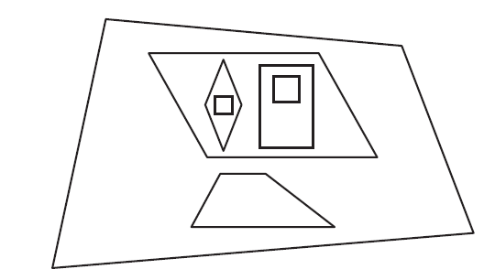

1. Why is the trapezoid inside the quadrilateral but outside the parallelogram?
2. Why are there a rhombus and a rectangle inside the parallelogram?
3. Why are there two squares, one inside the rhombus and one inside the rectangle?
4. Write at least 2 other observations to explain why the shapes in this diagram have been placed where they are in relation to each other.
5. Do you agree with the placement of the trapezoid? Redraw this diagram to show the actual relationship of the trapezoid to the parallelograms.
6. Which shape can be given the most names? Why?
7. What is the difference between a rhombus and a square?

Name _____________________________ Date _______________ Class ______________

**Parallelogram**

**Four right angles,**

**only opposite sides are equal in length**

**Parallelogram,**

**Four right angles,**

**all sides equal length**

**Parallelogram,**

**all sides equal length**

**4 Sides**

**3 equal sides**

**2 equal sides**

**0 equal Sides**

**3 Sides**

**6 Sides**

Polygons

**5 Sides**

**At least one set of parallel sides**

**Word Bank**

rhombus triangle hexagon square

equilateral trapezoid pentagon scalene

rectangle isosceles quadrilateral