

**Georgia**

**Standards of Excellence**

**Frameworks**

**Mathematics**

GSE Fourth Grade

Unit 5: Fractions and Decimals



**Unit 5: Fractions and Decimals**

**TABLE OF CONTENTS (* indicates new task; **indicates modified task)**

Overview 3

Standards for Mathematical Practices 3

Standards for Mathematical Content 4

Big Ideas 5

Essential Questions 5

Concepts and Skills to Maintain 6

Strategies for Teaching and Learning 7

Selected Terms and Symbols 8

Tasks 9

Formative Assessment Lessons 13

**Tasks**

* Decimal Fraction Number Line 14
* Base Ten Decimals 21
* Decimal Designs 33
* Fraction Flags 43
* Dismissal Duty Dilemma 48
* Expanding Decimals with Money 52
* Double Number Line Decimals 57
* Money Exchange 60
* Trash Can Basketball 67
* Calculator Decimal Counting 76
* Meter of Beads 80
* Measuring Up Decimals 91
* Decimal Line-up 95
* In the Paper 103
* Planning a 5K 109
* Taxi Trouble 116
* **Culminating Task**

Cell Phone Plans 120

***Please note that all changes made to standards will appear in red bold type. Additional changes will appear in green.

**OVERVIEW**

In this unit students will:

* express fractions with denominators of 10 and 100 as decimals
* understand the relationship between decimals and the base ten system
* understand decimal notation for fractions
* use fractions with denominators of 10 and 100 interchangeably with decimals
* express a fraction with a denominator 10 as an equivalent fraction with a denominator 100
* add fractions with denominators of 10 and 100 (including adding tenths and hundredths)
* compare decimals to hundredths by reasoning their size
* understand that comparison of decimals is only valid when the two decimals refer to the same whole
* justify decimals comparisons using visual models

Although the units in this instructional framework emphasize key standards and big ideas at specific times of the year, routine topics such as estimation, mental computation, and basic computation facts should be addressed on an ongoing basis. Ideas related to the eight standards of mathematical practice: making sense of problems and persevering in solving them, reasoning abstractly and quantitatively, constructing viable arguments and critiquing the reasoning of others, modeling mathematics, using appropriate tools strategically, attending to precision, looking for and making use of structure, and looking for and expressing regularity in repeated reasoning, should be addressed continually as well. The first unit used each year should establish these routines, allowing students to gradually enhance their understanding of the concept of numbers and to develop computational proficiency.

The Critical Areas are designed to bring focus to the standards at each grade by describing the big ideas that educators can use to build their curriculum and to guide instruction.Students develop understanding of fraction equivalence and operations with fractions. They recognize that two different fractions can be equal (e.g., $\frac{15}{9}$ = $\frac{5}{3}$), and they develop methods for generating and recognizing equivalent fractions. Students extend previous understandings about how fractions are built from unit fractions, composing fractions from unit fractions, decomposing fractions into unit fractions, and using the meaning of fractions and the meaning of multiplication to multiply a fraction by a whole number.

For more detailed information about unpacking the content standards, unpacking a task, math routines and rituals, maintenance activities and more, please refer to the Grade Level Overview.

**STANDARDS FOR MATHEMATICAL PRACTICES**

This section provides examples of learning experiences for this unit that support the development of the proficiencies described in the Standards for Mathematical Practice. These proficiencies correspond to those developed through the Literacy Standards. The statements provided offer a few examples of connections between the Standards for Mathematical Practice and the Content Standards of this unit. This list is not exhaustive and will hopefully prompt further reflection and discussion.

1. **Make sense of problems and persevere in solving them.** Students will create and compare decimals to solve problems in the tasks “Taxi Trouble” and “Cell Phone Plans.”
2. **Reason abstractly and quantitatively.** Students will order decimal fractions to hundredths on a number line or with visual models and understand that fraction equivalency is only valid when comparing parts of the same whole.
3. **Construct viable arguments and critique the reasoning of others.** Students will communicate why one decimal or fraction is either greater than, less than or equal to another decimal or fraction and be able to question the interpretations of others when discussing the same decimals and fractions.
4. **Model with mathematics.** Students will use base ten models (blocks, number lines, etc.) to model relative size of decimals and fractions and use the same models to represent fraction and decimal equivalency.
5. **Use appropriate tools strategically.** Students will determine which tools (blocks, number lines, etc.) would be best used to represent situations involving decimals and decimal fractions.
6. **Attend to precision.** Students attend to the language of real-world situations to order decimals and decimal fractions.
7. **Look for and make use of structure.** Students relate the structure of number lines and base ten models to the ordering of decimals and decimal fractions. Furthermore, students will relate the structure of the models to fractional and decimal equivalency.
8. **Look for and express regularity in repeated reasoning.** Students will use mathematical reasoning to relate new experiences with similar experiences when dealing with fractional and decimal equivalency and with ordering decimals to hundredths.

**\*\*\*Mathematical Practices 1 and 6 should be evident in EVERY lesson\*\*\***

**STANDARDS FOR MATHEMATICAL CONTENT**

**Understand decimal notation for fractions and compare decimal fractions.**

**MGSE4.NF.5** Express a fraction with denominator 10 as an equivalent fraction with denominator 100, and use this technique to add two fractions with respective denominators 10 and 100. *For example, express 3/10 as 30/100, and add 3/10 + 4/100 = 34/1001.*

**MGSE4.NF.6** Use decimal notation for fractions with denominators 10 or 100. *For example, rewrite 0.62 as 62/100; describe a length as 0.62 meters; locate 0.62 on a number line diagram.*

**MGSE4.NF.7** Compare two decimals to hundredths by reasoning about their size. Recognize that comparisons are valid only when the two decimals refer to the same whole. Record the results of the comparisons with the symbols >, =, or <, and justify the conclusions, e.g. by using a visual model.

**Solve problems involving measurement and conversion of measurements from a larger unit to a smaller unit.**

**MGSE4.MD.2** Use the four operations to solve word problems involving distances, intervals of time, liquid volumes, masses of objects, and money, including problems involving simple fractions or decimals, and problems that require expressing measurements given in a larger unit in terms of a smaller unit. Represent measurement quantities using diagrams such as number line diagrams that feature a measurement scale.

**BIG IDEAS**

* Fractions can be expressed as decimals.
* Decimals can be represented visually in models like hundredths grids and number lines

and in written form.

* Decimals are a part of the base ten system.
* Tenths can be expressed using an equivalent fraction with a denominator of 100.
* Comparisons of two decimals are only valid when the two decimals refer to the same

whole.

* The sum of two fractions with the respective denominators 10 and 100 can be determined.

**ESSENTIAL QUESTIONS** Choose a few questions based on the needs of your students.

* How are decimal fractions written using decimal notation?
* How are decimal numbers and decimal fractions related?
* How are decimals and fractions related?
* How can I combine the decimal length of objects I measure?
* How can I model decimals fractions using the base-ten and place value system?
* How can I write a decimal to represent a part of a group?
* How does the metric system of measurement show decimals?
* What is a decimal fraction and how can it be represented?
* What models can be used to represent decimals?
* What patterns occur on a number line made up of decimal fractions?
* When adding decimals, how does decimal notation show what I expect? How is it different?
* When is it appropriate to use decimal fractions?
* When you compare two decimals, how can you determine which one has the greater value?
* Why is the number 10 important in our number system?

**CONCEPTS/SKILLS TO MAINTAIN**

It is expected that students will have prior knowledge/experience related to the concepts and skills identified below. It may be necessary to pre-assess in order to determine if time needs to be spent on conceptual activities that help students develop a deeper understanding of these ideas.

* Recognize and represent that the denominator determines the number of equal sized pieces that make up a whole.
* Recognize and represent that the numerator determines how many pieces of the whole are being referred to in the fraction.
* Compare fractions with denominators of 2, 3, 4, 6, 10, or 12 using concrete and pictorial models.
* Understand that a decimal represents a part of 10

**Fluency**: Procedural fluency is defined as skill in carrying out procedures flexibly, accurately, efficiently, and appropriately. Fluent problem solving does not necessarily mean solving problems within a certain time limit, though there are reasonable limits on how long computation should take. Fluency is based on a deep understanding of quantity and number.

**Deep Understanding**: Teachers teach more than simply “how to get the answer” and instead support students’ ability to access concepts from a number of perspectives. Therefore students are able to see math as more than a set of mnemonics or discrete procedures. Students demonstrate deep conceptual understanding of foundational mathematics concepts by applying them to new situations, as well as writing and speaking about their understanding.

**Memorization**: The rapid recall of arithmetic facts or mathematical procedures. Memorization is often confused with fluency. Fluency implies a much richer kind of mathematical knowledge and experience.

**Number Sense:** Students consider the context of a problem, look at the numbers in a problem, make a decision about which strategy would be most efficient in each particular problem. Number sense is not a deep understanding of a single strategy, but rather the ability to think flexibly between a variety of strategies in context.

**Fluent students**:

* flexibly use a combination of deep understanding, number sense, and memorization.
* are fluent in the necessary baseline functions in mathematics so that they are able to spend their thinking and processing time unpacking problems and making meaning from them.
* are able to articulate their reasoning.
* find solutions through a number of different paths.

For more about fluency, see: <http://www.youcubed.org/wp-content/uploads/2015/03/FluencyWithoutFear-2015.pdf>  and: <http://joboaler.com/timed-tests-and-the-development-of-math-anxiety/>

**STRATEGIES FOR TEACHING AND LEARNING**

The place value system developed for whole numbers extends to fractional parts of a whole represented as decimals. This is a connection to the metric system. Decimals are another way to represent fractions. The place-value system developed for whole numbers extends to decimals. The concept of one whole used in fractions is extended to models of decimals.

Students can use base-ten blocks to represent decimals. A 10 x 10 block can be assigned the value of one whole to allow other blocks to represent tenths and hundredths. They can show a decimal representation from the base-ten blocks by shading on a 10 x 10 grid.

Students need to make connections between fractions and decimals. They should be able to write decimals for fractions with denominators of 10 or 100. Have students say the fraction with denominators of 10 and 100 aloud. For example $\frac{4}{10}$ would be “four tenths” or $\frac{27}{100}$ would be “twenty-seven hundredths.” Also, have students represent decimals in word form with digits and the decimal place value, such as $\frac{4}{10}$ would be 4 tenths.

Students should be able to express decimals to the hundredths as the sum of two decimals or fractions. This is based on understanding of decimal place value. For example 0.32 would be the sum of 3 tenths and 2 hundredths. Using this understanding, students can write 0.32 as the sum of two fractions $\frac{3}{10}$ + $\frac{2}{100}$.

Students’ understanding of decimals to hundredths is important in preparation for performing operations with decimals to hundredths in Grade 5.

In decimal numbers, the value of each place is 10 times the value of the place to its immediate right. Students need an understanding of decimal notations before they try to do conversions in the metric system. Understanding of the decimal place value system is important prior to the generalization of moving the decimal point when performing operations involving decimals.

Students extend fraction equivalence from Grade 3 with denominators of 2, 3 4, 6 and 8 to fractions with a denominator of 10. Provide fraction models of tenths and hundredths so that students can express a fraction with a denominator of 10 as an equivalent fraction with a denominator of 100. Mathematically proficient students communicate precisely by engaging in discussion about their reasoning using appropriate mathematical language. The terms students should learn to use with increasing precision with this cluster are**: fraction, numerator, denominator, equivalent, reasoning, decimals,** **tenths, hundreds, multiplication, comparisons/compare, ‹, ›, =.**

* Students should be actively engaged by developing their own understanding.
* Mathematics should be represented in as many ways as possible by using graphs, tables, pictures, symbols, and words.
* Interdisciplinary and cross curricular strategies should be used to reinforce and extend the learning activities.
* Appropriate manipulatives and technology should be used to enhance student learning.
* Students should be given opportunities to revise their work based on teacher feedback, peer feedback, and metacognition which includes self-assessment and reflection.
* Students should write about the mathematical ideas and concepts they are learning.
* Books such as *Fractions and Decimals Made Easy* (2005) by Rebecca Wingard-Nelson, illustrated by Tom LaBaff, are useful resources to have available for students to read during the instruction of these concepts.
* Consideration of all students should be made during the planning and instruction of this unit. Teachers need to consider the following:
  + What level of support do my struggling students need in order to be successful with this unit?
  + In what way can I deepen the understanding of those students who are competent in this unit?
  + What real life connections can I make that will help my students utilize the skills practiced in this unit?

**SELECTED TERMS AND SYMBOLS**

The following terms and symbols are often misunderstood. These concepts are not an inclusive list and should not be taught in isolation. However, due to evidence of frequent difficulty and misunderstanding associated with these concepts, instructors should pay particular attention to them and how their students are able to explain and apply them.

Teachers should present these concepts to students with models and real life examples. Students should understand the concepts involved and be able to recognize and/or demonstrate them with words, models, pictures, and numbers.

The websites below are interactive and include a math glossary suitable for elementary children. It has activities to help students more fully understand and retain new vocabulary. (i.e. The definition for *dice* actually generates rolls of the dice and gives students an opportunity to add them.) **Note – At the elementary level, different sources use different definitions. Please preview any website for alignment to the CCGPS.**

<http://www.corestandards.org/Math/Content/mathematics-glossary/glossary>

**The terms below are for teacher reference only and are not to be memorized by the students**.

* decimal
* decimal fraction
* decimal point
* denominator
* equivalent sets
* increment
* numerator
* term
* unit fraction
* whole number

**TASKS**

The following tasks represent the level of depth, rigor, and complexity expected of all fourth grade students. These tasks or tasks of similar depth and rigor should be used to demonstrate evidence of learning. It is important that all elements of a task be addressed throughout the learning process so that students understand what is expected of them. While some tasks are identified as performance tasks, they also may be used for teaching and learning.

|  |  |
| --- | --- |
| **Scaffolding Task** | Tasks that build up to the learning task. |
| **Constructing Task** | Constructing understanding through deep/rich contextualized problem solving tasks. |
| **Practice Task** | Tasks that provide students opportunities to practice skills and concepts. |
| **Performance Task** | Tasks which may be a formative or summative assessment that checks for student understanding/misunderstanding and or progress toward the standard/learning goals at different points during a unit of instruction. |
| **Culminating Task** | Designed to require students to use several concepts learned during the unit to answer a new or unique situation. Allows students to give evidence of their own understanding toward the mastery of the standard and requires them to extend their chain of mathematical reasoning. |
| **Formative Assessment Lesson (FAL)** | Lessons that support teachers in formative assessment which both reveal and develop students’ understanding of key mathematical ideas and applications. These lessons enable teachers and students to monitor in more detail their progress towards the targets of the standards. |
| **CTE Classroom Tasks** | Designed to demonstrate how the Career and Technical Education knowledge and skills can be integrated. The tasks provide teachers with realistic applications that combine mathematics and CTE content. |
| **3-Act Task** | A Three-Act Task is a whole-group mathematics task consisting of 3 distinct parts: an engaging and perplexing Act One, an information and solution seeking Act Two, and a solution discussion and solution revealing Act Three. More information along with guidelines for 3-Act Tasks may be found in the ***Guide to Three-Act Tasks*** on georgiastandards.org and the K-5 CCGPS Mathematics Wiki. |

|  |  |  |  |  |
| --- | --- | --- | --- | --- |
| **Task Name** | **Task Type/Grouping Strategy** | **Content Addressed** | **Standard(s)** | **Task Description** |
| Decimal Fraction Number Line | Scaffolding Task  *Individual/Partner Task* | Represent and place decimal fractions on a number line | MGSE4.NF.7 | Students will discover the characteristics of a decimal fraction while making models and plotting the decimal fraction on number lines. |
| Base Ten Decimals | Scaffolding Task  *Partner/Small Group Task* | Represent decimal fractions using the base ten model | MGSE4.NF.6 | Students will model decimal numbers using base ten blocks. |
| Decimal Designs | Constructing Task  *Individual/Partner Task* | Representing decimals and finding equivalent fractions between tenths and hundredths | MGSE4.NF.5  MGSE4.NF.6 | Students make designs on tenths and hundredths grids to learn how to write decimal fractions and decimals. |
| Fractions Flags | Performance Task  *Individual Task* | Representing decimals using decimal squares and decimal notation | MGSE4.NF.5  MGSE4.NF.6 | Students color in and design flags. The, students represent the fraction of colors in the flag using decimal fractions and decimals. |
| Dismissal Duty Dilemma | Constructing Task  *Individual/Partner Task* | Using fractions and decimals interchangeably | MGSE4.NF.5  MGSE4.NF.6  MGSE4.NF.7 | Students create a plan for teachers to monitor certain parts of the building using decimal fractions. |
| Expanding Decimals with Money | Scaffolding Task  *Individual/Partner Task* | Building decimal fractions and decimals in expanded notation | MGSE4.NF.7 | Students relate decimal place value to our money system and recognize equivalency between tenths and hundredths. |
| Double Number Line Decimals | Constructing Task  *Individual/Partner Task* | Ordering tenths and hundredths on a double number line | MGSE4.NF.7 | Students shade decimal numbers on grids and order the numbers on a double number line. |
| Money Exchange | 3 Act Task  *Individual/Partner Task* | Represent and compare decimals | MGSE4.NF.7  **MGSE4.MD.2** | Students compare decimals in an exchange rate chart to determine who has the best money exchange rate. |
| Trash Can Basketball | Practice Task  *Partner/Small Group Task* | Representing decimals and comparing decimals | MGSE4.NF.7 | Students collect data that is written in decimal fraction and decimal form during a game of basketball. |
| Calculator Decimal Counting | Scaffolding Task  *Individual/Partner Task* | Observe and use patterns when adding decimals | MGSE4.NF.7 | Students will discover and describe patterns when working with decimals on a calculator. |
| Meter of Beads | Scaffolding Task  *Individual/Partner Task* | Exploring models of decimals and comparing decimals | MGSE4.NF.5  MGSE4.NF.6  MGSE4.NF.7  **MGSE4.MD.2** | Students will organize beads using a meter stick and a paper meter strip in order to report the number of beads as a decimal and a fraction of a meter. |
| Measuring Up | Constructing Task  *Individual/Partner Task* | Using the metric system to represent decimals | MGSE4.NF.5  MGSE4.NF.6  MGSE4.NF.7  **MGSE4.MD.2** | Students will measure a variety of classroom objects as fractions of a meter and represent, combine and compare the measurements. |
| Decimal Line Up | Practice Task  *Individual/Partner Task* | Order decimal numbers using number line | MGSE4.NF.5  MGSE4.NF.6  MGSE4.NF.7 | Students will order numbers on a number line. |
| In the Paper | Performance Task  *Individual/Partner Task* | Represent and use decimal fractions and decimal numbers, graph data | MGSE4.NF.5  MGSE4.NF.6  MGSE4.NF.7 | Students will read 100 words of a newspaper article or book and determine what part of the 100 words represent various word types. Students then make a bar graph to show the results. |
| Planning a 5K | 3 Act Task  *Individual/Partner Task* | Compare decimals | MGSE4.NF.7  **MGSE4.MD.2** | Students investigate the length of trails to answer questions they are wondering about. |
| Taxi Trouble | Constructing Task  *Individual/Partner Task* | Add tenths and hundredths, compare decimals | MGSE4.NF.5  MGSE4.NF.6  MGSE4.NF.7 | Students determine which taxi cab is offers this best deal for a ride to the airport. |
| Cell Phone Plans | **Culminating Task**  *Individual/Partner Task* | Add tenths and hundredths, compare decimals | MGSE4.NF.5  MGSE4.NF.6  MGSE4.NF.7 | Students determine which cell phone plan best meets the need of the customer. |

*Should you need further support for this unit, please view the appropriate unit webinar at :*[*https://www.georgiastandards.org/Common-Core/Pages/Math-PL-Sessions.aspx*](https://www.georgiastandards.org/Common-Core/Pages/Math-PL-Sessions.aspx)

**FORMATIVE ASSESSMENT LESSONS (FALS)**

Formative Assessment Lessons are designed for teachers to use in order to target specific strengths and weaknesses in their students’ mathematical thinking in different areas. A Formative Assessment Lesson (FAL) includes a short task that is designed to target mathematical areas specific to a range of tasks from the unit. Teachers should give the task in advance of the delineated tasks and the teacher should use the information from the assessment task to differentiate the material to fit the needs of the students. The initial task should not be graded. It is to be used to guide instruction.

Teachers may use the following Formative Assessment Lessons (FALS) Chart to help them determine the areas of strengths and weaknesses of their students in particular areas within the unit.

|  |  |  |  |
| --- | --- | --- | --- |
| **Formative Assessments** | **FALS**  **(Supporting Lesson Included)** | **Content Addressed** | **Pacing**  **(Use before and after these tasks)** |
| [Relating Fraction Equivalencies to Decimal Fractions](http://ccgpsmathematicsk-5.wikispaces.com/file/view/Relating%20Fraction%20Equivalencies%20to%20Decimals.pdf/437684076/Relating%20Fraction%20Equivalencies%20to%20Decimals.pdf) | X | Placing decimal fractions on a number line  Using fraction and decimals interchangeably  Add/Subtract Fractions | Decimal Fraction Number Line  Decimal Designs  Dismissal Duty Dilemma  Decimal Line Up  Taxi Trouble |
| [Fraction Decimal Relationship](http://ccgpsmathematicsk-5.wikispaces.com/K-5+Formative+Assessment+Lessons+%28FALs%29) |  | Adding Tenths and Hundredths  Ordering on a Number line | Expanding Decimals with Money  Trash Can Basketball |
| [Fraction Equivalents](http://s3.amazonaws.com/illustrativemathematics/illustration_pdfs/000/000/154/original/illustrative_mathematics_154.pdf?1343856867) |  | Base Ten Models | Base Ten Decimals  Flag Fractions  Meter of Beads |

**Materials Note: All fraction model Blacklines are located at the end of “Decimal Fraction Number Line Task” and will be used throughout this unit.**

**Scaffolding Task:** Decimal Fraction Number Line

**TASK CONTENT****:** Students will represent and place decimal fractions on a number line.

**STANDARDS FOR MATHEMATICAL CONTENT**

**MGSE4.NF.7** Compare two decimals to hundredths by reasoning about their size. Recognize that comparisons are valid only when the two decimals refer to the same whole. Record the results of the comparisons with the symbols >, =, or <, and justify the conclusions, e.g. by using a visual model.

**STANDARDS FOR MATHEMATICAL PRACTICE TO BE EMPHASIZED**

1. Make sense of problems and persevere in solving them.

2. Reason abstractly and quantitatively.

4. Model with mathematics.

5. Use appropriate tools strategically.

6. Attend to precision.

7. Look for and make use of structure.

**BACKGROUND KNOWLEDGE**

To make the link between fractions and decimals, students need to understand how the base-ten system can be extended to include numbers less than 1. Fractions that have denominators of 10, 100, and 1,000 and so on are commonly referred to as decimal or base-ten fractions. Focusing on these fractions during early decimal concept development can make the transition between fractions and decimals easier.

**ESSENTIAL QUESTIONS**

* What are the characteristics of a decimal fraction?
* What patterns occur on a number line made up of decimal fractions?

**MATERIALS**

* Paper/Poster paper
* Pencils/markers
* Set of the attached decimals fraction cards for each pair
* Copies of “Tenths Squares” and “Hundredths Squares” (These are to be used throughout this unit and are located at the end of “Decimal Fraction Number Line)

**GROUPING**

Individual or partner grouping

**NUMBER TALKS**

Continue utilizing the different strategies in number talks and revisiting them based on the needs of your students. Catherine Fosnot has developed problem “strings” which may be included in number talks to further develop mental math skills. See Mini-lessons for Operations with Fractions, Decimals, and Percents by Kara Louise Imm, Catherine Twomey Fosnot and Willem Uittenbogaard. (Mini-lessons for Operation with Fraction, Decimal, and Percent, 2007, Kara Louise Imm, Catherine Twomey Fosnot and Willem Uittenbogaard)

**TASK DESCRIPTION, DEVELOPMENT AND DISCUSSION**

**Comments**

This may be many students’ first formal experience working with decimal fractions. This scaffolding task is meant to reinforce fraction comparison skills using visual models, as well as help students make the fractions to decimals connection by using familiar fraction concepts and models to explore numbers that are easily represented by decimals. Students will create models of decimal fractions using tenths and hundredths squares, order these decimal fractions on a number line, and look for patterns that occur when using decimal fractions.

**Task Directions:**

**Part 1**

*1. Using the 2 sets of decimal fraction cards, create a model for each fraction using a tenths or hundredths square.*

*2. Create 2 number lines using the decimal fraction cards and the models you created.*

*3. Answer the following questions for reflection and be ready to share your thinking!*

* *How did you know the models you made matched the fraction cards?*
* *How did you know where to place your fraction cards and models on the number line?*
* *What patterns did you see as you completed your number line?*

**PART 2**

Have students share their number lines and explain how they placed their fractions and models on the number line. Guide students through a discussion of decimal fractions by using the following prompt:

* *All of the fractions we used today are examples of “decimal fractions.” Based on the fractions you see on your number line, what do you think a decimal fraction is? Explain your thinking.*

**FORMATIVE ASSESSMENT QUESTIONS**

* How did you know your models matched the fraction card?
* What was your strategy for placing the fractions on a number line?
* What have you noticed about the fractions that you’re working with today?
* What patterns do you see in the fractions you’re working with today?

**DIFFERENTIATION**

**Extension**

* Provide students with mixed numbers that have decimal fractions to extend their number lines. Have them label each mixed number as an improper fraction as well.

**Intervention**

* Give students only the tenths or hundredths cards to work with in order to focus on simply placing fractions on a number line without comparisons between tenths and hundredths. Provide a number line with endpoints listed.

**TECHNOLOGY**

* <http://www.prometheanplanet.com/en-us/Resources/Item/92384/decimal-numbers-introduction> This introductory lesson can be used with an ActivSlate or Smartboard. It can be used to introduce the task.
* <http://www.ixl.com/math/grade-3/put-decimal-numbers-in-order> This game involving putting two digit decimals in order can be used for independent practice.

Decimal Fraction Cards Set 1

|  |  |  |  |  |  |  |  |  |  |  |  |  |  |  |
| --- | --- | --- | --- | --- | --- | --- | --- | --- | --- | --- | --- | --- | --- | --- |
| |  | | --- | | 1 | | 10 | | |  | | --- | | 7 | | 10 | | |  | | --- | | 3 | | 10 | | |  | | --- | | 5 | | 10 | | |  | | --- | | 6 | | 10 | |
| |  | | --- | | 8 | | 10 | | |  | | --- | | 2 | | 10 | | |  | | --- | | 10 | | 10 | | |  | | --- | | 9 | | 10 | | |  | | --- | | 4 | | 10 | |

Decimal Fraction Cards Set 2

|  |  |  |  |  |  |  |  |  |  |  |  |  |  |  |
| --- | --- | --- | --- | --- | --- | --- | --- | --- | --- | --- | --- | --- | --- | --- |
| |  | | --- | | 10 | | 100 | | |  | | --- | | 70 | | 100 | | |  | | --- | | 30 | | 100 | | |  | | --- | | 50 | | 100 | | |  | | --- | | 60 | | 100 | |
| |  | | --- | | 80 | | 100 | | |  | | --- | | 20 | | 100 | | |  | | --- | | 100 | | 100 | | |  | | --- | | 90 | | 100 | | |  | | --- | | 40 | | 100 | |

Tenths Squares

|  |  |  |  |  |  |  |  |  |  |
| --- | --- | --- | --- | --- | --- | --- | --- | --- | --- |
|  |  |  |  |  |  |  |  |  |  |

|  |  |  |  |  |  |  |  |  |  |
| --- | --- | --- | --- | --- | --- | --- | --- | --- | --- |
|  |  |  |  |  |  |  |  |  |  |

|  |  |  |  |  |  |  |  |  |  |
| --- | --- | --- | --- | --- | --- | --- | --- | --- | --- |
|  |  |  |  |  |  |  |  |  |  |

|  |  |  |  |  |  |  |  |  |  |
| --- | --- | --- | --- | --- | --- | --- | --- | --- | --- |
|  |  |  |  |  |  |  |  |  |  |

|  |  |  |  |  |  |  |  |  |  |
| --- | --- | --- | --- | --- | --- | --- | --- | --- | --- |
|  |  |  |  |  |  |  |  |  |  |

|  |  |  |  |  |  |  |  |  |  |
| --- | --- | --- | --- | --- | --- | --- | --- | --- | --- |
|  |  |  |  |  |  |  |  |  |  |

Hundredths Squares

|  |  |  |  |  |  |  |  |  |  |
| --- | --- | --- | --- | --- | --- | --- | --- | --- | --- |
|  |  |  |  |  |  |  |  |  |  |
|  |  |  |  |  |  |  |  |  |  |
|  |  |  |  |  |  |  |  |  |  |
|  |  |  |  |  |  |  |  |  |  |
|  |  |  |  |  |  |  |  |  |  |
|  |  |  |  |  |  |  |  |  |  |
|  |  |  |  |  |  |  |  |  |  |
|  |  |  |  |  |  |  |  |  |  |
|  |  |  |  |  |  |  |  |  |  |
|  |  |  |  |  |  |  |  |  |  |

|  |  |  |  |  |  |  |  |  |  |
| --- | --- | --- | --- | --- | --- | --- | --- | --- | --- |
|  |  |  |  |  |  |  |  |  |  |
|  |  |  |  |  |  |  |  |  |  |
|  |  |  |  |  |  |  |  |  |  |
|  |  |  |  |  |  |  |  |  |  |
|  |  |  |  |  |  |  |  |  |  |
|  |  |  |  |  |  |  |  |  |  |
|  |  |  |  |  |  |  |  |  |  |
|  |  |  |  |  |  |  |  |  |  |
|  |  |  |  |  |  |  |  |  |  |
|  |  |  |  |  |  |  |  |  |  |

|  |  |  |  |  |  |  |  |  |  |
| --- | --- | --- | --- | --- | --- | --- | --- | --- | --- |
|  |  |  |  |  |  |  |  |  |  |
|  |  |  |  |  |  |  |  |  |  |
|  |  |  |  |  |  |  |  |  |  |
|  |  |  |  |  |  |  |  |  |  |
|  |  |  |  |  |  |  |  |  |  |
|  |  |  |  |  |  |  |  |  |  |
|  |  |  |  |  |  |  |  |  |  |
|  |  |  |  |  |  |  |  |  |  |
|  |  |  |  |  |  |  |  |  |  |
|  |  |  |  |  |  |  |  |  |  |

**Large 10 x 10 Grid**

**Scaffolding Task:** Base Ten Decimals

**TASK CONTENT:** Students will represent decimal fractions using the base ten model.

**STANDARDS FOR MATHEMATICAL CONTENT**

**MGSE4.NF.6** Use decimal notation for fractions with denominators 10 or 100. *For example, rewrite 0.62 as 62/100; describe a length as 0.62 meters; locate 0.62 on a number line diagram.*

**STANDARDS FOR MATHEMATICAL PRACTICE TO BE EMPHASIZED**

1. Make sense of problems and persevere in solving them.

2. Reason abstractly and quantitatively.

4. Model with mathematics.

5. Use appropriate tools strategically.

6. Attend to precision.

7. Look for and make use of structure.

**BACKGROUND KNOWLEDGE**

When exploring whole-number place value relationships, the pieces represented by each of the values become increasingly ten times greater as you move to the left. Similarly, it is important that students understand as you move to the right past the decimal point the pieces become smaller and smaller. One critical question becomes, “Will there ever be a smallest piece?” There is no largest piece or smallest piece when it comes to our place value system, and as the students begin to explore decimals, it is important to reinforce the 10-to-1 relationship that occurs between the places in our place value system.

Using the base-ten model system, decimals to many places can be represented, though when working with base-ten models to the hundredths, the square is most often referred to as the whole or one unit, the rods become the tenths, and the unit cubes become hundredths.

**ESSENTIAL QUESTIONS**

* What role does the decimal point play in our base-ten system?
* How can I model decimal fractions using the base-ten and place value system?
* How are decimal fractions written using decimal notation?

**MATERIALS**

* Base-ten blocks (or copies of 10 x 10 grids cut into base ten pieces)
* Place-value chart
* Copies of “Base-Ten Decimal Cards”

**GROUPING**

Individual or partner grouping

**NUMBER TALKS**

Continue utilizing the different strategies in number talks and revisiting them based on the needs of your students. Catherine Fosnot has developed problem “strings” which may be included in number talks to further develop mental math skills. See Mini-lessons for Operations with Fractions, Decimals, and Percents by Kara Louise Imm, Catherine Twomey Fosnot and Willem Uittenbogaard. (Mini-lessons for Operation with Fraction, Decimal, and Percent, 2007, Kara Louise Imm, Catherine Twomey Fosnot and Willem Uittenbogaard)

**TASK DESCRIPTION, DEVELOPMENT AND DISCUSSION**

**Comments**

The purpose of this scaffolding task is to help link decimal fraction understandings to our base-ten place value system. In this task students will learn how the base-ten model can be used to model decimal fractions to the hundredths place. They will also learn how decimal fractions are written using decimal notation.

As you extend the base-ten system into decimals, it is important to review concepts of whole-number place value. Review with students the 10-to-1 relationship between the values of any two place value positions that are next to each other. For example, 260 can be represented as 26 tens. In reference to the base-ten model, 10 of any one piece will make 1 of the next larger, and vice versa.

If base-ten manipulative blocks are not available, use copies of a large *10 x 10 Grid*. Copy additional grids on one color of paper to cut into rods and copy additional grids on another color to cut into units. Large 10 x 10 grids and smaller 10 x 10 grids are provided.

**Task Directions:**

**Part 1**

* Show students examples of base-ten blocks and lead a review discussion of what they have already seen these blocks referred to as (hundreds, tens, and ones).
* Review the concept of each larger piece representing a group of 10 of the smaller piece to its right (1 flat = 10 rods, 1 rod = 10 cubes, etc.).
* Ask student to imagine what the next smallest unit would look like if the pattern continued. What would the next unit look like? What should it be called?
* Guide students to develop a “new” way to look at these base-ten blocks; they are now representations of parts of a whole. The flat becomes the ones, the rods become the tenths, and the units become the hundredths.
* Have students complete the Part 1 task using this new meaning for the base-ten blocks.

*Student Directions:*

*1. Represent the following decimal fractions using base-ten models.*

$\frac{3}{10}$*, $\frac{4}{10}$, $\frac{54}{100}$, $\frac{75}{100}$, $\frac{60}{100}$*

*2. Choose three decimal fractions with a denominator of 10 or 100. Draw a base-ten representation of these three decimal fractions and explain how you know your base-ten model matches your decimal fraction.*

* Have students present their work to each other. Use their work and the questions below to prompt discussion during their share time.

**PART 2**

* Review our place-value system and the 10-to-1 relationship between each place

(100 = 10 tens, 1 = 10 ones, etc.).

* Show a place-value chart such as the one below with the decimal point and the places to the right of the decimal point covered and guide students to discuss what would be true of the place to the right of the ones place.
* Introduce the placement of the decimal point as a way to show we’re moving from wholes to parts of wholes in our base-ten notation. Have students discuss what the next places should be called.
  + What would one of the ten pieces that a “one” would be broken up into be called?
  + What would one of the ten pieces that a “tenth” would be broken up into be called?

|  |  |  |  |  |  |  |
| --- | --- | --- | --- | --- | --- | --- |
| *Thousands* | *Hundreds* | *Tens* | *Ones* | ***.*** | *Tenths* | *Hundredths* |
|  |  |  |  |  |  |  |

* Revisit the base-ten representations the students made during Part 1 and have them discuss how they might write each model using base-ten decimal notation on the place value chart.
* After having students practice several examples of writing base ten fractions and base-ten models using decimal notation, have students match the base-ten models, decimal fractions, and decimals on the Base-Ten Decimals Cards.

*Student Directions:*

* *Use what you know about base-ten models, decimal fractions, and decimals to find the matching cards. Create a poster that shows the cards grouped together correctly. Be ready to explain your thinking about how you matched your cards.*

**FORMATIVE ASSESSMENT QUESTIONS**

* What strategies did you use when building your model for the decimal fraction?
* What patterns did you see as you created your models?
* How did you know your models matched the fraction and decimals cards?
* What strategies did you use for counting the squares in the models? How did these strategies related to the decimals?

**DIFFERENTIATION**

**Extension**

* Have students create their own new model/representation for wholes, tenths, and hundredths and use these models to draw decimal fractions. Students should label their models with decimal notation.

**Intervention**

* Have students create base-ten models on a place value mat and put the decimal notation directly underneath the model using the place-value chart.

**TECHNOLOGY**

<http://www.decimalsquares.com/dsGames/games/concentration.html> This activity matches decimals in tenths to decimals in hundredths. It can be used for additional practice, as a mini-lesson for this task or for remediation purposes.

**Large 10 x 10**

|  |  |  |  |  |  |  |  |  |  |
| --- | --- | --- | --- | --- | --- | --- | --- | --- | --- |
|  |  |  |  |  |  |  |  |  |  |
|  |  |  |  |  |  |  |  |  |  |
|  |  |  |  |  |  |  |  |  |  |
|  |  |  |  |  |  |  |  |  |  |
|  |  |  |  |  |  |  |  |  |  |
|  |  |  |  |  |  |  |  |  |  |
|  |  |  |  |  |  |  |  |  |  |
|  |  |  |  |  |  |  |  |  |  |
|  |  |  |  |  |  |  |  |  |  |
|  |  |  |  |  |  |  |  |  |  |

Small 10 x 10 Grids

|  |  |  |  |  |  |  |  |  |  |
| --- | --- | --- | --- | --- | --- | --- | --- | --- | --- |
|  |  |  |  |  |  |  |  |  |  |
|  |  |  |  |  |  |  |  |  |  |
|  |  |  |  |  |  |  |  |  |  |
|  |  |  |  |  |  |  |  |  |  |
|  |  |  |  |  |  |  |  |  |  |
|  |  |  |  |  |  |  |  |  |  |
|  |  |  |  |  |  |  |  |  |  |
|  |  |  |  |  |  |  |  |  |  |
|  |  |  |  |  |  |  |  |  |  |
|  |  |  |  |  |  |  |  |  |  |

|  |  |  |  |  |  |  |  |  |  |
| --- | --- | --- | --- | --- | --- | --- | --- | --- | --- |
|  |  |  |  |  |  |  |  |  |  |
|  |  |  |  |  |  |  |  |  |  |
|  |  |  |  |  |  |  |  |  |  |
|  |  |  |  |  |  |  |  |  |  |
|  |  |  |  |  |  |  |  |  |  |
|  |  |  |  |  |  |  |  |  |  |
|  |  |  |  |  |  |  |  |  |  |
|  |  |  |  |  |  |  |  |  |  |
|  |  |  |  |  |  |  |  |  |  |
|  |  |  |  |  |  |  |  |  |  |

Small 10 x 10 Grids

|  |  |  |  |  |  |  |  |  |  |
| --- | --- | --- | --- | --- | --- | --- | --- | --- | --- |
|  |  |  |  |  |  |  |  |  |  |
|  |  |  |  |  |  |  |  |  |  |
|  |  |  |  |  |  |  |  |  |  |
|  |  |  |  |  |  |  |  |  |  |
|  |  |  |  |  |  |  |  |  |  |
|  |  |  |  |  |  |  |  |  |  |
|  |  |  |  |  |  |  |  |  |  |
|  |  |  |  |  |  |  |  |  |  |
|  |  |  |  |  |  |  |  |  |  |
|  |  |  |  |  |  |  |  |  |  |

|  |  |  |  |  |  |  |  |  |  |
| --- | --- | --- | --- | --- | --- | --- | --- | --- | --- |
|  |  |  |  |  |  |  |  |  |  |
|  |  |  |  |  |  |  |  |  |  |
|  |  |  |  |  |  |  |  |  |  |
|  |  |  |  |  |  |  |  |  |  |
|  |  |  |  |  |  |  |  |  |  |
|  |  |  |  |  |  |  |  |  |  |
|  |  |  |  |  |  |  |  |  |  |
|  |  |  |  |  |  |  |  |  |  |
|  |  |  |  |  |  |  |  |  |  |
|  |  |  |  |  |  |  |  |  |  |

Small 10 x 10 Grids

|  |  |  |  |  |  |  |  |  |  |
| --- | --- | --- | --- | --- | --- | --- | --- | --- | --- |
|  |  |  |  |  |  |  |  |  |  |
|  |  |  |  |  |  |  |  |  |  |
|  |  |  |  |  |  |  |  |  |  |
|  |  |  |  |  |  |  |  |  |  |
|  |  |  |  |  |  |  |  |  |  |
|  |  |  |  |  |  |  |  |  |  |
|  |  |  |  |  |  |  |  |  |  |
|  |  |  |  |  |  |  |  |  |  |
|  |  |  |  |  |  |  |  |  |  |
|  |  |  |  |  |  |  |  |  |  |

|  |  |  |  |  |  |  |  |  |  |
| --- | --- | --- | --- | --- | --- | --- | --- | --- | --- |
|  |  |  |  |  |  |  |  |  |  |
|  |  |  |  |  |  |  |  |  |  |
|  |  |  |  |  |  |  |  |  |  |
|  |  |  |  |  |  |  |  |  |  |
|  |  |  |  |  |  |  |  |  |  |
|  |  |  |  |  |  |  |  |  |  |
|  |  |  |  |  |  |  |  |  |  |
|  |  |  |  |  |  |  |  |  |  |
|  |  |  |  |  |  |  |  |  |  |
|  |  |  |  |  |  |  |  |  |  |

**Base-Ten Decimal Cards**

|  |  |  |  |  |  |  |  |  |  |  |  |  |  |  |  |  |  |  |  |  |  |  |  |  |  |  |  |  |  |  |  |  |  |  |  |  |  |  |  |  |  |  |  |  |  |  |  |  |  |  |  |  |  |  |  |  |  |  |  |  |  |  |  |  |  |  |  |  |  |  |  |  |  |  |  |  |  |  |  |  |  |  |  |  |  |  |  |  |  |  |  |  |  |  |  |  |  |  |  |  |  |  |  |  |
| --- | --- | --- | --- | --- | --- | --- | --- | --- | --- | --- | --- | --- | --- | --- | --- | --- | --- | --- | --- | --- | --- | --- | --- | --- | --- | --- | --- | --- | --- | --- | --- | --- | --- | --- | --- | --- | --- | --- | --- | --- | --- | --- | --- | --- | --- | --- | --- | --- | --- | --- | --- | --- | --- | --- | --- | --- | --- | --- | --- | --- | --- | --- | --- | --- | --- | --- | --- | --- | --- | --- | --- | --- | --- | --- | --- | --- | --- | --- | --- | --- | --- | --- | --- | --- | --- | --- | --- | --- | --- | --- | --- | --- | --- | --- | --- | --- | --- | --- | --- | --- | --- | --- | --- | --- |
| |  |  |  |  |  |  |  |  |  |  | | --- | --- | --- | --- | --- | --- | --- | --- | --- | --- | |  |  |  |  |  |  |  |  |  |  | |  |  |  |  |  |  |  |  |  |  | |  |  |  |  |  |  |  |  |  |  | |  |  |  |  |  |  |  |  |  |  | |  |  |  |  |  |  |  |  |  |  | |  |  |  |  |  |  |  |  |  |  | |  |  |  |  |  |  |  |  |  |  | |  |  |  |  |  |  |  |  |  |  | |  |  |  |  |  |  |  |  |  |  | |  |  |  |  |  |  |  |  |  |  | | |  | | --- | | 12 | | 100 | | 0.12 |
| |  |  |  |  |  |  |  |  |  |  | | --- | --- | --- | --- | --- | --- | --- | --- | --- | --- | |  |  |  |  |  |  |  |  |  |  | |  |  |  |  |  |  |  |  |  |  | |  |  |  |  |  |  |  |  |  |  | |  |  |  |  |  |  |  |  |  |  | |  |  |  |  |  |  |  |  |  |  | |  |  |  |  |  |  |  |  |  |  | |  |  |  |  |  |  |  |  |  |  | |  |  |  |  |  |  |  |  |  |  | |  |  |  |  |  |  |  |  |  |  | |  |  |  |  |  |  |  |  |  |  | | |  | | --- | | 15 | | 100 | | 0.15 |
| |  |  |  |  |  |  |  |  |  |  | | --- | --- | --- | --- | --- | --- | --- | --- | --- | --- | |  |  |  |  |  |  |  |  |  |  | |  |  |  |  |  |  |  |  |  |  | |  |  |  |  |  |  |  |  |  |  | |  |  |  |  |  |  |  |  |  |  | |  |  |  |  |  |  |  |  |  |  | |  |  |  |  |  |  |  |  |  |  | |  |  |  |  |  |  |  |  |  |  | |  |  |  |  |  |  |  |  |  |  | |  |  |  |  |  |  |  |  |  |  | |  |  |  |  |  |  |  |  |  |  | | |  | | --- | | 79 | | 100 | | 0.79 |
| |  |  |  |  |  |  |  |  |  |  | | --- | --- | --- | --- | --- | --- | --- | --- | --- | --- | |  |  |  |  |  |  |  |  |  |  | |  |  |  |  |  |  |  |  |  |  | |  |  |  |  |  |  |  |  |  |  | |  |  |  |  |  |  |  |  |  |  | |  |  |  |  |  |  |  |  |  |  | |  |  |  |  |  |  |  |  |  |  | |  |  |  |  |  |  |  |  |  |  | |  |  |  |  |  |  |  |  |  |  | |  |  |  |  |  |  |  |  |  |  | |  |  |  |  |  |  |  |  |  |  | | |  | | --- | | 60 | | 100 | | 0.60 |
| |  |  |  |  |  |  |  |  |  |  | | --- | --- | --- | --- | --- | --- | --- | --- | --- | --- | |  |  |  |  |  |  |  |  |  |  | |  |  |  |  |  |  |  |  |  |  | |  |  |  |  |  |  |  |  |  |  | |  |  |  |  |  |  |  |  |  |  | |  |  |  |  |  |  |  |  |  |  | |  |  |  |  |  |  |  |  |  |  | |  |  |  |  |  |  |  |  |  |  | |  |  |  |  |  |  |  |  |  |  | |  |  |  |  |  |  |  |  |  |  | |  |  |  |  |  |  |  |  |  |  | | |  | | --- | | 50 | | 100 | | 0.50 |
| |  |  |  |  |  |  |  |  |  |  | | --- | --- | --- | --- | --- | --- | --- | --- | --- | --- | |  |  |  |  |  |  |  |  |  |  | |  |  |  |  |  |  |  |  |  |  | |  |  |  |  |  |  |  |  |  |  | |  |  |  |  |  |  |  |  |  |  | |  |  |  |  |  |  |  |  |  |  | |  |  |  |  |  |  |  |  |  |  | |  |  |  |  |  |  |  |  |  |  | |  |  |  |  |  |  |  |  |  |  | |  |  |  |  |  |  |  |  |  |  | |  |  |  |  |  |  |  |  |  |  | | |  | | --- | | 1 | | 100 | | 0.01 |
| |  |  |  |  |  |  |  |  |  |  | | --- | --- | --- | --- | --- | --- | --- | --- | --- | --- | |  |  |  |  |  |  |  |  |  |  | |  |  |  |  |  |  |  |  |  |  | |  |  |  |  |  |  |  |  |  |  | |  |  |  |  |  |  |  |  |  |  | |  |  |  |  |  |  |  |  |  |  | |  |  |  |  |  |  |  |  |  |  | |  |  |  |  |  |  |  |  |  |  | |  |  |  |  |  |  |  |  |  |  | |  |  |  |  |  |  |  |  |  |  | |  |  |  |  |  |  |  |  |  |  | | |  | | --- | | 10 | | 100 | | 0.10 |

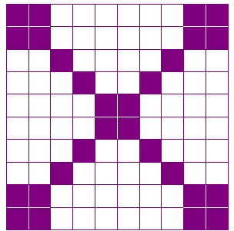**Constructing Task:** Decimal Designs

**TASK CONTENT:** Students represent decimals and find equivalent fractions between tenths and hundredths by making designs on a hunderedths grid.

**STANDARDS FOR MATHEMATICAL CONTENT**

**MGSE4.NF.5** Express a fraction with denominator 10 as an equivalent fraction with denominator 100, and use this technique to add two fractions with respective denominators 10 and 100. *For example, express 3/10 as 30/100, and add 3/10 + 4/100 = 34/1001.*

**MGSE4.NF.6** Use decimal notation for fractions with denominators 10 or 100. *For example, rewrite 0.62 as 62/100; describe a length as 0.62 meters; locate 0.62 on a number line diagram.*

**STANDARDS FOR MATHEMATICAL PRACTICE TO BE EMPHASIZED**

1. Make sense of problems and persevere in solving them.

2. Reason abstractly and quantitatively.

4. Model with mathematics.

5. Use appropriate tools strategically.

6. Attend to precision.

7. Look for and make use of structure.

**BACKGROUND KNOWLEDGE**

While students will have previous experiences expressing fractions with denominators of 10 or 100 as fractions, this will be their first experiences with using decimal notation and investigation into decimal fractions. Students’ understanding of decimal numbers develops in grades 4-5 as follows.

4th Grade – Focus on the relationship between decimal fractions and decimal numbers and investigate the relationship between decimal fractions and decimal numbers, limited to tenths and hundredths, order decimals to hundredths, add decimal fractions with denominators of 10 and 100 (respectively)

5th Grade – Compare decimals up to thousandths; use decimals in operations

**ESSENTIAL QUESTIONS**

* What is a decimal fraction and how can it be represented?

**GROUPING**

Individual/Partner Task

**NUMBER TALKS**

Continue utilizing the different strategies in number talks and revisiting them based on the needs of your students. Catherine Fosnot has developed problem “strings” which may be included in number talks to further develop mental math skills. See Mini-lessons for Operations with Fractions, Decimals, and Percents by Kara Louise Imm, Catherine Twomey Fosnot and Willem Uittenbogaard. (Mini-lessons for Operation with Fraction, Decimal, and Percent, 2007, Kara Louise Imm, Catherine Twomey Fosnot and Willem Uittenbogaard)

**MATERIALS**

* + “Decimal Designs: Part 1” student recording sheet
  + “Decimal Designs: Part 1, Table, Page 1” student recording sheet
  + “Decimal Designs: Part 1, Table, Page 2” student recording sheet
  + “Decimal Designs: Part 2” student recording sheet
  + “Decimal Designs: Part 2, Table” student recording sheet
  + Crayons or colored pencils

**TASK DESCRIPTION, DEVELOPMENT, AND DISCUSSION**

In this task, students will work with occurrences out of 10 and 100, translating them into decimal fractions and then decimals. Students will also explore and investigate the relationship between tenths and hundredths in a visual model and in decimal notation. Students will also begin to rename tenths using hundredths.

**Comments**

This lesson could be introduced by sharing shaded 10-frames and hundredths grids to represent a decimal fraction or decimal. For example, share with students some of the designs below.

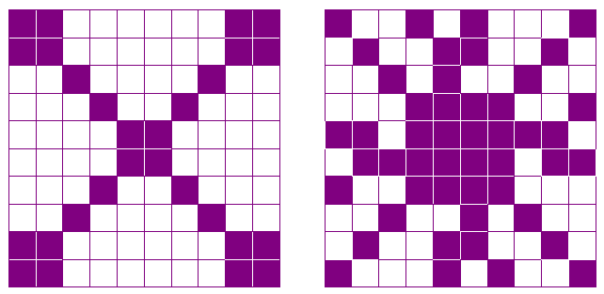

Discuss strategies students could use to count the number of shaded squares. Did they use multiplication? (e.g. Did they count the number of shaded squares in one part and multiply that number by the number of identical parts in the design? Did they count the number of unshaded squares and subtract from 100?) Once students have determined the decimal fraction and fraction for their favorite design ask students to share their thinking.

Finding the number of shaded squares is one way to give students an opportunity to think about pairs that make 100. As students make their decimal designs on the 10 x 10 grid, ask them if they have more shaded or unshaded parts. If they have more shaded, ask them to count the number of squares that are UNSHADED and subtract that number from 100 (i.e. think about what number added to the number of unshaded squares would equal 100). This is a great opportunity to review numbers that add up to 100 and for students to explain how they know how many squares are shaded.

During the introduction or mini-lesson, students may need specific instruction on writing and reading decimal fractions and decimals. For example, the tenths square below shows 5 out of 10 shaded boxes. As a fraction, that would be written as $\frac{5}{10}$, and read, “five tenths.” As a decimal, it would be written as 0.5, and read, “five tenths.”

|  |  |  |  |  |  |  |  |  |  |
| --- | --- | --- | --- | --- | --- | --- | --- | --- | --- |
|  |  |  |  |  |  |  |  |  |  |

|  |  |  |  |  |  |  |  |  |  |
| --- | --- | --- | --- | --- | --- | --- | --- | --- | --- |
|  |  |  |  |  |  |  |  |  |  |

or 0. 5

The 100 grid below shows 28 shaded squares out of 100. As a fraction, that would be $\frac{28}{100}$, and read, “twenty-eight hundredths.” As a decimal, it would be written as 0.28 and read, “twenty-eight hundredths.”

$\frac{28}{100}$ or 0. 28

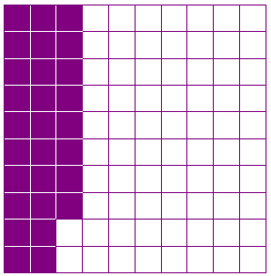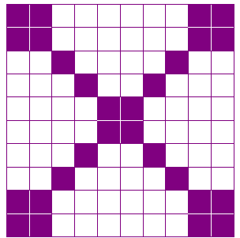

It is important for students to recognize that it doesn’t matter where the fractional parts are placed. They can be scattered (above left) or they can be connected (above right).

**Task Directions**

PART 1

First, students will follow the directions below from the “Decimal Designs: Part 1” student recording sheet.

*Create tenths and hundredths designs and label them accurately.*

Next, students will follow the directions below for the “Decimal Designs, Table” student recording sheet.

1. *Look at the example in the table below. Read the following questions and discuss how you would answer them with your partner.*

* *What do you notice about how “1 out of 10” is written in decimal fraction form?*
* *What do you notice about how “1 out of 10” is written in decimal form?*
* *How are they alike? How are they different?*

1. *Complete the table below. Fill in the last three rows of the table from the “Decimal Designs” student recording sheet.*
2. *Look at the example in the table below. Read the following questions and discuss how you would answer them with your partner.*

* *What do you notice about how “29 out of 100” is written in decimal fraction form?*
* *What do you notice about how “29 out of 100” is written in decimal form?*
* *How are they alike? How are they different?*

1. Complete the table below. Fill in the last three rows of the table from the “Decimal Designs” student recording sheet.

**PART 2**

First, students will follow the directions below from the “Decimal Designs: Part 2” student recording sheet.

*Create tenths and hundredths designs and label them accurately.*

Next, students will follow the directions below for the “Decimal Designs: Part 2, Table” student recording sheet.

1. Look at the example in the table below. Read the following questions and discuss how you would answer them with your partner.

* What do you notice about how “2 out of 10” is written in decimal form using tenths?
* What do you notice about how “20 out of 100” is written in decimal form using hundredths?

1. How are they alike? How are they different?
2. Complete the table below. Fill in the last four rows of the table from the “Decimal Designs: Part 2” student recording sheet.

**FORMATIVE ASSESSMENT QUESTIONS**

**Part 1:**

* How many squares are shaded out of 10 (or 100)?
* How many squares total are in the figure?
* What decimal fraction represents the shaded part? How do you know?
* What decimal represents the shaded part? How do you know?
* How would you read the decimal fraction (or decimal) you have written?

**Part 2:**

* How many squares are shaded out of 10 (or 100)?
* How many squares total are in the figure?
* What decimal fraction represents the shaded part? How do you know?
* What decimal represents the shaded part? How do you know?
* How would you read the decimal fraction (or decimal) you have written?
* How are the models of tenths related to the models of hundredths?
* What do the models of the tenths and hundredths have in common? What is different?
* How can a decimal written in tenths be written as a decimal expressed in hundredths?

**DIFFERENTIATION**

**Extension**

* Students can be encouraged to conduct a survey of 10 people or 100 people and report the results as decimal fractions.

**Intervention**

* Some students may need to continue to represent the decimal fractions and decimals using base 10 blocks. See “Base Ten Decimals” in this unit for more information about using base 10 blocks to represent decimal fractions and decimals.

**TECHNOLOGY**

* <http://www.ixl.com/math/grade-4/what-decimal-number-is-illustrated> This online game is a quiz activity for illustrating decimals as part of the base-ten system. It can be used as a mini-lesson for this task, additional practice or for remediation purposes.
* <http://www.harcourtschool.com/activity/con_math/g04c22a.html> This activity has students match fractions with denominators of 10 or 100 with their matching decimals. It can be used for additional practices or for remediation purposes.
* <http://www.prometheanplanet.com/en-us/Resources/Item/41735/reading-and-writing-decimals> Reading and Writing Decimals: This resource can be used with an ActivSlate or Smartboard to discuss reading and writing decimals in many different ways. It can be used as a mini-lesson for this task, additional practice or for remediation purposes.

Name___________________________________ Date_______________________

Decimal Designs: Part 1

Create tenths and hundredths designs and label them accurately.

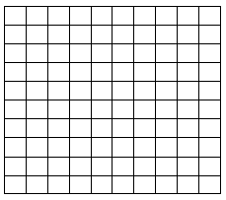

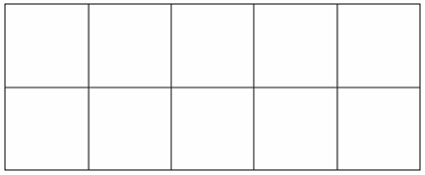

___ shaded boxes out of 10

Decimal Fraction _____

___shaded boxes out of 100

Decimal _____

Decimal Fraction _____



___ shaded boxes out of 10

Decimal Fraction _____ ___shaded boxes out of 100

Decimal _____ Decimal Fraction _____



___ shaded boxes out of 10

Decimal Fraction _____

___shaded boxes out of 100

Decimal _____

Decimal Fraction _____

Decimal Designs: Part 1

Table

1. Look at the example in the table below. Read the following questions and discuss how you would answer them with your partner.

* What do you notice about how “1 out of 10” is written in decimal fraction form?
* What do you notice about how “1 out of 10” is written in decimal form?
* How are they alike? How are they different?

1. Complete the table below. Fill in the last three rows of the table from the “Decimals Designs: Part 1” student recording sheet.

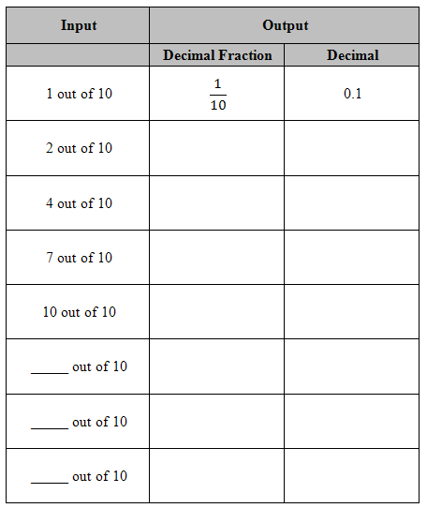

Decimal Designs: Part 1

Table, Page 2

1. Look at the example in the table below. Read the following questions and discuss how you would answer them with your partner.

* What do you notice about how “29 out of 100” is written in decimal fraction form?
* What do you notice about how “29 out of 100” is written in decimal form?
* How are they alike? How are they different?

1. Complete the table below. Fill in the last three rows of the table from the “Decimals Designs” student recording sheet.

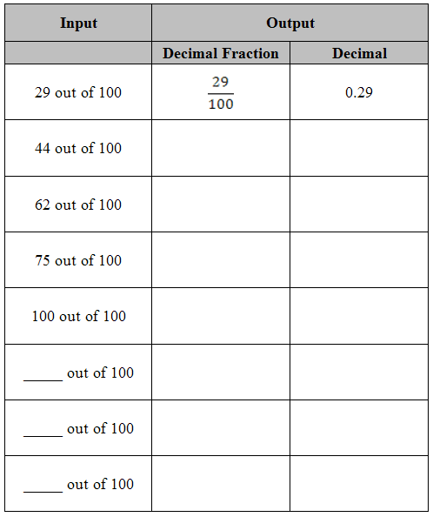

Name___________________________________ Date_______________________

Decimal Designs: Part 2

Create tenths and hundredths designs that represent the same amount and label them accurately.





___shaded boxes out of 100

Decimal Fraction _____

___ shaded boxes out of 10

Decimal Fraction _____

Decimal _____

___shaded boxes out of 100

Decimal Fraction _____

___ shaded boxes out of 10

Decimal Fraction _____

Decimal _____

___shaded boxes out of 100

Decimal Fraction _____

___ shaded boxes out of 10

Decimal Fraction _____

Decimal _____



Name _______________________________________ Date _________________

Decimal Designs: Part 2

Table

1. Look at the example in the table below. Read the following questions and discuss how you would answer them with your partner.

* What do you notice about how “2 out of 10” is written in decimal form using tenths?
* What do you notice about how “20 out of 100” is written in decimal form using hundredths?

1. How are they alike? How are they different?

Complete the table below. Fill in the last three rows of the table from the “Decimals Designs: Part 2” student recording sheet.

|  |  |  |
| --- | --- | --- |
| **Input** | **Output** | |
|  | **Decimal Fraction**  **(using tenths)** | **Decimal**  **(using tenths)** |
| 2 out of 10 | $$\frac{2}{10}$$ | 0.2 |
| 20 out of 100 | $$\frac{20}{100}$$ | 0.20 |
| 8 out of 10 |  |  |
| 80 out of 100 |  |  |
| __out of 10 |  |  |
| __ out of 100 |  |  |
| __out of 10 |  |  |

**Performance Task:**  Fraction Flags

**TASK CONTENT:** Students will represent decimals using decimal squares and decimal notation.

**STANDARDS FOR MATHEMATICAL CONTENT**

**MGSE4.NF.5** Express a fraction with denominator 10 as an equivalent fraction with denominator 100, and use this technique to add two fractions with respective denominators 10 and 100. *For example, express 3/10 as 30/100, and add 3/10 + 4/100 = 34/1001.*

**MGSE4.NF.6** Use decimal notation for fractions with denominators 10 or 100. *For example, rewrite 0.62 as 62/100; describe a length as 0.62 meters; locate 0.62 on a number line diagram.*

**STANDARDS FOR MATHEMATICAL PRACTICE TO BE EMPHASIZED**

1. Make sense of problems and persevere in solving them.

2. Reason abstractly and quantitatively.

4. Model with mathematics.

5. Use appropriate tools strategically.

6. Attend to precision.

7. Look for and make sure of structure.

**BACKGROUND KNOWLEDGE**

This task is expected to follow “Decimal Designs,” therefore students should be familiar with describing a shaded region of a whole as a decimal fraction and as a decimal number.

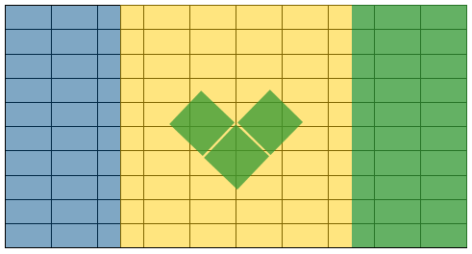

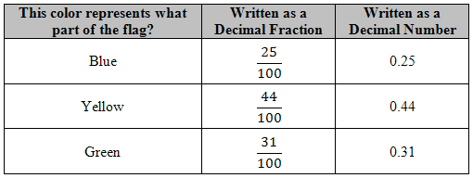

Students may need some assistance estimating the shaded region of a color. In the example above, the blue region was found by counting two columns of 10 and then half of a column of 10, or 5 more. Therefore $\frac{25}{100}$ or 0.25 can be used to represent the blue shaded region. The yellow region was found by counting four columns of 10 and two columns of half of 10 for a total of 50 blocks, but blocks that the three green squares cover is approximately two blocks per green square for a total of 6 blocks. This needs to be subtracted from the 50 blocks leaving 44 yellow blocks. The yellow region can be represented by $\frac{44}{100}$ or 0.44 of the flag. Finally the rightmost green region is the same as the blue region, but the 6 green blocks needs to be added for the three green squares in the middle. This makes the green section $\frac{31}{100}$ or 0.31 of the flag.

**ESSENTIAL QUESTIONS**

* What is a decimal fraction and how can it be represented?
* When is it appropriate to use decimal fractions?
* How are decimal numbers and decimal fractions related?

**MATERIALS**

* “Flag Fractions, Flags From Around the World” student recording sheet
* “Flag Fractions, Create-a-Flag” student recording sheet
* crayons, colored pencils, or markers
* examples of flags (optional)

**GROUPING**

Individual/Partner Task

**NUMBER TALKS**

Continue utilizing the different strategies in number talks and revisiting them based on the needs of your students. Catherine Fosnot has developed problem “strings” which may be included in number talks to further develop mental math skills. See Mini-lessons for Operations with Fractions, Decimals, and Percents by Kara Louise Imm, Catherine Twomey Fosnot and Willem Uittenbogaard. (Mini-lessons for Operation with Fraction, Decimal, and Percent, 2007, Kara Louise Imm, Catherine Twomey Fosnot and Willem Uittenbogaard)

**TASK DESCRIPTION, DEVELOPMENT, AND DISCUSSION**

In this task, students will work to determine the decimal fraction and decimal number represented by each color of a flag. Then students will create their own flag and identify the decimal fraction and decimal number represented by each color of a flag.

**Comments**

This task can be introduced by asking students to write the decimal fraction and decimal number that represents the shaded area of one or more of the decimal patterns students created during the “Decimal Patterns” task.

Allow students to complete the first student sheet, “Flag Fractions, Flags From Around the World” and discuss the results before asking students to create their own flag designs. Students may need assistance estimating the number of blocks to count for each color. See the example in the “Background Knowledge” section below.

Students should be encouraged to share their work by presenting or posting the flags they created.

**Task Directions**

Students will follow the directions below from the “Flag Fractions, Flags From Around the World” student recording sheet.

Choose one of the flags below. Sketch the flag on the 10 x 10 grid below. When finished, determine the number of sections for each color. Record your answer as a fraction and a decimal. If one color does not completely fill a box, choose the color that fills most of the box. (You do not need to sketch a crest, i.e. Paraguay, Portugal, Rwanda, San Marino etc.)

Then students will follow the directions below from the “Flag Fractions, Create-a-Flag” student recording sheet.

You have the unique opportunity to create your own flag.

1. Decide a name for the country your flag will represent.
2. On the grid paper below, create a flag for the country using as many colors as desired.
3. Complete the chart below.
4. If one color does not completely fill a box, choose the color that fills most of the box.

**FORMATIVE ASSESSMENT QUESTIONS**

* How many blocks make up the flag? (100) How many blocks are shaded this color?
* How would you write that as a decimal fraction? How do you know?
* How would you write that as a decimal number? How do you know?
* How do you read this decimal fraction? Decimal number? How do you know?
* How are these numbers (decimal fraction, decimal number) alike? Different?
* How could you estimate the number of blocks that are filled with this color?
* Which students are able to recognize and represent colored regions of the flag using decimal fractions and decimal numbers?
* Which students are able to describe how decimal fractions and decimal numbers are alike and different? (Alike because they both represent the same sized region and they are both read the same. Different because they are written in two different forms.)

**DIFFERENTIATION**

**Extension**

* Explain what your flag color/design represents for your country.
* Ask students to find the value to represent two regions, i.e. how would you represent the combined blue and green regions of the flag?
* Asks students to compare two flags and their graphs. What similarities/differences can be found?

**Intervention**

* + When working on the “Flag Fractions, Flags From Around the World” student recording sheet, allow students to work on the same flag design with a partner or in a small group.

**TECHNOLOGY**

* <http://www.ixl.com/math/grade-4/what-decimal-number-is-illustrated> This online game is a quiz activity for illustrating decimals as part of the base-ten system. It can be used as a mini-lesson for this task, additional practice or for remediation purposes.
* <http://www.harcourtschool.com/activity/con_math/g04c22a.html> This activity has students match fractions with denominators of 10 or 100 with their matching decimals. It can be used for additional practices or for remediation purposes.
* <http://www.prometheanplanet.com/en-us/Resources/Item/41735/reading-and-writing-decimals> Reading and Writing Decimals: This resource can be used with an ActivSlate or Smartboard to discuss reading and writing decimals in many different ways. It can be used as a mini-lesson for this task, additional practice or for remediation purposes.

Flag Fractions

Flags From Around the World

Choose one of the flags below. Sketch the flag on the 10 x 10 grid below. When finished, determine the number of sections for each color. Record your answer as a fraction and a decimal. If one color does not completely fill a box, choose the color that fills most of the box. You do not need to sketch a crest, i.e. Paraguay, Portugal, Rwanda, San Marino etc.

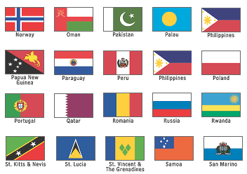

Flag images above are from <http://www.factmonster.com/ipka/A0772159.html>

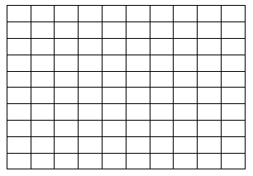

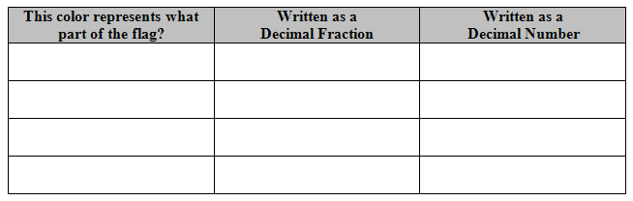

Flag Fractions

Create-a-Flag

You have the unique opportunity to create your own flag.

1. Decide a name for the country your flag will represent.
2. On the grid paper below, create a flag for the country using as many colors as desired.
3. Complete the chart below.
4. If one color does not completely fill a box, choose the color that fills most of the box.

Name of your country ___________________________

Flag for your country:

|  |  |  |  |  |  |  |  |  |  |
| --- | --- | --- | --- | --- | --- | --- | --- | --- | --- |
|  |  |  |  |  |  |  |  |  |  |
|  |  |  |  |  |  |  |  |  |  |
|  |  |  |  |  |  |  |  |  |  |
|  |  |  |  |  |  |  |  |  |  |
|  |  |  |  |  |  |  |  |  |  |
|  |  |  |  |  |  |  |  |  |  |
|  |  |  |  |  |  |  |  |  |  |
|  |  |  |  |  |  |  |  |  |  |
|  |  |  |  |  |  |  |  |  |  |
|  |  |  |  |  |  |  |  |  |  |

Fill in the information below for each color used in your flag. If you use more than 4 colors, continue on the back of this paper.



**Constructing Task:** Dismissal Duty Dilemma

**TASK CONTENT:** Students will use fractions and decimals interchangeably.

**STANDARDS FOR MATHEMATICAL CONTENT**

**MGSE4.NF.5** Express a fraction with denominator 10 as an equivalent fraction with denominator 100, and use this technique to add two fractions with respective denominators 10 and 100. *For example, express 3/10 as 30/100, and add 3/10 + 4/100 = 34/1001.*

**MGSE4.NF.6** Use decimal notation for fractions with denominators 10 or 100. *For example, rewrite 0.62 as 62/100; describe a length as 0.62 meters; locate 0.62 on a number line diagram.*

**MGSE4.NF.7** Compare two decimals to hundredths by reasoning about their size. Recognize that comparisons are valid only when the two decimals refer to the same whole. Record the results of the comparisons with the symbols >, =, or <, and justify the conclusions, e.g. by using a visual model.

**STANDARDS FOR MATHEMATICAL PRACTICE TO BE EMPHASIZED**

1. Make sense of problems and persevere in solving them.

2. Reason abstractly and quantitatively.

3. Construct viable arguments and critique the reasoning of others.

4. Model with mathematics.

5. Use appropriate tools strategically.

6. Attend to precision.

7. Look for and make use of structure.

**BACKGROUND KNOWLEDGE**

This task involves the students dividing a whole into tenths and hundredths, so students will need experiences with tenths and hundredths in both decimal fraction and decimal notation form. In addition, this task calls for students to change decimal fractions into decimals and one common fraction ( $\frac{4}{8}$ or $\frac{1}{2}$) into a common decimal (0.5). Students **do not** need to know how to convert fractions to decimals by a procedure, but should instead use reasoning to determine what decimal would be equivalent to $\frac{4}{8}$.

**ESSENTIAL QUESTIONS**

* How can decimals and decimal fractions be represented as a part of a whole?

**MATERIALS**

* “Dismissal Duty Recording Sheet” for each students
* Crayons/Markers

**GROUPING**

Individual or partner

**NUMBER TALKS**

Continue utilizing the different strategies in number talks and revisiting them based on the needs of your students. Catherine Fosnot has developed problem “strings” which may be included in number talks to further develop mental math skills. See Mini-lessons for Operations with Fractions, Decimals, and Percents by Kara Louise Imm, Catherine Twomey Fosnot and Willem Uittenbogaard. (Mini-lessons for Operation with Fraction, Decimal, and Percent, 2007, Kara Louise Imm, Catherine Twomey Fosnot and Willem Uittenbogaard)

**TASK DESCRIPTION, DEVELOPMENT AND DISCUSSION:**

**Comments**

This constructing task is intended to give students an opportunity to use multiple representations of decimals (decimal notations, decimal fractions, shaded grids, etc.) to represent decimals of different values. There may be multiple solutions to this task, as students could shade the decimals in different portions of the grid and still be correct. The guiding questions during the closing of this task should focus on which parts of the grids/recording sheets MUST be the same: the number of squares colored for each person must be consistent; all of the decimals must add up to 1 since all of the school’s hallways must be covered for dismissal, etc.

**Task Directions**

Ms. Collins has asked several teachers from Center Elementary School to take care of duty during bus dismissal. The teachers are really confused and asked Ms. Collins for a floor plan of the school so that they can understand where they are supposed to be during dismissal time.

Each teacher has been asked to take care of a certain section of the school. Below is a floor plan of the hallways at Center Elementary School. Color in the section of the school that each teacher could have been asked to take care of.

Mr. Medders: $\frac{2}{10}$ Mr. Ellis: 0.15 Ms. Little: $\frac{1}{10}$ Ms. Bremer: $\frac{4}{8}$ Mr. Fletcher $\frac{5}{100}$

Green Blue Red Yellow Purple

**Hallway Duty Floor Plan**

|  |  |  |  |  |  |  |  |  |  |  |  |  |  |  |  |  |  |
| --- | --- | --- | --- | --- | --- | --- | --- | --- | --- | --- | --- | --- | --- | --- | --- | --- | --- |
|  |  |  |  |  |  |  |  |  |  |  |  |  |  |  |  |  |  |
|  |  |  |  | Kindergarten and 4th Grade Hall |  |  |  |  |  |  |  |  | 2nd, 3rd, and 5th Grade Hall |  |  |  |  |
|  |  | 1st Grade Hall |  |  |  |  |  |  |  |  |  |  |  |  |  |  |  |
|  |  |  |  |  |  |  |  |  |  |  |  |  |  |  |  |  |  |
|  |  |  |  |  |  |  |  |  |  |  |  | | | |  |  |  |
|  |  |  |  |  |  |  |  |  |  |  |  |  |  |
|  |  |  |  |  |  |  |  |  |  |  |  |  |  |
|  |  |  |  |  |  |  |  |  |  |  |  |  |  |
|  |  |  |  |  |  |  |  |  |  |  |  |  |  |  |  |  |  |
|  |  |  |  |  |  |  |  |  |  |  |  |  |  |  |  |  |  |
|  |  |  |  |  |  |  |  |  |  |  |  |  |  |  |  |  |  |
|  |  |  |  |  |  |  |  |  |  |  |  |  |  |  |  |  |  |

**FORMATIVE ASSESSMENT QUESTIONS**

* How did you know how many squares to color in for each teacher?
* How did you find the number of squares to shade in for each teacher?
* How can you prove that all of the school has been covered by teachers using the decimals and fractions you were given?
* What was your strategy for coloring in each teacher’s sections?

**DIFFERENTIATION**

**Extension**

* Write each section as a decimal, as a fraction and simplify each fraction (if possible).

**Intervention**

* Give students all of the sections written as decimal fractions. Students may also benefit from a floor plan that looks more like a hundredths grid that can be cut apart and pasted onto the floor plan used in this activity.

**TECHNOLOGY**

* <http://www.ixl.com/math/grade-3/put-decimal-numbers-in-order> This online game is a quiz activity for putting two digit decimals in order. It can be used for additional practice or for remediation purposes.
* <http://www.prometheanplanet.com/en-us/Resources/Item/68401/the-great-decimal-race> The Great Decimal Race: This resource can be used with an ActivSlate or Smartboard. It can be used for a mini-lesson, additional practice or for remediation purposes.

Dismissal Duty Dilemma

Ms. Collins has asked several teachers from Center Elementary School to take care of duty during bus dismissal. The teachers are really confused and asked Ms. Collins for a floor plan of the school so that they can understand where they are supposed to be during dismissal time.

Each teacher has been asked to take care of a certain section of the school. Below is a floor plan of the hallways at Center Elementary School. Color in the section of the school that each teacher could have been asked to take care of.

Mr. Medders: $\frac{2}{10}$ Mr. Ellis: 0.15 Ms. Little: $\frac{1}{10}$ Ms. Bremer: $\frac{4}{8}$ Mr. Fletcher $\frac{5}{100}$

Green Blue Red Yellow Purple

**Hallway Duty Floor Plan**

|  |  |  |  |  |  |  |  |  |  |  |  |  |  |  |  |  |  |
| --- | --- | --- | --- | --- | --- | --- | --- | --- | --- | --- | --- | --- | --- | --- | --- | --- | --- |
|  |  |  |  |  |  |  |  |  |  |  |  |  |  |  |  |  |  |
|  |  |  |  |  |  |  |  |  |  |  |  |  | 2nd, 3rd, and 5th Grade Hall |  |  |  |  |
|  |  | 1st Grade Hall |  | Kindergarten and 4th Grade Hall |  |  |  |  |  |  |  |  |  |  |  |  |  |
|  |  |  |  |  |  |  |  |  |  |  |  |  |  |  |  |  |  |
|  |  |  |  |  |  |  |  |  |  |  |  | | | |  |  |  |
|  |  |  |  |  |  |  |  |  |  |  |  |  |  |
|  |  |  |  |  |  |  |  |  |  |  |  |  |  |
|  |  |  |  |  |  |  |  |  |  |  |  |  |  |
|  |  |  |  |  |  |  |  |  |  |  |  |  |  |  |  |  |  |
|  |  |  |  |  |  |  |  |  |  |  |  |  |  |  |  |  |  |
|  |  |  |  |  |  |  |  |  |  |  |  |  |  |  |  |  |  |
|  |  |  |  |  |  |  |  |  |  |  |  |  |  |  |  |  |  |

**Scaffolding Task:** Expanding Decimals with Money

**TASK CONTENT:** Students will build decimal fractions and decimals in expanded notation.

**STANDARDS FOR MATHEMATICAL CONTENT**

**MGSE4.NF.7** Compare two decimals to hundredths by reasoning about their size. Recognize that comparisons are valid only when the two decimals refer to the same whole. Record the results of the comparisons with the symbols >, =, or <, and justify the conclusions, e.g. by using a visual model.

**STANDARDS FOR MATHEMATICAL PRACTICE TO BE EMPHASIZED**

1. Make sense of problems and persevere in solving them.

2. Reason abstractly and quantitatively.

3. Construct viable arguments and critique the reasoning of others.

4. Model with mathematics.

5. Use appropriate tools strategically.

6. Attend to precision.

7. Look for and make sure of structure.

8. Look for and express regularity in repeated reasoning.

**BACKGROUND KNOWLEDGE**

Using our money system, where the dime represents tenths and the penny represents hundredths, students may more easily see decimals as parts of a whole, with the whole being one dollar. Decimal fractions such as $\frac{45}{100}$ can be easily modeled using dimes and pennies as 4 dimes and 5 pennies. This allows the students to easily see that $\frac{45}{100}$ as $\frac{40}{100}$ + $\frac{5}{100}$ as well as + .

|  |  |  |  |  |  |  |  |  |  |
| --- | --- | --- | --- | --- | --- | --- | --- | --- | --- |
|  |  |  |  |  |  |  |  |  |  |
|  |  |  |  |  |  |  |  |  |  |
|  |  |  |  |  |  |  |  |  |  |
|  |  |  |  |  |  |  |  |  |  |
|  |  |  |  |  |  |  |  |  |  |
|  |  |  |  |  |  |  |  |  |  |
|  |  |  |  |  |  |  |  |  |  |
|  |  |  |  |  |  |  |  |  |  |
|  |  |  |  |  |  |  |  |  |  |
|  |  |  |  |  |  |  |  |  |  |

|  |  |
| --- | --- |
| 4 Dimes and 5 Pennies | 40 Pennies and 5 Pennies |

**ESSENTIAL QUESTIONS**

* When can tenths and hundredths be used interchangeably?
* When you compare two decimals, how can you determine which one has the greater value?

**MATERIALS**

* 10 dimes and 10 pennies for each pair
* “Expanding Decimals with Money” Recording Sheet

**GROUPING**

Individual or partner grouping

**NUMBER TALKS**

Continue utilizing the different strategies in number talks and revisiting them based on the needs of your students. Catherine Fosnot has developed problem “strings” which may be included in number talks to further develop mental math skills. See Mini-lessons for Operations with Fractions, Decimals, and Percents by Kara Louise Imm, Catherine Twomey Fosnot and Willem Uittenbogaard. (Mini-lessons for Operation with Fraction, Decimal, and Percent, 2007, Kara Louise Imm, Catherine Twomey Fosnot and Willem Uittenbogaard)

**TASK DESCRIPTION, DEVELOPMENT AND DISCUSSION**

**Comments**

As students develop their decimal understanding, we need to continually emphasize the link between fraction concepts and our base-ten place value system. Revisiting the link between decimal fractions and decimals often and working with familiar contexts for decimal fractions will help build that bridge. Additionally, continuing to help students see decimals as a continuation of our base-ten whole number system will help them apply the rules of whole numbers within fraction situations. This lesson helps students see decimals and decimal fractions in expanded form, much like they have done expanded form using whole numbers. This ability to expand tenths and hundredths will help in later tasks as students add tenths and hundredths.

Students need to develop the ability to think flexibly about decimals in a variety of contexts. One of the contexts of decimals they are most familiar with is that of our money system.

**Task:**

Review with students that pennies represent hundredths of a dollar and dimes represent tenths of a dollar. Have students compare this model of decimals with base-ten models they have used previously.

* Which pieces of the base ten model match with the dimes? With the pennies? With the dollar?

Review expanded form notations using whole numbers. Model how to write a decimal fraction in expanded form based on students’ previous knowledge.

$\frac{45}{100}$ = $\frac{40}{100}$ + $\frac{5}{100}$ = $\frac{4}{10}$ + $\frac{5}{100}$

*Student Directions:*

*Pull a handful of coins from your bag of dimes and pennies. Fill in the table below with the decimal represented by your coins. Write your decimals in expanded notation using both the dime and penny combination and how you would represent it if you only used pennies. See the example in the table.*

|  |  |  |
| --- | --- | --- |
| Decimal | Decimal Made with Pennies (with Expanded Notation) | Decimal Made with Pennies and Dimes  (with Expanded Notation) |
| 0.36 | 30 pennies + 6 pennies $\frac{30}{100}$ + $\frac{6}{100}$ | 3 dimes + 6 pennies $\frac{3}{10}$ + $\frac{6}{100}$ |
|  |  |  |
|  |  |  |

**FORMATIVE ASSESSMENT QUESTIONS**

* How do the dimes represent decimal fractions? The pennies?
* How does a money model help you represent tenths and hundredths?
* What strategies did you use to add tenths and hundredths?
* What is the connection between the money models and the base ten models?
* What patterns occur with decimal fractions in this activity?

**DIFFERENTIATION**

**Extension**

* Provide students all types of coins and/or bills in the bag of money and have them complete the same activity having to change all coins into “decimal fraction” friendly coins and justify the exchanges.

**Intervention**

* Have students create the money amount using base ten models and place the coins on top of the base-ten blocks they match with in order to write the decimals. Have students write the value of each place (tenths and hundredths) directly under the model on place value mats.

**TECHNOLOGY**

* <http://www.ixl.com/math/grade-3/put-decimal-numbers-in-order> This online game is a quiz activity for putting two digit decimals in order. It can be used for additional practice or for remediation purposes.
* <http://www.prometheanplanet.com/en-us/Resources/Item/68401/the-great-decimal-race> The Great Decimal Race: This resource can be used with an ActivSlate or Smartboard. It can be used for a mini-lesson, additional practice or for remediation purposes.

Expanding Decimals with Money

*Pull a handful of coins from your bag of dimes and pennies. Fill in the table below with the decimal represented by your coins. Write your decimals in expanded notation using both the dime and penny combination and how you would represent it if you only used pennies. See the example in the table.*

|  |  |  |
| --- | --- | --- |
| Decimal | Decimal Made with Pennies (with Expanded Notation) | Decimal Made with Pennies and Dimes  (with Expanded Notation) |
| 0.36 | 30 pennies + 6 pennies $\frac{30}{100}$ + $\frac{6}{100}$ | 3 dimes + 6 pennies $\frac{3}{10}$ + $\frac{6}{100}$ |
|  |  |  |
|  |  |  |
|  |  |  |
|  |  |  |
|  |  |  |
|  |  |  |
|  |  |  |
|  |  |  |
|  |  |  |

**Scaffolding Task:** Double Number Line Decimals

**TASK CONTENT:** Students order tenths and hundredths on a double number line.

**STANDARDS FOR MATHEMATICAL CONTENT**

**MGSE4.NF.7** Compare two decimals to hundredths by reasoning about their size. Recognize that comparisons are valid only when the two decimals refer to the same whole. Record the results of the comparisons with the symbols >, =, or <, and justify the conclusions, e.g. by using a visual model.

**STANDARDS FOR MATHEMATICAL PRACTICE TO BE EMPHASIZED**

1. Make sense of problems and persevere in solving them.

2. Reason abstractly and quantitatively.

4. Model with mathematics.

5. Use appropriate tools strategically.

6. Attend to precision.

7. Look for and make use of structure.

**BACKGROUND KNOWLEDGE**

A double number line is a visual model that can be used in a variety of ways. In this task, students will create a double number line that can be used to compare tenths and hundredths. The top line will show tenths while the bottom line shows hundredths. Students can compare decimals with tenths and hundredths using the double number line as they are still gaining the foundation of being able to move easily between tenths and hundredths. Students have had experiences working with a number line during the task, Decimal Fraction Number Line, found at the beginning of this unit. You may have to model for them how to create a Double Number Line if this is their first experience using one.

The discussion of the strategies that students use to place the decimals on the number lines is the most important part of this lesson. As students work, rotate through and ask them to explain their thinking and justify their thinking using the number line and the visual models.

**Task:**

Create a decimal square that shows each of the decimals on the decimal cards. Place the decimal cards with the modeled decimal square on a double number line, showing tenths across the top and hundredths along the bottom. Be prepared to justify and explain how you ordered the decimals.

**FORMATIVE ASSESSMENT QUESTIONS**

* How did you know where to place the decimals on the number lines?
* When comparing two decimals, how do you know which is the greater decimal?
* Explain, using the decimal squares you created, how you know one decimal is greater than another.
* What patterns did you notice in the models or in the decimals as you placed them on the number line?
* What do you notice about the relationship between the tenths and hundredths?

**DIFFERENTIATION**

**Extension**

* For students who are ready to explore into the thousandths, have them add a third line and make a triple number line, placing additional decimals that go to the thousandths place on that number line.

**Intervention**

* Have students place just the decimal squares they create in line according to size, mixing tenths and hundredths. Have them use this to create a number line and then match the decimals with the decimal squares. (Having them vertically line up the pictures may help them to see which squares have more hundredths shaded in.)

**TECHNOLOGY**

* <http://www.ixl.com/math/grade-3/put-decimal-numbers-in-order> This online game is a quiz activity for putting two digit decimals in order. It can be used for additional practice or for remediation purposes.
* <http://www.prometheanplanet.com/en-us/Resources/Item/68401/the-great-decimal-race> The Great Decimal Race: This resource can be used with an ActivSlate or Smartboard. It can be used for a mini-lesson, additional practice or for remediation purposes.

Double Number Line Decimal Cards

|  |  |  |  |  |
| --- | --- | --- | --- | --- |
| 0.1 | 0.7 | 0.3 | 0.5 | 0.6 |
| 0.8 | 0.2 | 1.0 | 0.9 | 0.4 |
| 0.0 | 0.0 | 1.0 | 0.23 | 0.56 |
| 0.45 | 0.46 | 0.99 | 0.60 | 0.34 |
| 0.29 | 0.40 | 0.75 | 0.50 | 0.11 |
| 0.10 | 0.86 | 0.89 | 0.79 | 0.80 |

**3 ACT TASK:** Money Exchange

**TASK CONTENT:** Students will represent and compare decimals. Approximate time, 1 class period.

**STANDARDS FOR MATHEMATICAL CONTENT**

**MGSE4.NF.7** Compare two decimals to hundredths by reasoning about their size. Recognize that comparisons are valid only when the two decimals refer to the same whole. Record the results of the comparisons with the symbols >, =, or <, and justify the conclusions, e.g. by using a visual model.

**MGSE4.MD.2** Use the four operations to solve word problems involving distances, intervals of time, liquid volumes, masses of objects, and money, including problems involving simple fractions or decimals, and problems that require expressing measurements given in a larger unit in terms of a smaller unit. Represent measurement quantities using diagrams such as number line diagrams that feature a measurement scale.

**STANDARDS FOR MATHEMATICAL PRACTICE**

1. Make sense of problems and persevere in solving them.

2. Reason abstractly and quantitatively.

4. Model with mathematics.

5. Use appropriate tools strategically.

6. Attend to precision.

7. Look for and make use of structure.

**BACKGROUND KNOWLEDGE**

Often when counting or showing decimals on a number line, it is common for a student to say “seven tenths, eight tenths, nine tents, ten tenths, eleven tenths..” while writing “0.7, 0.8, 0.9, 0.10, 0.11.” This common misconception can be avoided by showing students a model of what correct decimal notation looks like and pairing it with a visual model.

This task follows the 3-Act Math Task format originally developed by Dan Meyer. More information on this type of task may be found at <http://blog.mrmeyer.com/category/3acts/>. A Three-Act Task is a whole-group mathematics task consisting of 3 distinct parts: an engaging and perplexing Act One, an information and solution seeking Act Two, and a solution discussion and solution revealing Act Three. More information along with guidelines for 3-Act Tasks may be found in the ***Guide to Three-Act Tasks*** on georgiastandards.org and the K-5 CCGPS Mathematics Wiki.

**ESSENTIAL QUESTIONS**

* When you compare two decimals, how can you determine which one has the greater value?

**MATERIALS**

* Money Exchange Student Recording Sheet
* Act 1 image
* Base ten blocks (where needed)

**GROUPING**

Individual/Partner Task

**TASK DESCRIPTION, DEVELOPMENT AND DISCUSSION**

**Comments**

Students need the opportunity to work with manipulatives on their own or with a partner in order to develop the understanding of comparing decimals. From the manipulatives, students will be able to move to pictorial representations of the display, then more abstract representations (such as sketches), and finally to abstract representation of decimals using numbers. It is important to remember that this progression begins with concrete representations using manipulatives.

**Task Directions**

**Act I – Whole Group** - Pose the conflict and introduce students to the scenario by showing the Act I picture.

1. Students are shown the Exchange Rates graphic.

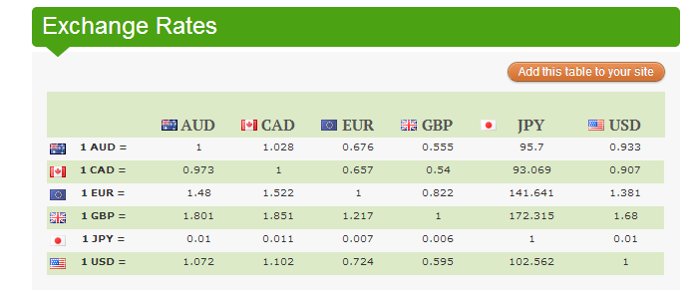

1. Pass out the 3 Act recording sheet.
2. Ask students what they wonder about and what questions they have about what they saw. Students should share with each other first before sharing aloud and then record these questions on the recording sheet (think-pair-share). The teacher may need to guide students so that the questions generated are math-related.

**Anticipated questions:**

What are exchange rates?

Is the American dollar worth the same amount in the other countries?

Is the American dollar worth more in the other countries?

If I travel to Japan, how much will my money be worth?

In which of the countries would I have the most money?

1. As the facilitator, you can select which question you would like every student to answer, have students vote on which question the class will answer or allow the students to pick which question they would like to answer. Once the question is selected ask students to estimate answers to their questions (think-pair-share). Students will write their best estimate, then write two more estimates – one that is too low and one that is too high so that they establish a range in which the solution should occur. Instruct students to record their estimates on a number line.

**Act II** – **Student Exploration** - Provide additional information as students work toward solutions to their questions.

1. Ask students to determine what additional information they will need to solve their questions. The teacher provides that information only when students ask for it.:

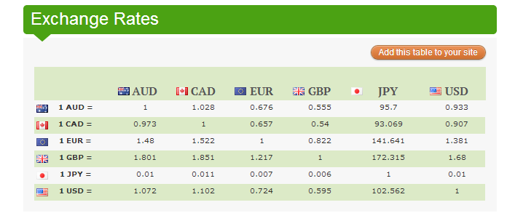

“What is Currency? What is Foreign Exchange Rate?”

<http://www.businessnewsforkids.com/volume.php?id=volume14.html>

1. Ask students to work to answer the questions they created in Act I. The teacher provides guidance as needed during this phase by asking questions such as:
   * Can you explain what you’ve done so far?
   * What strategies are you using?
   * What assumptions are you making?
   * What tools or models may help you?
   * Why is that true?
   * Does that make sense?

**Act III – Whole Group** - Share student solutions and strategies as well as Act III solution.

1. Ask students to present their solutions and strategies.
2. Compare solutions.
3. Lead discussion to compare these, asking questions such as:
   * How reasonable was your estimate?
   * Which strategy was most efficient?
   * Can you think of another method that might have worked?
   * What might you do differently next time?

**Comments**

Act IV is an extension question or situation of the above problem. An Act IV can be implemented with students who demonstrate understanding of the concepts covered in acts II and III. The following questions and/or situations can be used as an Act IV:

* How much would $2 American dollars be worth in each of the other countries?

**FORMATIVE ASSESSMENT QUESTIONS**

* What models did you create?
* What organizational strategies did you use?

**DIFFERENTIATION**

**Extension**

* Use the interactive Travel Brochures to help you consider which country to visit. <http://www.travimp.com/brochures/> Determine what would be the best place to visit based on the value of the American dollar.

**Intervention**

* Have students compare the value of the American dollar in three of the countries. Encourage them to record numbers on a number line.

**TECHNOLOGY CONNECTIONS**

* <http://www.ixl.com/math/grade-3/put-decimal-numbers-in-order> This online game is a quiz activity for putting two digit decimals in order. It can be used for additional practice or for remediation purposes.
* <http://www.prometheanplanet.com/en-us/Resources/Item/68401/the-great-decimal-race> The Great Decimal Race: This resource can be used with an ActivSlate or Smartboard. It can be used for a mini-lesson, additional practice or for remediation purposes.



Name: ________________________

*Adapted from Andrew Stadel*

Task Title:

**ACT 1**

|  |
| --- |
| What questions come to your mind? |
| Main question: |
| On an empty number line, record an estimate that is too low, just right and an estimate that is too high. Explain your estimates.  ________________________________________________________________________________________________________________________________________________________________________________________________________________________________________________________________________________________________________________________________________________________________________ |

**ACT 2**

|  |
| --- |
| What information would you like to know or need to solve the MAIN question? |
|  |

Use this area for your work, tables, calculations, sketches, and final solution.

**ACT 3**

|  |
| --- |
| What was the result? |
|  |

**ACT 4 (use this space when necessary)**

**Practice Task:** Trash Can Basketball

**TASK CONTENT:** Students willrepresent and compare decimals as they collect data.

**STANDARDS FOR MATHEMATICAL CONTENT**

**MGSE4.NF.7** Compare two decimals to hundredths by reasoning about their size. Recognize that comparisons are valid only when the two decimals refer to the same whole. Record the results of the comparisons with the symbols >, =, or <, and justify the conclusions, e.g. by using a visual model.

**STANDARDS FOR MATHEMATICAL PRACTICE TO BE EMPHASIZED**

1. Make sense of problems and persevere in solving them.

2. Reason abstractly and quantitatively.

4. Model with mathematics.

5. Use appropriate tools strategically.

6. Attend to precision.

7. Look for and make use of structure.

**BACKGROUND KNOWLEDGE**

Before the activity, the class should have several lessons to demonstrate and practice understanding and representing tenths. One tenth of a final score is determined by one throw if your final score (the whole) is determined by ten throws.

**ESSENTIAL QUESTIONS**

* How are decimals and fractions related?
* Why is the number 10 important in our number system?
* How can I write a decimal to represent a part of a group?
* When we compare two decimals, how do we know which has a greater value?

**MATERIALS**

* “Trash Can Basketball” student recording sheet
* Each group will need 10 pieces of “trash” (paper balls).
* Box, tub, or trash can for a container
* Crayons or markers and construction paper for making a poster

**GROUPING**

Partner/Small Group Activity

**NUMBER TALKS**

Continue utilizing the different strategies in number talks and revisiting them based on the needs of your students. Catherine Fosnot has developed problem “strings” which may be included in number talks to further develop mental math skills. See Mini-lessons for Operations with Fractions, Decimals, and Percents by Kara Louise Imm, Catherine Twomey Fosnot and Willem Uittenbogaard. (Mini-lessons for Operation with Fraction, Decimal, and Percent, 2007, Kara Louise Imm, Catherine Twomey Fosnot and Willem Uittenbogaard)

**TASK DESCRIPTION, DEVELOPMENT, AND DISCUSSION**

Students collect data by playing “Trash Can Basketball.” They use the data to write decimal fractions and equivalent decimal numbers.

**Comments**

The copy room is a good source of trash paper. Be sure the paper balls are tight. Loosely packed ones make it really difficult to throw accurately.

All solutions reached in this task should be specific to the data collected. All student work should show both their data and their partner’s data. Tallies should match decimal numbers assigned. Explanations should be clearly stated and specific.

Before beginning the throwing contest, as a class, decide on any rules regarding practice throws and how to conduct the experiment.

**Task Directions**

**Part 1**

Students will follow directions below from the “Trash Can Basketball: Part 1” student recording sheet.

This is your chance to demonstrate your basketball skills! You have been chosen to participate in a paper-ball throwing contest.

Directions:

1. Use the scrap paper to make 10 paper balls per group. (Wad the paper balls up tightly so they are easier to aim.)
2. Place a trash can (or other large container) 5 feet away.
3. Predict how many paper balls you will be able to get into the basket. Write your prediction in the chart below.
4. Take turns with your partner(s) throwing the ten paper balls into the trash can. Your partner will collect data using tally marks on the chart below to show how many of the 10 paper balls went into the trash can.
5. 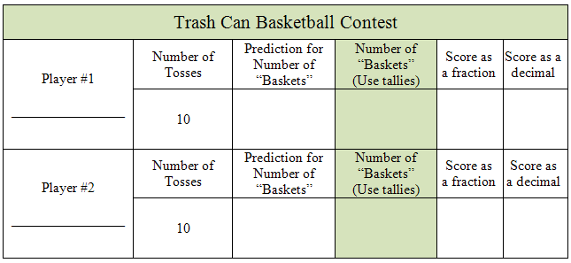Create a poster to display your group’s results. Your poster should include the following:
   1. Represent the number of baskets for each partner as a decimal fraction and express a comparison of the decimal fraction scores using a >, <, or = symbol.
   2. Represent the number of baskets for each partner as decimal numbers and express a comparison of decimal scores using a >, <, or = symbol.

Example:

Player #1 $\frac{6}{10}$ 0.6 of the baskets

Player # 2 0.7 of the baskets

0.6 < 0.7

* 1. Write to explain the results of the contest. Be prepared to share your poster and results with the class.

**Part 2**

Students will follow directions below from the “Trash Can Basketball: Part 2” student recording sheet.

This is your chance to demonstrate your basketball skills! You have been chosen to participate in a paper-ball throwing contest.

Directions:

1. Use the scrap paper to make 10 paper balls per group. (Wad the paper balls up tightly so they are easier to aim.)
2. Place a trash can (or other large container) 5 feet away.
3. Predict how many paper balls you will be able to get into the basket. Write your prediction in the chart below.
4. Take turns with your partner(s) throwing the ten paper balls into the trash can. Your partner will collect data using tally marks on the chart below to show how many of the 10 paper balls went into the trash can.
5. Combine your data with the data of 9 other people and record it below, for a total of 100 throws.
6. Create a poster to display your group’s results. Your poster should include the following:
   1. Represent the number of baskets for each partner as a decimal fraction and decimal out of 100 throws for the entire group.
   2. Represent the total number of baskets for the entire group as a decimal fraction and decimal out of 100 throws for the entire group.

Example:

Player #1 $\frac{5}{100}$ 0.05 of the baskets

Player #2 $\frac{7}{100}$ 0.07 of the baskets

TOTAL $\frac{12}{100}$ 0.12 of the baskets

* 1. Write to explain the results of the contest. Be prepared to share your poster and results with the class.
  2. Compare your group data with the data of other people in your class.

**FORMATIVE ASSESSMENT QUESTIONS**

* How did you determine your score? How many times did you throw the paper ball?
* How many times did you “make a basket”?
* How is your score written as a decimal fraction?
* How is your score written as a decimal?
* How do we compare two decimal fractions?
* How do we compare two decimals?
* How did you collect your data for Part 2?
* Why did the denominator of the fractions change for part 2?
* How are the decimals from Part 1 like the decimals from Part 2? How are they different?

**DIFFERENTIATION**

**Extension**

* Have students compare their group data of several people and compare the decimals for those groups.
* Have students plot the results of Part 1 or Part 2 on a line plot.

**Intervention**

* Have the chart pre-made on the poster for student use and/or allow student to write his/her results on a computer, print, and attach to the poster.

**TECHNOLOGY**

* <http://www.ixl.com/math/grade-3/put-decimal-numbers-in-order> This online game is a quiz activity for putting two digit decimals in order. It can be used for additional practice or for remediation purposes.
* <http://www.prometheanplanet.com/en-us/Resources/Item/68401/the-great-decimal-race> The Great Decimal Race: This resource can be used with an ActivSlate or Smartboard. It can be used for a mini-lesson, additional practice or for remediation purposes.

Name ________________________________________ Date ___________________________

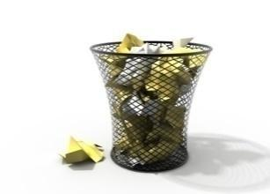

Trash Can Basketball: Part 1

This is your chance to demonstrate your basketball skills! You have been chosen to participate in a paper-ball throwing contest.

Directions:

1. Use the scrap paper to make 10 paper balls per group. (Wad the paper balls up tightly so they are easier to aim.)
2. Place a trash can (or other large container) 5 feet away.
3. Predict how many paper balls you will be able to get into the basket. Write your prediction in the chart below.
4. Take turns with your partner(s) throwing the ten paper balls into the trash can. Your partner will collect data using tally marks on the chart below to show how many of the 10 paper balls went into the trash can.

|  |  |  |  |  |  |
| --- | --- | --- | --- | --- | --- |
| Trash Can Basketball Contest | | | | | |
| Player #1 | Number of Tosses | Prediction for Number of “Baskets” | Number of “Baskets”  (Use tallies) | Score as a fraction | Score as a decimal |
|  | 10 |  |  |  |  |
| Player #2 | Number of Tosses | Prediction for Number of “Baskets” | Number of “Baskets”  (Use tallies) | Score as a fraction | Score as a decimal |
|  | 10 |  |  |  |  |

1. Create a poster to display your group’s results. Your poster should include the following:.
   1. Represent the number of baskets for each partner as a decimal fraction and express a comparison of the decimal fraction scores using a >, <, or = symbol.
   2. Represent the number of good throws for each partner as decimal numbers and express a comparison of decimal scores using a >, <, or = symbol.

Example:

Player #1 $\frac{6}{10}$ 0.6 of the baskets

Player # 2 0.7 of the baskets

0.6 < 0.7

* 1. Write to explain the results of the contest. Be prepared to share your poster and results with the class.

Name ________________________________________ Date ___________________________



Trash Can Basketball: Part 2

Now that you’ve compared your and your partner’s data, let’s see how we can represent the results of more people!

Directions:

1. Combine your data with the data of 9 other people and record it below, for a total of 100 throws.

|  |  |  |  |
| --- | --- | --- | --- |
| Player | Number of “Baskets” | Score as a fraction  (out of 100) | Score as a decimal (out of 100) |
|  |  |  |  |
|  |  |  |  |
|  |  |  |  |
|  |  |  |  |
|  |  |  |  |
|  |  |  |  |
|  |  |  |  |
|  |  |  |  |
|  |  |  |  |
|  |  |  |  |
| TOTAL |  |  |  |

1. Create a poster to display your results. Your poster should include the following:

a. Represent the number of baskets for each partner as a decimal fraction and decimal out of 100 throws for the entire group.

b. Represent the total number of baskets for the entire group as a decimal fraction and decimal out of 100 throws for the entire group.

c. Write to explain the results of the contest. Be prepared to share your poster and results with the class.

d. Compare your group data with the data of other people in your class.

**Scaffolding Task:** Calculator Decimal Counting

*Adapted from Teaching Student Centered Mathematics: Grades 3-5 by John van de Walle and Louann Lovin, 2006*

**TASK CONTENT:** Students observe and use patterns when adding decimals.

**STANDARDS FOR MATHEMATICAL CONTENT**

**MGSE4.NF.7** Compare two decimals to hundredths by reasoning about their size. Recognize that comparisons are valid only when the two decimals refer to the same whole. Record the results of the comparisons with the symbols >, =, or <, and justify the conclusions, e.g. by using a visual model.

**STANDARDS FOR MATHEMATICAL PRACTICE TO BE EMPHASIZED**

1. Make sense of problems and persevere in solving them.

2. Reason abstractly and quantitatively.

4. Model with mathematics.

5. Use appropriate tools strategically.

6. Attend to precision.

7. Look for and make use of structure.

**BACKGROUND KNOWLEDGE**

Often when counting or showing decimals on a number line, it is common for a student to say “seven tenths, eight tenths, nine tenths, ten tenths, eleven tenths..” while writing “0.7, 0.8, 0.9, 0.10, 0.11.” This common misconception can be avoided by showing students a model of what correct decimal notation looks like and pairing it with a visual model.

Before the lesson, make sure students know how to make the calculator “count” by pressing + 1 = = = …

**ESSENTIAL QUESTIONS**

* When adding decimals, how does decimal notation show what I expect? How is it different?

**MATERIALS**

* Calculators
* Pre-made decimal squares or ones students have made

**GROUPING**

Individual or partner

**NUMBER TALKS**

Continue utilizing the different strategies in number talks and revisiting them based on the needs of your students. Catherine Fosnot has developed problem “strings” which may be included in number talks to further develop mental math skills. See Mini-lessons for Operations with Fractions, Decimals, and Percents by Kara Louise Imm, Catherine Twomey Fosnot and Willem Uittenbogaard. (Mini-lessons for Operation with Fraction, Decimal, and Percent, 2007, Kara Louise Imm, Catherine Twomey Fosnot and Willem Uittenbogaard)

**TASK DESCRIPTION, DEVELOPMENT AND DISCUSSION**

**Comments**

One common misconception that students have when working with decimals is the next number that occurs when moving up from nine tenths to ten tenths or 99 hundredths to 100 hundredths. This calculator activity helps to bring students' attention to what happens when the tenths are joined to become 1 or when hundredths are combined to make tenths. The purpose of this scaffolding activity is to develop decimal number sense as students explore addition of decimals with a calculator.

**TASK:**

Students will follow the directions below from the “Calculator Decimal Counting” recording sheet.

* Use the calculator to add 0.1 until you reach 0.9. Collect base ten blocks as you do this, adding 0.1 to your pile as you add 0.1 in the calculator.
  + What do you predict the calculator will show next?______
  + What does the calculator show? ____
  + Is this surprising? Why or why not? __________________
* Continue to count by 0.1 on your calculator as you collect base ten blocks until you reach 3. Keep track of the numbers on the display below.

0.1, 0.2, 0.3,________________________________________________________

* + What patterns to do you see?
  + How many presses of the = key did it take to get to the next whole number?
* Now use the calculator to count by 0.01. Collect base ten blocks as you do this, adding 0.01 to your pile as you add 0.01 in the calculator.
  + How many presses did it take to reach 0.1?____________
  + How many presses did it take to reach 0.5?____________
  + How many presses did it take to reach 1?_____________
* Keep track of the numbers on the calculator’s display as you count from 0.5 to 0.7 by 0.01.
  + What patterns did you notice?

**FORMATIVE ASSESSMENT QUESTIONS**

* What happens to the way the decimal is notated as you move from 9 hundredths to the next hundredth?
* What happens to the way a decimal is notated as you move from 9 tenths to the next tenth?
* When counting by tenths or hundredths on a list or a number line, what do you think is important to remember?

**DIFFERENTIATION**

**Extension**

* Have students explore adding by 0.001. Student should predict how many times they must add 0.001 to get to the next 0.01, 0.1, and whole number.

**Intervention**

* Give students a blank hundreds chart and have them complete it, making it a 1 chart where each square represents 0.01. Have them fill in the chart as they add on the calculator and compare this chart with a regular hundreds chart. What patterns are the same? What patterns are different?

**TECHNOLOGY**

* <http://www.ixl.com/math/grade-3/put-decimal-numbers-in-order> This online game is a quiz activity for putting two digit decimals in order. It can be used for additional practice or for remediation purposes.
* <http://www.prometheanplanet.com/en-us/Resources/Item/68401/the-great-decimal-race> The Great Decimal Race: This resource can be used with an ActivSlate or Smartboard. It can be used for a mini-lesson, additional practice or for remediation purposes.

Name ___________________________________________ Date ________________________

Calculator Decimal Counting

Use the calculator to add 0.1 until you reach 0.9. Collect base ten blocks as you do this, adding 0.1 to your pile as you add 0.1 in the calculator.

* + What do you predict the calculator will show next?
  + What does the calculator show?
  + Is this surprising? Why or why not?

Continue to count by 0.1 on your calculator as you collect base ten blocks until you reach 3.

Keep track of the numbers on the display by writing them on this paper.

* + How many presses of the = key did it take to get to the next whole number?
  + What patterns to do you see?

Now use the calculator to count by 0.01. Collect base ten blocks as you do this, adding 0.01 to your pile as you add 0.01 in the calculator.

* + How many presses did it take to reach 0.1?
  + How many presses did it take to reach 0.5?
  + How many presses did it take to reach 1?

Keep track of the numbers that display as you count from 0.5 to 0.7 by 0.01 by writing them on this paper.

* + What patterns did you notice?

**Scaffolding Task:** Meters of Beads

**TASK CONTENT:** Studentsexplore models of decimals and compare decimals

**STANDARDS FOR MATHEMATICAL CONTENT**

**MGSE4.NF.5** Express a fraction with denominator 10 as an equivalent fraction with denominator 100, and use this technique to add two fractions with respective denominators 10 and 100. *For example, express 3/10 as 30/100, and add 3/10 + 4/100 = 34/1001.*

**MGSE4.NF.6** Use decimal notation for fractions with denominators 10 or 100. *For example, rewrite 0.62 as 62/100; describe a length as 0.62 meters; locate 0.62 on a number line diagram.*

**MGSE4.NF.7** Compare two decimals to hundredths by reasoning about their size. Recognize that comparisons are valid only when the two decimals refer to the same whole. Record the results of the comparisons with the symbols >, =, or <, and justify the conclusions, e.g. by using a visual model.

**MGSE4.MD.2** Use the four operations to solve word problems involving distances, intervals of time, liquid volumes, masses of objects, and money, including problems involving simple fractions or decimals, and problems that require expressing measurements given in a larger unit in terms of a smaller unit. Represent measurement quantities using diagrams such as number line diagrams that feature a measurement scale.

**STANDARDS FOR MATHEMATICAL PRACTICE TO BE EMPHASIZED**

1. Make sense of problems and persevere in solving them.

2. Reason abstractly and quantitatively.

4. Model with mathematics.

5. Use appropriate tools strategically.

6. Attend to precision.

7. Look for and make sure of structure.

**BACKGROUND KNOWLEDGE**

The meter stick is a length model of decimals that is a familiar context for the use of decimals. This lesson provides students a visual model for seeing the centimeters within a meter as decimals of a whole meter, as well as seeing each decimeter as a tenth of the meter stick.

**ESSENTIAL QUESTIONS**

* What models can be used to represent decimals?
* What are the benefits and drawbacks of each of these models?

**MATERIALS**

* 100 beads of 2 different colors per partner pair (or 100 paper cm squares of different colors to be taped together)
* Approximately 1.5 meters of yarn per partner pair
* Meter sticks
* Adding tape or a strip of paper approximately a meter long

**GROUPING**

Individual or partner

**NUMBER TALKS**

Continue utilizing the different strategies in number talks and revisiting them based on the needs of your students. Catherine Fosnot has developed problem “strings” which may be included in number talks to further develop mental math skills. See Mini-lessons for Operations with Fractions, Decimals, and Percents by Kara Louise Imm, Catherine Twomey Fosnot and Willem Uittenbogaard. (Mini-lessons for Operation with Fraction, Decimal, and Percent, 2007, Kara Louise Imm, Catherine Twomey Fosnot and Willem Uittenbogaard)

**TASK DESCRIPTION, DEVELOPMENT AND DISCUSSION**

**Comments**

Prepare a sandwich bag of 100 beads for each group, 50 of two different colors. Try to find beads that are slightly less than 1 cm in diameter so that 100 beads fit well along the edge of a meter stick. If beads are larger than 1 cm, students will have to offset each bead slightly to fit 100 pieces along the meter. As this may cause confusion, it is best to find beads that are an appropriate size. (If beads are not available, unit squares copied on different colored pieces of papers could be used and taped together rather than strung together.)

Also prepare for each group a paper strip cut slightly longer than 100 cm. Provide one mark on the paper strip 2–3 cm from one end for students to label as 0. Adding machine tape works well for the strips.

**Task:**

Show students a meter stick and review the number of centimeters in a meter stick. Discuss how each centimeter can be expressed as a decimal of the whole meter stick. (1 cm = 0.01 m)

Organize students into groups of 2 or 3. Don't tell them how many beads are in each bag. Let them estimate and discuss individual estimates.

Next, have groups place their 100 beads randomly along a meter stick, one bead per hundredth. Ask, "Can you easily tell what decimal of the beads are red? green? Why or why not? What would help you to determine the decimals?"

Guide students to understand that grouping the bead pieces by color along the meter stick does not change the decimal of each bead color, but it does provide a clearer visual representation of the decimal of each color.

For the moment, ask students to return their beads to the sandwich bag; the beads will be used again later in the lesson.

**Part 1: Linear Model - The Meter**

Have each group make a linear representation of their collection of 100 beads. First, they should label 0 on their strip, at the mark you made previously. Then, have students lay their paper along a meter stick, lining up the 0 on the paper strip with the 0 cm mark on the stick. Ideally, they should place a pencil mark at each centimeter from 0–100. However, the paper meters become too messy if every centimeter is labeled with a numeral. Introduce *decimeter* as you have students count and label by tenths from 0 – 100 cm. Discussion about a centimeter representing 1/100 of a meter and a decimeter representing 1/10 of a meter would happen at this time.

Next, ask students to make piles of their bead pieces by color. Ask students:

* How easily can you estimate the decimal that represents each color if the whole is the meter? [Not very; large groups need actual counting.]
* How can the meter stick help you? [It shows hundredths.]

Reinforce the connection between hundredths written as fractions and decimals. Have students count and record their bead data (colors/numbers) on the “Meters of Beads” activity sheet.

Finally, have students place the beads by color along their paper meter strip and color the paper according to the colors of their beads. Students can complete Questions 1–3 on the activity sheet.

Have students share their colored paper meters. Post the meters around the classroom. Emphasize that the meter is a linear model showing decimals. You can verify understanding by having students do a museum walk among paper meters and share the decimal values of colors verbally using the terms *hundredth*. Have one member of each group remain by his/her paper strip while other students visit and ask questions. Rotate the students from each group so everyone has a chance to present to classmates (and you can listen in).

**Part 2: The Area Model- Grid Paper**

Suggest to students that decimals can be shown on a grid. Ask students:

* How many squares should be in the grid? [100]
* Is the number of squares important? [yes]
* What shape should the grid be? [It can vary.]
* Does the grid shape matter? [no]
* Will the decimals stay the same? [yes]

Use the [Grids](http://illuminations.nctm.org/Lessons/MeterOfCandy/MeterOfCandy-AS-Grids.pdf) activity sheet, which has grids of 10×10, 4×25, and 5×20. All the grids use the same unit size. You may want to enlarge the activity sheet so students have room to place their beads on the grids prior to coloring. The members of the small groups can do the same grids or different ones. Depending on students' understanding, have them lay out their beads prior to coloring or just color according to their data sheet.

Have students think about and discuss the best ways to group the colors. Let them discuss and decide choices. Students should then color the grids according to the decimals of their bead colors. Once the grids are posted, students can discuss similarities and differences. If a student randomly colors individual squares, it will be apparent that counting is required to determine the decimals for each color. After the grid work, students can complete Questions 4–6 of the “Meters of Beads” sheet.

Review with students the grids they created, and compare the linear and area representations. Spend time discussing the different rectangular shapes of the area models.

**Part 3: The Region Model- Decimal Circles and Hundredths Disks**

Have students brainstorm other figures that could show decimals. Lead the discussion towards the idea of a decimal circle, which is a circular model that can show decimals.

To begin creating decimal circles, have students connect the ends of their linear meter to form a circle. Students match the 0 cm mark with the 100 cm mark and tape the circle closed. Have students lay their meter strip around the circumference of their poster-board circle. They should mark where each color begins and ends. Then, have students connect these marks to the center of the circle to create each piece of the circle. The pieces become area representations of the decimal of each color of bead. Students should color and then label each sector of the circle with decimals and fractions.

Show students the Hundredths Disk and compare these to their Decimal Circles. Have them discuss which would be more precise to show the decimals of the bead colors. (The hundredths disks because it would show exact values.) Have students create a Hundredths Disk that matches their decimal circles. Students should color and then label each section of the circle with decimals and fractions.

**Part 4: Putting It All Together**

To help students contemplate all three models (linear, area, and region), direct them to individually write one true mathematical statement about each model. This can be done in journals or on cardstock (for posting later). Have them review their statements with peers for clarification. Then, as a class, share their statements aloud. This is a great time to highlight statements that are similar even though they are about different types of models because this shows the interconnectedness of the representations. You can also challenge students to count how many unique statements are made throughout the sharing.

Have students write a series of statements comparing the decimals of each color within their bag of beads. This can be done in journals or on cardstock (for posting later). Have them review their statements with peers for clarification. Then, as a class, share their statements aloud. Compare the decimals of each color in different bags and have the students make statements comparing the decimals of each color around the room. For instance, students could compare the decimal of red beads in each bag. Who had the greatest decimal of reds? How can we be sure? Which model shows this clearly?

**FORMATIVE ASSESSMENT QUESTIONS**

**Part 1:**

* What strategies did you use to count your beads?
* How did your strategy help you determine the decimals representation of each color of beads?
* How did you know you had accounted for all of the beads?
* What were the benefits of each model you used?
* What were the drawbacks of each model?
* Which model did you prefer and why?
* Which model might be easiest to use when comparing decimals?
* Which would be easier for combining decimals (like adding together 2 colors)?
* Which model showed the link between tenths and hundredths best? Why do you think that?

**Part 2:**

* What strategies did you use to complete your grids?
* How did you decide the color in your grids? Why did you choose this?
* How did you count the colors of the squares? What strategies did you use?
* What strategy did you use to determine the decimal representation of each color on this grid model?
* Was this model or the linear model easier for you to see the decimals on?

**Part 3:**

* How did the linear model help you create a decimal circle?
* How can you be sure your model accounts for all the beads?
* How were your decimal circles and hundredths disks the same? Different?
* Which of the two circle representations were easier to “see” the decimals on? Why was that one easier?

**Part 4:**

* What were the benefits of each model you used?
* What were the drawbacks of each model?
* Which model did you prefer and why?
* Which model might be easiest to use when comparing decimals?
* Which would be easier for combining decimals (like adding together 2 colors)?
* Which model showed the link between tenths and hundredths best? Why do you think that?

**DIFFERENTIATION**

**Extension**

* Give students another bag of beads with different numbers of beads in it and have them create another set of the three models using the new number. Have them compare their models with another student and write about the differences shown in their bags on the three types of models.

**Intervention**

* Allow students to lay the beads on the meter stick, on the grid, and around in a circle as they create each model.

**TECHNOLOGY**

* <http://nlvm.usu.edu/en/nav/frames_asid_334_g_2_t_1.html?from=category_g_2_t_1.html> Place Value Number Line: This interactive number line useful for zooming in to show smaller and smaller unit fractions. It can be used for additional practice.
* <https://www-k6.thinkcentral.com/content/hsp/math/hspmath/ca/common/mega_math_9780153663963_/megamathcd6/cm/launch.html?strActivityName=g36_3_2_N&strAssignID=1> Number Line Mine: This resource allows students to locate decimals that represent a given fraction. It can be used for additional practice or for remediation purposes.

Name ___________________________________________ Date ________________________

Meters of Beads

Create a chart or table below to organize the data from your bag of beads.

**Part 1: Linear Model – The Meter**

What was your strategy for placing your beads along the meter? Explain how you and your partner(s) created your meter strip.

______________________________________________________________________________

______________________________________________________________________________

______________________________________________________________________________

______________________________________________________________________________

______________________________________________________________________________

How easy is it to determine the decimal of each color when looking at the meter strip? Explain.

______________________________________________________________________________

______________________________________________________________________________

______________________________________________________________________________

______________________________________________________________________________

______________________________________________________________________________

**Area Model – The Grid**

How could you color a 10×10 grid to calculate the decimals? Explain.

______________________________________________________________________________

______________________________________________________________________________

______________________________________________________________________________

______________________________________________________________________________

______________________________________________________________________________

Color the grid according to your bead colors.

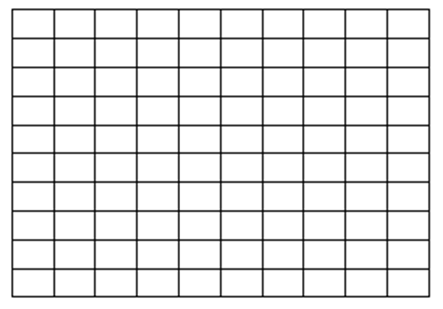

Create a table below to show each color, decimal fraction, and decimal below.

Name ___________________________________________ Date ________________________

**Grids Sheet**

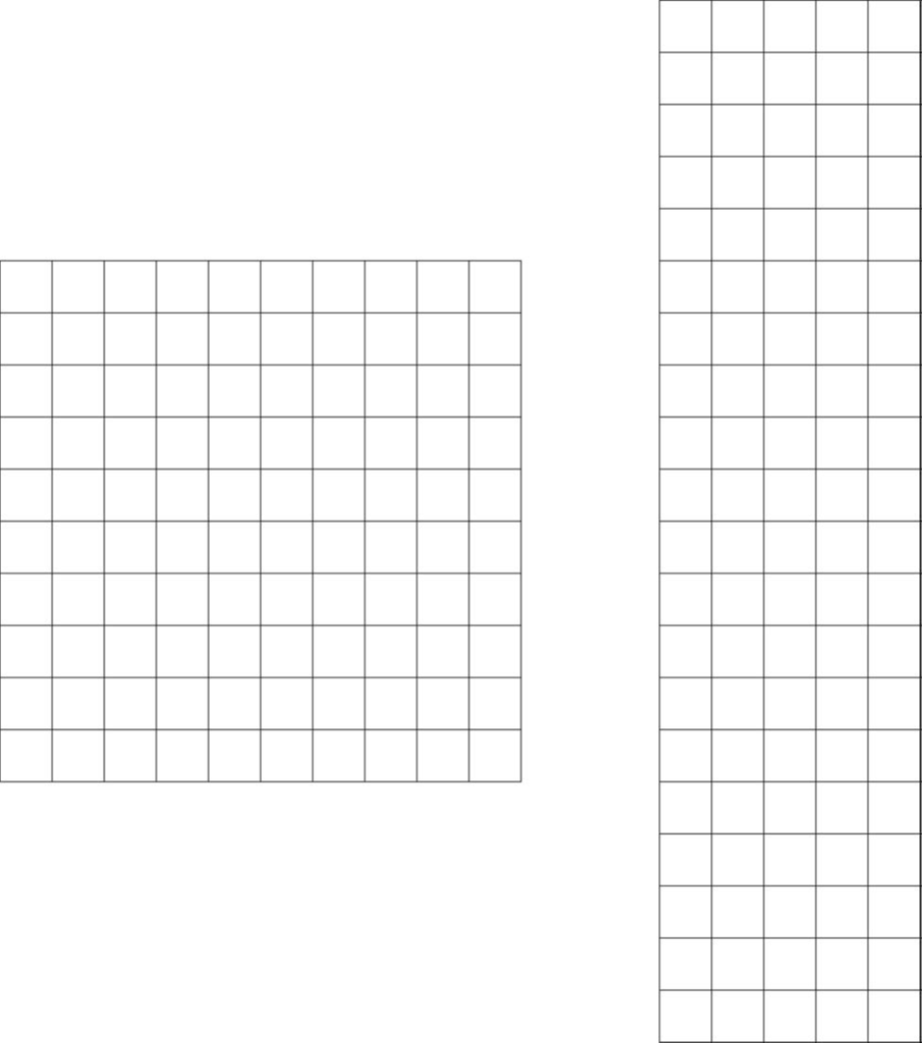

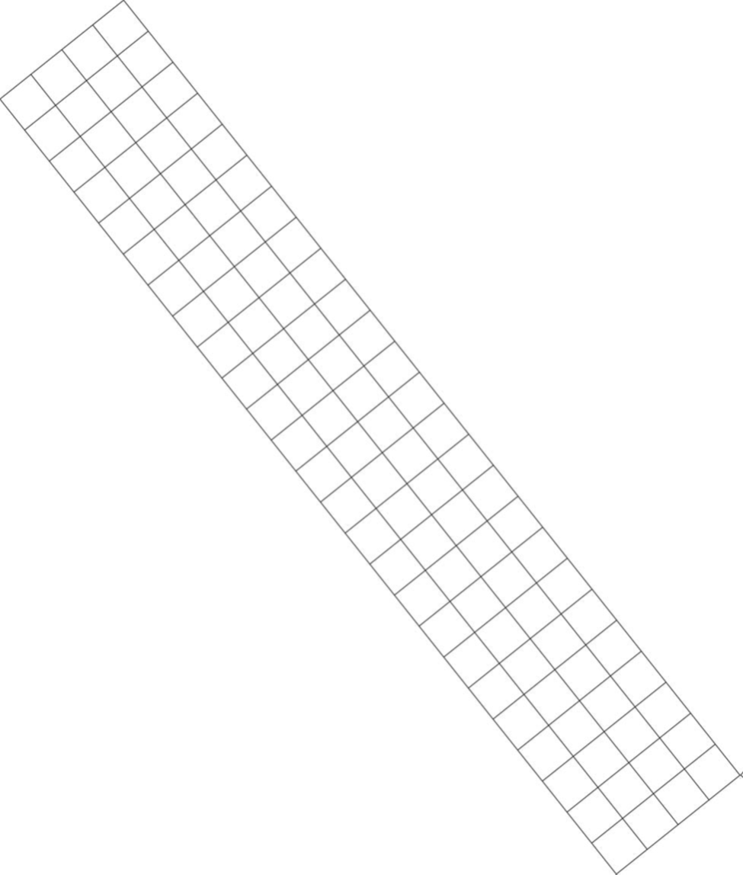

Hundredths Disk

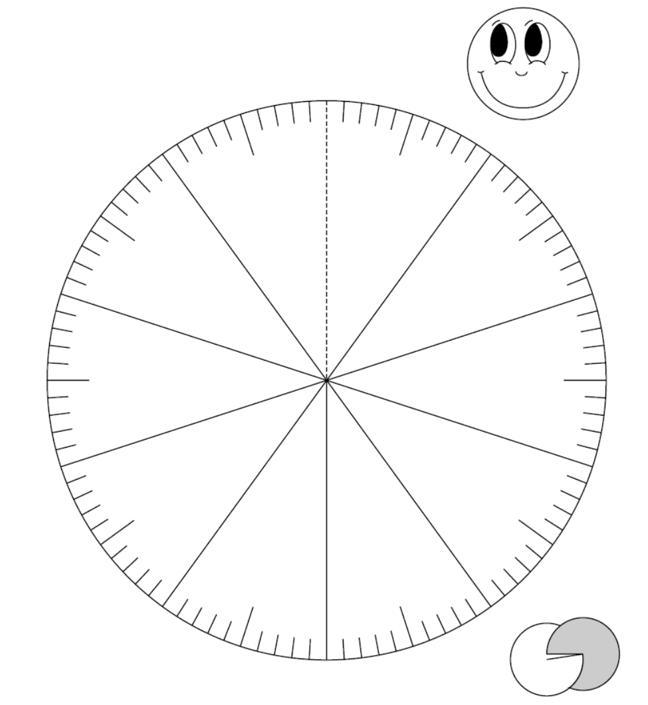

**Constructing Task:** Measuring Up Decimals

**TASK CONTENT:** Students will use the metric system to represent and compare decimals.

**STANDARDS FOR MATHEMATICAL CONTENT**

**MGSE4.NF.5** Express a fraction with denominator 10 as an equivalent fraction with denominator 100, and use this technique to add two fractions with respective denominators 10 and 100. *For example, express 3/10 as 30/100, and add 3/10 + 4/100 = 34/1001.*

**MGSE4.NF.6** Use decimal notation for fractions with denominators 10 or 100. *For example, rewrite 0.62 as 62/100; describe a length as 0.62 meters; locate 0.62 on a number line diagram.*

**MGSE4.NF.7** Compare two decimals to hundredths by reasoning about their size. Recognize that comparisons are valid only when the two decimals refer to the same whole. Record the results of the comparisons with the symbols >, =, or <, and justify the conclusions, e.g. by using a visual model.

**MGSE4.MD.2** Use the four operations to solve word problems involving distances, intervals of time, liquid volumes, masses of objects, and money, including problems involving simple fractions or decimals, and problems that require expressing measurements given in a larger unit in terms of a smaller unit. Represent measurement quantities using diagrams such as number line diagrams that feature a measurement scale.

**STANDARDS FOR MATHEMATICAL PRACTICE**

1. Make sense of problems and persevere in solving them.

2. Reason abstractly and quantitatively.

4. Model with mathematics.

5. Use appropriate tools strategically.

6. Attend to precision.

7. Look for and make sure of structure.

**BACKGROUND KNOWLEDGE**

The meter stick is a length model of decimals that is a familiar context for the use of decimals. This lesson provides students with a visual model for seeing the centimeters within a meter as decimals of a whole meter, as well as seeing each decimeter as a tenth of the meter stick.

As students share their strategies and methods for writing the decimal representations, comparing the decimals, and combining lengths of objects, make sure they are explaining their thinking and critiquing the reasoning of others.

The task directions purposely give few directions on “how” student must complete this task. You may wish to brainstorm ahead of time ways to organize their work (tables and charts) and important information for communicating their ideas (number sentences using the comparison symbols, using grid models, etc.), but it is important that students have the opportunity to show their thinking for each step in a way that makes sense to them. The discussion you have with students during the task completion should focus on guided questions rather than guiding statements. For instance, asking, “What do you know about the relationship between centimeters and meters?” when students are writing the length of an object in terms of meters, rather than saying, “Don’t forget that there are 100 centimeters in a meter and a meter is the whole” puts the responsibility and opportunity for thinking back on the student.

**ESSENTIAL QUESTIONS:**

* How does the metric system of measurement show decimals?
* How can I combine the decimal length of objects I measure?

**MATERIALS**

* Meter sticks
* Objects of varying lengths (including those larger than 1 meter) labeled with a letter

**GROUPING**

Individual or partner

**NUMBER TALKS**

Continue utilizing the different strategies in number talks and revisiting them based on the needs of your students. Catherine Fosnot has developed problem “strings” which may be included in number talks to further develop mental math skills. See Mini-lessons for Operations with Fractions, Decimals, and Percents by Kara Louise Imm, Catherine Twomey Fosnot and Willem Uittenbogaard. (Mini-lessons for Operation with Fraction, Decimal, and Percent, 2007, Kara Louise Imm, Catherine Twomey Fosnot and Willem Uittenbogaard)

**TASK DESCRIPTION, DEVELOPMENT AND DISCUSSION**

**Comments**

This is a constructing task, so it is important that as students begin to write the decimal representations of the objects they measure that they have the opportunity to struggle and consider what the “whole” is in this situation. As they join together lengths in the latter part of the task, allow them to use their own methods for adding the tenths and hundredths together. DO NOT show them the place value addition model, as they need to develop this method on their own. Fourth grade students should focus on using the idea of decimal fractions to combine decimals.

Opportunities for discussing measurement will present themselves during this task. Use this lesson as an opportunity to build background for the upcoming Measurement Unit. Choose a variety of objects to measure, including objects over 1 meter in length so that students must problem-solve to measure and write the decimal length.

**Task**

Review the various models of decimals and reintroduce the meter as one model for showing linear decimals. Introduce today’s task with students focusing on the 3 parts they are to complete.

Students will follow the directions below.

You have a variety of objects to measure today!

* Measure each object and write its length in centimeters and meters. (You may need to write the length in meters as a decimal of a meter.)
* Choose 3 pairs of object and combine their lengths. Write the combination length in terms of meters. Explain how you combined the lengths, using fraction and decimal notation.
* Choose 3 pairs of objects to compare their lengths. Use a model to explain how you compared the lengths of the objects.

After the students complete the task, have each pair or group share their work. Focus their discussion on:

* + The methods they used for representing the objects that measured less than a meter as a decimal of a meter.
  + The methods they used for combining the lengths of two objects and the mathematical representations they used for this.
  + The methods they used for comparing the lengths of the objects and the visual models they used to defend their thinking.
* After and while groups are sharing, have them look for groups that had efficient strategies, as well as the similarities and differences between the methods used to represent, combine and compare decimals.

**FORMATIVE ASSESSMENT QUESTIONS**

* How did you know how to write the length of an object shorter than a meter in terms of a meter?
* When you combined the lengths of objects, how did that change the decimal representations you used?
* How did decimals help you compare the lengths of objects? What models of decimals helped you prove your comparisons?

**DIFFERENTIATION**

**Extension**

* Have students also write the lengths of the objects in terms of decimeters. Have a discussion comparing the lengths written in centimeters, decimeters, and meters. How do these measurements look different? What patterns are seen when comparing the lengths?

**Intervention**

* If the measurement of the objects is an issue, label the objects ahead of times in terms of centimeters so that the focus can be on the decimal representation of that length in terms of a meter.
* Have students complete a decimals grid for each length to use for comparing and combining the lengths of the objects.

**TECHNOLOGY**

* <http://nlvm.usu.edu/en/nav/frames_asid_334_g_2_t_1.html?from=category_g_2_t_1.html> Place Value Number Line: This interactive number line useful for zooming in to show smaller and smaller unit fractions. It can be used for additional practice.
* <https://www-k6.thinkcentral.com/content/hsp/math/hspmath/ca/common/mega_math_9780153663963_/megamathcd6/cm/launch.html?strActivityName=g36_3_2_N&strAssignID=1> Number Line Mine: This resource allows students to locate decimals that represent a given fraction. It can be used for additional practice or for remediation purposes.

**Practice Task:** Decimal Line-up

**TASK CONTENT:** Students will order decimal numbers and place decimal numbers on a number line.

**STANDARDS FOR MATHEMATICAL CONTENT**

**MGSE4.NF.5** Express a fraction with denominator 10 as an equivalent fraction with denominator 100, and use this technique to add two fractions with respective denominators 10 and 100. *For example, express 3/10 as 30/100, and add 3/10 + 4/100 = 34/1001.*

**MGSE4.NF.6** Use decimal notation for fractions with denominators 10 or 100. *For example, rewrite 0.62 as 62/100; describe a length as 0.62 meters; locate 0.62 on a number line diagram.*

**MGSE4.NF.7** Compare two decimals to hundredths by reasoning about their size. Recognize that comparisons are valid only when the two decimals refer to the same whole. Record the results of the comparisons with the symbols >, +, or <, and justify the conclusions, e.g. by using a visual model.

**STANDARDS FOR MATHEMATICAL PRACTICE TO BE EMPHASIZED**

1. Make sense of problems and persevere in solving them.

2. Reason abstractly and quantitatively.

4. Model with mathematics.

5. Use appropriate tools strategically.

6. Attend to precision.

7. Look for and make sure of structure.

**BACKGROUND KNOWLEDGE**

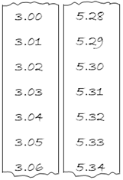

Students need to be very familiar with number lines and counting using decimal numbers. One way to give students practice in counting using decimal numbers is to provide students with adding machine tape on which they can list decimal numbers. Give them a starting number and ask them to list the numbers to the hundredths place (or to the tenths place). Students can be given an ending number or they may be asked to fill a strip of adding machine tape. See the two examples shown.

**ESSENTIAL QUESTIONS**

* What models can be used to represent decimals?
* What are the benefits and drawbacks of each of these models?

**MATERIALS**

* “Decimal Line-up” student recording sheet (2 pages)

**GROUPING**

Partner/Small Group

**NUMBER TALKS**

Continue utilizing the different strategies in number talks and revisiting them based on the needs of your students. Catherine Fosnot has developed problem “strings” which may be included in number talks to further develop mental math skills. See Mini-lessons for Operations with Fractions, Decimals, and Percents by Kara Louise Imm, Catherine Twomey Fosnot and Willem Uittenbogaard. (Mini-lessons for Operation with Fraction, Decimal, and Percent, 2007, Kara Louise Imm, Catherine Twomey Fosnot and Willem Uittenbogaard)

**TASK**

Students will order and then place decimal numbers (tenths and hundredths) on a number line.

**Comments**

To introduce this task, discuss as a large group the structure of a number line that includes decimals. Students need to recognize that like a ruler, tick marks of different lengths and weights represent different types of numbers.

One way to begin this task is to display the number line shown below:



As a class, discuss where the following decimal numbers would be located on the number line: 6.5, 6.25, 6.36, 6.72, and 6.9. Start by discussing which benchmark whole numbers would be required for the set of numbers to be placed on the number line. Students should recognize that the no number is greater than 6, so the number line would need to start at 6. The greatest number is less than 7, so the number line would need to go to 7.

Once the benchmark numbers have been labeled, ask students how to place the following decimal numbers: 6.5 and 6.9. Students should be able to place these decimal numbers on the number line as shown below.



Once the tenths have been labeled, work as a class to place the decimal numbers 6.25, 6.36, and 6.72 on the number line. While placing these decimal numbers on the number line use the “think aloud” strategy to explain how you know it is being placed in the correct location on the number line. Alternatively, ask students to explain where to correctly place these decimal numbers on the number line. Once all of the given decimal numbers are placed, the number line should be similar to the one shown below:



Before students begin to work on this task, help students label the landmark numbers on the number lines of the “Decimal Line-up” student sheet.

Ask students to consider the benchmark numbers that they will need to place on the number line. For example, the first problem asks students to place the following decimal numbers on the number line: 3.7, 2.3, 1.6, 0.9, and 1.2. Ask students what whole numbers these decimal numbers fall between. Students should recognize that the number that is the least is less than 1, so the number line would need to start at zero. The greatest number is greater than 3, so the number line would need to go to at least 4. As a large group, have students label the number line on their student recording sheets correctly (see below).

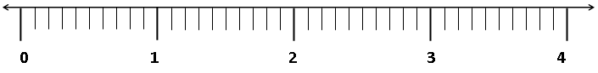

Continue working as a large group to label the number line in the second problem. This number line has three different types of tick marks on it. The longest and heaviest tick marks indicate whole numbers, the next heaviest indicate decimal numbers to the tenths, and the shortest and lightest tick marks indicate decimal numbers to the hundredths.

Ask students to consider the benchmark numbers that they will need to place on the number line. Students are asked to place the following decimal numbers on the number line: 2.53, 2.19, 2.46, 2.02, and 2.85. Ask students what whole numbers these decimal numbers fall between. Students should recognize that the least number is greater than 2, so the number line would need to start at 2. The greatest number is less than 3, so the number line would need to go to 3. As a large group, have the students label the number line on their student recording sheets correctly as shown below.

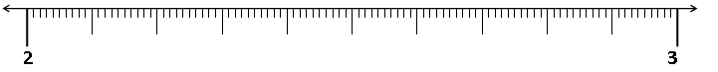

Next, ask students which decimal numbers to the tenths come between 2 and 3. Help students recognize and label the number line with 2.1, 2.2, 2.3, 2.4, 2.5, 2.6, 2.7, 2.8, 2.9. Ask students to label the number line on their student recording sheets (see below).



**Task**

Students will follow directions on the “Decimal Line-up” student recording sheet.

To complete this task, students will need to correctly label one number line with decimal numbers to the tenths and a second number line with decimal numbers to the hundredths. Finally, students will be asked to create their own decimal numbers and use their numbers to correctly label a number line.

**FORMATIVE ASSESSMENT QUESTIONS**

* What are the whole number benchmark numbers for your decimals? How do you know?
* What are the benchmark numbers to the tenths place? How do you know?
* What is the greatest/ least decimal number? How will you use that information?
* Which tick marks will be used to represent decimal numbers to the tenths? Hundredths?

**DIFFERENTIATION**

**Extension**

* Give students two numbers, for example 3.2 and 3.3. Ask students to list at least 9 numbers that come between these two numbers (3.21, 3.22, 3.23, 3.24...3.29). Ask students if they think there are numbers between 3.21 and 3.22.

**Intervention**

* Allow students to refer to a meter stick while working on number lines. Each decimeter is one tenth of a meter and each centimeter is one hundredth of a meter.

**TECHNOLOGY**

* <http://nlvm.usu.edu/en/nav/frames_asid_334_g_2_t_1.html?from=category_g_2_t_1.html> Place Value Number Line: This interactive number line useful for zooming in to show smaller and smaller unit fractions. It can be used for additional practice.
* <https://www-k6.thinkcentral.com/content/hsp/math/hspmath/ca/common/mega_math_9780153663963_/megamathcd6/cm/launch.html?strActivityName=g36_3_2_N&strAssignID=1> Number Line Mine: This resource allows students to locate decimals that represent a given fraction. It can be used for additional practice or for remediation purposes.

Name ____________________________________________ Date _______________________

Decimal Line-up

1. Ordering tenths
   1. Order the following decimals from least to greatest.

**3.7 2.3 1.6 0.9 1.2**

**___________ ___________ ___________ ___________ ___________**

* 1. Next, place the decimal numbers on the number line below. Add whole numbers as needed to the number line.



* 1. Write to explain how you know the decimal numbers are placed correctly.

**________________________________________________________________________________________________________________________________________________________________________________________________________________________________________________________________________________________________________________________________________________________________________________________________________________________________________________**

1. Ordering hundredths
2. Order the following decimals from least to greatest.

**2.53 2.19 2.46 2.02 2.85**

**___________ ___________ ___________ ___________ ___________**

1. Next, place the decimal numbers on the number line below. Add whole numbers as needed to the number line.



Write to explain how you know the decimal numbers are placed correctly.

**________________________________________________________________________________________________________________________________________________________________________________________________________________________________________________________________________________________________________________________________________________________________________________________________________________________________________________________________________________________________________________________**

1. Ordering decimals
2. Write five decimals that you will be able to place on the number line below. Then order your decimals from least to greatest.

**___________ ___________ ___________ ___________ ___________**

**___________ ___________ ___________ ___________ ___________**

1. Next, place your decimal numbers on the number line below. Add whole numbers as needed to the number line.



1. Write to explain how you know your decimals are placed correctly.

**___________________________________________________________________________________________________________________________________________________________________________________________________________________________________________________________________________________________________________________________________________________________________________________________________________________________________________________________________________________**

**CONSTRUCTING TASK:** In the Paper

**TASK CONTENT:** Students will represent and use decimal fractions and decimal numbers to graph data.



**STANDARDS FOR MATHEMATICAL CONTENT**

**MGSE4.NF.5** Express a fraction with denominator 10 as an equivalent fraction with denominator 100, and use this technique to add two fractions with respective denominators 10 and 100. *For example, express 3/10 as 30/100, and add 3/10 + 4/100 = 34/1001.*

**MGSE4.NF.6** Use decimal notation for fractions with denominators 10 or 100. *For example, rewrite 0.62 as 62/100; describe a length as 0.62 meters; locate 0.62 on a number line diagram.*

**MGSE4.NF.7** Compare two decimals to hundredths by reasoning about their size. Recognize that comparisons are valid only when the two decimals refer to the same whole. Record the results of the comparisons with the symbols >, +, or <, and justify the conclusions, e.g. by using a visual model.

**STANDARDS FOR MATHEMATICAL PRACTICE**

1. Make sense of problems and persevere in solving them.

2. Reason abstractly and quantitatively.

4. Model with mathematics.

5. Use appropriate tools strategically.

6. Attend to precision.

7. Look for and make sure of structure.

**BACKGROUND KNOWLEDGE**

Students should have prior experiences and/or instruction with writing decimal fractions and decimal numbers. Students also need background knowledge in the types of words being looked for in the newspaper articles.

When students are creating a bar graph, talk with them about what the scale increments should be for their graph. Because all of the sections were equal in size, (100 words) it is possible to graph the frequency of occurrence for each type of word. However, because the focus is on writing and ordering decimal numbers, students could be asked to label the scale using increments of 0.10, 0.05, or as appropriate for the data. If decimal increments are used, students should be made aware that the fraction created by the number of occurrences out of 100 words is called the “relative frequency.” Therefore, the vertical axis on the graph should be labeled “relative frequency.” Example of a graph is shown below. The National Center for Education Statistics (NCES) Kids’ Zone (Create-a-Graph) was used to create the graphs. You’ll find the link under “Technology Connection” below.

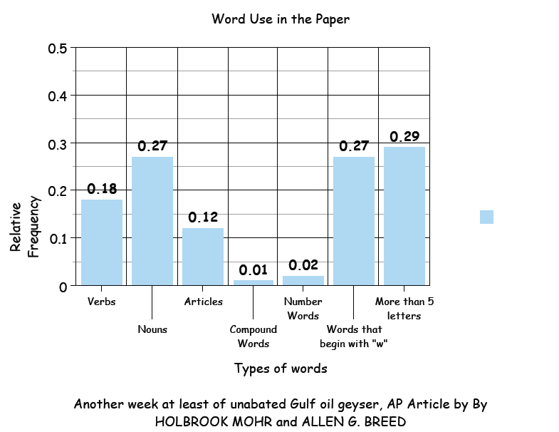

**ESSENTIAL QUESTIONS**

* How do you order two-digit decimal fractions?
* How are decimal numbers and decimal fractions related?
* What is a decimal fraction and how can it be represented?
* When is it appropriate to use decimal fractions?

**MATERIALS**

* + “In the Paper” student recording sheet
  + A page or article from a newspaper
  + Highlighters, crayons, or colored pencils

**GROUPING**

Individual/Partner Task

**NUMBER TALKS**

By now number talks should be incorporated into the daily math routine. Continue utilizing the different strategies in number talks and revisiting them based on the needs of your students. In addition Catherine Fosnot has developed “strings” of numbers and fractions that could be included in a number talk to further develop mental math skills. See Mini-Lessons for Operations with Fractions, Decimals, and Percents by Kara Louise Imm, Catherine Twomey Fosnot and Willem Uittenbogaard. (Minilessons for Operation with Fraction, Decimal, and Percent, 2007,Kara Louise Imm, Catherine Twomey Fosnot and Willem Uittenbogaard).

**TASK DESCRIPTION, DEVELOPMENT, AND DISCUSSION**

In this task, students will explore the characteristics of words in a 100 word passage of a newspaper article. They will report their findings in decimal form and order decimals from smallest to largest.

**Comments**

This activity can be used as a Language Arts integration activity. The possibilities of calculating decimal fractions of various words or word parts are endless.

**Task Directions**

Discuss with students different types of words that make up the articles and books that are read. Review with students what a noun, verb, article, compound word and number word are. Have students give examples of each type of word. Create a chart of these examples so that students have a reference during the activity if they have a question.

Students will follow the directions below from the “In the Paper” student recording sheet.

Look through the newspaper and find an article that is interesting to you. Count the first 100 words in the article and put a box around that section with a highlighter or marker. Follow the directions in the table below.

In the first 100 words of the article, what part does each word type represent?

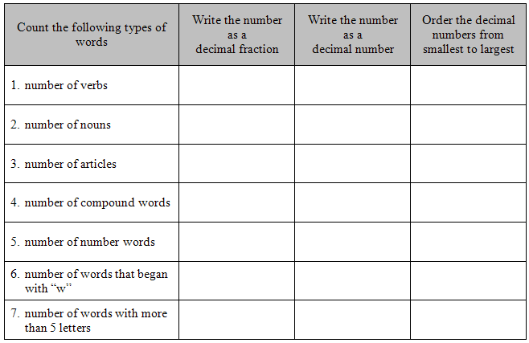

* Create a bar graph to present your data to the class.
* What is your graph title?
* What scale increments will you use?
* How will you label the horizontal axis of your graph?
* How will you label the vertical axis of your graph?
* What categories will you use?

**FORMATIVE ASSESSMENT QUESTIONS**

* How many of the words did you find? How many are in the part of the selection you identified?
* How do you represent that amount as a decimal fraction? How do you represent that amount as a decimal number?
* Look at the decimal fraction. Which fraction is larger? How do you know? So, which decimal number is larger? How do you know?
* What will be the scale increments for your graph? Why did you choose the scale increments?
* What are the parts of a bar graph? Have you included them all in your graph?
* What strategies are students using to order decimals?

**DIFFERENTIATION**

**Extension**

* The decimal amount of words found in various categories can be compared between articles, thus comparing decimal fractions in a different way.
* Students can decide on various categories of words to find and report their answers as decimal fractions.

**Intervention**

* Instead of a newspaper, books written at a student’s reading level can be used. So students are able to write on the page(s), have students choose a book before beginning this task in class and make a copy of the page(s).
* Allow students to use the NCES Kids’ Zone web site <http://nces.ed.gov/nceskids/createagraph/> to create a graph to represent the data collected. Alternatively, allow students to refer to a completed graph as a model for the graph they need to create. Use a completed graph such as the sample below.

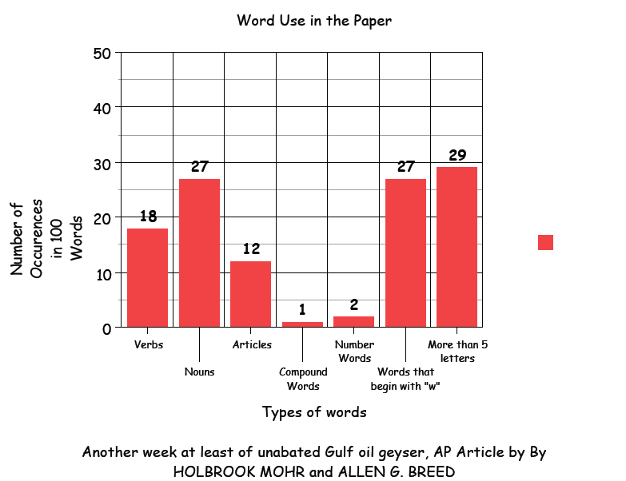

**TECHNOLOGY**

* <http://nces.ed.gov/nceskids/createagraph/> NCES Kids’ Zone This website allows students to create various types of graphs to represent data that has been gathered.
* <https://www-k6.thinkcentral.com/content/hsp/math/hspmath/ca/common/mega_math_9780153663963_/megamathcd6/cm/launch.html?strActivityName=g36_3_2_N&strAssignID=1> This resource allows students to locate decimals that represent a given fraction. It can be used for additional practice or for remediation purposes.

Name_________________________________ Date ________________________



In the Paper

Look through the newspaper and find an article that is interesting to you. Count the first 100 words in the article and put a box around that section with a highlighter or marker. Follow the directions in the table below.

In the first 100 words of the article, what part does each word type represent?

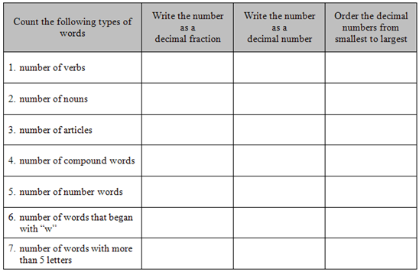

Create a bar graph to present your data to the class.

* What is your graph title?
* What scale increments will you use?
* How will you label the horizontal axis of your graph?
* How will you label the vertical axis of your graph?
* What categories will you use?

**3 ACT TASK:** Planning a 5K Race

**TASK CONTENT:** In this lesson, students will compare decimals and use their sizes to estimate laps needed to complete a 5K race.

**STANDARDS FOR MATHEMATICAL CONTENT**

**MCC.4.NF.7** Compare two decimals to hundredths by reasoning about their size. Recognize the comparisons are only valid when two decimals are referring to the same whole. Record the results using symbols <, >, or = and justify the conclusions, e.g. by using visual models.

**MGSE4.MD.2** Use the four operations to solve word problems involving distances, intervals of time, liquid volumes, masses of objects, and money, including problems involving simple fractions or decimals, and problems that require expressing measurements given in a larger unit in terms of a smaller unit. Represent measurement quantities using diagrams such as number line diagrams that feature a measurement scale.

**STANDARDS FOR MATHEMATICAL PRACTICE**

1. Make sense of problems and persevere in solving them.

2. Reason abstractly and quantitatively.

3. Construct viable arguments and critique the reasoning of others.

4. Model with mathematics.

5. Use appropriate tools strategically.

6. Attend to precision.

7. Look for and make use of structure.

8. Look for and express regularity in repeated reasoning.

**BACKGROUND KNOWLEDGE**

This task follows the 3-Act Math Task format originally developed by Dan Meyer. More information on this type of task may be found at <http://blog.mrmeyer.com/category/3acts/>. A Three-Act Task is a whole-group mathematics task consisting of 3 distinct parts: an engaging and perplexing Act One, an information and solution seeking Act Two, and a solution discussion and solution revealing Act Three. More information along with guidelines for 3-Act Tasks may be found in the ***Guide to Three-Act Tasks*** on georgiastandards.org and the K-5 CCGPS Mathematics Wiki.

A double number line is a visual model that can be used in a variety of ways. In this task, students will create a double number line that can be used to compare tenths and hundredths. The top line will show tenths while the bottom line shows hundredths. Students can compare decimals with tenths and hundredths using the double number line as they are still gaining the foundation of being able to move easily between tenths and hundredths. Students have had experiences working with a number line during the previous task, Decimal Fraction Number Line. You may have to model for them how to create a Double Number Line if this is their first experience using one.

The discussion of the strategies that students use to place the decimals on the number lines is the most important part of this lesson. As students work, rotate through and ask them to explain and justify their thinking using the number line and visual models.

**ESSENTIAL QUESTIONS**

* How does mental math help us calculate more quickly and develop an internal sense of numbers?

**MATERIALS**

* Planning a 5K recording sheet
* Act 1 image

**GROUPING**

Individual/Partner Task

**TASK DESCRIPTION, DEVELOPMENT AND DISCUSSION**

In this task, students will view a picture and scenario and then tell what they noticed. Next, they will be asked to discuss what they wonder about or are curious about. Their curiosities will be recorded as questions on a class chart or on the board. Students will then use mathematics to answer their own questions. Students will be given information to solve the problem based on need. When they realize they don’t have the information they need, and ask for it, it will be given to them.

**Task Directions**

**Act I – Whole Group** - Pose the conflict and introduce students to the scenario by showing the Act I image and scenario.

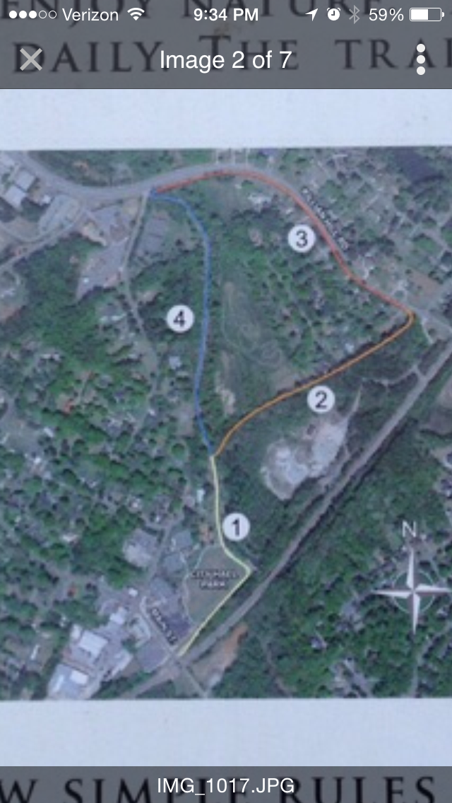Camp Creek Greenway Trail in Lilburn, GA is the location of your school's 5K fundraiser.

1. Show Act I image and scenario to students.
2. Pass out the 3 Act recording sheet.
3. Ask students what they wonder about and what questions they have about what they saw. Students should share with each other first before sharing aloud and then record these questions on the recording sheet (think-pair-share). The teacher may need to guide students so that the questions generated are math-related.

**Anticipated questions students may ask and wish to answer:**

Which trail is the longest?

Which trail is best to use for a 5K?

Can all four trails be used during a 5K?

What is the length of each trail?

What is the sum of the distance around all the trails?

1. As the facilitator, you can select which question you would like every student to answer, have students vote on which question the class will answer or allow the students to pick which question they would like to answer. Once the question is selected ask students to estimate answers to their questions (think-pair-share). Students will write their best estimate, then write two more estimates – one that is too low and one that is too high so that they establish a range in which the solution should occur. Instruct students to record their estimates on a number line.

**Act II – Student Exploration** - Provide additional information as students work toward solutions to their questions.

Ask students to determine what additional information they will need to solve their questions. The teacher provides that information only when students ask for it.:

* Trail 1 is 0.3 miles
* Trail 2 is 0.31 miles
* Trail 3 is 0.42 miles
* Trail 4 is 0.37 miles
* A 5K race is 3.1 miles

Ask students to work to answer the questions they created in Act I. The teacher provides guidance as needed during this phase by asking questions such as:

* Can you explain what you’ve done so far?
* What strategies are you using?
* What assumptions are you making?
* What tools or models may help you?
* Why is that true?
* Does that make sense?

**Act III – Whole Group** - Share student solutions and strategies as well as Act III solution.

1. Ask students to present their solutions and strategies.
2. Compare solution(s).
3. Lead discussion to compare these, asking questions such as:

* How reasonable was your estimate?
* Which strategy was most efficient?
* Can you think of another method that might have worked?
* What might you do differently next time?

**FORMATIVE ASSESSMENT QUESTIONS**

* How did you know where to place the decimals on the number lines?
* When comparing two decimals, how do you know which is the greater decimal?
* Explain, using the decimal squares you created, how you know one decimal is greater than another.
* Did you notice any patterns in the models or in the decimals as you placed them on the number line?
* What do you notice about the relationship between the tenths and hundredths?
* How did students show connections between tenths and hundredths?

**DIFFERENTIATION**

**Extension**

* For students who are ready to explore into the thousandths, have them add a fifth route and make a triple number line, placing additional decimals that go to the thousandths place on that number line.

**Intervention**

* Encourage students to record the decimal amounts on a number line to help with the comparisons.

**Act One Image**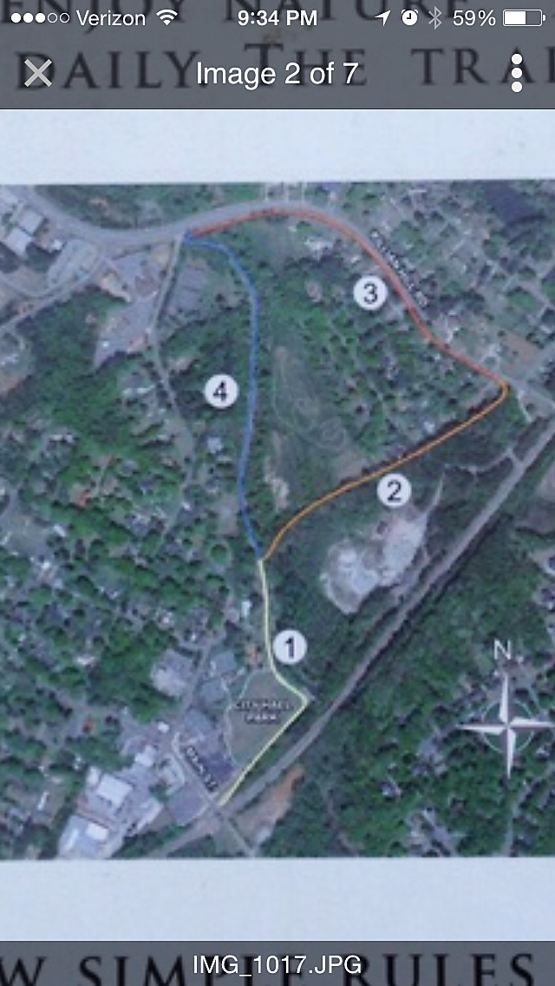

Name: ________________________

*Adapted from Andrew Stadel*

Task Title:

**ACT 1**

|  |
| --- |
| What questions come to your mind? |
| Main question: |
| On an empty number line, record an estimate that is too low, just right and an estimate that is too high. Explain your estimates.  ________________________________________________________________________________________________________________________________________________________________________________________________________________________________________________________________________________________________________________________________________________________________________ |

**ACT 2**

|  |
| --- |
| What information would you like to know or need to solve the MAIN question? |
|  |

Use this area for your work, tables, calculations, sketches, and final solution.

**ACT 3**

|  |
| --- |
| What was the result? |
|  |

**Record the actual answer on the number line above containing the three previous estimates.**

**ACT 4 (use this space when necessary)**

**Constructing Task:** Taxi Trouble

**TASK CONTENT:** Students will add tenths and hundredths, as well as compare decimals.

**STANDARDS FOR MATHEMATICAL CONTENT**

**MGSE4.NF.5** Express a fraction with denominator 10 as an equivalent fraction with denominator 100, and use this technique to add two fractions with respective denominators 10 and 100. *For example, express 3/10 as 30/100, and add 3/10 + 4/100 = 34/1001.*

**MGSE4.NF.6** Use decimal notation for fractions with denominators 10 or 100. *For example, rewrite 0.62 as 62/100; describe a length as 0.62 meters; locate 0.62 on a number line diagram.*

**MGSE4.NF.7** Compare two decimals to hundredths by reasoning about their size. Recognize that comparisons are valid only when the two decimals refer to the same whole. Record the results of the comparisons with the symbols >, +, or <, and justify the conclusions, e.g. by using a visual model.

**STANDARDS FOR MATHEMATICAL PRACTICE TO BE EMPHASIZED**

1. Make sense of problems and persevere in solving them.

2. Reason abstractly and quantitatively.

4. Model with mathematics.

5. Use appropriate tools strategically.

6. Attend to precision.

7. Look for and make sure of structure.

**BACKGROUND KNOWLEDGE**

Students may need some background knowledge built on how taxi companies charge for their services. Many of them have a flat fee plus an additional rate per mile or fraction of a mile traveled. Often the flat fee is a distractor from the per mile rate. It is important that students make predictions from their initial reading of the rate and then compare that with the actual result. This will show them how important it is to do the math when making choices on how to spend their money!

Students sometimes treat decimals as whole numbers when making comparison of two decimals. They think the longer the number, the greater the value. For example, they think that .03 is greater than 0.3. Furthermore, students do not understand how the places in decimal notation have the same correspondence (places to the left are 10 times greater than the places to their immediate right) as the places in whole numbers.

**ESSENTIAL QUESTIONS**

* How can decimal fractions help me determine the best choices on how to spend my money?

**MATERIALS**

* Paper
* Pencils
* “Taxi Trouble” Student Sheet

**GROUPING**

Individual or partner

**NUMBER TALKS**

Continue utilizing the different strategies in number talks and revisiting them based on the needs of your students. Catherine Fosnot has developed problem “strings” which may be included in number talks to further develop mental math skills. See Mini-lessons for Operations with Fractions, Decimals, and Percents by Kara Louise Imm, Catherine Twomey Fosnot and Willem Uittenbogaard. (Mini-lessons for Operation with Fraction, Decimal, and Percent, 2007, Kara Louise Imm, Catherine Twomey Fosnot and Willem Uittenbogaard)

**TASK DESCRIPTION, DEVELOPMENT AND DISCUSSION**

**Task**:

* Introduce the problem. Make sure students understand they are to defend their choice and use mathematics (shown in number and word form) to defend their choices.
* Have students briefly read the task and make predictions about which Taxi Company they think will be the best deal. Have them explain the thinking for their predictions.

Students will follow the directions below from the “Taxi Trouble” recording sheet.

Sam is in downtown Atlanta and needs to take a taxi 5 miles to the convention center. There is a sign posted with the different taxi companies and their rate.

|  |
| --- |
| Taxi Company A: $4.00 sitting fee and 30/100 of a dollar for every 1/10 of a mile.  Taxi Company B: Free sitting fee and 5/10 of a dollar for every 1/10 of a mile.  Taxi Company C: $10.00 sitting fee and 2/10 of a dollar for every 1/10 of a mile. (Sam has a 1/10 off of your total price coupon.) |

Which taxi cab company should Sam choose to ride to the convention center?

**FORMATIVE ASSESSMENT QUESTIONS**

Have each pair or group share their work. Focus their discussion on:

* How are you determining the cost of the ride for each Taxi Company?
* How are you organizing your work?
* Where have you used decimal fractions and decimal to defend your thinking?
* Which company should Sam choose?
* How did you determine the cost of each company’s taxi ride?
* After and while groups are sharing, have them look for groups that had efficient strategies, the similarities between the methods used, and the differences between the methods used.
* Which strategies for combining tenths and hundredths did you see today that worked best?
* Were you surprised by the results? Explain.
* What did you learn about the decimal representations of the money being spent?

**DIFFERENTIATION**

**Extension**

* Have students create their own taxi company and write its sitting fee and charge per mile in terms of tenths of a mile. Have them compare their company’s price with the companies listed.

**Intervention**

* Have students use grids, money manipulatives, and/or other concrete models to build each amount of money for the ride. Use this concrete model as the basis for the number representations they use to explain their thinking.

**TECHNOLOGY**

* <http://nlvm.usu.edu/en/nav/frames_asid_334_g_2_t_1.html?from=category_g_2_t_1.html> Place Value Number Line: This interactive number line useful for zooming in to show smaller and smaller unit fractions. It can be used for additional practice.
* <https://www-k6.thinkcentral.com/content/hsp/math/hspmath/ca/common/mega_math_9780153663963_/megamathcd6/cm/launch.html?strActivityName=g36_3_2_N&strAssignID=1> Number Line Mine: This resource allows students to locate decimals that represent a given fraction. It can be used for additional practice or for remediation purposes.

Name ___________________________________________ Date ________________________



Taxi Trouble

Sam is in downtown Atlanta and needs to take a taxi 5 miles to the convention center. There is a sign posted with the different taxi companies and their rate.

|  |
| --- |
| Taxi Company A: $4.00 sitting fee and 30/100 of a dollar for every 1/10 of a mile.  Taxi Company B: Free sitting fee and 5/10 of a dollar for every 1/10 of a mile.  Taxi Company C: $10.00 sitting fee and 2/10 of a dollar for every 1/10 of a mile. (Sam has a 1/10 off of your total price coupon.) |

Which taxi cab company should Sam choose to ride to the convention center? Use math words, numbers, models, and symbols to explain and justify your choice.

**Culminating Task**

**Performance Task:** Cell Phone Plans

**STANDARDS FOR MATHEMATICAL CONTENT**

**MGSE4.NF.5** Express a fraction with denominator 10 as an equivalent fraction with denominator 100, and use this technique to add two fractions with respective denominators 10 and 100. *For example, express 3/10 as 30/100, and add 3/10 + 4/100 = 34/1001.*

**MGSE4.NF.6** Use decimal notation for fractions with denominators 10 or 100. *For example, rewrite 0.62 as 62/100; describe a length as 0.62 meters; locate 0.62 on a number line diagram.*

**MGSE4.NF.7** Compare two decimals to hundredths by reasoning about their size. Recognize that comparisons are valid only when the two decimals refer to the same whole. Record the results of the comparisons with the symbols >, +, or <, and justify the conclusions, e.g. by using a visual model.

**STANDARDS FOR MATHEMATICAL PRACTICE TO BE EMPHASIZED**

1. Make sense of problems and persevere in solving them.

2. Reason abstractly and quantitatively.

4. Model with mathematics.

5. Use appropriate tools strategically.

6. Attend to precision.

7. Look for and make sure of structure.

**BACKGROUND KNOWLEDGE**

As the culminating performance task for this unit, this task is designed for students to use portions of all of the standards studied during this unit. It is important even now for students to explain and justify their reasoning as evidence of their learning. This task is very similar to the previous task “Taxi Cab.” The “Taxi Cab” task is used as a constructing task for students to develop understanding and meaning. This task is intended to be a performance task, which checks for student understanding.

You may want to develop and use a problem-solving rubric to assess student understanding. Include students as a part of the rubric-making, allowing them input on what the most important parts of their project will be and also highlighting with them what is most important - the “whys” and “hows” behind their answer, rather than just getting the right answer.

**ESSENTIAL QUESTIONS**

* How can I determine the best cell phone plan?

**MATERIALS**

* A copy of “Cell Phone Plans” for each student

**GROUPING**

Individual or partner

**NUMBER TALKS**

Continue utilizing the different strategies in number talks and revisiting them based on the needs of your students. Catherine Fosnot has developed problem “strings” which may be included in number talks to further develop mental math skills. See Mini-lessons for Operations with Fractions, Decimals, and Percents by Kara Louise Imm, Catherine Twomey Fosnot and Willem Uittenbogaard. (Mini-lessons for Operation with Fraction, Decimal, and Percent, 2007, Kara Louise Imm, Catherine Twomey Fosnot and Willem Uittenbogaard)

**TASK DESCRIPTION, DEVELOPMENT AND DISCUSSION**

**Task:**

* Introduce the problem. Make sure students understand they are to defend their choice and use mathematics (shown in number and word form) to defend their choices.
* Have students briefly read the task and make predictions about which Cell Phone company they think will be the best deal. Have them explain their thinking for their predictions.

Students will follow the directions below from the “Cell Phone Plans” recording sheet.

It is time for McKinley to purchase a new cell phone. With so many new phones and so many companies, McKinley has a lot to consider before she purchases her phone. Read all the information she has gathered below and help her decide which plan is best! Rank the three plans according to which you think is the best deal and be prepared to defend your thinking! Use math words, numbers, models, and symbols to explain your thinking!

McKinley’s Usual Phone Usage Per Month

* 300 minutes of talk time
* 200 texts
* 200 megabytes of data

|  |  |  |  |  |
| --- | --- | --- | --- | --- |
| **Phone Company** | **Monthly Fee** | **Talk Time** | **Texts** | **Data Usage** |
| Cecelia’s Cells | $30 | 200 minutes free ( of a dollar per minute after that) | 100 texts free  (10 texts per dollar after that) | 50 megabytes free  ( of a dollar per megabyte after that) |
| Matt’s Mobiles | None | of a dollar per minute | of a dollar per text | of a dollar per megabyte |
| Phyllis’s Phones | $ 15 | 200 minutes free ( of a dollar per minute after that) | 150 texts free  ( $\frac{2}{10}$ of a dollar per text after that) | 150 megabytes free  ( $\frac{2}{10}$ of a dollar after that) |

After completing the task, have each pair or person share their work. Focus their discussion on:

* How did you determine the cost for each phone plan?
* How did you organize your work?
* Where have you used decimal fractions and decimals to defend your thinking?
  + Which company should McKinley choose? Justify your thinking.
  + What methods were used for determining the cost of each company.
* After and while groups are sharing, have them look for groups that had efficient strategies, similarities between the methods used, and differences between the methods used.

**FORMATIVE ASSESSMENT QUESTIONS**

* Which strategies for combining tenths and hundredths did you see today that worked best?
* Were you surprised by the results?
* What did you learn about the decimal representations of the money being spent?

**DIFFERENTIATION**

**Extension**

* Have students create their own phone company and write its fees in terms of tenths of a minute. Have them compare their company’s price with the companies listed.

**Intervention**

* Have students use grids, money manipulatives, and/or other concrete models to build each amount of money for each company. Use this concrete model as the basis for the number representations they use to explain their thinking.

**TECHNOLOGY**

* <http://nlvm.usu.edu/en/nav/frames_asid_334_g_2_t_1.html?from=category_g_2_t_1.html> Place Value Number Line: This interactive number line useful for zooming in to show smaller and smaller unit fractions. It can be used for additional practice.
* <https://www-k6.thinkcentral.com/content/hsp/math/hspmath/ca/common/mega_math_9780153663963_/megamathcd6/cm/launch.html?strActivityName=g36_3_2_N&strAssignID=1> Number Line Mine: This resource allows students to locate decimals that represent a given fraction. It can be used for additional practice or for remediation purposes.

C:\Program Files\Microsoft Office\MEDIA\CAGCAT10\j0332268.wmfName ___________________________________________ Date _______________________ _

Cell Phone Plans

It is time for McKinley to purchase a new cell phone. With so many new phones and so many companies, McKinley has a lot to consider before she purchases her phone. Read all the information she has gathered below and help her decide which plan is best! Rank the three plans according to which you think is the best deal and be prepared to defend your thinking! Use math words, numbers, models, and symbols to explain your thinking!

McKinley’s Usual Phone Usage Per Month

* 300 minutes of talk time
* 200 texts
* 200 megabytes of data

|  |  |  |  |  |
| --- | --- | --- | --- | --- |
| Phone Company | Monthly Fee | Talk Time | Texts | Data Usage |
| Cecelia’s Cells | $30 | 200 minutes free ( of a dollar per minute after that) | 100 texts free  (10 texts per dollar after that) | 50 megabytes free  ( of a dollar per megabyte after that) |
| Matt’s Mobiles | None | of a dollar per minute | of a dollar per text | of a dollar per megabyte |
| Phyllis’s Phones | $ 15 | 200 minutes free ( of a dollar per minute after that) | 150 texts free  ( of a dollar per text after that) | 150 megabytes free  ( of a dollar after that) |