**Georgia** 

**Standards of Excellence**

**Frameworks**



GSE Fourth Grade

Unit 1: Whole Numbers, Place Value, and Rounding



**Unit 1: WHOLE NUMBERS, PLACE VALUE, AND ROUNDING**

**TABLE OF CONTENTS (*indicates new task, **indicates a modified task)**

Overview………………………………………………………………………………….. 3

Standards for Mathematical Practice……………………………………………………… 3

Standards for Mathematical Content……………………………………………………... 4

Big Ideas…………………………………………………………………………………...5

Essential Questions for the Unit…………………………………………………………... 5

Concepts & Skills to Maintain…………………………………………………………….5

Strategies for Teaching and Learning…………………………………………………….. 6

Selected Terms and Symbols……………………………………………………………... 6

Tasks……………………………………………………………………………………....7

Formative Assessment Lessons………………………………………………………….. 12

**TASKS**

* What Comes Next?.................................................................................... 13
* Relative Value of Places…………………………………………………. 17
* **Building 1,000 (deleted)……………………………………………….­ -
* Number Scramble………………………………………………………... 22
* Super Bowl Numbers……………………………………………………. 26
* **Ordering and Comparing Numbers…………………………………… 32
* NFL Salaries……………………………………………………………... 37
* Nice Numbers…………………………………………………………… 45
* **Estimation as a Check………………………………………………… 49
* Making Sense of the Algorithm…………………………………………. 53
* Reality Checking………………………………………………………... 57
* **Culminating Task:** It’s in the Numbers!................................................... 65

***Please note that all changes made to standards will appear in red bold type. Additional changes will appear in green.

**OVERVIEW**

In this unit students will:

* read numbers correctly through the millions
* write numbers correctly through millions in standard form
* write numbers correctly through millions in expanded form
* identify the place value name for multi-digit whole numbers
* identify the place value locations for multi-digit whole numbers
* round multi-digit whole numbers to any place
* fluently solve multi-digit addition and subtraction problems using the standard algorithm
* solve multi-step problems using the four operations

Although the units in this instructional framework emphasize key standards and big ideas at specific times of the year, routine topics such as estimation, mental computation, and basic computation facts should be addressed on an ongoing basis.  The first unit should establish these routines, allowing students to gradually enhance their understanding of the concept of number and to develop computational proficiency.

To assure that this unit is taught with the appropriate emphasis, depth, and rigor, it is important that the tasks listed under “Big Ideas” be reviewed early in the planning process. A variety of resources should be utilized to supplement the tasks in this unit. The tasks in these units illustrate the types of learning activities that should be utilized from a variety of sources.

For more detailed information about unpacking the content standards, unpacking a task, math routines and rituals, maintenance activities and more, please refer to the Grade Level Overview for fourth grade.

**STANDARDS FOR MATHEMATICAL PRACTICE**

This section provides examples of learning experiences for this unit that support the development of the proficiencies described in the Standards for Mathematical Practice. These proficiencies correspond to those developed through the Literacy Standards. The statements provided offer a few examples of connections between the Standards for Mathematical Practice and the Content Standards of this unit. This list is not exhaustive and will hopefully prompt further reflection and discussion.

1. **Make sense of problems and persevere in solving them.** Students make sense of problems involving place value and rounding in computation.

1. **Reason abstractly and quantitatively.** Students demonstrate abstract reasoning about relative size of numbers.
2. **Construct viable arguments and critique the reasoning of others.** Students construct and critique arguments regarding number strategies including addition and subtraction or rounding strategies.
3. **Model with mathematics.** Students use base ten materials to demonstrate understanding of a multi-digit whole number.
4. **Use appropriate tools strategically.** Students select and use tools such as place value charts and base ten materials to identify patterns within the base ten system.
5. **Attend to precision.** Students attend to the language of real-world situations to determine if addition and subtraction answers are reasonable.

1. **Look for and make use of structure.** Students relate the structure of the base ten system to recognize that in a multi-digit whole number, a digit in one place represents ten times what it represents in the place to its right.
2. **Look for and express regularity in repeated reasoning.** Students relate the structure of the base ten system to explain that in a multi-digit whole number, a digit in one place represents ten times what it represents in the place to its right.

**\*\*\*Mathematical Practices 1 and 6 should be evident in EVERY lesson. \*\*\***

**STANDARDS FOR MATHEMATICAL CONTENT**

**Use the four operations with whole numbers to solve problems.**

**MGSE4.OA.3 Solve multistep word problems with whole numbers and having whole-number answers using the four operations, including problems in which remainders must be interpreted. Represent these problems using equations with a symbol or letter standing for the unknown quantity. Assess the reasonableness of answers using mental computation and estimation strategies including rounding.**

**Generalize place value understanding for multi-digit whole numbers.**

**MGSE4.NBT.1 Recognize that in a multi-digit whole number, a digit in any one place represents ten times what it represents in the place to its right. *For example, recognize that 700 ÷ 70 = 10 by applying concepts of place value and division.***

**MGSE4.NBT.2** Read and write multi-digit whole numbers using base-ten numerals, number names, and expanded form. Compare two multi-digit numbers based on meanings of the digits in each place, using >, =, and < symbols to record the results of comparisons.

**MGSE4.NBT.3** Use place value understanding to round multi-digit whole numbers to any place.

**Use place value understanding and properties of operations to perform multi-digit arithmetic.**

**MGSE4.NBT.4** Fluently add and subtract multi-digit whole numbers using the standard algorithm.

**Solve problems involving measurement and conversion of measurements from a larger unit to a smaller unit.**

**MGSE4.MD.2** Use the four operations to solve word problems involving distances, intervals of time, liquid volumes, masses of objects, and money, including problems involving simple fractions or decimals, and problems that require expressing measurements given in a larger unit in terms of a smaller unit. Represent measurement quantities using diagrams such as number line diagrams that feature a measurement scale.

**BIG IDEAS**

* The value of a number is determined by the place of its digits.
* Using rounding is an appropriate estimation strategy for solving problems and

estimating.

* Rounded numbers are approximate and not exact. Exact answers can be rounded to

different place values.

* A number can be written using digits in standard form, word, or expanded form.
* Larger numbers can be compared using the place value of the digits within the numbers. The relationship between the two numbers can be expressed using the symbols >, <, or =.

**ESSENTIAL QUESTIONS**

Choose a few questions based on the needs of your students.

* How does our base ten number system work?
* How does understanding the base ten number system help us add and subtract?
* How does the value of a digit change if its location is changed in a large number?
* What determines the value of a digit?
* How does estimation help us understand large numbers?
* How are large numbers estimated?
* What conclusions can I make about the places within our base ten number system?
* What happens to a digit when it is multiplied and divided by 10?
* What effect does the location of a digit have on the value of the digit?
* How can we compare large numbers?
* What determines the value of a number?
* Why is it important for me to be able to compare numbers?
* What is a sensible answer to a real problem?
* What information is needed in order to round a whole number to any place?
* How can I ensure my answer is reasonable?
* How can rounding help me compute numbers?
* What effect does a remainder have on my rounded answer?
* What strategies can I use to help me make sense of a written algorithm?

**CONCEPTS/SKILLS TO MAINTAIN**

It is expected that students will have prior knowledge/experience related to the concepts and skills identified below. It may be necessary to pre-assess in order to determine if time needs to be spent on conceptual activities that help students develop a deeper understanding of these ideas.

* Place value understanding for multi-digit whole numbers
* Round a whole number to the nearest ten or hundred
* Fluently add and subtract within 1000 using strategies

**Fluency**: Procedural fluency is defined as skill in carrying out procedures flexibly, accurately, efficiently, and appropriately. Fluent problem solving does not necessarily mean solving problems within a certain time limit, though there are reasonable limits on how long computation should take. Fluency is based on a deep understanding of quantity and number.

**Deep Understanding**: Teachers teach more than simply “how to get the answer” and instead support students’ ability to access concepts from a number of perspectives. Therefore students are able to see math as more than a set of mnemonics or discrete procedures. Students demonstrate deep conceptual understanding of foundational mathematics concepts by applying them to new situations, as well as writing and speaking about their understanding.

**Memorization**: The rapid recall of arithmetic facts or mathematical procedures. Memorization is often confused with fluency. Fluency implies a much richer kind of mathematical knowledge and experience.

**Number Sense:** Students consider the context of a problem, look at the numbers in a problem, make a decision about which strategy would be most efficient in each particular problem. Number sense is not a deep understanding of a single strategy, but rather the ability to think flexibly between a variety of strategies in context.

**Fluent students**:

* flexibly use a combination of deep understanding, number sense, and memorization.
* are fluent in the necessary baseline functions in mathematics so that they are able to spend their thinking and processing time unpacking problems and making meaning from them.
* are able to articulate their reasoning.
* find solutions through a number of different paths.

For more about fluency, see: <http://www.youcubed.org/wp-content/uploads/2015/03/FluencyWithoutFear-2015.pdf> and: <http://joboaler.com/timed-tests-and-the-development-of-math-anxiety/>

**STRATEGIES FOR TEACHING AND LEARNING**

* Students should be actively engaged by developing their own understanding.
* Mathematics should be represented in as many ways as possible using graphs, tables, pictures, symbols, and words.
* Appropriate manipulatives and technology should be used to enhance student learning.
* Students should be given opportunities to revise their work based on teacher and peer feedback, as well as metacognition which includes self-assessment and reflection.
* Students should write about the mathematical ideas and concepts they are learning.

**SELECTED TERMS AND SYMBOLS**

Note – At the elementary level, different sources use different definitions. Please preview any website for alignment to the definitions given in the frameworks. The writers of the Common Core Standards wrote a glossary of mathematical terms and it can be found at: <http://www.corestandards.org/Math/Content/mathematics-glossary/glossary>. **The terms below are for teacher reference only and are not to be memorized by the students**.

* algorithm
* digits
* estimate
* expanded form
* numbers
* numerals
* period
* place value
* rounding

**TASKS**

The following tasks represent the level of depth, rigor, and complexity expected of all fourth grade students. These tasks or tasks of similar depth and rigor should be used to demonstrate evidence of learning. It is important that all elements of a task be addressed throughout the learning process so that students understand what is expected of them. While some tasks are identified as a performance tasks, they also may be used for teaching and learning.

|  |  |
| --- | --- |
| **Scaffolding Task** | Tasks that build up to the learning task. |
| **Constructing Task** | Constructing understanding through deep/rich contextualized problem solving tasks. |
| **Practice Task** | Tasks that provide students opportunities to practice skills and concepts. |
| **Performance Task** | Tasks which may be a formative or summative assessment that checks for student understanding/misunderstanding and or progress toward the standard/learning goals at different points during a unit of instruction. |
| **Culminating Task** | Designed to require students to use several concepts learned during the unit to answer a new or unique situation. Allows students to give evidence of their own understanding toward the mastery of the standard and requires them to extend their chain of mathematical reasoning. |
| **Formative Assessment Lesson (FAL)** | Lessons that support teachers in formative assessment which both reveal and develop students’ understanding of key mathematical ideas and applications. These lessons enable teachers and students to monitor in more detail their progress towards the targets of the standards. |
| **CTE Classroom Tasks** | Designed to demonstrate how the Career and Technical Education knowledge and skills can be integrated. The tasks provide teachers with realistic applications that combine mathematics and CTE content. |
| **3-Act Task** | A Three-Act Task is a whole-group mathematics task consisting of 3 distinct parts: an engaging and perplexing Act One, an information and solution seeking Act Two, and a solution discussion and solution revealing Act Three. More information along with guidelines for 3-Act Tasks may be found in the ***Guide to Three-Act Tasks*** on georgiastandards.org and the K-5 CCGPS Mathematics Wiki. |

|  |  |  |  |  |
| --- | --- | --- | --- | --- |
| **Task Name** | **Task Type/Grouping Strategy** | **Content Addressed** | **Standard(s)** | **Description of Task** |
| What Comes Next? | Scaffolding Task  *Partner/Small Group Task* | Relative size of numbers | MGSE4.NBT. 1 | Students work with base ten materials to experience that a place value in a number is ten times more than the digit to its right. |
| Relative Value of Places | Constructing Task  *Partner/ Small Group Task* | Relative size of numbers | MGSE4.NBT.2  MGSE4.NBT. 1 | Students work with dotty array pieces to understand patterns within the base ten number system. Students solve place value problems to show understanding of the patterns learned. |
| **Building 1,000  This task has been removed from the frameworks. |  | . |  | This task is more appropriate for 2nd grade base ten standards, and so has been removed from the frameworks. |
| Number Scramble | Practice Task  *Individual/Partner Task* | Making and Naming Large Numbers | MGSE4.NBT.2 | Students create numbers given specific directions and write those numbers in standard, word and expanded form. |
| Super Bowl Numbers | 3 Act Task  *Individual/Partner Task* | Comparing Multi-digit Numbers, Adding Multi-digit Numbers | MGSE4.NBT.2  MGSE4.NBT.4 | Students make connections between the base ten number system and the Roman Numeral number system. |
| **Ordering and Comparing Numbers | Practice Task  *Individual/Partner Task* | Ordering Larger Numbers | MGSE4.NBT.2 | Students order and compare numbers through a dice game played with a partner. |
| NFL Salaries | 3 Act Task  *Individual/Partner Task* | Comparing Multi-digit Numbers, Adding Multi-digit Numbers | MGSE4.OA.3 MGSE4.NBT.4 | Students compare salaries of football players to discuss why certain players are paid a particular amount of money. |
| Nice Numbers | Constructing Task  *Partner/Small group Task* | Rounding, Four Operations | MGSE4.OA.3 MGSE4.NBT.4  MGSE4.NBT.3  **MGSE4.MD.2** | Students apply rounding concepts to find estimated solutions to word problems. |
| **Estimation as a Check | Constructing Task  *Individual/ Partner Task* | Rounding, Adding, Subtracting multi-digit numbers | MGSE4.NBT.4  MGSE4.NBT.3 | Students find estimated solutions to problems. |
| Making Sense of the Algorithm | Constructing Task  *Individual/Partner Task* | Fluently subtracting multi-digit numbers | MGSE4.NBT.4 | Students write about strategies that are used for given problems in the task, leading to a discussion of procedures within the subtraction standard algorithm. |
| Reality Checking | Constructing Task  *Individual/ Partner Task* | Ordering, Adding, Subtracting and Rounding multi-digit numbers | MGSE4.NBT.2 MGSE4.NBT.4  MGSE4.NBT.3  **MGSE4.MD.2** | Students apply knowledge of the addition and subtraction standard algorithm in order to balance a mock check registry . |
| It’s in the Number | Culminating Task  *Individual Task* | Calculation and Estimation with Whole Numbers | MGSE4.OA.3  MGSE4.NBT.2  MGSE4.NBT.3  **MGSE4.MD.2** | Students gather data about populations in the U.S. to draw conclusions about why people choose to live in certain regions of the country. |

*Should you need further support for this unit, please view the appropriate unit webinar at :*

[*https://www.georgiastandards.org/Common-Core/Pages/Math-PL-Sessions.aspx*](https://www.georgiastandards.org/Common-Core/Pages/Math-PL-Sessions.aspx)

**FORMATIVE ASSESSMENT LESSONS (FALS)**

Formative Assessment Lessons are designed for teachers to use in order to target specific strengths and weaknesses in their students’ mathematical thinking in different areas. A Formative Assessment Lesson (FAL) includes a short task that is designed to target mathematical areas specific to a range of tasks from the unit. Teachers should give the task in advance of the delineated tasks and the teacher should use the information from the assessment task to differentiate the material to fit the needs of the students. The initial task should not be graded. It is to be used to guide instruction.

Teachers may use the following Formative Assessment Lessons (FALS) Chart to help them determine the areas of strengths and weaknesses of their students in particular areas within the unit.

|  |  |  |  |
| --- | --- | --- | --- |
| **Formative Assessments** | **FALS**  **(Supporting Lesson Included)** | **Content Addressed** | **Pacing**  **(Use before and after these tasks)** |
| [Ordering 4-digit numbers](http://www.illustrativemathematics.org/illustrations/459) |  | Ordering Larger Numbers | What Comes Next  Build 1,000  Relative Value of Places  Number Scramble  Ticket Master |
| [To regroup or not to regroup](http://www.illustrativemathematics.org/illustrations/1189) |  | Using the Addition Algorithm | Nice Numbers  Estimation as a Check  Making sense of an Algorithm  Reality Checking |

**SCAFFOLDING TASK:**  What Comes Next?

(*Adapted from Teaching Student Centered Mathematics Volume 2)*

**TASK CONTENT:** This task helps pre-assess students' previous knowledge and misconceptions about place value and number sense.

**STANDARDS FOR MATHEMATICAL CONTENT**

**MGSE4.NBT.1 Recognize that in a multi-digit whole number, a digit in any one place represents ten times what it represents in the place to its right. *For example, recognize that 700 ÷ 70 = 10 by applying concepts of place value and division.***

**STANDARDS FOR MATHEMATICAL PRACTICE**

1.  Make sense of problems and persevere in solving them.

2.  Reason abstractly and quantitatively.

3.  Construct viable arguments and critique the reasoning of others.

4.  Model with mathematics.

5.  Use appropriate tools strategically.

6.  Attend to precision.

7.  Look for and make use of structure.

8.  Look for and express regularity in repeated reasoning.

**BACKGROUND KNOWLEDGE**

This task helps pre-assess students' previous knowledge and misconceptions about place value and number sense. The strategies they use to solve the problem demonstrate students' understanding about a number of concepts including place value, grouping, computation, number sense, patterns, and mathematical communication.

**COMMON MISCONCEPTIONS**

        Two important ideas developed for three-digit numbers should be extended to larger numbers.  First, the grouping idea should be generalized.  That is, ten in any position makes a single thing (group) in the next position, and vice versa.  Second, the oral and written patterns for numbers in three digits are duplicated in a clever way for every three digits to the left.  These two related ideas are not as easy for students to understand as adults seem to believe.  Because models for large numbers are often difficult to demonstrate or visualize, textbooks frequently deal with these ideas in a predominantly symbolic manner.  That is not sufficient! (Van de Walle, page 47-48)

**ESSENTIAL QUESTIONS**

* How does our base ten number system work?
* How does understanding the base ten number system help us add and subtract?

**MATERIALS**

* base-ten blocks
* base ten materials grid #14 from wps.ablongman.com: <http://wps.ablongman.com/wps/media/objects/3464/3547873/blackline_masters/BLM_14.pdf>

**GROUPING**

Students work in groups or pairs.

**NUMBER TALKS**

In the Fourth Grade Grade Level Overview, the importance of giving students opportunities to mentally compute and explain computational strategies is discussed. *Number Talks* is an excellent way to do this. 5 to 15 minutes each day is dedicated to students sharing the ownership of determining whether answers are accurate, and given the expectation of thinking through all solutions and strategies carefully (Parrish, 2010). During the *Number Talk*, the teacher is not the definitive authority. The teacher is the facilitator and is listening and learning for and from the students’ natural mathematical thinking. The teacher gives a problem on the board in whole group or small group setting. The students mentally solve the problem and share with the whole group HOW they arrived at their answer. They must justify and defend their answer and their thinking. The teacher simply records the students’ thinking and poses extended questions to draw out deeper understanding for all. To let the teacher know they are ready, they make a fist and place it on their chest. If they have two strategies to share, they place two fingers on their chest and so on.

Some lessons lend themselves to Number Talks better than others. You may modify/change them based on the needs of your students. Number Talks suggestions are included in tasks where appropriate.

**TASK DESCRIPTION, DEVELOPMENT AND DISCUSSION**

Throughout the year, you will be incorporating Number Talks into your daily mathematical discussions.  Number Talks is based on the premise of mental computations which means students will rely heavily on **place value knowledge and understanding**.   The following task will cause the students to focus on number relationships and use these relationships to develop efficient, flexible strategies with accuracy (Parrish, page 13).  It is important for students to realize that the number system does have a logical structure, is not totally arbitrary, and can be understood (Van de Walle, page 166).

Students will be able to compose or make large numbers up to 1000 using base 10.  This task will aid the students in their conceptual understanding of composing numbers which will later lead to them decomposing numbers when doing expanded notation and calculating mentally during the computation of addition, subtraction, multiplication, and division. **This lesson by Van de Walle is full of rigor for the student and teacher and worth the conceptual understanding of a number.**

* Students will use paper models of base-ten strips and squares to complete this activity. (See the attached website in the “Materials” section of the lesson to download the Blackline Master.)
* After passing out the materials, ask students, “What piece of the base ten materials can be used to represent one?” (The unit or ones piece is a one cm square and can be used to represent one.)
* Then ask students, “What is next?” Discuss with students that ten centimeter squares can be grouped to make the tens piece. The tens piece is a 10 cm by 1 cm strip.
* Ask students again, “What is next?” Discuss with students that ten strips that are 10 cm by 1 cm can be grouped together to form the hundreds piece. The hundreds piece is a 10 cm by 10 cm square.
* Again, pose the question, “What is next?” Allow students to turn and talk with a partner about what can be made next and how it will be made. (Placing ten 10 cm by 10 cm squares together is ten hundreds, or a thousand.)  Ask students, “What shape would a thousand be?” Tape together a long strip made of ten paper hundreds squares.
* Continue the discussion by asking students, “What comes next?”  Reinforce the idea of ten making one that has progressed to this point.  Ten thousand strips would make a square measuring one meter on each side making a paper 10,000 model.
* As the class figures out the shape of each piece, continue to pose the question, “What comes next?”
* Let small groups work on the dimensions on a 100,000 piece.  Ten ten-thousand squares (100,000) go together to make a huge strip.  Draw this strip on a long sheet or roll of paper, and mark off the 10 squares that make it.  It may be necessary to go out in the hall.

**FORMATIVE ASSESSMENT QUESTIONS**

* What’s a consistent pattern seen as the place values are being built?
* What is the meaning of the phrase “base ten” as a digit progresses from right to left in a larger number?
* Could there be another base besides 10?  Justify or defend your thinking.

**DIFFERENTIATION**

**Extension**

* *Collections*-  As a class or grade-level project, collect some type of object with the objective of reaching some specific quantity-for example, 1,000 or 10,000 buttons, walnuts, old pencils, jar lids, pieces of junk mail, soup labels, or cereal box tops.
* *Illustrations*- Sometimes it is easier to create large amounts.  For example, start a project where students draw 100, 200 or even 500 dots on a sheet of paper.
* Allow students to use rulers to create the squares and rectangles in the activity. Students can draw the squares and rectangles on a large piece of chart or bulletin board paper.

**Intervention**

* Using the base ten blocks, the students could build a number and have a peer determine what number was created and orally give the value of each place contingent upon the blocks.

**TECHNOLOGY**

* <http://illuminations.nctm.org/LessonDetail.aspx?ID=L367> Use this resource as a follow-up lesson to extend place value understanding.
* <http://www.prometheanplanet.com/en-us/Resources/Item/109644/place-value-through-100-000> A lesson for your ActivSlate or SmartBoard to reinforce basic place value ideas through 100,000.

**Constructing Task:** Relative Value of Places

*Adapted from Relative Value of Places, nzmaths, Adding, Subtraction and Place Value*

**TASK CONTENT:** In this task, students will explore patterns in the base-ten system.

**STANDARDS FOR MATHEMATICAL CONTENT**

**MGSE4.NBT.1 Recognize that in a multi-digit whole number, a digit in any one place represents ten times what it represents in the place to its right. *For example, recognize that 700 ÷ 70 = 10 by applying concepts of place value and division.***

**MGSE4.NBT.2** Read and write multi-digit whole numbers using base-ten numerals, number names, and expanded form. Compare two multi-digit numbers based on meanings of the digits in each place, using >, =, and < symbols to record the results of comparisons.

**STANDARDS FOR MATHEMATICAL PRACTICE TO BE EMPHASIZED**

2. Reason abstractly and quantitatively.

4. Model with mathematics

6. Attend to precision.

7. Look for and make use of structure.

**BACKGROUND KNOWLEDGE**

Students unfamiliar with dotty arrays will need to become familiar with the representation of 1, 10, 100, 1 000, and so on as arrays of single dots. This will help them to recognize the relative value of the places.

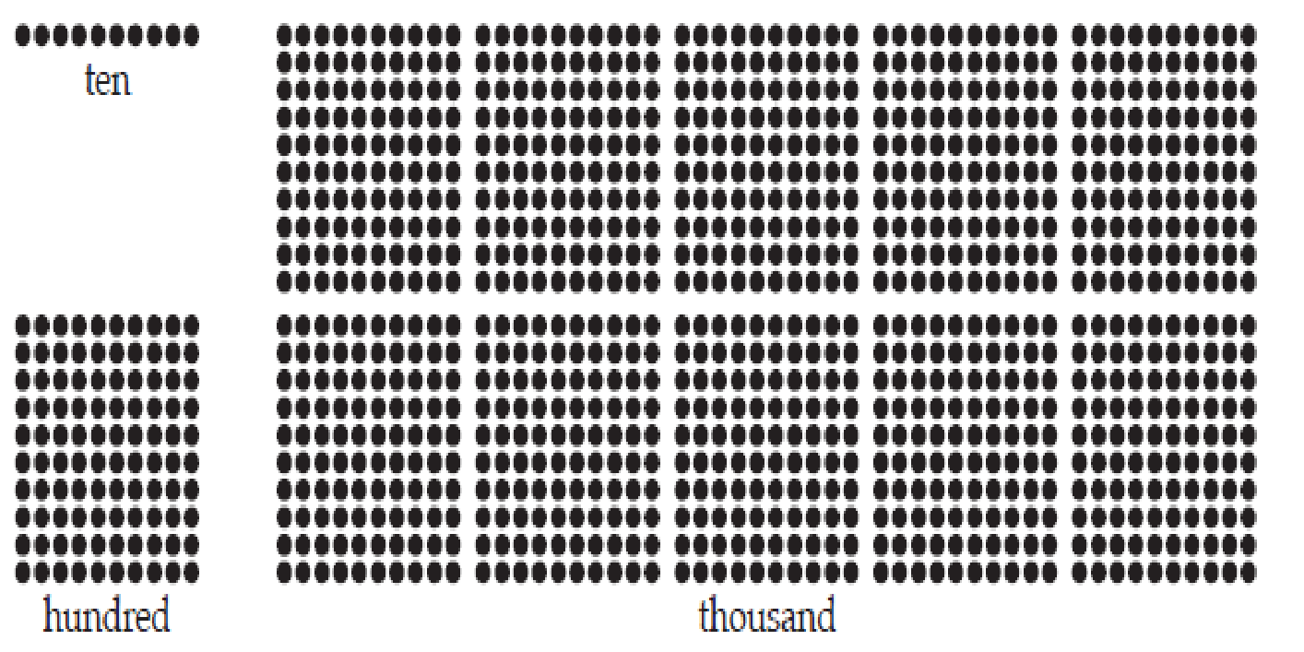

**ESSENTIAL QUESTIONS**

* What conclusions can I make about the places within our base ten number system?
* What happens to a digit when multiplied and divided by 10?
* What effect does the location of a digit have on the value of the digit?

**MATERIALS**

* Large dot arrays

**GROUPING**

Partner or small group

**NUMBER TALKS**

In her book *Number Talks,* Sherry Parrish discusses the importance of place value. She states, “...the true test of whether students understand place value is if they can apply their understanding in computation.” This lesson helps students understand what happens to numbers when they are multiplied or divided by 10. Students can begin using this skill to write numbers in expanded form and begin applying those skills to multiplying partial products.

**TASK DESCRIPTION, DEVELOPMENT AND DISCUSSION**

* Ask ten students to make a two-digit number, e.g., 37, using the dotty array pieces.
* Pose this problem: “Imagine there are ten students and they each have 37 marbles/apples/dollars.” Put the sets of 37 into a central space.
* Ask students,“How many dots is that altogether?” Some students are likely to have symbolic algorithms, such as “add a zero,” that enable them to get an answer of 370. Examine the actions on materials that explain the use of zero as a place holder. For example:

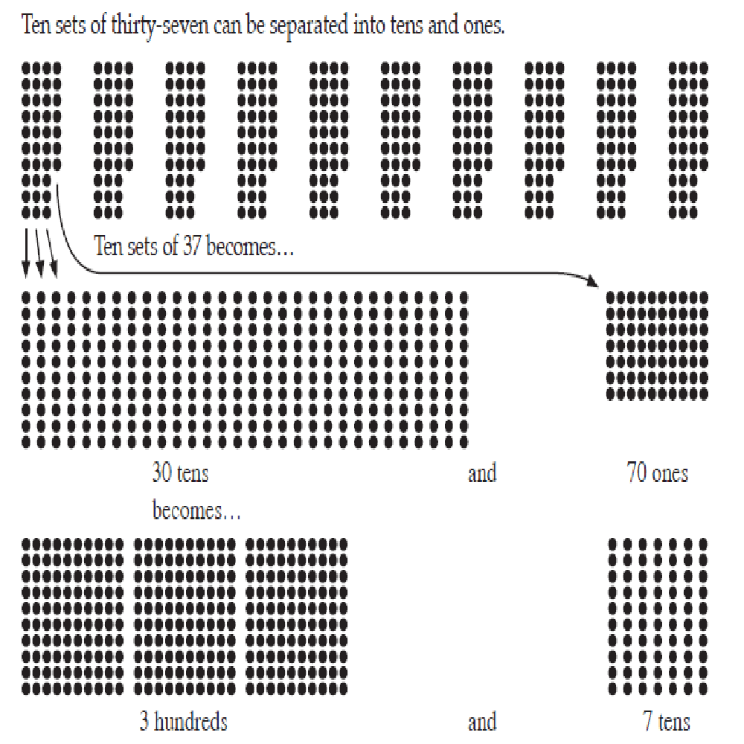

* Using a place value chart, connect 37 with the result of 10 x 37:

|  |  |  |  |  |
| --- | --- | --- | --- | --- |
| Ten Thousands | Thousands | Hundreds | Tens | Ones |
|  |  |  | 3 | 7 |
|  |  | 3 | 7 | 0 |

Students should notice that the digits have shifted one place to the left. Discuss with

students and ask students, “Would the digits shift to the left again if we tried another

problem?”

* Pose several other problems where ten students make numbers with dot array parts and look at the combined product. For each example, separate the place values to see what contribution they make to the whole product, and write the number and it’s ten times equivalent on the place value chart.
* Further challenge the students by making a two-digit number and posing problems such as, “Imagine that one hundred students had 42 marbles/apples/dollars each. How many would that be in total?”
* Ask students how this might be modeled. In these cases, each of the ten students will need to create each number ten times. This is a useful generalization that shows that ten times ten times of any number is one hundred times that number.
* Transfer the focus to dividing by ten and by one hundred. Begin with a four-digit number like 3,800 (zero in the tens and ones places). Make this number with dot array pieces. Pose this problem: “I have 3,800 marbles and I am going to share them equally among all ten of you. How many marbles will you get each?” Ask the students to predict the result of the sharing, and then confirm it by modeling with the materials.
* The result of dividing 3,800 by ten can be shown on a place value chart as:

|  |  |  |  |  |
| --- | --- | --- | --- | --- |
| Ten Thousands | Thousands | Hundreds | Tens | Ones |
|  | 3 | 8 | 0 | 0 |
|  |  | 3 | 8 | 0 |

* The symbolic effect of dividing by ten is to shift the digits of the dividend (3,800) one place to the right. Ask the students to predict what the result would be if they shared 3,800 into one hundred equal sets. Expect them to realize that the shares would be one-tenth of 380, which is 38. This may need to be acted out by cutting the 3 hundreds in 30 tens and the 8 tens into 80 ones so the tenth shares can be established. Use the place chart to connect 3,800 and the result of 3,800 ÷ 100 = 38. In this case, the symbolic effect is a two-place shift to the right.
* Pose problems like these below, expecting the students to reason the answers using place value understanding, not through the use of multiplication. The students must be able to justify their answers by explaining what occurs with the quantities involved.
  + 1. 100 boxes of 376 coins *(37,600)*
    2. 10 boxes of 376 coins *(3,760)*
    3. 960 skittles shared among 10 people *(96)*
    4. 960 skittles shared among 1 people *(960)*
    5. 10 sets of 40 pencils *(400)*
    6. 100 sets of 40 pencils *(4,000)*
    7. 1000 sets of 40 pencils *(40,000)*
    8. 4,300 movie tickets shared among 100 people *(43)*
    9. 4,300 movie tickets shared among 10 people *(430)*
  1. s of 56 marbles *(56,000)*

11.10,000 sets of 56 marbles *(560,000)*

**FORMATIVE ASSESSMENT QUESTIONS**

* What happens to the value of the digit in the ones place when the number is multiplied by 10?
* What happens to the value of the digit in the tens place when the number is divided by 10?
* What can be concluded about the value of a digit in the ones place compared to the value of that same digit in the tens place? What about the tens place and hundreds place? What about the hundreds place and thousands place?
* Which number is larger 960 or 96? How do you know? Why?

**DIFFERENTIATION**

**Extension**

* Have students explain what the value of a digit to the right of the ones place would be based on their conclusion about whole numbers.
* Have students record the number sentences associated with each problem.

**Intervention**

* Allow students to use base ten blocks to build numbers.

**TECHNOLOGY**

* <http://www.ixl.com/math/grade-4/convert-between-place-values> This serves as a means for students to practice place value understanding.
* <https://www.illustrativemathematics.org/content-standards/tasks/1808> Thousands and Millions of Fourth Graders is a task from the Illustrative Mathematics website that provides students with an opportunity to apply knowledge learned about the relationship between digits in a number.

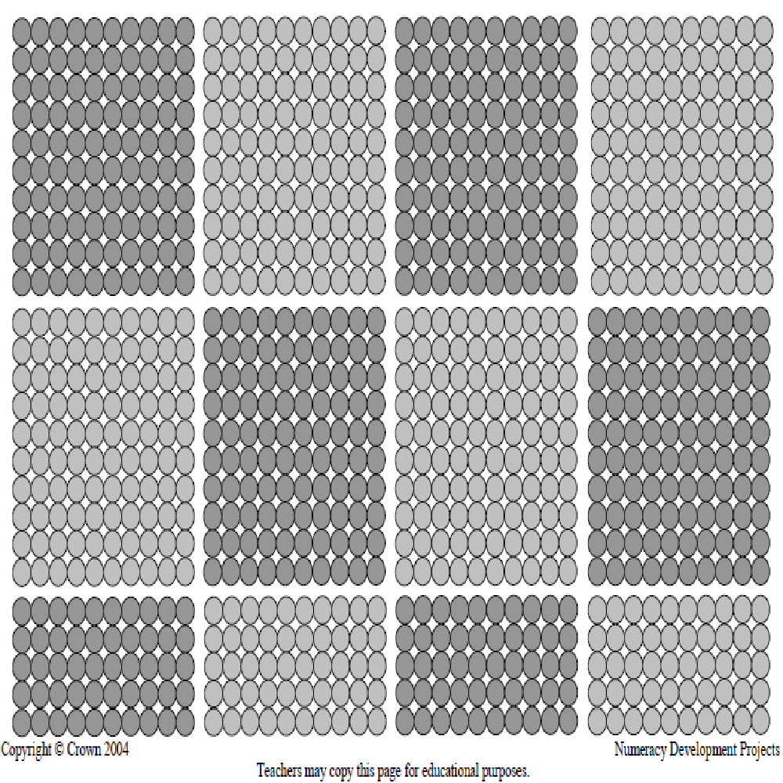

**Practice Task:**  Number Scramble

**TASK CONTENT:** In this task, students will manipulate the tens digit of the base ten-numeration system to complete various activities such as constructing large and small numbers and numbers with specific values in a given place. Students will also write numbers in expanded and standard form.

**STANDARDS FOR MATHEMATICAL CONTENT**

**MGSE4.NBT.2** Read and write multi-digit whole numbers using base-ten numerals, number names, and expanded form. Compare two multi-digit numbers based on meanings of the digits in each place, using >, =, and < symbols to record the results of comparisons.

**STANDARDS FOR MATHEMATICAL PRACTICE TO BE EMPHASIZED**

2. Reason abstractly and quantitatively.

4. Model with mathematics.

6. Attend to precision.

BACKGROUND KNOWLEDGE

Students should have prior experiences and/or instruction with ordering, writing numbers in expanded and standard form and comparing large numbers.

**ESSENTIAL QUESTIONS**

* How do digit values change as they are moved around in large numbers?
* What determines the value of a digit?

**MATERIALS**

* Scissors
* “Number Scramble” Recording Sheet
* Blank Place Value Chart

**GROUPING**

Individual/Partner Task

**NUMBER TALKS**

Now that students have explored what happens to a number when it is multiplied or divided by 10, they should be ready to attempt some mental calculations using partial products. For example, students could calculate 4 x 16 by first decomposing 16 into 10 + 6, then solving 4 x 10, and then 4 x 6. Finally they could combine the products of 40 and 24 for a final product of 64. Keep in mind that students may arrive at the product of 64 without using this particular strategy.

Please refer to pgs. 272-275 in *Number Talks* by Sherry Parrish for more examples of number talks that will further develop this strategy.

**TASK DESCRIPTION, DEVELOPMENT AND DISCUSSION**

**Comments**

As students manipulate the numbers in this task, you will be able to see quickly which students have a good grasp of place value and the value of digit in a number. For example, in steps 1 and 2, if students randomly place their digits, they may need more practice to understand how the value of a number changes as its digits change.

**Task Directions**

Students will cut out number boxes (tiles) and use them to create numbers with the given requirements.

1. Make the largest whole number possible using 9 different tiles. Write your answer in standard form and expanded form.
2. Make the smallest whole number possible using 9 different tiles. Write your answer in standard form and expanded form.
3. Make a number worth more than two million, with a six in the ten-thousands place. Write the number in standard form and expanded form. Compare your number with your partner.
4. Make a number less than five million that has a two in the thousands’ place. Write the number in standard form and expanded form. Compare your number with your partner.
5. Make a number that has only odd digits in the thousands’ period of the place value chart. Write the number in words.
6. Look carefully at your answers to Questions 1 and 2. Find one digit that is in **both** of your answers. How does the value of this digit change from the way you used it in Question 1 to the way you used it in Question 2? Use complete sentences to explain how and why the value of the digit did or did not change between the two answers.

FORMATIVE ASSESSMENT QUESTIONS

* Explain how you decided the order of the digits for each number you created.
* How can you tell which number is the largest or smallest?
* How does the value of a digit change when it is moved to the left on the place value chart? To the right?

**DIFFERENTIATION**

**Extension**

* Have students use all ten tiles to answer questions.
* Have students use tiles to create two more additional questions. Students will give their problems to a partner to solve using the tiles.

**Intervention**

* Start students with building numbers in the hundreds, then the thousands, etc.
* Allow students to use a blank place value chart and write the numbers in the chart, showing the correct placement of the digits. This cueing device may assist students in comparing digits in the same place in order to determine value.
* Have students to use base ten blocks to model the numbers made with the tiles.

**TECHNOLOGY CONNECTIONS**

* <http://www.prometheanplanet.com/en-us/Resources/Item/93852/compare-whole-numbers-to-the-millions> This interactive flipchart lesson on comparing whole numbers, can be used n used with your ActivSlate or Smartboard. It can be used in whole group, small group or student led centers.
* <http://www.aaamath.com/cmp.htm> This online activity has students comparing large numbers and determine their placement in a series of numbers. It can serve as a center activity for practice.

**Number Scramble**

**Task Directions:**  Cut out the number boxes at the bottom of the page by cutting on the black lines. Use the digits to complete each task.

1.Make the largest whole number possible using 9 different tiles. Write your answer below.

Standard Form ____________________ Word Form _______________________________

Expanded Form______________________________________________________________

1. Make the smallest whole number possible using 9 different tiles. Write your answer below.

Standard Form _____________________ Word Form _______________________________

Expanded Form_______________________________________________________________

1. Make a number larger than two million with a six in the ten-thousands place.

What is your number? __________________________________________

Expanded Form________________________________________________

1. Make a number smaller than five million with a two in the thousands place.

What is your number? __________________________________________

What is your partner’s number? _____________________________________

Expanded Form________________________________________________

1. Look carefully at your answers to Questions 1 and 2. Find one digit that is in BOTH of your answers. Write it here. ________________________________________________________

How does the value of this digit change from the way you used it in Question 1 to the way you used it in Question 2? On the back of this sheet, use complete sentences to explain how and why the value of the digit did or did not change between the two answers.

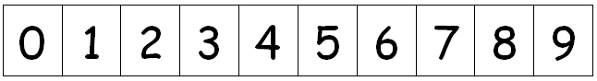

**3 ACT TASK:** Super Bowl Numbers

A*dapted from www.101qs.com*

**TASK CONTENT:** Comparing multi-digit whole numbers with the possibility of adding multi-digit whole numbers. Approximate time, 1 class period.

**STANDARDS FOR MATHEMATICAL CONTENT**

**MGSE4.NBT.2** Read and write multi-digit whole numbers using base-ten numerals, number names, and expanded form. Compare two multi-digit numbers based on meanings of the digits in each place, using >, =, and < symbols to record the results of comparisons.

**MGSE4.NBT.4** Fluently add and subtract multi-digit whole numbers using the standard algorithm.

**STANDARDS FOR MATHEMATICAL PRACTICE**

1. Make sense of problems and persevere in solving them.

2. Reason abstractly and quantitatively.

3. Construct viable arguments and critique the reasoning of others.

4. Model with mathematics.

6. Attend to precision.

7. Look for and make use of structure.

**BACKGROUND KNOWLEDGE**

This task follows the 3-Act Math Task format originally developed by Dan Meyer. More information on this type of task may be found at <http://blog.mrmeyer.com/category/3acts/>. A Three-Act Task is a whole-group mathematics task consisting of 3 distinct parts: an engaging and perplexing Act One, an information and solution seeking Act Two, and a solution discussion and solution revealing Act Three. More information along with guidelines for 3-Act Tasks may be found in the ***Guide to Three-Act Tasks*** on georgiastandards.org and the K-5 CCGPS Mathematics Wiki.

Students should have a thorough knowledge by this time of how to compare and order whole numbers. Students must be able to articulate how they know the sizes of digits in a given number and how to equate any number with its word form and/or expanded form. This task provides an opportunity for students to connect numerals from other systems to our base ten system. Students should have flexibility in thinking about numbers and how they relate to the base ten system.

**ESSENTIAL QUESTIONS**

* What kinds of things are large numbers used to measure?
* How can we tell which multi-digit number is the largest or smallest?

**MATERIALS**

* Super Bowl Numbers Student Recording Sheet
* Act 1 video <http://101qs-media.s3.amazonaws.com/videos/2939-super-bowl-numbers.mp4>
* Roman Numeral information (Act 2)
* Act 3 video <http://101qs-media.s3.amazonaws.com/videos/_2330_supe.mp4>

**GROUPING**

Individual/Partner Task

**TASK DESCRIPTION, DEVELOPMENT AND DISCUSSION**

**Comments**

In this task, students will watch a video and then tell what they noticed. Next, they will be asked to discuss what they wonder about or are curious about. Their curiosities will be recorded as questions on a class chart or on the board. Students will then use mathematics to answer their own questions. Students will be given information to solve the problem based on need. When they realize they don’t have the information they need, and ask for it, it will be given to them.

**Task Directions**

**Act I – Whole Group** - Pose the conflict and introduce students to the scenario by showing Act I video.

1. Students are shown the video: <http://101qs-media.s3.amazonaws.com/videos/2939-super-bowl-numbers.mp4>. Students may need to view the video multiple times. If Windows is being used as the browser to open the video, there may be trouble when the video tries to open. Open the browser Chrome and copy and paste the aforementioned link in the address bar and click “Enter” to access the video.
2. Pass out the 3 Act recording sheet.
3. Ask students what they wonder about and what questions they have about what they saw. Students should share with each other first before sharing aloud and then record these questions on the recording sheet (think-pair-share). The teacher may need to guide students so that the questions generated are math-related.

**Anticipated questions:**

* What was the order of Super Bowls in the video?
* What was the number of the 2014 Super Bowl?
* What will be the number of the 2015 Super Bowl?
* When did these Super Bowls happen?
* How is the Roman Numeral system like our place value system? How are the two different?

1. As the facilitator, you can select which question you would like every student to answer, have students vote on which question the class will answer or allow the students to pick which question they would like to answer. Once the question is selected ask students to estimate answers to their questions (think-pair-share). Students will write their best estimate.

**Act II** – **Student Exploration** - Provide additional information as students work toward solutions to their questions.

1. Ask students to determine what additional information they will need to solve their questions. The teacher provides that information only when students ask for it.

|  |  |  |  |
| --- | --- | --- | --- |
| Basic Roman Numerals    I- 1  V- 5  X- 10  L- 50  C- 100 | Roman Numerals are written in a descending order of quantity. | When a smaller symbol is written to the left of a larger symbol, you must subtract the lesser value from the greater value to determine the actual amount. | XLVIII was the number for 2014’s Super Bowl |

1. Ask students to work in small groups to answer the question(s) they created in Act I. The teacher provides guidance as needed during this phase by asking questions such as:
   * Can you explain what you’ve done so far?
   * What strategies are you using?
   * What assumptions are you making?
   * What tools or models may help you?
   * Why is that true?
   * Does that make sense?

**Act III – Whole Group** - Share student solutions and strategies as well as Act III solution.

1. Ask students to present their solutions and strategies.
2. Share solution in Act III solution. <http://101qs-media.s3.amazonaws.com/videos/_2330_supe.mp4> If Windows is being used as the browser to open the video, there may be trouble when the video tries to open. Open the browser Chrome and copy and paste the aforementioned link in the address bar and click “Enter” to access the video.
3. Lead discussion to compare these, asking questions such as:
   * How reasonable was your estimate?
   * Which strategy was most efficient?
   * Can you think of another method that might have worked?
   * What might you do differently next time?

**Comments**

Act IV is an extension question or situation of the above problem. An Act IV can be implemented with students who demonstrate understanding of the concepts covered in acts II and III. The following questions and/or situations can be used as an Act IV:

* When you are 20 years old, what will the Roman numerals be for the Super Bowl will you watch?

**FORMATIVE ASSESSMENT QUESTIONS**

* What models did you create?
* What organizational strategies did you use?

**DIFFERENTIATION**

**Extension**

* Work more with Roman Numerals:

Roman numerals are used for numbering the Olympics, numbering the Super Bowls, writing outlines and often for copyright dates. Usually the pages before Chapter 1 in a book are written in lowercase Roman numerals. (i, ii, iii, iv, etc.)

a. In 2012 the summer Olympics was in London. What was the Roman numeral representation for this event? _______________

b. In 2016 the summer Olympics will be in Rio de Janiero. What is this year in Roman numerals? _______________

c. A copy of Catcher in the Rye has the copyright date of MCMLI. When was the book written? _______________

d. The movie King Kong was made in MCMXXXIII. When was that? __________

**TECHNOLOGY**

* <http://www.prometheanplanet.com/en-us/Resources/Item/93852/compare-whole-numbers-to-the-millions> This interactive flipchart lesson on comparing whole numbers, can be used with your ActivSlate or Smartboard. It can be used in whole group, small group or student led centers.
* <http://www.aaamath.com/cmp.htm> This online activity has students comparing large numbers and determine their placement in a series of numbers. It can serve as a center activity for practice.

Name: ________________________ *Adapted from Andrew Stadel*

Task Title:

**ACT 1**

|  |
| --- |
| What questions come to your mind? |
| Main question: |

Write an estimate for the question selected in Act 1. Explain your estimates.

________________________________________________________________________________________________________________________________________________________________________________________________________________________________________________________________________________________________________________________________________________________________________________________________________________________________________________________________________________________________

**ACT 2**

|  |
| --- |
| What information would you like to know or need to solve the MAIN question? |
| Use this area for your work, tables, calculations, sketches, and final solution. |

**ACT 3**

|  |
| --- |
| What was the result? |
|  |

**ACT 4 (use this space when necessary)**

**\*\*Practice Task:** Ordering and Comparing Numbers

**TASK CONTENT:** In this task, students will create and order numbers with up to six digits using dice or spinners. Students will order and compare the numbers they have created.

**STANDARDS FOR MATHEMATICAL CONTENT**

**MGSE4.NBT.2** Read and write multi-digit whole numbers using base-ten numerals, number names, and expanded form. Compare two multi-digit numbers based on meanings of the digits in each place, using >, =, and < symbols to record the results of comparisons.

**STANDARDS FOR MATHEMATICAL PRACTICE TO BE EMPHASIZED**

2. Reason abstractly and quantitatively.

4. Model with mathematics.

6. Attend to precision.

**BACKGROUND KNOWLEDGE**

Students should have prior experiences and/or instruction with ordering large numbers. This activity may be used as an assessment or as an independent follow-up activity for reinforcement or review.

**ESSENTIAL QUESTIONS**

* How are large numbers compared?
* What determines the value of a digit in a number?

**MATERIALS**

For Line Them Up:

* 0-9 die or spinner
* “Line Them Up” Recording Sheet

For Dare to Compare:

* 1-6 die or spinner
* Deck of cards (face cards removed)
* “Dare to Compare” recording sheet

**GROUPING**

Partner Task

**NUMBER TALKS**

Please refer to pgs. 272-275 in *Number Talks* by Sherry Parrish for more examples of number talks that will further develop this strategy.

**TASK DESCRIPTION, DEVELOPMENT AND DISCUSSION**

In this task, students order and compare 6-digit numbers generated using dice or spinners. They will place them in ascending and/or descending order. Then they will compare two numbers using a greater than (>), less than (<), or equal to (=) symbol.

**Comments**

**Part 1 – Line Them Up**

* Students will need a partner, a 0-9 die or spinner and a copy of the “Line Them Up” recording sheet. The object of the game is to be the first person to line up six numbers in order from least to greatest or in order from greatest to least.
* Partners need to decide if they will order their numbers from least to greatest or from greatest to least. Students can write their decision above the words “Start” and “Finish” at the bottom of their recording sheet.
* Player 1 will roll a die six times and record the digit rolled each time in the “Digits” column on the “Line Them Up” recording sheet. Then, player 1 will record the number on a blank line at the bottom of the page.
* Player 2 will continue play in the same manner, creating a six digit number from the digits rolled and placing the number on a blank line.
* If digits are rolled and a number cannot be created to fill in a blank line on the gameboard, that player loses a turn.
* Play continues in this manner until one player fills in all six spaces in the correct order.

**Part 2 – Dare to Compare**

* Students will need a partner, a 1-6 die or spinner, a deck of cards and a copy of the “Dare to Compare” recording sheet. The object of the game is to get the most points after eight rounds of play.
* Partners need to remove the face cards (kings, queens and jacks) from the deck. The aces act as the digit one and the ten cards act as the digit zero. Players will need to shuffle the deck of cards and place them face down in the middle of the playing area.
* For each round, the players will take turns turning over the top card on the deck. Each player secretly places the digit somewhere in the place value chart on the recording sheet.
* After all digits have been placed, students write down their number and their partner’s number on one of the two empty lines under the place value chart. Players compare the two numbers placing the appropriate <, > or = symbols between the two numbers.
* One player rolls the die one more time. If an odd digit is rolled, the smaller number wins. If an even digit is rolled, the larger number wins.
* Play continues in this manner for eight rounds.
* Students can place a tally mark on the recording sheet for each round they win. The player with the most tally marks at the end of eight rounds wins the game.

**FORMATIVE ASSESSMENT QUESTIONS**

* How can you tell which number is the largest or smallest?
* What do you do if two tickets have numbers with the same values?
* How could a place value chart help you order the numbers?
* What symbol would be appropriate to compare these two numbers? How do you know?

**DIFFERENTIATION**

**Extension**

* For Line Them Up, students can play with a 1-6 die to limit the digits being used to create numbers. This can make the numbers created more challenging to place.
* For Dare to Compare, have each player roll the die once to determine how many cards they should turn over. Players still secretly place the digits in the place value chart and play the game with the rules stated above.

**Intervention**

* For each game, students can change the number of rolls to create five digit or four digit numbers instead of six digit numbers.

**TECHNOLOGY CONNECTIONS**

* <http://real.doe.k12.ga.us/content/math/destination_math/msc3/msc3/msc3/MSC3/MSC3/Module1/Unit1/Session2/Tutorial.html> This tutorial session involving comparing and ordering large numbers can be used as an introduction to a concept or as remediation for struggling learners.
* <http://www.prometheanplanet.com/en-us/Resources/Item/93852/compare-whole-numbers-to-the-millions> This interactive flipchart lesson on comparing whole numbers, can be used n used with your ActivSlate or Smartboard. It can be used in whole group, small group or student led centers.
* <http://www.aaamath.com/cmp.htm> This online activity has students comparing large numbers and determine their placement in a series of numbers. It can serve as a center activity for practice.

Name __________________________________ Date ____________________________

Line Them Up

|  |  |  |  |
| --- | --- | --- | --- |
| **Digits** | **Number Created** | **Digits** | **Number Created** |
|  |  |  |  |
|  |  |  |  |
|  |  |  |  |
|  |  |  |  |
|  |  |  |  |
|  |  |  |  |
|  |  |  |  |
|  |  |  |  |
|  |  |  |  |
|  |  |  |  |
|  |  |  |  |
|  |  |  |  |

FINISH

START

__________ __________ __________ __________ __________ __________

Dare to Compare

|  |  |  |  |  |  |  |  |  |  |  |  |  |  |  |  |  |  |  |  |  |  |  |  |  |  |
| --- | --- | --- | --- | --- | --- | --- | --- | --- | --- | --- | --- | --- | --- | --- | --- | --- | --- | --- | --- | --- | --- | --- | --- | --- | --- |
| |  |  |  |  |  |  | | --- | --- | --- | --- | --- | --- | | **HTh** | **TTh** | **Th** | **H** | **T** | **O** | |  |  |  |  |  |  |   _________ _________ | |  |  |  |  |  |  | | --- | --- | --- | --- | --- | --- | | **HTh** | **TTh** | **Th** | **H** | **T** | **O** | |  |  |  |  |  |  |   _________ _________ |
| |  |  |  |  |  |  | | --- | --- | --- | --- | --- | --- | | **HTh** | **TTh** | **Th** | **H** | **T** | **O** | |  |  |  |  |  |  |   _________ _________ | |  |  |  |  |  |  | | --- | --- | --- | --- | --- | --- | | **HTh** | **TTh** | **Th** | **H** | **T** | **O** | |  |  |  |  |  |  |   _________ _________ |
| |  |  |  |  |  |  | | --- | --- | --- | --- | --- | --- | | **HTh** | **TTh** | **Th** | **H** | **T** | **O** | |  |  |  |  |  |  |   _________ _________ | |  |  |  |  |  |  | | --- | --- | --- | --- | --- | --- | | **HTh** | **TTh** | **Th** | **H** | **T** | **O** | |  |  |  |  |  |  |   _________ _________ |
| |  |  |  |  |  |  | | --- | --- | --- | --- | --- | --- | | **HTh** | **TTh** | **Th** | **H** | **T** | **O** | |  |  |  |  |  |  |   _________ _________ | |  |  |  |  |  |  | | --- | --- | --- | --- | --- | --- | | **HTh** | **TTh** | **Th** | **H** | **T** | **O** | |  |  |  |  |  |  |   _________ _________ |

Even digit rolled Odd digit rolled

greatest number wins the round least number wins the round

**3 ACT TASK:** NFL Salaries

A*dapted from www.101qs.com*

**TASK CONTENT:** Comparing multi-digit whole numbers with the possibility of adding multi-digit whole numbers. Approximate time: 1 class period.

**STANDARDS FOR MATHEMATICAL CONTENT**

**MGSE4.OA.3 Solve multistep word problems with whole numbers and having whole-number answers using the four operations, including problems in which remainders must be interpreted. Represent these problems using equations with a symbol or letter standing for the unknown quantity. Assess the reasonableness of answers using mental computation and estimation strategies including rounding.**

**MGSE4.NBT.2** Read and write multi-digit whole numbers using base-ten numerals, number names, and expanded form. Compare two multi-digit numbers based on meanings of the digits in each place, using >, =, and < symbols to record the results of comparisons.

**STANDARDS FOR MATHEMATICAL PRACTICE**

1. Make sense of problems and persevere in solving them.

2. Reason abstractly and quantitatively.

3. Construct viable arguments and critique the reasoning of others.

4. Model with mathematics.

6. Attend to precision.

7. Look for and make use of structure.

**BACKGROUND KNOWLEDGE**

This task follows the 3-Act Math Task format originally developed by Dan Meyer. More information on this type of task may be found at <http://blog.mrmeyer.com/category/3acts/>. A Three-Act Task is a whole-group mathematics task consisting of 3 distinct parts: an engaging and perplexing Act One, an information and solution seeking Act Two, and a solution discussion and solution revealing Act Three. More information along with guidelines for 3-Act Tasks may be found in the ***Guide to Three-Act Tasks*** on georgiastandards.org and the K-5 CCGPS Mathematics Wiki.

Students should have a thorough knowledge by this time of how to compare and order whole numbers. Students must be able to articulate how they know the sizes of digits in a given number and how to equate any number with its word form and/or expanded form. Students should know how to round to the nearest whole, ten, hundred, and thousand.

**ESSENTIAL QUESTIONS**

* What kinds of things are large numbers used to measure?
* How can we tell which number multi-digit number is the largest or smallest?

**MATERIALS**

* NFL Salaries Student Recording Sheet
* Base Salaries for Atlanta Falcons graph (Act 1)
* List of players’ salaries (Act 2)

**GROUPING**

Individual/Partner Task

**TASK DESCRIPTION, DEVELOPMENT AND DISCUSSION**

**Comments**

In this task, students will consider the scenario and then tell what they noticed. Next, they will be asked to discuss what they wonder about or are curious about. Their curiosities will be recorded as questions on a class chart or on the board. Students will then use mathematics to answer their own questions. Students will be given information to solve the problem based on need. When they realize they don’t have the information they need, and ask for it, it will be given to them.

**Task Directions**

**Act I – Whole Group** - Pose the conflict and introduce students to the scenario by showing Act I picture.

1. Students are shown the 2014 Base Salaries for the Atlanta Falcons graph.

2014 Base Salaries for the Atlanta Falcons

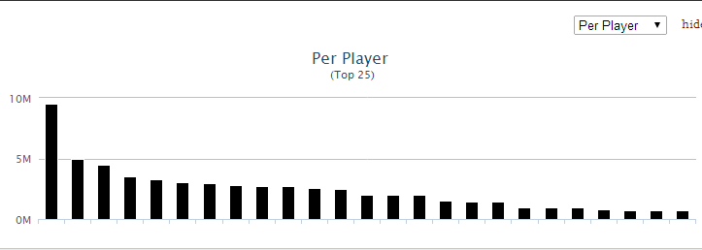

1. Pass out the 3 Act recording sheet.
2. Ask students what they wonder about and what questions they have about what they saw. Students should share with each other first before sharing aloud and then record these questions on the recording sheet (think-pair-share). The teacher may need to guide students so that the questions generated are math-related.

Anticipated questions:

* How much money does the highest paid Falcon make?
* How much more money does the highest paid player make than the lowest paid Falcon?
* How much money do the Falcons pay their top players?
* Which position makes the most money?
* What is Matt Ryan’s monthly salary?

1. As the facilitator, you can select which question you would like every student to answer, have students vote on which question the class will answer or allow the students to pick which question they would like to answer. Once the question is selected ask students to estimate answers to their questions (think-pair-share). Students will write their best estimate, then write two more estimates – one that is too low and one that is too high so that they establish a range in which the solution should occur. Instruct students to record their estimates on a number line.

**Act II** – **Student Exploration** - Provide additional information as students work toward solutions to their questions.

1. Ask students to determine what additional information they will need to solve their questions. The teacher provides that information only when students ask for it.:

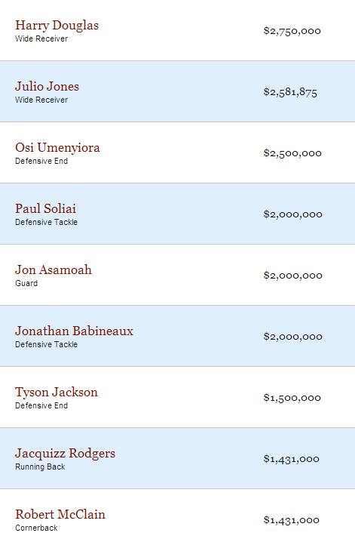

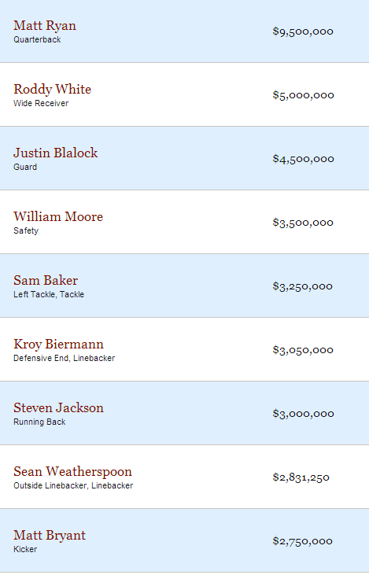

1. Ask students to work in small groups to answer the questions they created in Act I. The teacher provides guidance as needed during this phase by asking questions such as:
   * Can you explain what you’ve done so far?
   * What strategies are you using?
   * What assumptions are you making?
   * What tools or models may help you?
   * Why is that true?
   * Does that make sense?

**Act III – Whole Group** - Share student solutions and strategies as well as Act III solution.

1. Ask students to present their solutions and strategies.
2. Compare solutions.
3. Lead discussion to compare these, asking questions such as:
   1. How reasonable was your estimate?
   2. Which strategy was most efficient?
   3. Can you think of another method that might have worked?
   4. What might you do differently next time?

**Act IV**

Act IV is an extension question or situation of the above problem. An Act IV can be implemented with students who demonstrate understanding of the concepts covered in acts II and III. The following questions and/or situations can be used as an Act IV:

* The Falcons have a salary cap, an amount of money they can spend on personnel, of two hundred forty-six million dollars for next season. Can they keep their top 25 highest paid players without going over the cap? If not, who should they cut and why?

**FORMATIVE ASSESSMENT QUESTIONS**

* What models did you create?
* What organizational strategies did you use?

**DIFFERENTIATION**

**Extension**

* Students can compare data across NFL teams and/or players. This link can be used to find more data: <http://www.spotrac.com/rankings/nfl/> .

**Intervention**

* Students should focus on the top 10 player’s data to answer the question(s).
* Provide students with a place value mat that extends to the millions.

**TECHNOLOGY**

* <http://www.prometheanplanet.com/en-us/Resources/Item/93852/compare-whole-numbers-to-the-millions> This interactive flipchart lesson on comparing whole numbers, can be used n used with your ActivSlate or Smartboard. It can be used in whole group, small group or student led centers.
* <http://www.aaamath.com/cmp.htm> This online activity has students comparing large numbers and determine their placement in a series of numbers. It can serve as a center activity for practice.

Act II Information:

**2014 Base Salaries for the Atlanta Falcons**





Name: ________________________ *Adapted from Andrew Stadel*

Task Title:

**ACT 1**

|  |
| --- |
| What questions come to your mind? |
| Main Question: |
| On an empty number line, record an estimate that is too low, just right and an estimate that is too high. Explain your estimates. |

**ACT 2**

|  |
| --- |
| What information would you like to know or need to solve the MAIN question? |
|  |

Use this area for your work, tables, calculations, sketches, and final solution.

**ACT 3**

|  |
| --- |
| What was the result? |
|  |

**Record the actual answer on the number line above containing the three previous estimates.**

**ACT 4 (use this space when necessary)**

**Constructing Task:** Nice Numbers

**TASK CONTENT:** In this task, students use estimates to add and subtract quantities.

**STANDARDS FOR MATHEMATICAL CONTENT**

**MGSE4.OA.3 Solve multistep word problems with whole numbers and having whole-number answers using the four operations, including problems in which remainders must be interpreted. Represent these problems using equations with a symbol or letter standing for the unknown quantity. Assess the reasonableness of answers using mental computation and estimation strategies including rounding.**

**MGSE4.NBT.3** Use place value understanding to round multi-digit whole numbers to any place.

**MGSE4.NBT.4** Fluently add and subtract multi-digit whole numbers using the standard algorithm.

**MGSE4.MD.2** Use the four operations to solve word problems involving distances, intervals of time, liquid volumes, masses of objects, and money, including problems involving simple fractions or decimals, and problems that require expressing measurements given in a larger unit in terms of a smaller unit. Represent measurement quantities using diagrams such as number line diagrams that feature a measurement scale.

**STANDARDS FOR MATHEMATICAL PRACTICE TO BE EMPHASIZED**

1. Make sense of problems and persevere in solving them.

2. Reason abstractly and quantitatively.

4. Model with mathematics.

5. Use appropriate tools strategically.

6. Attend to precision.

7. Look for and make use of structure.

8. Look for and express regularity in repeated reasoning.

**BACKGROUND KNOWLEDGE**

According to Van De Walle, to round a number simply means to substitute a “nice” number that is close so that some computation can be done more easily. The close number can be any nice number and need not be a multiple of ten or one hundred. It should be whatever makes the computation or estimation easier or simplifies numbers sufficiently in a story, chart, or conversation. (*Van de Walle, Elementary and Middle School Mathematics, 2010*)

**ESSENTIAL QUESTIONS**

* What is a sensible answer to a real problem?
* What information is needed in order to round a whole number to any place?
* How can I ensure my answer is reasonable?
* How can rounding help me compute numbers?

**MATERIALS**

* Nice Numbers recording sheet
* Empty number lines
* Blank number lines labeled in different ways

**GROUPING**

Partner or small group

**NUMBER TALKS**

You may wish to explore the multiplying up strategy discussed on pgs. 293-297 in *Number Talks.* Using what students already know about place value and what happens to a number when they multiply it by 10, they can begin multiplying the divisor by 10, 20, 30 etc. until the find a “nice number” close to the dividend.

**TASK DESCRIPTION, DEVELOPMENT AND DISCUSSION**

**Comments:**

For addition and subtraction problems involving only two terms, one strategy is to round only one of the two numbers. For example, you can round only the subtracted number in 2367-1678 so that an estimate can be found using the problem 2367-1700. Rounding to “nice” numbers depends on what the estimator considers “nice”. The point is that are no rigid rules. Choices depend on the number relationships the estimator is proficient with, how quickly the estimate is needed, and how accurate an estimate needs to be.

**Task Directions:**

Students will follow the directions below from the “Nice Numbers” recording sheet.

* What is the approximate value of this coin collection? Justify your answer.
* The most popular boy band is coming to town for a concert. The concert tickets cost $39.95. Parking at the arena cost $15. About how much will you pay to attend the concert? How do you know?
* Robert and his family traveled from Atlanta, Georgia to Washington D.C. to visit the Martin Luther King Monument. They traveled a total 648 miles. It took them a total of 9 hours to get to Washington, D.C. If they traveled the same route back to Georgia, about how many miles would they drive? Explain your answer.
* For the previous problem, determine the exact mileage for Robert’s family’s trip. Based on your estimation, is your answer reasonable? Explain.

**FORMATIVE ASSESSMENT QUESTIONS**

* What is the problem asking you?
* Does your answer make sense? How do you know?
* How does rounding help you in this context?

**DIFFERENTIATION**

**Extension**

* Plan a family trip, then estimate and calculate the mileage.

**Intervention**

* Provide students with a number line with a range of numbers noted.

**TECHNOLOGY**

* <http://www.bbc.co.uk/skillswise/topic/rounding-and-estimating> This resource starts with descriptions and examples, moves along to quizzes and practice sheets.
* <http://www.prometheanplanet.com/en-us/Resources/Item/99649/rounding> This lesson can be used as a review of the concept of rounding relating to the 3rd grade standard 3.NBT.1. It can serve as a mini-lesson prior to completing this task or an entrance

Name _________________________________________ Date___________________________

Nice Numbers

Directions

What is the approximate value of this coin collection? Justify your answer.

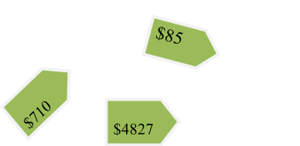

The most popular boy band is coming to town for a concert. The concert tickets cost $39.95. Parking at the arena cost $15. About how much will you pay to attend the concert? How do you know?

Robert and his family traveled from Atlanta, Georgia to Washington D.C. to visit the Martin Luther King Monument. They traveled a total 648 miles. It took them a total of 9 hours to get to Washington, D.C. If they traveled the same route back to Georgia, about how many miles would they drive? Explain your answer.

For the previous problem, determine the exact mileage for Robert’s family’s trip. Based on your estimation, is your answer reasonable? Explain.

**\*\*Constructing Task:** Estimation as a Check

**TASK CONTENT:** Before students attempt this task, they should have had opportunities to work with various contexts which required rounding to determine a reasonable answer. Students should be comfortable using place value concepts within their explanation of a rounded answer.

**STANDARDS FOR MATHEMATICAL CONTENT**

**MGSE4.OA.3 Solve multistep word problems with whole numbers and having whole-number answers using the four operations, including problems in which remainders must be interpreted. Represent these problems using equations with a symbol or letter standing for the unknown quantity. Assess the reasonableness of answers using mental computation and estimation strategies including rounding.**

**MGSE4.NBT.3** Use place value understanding to round multi-digit whole numbers to any place.

**MGSE4.NBT.4** Fluently add and subtract multi-digit whole numbers using the standard algorithm.

**STANDARDS FOR MATHEMATICAL PRACTICE TO BE EMPHASIZED**

1. Make sense of problems and persevere in solving them.

2. Reason abstractly and quantitatively.

4. Model with mathematics.

5. Use appropriate tools strategically.

6. Attend to precision.

7. Look for and make use of structure.

8. Look for and express regularity in repeated reasoning.

**BACKGROUND KNOWLEDGE**

In order for students to be able to round accurately, “rounding should be flexible and well understood conceptually” (Van de Walle, 246). In order for students to conceptually understand rounding, they must be engaged in contexts to allow them to make sense of this concept. This task provides several contexts in which students will have to determine the best estimation for the situation. With these estimations, students will use the most familiar form of estimation, which is known as rounding (Van de Walle, 241).

When students calculate answers using a written algorithm or a calculator, it is essential that they demonstrate good number sense in rejecting answers that are obviously wrong. Estimation is an essential part of number sense that helps students understand if a solution to a problem is reasonable.

**ESSENTIAL QUESTIONS**

* What is a sensible answer to a real problem?
* What information is needed in order to round a whole number to any place?
* How can I ensure my answer is reasonable?
* What effect does a remainder have on my rounded answer?

**MATERIALS**

* Estimation as a Check recording sheet
* Empty number lines

**GROUPING**

Partner or small group

**NUMBER TALKS**

The number talks strategies teaches student how to find an exact answer. However, the adding up in chunks strategy discussed on pgs. 201-204 of Sherry Parrish’s *Number Talks* would help some students see how to make estimations and reasonable answers prior to making their calculations.

**TASK DESCRIPTION, DEVELOPMENT AND DISCUSSION**

**Comments:**

Before students attempt this task, they should have opportunities to work with various contexts which require rounding to determine a reasonable answer. Students should be comfortable using place value concepts within their explanation of a rounded answer. Through context problems, students should have concluded a reasonable rounded answer is based on the context of the situation and not rules or procedures for rounding.

**Task directions:**

Students will solve the four problems on the recording sheet.

**FORMATIVE ASSESSMENT QUESTIONS**

* What is the problem asking you?
* Does your answer make sense? How do you know?
* How does rounding help you in this context?

**DIFFERENTIATION**

**Extension**

* Give students a number that is rounded. Have students create expressions that have a solution that will round to that number. Students can use any operation when creating expressions. For example, if a child is given the number 800, the child could write the expression 234 x 4 as an expression that has a solution that is close to 800.

**Intervention**

* Pair students with a partner so they can have a mathematical conversation about their thoughts and the strategies they are thinking of using.
* Provide students with a number line with a range of numbers noted.

**TECHNOLOGY CONNECTIONS**

* <http://studyjams.scholastic.com/studyjams/jams/math/problem-solving/psestimate-whole-numbers.htm> This resource is an activity with 5-10 multiple choice questions asked in a variety of ways. It can be used as a form of assessment.

Name _________________________________________ Date___________________________

Estimation as a Check

1. For his party, John bought 21 prizes that cost $3.15 each. What is a reasonable estimate of the total cost, not including tax? Explain your thinking.

2. Renee divided a sack of jelly beans equally among eight people. About how many jelly beans did each person get if there were 789 jelly beans in the sack? Explain your thinking.

3. Nancy is estimating answers to these problems:

a) 144 + 460 b) 531 x 3 c) 891 ÷ 3 d) 801 – 310

Part 1: Which problem has a solution greater than 1,000? Explain.

Part 2: Which problem has a solution of about 300? Explain.

Part 3: Which problem has the smallest solution? Explain how you know.

4. Round 2,673 to the nearest thousand, the nearest hundred and the nearest ten.

Part 1: Which place value would you want to round to if the number was the amount of money you won in a contest? Explain why.

Part 2: Which place value would you want to round to if the number was the amount of money you had to pay for an item? Explain why.

**CONSTRUCTING TASK:** Making Sense of the Algorithm

*Adapted from: A Written Form of Subtraction, nzmaths, Adding, Subtraction , and Place Value*

**TASK CONTENT:** This task allows students to make sense of the standard algorithm for subtraction.

**STANDARDS FOR MATHEMATICAL CONTENT**

**MGSE4.NBT.4** Fluently add and subtract multi-digit whole numbers using the standard algorithm.

**STANDARDS FOR MATHEMATICAL PRACTICE TO BE EMPHASIZED**

1. Make sense of problems and persevere in solving them.

2. Reason abstractly and quantitatively.

5. Use appropriate tools strategically.

6. Attend to precision.

7. Look for and make use of structure.

8. Look for and express regularity in repeated reasoning.

**BACKGROUND KNOWLEDGE**

For students who are good at multi-digit addition and subtraction, learning a standard written subtraction algorithm is straightforward, provided they understand the core idea that the particular decomposition needed in a given subtraction algorithm depends on what is subtracted.

**ESSENTIAL QUESTIONS**

* What strategies can I use to help me make sense of a written algorithm?

**MATERIALS**

* Play money if needed
* Base-ten blocks
* Making Sense of the Algorithm recording sheet

**GROUPING**

Individual or partner

**NUMBER TALKS**

Number Talks doesn’t explicitly teach any algorithms, however, many of the talks are crafted in a way that students could gain a better understanding the standard algorithm. For example, the removal strategy discussed on 212-216, as well as the place value and negative number strategy on pgs. 218-220, both help students develop the concept of regrouping. The place value and negative number strategy prepare them for middle school and reinforce the idea that you can subtract a large number from a smaller one. (Number Talks, 2010, Sherry Parrish).

**TASK DESCRIPTION, DEVELOPMENT AND DISCUSSION**

**Comments:**

This task allows students to make sense of the standard algorithm for subtraction. It is important you allow them to grapple with the strategies used by Jane. Through this grappling, students make sense of what Jane did to solve each problem. Through classroom discussion, student understanding will be shared and developed. Therefore, it is not necessary to work them through the methods presented in Jane’s work.

After engaging in this task, students should know that it is mathematically possible to subtract a larger number from a smaller number but the difference would result in a negative number.

**Task directions:**

Students will follow the directions below from the “Making Sense of the Algorithm” recording sheet.

Problems:

1. “To work out 856 – 138, Jane rearranges 856 as 800 + 40 + 16. Why does she do this?”

Explain, using play money, if necessary. *(In the decomposition method of subtraction, there are sufficient hundreds and tens to solve the problem, but there are insufficient ones.)* “So find 856 –138.”

2. “To work out 856 – 162, Jane rearranges 856 as 700 + 150 + 6. Why does she do this?”

Explain, using play money, if necessary. *(In the decomposition method of subtraction, there are sufficient hundreds and ones to solve the problem, but there are insufficient tens.)* “So find 856 – 162.”

3. “To work out 856 – 168, Jane rearranges 856 as 700 + 140 + 16. Why does she do this?” Explain, using play money, if necessary. “So find 856 – 168.”

4. “To work out 856 – 123, Jane does not have to rearrange 856 at all. Why not?”

Explain, using play money, if necessary. “So find 856 – 123.”

Now establish a standard written form for subtraction. A good way to do this is to explain why 546 – 278 require 546 to be renamed 4 hundreds + 13 tens and 16 ones and link this to the problem below.

**FORMATIVE ASSESSMENT QUESTIONS**

* When you write the numbers in expanded form, what do you discover?
* What happens when one number has more or less tens than the other?
* Why do you think Jane rearranged the numbers before subtracting?

**DIFFERENTIATION**

**Extension**

* In each of these subtractions, explain how to split up 953 to solve the problem, then find the answers: 953 – 234; 953 – 184; 953 – 594; 953 – 284; 953 – 388 ...

**Intervention**

* Have students model Jane’s methods using play money or base ten blocks.

**TECHNOLOGY CONNECTIONS**

* https://www.illustrativemathematics.org/content-standards/tasks/1189 To Regroup or Not Regroup is a task from the Illustrative Mathematics website which allows students to create problems where regrouping is necessary in a variety of scenarios.

Name _________________________________________ Date___________________________

Making Sense of the Algorithm

Directions

Problems:

1. To work out 856 – 138, Jane rearranges 856 as 800 + 40 + 16. Why does she do this?

Explain, using play money or base ten blocks, if necessary.

2. To work out 856 – 162, Jane rearranges 856 as 700 + 150 + 6. Why does she do this?

Explain, using play money or base ten blocks, if necessary.

3. To work out 856 – 168, Jane rearranges 856 as 700 + 140 + 16. Why does she do

this? Explain, using play money or base ten blocks, if necessary.

4. To work out 856 – 123, Jane does not have to rearrange 856 at all. Why not?

Explain, using play money or base ten blocks, if necessary.

Now establish a standard written form for subtraction. A good way to do this is to explain why 546 – 278 requires 546 to be renamed 4 hundreds + 13 tens and 16 ones and link this to the problem below.

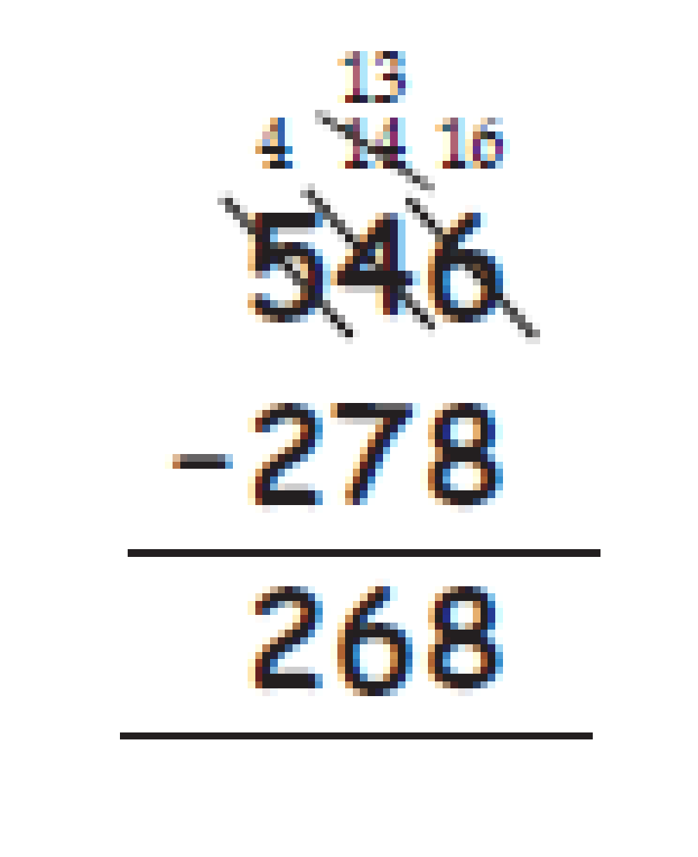

**Constructing Task:** Reality Checking

**TASK CONTENT:** This task provides a real world connection for students to apply the addition and subtraction strategies which helps them explain the standard algorithm.

**STANDARDS FOR MATHEMATICAL CONTENT**

**MGSE4.NBT.4** Fluently add and subtract multi-digit whole numbers using the standard algorithm.

**MGSE4.NBT.3** Use place value understanding to round multi-digit whole numbers to any place.

**MGSE4.NBT.2** Read and write multi-digit whole numbers using base-ten numerals, number names, and expanded form. Compare two multi-digit numbers based on meanings of the digits in each place, using >, =, and < symbols to record the results of comparisons.

**MGSE4.MD.2** Use the four operations to solve word problems involving distances, intervals of time, liquid volumes, masses of objects, and money, including problems involving simple fractions or decimals, and problems that require expressing measurements given in a larger unit in terms of a smaller unit. Represent measurement quantities using diagrams such as number line diagrams that feature a measurement scale.

**STANDARDS FOR MATHEMATICAL PRACTICE TO BE EMPHASIZED**

1. Make sense of problems and persevere in solving them.

2. Reason abstractly and quantitatively.

4. Model with mathematics.

5. Use appropriate tools strategically.

6. Attend to precision.

7. Look for and make use of structure.

8. Look for and express regularity in repeated reasoning.

**BACKGROUND KNOWLEDGE**

When students begin using the standard algorithm their explanation may be quite lengthy. After much practice with using place value to justify their steps, they will develop fluency with the algorithm. Students should be able to explain why the algorithm works. Often students mix up what regrouping looks like in the addition algorithm and what regrouping looks like in the subtraction algorithm. Also students sometimes forget to regroup and just take the smaller digit from the larger one. Emphasize place value and the meaning of each of the digits.

**ESSENTIAL QUESTIONS**

* How can I combine hundreds, tens and ones in two or more numbers efficiently?
* What strategies help me add and subtract multi-digit numbers?
* How does the value of digits in a number help me compare two numbers?
* How can I round to help me find a reasonable answer to a problem?
* How does understanding place value help me explain my method for rounding a number to any place?

**MATERIALS**

* Hundreds chart or number line
* Reality Checking recording sheet

**GROUPING**

Individual or partner

**NUMBER TALKS**

In addition to standard algorithms, students could use a number of strategies to accomplish this task. Various number talks can be found in chapter 6. (Number Talks, 2010, Sherry Parrish).

**TASK DESCRIPTION, DEVELOPMENT AND DISCUSSION**

**Comments:**

This task provides a real world connection for students to apply the addition and subtraction strategies which helps them explain the standard algorithm. Students will engage in the balancing of a mock checking account register. Students will add whole number deposits and subtract whole number withdrawals using addition and subtraction strategies such as place value or the standard algorithm. Students will be required to explain how their understanding of place value helped add and subtract the given amounts.

Within their explanations, students should use language noting the number of hundreds, tens and ones combined and/or separated in order to determine the final balance in the register. Students will also be required to compare the amounts in the banking statement and the register for accurate balancing of the checking account.

A context problem is included to encourage students to think about the reasonableness of their answers. Students will round the determined amount based on the context, so it will be important to keep students grounded in the context. Encourage them to round based on the context and not apply a procedure for rounding.

**Task Directions:**

Students will follow the directions below from the “Reality Checking” recording sheet.

**Part 1:**

1. First finish subtracting the checks and adding the deposit in the check register.
2. First mark off each check and deposit that are in the **check register** and checking statement from Reality Bank. This will tell you which checks and deposits cleared the bank. The check goes underneath the column that has the check in your register.
3. Write down the checks that are i**n the check register and not in the bank statement**. Add up all of these checks. This tells you what checks you wrote but are still outstanding from the bank.
4. Subtract this sum from your **ending balance** on your statement.
5. Add to this balance (line 4) any **deposits** that weren't checked off. The answer that you get here should match the last balance from your check register.

**Part 2:**

After balancing her check register above, Marsha realized she did not include a check she received for her birthday from her grandmother. She remembers depositing the check in the bank on March 29th close to closing time. However, she cannot remember the exact amount of the check. She believes it is between $125 and $130 dollars. About how much will her ending balance be when she includes the amount of her birthday check?

**Part 3:**

After taking a financial course to help her manage her money, Marsha decided to create a monthly budget. She used her March checking register to determine how much money she spent on food, bills like her car payment or phone bill, and spending at her favorite stores. Help Marsha determine in which of the three areas she spends the most money and in which she spends the least. Use what you know about place value to explain which area uses most of her money and which area uses the least of her money.

**FORMATIVE ASSESSMENT QUESTIONS**

* Can you explain how you are subtracting the withdrawals from the balance? Explain how you are adding the deposits to the balance.
* What is the beginning balance in Marsha’s register? What is the ending balance? Which is greater, the beginning balance or the ending balance?
* How can you determine Marsha’s new ending balance after including the birthday check?

**DIFFERENTIATION**

**Extension**

* Have students create a monthly budget for Marsha based on her March spending.

**Intervention**

* Have students use the hundreds chart or number line to aid in rounding the amount of the birthday check and new ending balance.
* Provide students with more entries for the register to require limited addition and subtraction opportunities.
* Have base-ten blocks available to help students formulate their thoughts about using place value to help add and subtract the deposits and withdrawals.

**TECHNOLOGY**

* <https://learnzillion.com/lessons/3122-add-using-the-standard-addition-algorithm> Add using the Addition Standard Algorithm is a video from Learnzillion that can be used as a minilesson to start the lesson.
* <https://learnzillion.com/lessons/3160-subtract-using-the-standard-subtraction-algorithm> Subtract Using the Standard Subtraction Algorithm is a video from Learnzillion that can be used as a minilesson to start the lesson.

Name _________________________________________ Date___________________________



Reality Checking

Directions

**Checking Statement**

**Reality Bank**

**March 1 - 30**

Beginning Balance: $1234.00

Deposits $1800.00

Withdrawals $2095.00

Ending Balance: $939.00

|  |  |  |  |
| --- | --- | --- | --- |
| **Date** | **Check #** | **Amount** | **Balance** |
| 2- Mar | 231 | $300.00 | 934.00 |
| 2-Mar | Deposit | $890.00 | 1824.00 |
| 4-Mar | 223 | $45.00 | 1779.00 |
| 5-Mar | 221 | $35.00 | 1744.00 |
| 6-Mar | 228 | $450.00 | 1294.00 |
| 7-Mar | 229 | $56.00 | 1238.00 |
| 8-Mar | Deposit | $910.00 | 2148.00 |
| 10-Mar | 239 | $430.00 | 1718.00 |
| 13-Mar | 225 | $50.00 | 1668.00 |
| 15-Mar | 226 | $46.00 | 1622.00 |
| 19-Mar | 237 | $52.00 | 1570.00 |
| 23-Mar | 222 | $85.00 | 1485.00 |
| 25-Mar | 232 | $96.00 | 1389.00 |
| 28-Mar | 236 | $125.00 | 1264.00 |
| 28-Mar | 224 | $325.00 | 939.00 |

|  |  |  |  |  |  |  |  |  |  |  |
| --- | --- | --- | --- | --- | --- | --- | --- | --- | --- | --- |
| Check No. | Date | Description of Transaction | (-)  Amount of Payment or Withdrawal | O  T | (+ -)  other | (-)  Amount of Deposit or Interest | Balance   1234.00 |  |  |  |
| 221 | 2/15 | Mr. Jones | 35 | 00 |  |  |  |  | 1199 | 00 |
| 222 | 2/15 | Mrs. Wilkinson | 85 | 00 |  |  |  |  | 1114 | 00 |
| 223 | 2/16 | Phone | 45 | 00 |  |  |  |  | 1069 | 00 |
| 224 | 2/18 | Car Payment | 325 | 00 |  |  |  |  | 744 | 00 |
| 225 | 2/18 | Insurance | 50 | 00 |  |  |  |  | 694 | 00 |
| 226 | 2/20 | Dr. Norris | 46 | 00 |  |  |  |  | 648 | 00 |
| 227 | 2/21 | Groceries | 24 | 00 |  |  |  |  | 624 | 00 |
| Dep | 2/24 | Paycheck |  |  |  |  | 890 | 00 | 1514 | 00 |
| 228 | 2/26 | Rent | 450 | 00 |  |  |  |  |  |  |
| 229 | 2/26 | Groceries | 56 | 00 |  |  |  |  |  |  |
| 230 | 2/28 | Wal-Mart | 10 | 00 |  |  |  |  |  |  |
| 231 | 2/28 | K-mart | 300 | 00 |  |  |  |  |  |  |
| 232 | 2/28 | Dining | 96 | 00 |  |  |  |  |  |  |
| 233 | 2/28 | Cable | 23 | 00 |  |  |  |  |  |  |
| 234 | 2/28 | Pizza | 9 | 00 |  |  |  |  |  |  |
| 235 | 3/1 | Water | 23 | 00 |  |  |  |  |  |  |
| Dep | 3/1 | Paycheck |  |  |  |  | 910 | 00 |  |  |
| 236 | 3/1 | Books | 125 | 00 |  |  |  |  |  |  |
| 237 | 3/2 | Dining | 52 | 00 |  |  |  |  |  |  |
| 238 | 3/2 | Groceries | 83 | 00 |  |  |  |  |  |  |
| 239 | 3/2 | Visa | 430 | 00 |  |  |  |  |  |  |
| Dep | 3/5 | Paycheck |  |  |  |  | 1123 | 00 |  |  |

**Part 1:**

First finish subtracting the checks and adding the deposit in the check register.

1. First put a mark by each check and deposit that are in the **check register** and checking statement from Reality Bank. This will tell you which checks and deposits cleared the bank. The check mark goes underneath the column that has the check in your register.

2. Write down the checks that are **in the check register and not in the bank statement**. Add up all of these checks. This tells you what checks you wrote but are still outstanding from the bank.

___________________________ ___________________________

___________________________ ___________________________

___________________________ ___________________________

___________________________ Total: ___________________________

3. Subtract this sum from your **ending balance** on your statement.

 ______________________-______________________=____________________

4. Add to this balance (line 4) any **deposits** that weren't checked off. The answer that you get here should match the last balance from your check register.

 ______________________+______________________=____________________

5. Explain how you balanced the equation in problem #5. Use what you know about place value to help you explain how you added the two amounts to make it equal the ending balance in the checking statement.

**Part 2:**

After balancing her check register above, Marsha realized she did not include a check she received for her birthday from her grandmother. She remembers depositing the check in the bank on March 29th close to closing time. However, she cannot remember the exact amount of the check. She believes it is between $125 and $130 dollars. About how much will her ending balance be when she includes the amount of her birthday check?

**Part 3:**

After taking a financial course to help her manage her money, Marsha decided to create a monthly budget. She used her March checking register to determine how much money she spent on food, bills like car payment and phone bill and spending on at her favorite stores. Help Marsha determine which of the three areas she spends the most money and which she spends the least. Use what you know about place value to explain which area uses most of her money and which area uses the least of her money.

**CULMINATING TASK:** It’s in the Numbers!

**TASK CONTENT:** In this culminating task, students will collect data related to U.S. regional demographics, including population, precipitation, and area and use these data to draw conclusions about why people might choose to live there.

**STANDARDS FOR MATHEMATICAL CONTENT**

**MGSE4.OA.3 Solve multistep word problems with whole numbers and having whole-number answers using the four operations, including problems in which remainders must be interpreted. Represent these problems using equations with a symbol or letter standing for the unknown quantity. Assess the reasonableness of answers using mental computation and estimation strategies including rounding.**

**MGSE4.NBT.2** Read and write multi-digit whole numbers using base-ten numerals, number names, and expanded form. Compare two multi-digit numbers based on meanings of the digits in each place, using >, =, and < symbols to record the results of comparisons.

**MGSE4.NBT.3** Use place value understanding to round multi-digit whole numbers to any place.

**STANDARDS FOR MATHEMATICAL PRACTICE TO BE EMPHASIZED**

1. Make sense of problems and persevere in solving them.

2. Reason abstractly and quantitatively.

4. Model with mathematics.

5. Use appropriate tools strategically.

6. Attend to precision.

7. Look for and make use of structure.

**BACKGROUND KNOWLEDGE**

Students should have a thorough knowledge by this time of how to compare and order whole numbers. Students must be able to articulate how they know the sizes of digits in a given number and how to equate any number with its word form and/or expanded form. Students should know how to round to the nearest whole, ten, hundred, and thousand.

**ESSENTIAL QUESTIONS**

* What kinds of things are large numbers used to measure?
* How can we tell which number among many large numbers is the largest or smallest?
* How do people use data to make decisions in their lives?
* How does numerical data inform us when choosing a place to live?

**MATERIALS**

* “It’s in the Numbers! Directions” Student Sheet
* “It’s in the Numbers! Data Collection” Recording Sheet
* “It’s in the Numbers! Questions” Recording Sheet
* Research materials
* Computers with Internet access
* Notebook paper

**GROUPING**

Individual Task

**NUMBER TALKS**

This task allows for review of several number talks strategies. Revisit chapter 8 of Number Talks by Sherry Parrish, and explore the strategies most appropriate for your students, as well as any addition and subtraction strategies that seem applicable and appropriate.

**TASK DESCRIPTION, DEVELOPMENT AND DISCUSSION**

In this culminating task, students will collect data related to U.S. regional demographics, including population, precipitation, and area and use these data to draw conclusions about why people might choose to live there.

**Comments**

This task is intended to serve as a summative assessment. A sample rubric has been provided to support the use of this task as a culminating performance assessment. Students should be given a copy of the rubric as part of the teacher introduction to the assessment so they are aware of the rigor and quality of work that is expected. This task is appropriate to use in a variety of ways, including:

* Peer Review
* Display for parent night
* Portfolio

**Task Directions**

Students will follow the directions below from the “It’s in the Numbers!” Recording Sheet.

Your job is to work on a committee to compare life in different regions of the United States. People will use your information when deciding in which part of the country they want to live.

**FORMATIVE ASSESSMENT QUESTIONS**

* What is the best way to organize your research?
* When comparing numbers how can you check to be sure that the comparisons are correct?
* What strategy for rounding works best for you? Can you demonstrate and explain it to me or another classmate?
* Explain how you know the value of multi-digit number.
* What do the numbers in your chart tell you about a particular region?

**DIFFERENTIATION**

**Extension**

* Activities such as these lend themselves to extended exploration of analyzing data using whole to compare further U.S. demographics and/or countries all over the world. An additional website is offered for the purpose of extending student understanding: <http://www.allcountries.org/uscensus/411_normal_monthly_and_annual_precipitation_selected.html>

**Intervention**

* Help students organize the task and break it into smaller steps.
* Limit the number of student choices in terms of states or research resources to help them use their time wisely.
* Limit the number of regions (not less than three) so students will be able to round and compare sufficient data while avoiding getting bogged down in the research process.

**TECHNOLOGY**

Please refer to the technology links within the previous lessons.

Name __________________________________ Date ______________________

It’s in the Numbers!

Directions

Your job is to work on a committee to compare life in different regions of the United States. People will use your information when deciding in which part of the country they want to live.

Step 1:

* Choose one state from each of the seven geographic regions of the country. Examples of possible states in each region are listed. Use the resources provided to decide which state you will research.
* The geographic regions are:
* New England: Connecticut, Maine, Massachusetts, New Hampshire, Rhode Island
* Mid-Atlantic: Delaware, Maryland, New Jersey, New York, Pennsylvania
* Southeast: Florida, Georgia, North Carolina, South Carolina, Alabama
* Midwest: Illinois, Iowa, Indiana, Kansas, Michigan, Minnesota, Missouri, Nebraska, North Dakota, Ohio, South Dakota, Wisconsin
* Rocky Mountain: Colorado, Idaho, Montana, Nevada, Utah, Wyoming
* Southwest: Arizona, California, New Mexico, Texas
* Northwest: Alaska, Oregon, Washington

Step 2:

* Using appropriate resources, record the information required to complete your data chart.
* Resources such as the Internet, Atlases, Almanacs, and Encyclopedias provide excellent current data.
* Suggested websites for Internet research include:
  + <http://www.census.gov/schools/facts/>
  + <http://www.ers.usda.gov/statefacts/>
  + <http://www.statemaster.com/index.php>
  + <http://www.allcountries.org/uscensus/411_normal_monthly_and_annual_precipitation_selected.html>

Step 3:

* Answer the questions provided using the data charts on your own notebook paper. Explain your answers thoroughly using complete sentences and correct math vocabulary.

|  |  |  |  |  |
| --- | --- | --- | --- | --- |
| **Region** | **State** | **Population** | **Precipitation** | **Size** |
|  |  |  | In inches (use whole numbers) | In square miles (use whole numbers) |
| New England |  |  |  |  |
| Mid-Atlantic |  |  |  |  |
| Southeast |  |  |  |  |
| Midwest |  |  |  |  |
| Rocky Mountain |  |  |  |  |
| Southwest |  |  |  |  |
| Northwest |  |  |  |  |

Name _____________________________ Date __________________

It’s in the Numbers!

Questions

1.If someone wanted to live in a region with a large population, which region would you recommend to them and why?

________________________________________________________________________________

________________________________________________________________________________________________________________________________________________________________

1. If someone wanted to live in a region that didn’t rain much, which region would you recommend to them and why?

________________________________________________________________________________

________________________________________________________________________________________________________________________________________________________________

1. If someone wanted to live in a region that had lots of space in which to move around without a lot of people, which region would you recommend to them and why?

________________________________________________________________________________

________________________________________________________________________________________________________________________________________________________________

1. Which two regions seem most likeeach other? How do you know?

________________________________________________________________________________

________________________________________________________________________________________________________________________________________________________________

1. Write all of the exact data for one state in expanded form and word form.

________________________________________________________________________________

________________________________________________________________________________________________________________________________________________________________

1. In which region would you prefer to live? Explain why, using the data you collected.

________________________________________________________________________________

________________________________________________________________________________________________________________________________________________________________________________________________________________________________________________________________________________________________________________________________

4th Grade Math Unit 1 Performance Assessment RUBRIC

|  |  |  |  |
| --- | --- | --- | --- |
| Standard | Exceeding | Meeting | Not Yet Meeting |
| **MGSE4.OA.3 Solve multistep word problems with whole numbers and having whole-number answers using the four operations, including problems in which remainders must be interpreted. Represent these problems using equations with a symbol or letter standing for the unknown quantity. Assess the reasonableness of answers using mental computation and estimation strategies including rounding.** | Student explanation gives thorough description of numbers involved, the relative size of those numbers in relation to another, and how the number might impact a person’s decision to live in that region. | Student explanation in regards to precipitation demonstrates an understanding of the relative size of various numbers. | Student response shows an inability to accurately equate standard form with either word name or expanded form or both. |
| **MGSE4.NBT.2** Read and write multi-digit whole numbers using base-ten numerals, number names, and expanded form. Compare two multi-digit numbers based on meanings of the digits in each place, using >, =, and < symbols to record the results of comparisons. | Student response shows all correct word and/or expanded form for whole numbers. | Student responses have minor errors in word and/or expanded form for whole numbers. | Student response has errors in word and/or expanded form for whole numbers. |
| **MGSE4.NBT.3 Use** place value understanding to round multi-digit whole numbers to any place. | A student response shows all numbers are rounded to the nearest whole number correctly. | Student responses have minor errors in rounding whole numbers. | Student response has errors in whole number rounding and expanded forms. |