****

**Georgia**

**Standards of Excellence**

**Frameworks**

**Mathematics**

GSE Third Grade

Unit 6: Measurement



**TABLE OF CONTENTS**

Unit Overview 3

Standards for Mathematical Practice 3

Content Standards 4

Big Ideas 5

Essential Questions 5

Concepts and Skills to Maintain 6

Strategies for Teaching and Learning 7

Selected Terms and Symbols 8

Tasks 10

* Let’s Talk About Time 15
* Time to Get Clean 19
* Daily Schedule 24
* Plane Ride 29
* How Do I Spend My Day? 41
* How Many Paper Clips? 48
* Setting the Standard 54
* Making a Kilogram 59
* Worth the Weight 63
* Fill It Up! 70
* More Punch Please! 75
* The Data Station 80
* The Magic Number! 86
* It’s in the Data 90
* Culminating Task: Field Trip to the Zoo 97

\*\*\*Please note that all changes made to the standards will appear in red bold type. Additional changes will appear in green.

**UNIT OVERVIEW**

In this unit students will:

* Tell and write time to the nearest minute and measure time intervals in minutes.
* Solve elapsed time, including word problems, by using a number line diagram.
* Reason about the units of mass and liquid volume.
  + Understand that larger units can be subdivided into equivalent units (partition).
  + Understand that the same unit can be repeated to determine the measure (iteration).
  + Understand the relationship between the size of a unit and the number of units needed (compensatory principle).
* Graph data that is relevant to their lives. While exploring data concepts, students should **P**ose a question, **C**ollect data, **A**nalyze data, and **I**nterpret data (PCAI).

**STANDARDS FOR MATHEMATICAL PRACTICE (SMP)**

This section provides examples of learning experiences for this unit that support the development of the proficiencies described in the Standards for Mathematical Practice. The statements provided offer a few examples of connections between the Standards for Mathematical Practice and the Content Standards of this unit. The list is not exhaustive and will hopefully prompt further reflection and discussion.

1. **Make sense of problems and persevere in solving them.** Students make sense of problems involving intervals of time, measuring and estimating liquid volume and masses, and interpreting scaled picture graphs and scaled bar graphs.
2. **Reason abstractly and quantitatively.** Students demonstrate abstract reasoning by connecting quantity of data and representing the data using a scaled picture graph or scaled bar graph.
3. **Construct viable arguments and critique the reasoning of others.** Students construct and critique arguments regarding their solutions for word problems involving addition and subtraction of time intervals in minutes.
4. **Model with mathematics.** Students represent data in multiple ways using a scaled picture graph, scaled bar graph and line plot. Additionally, they record their thinking using words, pictures, and numbers to further explain their reasoning in problems throughout many of the tasks in this unit.
5. **Use appropriate tools strategically.** Students utilize a number line to assist with determining time intervals to the nearest minute. Students also use estimation when determining liquid volume and masses.
6. **Attend to precision.** Students attend to the language of real-world situations to determine appropriate ways to organize data.
7. **Look for and make use of structure.** Students make sense of structure when looking at multiplicative patterns in word problems.
8. **Look for and express regularity in repeated reasoning.** Students continually evaluate their work by asking themselves “Does this make sense?”

***\*Mathematical Practices 1 and 6 should be evident in EVERY lesson!***

**CONTENT STANDARDS ADDRESED**

Content standards are interwoven and should be addressed throughout the year in as many different units and activities as possible in order to emphasize the natural connections that exist among mathematical topics.

**Solve problems involving measurement and estimation of intervals of time, liquid volumes, and masses of objects.**

**MGSE3.MD.1 Tell and write time to the nearest minute and measure elapsed time intervals in minutes. Solve word problems involving addition and subtraction of time intervals in minutes, e.g., by representing the problem on a number line diagram, drawing a pictorial representation on a clock face, etc.**

**MGSE3.MD.2** Measure and estimate liquid volumes and masses of objects using standard units of grams (g), kilograms (kg), and liters (l). Add, subtract, multiply, or divide to solve one-step word problems involving masses or volumes that are given in the same units, e.g., by using drawings (such as a beaker with a measurement scale) to represent the problem.

**Represent and interpret data.**

**MGSE3.MD.3** Draw a scaled picture graph and a scaled bar graph to represent a data set with several categories. Solve one- and two-step “how many more” and “how many less” problems using information presented in scaled bar graphs. For example, draw a bar graph in which each square in the bar graph might represent 5 pets.

**MGSE3.MD.4** Generate measurement data by measuring lengths using rulers marked with halves and fourths of an inch. Show the data by making a line plot, where the horizontal scale is marked off in appropriate units – whole numbers, halves, or quarters.

For more detailed information about unpacking the content standards, unpacking a task, math routines and rituals, maintenance activities and more, please refer to the Grade Level Overview.

**BIG IDEAS**

*Time…*

* The duration of an event is called elapsed time and it can be measured.

*Mass and Liquid Volume…*

* Mass and liquid volume are important parts of everyday life and can determined a variety of ways.
* Larger units can be subdivided into equivalent units (partition).
* The same unit can be repeated to determine the measure (iteration).
* There is a relationship between the size of a unit and the number of units needed (compensatory principle).

*Data and Graphing…*

* Charts, tables, line plot graphs, pictographs, Venn diagrams, and bar graphs may be used to display data.
* One way to compare data is through the use of graphs.
* The scale increments used when making a bar graph is determined by the scale intervals being graphed.

**ESSENTIAL QUESTIONS**

*Telling Time…*

* What strategies can I use to help me tell and write time to the nearest minute and measure time intervals in minutes?
* How can I use what I know about number lines to help me figure out how much time has passed between two events?

*Liquid Volume and Mass…*

* What happens when your units of measure change?
* Why is it important to know the mass of an object?
* In what ways can we determine the mass of an object?
* What units are appropriate to measure mass?
* How are units in the same system of measurement related?
* What strategies could you use to figure out the mass of multiple objects?
* What are some ways I can measure the liquid volume?

*Graphing and Data…*

* · How are tables, bar graphs, and line plot graphs useful ways to display data?
* · How can you use graphs to answer a question?
* · How can surveys be used to collect data?
* · How can surveys be used to gather information?
* · How can graphs be used to display data gathered from a survey?

**CONCEPTS AND SKILLS TO MAINTAIN**

It is expected that students will have prior knowledge/experience related to the concepts and skills identified below. It may be necessary to pre-assess in order to determine if time needs to be spent on conceptual activities that help students develop a deeper understanding of these ideas.

* Fluency with basic addition and subtraction
* Conceptual understanding of multiplication
* Duration and sequence of events
* Telling time
* Comparison/Estimation/Ordering of measurements (length, weight, liquid volume)
* Use straight edge and pencil to draw straight lines
* Measurement to the nearest inch
* Collecting and representing data
* Interpreting line plot and bar graphs
* Organizing and recording data using objects, pictures, pictographs, bar graphs, and simple charts/tables
* Relate addition and subtraction to length
* Using and understanding number lines

**Fluency**: Procedural fluency is defined as skill in carrying out procedures flexibly, accurately, efficiently, and appropriately. Fluent problem solving does not necessarily mean solving problems within a certain time limit, though there are reasonable limits on how long computation should take. Fluency is based on a deep understanding of quantity and number.

**Deep Understanding**: Teachers teach more than simply “how to get the answer” and instead support students’ ability to access concepts from a number of perspectives. Therefore students are able to see math as more than a set of mnemonics or discrete procedures. Students demonstrate deep conceptual understanding of foundational mathematics concepts by applying them to new situations, as well as writing and speaking about their understanding.

**Memorization**: The rapid recall of arithmetic facts or mathematical procedures. Memorization is often confused with fluency. Fluency implies a much richer kind of mathematical knowledge and experience.

**Number Sense:** Students consider the context of a problem, look at the numbers in a problem, make a decision about which strategy would be most efficient in each particular problem. Number sense is not a deep understanding of a single strategy, but rather the ability to think flexibly between a variety of strategies in context.

**Fluent students**:

* flexibly use a combination of deep understanding, number sense, and memorization.
* are fluent in the necessary baseline functions in mathematics so that they are able to spend their thinking and processing time unpacking problems and making meaning from them.
* are able to articulate their reasoning.
* find solutions through a number of different paths.

For more about fluency, see: <http://www.youcubed.org/wp-content/uploads/2015/03/FluencyWithoutFear-2015.pdf>  and: <http://joboaler.com/timed-tests-and-the-development-of-math-anxiety/>

**STRATEGIES FOR TEACHING AND LEARNING**

*Taken from:* [*http://www.education.ohio.gov/GD/Templates/Pages/ODE/ODEDetail.aspx?Page=3&TopicRelationID=1704&Content=118060*](http://www.education.ohio.gov/GD/Templates/Pages/ODE/ODEDetail.aspx?Page=3&TopicRelationID=1704&Content=118060)

**Solve problems involving measurement and estimation of intervals of time, liquid volumes, and masses of objects.**

**MGSE3.MD.1** **Tell and write time to the nearest minute and measure elapsed time intervals in minutes. Solve word problems involving addition and subtraction of time intervals in minutes, e.g., by representing the problem on a number line diagram, drawing a pictorial representation on a clock face, etc.**

**MGSE3.MD.2** Measure and estimate liquid volumes and masses of objects using standard units of grams (g), kilograms (kg), and liters (l). Add, subtract, multiply, or divide to solve one-step word problems involving masses or volumes that are given in the same units, e.g., by using drawings (such as a beaker with a measurement scale) to represent the problem.

*Time…*

* A clock is a common instrument for measuring time. Learning to tell time has much to do with learning to read a dial-type instrument and little to do with time measurement.
* Students have experience in telling and writing time from analog and digital clocks to the hour and half hour in Grade 1 and to the nearest five minutes, using a.m. and p.m. in Grade 2. Now students will tell and write time to the nearest minute and measure time intervals in minutes.
* Provide analog clocks that allow students to move the minute hand.
* Students need experience representing time from a digital clock to an analog clock and vice versa.
* Provide word problems involving addition and subtraction of time intervals in minutes. Have students represent the problem on a number line. Student should relate using the number line with computation from Grade 2.

*Liquid Volume and Mass…*

* Provide opportunities for students to use appropriate tools to measure and estimate liquid volumes in liters only and masses of objects in grams and kilograms. Students need practice in reading the scales on measuring tools since the markings may not always be in intervals of one. The scales may be marked in intervals of two, five or ten.
* Allow students to hold gram and kilogram weights in their hand to use as a benchmark. Use water colored with food coloring so that the water can be seen in a beaker.
* Students should estimate liquid volumes and masses before actually finding the measuring. Show students a group containing the same kind of objects. Then, show them one of the objects and tell them its weight. Fill a container with more objects and ask students to estimate the weight of the objects.
* Use similar strategies with liquid measures. Be sure that students have opportunities to pour liquids into different size containers to see how much liquid will be in certain whole liters. Show students containers and ask, “How many liters do you think will fill the container?”

**Represent and interpret data.**

**MGSE3.MD.3** Draw a scaled picture graph and a scaled bar graph to represent a data set with several categories. Solve one- and two-step “how many more” and “how many less” problems using information presented in scaled bar graphs. For example, draw a bar graph in which each square in the bar graph might represent 5 pets.

**MGSE3.MD.4** Generate measurement data by measuring lengths using rulers marked with halves and fourths of an inch. Show the data by making a line plot, where the horizontal scale is marked off in appropriate units – whole numbers, halves, or quarters.

*Data and Graphing…*

* Representation of a data set is extended from picture graphs and bar graphs with single-unit scales to scaled picture graphs and scaled bar graphs. Intervals for the graphs should relate to multiplication and division with 100 (product is 100 or less and numbers used in division are 100 or less). In picture graphs, use values for the icons in which students are having difficulty with multiplication facts. For example, an icon represents 7 people. If there are three icons, students should use known facts to determine that the three icons represents 21 people. The intervals on the vertical scale in bar graphs should not exceed 100.
* Students are to draw picture graphs in which a symbol or picture represents more than one object. Bar graphs are drawn with intervals greater than one. Ask questions that require students to compare quantities and use mathematical concepts and skills. Use symbols on picture graphs that student can easily represent half of, or know how many half of the symbol represents.
* Students are to measure lengths using rulers marked with halves and fourths of an inch and record the data on a line plot. The horizontal scale of the line plot is marked off in whole numbers, halves or fourths. Students can create rulers with appropriate markings and use the ruler to create the line plots.

\*\*For additional assistance see the [Unit Webinar](https://www.georgiastandards.org/Common-Core/Pages/Math.aspx) at Georgiastandards.org.

**SELECTED TERMS AND SYMBOLS**

The following terms and symbols are often misunderstood. These concepts are not an inclusive list and should not be taught in isolation. However, due to evidence of frequent difficulty and misunderstanding associated with these concepts, teachers should pay particular attention to them and how their students are able to explain and apply them.

The terms below are **for teacher reference only** and are not to be memorized by the students. Teachers should present these concepts to students with models and real life examples. Students should understand the concepts involved and be able to recognize and/or demonstrate them with words, models, pictures, or numbers. [Mathematics Glossary](http://www.corestandards.org/Math/Content/mathematics-glossary/glossary/)

* decompose
* elapsed time
* estimate
* gap
* gram (g)
* hour
* kilogram (kg)
* liquid volume
* liter (l)
* mass
* measure
* metric
* minute
* nonstandard units
* standard units
* time
* time intervals

**BIG IDEAS**

By the conclusion of this unit, students should be able to demonstrate the following competencies:

*Time…*

* Tell time to the minute.
* Solve elapsed time, including word problems.
* Use a number line to solve for elapsed time

*Mass and Liquid Volume…*

* Reason about the units of mass and liquid volume and demonstrate a basic understanding of the size and weight of a liter, a gram, and a kilogram.
* Solve one-step word problems about mass and liquid volume that include the same units.

*Data and Graphing…*

* Read and solve problems using scaled graphs using different intervals.
* Use understanding of number facts to create
* Use the PCAI model to **P**ose a question, **C**ollect data, **A**nalyze data, and **I**nterpret data and graph data that is relevant to their lives.

**TASKS**

The following tasks represent the level of depth, rigor, and complexity expected of all students. These tasks or a task of similar depth and rigor should be used to demonstrate evidence of learning. It is important that all standards of a task be addressed throughout the learning process so that students understand what is expected of them. While some tasks are identified as performance tasks, they may also be used for teaching and learning (constructing task).

|  |  |
| --- | --- |
| **Scaffolding Task** | Tasks that build up to the learning task. |
| **Constructing Task** | Constructing understanding through deep/rich contextualized problem solving tasks. |
| **Practice Task** | Tasks that provide students opportunities to practice skills and concepts. |
| **Performance Task** | Tasks which may be a formative or summative assessment that checks for student understanding/misunderstanding and or progress toward the standard/learning goals at different points during a unit of instruction. |
| **Culminating Task** | Designed to require students to use several concepts learned during the unit to answer a new or unique situation. Allows students to give evidence of their own understanding toward the mastery of the standard and requires them to extend their chain of mathematical reasoning. |
| **Formative Assessment Lesson (FAL)** | Lessons that support teachers in formative assessment which both reveal and develop students’ understanding of key mathematical ideas and applications. These lessons enable teachers and students to monitor in more detail their progress towards the targets of the standards. |
| **CTE Classroom Tasks** | Designed to demonstrate how the Georgia Standards of Excellence and Career and Technical Education knowledge and skills can be integrated. The tasks provide teachers with realistic applications that combine mathematics and CTE content. |
| **3-Act Task** | A Three-Act Task is a whole-group mathematics task consisting of 3 distinct parts: an engaging and perplexing Act One, an information and solution seeking Act Two, and a solution discussion and solution revealing Act Three. More information along with guidelines for 3-Act Tasks may be found in the ***Guide to Three-Act Tasks*** on georgiastandards.org and the K-5 CCGPS Mathematics Wiki. |

Although the units in this instructional framework emphasize key standards and big ideas at specific times of the year, routine topics such as estimation, mental computation, and basic computation facts should be addressed on an ongoing basis. Ideas related to the eight practice standards should be addressed constantly as well. This unit provides much needed content information and excellent learning activities. However, the intent of the framework is not to provide a comprehensive resource for the implementation of all standards in Unit 6. A variety of resources should be utilized to supplement this unit. The tasks in this unit framework illustrate the types of learning activities that should be utilized from a variety of sources. To assure that this unit is taught with the appropriate emphasis, depth, and rigor, it is important that the **“Strategies for Teaching and Learning”** and the tasks listed under **“Big Ideas”** be reviewed early in the planning process.

|  |  |  |  |  |
| --- | --- | --- | --- | --- |
| **Task Name** | **Task Type**  ***Grouping Strategy*** | **Content Addressed** | **Standard(s)** | **Description** |
| [Let’s Talk About Time](#LetsTalkAboutTime) | Scaffolding Tasks  *Individually, Pairs, or*  *Small Group Task* | Time to the Minute, Elapsed Time | MGSE3.MD.1 | In this task, students will work with familiar schedules and lengths of time to find elapsed time. |
| [Time to Get Clean](#id.3r4jijckq79a) | Constructing Task  *Partner/Small Group Task* | Problem Solving with Elapsed Time | MGSE3.MD.1 | In this task, students will examine a family’s morning bathroom routine. They will discuss and explore telling time to the minute as well as elapsed time. |
| [Daily Schedule](#id.iylb6pmfesr5) | Constructing Task  *Whole Group/Individual Task* | Elapsed Time | MGSE3.MD.1 | In this task, students will record and draw time to the nearest minute and calculate elapsed time in 15, 30, and 60 minute intervals. |
| [Plane Ride](#planeride) | 3-Act Task  *Whole Group* | Elapsed Time | MGSE3.MD.1 | In this task, students will view a picture and tell what they noticed. Next, they will be asked to discuss what they wonder about or are curious about. Students will then use mathematics to answer their own questions |
| [How Do I Spend My Day?](#howdoispendmyday) | Constructing Task  *Individual/Partner Task* | Collect, Record, and Display Data  (tables, line plots, bar graphs)  Elapsed Time | MGSE3.MD.1  MGSE3.MD.3 | In this task, students track how they use their time during the week. Using these results, students create a bar graph and then write a letter a paragraph explaining the amount of time spent watching television. |
| [How Many Paper Clips?](#Howmanypaperclips) | Constructing Task  *Small Group Task* | Use a balance scale; Estimate and measure using a non-standard unit | MGSE3.MD.2 | In this task, students will explore weight using simple household items and a balance scale. Students are introduced to the need for standardized units while exploring weight using paper clips. |
| [Setting the Standard](#settingthestandard) | Constructing Task  *Small Group Task* | Understand and use a standard unit of measure (gram) | MGSE3.MD.2 | In this task, students transition from non-standard to a standard unit of measure (grams). Then students use grams to measure the weight of fruit. |
| [Making a Kilogram](#makingakilogram) | Constructing Task  *Whole Group/Individual Task* | Use a spring scale;  Estimate and measure using kilograms | MGSE3.MD.2 | In this task, students will experience how heavy a kilogram is and develop a conceptual understanding of a kilogram. Students will then use that experience to estimate the weight of everyday items |
| [Worth the Weight](#id.804e99gyxczl) | Constructing Task  *Small Group Task* | Estimate and weigh items using grams and kilograms | MGSE3.MD.2 | In this task, students will experiment with gram and kilogram weights. They will select objects to weigh, estimate their weight, and then use a spring scale to determine the actual weight |
| [Fill It Up!](#id.kzu1dxexpska) | Constructing Task  *Small Group Task* | Estimate and measure capacity using liters | MGSE3.MD.2 | In this task, students estimate and compare liquid volume making connections to everyday items to build understanding of liquid volume  and the liter. |
| [More Punch Please!](#morepunchplease) | Constructing Task  *Small Group Task* | Estimate and measure capacity using liters | MGSE3.MD.2 | In this task, students work with liquid volume to determine the amount of punch needed for a class party. |
| [The Data Station](#id.63i2b64tdmk4) | Scaffolding Tasks  *Individually, Pairs, or*  *Small Groups* | Data and Graphing | MGSE3.MD.3  MGSE3.MD.4 | In this task, students will begin by posing a question. They will then collect, display, and interpret data to the question. Students will need to determine the most appropriate graph to use |
| [The Magic Number](#id.jsqq3vnuhu6f) | Practice Task  *Whole Group/Individual Task* | Elapsed Time | MGSE3.MD.3  MGSE3.NBT.2 | In this task, students will play a game to collect data concerning target numbers and sums. Students will then create a pictograph and bar graph to display results. Students will formulate questions that could be answered using the graphs |
| [It’s in the Data](#id.yqtylrrz4h2e) | Constructing Task  *Small Group Task* | Collect, Record, and Display Data (tables, line plots, bar graphs) | MGSE3.MD.3  MGSE3.MD.4 | In this task, students will collect and display data using line plots and bar graphs. Students will answer teacher provided questions. |
| [**Field Trip to the Zoo**](#id.t2p0vjmfu5j7) | **Culminating Task**  ***Individual*** | Problem solving tasks involving elapsed time, area, perimeter, mass, and capacity | MGSE3.MD.1  MGSE3.MD.2  MGSE3.MD.7  MGSE3.MD.8 | In this three-part task, students will use thinking and problem solving skills to plan a field trip to the zoo that includes a class picnic |

These tasks will help your students build up to the culminating task in this unit. Each task is an opportunity for teachers to formatively assess student knowledge of key concepts and identify strengths, weaknesses, and misunderstandings.

**SCAFFOLDING TASK: LET’S TALK ABOUT TIME**j0234131

*Adapted from North Carolina’s Core Essentials Mathematics Program*

In this task, students will work with familiar schedules and lengths of time to find elapsed time.

**APPROXIMATE TIME:** 1-2 Class Sessions

**CONTENT STANDARDS**

**MGSE3.MD.1 Tell and write time to the nearest minute and measure elapsed time intervals in minutes. Solve word problems involving addition and subtraction of time intervals in minutes, e.g., by representing the problem on a number line diagram, drawing a pictorial representation on a clock face, etc.**

**STANDARDS FOR MATHEMATICAL PRACTICE**

1. Make sense of problems and persevere in solving them.

2. Reason abstractly and quantitatively.

3. Construct viable arguments and critique the reasoning of others.

4. Model with mathematics.

5. Use appropriate tools strategically.

6. Attend to precision.

8. Look for and express regularity in repeated reasoning.

**BACKGROUND KNOWLEDGE**

One expectation in the third grade is for students to solve elapsed time, including word problems. Students could use clock models or number lines to solve. On the number line, students should be given the opportunities to determine the intervals and size of jumps on their number line. Students could use pre-determined number lines (intervals every 5 or 15 minutes) or open number lines (intervals determined by students).

“As a general model for all of these elapsed time problems, suggest that students sketch an empty time line (similar to the empty number line discussed for computation). This is also the physical model suggested in the *Common Core State Standards*. It is important not to be overly prescriptive in telling students how to use the time line because there are various alternatives (Dixon, 2008).” From Second Edition, *Teaching Student-Centered Mathematics* by John Van de Walle.

Example:

Tonya wakes up at 6:45 a.m. It takes her 5 minutes to shower, 15 minutes to get dressed, and 15 minutes to eat breakfast. What time will she be ready for school?

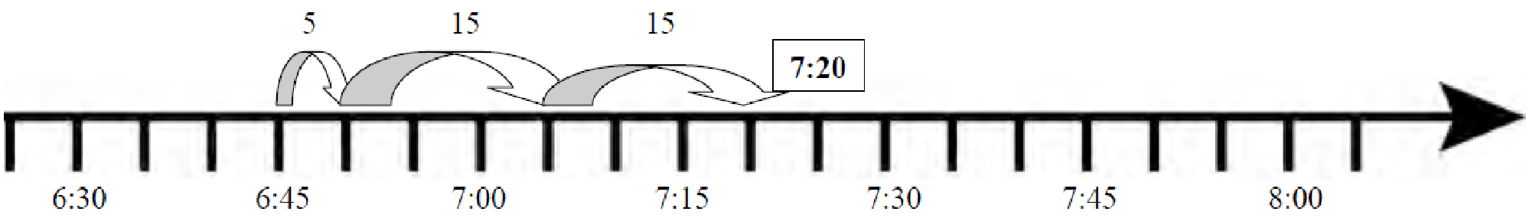

**COMMON MISCONCEPTIONS**

“Student overgeneralizes base-10 and applies it to measurements inappropriately. For example, when asked to change 1 hour 15 minutes to minutes, the student responds with 115 minutes or with 25 minutes. When asked to change 1 hour 15 minutes to hours, the student responds with 1.15 hours.” (from, America’s Choice, *Misconceptions and Errors*)

Students may not understand how noon and midnight are shown on a clock and how this impacts computing elapsed time. Therefore, students may have difficulty counting these intervals of time. (Van de Walle, Grades 3-5, pg.339)

**ESSENTIAL QUESTIONS**

* What does it mean to tell time to the nearest minute?
* What strategies can I use to help me tell and write time to the nearest minute and measure time intervals in minutes?
* What connections can I make between a clock and a number line?
* How can I use what I know about number lines to help me figure out how much time has passed between two events?
* How can we determine the amount of time that passes between two events?
* What part does elapsed time play in our daily living?

**MATERIALS**

* clock
* number lines (teacher created or previously made)
* math journals (or paper)
* manipulatives/cut outs (to help students create models for their problems)

**GROUPING**

Students may be grouped individually, in pairs, or in small groups at the teacher’s discretion.

**NUMBER TALKS**

By now number talks should be incorporated into the daily math routine. Continue utilizing the different strategies in number talks and revisiting them based on the needs of the students.

**TASK DESCRIPTION, DEVELOPMENT AND DISCUSSION**

**Part I (SMP 1, 2, 3, 5, and 6)**

As a class, create a list of people/places that use schedules on a regular basis. Talk about why time to the minute and elapsed time are important. Try these activities to build understanding of time to the minute and elapsed time. Discuss and clarify misunderstandings and misconceptions.

* What strategies can you use to help you figure out time to the minute?
  + Ask students to figure out the time to the minute for various analog clock faces.
  + Using a clock, have students show a selected time while thinking aloud.
* How is figuring out elapsed time like giving back change or counting on? What strategies do you use? Show with pictures, numbers, and words.
* What time is it three hours and thirty minutes before 12:36? Four hours after?

**Part II (SMP 1, 2, 3, 4, 5, and 6)**

“TV Time!”

In small groups, solve this problem. Use pictures, numbers, models, and words to prove your thinking. When you are finished, compare your findings with other groups.

As a group, create a list of 10 to 15 favorite TV shows and the length of time of each. If you watched all of these shows in one week, how much time did you spend watching TV? 

If you started watching all of your favorite TV shows at 8:00 a.m. on Saturday morning, at what time would you finish watching all of your T.V shows?

*Share your findings with a friend.*

**Part III (SMP 1, 2, 3, 4, 5, 6 and 8)**

With a partner, create a number line from 1 to 12. Use your number line to help fill in the movie schedule below for Hollywood 12 Cinema. (Use classroom clock as needed.)

|  |  |  |  |
| --- | --- | --- | --- |
| **Movie** | **Start Time** | **End Time** | **Duration** |
| **Alvin and the Chipmunks** | **12:15** |  | **1 hour, 10 minutes** |
| **Harry Potter** | **2:34** | **4:34** |  |
| **Ice Age** | **4:30** |  | **90 minutes** |
| **The Muppets** |  | **7:20** | **1 hour, 20 minutes** |
| **The Smurfs** | **7:30** | **8:47** |  |

**FORMATIVE ASSESSMENT QUESTIONS**

* How did you determine a start time when the end time and duration were given?
* How did you determine the end time, when the start time and duration were given?
* How did you determine the total time you spent in one week watching T.V?

**DIFFERENTIATION**

**Extension**

* Imagine that you have a friend who can tell time to the nearest five minutes, but cannot tell time to the minute. Write a letter to him/or her explaining how to do it. Try to explain it to them in at least two different ways.
* Larry reads an average of 20 pages in an hour. How many hours will it take him to read 160 pages? 200?

**Intervention**

* Write your daily schedule from the time you wake up, until the time you go to bed. Tell how much time elapses from event to event.
* It takes Nancy 15 minutes to walk one mile. How many miles would she walk in one and a half hours?

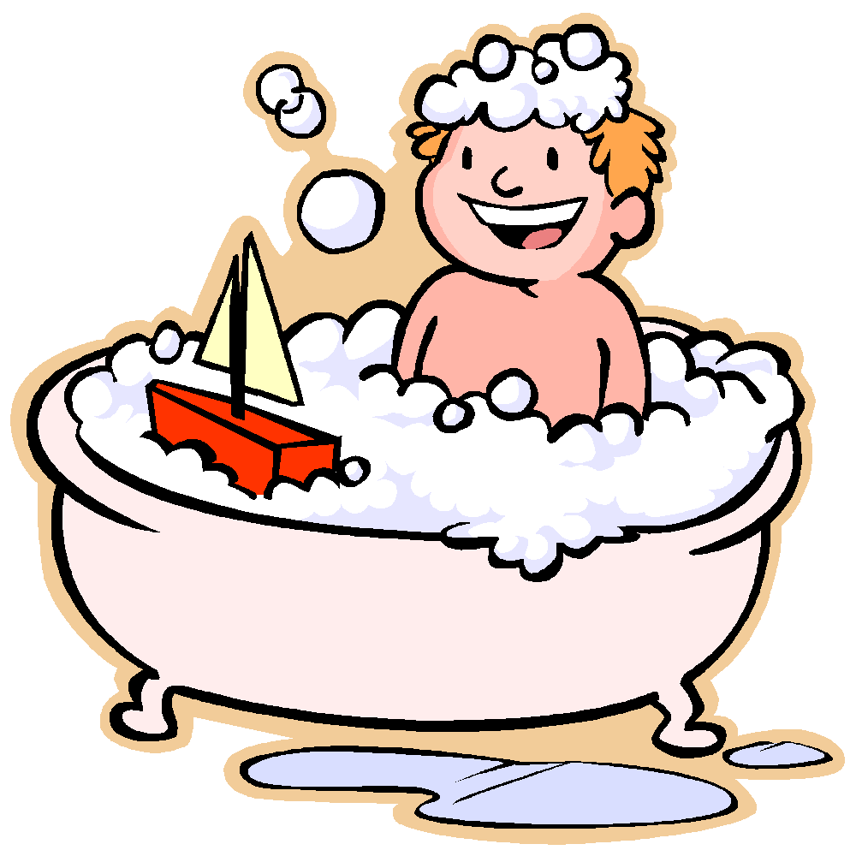**CONSTRUCTING TASK: TIME TO GET CLEAN**

*Adapted from Inside Mathematics (Noyce Foundation)*

In this task, students will examine a family’s morning bathroom routine. They will discuss and explore telling time to the minute as well as elapsed time.

**APPROXIMATE TIME:** 2 Days

**CONTENT STANDARDS**

**MGSE3.MD.1 Tell and write time to the nearest minute and measure elapsed time intervals in minutes. Solve word problems involving addition and subtraction of time intervals in minutes, e.g., by representing the problem on a number line diagram, drawing a pictorial representation on a clock face, etc.**

**STANDARDS FOR MATHEMATICAL PRACTICE**

1. Make sense of problems and persevere in solving them.

2. Reason abstractly and quantitatively.

3. Construct viable arguments and critique the reasoning of others.

4. Model with mathematics.

5. Use appropriate tools strategically.

6. Attend to precision.

8. Look for and express regularity in repeated reasoning.

**BACKGROUND KNOWLEDGE**

In this task, students will record and draw time to the nearest minute and calculate elapsed time in 15, 30, and 60 minute intervals.

Teachers may want to begin with a discussion of daily activities in students’ lives and the amount of time those activities typically take. For example, getting ready for school may begin at 7:06 AM and end at 7:36 AM, a 30 minute duration. Then engage students in a discussion of activities that typically happen during the school day and their estimates of the duration of these activities. One book that explores elapsed time, *The Long Wait* by Annie Cobb, discusses wait-time at an amusement park. As the calculations are made, you should encourage students to explore a linear model of time as well as a traditional analog clock. The linear model can be created using an open number line. Jumps are made from the beginning time to the ending time much like movement on a number line and increments of time may be recorded above the jumps. An example is shown below:

To find the elapsed time from 2:16 pm to 4:31 pm,

* + start with an open number line
  + add the starting time, and
  + then count up to the ending time using jumps that make sense to the students:

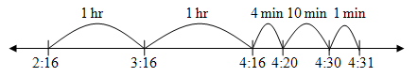

If telling time is built into daily routines, students should have had classroom experiences with telling time to the nearest minute. Daily routines can be extended to elapsed time by asking students the stopping time if they start work now and work for 15 minutes or 30 minutes. Additionally, students could be asked what time they will return to the classroom if they will be returning in one hour.

**COMMON MISCONCEPTIONS**

“Student overgeneralizes base-10 and applies it to measurements inappropriately. For example, when asked to change 1 hour 15 minutes to minutes, the student responds with 115 minutes or with 25 minutes. When asked to change 1 hour 15 minutes to hours, the student responds with 1.15 hours.” (from, America’s Choice, *Misconceptions and Errors*)

Students may not understand how noon and midnight are shown on a clock and how this impacts computing elapsed time. Therefore, students may have difficulty counting these intervals of time. (Van de Walle, Grades 3-5, pg.339)

**ESSENTIAL QUESTIONS**

* What strategies can I use to help me tell and write time to the nearest minute and measure time intervals in minutes?
* How can we determine the amount of time that passes between two events?
* What part does elapsed time play in our daily living?
* How can I demonstrate my understanding of the measurement of time?

**MATERIALS**

* book, *The Long Wait* by Annie Cobb, or similar text
* “Time to Get Clean” student recording sheet
* clock (classroom clock or individual clocks for each student)
* empty number line, or any material students may need to assist them with measuring elapsed time

**GROUPING**

Small Group/Partner Task

**NUMBER TALKS**

By now number talks should be incorporated into the daily math routine. Continue utilizing the different strategies in number talks and revisiting them based on the needs of the students.

**TASK DESCRIPTION, DEVELOPMENT, AND DISCUSSION (SMP 1, 2, 3, 5, and 6)**

Students will follow the directions below from the “Time to Get Clean” student recording sheet.

* Closely examine the *Time to Get Clean* chart below.
* With a partner or small group, fill in the missing parts of this schedule.
* Answer the questions below about the bathroom schedule.
  + Who spends the most time in the bathroom?
  + Who spends the shortest time in the bathroom?
  + How long to Dad and Grandpa spend in the bathroom in all?
  + How much longer does Meagan spend in the bathroom than Carl?
  + The first person goes into the bathroom at 6AM. It is in use until everyone is finished getting clean. At what time will the bathroom be free each day?
  + Choose one person’s bathroom slot. Tell how you figured out their missing information.

**FORMATIVE ASSESSMENT QUESTIONS**

* What strategies did you use to figure out the missing times on the chart?
* What connections can you make to parts of the hour? (half hour, quarter hour, etc?)
* What is the hardest part about telling time to the nearest minute and elapsed time?
* What part of this task did you find was easiest to complete?
* How did you determine the elapsed time?
* Is there more than one way to figure out elapsed time?

**DIFFERENTIATION**

**Extension**

* Have students make and use a list of other values and their equivalents (i.e. ½ hour = 30 minutes).
* Have students create their own schedule with missing values for a classmate to complete.
* Have students prepare a “Telling Time Toolkit” for a visitor from prehistory (or at least before clocks were invented) explaining everything they need to know about telling time to the nearest minute and explaining how to figure out elapsed time.

**Intervention**

* Provide beginning and ending times for activities that do not cross the hour mark. For example, show a beginning time of 11:15 and an ending time of 11:45 for a given activity. Be sure students understand the elapsed time of 30 minutes before moving to activities of a longer duration that begin and end in different hours.
* Only provide the elapsed time in minute form.
* Allow students to use clock, calculators, and number lines for help.
* Facilitate a teacher-guided group.

**TECHNOLOGY CONNECTION**

* <http://nlvm.usu.edu/en/nav/frames_asid_318_g_2_t_4.html>

This website features elapsed time problems using both analog and digital clocks.

* <http://www.shodor.org/interactivate/activities/ElapsedTime/?version=disabled&browser=MSIE&vendor=na&flash=10.0.32>

This website features several activities surrounding elapsed time using analog or digital clocks.

* <http://donnayoung.org/math/clock.htm>

This website has printable blank clock faces.

 **Time to Get Clean!**

The Freeman Family Bathroom is a busy place in the mornings! So, the Freeman kids decided to create a chart for everyone to follow so things wouldn’t get too crowded. There’s one problem. Baby Freeman (Georgie) erased some important parts of the schedule. The Freeman kids are very nervous about this because they will have to show their new schedule to the family tonight and be ready to explain it. Can you help them?

* Closely examine the Freeman Family Morning Bathroom Schedule below.
* Fill in the missing parts of the schedule. Use clocks or other tools to help you.
* Answer the questions about the schedule on the space provided.

**Part I: The Freeman Family Morning Bathroom Schedule**

|  |  |  |  |  |
| --- | --- | --- | --- | --- |
| **Person** | **Activities** | **Start Time** | **End Time** | **Time Taken** |
| Megan | Shower, wash hair, dry hair, brush teeth |  | 6:30 | ½ hour |
| Carl | Shower, brush teeth | 6:30 | 6:56 |  |
| Baby Georgie | Take a bath | 6:56 |  | 24 minutes |
| Mom | Shower, brush teeth |  | 8:05 | ¾ hour |
| Dad | Shower, shave, brush teeth | 8:05 | 8:47 |  |
| Grandpa | Take a bath, shave | 8:47 |  | 35 minutes |

**Part II: Explanations for the Family Meeting**

1. Who spends the most time in the bathroom? \_\_\_\_\_\_\_\_\_\_\_\_\_\_\_\_\_\_\_\_\_\_\_\_\_\_\_\_\_\_\_\_\_\_\_
2. Who spends the shortest time in the bathroom? \_\_\_\_\_\_\_\_\_\_\_\_\_\_\_\_\_\_\_\_\_\_\_\_\_\_\_\_\_\_\_\_\_
3. How long to Dad and Grandpa spend in the bathroom in all? \_\_\_\_\_\_\_\_\_\_\_\_\_\_\_\_\_\_\_\_\_\_
4. How much longer does Meagan spend in the bathroom than Carl? \_\_\_\_\_\_\_\_\_\_\_\_\_\_\_\_\_\_
5. The first person goes into the bathroom at 6AM. It is in use until everyone is finished getting clean. At what time will the bathroom be free each day? \_\_\_\_\_\_\_\_\_\_\_\_\_\_\_\_\_\_\_
6. Choose one person’s bathroom slot. Tell how you figured out their missing information below. \_\_\_\_\_\_\_\_\_\_\_\_\_\_\_\_\_\_\_\_\_\_\_\_\_\_\_\_\_\_\_\_\_\_\_\_\_\_\_\_\_\_\_\_\_\_\_\_\_\_\_\_\_\_\_\_\_\_\_\_\_\_\_\_\_\_\_\_\_\_\_\_\_\_\_\_\_\_\_\_\_\_\_\_\_\_\_\_\_\_\_\_\_\_\_\_\_\_\_\_\_\_\_\_\_\_\_\_\_\_\_\_\_\_\_\_\_\_\_\_\_\_\_\_\_\_\_\_\_\_\_\_\_\_\_\_\_\_\_\_\_\_\_\_

**CONSTRUCTING TASK: DAILY SCHEDULE**

In this task, students will record and draw time to the nearest minute and calculate elapsed time in 15, 30, and 60 minute intervals.



**APPROXIMATE TIME:** 1-2 Days

**CONTENT STANDARDS**

**MGSE3.MD.1 Tell and write time to the nearest minute and measure elapsed time intervals in minutes. Solve word problems involving addition and subtraction of time intervals in minutes, e.g., by representing the problem on a number line diagram, drawing a pictorial representation on a clock face, etc.**

**STANDARDS FOR MATHEMATICAL PRACTICE**

1. Make sense of problems and persevere in solving them.

2. Reason abstractly and quantitatively.

3. Construct viable arguments and critique the reasoning of others.

4. Model with mathematics.

5. Use appropriate tools strategically.

6. Attend to precision.

8. Look for and express regularity in repeated reasoning.

**BACKGROUND KNOWLEDGE**

Teachers may want to begin with a discussion of daily activities in students’ lives and the amount of time those activities typically take. For example, getting ready for school may begin at 7:06 AM and end at 7:36 AM, a 30 minute duration. Then engage students in a discussion of activities that typically happen during the school day and their estimates of the duration of these activities. One book that explores elapsed time, *The Long Wait* by Annie Cobb, discusses wait-time at an amusement park. As the calculations are made, you want to encourage students to explore a linear model of time as well as a traditional analog clock. The linear model can be created using an open number line. Jumps are made from the beginning time to the ending time much like movement on a number line and increments of time may be recorded above the jumps. An example is shown below:

* To find the elapsed time from 2:16 pm to 4:31 pm, start with an open number line.
* Add the starting time.
* Then count up to the ending time using jumps that make sense to the students.



If telling time is built into daily routines, students should have had classroom experiences with telling time to the nearest minute. Daily routines can be extended to elapsed time by asking students the stopping time if they start work now and work for 15 minutes or 30 minutes. Additionally, students could be asked what time they will return to the classroom if they will be returning in one hour.

**COMMON MISCONCEPTIONS**

“Student overgeneralizes base-10 and applies it to measurements inappropriately. For example, when asked to change 1 hour 15 minutes to minutes, the student responds with 115 minutes or with 25 minutes. When asked to change 1 hour 15 minutes to hours, the student responds with 1.15 hours.” (from, America’s Choice, *Misconceptions and Errors*)

Students may not understand how noon and midnight are shown on a clock and how this impacts computing elapsed time. Therefore, students may have difficulty counting these intervals of time. (Van de Walle, Grades 3-5, pg.339)

**ESSENTIAL QUESTIONS**

* How can we determine the amount of time that passes between two events?
* What part does elapsed time play in our daily living?
* What does it mean to tell time to the minute?
* What strategies can I use to help me tell and write time to the nearest minute and measure time intervals in minutes?

**MATERIALS**

* *The Long Wait* by Annie Cobb, or a similar book about elapsed time
* “Daily Schedule” student recording sheet
* Clock (Classroom clock or individual clocks for each student)

**GROUPING**

Whole Group/Individual Task

**NUMBER TALKS**

By now number talks should be incorporated into the daily math routine. Continue utilizing the different strategies in number talks and revisiting them based on the needs of the students.

**TASK DESCRIPTION, DEVELOPMENT, AND DISCUSSION (SMP 1, 2, 3, 4, 5, 6, and 8)**

Note: As students record daily events, be sure the elapsed time is in 15, 30, or 60 minute intervals. Alternatively, provide a daily schedule that is already filled in with start and stop times. Then have students calculate the elapsed time, or duration, of each activity and record it on the chart.

Students will follow the directions below from the “Daily Schedule” student recording sheet.

* In the Daily Schedule chart below, record six of your class’ daily activities.
* Then calculate the elapsed time, or duration, of each activity and record it on the chart.
* Choose three events. List the event and record the start time and end time for each event on the clock faces below.
* Choose one of the events above and explain how you found the elapsed time.

**FORMATIVE ASSESSMENT QUESTIONS**

* How did you determine your start and end times?
* What kinds of activities can you typically complete in a quarter-hour, half-hour and hour?
* How did you determine the elapsed time?
* Is there more than one way to figure out elapsed time?

**DIFFERENTIATION**

**Extension**

* Have students use a digital camera to create an interactive slide show, flipchart, or schedule chart for display of the daily school events.

**Intervention**

* Provide beginning and ending times for activities that do not cross the hour mark. For example, show a beginning time of 11:15 and an ending time of 11:45 for a given activity. Be sure students understand the elapsed time of 30 minutes before moving to activities of a longer duration that begin and end in different hours.
* On a paper divided into fourths, have students list as many things as they can that last approximately 15 minutes/30 minutes/1 hour/more than 1 hour.
* Ask students to complete a similar chart for a typical weekend day.

**TECHNOLOGY CONNECTION**

* <http://nlvm.usu.edu/en/nav/frames_asid_318_g_2_t_4.html>

This website features elapsed time problems using both analog and digital clocks.

* <http://www.shodor.org/interactivate/activities/ElapsedTime/?version=disabled&browser=MSIE&vendor=na&flash=10.0.32>

This website features several activities surrounding elapsed time using analog and digital clocks.

* <http://donnayoung.org/math/clock.htm> Printable blank clock faces.

Name \_\_\_\_\_\_\_\_\_\_\_\_\_\_\_\_\_\_\_\_\_\_\_\_\_\_\_\_\_\_\_\_\_\_\_\_\_ Date \_\_\_\_\_\_\_\_\_\_\_\_\_\_\_\_\_\_\_\_\_\_



Daily Schedule

In the Daily Schedule chart below, record six of your daily class activities. Then calculate the elapsed time, or duration, of each activity and record it on the chart.

|  |  |  |  |
| --- | --- | --- | --- |
| **Daily Schedule** |  |  |  |
| **Event** | **Start Time** | **Stop Time** | **Duration of Event** |
|  |  |  |  |
|  |  |  |  |
|  |  |  |  |
|  |  |  |  |
|  |  |  |  |
|  |  |  |  |

Choose three events. List the event and record the start time and end time for each event on the clock faces below.

1. Event: \_\_\_\_\_\_\_\_\_\_\_\_\_\_\_\_\_\_\_\_\_\_\_\_\_\_\_\_\_\_\_\_\_\_\_\_\_\_\_\_\_\_\_\_\_\_\_\_\_\_\_\_\_\_\_\_\_\_\_\_\_\_\_\_\_\_\_

Start Time End Time

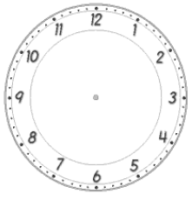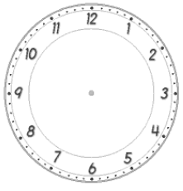

1. Event: \_\_\_\_\_\_\_\_\_\_\_\_\_\_\_\_\_\_\_\_\_\_\_\_\_\_\_\_\_\_\_\_\_\_\_\_\_\_\_\_\_\_\_\_\_\_\_\_\_\_\_\_\_\_\_\_\_\_\_\_\_\_\_\_\_\_\_

Start Time End Time



1. Event: \_\_\_\_\_\_\_\_\_\_\_\_\_\_\_\_\_\_\_\_\_\_\_\_\_\_\_\_\_\_\_\_\_\_\_\_\_\_\_\_\_\_\_\_\_\_\_\_\_\_\_\_\_\_\_\_\_\_\_\_\_\_\_\_\_\_\_

Start Time End Time



1. Choose one of the events above and explain how you found the elapsed time.

**3ACT TASK: P****LANE RIDE**

**APPROXIMATE TIME:** 1 class period

**CONTENT STANDARDS**

**MGSE3.MD.1 Tell and write time to the nearest minute and measure elapsed time intervals in minutes. Solve word problems involving addition and subtraction of time intervals in minutes, e.g., by representing the problem on a number line diagram, drawing a pictorial representation on a clock face, etc.**

**STANDARDS FOR MATHEMATICAL PRACTICE**

1. **Make sense of problems and persevere in solving them.** Students must make sense of the problem by identifying what information they need to solve their question.
2. **Reason abstractly and quantitatively.** Students are asked to make an estimate (high and low).
3. **Construct viable arguments and critique the reasoning of others.** After writing down their own questions, students discuss their question with partners, creating the opportunity to construct the argument of why they chose their question, as well as critiquing the questions that others came up with.
4. **Model with mathematics.** Once given the information, the students use that information to develop a mathematical model to solve their question. In this case, students use their gathered information and chosen model (number line, equation, etc.) to find start and end times.
5. **Use appropriate tools strategically.** Students use number lines, drawings, or manipulatives to help them answer their main questions regarding time.
6. **Attend to precision.** Students use vocabulary accurately and in-context as it relates to real-life and elapsed time with increasing precision to discuss their reasoning.
7. **Look for and express regularity in repeated reasoning.** Students continually evaluate their work by asking themselves “Does this make sense?”

**ESSENTIAL QUESTIONS**

In order to maintain a student-inquiry-based approach to this task, it may be beneficial to wait until Act 2 to share the EQ’s with your students. By doing this, students will be allowed the opportunity to be very creative with their thinking in Act 1. By sharing the EQ’s in Act 2, you will be able to narrow the focus of inquiry so that the outcome results in student learning directly related to the content standards aligned with this task.

* How can I demonstrate my understanding of the measurement of time?
* What part does elapsed time play in our daily living?
* What connections can I make between a clock and a number line?

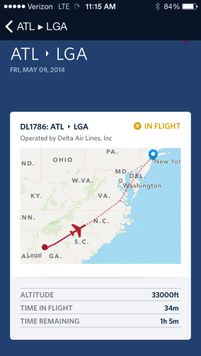**MATERIALS**

* Act 1 picture- Flight Location
* Act 3 picture- Flight Details
* Additional picture attached for possible extension
* Student recording sheet

**GROUPING**

Individual/Partner and or Small Group

**TASK DESCRIPTION, DEVELOPMENT AND DISCUSSION**

In this task, students will view the picture and tell what they noticed. Next, they will be asked to discuss what they wonder about or are curious about. These questions will be recorded on a class chart or on the board and on the student recording sheet. Students will then use mathematics to answer their own questions. Students will be given information to solve the problem based on **need**. When they realize they don’t have the information they need, and ask for it, it will be given to them.

**BACKGROUND KNOWLEDGE:**

This task follows the 3-Act Math Task format originally developed by Dan Meyer. More information on this type of task may be found at <http://blog.mrmeyer.com/category/3acts/>. A Three-Act Task is a whole-group mathematics task consisting of 3 distinct parts: an engaging and perplexing Act One, an information and solution seeking Act Two, and a solution discussion and solution revealing Act Three. More information along with guidelines for 3-Act Tasks may be found in the ***Guide to Three-Act Tasks*** on georgiastandards.org and the K-5 CCGPS Mathematics Wiki.

One expectation in the third grade is for students to solve elapsed time, including word problems.

Students could use clock models or number lines to solve. On the number line, students should

be given the opportunities to determine the intervals and size of jumps on their number line.

“As a general model for all of these elapsed time problems, suggest that students sketch an

empty time line (similar to the empty number line discussed for computation). This is also the

physical model suggested in the Common Core State Standards. It is important not to be overly

prescriptive in telling students how to use the time line because there are various alternatives

(Dixon, 2008).” From Second Edition, Teaching Student-Centered Mathematics by John Van de

Walle.

**COMMON MISCONCEPTIONS:**

“Student overgeneralizes base-10 and applies it to measurements inappropriately. For example, when asked to change 1 hour 15 minutes to minutes, the student responds with 115 minutes or with 25 minutes. When asked to change 1 hour 15 minutes to hours, the student responds with 1.15 hours.” (from America’s Choice, Misconceptions and Errors)

**Task Directions:**

**Act 1 – Whole Group** - Pose the conflict and introduce students to the scenario by showing Act I picture. **(Dan Meyer** <http://blog.mrmeyer.com/2011/the-three-acts-of-a-mathematical-story/>**)**

**“Introduce the central conflict of your story/task clearly, visually, viscerally, using as few words as possible.”**

* Show Act 1 picture – Flight Location to students. 
* Ask students what they noticed in the picture, what they wonder about, and what questions they have about what they saw in the picture. Do a think-pair-share so that students have an opportunity to talk with each other before sharing questions with the whole group.
* Share and record students’ questions. The teacher may need to guide students so that the questions generated are math-related.

**Anticipated questions students may ask and wish to answer:** (\*Main question(s) to be investigated)

* \*What time did the plane depart?
* \*What time will the plane land?
* How much longer is the flight?
* How long have they been in flight?
* How long is the flight?

Once students have their question, ask the students to estimate answers to their questions (think-pair-share). Students will write their best estimate, then write two more estimates – one that is too low and one that is too high so that they establish a range in which the solution should occur. Students should plot their three estimates on an empty number line. Note: As the facilitator, you may choose to allow the students to answer their own posed questions, one question that a fellow student posed, or a related question listed above. For students to be completely engaged in the inquiry-based problem solving process, it is important for them to experience ownership of the questions posed.

Important note: Although students will only investigate the main question(s) for this task, it is important for the teacher to not ignore student generated questions. Additional questions may be answered after they’ve found a solution to the main question, or as homework or extra projects.

**Act 2** – **Student Exploration** - Provide additional information as students work toward solutions to their questions. **(Dan Meyer** <http://blog.mrmeyer.com/2011/the-three-acts-of-a-mathematical-story/>**)**

**“The protagonist/student overcomes obstacles, looks for resources, and develops new tools.”**

* During Act 2, students decide on the facts, tools, and other information needed to answer the question(s) (from Act 1). When students decide what they need to solve the problem, they should ask for those things. It is pivotal to the problem solving process that students decide what is needed without being given the information up front.
* Required Information:

Current time: 11:15

The plane has been in flight for 34 minutes.

The plane has 1 hour 5 minutes remaining.

* The teacher provides guidance as needed during this phase. Some groups might need scaffolds to guide them. The teacher should question groups who seem to be moving in the wrong direction or might not know where to begin. Questioning is an effective strategy that can be used, with questions such as:
  + What is the problem you are trying to solve?
  + What do you think affects the situation?
  + Can you explain what you’ve done so far?
  + What strategies are you using?
  + What assumptions are you making?
  + What tools or models may help you?
  + Why is that true?
  + Does that make sense?

**Act 3 – Whole Group** – Share solutions and strategies.

* Students present their solutions and strategies and compare them.
* Reveal Act 3 picture to students. (Please note the scheduled times and actual times for departure as well as scheduled arrival and estimated arrival.) Students may want to discuss these times in the Act 3 and compare them to their solutions.
* Lead discussion to compare these, asking questions such as:
  + How reasonable was your estimate?
  + Which strategy was most efficient?
  + Can you think of another method that might have worked?
  + What might you do differently next time?

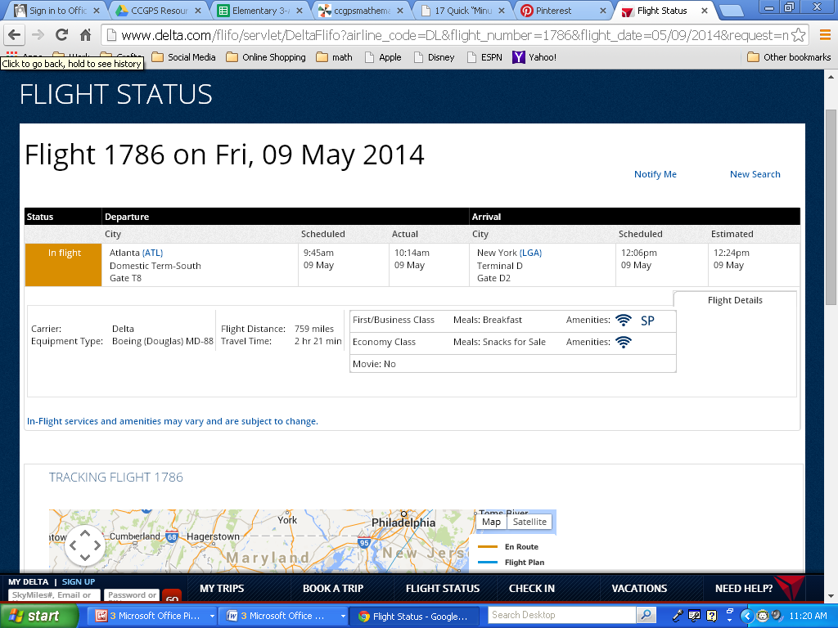

**Act 4, The Sequel -** “The goals of the sequel task are to a) challenge students who finished quickly so b) I can help students who need my help. It can't feel like punishment for good work. It can't seem like drudgery. It has to entice and activate the imagination.” Dan Meyer <http://blog.mrmeyer.com/2013/teaching-with-three-act-tasks-act-three-sequel/>

For Act 4, share ideas below (see extensions) or reference other student-generated questions that could be used for additional classwork, projects or homework.

Act 4 Ideas:

* Did the plane board on schedule? If not, how long was the boarding delayed?
* Once boarded, how long was the plane waiting before take off? (Use the actual boarding time in Act 3 and take off time found by answering one of the main questions.)
* How long between the scheduled arrival time and estimated arrival time?
* Is the plane on schedule to land at the estimated arrival time? Explain your reasoning using specific examples from the problem.

**FORMATIVE ASSESSMENT QUESTIONS**

* What organizational strategies did you use?
* What strategy did you use to find the departure/arrival time?
* What is the hardest part about telling time to the nearest minute and elapsed time?
* How did you determine the elapsed time?
* Is there more than one way to figure out elapsed time? Explain.

**DIFFERENTIATION**

**Extension**

* Provide students with a second flight plan (Flight plans can be found at delta.com) and have them compare and contrast the two flights (time in air, time remaining, etc).
* Allow students to make a schedule with times for the remaining portion of the day once landed in New York. (Start time on schedule should match the arrival time at airport.)
* Students can make a schedule of activities that they did on the flight. For example, watched a 75 minute movie from 10:20-11:35.
* Allow students to estimate how many miles the plane has traveled and how many miles are remaining using the total distance from Act 3. Students may wish to use the additional picture provided with distance scale to help determine mileage.

**Intervention**

* Provide students with number line with intervals labeled. (ex. 30 minute intervals)

Act 1 Picture- Flight Location:

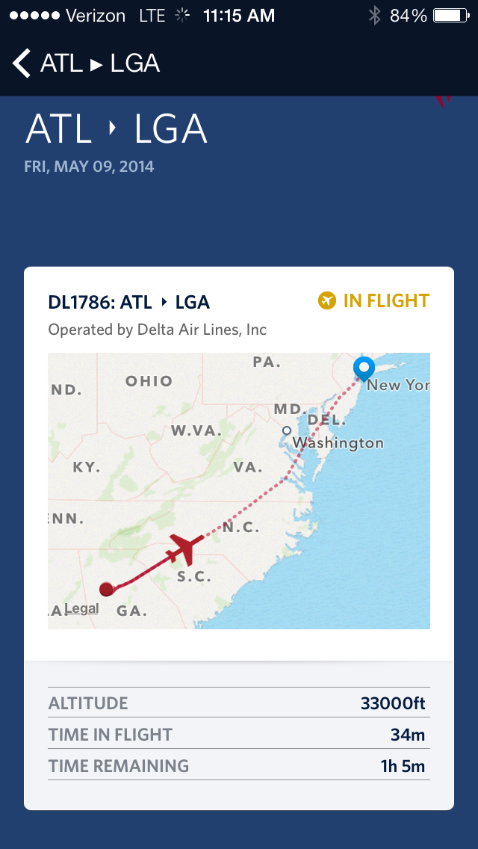

Act 3 Picture- Flight Details:



Additional Picture for possible extension: (flight location matches that on Act 1 picture)

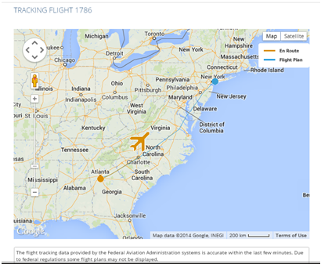

Task Title: \_\_\_\_\_\_\_\_\_\_\_\_\_\_\_\_\_\_\_\_\_\_\_\_ Name: \_\_\_\_\_\_\_\_\_\_\_\_\_\_\_\_\_\_\_\_\_\_\_\_

*Adapted from Andrew Stadel*

**ACT 1**

|  |
| --- |
| What did/do you notice? |
|  |
| What questions come to your mind? |
|  |

**Main Question**: \_\_\_\_\_\_\_\_\_\_\_\_\_\_\_\_\_\_\_\_\_\_\_\_\_\_\_\_\_\_\_\_\_\_\_\_\_\_\_\_\_\_\_\_\_\_\_\_\_\_\_\_\_\_\_\_\_\_\_\_\_\_\_\_

|  |
| --- |
| What is your 1st estimate and why?  On an empty number line, record an estimate that is too low and an estimate that is too high. |

**ACT 2**

|  |
| --- |
| What information would you like to know or need to solve the MAIN question? |
|  |

Record the given information (measurements, materials, etc…)

If possible, give a better estimation with this information: \_\_\_\_\_\_\_\_\_\_\_\_\_\_\_\_\_\_\_\_\_\_\_\_\_\_\_\_\_\_\_

**Act 2 (con’t)**

Use this area for your work, tables, calculations, sketches, and final solution.

**ACT 3**

|  |
| --- |
| What was the result? |
|  |

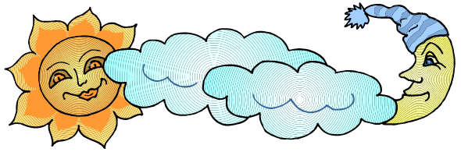**CONSTRUCTING TASK:** **HOW DO I SPEND MY DAY**

Using a recording sheet, students track how they use their time during the week. Using these results students create a bar graph and then write a letter a paragraph explaining the amount of time spent watching television.

**APPROXIMATE TIME*:*** 5 Days

**CONTENT STANDARDS**

**MGSE3.MD.1 Tell and write time to the nearest minute and measure elapsed time intervals in minutes. Solve word problems involving addition and subtraction of time intervals in minutes, e.g., by representing the problem on a number line diagram, drawing a pictorial representation on a clock face, etc.**

**MGSE3.MD.3** Draw a scaled picture graph and a scaled bar graph to represent a data set with several categories. Solve one- and two-step “how many more” and “how many less” problems using information presented in scaled bar graphs. For example, draw a bar graph in which each square in the bar graph might represent 5 pets.

**STANDARDS FOR MATHEMATICAL PRACTICE**

1. Make sense of problems and persevere in solving them.

2. Reason abstractly and quantitatively.

3. Construct viable arguments and critique the reasoning of others.

4. Model with mathematics.

5. Use appropriate tools strategically.

6. Attend to precision.

8. Look for and express regularity in repeated reasoning.

**BACKGROUND KNOWLEDGE**

It is important to understand student interests before beginning Part I of this task. A different question may be more appropriate for different groups of students.

The book *Lemonade for Sale,* by Stuart J. Murphy, or a similar book about using bar graphs to display data would be appropriate to use with this task. The characters in the book keep track of the number of cups of lemonade sold, using tallies and make a bar graph to show how much they’ve sold.

Students should have had opportunities to create and interpret data from bar graphs. Additionally, students should have had opportunities to work with telling time and working with elapsed time.

As elapsed time calculations are made, you may want to encourage students to explore a linear model of time as well as a traditional analog clock. The linear model can be created using an open number line. Jumps are made from the beginning time to the ending time much like movement on a number line and increments of time may be recorded above the jumps. An example is shown below:

To find the elapsed time from 2:15 pm to 4:30 pm,

* start with an open number line,
* add the starting time, and
* then count up to the ending time using jumps that make sense to the students.

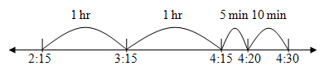

Because students can record their time to the nearest quarter hour, student should use start and finish times to the nearest quarter hour as shown in the example above. The exact start time may have been 2:21, which is closest to 2:15.

**COMMON MISCONCEPTIONS**

“Student overgeneralizes base-10 and applies it to measurements inappropriately. For example, when asked to change 1 hour 15 minutes to minutes, the student responds with 115 minutes or with 25 minutes. When asked to change 1 hour 15 minutes to hours, the student responds with 1.15 hours.” (from, America’s Choice, *Misconceptions and Errors*)

Students may not understand how noon and midnight are shown on a clock and how this impacts computing elapsed time. Therefore, students may have difficulty counting these intervals of time. (Van de Walle, Grades 3-5, pg.339)

**ESSENTIAL QUESTIONS**

* How can we determine the amount of time that passes between two events?
* How can you prove to your parents you do not spend too much time watching television?
* How can you use graphs to draw conclusions?

**MATERIALS**

* “How Do I Spend My Day?” students recording sheet
* Paper, markers, crayons, rulers, and other supplies needed to create graphs

**GROUPING**

Individual/Partner Task

**NUMBER TALKS**

By now number talks should be incorporated into the daily math routine. Continue utilizing the different strategies in number talks and revisiting them based on the needs of the students.

**TASK DESCRIPTION, DEVELOPMENT AND DISCUSSION**

**Part I (SMP 1, 2, 5 and 6)**

To begin this task, discuss possible activities with students – homework, school, eating, watching TV, reading, sports, sleeping, etc. Provide each student with a copy of the template and go through the example of how to complete the chart. Students should record ALL of their possible activities on the blank lines at this time. For the next 5 school days, students should record the time spent on each activity.

* Students should record the time they spend on each activity. This does not have to be an exact time, to the nearest quarter hour is sufficient.
* Check charts daily to ensure that students are keeping up with their data.

Once students have completed data collection, they can begin creating displays for their data.

* Discuss how to display the data. What information will your parents need to be convinced you do not spend too much time watching television? One way to display their data is to find the total number of hours spent on each activity for the week and graph these results.

**Part II (1, 2, 3, 5, and 6)**

Students will follow the directions below from the “How Do I Spend My Day?” student recording sheet.

Your parents claim you are spending too much time watching television during the week. You need to show your parents exactly how little of your time is spent watching television.

Using the recording sheet, keep track of what you do during a normal school week.

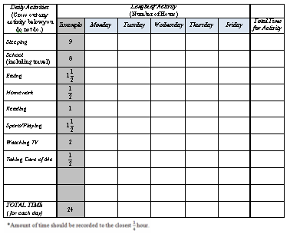

**Part III (SMP 1, 2, 3, 4, 5, 6, and 8)**

After completing your table, complete the following.

1. Use the data above to create a bar graph display of the data.
2. Use the data and your graph to decide whether or not you spend too much time watching television.
3. Write a paragraph explaining how the data informed your decision.

**FORMATIVE ASSESSMENT QUESTIONS**

* What data is important to display in your graph? Why?
* How did you use your data to support your explanation to your parents?
* Do you spend too much time watching television? How do you know? What is “too much”?
* What parts of a graph need to be included?
* What increments will you use to label the scale of your graph? (Typically the scale would be along the vertical axis, but a bar graph can be horizontal or vertical, so don’t limit students to labeling the vertical axis with a scale and the horizontal axis with categories.)
* What categories will you display on your graph? Why did you choose those categories?

**DIFFERENTIATION**

**Extension**

* Ask students to describe how the data could be used to convince parents to allow the student to add an activity to or remove an activity from their weekly schedule. Would this require a new graph? How would it need to be different?

**Intervention**

* Support students in the use of student clocks and/or open number lines to determine elapsed time.
* Allow students to use one of the web-based applications in the “Technology Connection” section below to create a bar graph.

**TECHNOLOGY CONNECTION**

* [*http://illuminations.nctm.org/ActivityDetail.aspx?ID=63*](http://illuminations.nctm.org/ActivityDetail.aspx?ID=63)

Students can use this website to enter their data and create a bar graph.

* <http://www.shodor.org/interactivate/activities/BarGraph/>

This is a different link to the same program as above.

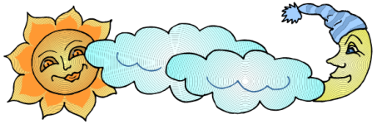Name \_\_\_\_\_\_\_\_\_\_\_\_\_\_\_\_\_\_\_\_\_\_\_\_\_\_\_\_\_\_\_\_\_\_\_\_\_ Date \_\_\_\_\_\_\_\_\_\_\_\_\_\_\_\_\_\_\_\_\_\_\_\_\_\_\_

How Do I Spend My Day?

Your parents claim you are spending too much time watching television during the week. You need to show your parents exactly how little of your time is spent watching television. Using the table below, keep track of what you do during a normal school week.

|  |  |  |  |  |  |  |  |
| --- | --- | --- | --- | --- | --- | --- | --- |
| ***Daily Activities***  (Cross out any activity you do not do.) | ***Length of Activity***  (Number of Hours) |  |  |  |  |  |  |
|  | ***Example*** | ***Monday*** | ***Tuesday*** | ***Wednesday*** | ***Thursday*** | ***Friday*** | ***Total Time for Activity*** |
| *Sleeping* | 9 |  |  |  |  |  |  |
| *School*  (including travel) | 8 |  |  |  |  |  |  |
| *Eating* |  |  |  |  |  |  |  |
| *Homework* |  |  |  |  |  |  |  |
| *Reading* | 1 |  |  |  |  |  |  |
| *Sports/Playing* |  |  |  |  |  |  |  |
| *Watching TV* | 2 |  |  |  |  |  |  |
| *Taking Care of Me* |  |  |  |  |  |  |  |
| ***TOTAL TIME***  *( for each day)* | 24 |  |  |  |  |  |  |

\*Amount of time should be recorded to the closest ¼ hour.

After completing your table, complete the following:

1. Use the data above to create a bar graph display of the data.
2. Use the data and your graph to decide whether or not you spend too much time watching television.
3. Write a paragraph explaining how the data informed you in your decision.

**CONSTRUCTING TASK:** **HOW MANY PAPER CLIPS?**

In this task, students will explore weight using simple household items and a balance scale. Students are introduced to the need for standardized units while exploring weight using paper clips.

**APPROXIMATE TIME:** 2-3 Days

# CONTENT STANDARDS

**MGSE3.MD.2** Measure and estimate liquid volumes and masses of objects using standard units of grams (g), kilograms (kg), and liters (l). Add, subtract, multiply, or divide to solve one-step word problems involving masses or volumes that are given in the same units, e.g., by using drawings (such as a beaker with a measurement scale) to represent the problem.

**STANDARDS FOR MATHEMATICAL PRACTICE**

1. Make sense of problems and persevere in solving them.

2. Reason abstractly and quantitatively.

3. Construct viable arguments and critique the reasoning of others.

4. Model with mathematics.

5. Use appropriate tools strategically.

6. Attend to precision.

8. Look for and express regularity in repeated reasoning.

**BACKGROUND KNOWLEDGE**

The emphasis of this the next few framework tasks within this unit should be placed on measurement.

“Weight is a measure of the pull or force of gravity on an object. Mass is the amount of matter in an object and a measure of the force needed to accelerate it. On the moon, where gravity is much less than on Earth, an object has a smaller weight but the identical mass as on Earth. For practical purposes, on Earth, the measure of mass and weight will be about the same”. (from, Van de Walle, *Teaching Student-Centered Mathematics, Grades 3-5, Volume II*.) As stated in the standard, students are measuring and recording mass, not weight. The correct term for this task is mass.

Students should have some experience using a balance scale and non-standard units of measurement. If necessary, explain to students that a balance scale is a tool that can help them be more accurate when comparing weight and measuring mass.

**COMMON MISCONCEPTIONS**

Students may confuse the amount of objects or size of objects with its weight. For example, if asked which weighs more, a pound of feathers or a pound of bricks, students may answer a pound of bricks. This is due to confusion concerning the weight or attributes of the objects being measured rather than an understanding of standard units of measure.

Confusion occurs in using the terms weight and mass. An 180 pound person has more mass than a 100 pound person. The 180 pound person’s mass remains the same whether on Earth, the moon or Mars. Weight does change depending upon the amount of gravitational pull upon the object. For example, the 180 pound person would weigh ⅙ as much on the moon as the Earth or about 60 pounds.

**ESSENTIAL QUESTIONS**

* What happens when your units of measure change?
* Why is it important to know the mass of an object?
* In what ways can we determine the mass of an object?

**MATERIALS**

For each group:

* “How Many Paper Clips?” student recording sheet
* Set of small objects to measure the mass (steel washer, plastic chip, wooden cube or dice, nickel, etc.)
* Primary balance (directions provided below)
* 100 paper clips (1/2 the class should have regular paper clips and 1\2 should have jumbo paper clips)

**GROUPING**

Small Group Task

**NUMBER TALKS**

By now number talks should be incorporated into the daily math routine. Continue utilizing the different strategies in number talks and revisiting them based on the needs of the students.

**TASK DESCRIPTION, DEVELOPMENT AND DISCUSSION (SMP 1, 2, 3, 4, 5, 6, and 8)**

Students will follow the directions below from the “How Many Paper Clips?” student recording sheet.

**Part 1**

Using a set of items,

* 1. Remove the items from the bag and order them from lightest to heaviest.
  2. Record your results on the chart below.
  3. Write to explain how you decided on the order of the items. Also, be ready to report to the class how you decided on the order.

**Part II**

Using a balance scale,

1. Explore the balance scale using the set of items.
2. Using the balance scale, compare and then order the items in your set from lightest to heaviest.
3. Record your results on the chart.
4. If the order of your items changed, write to explain why any changes that were made. Be prepared to explain to the class why you made any changes to the order of your items

**Part III**

Using paper clips,

1. Use the paper clips to measure the mass of each item in your set.
2. Record the mass of each item in the chart below. Use a number and a label (“jumbo paper clips” or “regular paper clips”) for each item.
3. Write below to explain what you noticed or learned during this task. Be prepared to share findings with the class.

**FORMATIVE ASSESSMENT QUESTIONS**

* What do you notice about the mass of the items in the set?
* Does the size of an object always determine its mass?
  + Can you give an example of a small object that’s mass is more/less than expected?
  + Can you give an example of a large object that’s mass is more/less than expected?
* How do you use measures of mass at home?
* What happens to measurement when you change units?

**DIFFERENTIATION**

**Extension**

Ask students to create a graph for the data collected for the mass of the objects.

**Intervention**

For the third part of the task, give intervention groups a smaller set of items and have them measure the mass of each item twice, once with each size paper clip, and show a direct comparison in a two-column chart.

**TECHNOLOGY CONNECTION**

* <http://public.doe.k12.ga.us/DMGetDocument.aspx/Grade%204%20Unit%203%20Creating%20Scales.pdf?p=6CC6799F8C1371F6CA1D4816B288AA4D386F6BD621BEA7BF4B4B9C6CFBBB4292&amp;Type=D>

This is link to directions on how to make a balance scale and a spring scale using common materials.

Name \_\_\_\_\_\_\_\_\_\_\_\_\_\_\_\_\_\_\_\_\_\_\_\_\_\_\_\_\_\_\_\_\_\_\_\_\_\_\_\_\_ Date \_\_\_\_\_\_\_\_\_\_\_\_\_\_\_\_\_\_\_\_\_\_\_\_\_\_



How Many Paper Clips?

1. Using a set of items.
   1. Remove the items from the bag and order them from lightest to heaviest.
   2. Record your results on the chart below.
   3. Write to explain how you decided on the order of the items. Also, be ready to report to the class how you decided on the order.

\_\_\_\_\_\_\_\_\_\_\_\_\_\_\_\_\_\_\_\_\_\_\_\_\_\_\_\_\_\_\_\_\_\_\_\_\_\_\_\_\_\_\_\_\_\_\_\_\_\_\_\_\_\_\_\_\_\_\_\_\_\_\_\_\_\_\_\_\_\_\_\_\_\_\_\_\_\_

|  |  |  |
| --- | --- | --- |
| **Order Items from**  **Lightest to Heaviest** | **Order Items from**  **Lightest to Heaviest**  **sing the Balance Scale** | **Give the Mass**  **in Paper Clips**  **of Each Object** |
|  |  |  |
|  |  |  |
|  |  |  |
|  |  |  |
|  |  |  |
|  |  |  |

1. Using a balance scale.
   1. Explore the balance scale using the set of items.
   2. Using the balance scale, compare and then order the items in your set from lightest to heaviest.
   3. Record your results on the chart.
   4. If the order of your items changed, write to explain why any changes that were made. Be prepared to explain to the class why you made any changes to the order of your items.

\_\_\_\_\_\_\_\_\_\_\_\_\_\_\_\_\_\_\_\_\_\_\_\_\_\_\_\_\_\_\_\_\_\_\_\_\_\_\_\_\_\_\_\_\_\_\_\_\_\_\_\_\_\_\_\_\_\_\_\_\_\_\_\_\_\_\_\_\_\_\_\_\_\_\_\_\_\_\_\_\_\_\_\_\_\_\_\_\_\_\_\_\_\_\_\_\_\_\_\_\_\_\_\_\_\_\_\_\_\_\_\_\_\_\_\_\_\_\_\_\_\_\_\_\_\_\_\_\_\_\_\_\_\_\_\_\_\_\_\_\_\_\_\_\_\_\_\_\_\_\_\_\_\_\_\_

1. Using paper clips.
   1. Use the paper clips to measure the mass of each item in your set.
   2. Record the mass of each item in the chart below. Use a number and a label (“jumbo paper clips” or “regular paper clips”) for each item.
   3. Write below to explain what you noticed or learned during this task. Be prepared to share findings with the class.

\_\_\_\_\_\_\_\_\_\_\_\_\_\_\_\_\_\_\_\_\_\_\_\_\_\_\_\_\_\_\_\_\_\_\_\_\_\_\_\_\_\_\_\_\_\_\_\_\_\_\_\_\_\_\_\_\_\_\_\_\_\_\_\_\_\_\_\_\_\_\_\_\_\_\_\_\_\_\_\_\_\_\_\_\_\_\_\_\_\_\_\_\_\_\_\_\_\_\_\_\_\_\_\_\_\_\_\_\_\_\_\_\_\_\_\_\_\_\_\_\_\_\_\_\_\_\_\_\_\_\_\_\_\_\_\_\_\_\_\_\_\_\_\_\_\_\_\_\_\_\_\_\_\_\_\_

\_\_\_\_\_\_\_\_\_\_\_\_\_\_\_\_\_\_\_\_\_\_\_\_\_\_\_\_\_\_\_\_\_\_\_\_\_\_\_\_\_\_\_\_\_\_\_\_\_\_\_\_\_\_\_\_\_\_\_\_\_\_\_\_\_\_\_\_\_\_\_\_\_\_\_\_\_\_\_\_\_\_\_\_\_\_\_\_\_\_\_\_\_\_\_\_\_\_\_\_\_\_\_\_\_\_\_\_\_\_\_\_\_\_\_\_\_\_\_\_\_\_\_\_\_\_\_\_\_\_\_\_\_\_\_\_\_\_\_\_\_\_\_\_\_\_\_\_\_\_\_\_\_\_\_\_

\_\_\_\_\_\_\_\_\_\_\_\_\_\_\_\_\_\_\_\_\_\_\_\_\_\_\_\_\_\_\_\_\_\_\_\_\_\_\_\_\_\_\_\_\_\_\_\_\_\_\_\_\_\_\_\_\_\_\_\_\_\_\_\_\_\_\_\_\_\_\_\_\_\_\_\_\_\_\_\_\_\_\_\_\_\_\_\_\_\_\_\_\_\_\_\_\_\_\_\_\_\_\_\_\_\_\_\_\_\_\_\_\_\_\_\_\_\_\_\_\_\_\_\_\_\_\_\_\_\_\_\_\_\_\_\_\_\_\_\_\_\_\_\_\_\_\_\_\_\_\_\_\_\_\_\_

**CONSTRUCTING TASK:** **SETTING THE STANDARD**

In this task, students transition from non-standard to a standard unit of measure (grams). Then students use grams to measure the weight of fruit.

**APPROXIMATE TIME:** 1 Day

**CONTENT STANDARDS**

**MGSE3.MD.2** Measure and estimate liquid volumes and masses of objects using standard units of grams (g), kilograms (kg), and liters (l). Add, subtract, multiply, or divide to solve one-step word problems involving masses or volumes that are given in the same units, e.g., by using drawings (such as a beaker with a measurement scale) to represent the problem.

**STANDARDS FOR MATHEMATICAL PRACTICE**

1. Make sense of problems and persevere in solving them.

2. Reason abstractly and quantitatively.

3. Construct viable arguments and critique the reasoning of others.

4. Model with mathematics.

5. Use appropriate tools strategically.

6. Attend to precision.

8. Look for and express regularity in repeated reasoning.

**BACKGROUND KNOWLEDGE**

The emphasis of this unit should be placed on measurement. In the classroom, teachers should use the correct name (mass or weight) depending of the instrument used to make the measurement. “Weight is a measure of the pull or force of gravity on an object. Mass is the amount of matter in an object and a measure of the force needed to accelerate it. On the moon, where gravity is much less than on Earth, an object has a smaller weight but the identical mass as on Earth. For practical purposes, on Earth, the measure of mass and weight will be about the same”. (Van de Walle, *Teaching Student-Centered Mathematics, Grades 3-5, Volume II*.) As stated in the standard, students are measuring and recording mass, not weight. The correct term for this task is mass.

As a review, ask students to share what they discovered during the previous task. To introduce this task, show a gram weight. Introduce its name and symbol and describe it as a standard unit of weight. Ask students to use the balance scale to compare 1 gram (1g) to both sizes of the paper clips used in the previous task. Show the other gram weights (5g, 10g, and 20g) and have students estimate and then measure how many paper clips would equal each weight. Ask students to share their findings. When discussing the weight of the fruit, guide students to suggest making new units (100g weights). These can be created using a zippered plastic bag and aquarium gravel. Let students show how these can be created. Students should determine that they will have to combine their weight sets to get a total of 100 grams on one side of the balance scale and then measure an equivalent amount of gravel to balance the scale. Provide the fruit and have students measure the fruit using the new and old weights. (A medium apple weighs about 200g.)

Some students may try to name this new unit 100 grams (100g). If so, encourage the use of metric roots and prefixes from prior knowledge to do so (see “Background Knowledge” below.) Finally, collect 10 of the 100g bags and place them in a large zippered plastic bag. Ask students to figure out how much this new unit weighs (1000 g). Guide students to the term kilogram meaning 1000 grams.

Students should have had experience measuring and comparing weight using a balance scale and understand the difference between standard and non-standard units in measurement.

**Remember, in third grade students are only responsible to know and understand the relationship between kilogram and gram**.

**COMMON MISCONCEPTIONS**

Students may confuse the amount of objects or size of objects with its weight. For example, if asked which weighs more, a pound of feathers or a pound of bricks, students may answer a pound of bricks. This is due to confusion concerning the weight or attributes of the objects being measured rather than an understanding of standard units of measure.

Confusion occurs in using the terms weight and mass. An 180 pound person has more mass than a 100 pound person. The 180 pound person’s mass remains the same whether on Earth, the moon or Mars. Weight does change depending upon the amount of gravitational pull upon the object. For example, the 180 pound person would weigh ⅙ as much on the moon as the Earth or about 60 pounds.

**ESSENTIAL QUESTIONS**

* What is the difference between a standard and non-standard unit of measurement?
* What units are appropriate to measure mass?
* How are units in the same system of measurement related?
* What strategies could you use to figure out the mass of multiple objects?
* What happens to an item’s measurement when units are changed?

**MATERIALS**

**For each group**

* Balance scale
* Set of small items (from previous task)
* Set of gram weights (1g, 5g, 10g, and 20g) *Common items weighing 1 gram- 1 lg paper clip, 1 dime, a business card, a dollar bill. 100 grams- 20 nickels (5 grams per nickel)*
* Paper clips (in two sizes from previous task)

**For each student**

* “Setting the Standard” student recording sheet
* Snack-size zippered plastic bag

**For the class**

* 5 lbs aquarium gravel
* Several pieces of fruit (apple, orange, banana)
* One 2-gallon zippered plastic bag (to create a 1 kilogram bag)

**GROUPING**

Small Group Task

**NUMBER TALKS**

By now number talks should be incorporated into the daily math routine. Continue utilizing the different strategies in number talks and revisiting them based on the needs of the students.

**TASK DESCRIPTION, DEVELOPMENT AND DISCUSSION (SMP 1, 2, 3, 5, 6, and 8)**

Students will follow the directions below from the “Setting the Standard” student recording sheet.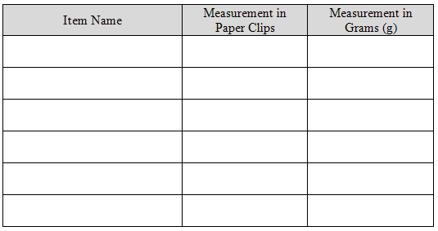

1. Find the mass of each object using paper clips and 1 gram (1 g) weights. Record in the chart below.
2. Place a piece of fruit in your balance scale. Talk with your group about how you would measure the fruit using standard units. Record your thoughts below.
3. Create a three-column chart similar to the one above. Label the first column **Fruit Name**, the second column **Paper Clips**, and the third column **Grams (g)**. Find the mass of each piece of fruit and record it in your chart.

**FORMATIVE ASSESSMENT QUESTIONS**

* What is the difference between a standard and non-standard unit of measurement?
* How can you use gram weights and a balance scale to measure the mass of an object?
* Ask what happens when the unit is too small to measure an object?
* What is the difference between units in the same system of measurement?
* How can you figure out the mass of multiple objects?

**DIFFERENTIATION**

**Extension**

* Ask students to find the mass of the objects using different units, such as hectograms and dekagrams.
* Ask students to estimate how many apples would be needed to make one kilogram? How many bananas? How many oranges?

**Intervention**

* Make the relationship between kilogram and gram (1kg = 1,000g) explicit.
* Add the second chart to the student recording sheet, allowing the student to focus on measurement, not creating a chart.

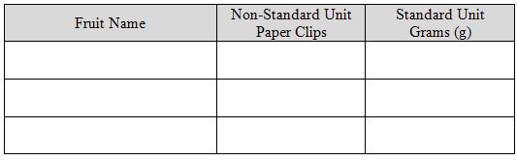

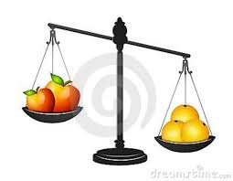Name \_\_\_\_\_\_\_\_\_\_\_\_\_\_\_\_\_\_\_\_\_\_\_\_\_\_\_\_\_\_\_\_\_\_\_\_\_\_\_\_\_ Date \_\_\_\_\_\_\_\_\_\_

Setting the Standard

1. Measure each item using paper clips in the balance scale, like you did in the “How Many Paper Clips?”task. Then measure each item using grams (g). Record the measures in the chart below.

|  |  |  |
| --- | --- | --- |
| Item Name | Measurement in Paper Clips | Measurement in Grams (g) |
|  |  |  |
|  |  |  |
|  |  |  |
|  |  |  |
|  |  |  |
|  |  |  |

1. Place a piece of fruit in your balance scale. Talk with your group about how you would measure the fruit using standard units. Record your thoughts below.

\_\_\_\_\_\_\_\_\_\_\_\_\_\_\_\_\_\_\_\_\_\_\_\_\_\_\_\_\_\_\_\_\_\_\_\_\_\_\_\_\_\_\_\_\_\_\_\_\_\_\_\_\_\_\_\_\_\_\_\_\_\_\_\_\_\_\_\_\_\_\_\_\_\_\_\_\_\_\_\_\_\_\_\_\_\_\_\_\_\_\_\_\_\_\_\_\_\_\_\_\_\_\_\_\_\_\_\_\_\_\_\_\_\_\_\_\_\_\_\_\_\_\_\_\_\_\_\_\_\_\_\_\_\_\_\_\_\_\_\_\_\_\_\_\_\_\_\_\_\_\_\_\_\_\_\_\_\_\_\_\_\_\_\_\_\_\_\_\_\_\_\_\_\_\_\_\_\_\_\_\_\_\_\_\_\_\_\_\_\_\_\_\_\_\_\_\_\_\_\_\_\_\_\_\_\_\_\_\_\_\_\_\_\_\_\_\_\_\_\_\_\_\_\_\_\_\_\_\_\_\_\_\_\_\_\_\_\_\_\_\_\_\_\_\_\_\_\_\_\_\_\_\_\_\_\_\_\_\_\_\_\_\_\_\_\_\_\_\_\_\_\_\_\_\_\_\_\_\_\_\_\_\_\_\_\_\_\_\_\_\_\_\_\_\_\_\_\_\_\_

1. Create a three-column chart similar to the one above. Label the first column **Fruit Name**, the second column **Non-Standard Unit – Paper Clips**, and the third column **Standard Unit – Grams (g)**. Find the weight of each piece of fruit and record it in your chart.

**CONSTRUCTING TASK:** **MAKING A KILOGRAM**

In this task, students will be involved in a kinesthetic activity that helps them experience how heavy a kilogram is and develop a conceptual understanding of a kilogram. Students will then use that experience to estimate the weight of everyday items.

**APPROXIMATE TIME:** 1 Day

**CONTENT STANDARDS**

**MGSE3.MD.2** Measure and estimate liquid volumes and masses of objects using standard units of grams (g), kilograms (kg), and liters (l). Add, subtract, multiply, or divide to solve one-step word problems involving masses or volumes that are given in the same units, e.g., by using drawings (such as a beaker with a measurement scale) to represent the problem.

**STANDARDS FOR MATHEMATICAL PRACTICE**

1. Make sense of problems and persevere in solving them.

2. Reason abstractly and quantitatively.

3. Construct viable arguments and critique the reasoning of others.

4. Model with mathematics.

5. Use appropriate tools strategically.

6. Attend to precision.

8. Look for and express regularity in repeated reasoning.

**BACKGROUND KNOWLEDGE**

Students should have had experience using a spring scale and understand that a kilogram is a standard unit of weight measurement.

**COMMON MISCONCEPTIONS**

Students may confuse the amount of objects or size of objects with its weight. For example, if asked which weighs more, a pound of feathers or a pound of bricks, students may answer a pound of bricks. This is due to confusion concerning the weight or attributes of the objects being measured rather than an understanding of standard units of measure.

Confusion occurs in using the terms weight and mass. An 180 pound person has more mass than a 100 pound person. The 180 pound person’s mass remains the same whether on Earth, the moon or Mars. Weight does change depending upon the amount of gravitational pull upon the object. For example, the 180 pound person would weigh ⅙ as much on the moon as the Earth or about 60 pounds.

**ESSENTIAL QUESTIONS**

* About how heavy is a kilogram?
* What items in the classroom weigh close to a kilogram?

**MATERIALS**

* “Making a Kilogram” student recording sheet
* 1 kilogram weight ( a liter of water weighs about one kilogram)
* Cloth or paper bags (one per student)
* Sand, aquarium gravel, blocks, cubes, beans, etc. for students to use when filling bags
* Spring scale

*Note*

A great amount of material (sand, aquarium gravel, blocks, cubes, and/or beans) will be needed if every student is going to create their own kilogram. A kilogram weighs about 2.2 pounds so you will need at least 50 pounds of material for 20 students. In order to allow students to experiment when creating one kilogram, there should be more than one kilogram of material per student. If you do not have enough material, students may work in pairs or triplets to create a kilogram. This can also be accomplished using empty student backpacks, with classroom items as filler to create the 1 kilogram weights.

**GROUPING**

Whole Group/Individual Task

**NUMBER TALKS**

By now number talks should be incorporated into the daily math routine. Continue utilizing the different strategies in number talks and revisiting them based on the needs of the students.

**TASK DESCRIPTION, DEVELOPMENT AND DISCUSSION (SMP 1, 2, 3, 4, 5, 6 and 8)**

Students will follow the directions below from the “Making a Kilogram” student recording sheet.

**Part I**

To introduce this task, have students think about the heaviness of a kilogram as you pass around an example of an one kilogram weight. Students are to try to remember how heavy the one kilogram weight feels.

Now have students create a one kilogram weight using a bag and provided materials. Do not allow students to use a scale when creating bag weights.

**Part II**

Students how empty and refill their bags at least three times, to determine if bag weighs more than, less than, or equal to one kilogram. Using mathematical words to describe whether the bag has more than, less than, or equal weight to a kilogram is an important part of this activity. Make sure the students don’t skip this step. Record your results in the chart below.

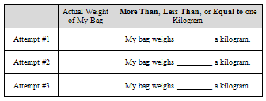

**FORMATIVE ASSESSMENT QUESTIONS**

* How can your created kilogram weight be used to measure items?
* Why is it important to have a standard unit of weight?
* What everyday items could be measured using kilograms?

**DIFFERENTIATION**

**Extension**

* Sometimes it is helpful to have referents for weights. Ask students to create a poster of common everyday objects that weigh a specific amount. (Be careful about weights indicated on a product package as that will *not* include the weight of the container, which may be significant in some situations. This would be a good discussion to have with students.)

**Intervention**

* Have students work in pairs to accomplish this task.

**TECHNOLOGY CONNECTION**

* <http://www.mathsisfun.com/measure/metric-mass.html>This site provides some background on metric measures and lists items that weigh about one kilogram.

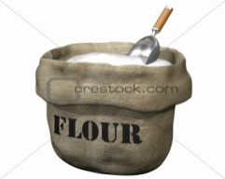Name \_\_\_\_\_\_\_\_\_\_\_\_\_\_\_\_\_\_\_\_\_\_\_\_\_\_\_\_\_\_\_\_\_\_\_\_\_\_\_\_\_ Date \_\_\_\_\_\_\_\_\_\_\_\_\_\_\_\_\_\_\_\_\_

Making a Kilogram

1. Think about the heaviness of the kilogram provided by your teacher.

You are now to create a bag you think will weigh about 1 kilogram. Do

not use a scale to create your bag!

2. Determine if your bag weighs more than, less than, or equal to one kilogram. Record your

results in the chart below.

|  |  |  |
| --- | --- | --- |
|  | Actual Weight of My Bag | **More Than**, **Less Than**, or **Equal to** one Kilogram |
| Attempt #1 |  | My bag weighs \_\_\_\_\_\_\_\_\_ a kilogram. |
| Attempt #2 |  | My bag weighs \_\_\_\_\_\_\_\_\_ a kilogram. |
| Attempt #3 |  | My bag weighs \_\_\_\_\_\_\_\_\_ a kilogram. |

Look at the actual weights of your bag. What could you do if you wanted to determine the weight of three bags with the same exact weight? Explain your thinking.

\_\_\_\_\_\_\_\_\_\_\_\_\_\_\_\_\_\_\_\_\_\_\_\_\_\_\_\_\_\_\_\_\_\_\_\_\_\_\_\_\_\_\_\_\_\_\_\_\_\_\_\_\_\_\_\_\_\_\_\_\_\_\_\_\_\_\_\_\_\_\_\_\_\_\_\_\_\_\_\_\_\_\_\_\_\_\_\_\_\_\_\_\_\_\_\_\_\_\_\_\_\_\_\_\_\_\_\_\_\_\_\_\_\_\_\_\_\_\_\_\_\_\_\_\_\_\_\_\_\_\_\_\_\_\_\_\_\_\_\_\_\_\_\_\_\_\_\_

**MCj01992100000[1]CONSTRUCTING TASK: WORTH THE WEIGHT**

In this task, students will experiment with gram and kilogram weights. They will select objects to weigh, estimate their weight, and then use a spring scale to determine the actual weight.

**APPROXIMATE TIME:** 2 Days

**CONTENT STANDARDS**

**MGSE3.MD.2** Measure and estimate liquid volumes and masses of objects using standard units of grams (g), kilograms (kg), and liters (l). Add, subtract, multiply, or divide to solve one-step word problems involving masses or volumes that are given in the same units, e.g., by using drawings (such as a beaker with a measurement scale) to represent the problem.

**STANDARDS FOR MATHEMATICAL PRACTICE**

1. Make sense of problems and persevere in solving them.

2. Reason abstractly and quantitatively.

3. Construct viable arguments and critique the reasoning of others.

4. Model with mathematics.

5. Use appropriate tools strategically.

6. Attend to precision.

8. Look for and express regularity in repeated reasoning.

**BACKGROUND KNOWLEDGE**

Before beginning this task, you may want to review the previous task in which students made kilogram weights from bags and material such as aquarium gravel.

This task can be broken into two parts or the class can be broken into groups and the students can rotate through each part of the task.

Students need to be familiar with the terms gram and kilogram, metric units used to measure the mass of an object. One kilogram is equal to 1,000 grams. One gram weighs about as much as a large paper clip or a packet of sweetener, and one kilogram is the weight of a textbook or liter of water. The standard only requires students to understand the relationship between kilogram and gram and to understand that the larger unit can be subdivided into equivalent units (partition). **However, the standard does not require students to convert these units of measurement.**

**COMMON MISCONCEPTIONS**

Students often confuse the units of measurement and their size (kilograms and grams). Students get easily confused when working with both of these units of measurement and mistakenly labels the weight with the wrong unit. Additionally, students may not include a label.

**ESSENTIAL QUESTIONS**

* How are grams and kilograms related?
* What everyday items weigh about a gram? About a kilogram?
* What happens to an item’s measurement when units are changed?

**MATERIALS**

* “Worth the Weight, Part 1 – Grams” student recording sheet
* “Worth the Weight, Part 2 – Kilograms” student recording sheet
* Large paper clip
* Gram weight
* Balance
* 1 kg reference weights
* Spring scales

**Note:**

One liter bottles filled with water weigh about one kilogram. Alternatively, fill bags with sand, aquarium gravel, or dried beans. Students can use these “reference weights” to compare weights when looking for items that weigh one kilogram.

**GROUPING**

Small Group Task

**NUMBER TALKS**

By now number talks should be incorporated into the daily math routine. Continue utilizing the different strategies in number talks and revisiting them based on the needs of the students.

**TASK DESCRIPTION, DEVELOPMENT AND DISCUSSION (SMP 1, 2, 3, 4, 5, 6, and 8)**

**Part I**

To introduce this part of the task, hold up a large paper clip and explain that it weighs about one gram. Pass some large paper clips around to the students so that they can get an idea of how heavy a gram feels. Involve the class in a discussion about what might be appropriate to measure in grams. After asking the class for a few suggestions, students will list items in the classroom they think they could weigh using grams. Ask students to record their items in the table on their student recording sheet, “Worth the Weight, Part 1 – Grams.”

For each item on their chart, students should:

* hold the item to estimate its weight
* measure its weight using a spring scale
* write down the actual weight of each item

When students are finished, hold a class discussion about the following:

* what objects are appropriate to weigh in grams
* what students learned from this part of the task

Students will follow the directions below from the “Worth the Weight, Part 1 - Grams” student recording sheet.

Think about how heavy a paper clip is. Now find five objects that you think should be weighed using grams. Do not use a scale to check yet! After you have found five objects:

* Write the name of the objects in the chart below.
* Make an estimate for each item and record it in the chart below.
* Weigh each item using the scale provided and record it in the chart below.

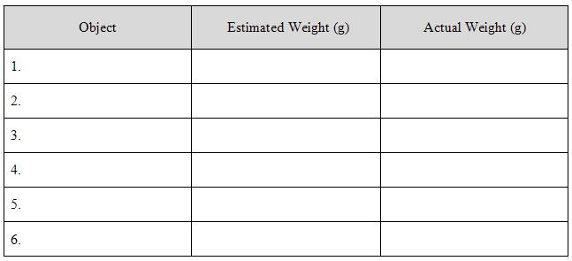

1. How did you make your estimates?
2. Why are the items you chose appropriate to measure in grams?

Be ready to share your thinking with the class.

**Part II**

To introduce this part of the task, pass the kilogram referents around to the students. Ask the class for a few suggestions of classroom items for which kilograms would be an appropriate unit of measure.

For each item on their chart, students should first hold the item to estimate its weight (more than, less than, or about 1 kilogram), measure its weight using a spring scale, and write down the actual weight of each item.

When students are finished, hold a class discussion about what objects are appropriate to weigh in grams and what students learned from this part of the task.

Students will follow the directions using “Worth the Weight, Part 2 - Kilograms” student recording sheet.

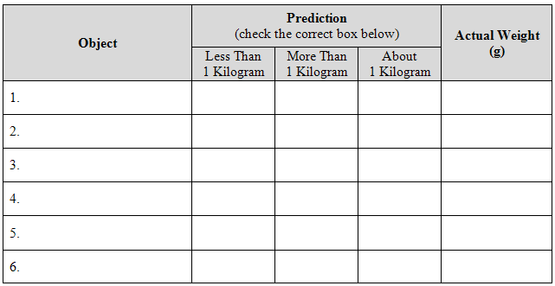

**FORMATIVE ASSESSMENT QUESTIONS**

* Why is it important to associate items with a weight?
* Explain which unit of measure, gram or kilogram, would be best to use when measuring a student’s library book.
* A student has a difficult time remembering the difference between gram and kilogram. What would you do to help the student learn the difference between these two units?

**DIFFERENTIATION**

**Extension**

* Have students find ten items around their house that they would measure using grams or kilograms. Encourage them to find five items for grams, and five items for kilograms. Have them estimate how much each item weighs.
* Have students investigate what units are used to measure items too large to be recorded in kilograms?
* Have students estimate how many kilograms five different people weigh (family members, neighbors, friends, babysitters, etc.).

**Intervention**

* Each week, have a ten minute discussion about units of weights. Ask students to choose an item from the classroom, discuss the appropriate unit to use to measure the weight, and then estimate the weight of the object. In math journals, have students keep a reference list of how much different items weigh using grams and kilograms. This can be used as a reference throughout the year.

**TECHNOLOGY CONNECTION**

* <http://gadoe.georgiastandards.org/mathframework.aspx?PageReq=MathHunt>

This a link to a classroom video of this task. Teachers may want to view this video to see how one teacher implemented this task in his classroom.

Name \_\_\_\_\_\_\_\_\_\_\_\_\_\_\_\_\_\_\_\_\_\_\_\_\_\_\_\_\_\_\_\_\_\_\_\_\_\_\_\_\_ Date \_\_\_\_\_\_\_\_\_\_\_\_\_\_\_\_\_\_\_\_\_\_\_\_\_\_

Worth the Weight**MCj01992100000[1]**

Part 1 - Grams

Think about how heavy a paper clip is. Find five objects you think should be weighed using grams. **Do not use a scale to check yet!**

* Write the name of the objects on the chart below.
* Estimate each item’s weight and record estimation in the chart below.
* Weigh each item using the scale provided and record weight in the chart below.

|  |  |  |
| --- | --- | --- |
| Object | Estimated Weight (g) | Actual Weight (g) |
| 1. |  |  |
| 2. |  |  |
| 3. |  |  |
| 4. |  |  |
| 5. |  |  |
| 6. |  |  |

1. How did you make your estimates?
2. Explain why you believe the items you chose should be measured in grams but not kilograms?
3. Choose one of your objects from the list above. **Using only the actual weight,** determine the weight of five of those items WITHOUT using a scale. Explain how you did it using pictures, numbers, and words.

Name \_\_\_\_\_\_\_\_\_\_\_\_\_\_\_\_\_\_\_\_\_\_\_\_\_\_\_\_\_\_\_\_\_\_\_\_\_\_\_\_\_ Date \_\_\_\_\_\_\_\_\_\_\_\_\_\_\_\_\_\_\_\_\_\_\_\_\_\_

**MCj01992100000[1]**Worth the Weight

Part 2 - Kilograms

You and your partner are going on a kilogram scavenger hunt! Use one of the reference weights to get an idea of how heavy one kilogram is. Then find items around the room that weigh less than, about, and more than one kilogram.

1. List the items in the table below.
2. Predict whether each item is more than, less than, or about 1 kilogram.
3. Weigh each item with a spring scale.
4. Record the weight in the last column.

Remember: 1 kg = 1,000 grams

|  |  |  |  |  |
| --- | --- | --- | --- | --- |
| **Object** | **Prediction**  (check the correct box below) | | | **Actual Weight (g)** |
| Less Than  1 Kilogram | More Than  1 Kilogram | About  1 Kilogram |
| 1. |  |  |  |  |
| 2. |  |  |  |  |
| 3. |  |  |  |  |
| 4. |  |  |  |  |
| 5. |  |  |  |  |
| 6. |  |  |  |  |

1. Look at the table. Write what you found about your understanding of a kilogram? Be prepared to discuss your findings with the class.
2. Choose one of your objects from the list above. **Using only the actual weight,** determine the weight of twelve of those items WITHOUT using a scale. Explain how you did it using pictures, numbers, and words.
3. On the back of this sheet, list at least five items for which kilograms would be appropriate as the unit of measure.

**CONSTRUCTING TASK:** **FILL IT UP!**

In this task, students estimate and compare liquid volume making connections to everyday items to build understanding of liquid volume and the liter.

**APPROXIMATE TIME**: 2 Days

**CONTENT STANDARDS**

**MGSE3.MD.2** Measure and estimate liquid volumes and masses of objects using standard units of grams (g), kilograms (kg), and liters (l). Add, subtract, multiply, or divide to solve one-step word problems involving masses or volumes that are given in the same units, e.g., by using drawings (such as a beaker with a measurement scale) to represent the problem.

**STANDARDS FOR MATHEMATICAL PRACTICE**

1. Make sense of problems and persevere in solving them.

2. Reason abstractly and quantitatively.

3. Construct viable arguments and critique the reasoning of others.

4. Model with mathematics.

5. Use appropriate tools strategically.

6. Attend to precision.

8. Look for and express regularity in repeated reasoning.

**BACKGROUND KNOWLEDGE**

According to Van de Walle (2006) “*volume* typically refers to the amount of space that an object takes up” whereas “*capacity* is generally used to refer to the amount that container will hold” (p. 265). To distinguish further between the two terms, consider how the two are measured. Volume is measured using linear measures for each dimension (ft, cm, in, m, etc) while capacity is measured using liquid measures (L, mL, qt, pt, g, etc). However, Van de Walle reminds educators, “having made these distinctions [between volume and capacity], they are not ones to worry about. The term *volume* can also be used to refer to the capacity of a container” (Van de Walle, J. A. & Lovin, L. H. (2006). *Teaching students-centered mathematics: Grades 3-5*. Boston: Pearson Education, Inc., p.266).

Students should have experience with basic capacity and conservation. Students will also need to be familiar with using liquid measuring tools (e.g. graduated cylinders).

**COMMON MISCONCEPTIONS**

This is the students’ first experience with measuring capacity. The terms and abbreviations, L and mL, may be confusing. Visual models made by the students will be important to display during this unit of study. Students may omit labels in final answers when recording answers.

**ESSENTIAL QUESTIONS**

* What is the tool best to use when measuring liquid volume?
* What connection can you make between liquid volumes and your everyday life?
* Does volume change when you change the measurement material? Why or why not?

**MATERIALS**

For each student:

* “Fill It Up” student recording sheet
* “Fill It Up, Measuring Stations” student recording sheet

For each group:

* a large pan or sheet of plastic (for spillage)
* a large graduated cylinder (1 liter)
* 2 different large containers (jar, bottle, bucket, pot, etc.)
* 1 bowl of water (may be colored for visual effect),
* 1 funnel

**GROUPING**

Small Group Task

**NUMBER TALKS**

By now number talks should be incorporated into the daily math routine. Continue utilizing the different strategies in number talks and revisiting them based on the needs of the students.

**TASK DESCRIPTION, DEVELOPMENT, AND DISCUSSION (SMP 1, 2, 3, 4, 5, 6, and 8)**

Remember that the goal is for the students to develop a concept of liquid volume. According to Van de Walle (2006), “Children often confuse “holds more” with “taller” or “fatter,” even though these may be misleading attributes. This is why a variety of container shapes not only adds interest but also can contribute to student understanding. (p.239)

Students will follow the directions below from the “Fill It Up” student recording sheet and the “Fill It Up Measuring Stations” recording sheet.

This task has four parts.

**Part I:**

Introduction, Discussion, Connections

The teacher will facilitate a conversation with the students about liquid volume. Discussion about the meaning of the concept and how it is measured should take place. The students and the teacher will make connections, cite examples, and clarify misconceptions. This would be a great opportunity to begin an anchor chart. The teacher should then show the class a container that measures one liter. Students should give examples of other containers that hold a liquid volume of about 1 liter to add to the anchor chart.

**Part II**

Exploring, Estimating, Comparing

In small groups, complete the mini activities below:

*\*Adapted from Teaching Student-Centered Mathematics, Van de Walle, Lovin, (2006)*

***Capacity Sort***

Provide a collection of labeled containers with one marked as the “target.” The task is to sort the collection into those that hold more than, less than, or about the same as the “target” container. Provide a recording sheet on which each container is listed and a place to circle or write, “holds more,” “holds less,” and “holds about the same.” List the choices twice for each container. The first choice is to record a guess made by observation. The second is to record what was found. (Beans, rice, liquid, or other fillers can be used to test estimates.)

***Liquid Volume Line Up!***

Given a series of five or six labeled containers of different sizes and shapes, order them from least capacity to most. Explain your thinking with your group members.

Notes for the teacher:

* Make sure that at least one of the containers measures 1 liter
* This can be quite a challenge, but let them “grapple” with it. Do not provide answers.
* Allow students to compare their findings with other groups.

**Part III**

Investigating, Estimating, Measuring

In small groups, students will explore, estimate, and measure liquid volume. Each group should have the following:

* a large plastic box or sheet of plastic (for spillage)
* a large graduated cylinder (1 liter)
* 2 different large containers (jar, bottle, bucket, pot, etc.)
* 1 bowl of water (may be colored for visual effect),
* 1 funnel

Using the funnel, have the students fill each of the containers until they believe that they have reached a liter. Once they have reached their estimate, allow them to pour the liquid from each container into the graduated cylinder. Ask the students to pay careful attention to what happens.

**Part IV**

Reflection

Once students have completed their work station task, ask students to complete the “Fill It Up” student recording sheet, and compare their estimations. Ask students to share their findings and to justify their findings by describing the process they followed.

**FORMATIVE ASSESSMENT QUESTIONS**

* What is an efficient way to measure liquid capacity?
* When estimating liquid capacity, what do you need to consider?
* How much is a liter?
* What other containers have you seen in your everyday life with a capacity of one liter?
* Does the shape of the container change the amount of liquid it can hold? Why or why not?

**DIFFERENTIATION**

**Extension**

* Ask students to compare the relationships between the containers and the amount of liquid they can hold. Several things may come to light in this discussion.
  + The amount of liquid used to fill two containers can be the same, even though the shape of the containers may be different.
  + Having a benchmark to look at helps to make more accurate measurements.

**Intervention**

* Have an adult work with a small group of students who need support using a graduated cylinder.
* Have students complete the task using only one container.

Name\_\_\_\_\_\_\_\_\_\_\_\_\_\_\_\_\_\_\_\_\_\_\_\_\_\_\_\_\_\_\_\_\_\_\_\_\_\_\_\_\_ Date \_\_\_\_\_\_\_\_\_\_\_\_\_\_\_\_\_\_\_\_

Fill It Up!

You will explore, estimate, and measure liquid volume. Your group should have the following:

* a large pan or sheet of plastic (for spillage)
* a large graduated cylinder (1 liter)
* 2 different large containers (jar, bottle, bucket, pot, etc.)
* 1 bowl of water (may be colored for visual effect),
* 1 funnel

Directions:

1. Look at your two containers. Estimate how much liquid it would take to fill each container to one liter.
2. Talk with your group members about how much liquid it would take to reach your goal of 1 liter.
3. Take turns filling each container until you believe that you have reached a liter. Use a funnel if you need to.
4. Once your group has reached their estimate, take turns pouring the liquid from the each container into the graduated cylinder.

|  |  |  |
| --- | --- | --- |
| **Fill it Up! Recording Table** | | |
|  | |  |
| **Type of Container** | **What happens when the liquid is poured into the graduated cylinder?** | **How close was your estimate to an actual liter?** |
|  |  |  |
|  |  |  |

1. Observe, discuss, and record what happens on the chart below. How close was your estimate?

**Reflection Questions:**

1. When estimating liquid capacity, what do you need to consider?
2. About how much liquid is there in a liter?
3. What other containers have you seen in your everyday life that have a capacity of one liter?
4. Does the shape of the container change the amount of liquid it can hold? Why or why not?

**CONSTRUCTING TASK:** **MORE PUNCH, PLEASE!**



In this task, students work with liquid volume to determine the amount of punch needed for a class party.

**APPROXIMATE TIME**: 1-2 Days

**CONTENT STANDARDS**

**MGSE3.MD.2** Measure and estimate liquid volumes and masses of objects using standard units of grams (g), kilograms (kg), and liters (l). Add, subtract, multiply, or divide to solve one-step word problems involving masses or volumes that are given in the same units, e.g., by using drawings (such as a beaker with a measurement scale) to represent the problem.

**STANDARDS FOR MATHEMATICAL PRACTICE**

1. Make sense of problems and persevere in solving them.

2. Reason abstractly and quantitatively.

3. Construct viable arguments and critique the reasoning of others.

4. Model with mathematics.

5. Use appropriate tools strategically.

6. Attend to precision.

7. Look for and make use of structure.

8. Look for and express regularity in repeated reasoning.

**BACKGROUND KNOWLEDGE**

This is the students’ first experience with measuring capacity.

According to Van de Walle (2006) “*volume* typically refers to the amount of space that an object

takes up” whereas “*capacity* is generally used to refer to the amount that container will hold” (p. 265). To distinguish further between the two terms, consider how the two are measured. Volume is measured using linear measures for each dimension (ft, cm, in, m, etc) while capacity is measured using liquid measures (L, mL, qt, pt, g, etc). However, Van de Walle reminds educators, “having made these distinctions [between volume and capacity], they are not ones to worry about. The term *volume* can also be used to refer to the capacity of a container” (Van de Walle, J. A. & Lovin, L. H. (2006). *Teaching students-centered mathematics: Grades 3-5*. Boston: Pearson Education, Inc., p.266).

Students should have experience with basic capacity and conservation. Students will also need to be familiar with using liquid measuring tools (e.g. graduated cylinders).

**COMMON MISCONCEPTIONS**

The terms and abbreviations, L and mL, may be confusing. Visual models made by the students will be important to display during this unit of study. Students may omit labels in final answers when recording answers.

**ESSENTIAL QUESTIONS**

* How can estimating help me to determine liquid volume?
* What are some ways I can measure the liquid volume?

**MATERIALS**

* “More Punch, Please!” student recording sheet
* “More Punch Please!” recipe items
* a 1 liter container
* construction paper

**GROUPING**

Small Group/Partner Task

**NUMBER TALKS**

By now number talks should be incorporated into the daily math routine. Continue utilizing the different strategies in number talks and revisiting them based on the needs of the students.

**TASK DESCRIPTION, DEVELOPMENT, AND DISCUSSION (SMP 1, 2, 3, 4, 5, 6, 7, and 8)**

*\*Adapted from Teaching Student-Centered Mathematics, Van de Walle, Lovin, (2006)*Students will explore and solve problems involving liquid volume.

**Part I**

Exploring, Estimating, Comparing

Complete the activity below as a class.

Tape two sheets of construction paper. Make a tube shape (cylinder) of one by taping the two long edges together. Make a shorter, fatter tube from the other sheet by taping the short edges together. When placed upright, which cylinder holds the most, or do they have the same capacity?

**Part II**

Investigating and Measuring

For this part of the task, students work with liquid volume to determine the amount of punch needed for a class party. Students can make simulated punch with colored water or actual punch with real ingredients.

Students will follow the directions below from the “More Punch, Please!” student recording sheet.

**Part III**

Reflection and Problem Solving

Answer the following questions about the punch for the party. Show all work and explain how you know your answers are accurate. Use pictures, numbers, and words.

1. How much liquid will be used for one batch?
2. How much of each ingredient needs to be purchased to serve punch at the party? Rewrite the recipe to serve 30 students.
3. How much liquid will be used in all for the entire party of 30 students? Show your work below.
4. Is there enough for students to receive seconds? Why or why not?

**FORMATIVE ASSESSMENT QUESTIONS**

* How many batches of the recipe will you need? How do you know?
* How much sherbet will you need to buy? How do you know?
* How much fruit punch do you need? How do you know?
* How much Lemon-Lime soda do you need? How do you know?
* What would you need to do to the recipe if more students came to the party?

**DIFFERENTIATION**

**Extension**

* Encourage students to find a different punch recipe and to rewrite the recipe to serve other numbers of students (50, 100).
* Ask students to determine what size drink is typical (they can consider the type of cup being used, whether ice will be available, and other factors that may influence the amount of punch served to each student). Once students have collected data, they can display the data, choosing the most effective data display.

**Intervention**

* Allow students to make only one batch.
* Facilitate a teacher guided group.

Name\_\_\_\_\_\_\_\_\_\_\_\_\_\_\_\_\_\_\_\_\_\_\_\_\_\_\_\_\_\_\_\_\_\_\_\_ Date \_\_\_\_\_\_\_\_\_\_\_\_\_\_\_\_\_\_\_\_\_\_\_\_\_\_\_\_\_\_

More Punch, Please!

We are making punch for a third grade party. 30 students will attend the party. The recipe below will serve 10 students.

**Party Punch Recipe**

*(Serves 10)*

**Ingredients:**

1 liter of sherbet

2 liters of fruit punch

1 liter of lemon-lime flavored carbonated beverage (or ginger-ale)

**Directions:**

* Place sherbet in punch bowl.
* Pour in fruit punch.
* Pour in lemon-lime soda.
* Stir, and serve chilled.

Answer the following questions about the punch for the party. Show all work and explain how you know your answers are accurate. Use pictures, numbers, and words.

1. **How much liquid will be used in all for one batch? Show your work below.**

|  |
| --- |
|  |

1. **How much of each ingredient needs to be purchased to serve punch at the party? Rewrite the recipe to serve 30 students.**

|  |  |
| --- | --- |
| Party Punch |  |
| Serves 10 | Serves \_\_\_\_\_\_ |
| 1 liter of sherbet  2 liters of fruit punch  1 liter of lemon-lime flavored carbonated beverage (or ginger-ale) | \_\_\_\_\_ Liters Sherbet  \_\_\_\_\_ Liters of Punch  \_\_\_\_\_ Liters of Lemon-Lime |
|  |  |

1. **How much liquid will be used in all for the entire party of 30 students? Show your math thinking below.**

|  |
| --- |
|  |

1. **Is there enough punch for students to receive seconds? Why or why not?** \_\_\_\_\_\_\_\_\_\_\_\_\_\_\_\_\_\_\_\_\_\_\_\_\_\_\_\_\_\_\_\_\_\_\_\_\_\_\_\_\_\_\_\_\_\_\_\_\_\_\_\_\_\_\_\_\_\_\_\_\_\_\_\_\_\_\_\_\_\_\_\_\_\_\_\_\_\_\_\_\_\_\_\_\_\_\_\_\_\_\_\_\_\_\_\_\_\_\_\_\_\_\_\_\_\_\_\_\_\_\_\_\_\_\_\_\_\_\_\_\_\_\_\_\_\_\_\_\_\_\_\_\_\_\_\_\_\_\_\_\_\_\_\_\_\_\_\_\_\_\_\_\_\_\_\_\_\_\_\_\_\_\_\_\_\_\_\_

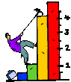**CONSTRUCTING TASK: THE DATA STATION**

*Adapted from North Carolina’s Core Essentials Mathematics Program*

In this task, students will begin by posing a question. They will then collect, display, and interpret data to the question. Students will need to determine the most appropriate graph to use.

**APPROXIMATE TIME:** 3-5 Days

**CONTENT STANDARDS**

**MGSE3.MD.3** Draw a scaled picture graph and a scaled bar graph to represent a data set with several categories. Solve one- and two-step “how many more” and “how many less” problems using information presented in scaled bar graphs. For example, draw a bar graph in which each square in the bar graph might represent 5 pets.

**MGSE3.MD.4** Generate measurement data by measuring lengths using rulers marked with halves and fourths of an inch. Show the data by making a line plot, where the horizontal scale is marked off in appropriate units – whole numbers, halves, or quarters.

**STANDARDS FOR MATHEMATICAL PRACTICE**

1. Make sense of problems and persevere in solving them.

2. Reason abstractly and quantitatively.

3. Construct viable arguments and critique the reasoning of others.

4. Model with mathematics.

5. Use appropriate tools strategically.

6. Attend to precision.

7. Look for and make use of structure.

8. Look for and express regularity in repeated reasoning.

**BACKGROUND KNOWLEDGE**

Students should have opportunities reading and solving problems using scaled graphs before being asked to draw one. The following graphs all use five as the scale interval, but students should experience different intervals to further develop their understanding of scale graphs and number facts. While exploring data concepts, students should **P**ose a question, **C**ollect data, **A**nalyze data, and **I**nterpret data (PCAI). Students should be graphing data that is relevant to their lives

Example:

**Pose a question:** Student should come up with a question. What is the typical genre read in our class?

**Collect and organize data:** student survey

Pictographs: Scaled pictographs include symbols that represent multiple units. Below is an example of a pictograph with symbols that represent multiple units. Graphs should include a title, categories, category label, key, and data. How many more books did Juan read than Nancy?

|  |  |
| --- | --- |
| **Number of Books Read** |  |
| Nancy |  |
| Juan |  |
|  | = 5 books |

Single Bar Graphs: Students use both horizontal and vertical bar graphs. Bar graphs include a title, scale, scale label, categories, category label, and data.

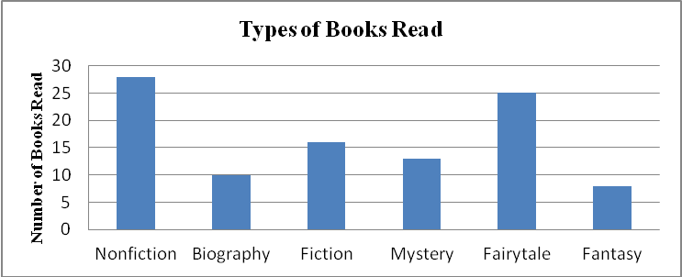

**Analyze and Interpret data:**

* How many more nonfiction books where read than fantasy books?
* Did more people read biography and mystery books or fiction and fantasy books?
* About how many books in all genres were read?

*Return to Contents*

* Using the data from the graphs, what type of book was read more often than a mystery but less often than a fairytale?
* What interval was used for this scale?
* What can we say about types of books read? What is a typical type of book read?

Students should have opportunities reading and solving problems using scaled graphs before being asked to draw one. The standard requires students to be able to solve one and two step word problems using graphs. Providing students with the opportunity to create questions that can be answered using their created graphs in addition to answering teacher derived questions should be part of the tasks in this unit. Should students not include two step problems, the teacher needs to model how to develop grade level appropriate problem solving questions. Students should experience using different intervals to further develop their understanding of scale graphs and number facts. While exploring data concepts, students should **P**ose a question, **C**ollect data, **A**nalyze data, and **I**nterpret data (PCAI). Students should graph data that is relevant to their lives.

Students in second grade measured length in whole units using both metric and U.S. customary systems. It is important to review with students how to read and use a standard ruler including details about halves and quarter marks on the ruler. Students should connect their understanding of fractions to measuring to one-half and one-quarter inch. Third graders need many opportunities measuring the length of various objects in their environment.

This standard provides a context for students to work with fractions by measuring objects to a quarter of an inch.

Example:

Measure objects in your desk to the nearest ½ or ¼ of an inch, display data collected on a line plot. How many objects measured ¼? ½? etc. …

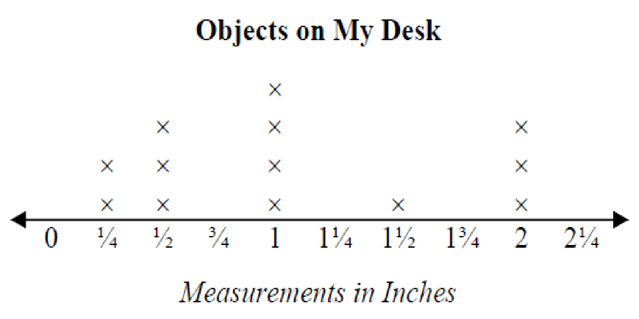

**COMMON MISCONCEPTIONS**

Students may still have difficulty measuring items to the nearest quarter inch and/or using measuring tools such as rulers, measuring tapes, etc. accurately. When measuring to the nearest quarter, students may not readily recognize one-half or one whole as a quarter measure.

Students might misread the scale or fail to use the key when determining the amounts shown on the graph. Often, students count each square as one. To avoid this error, have students include tick marks between each interval. Students should begin each scale with 0. They should think of skip-counting when determining the value of a bar since the scale is not in single units.

Students may encounter confusion when determining the most appropriate graph to use to display data. Through increased exploration and use of these three types of graphs, students should construct an understanding of which graph is the most appropriate to use depending upon the question and data collected. These experiences should lend themselves to students understanding the differences and similarities among pictographs, bar graphs, and line plots.

**ESSENTIAL QUESTIONS**

* How are tables, bar graphs, and line plot graphs useful ways to display data?
* How can you use graphs to answer a question?
* How can surveys be used to collect data?
* How can surveys be used to gather information?
* How can data displayed in tables and graphs be used to inform?

**MATERIALS**

* Math Journals (or paper)
* Connecting Cubes
* Newspapers
* Pennies
* Droppers
* Lima Beans
* Manipulatives/cut outs (to help students create models for their problems)

**GROUPING**

Students may be grouped individually, in pairs, or in small groups at the teacher’s discretion.

**NUMBER TALKS**

By now number talks should be incorporated into the daily math routine. Continue utilizing the different strategies in number talks and revisiting them based on the needs of the students.

**TASK DESCRIPTION, DEVELOPMENT, AND DISCUSSION (SMP 1, 2, 3, 4, 5, 6, 7 and 8)**

**PART I (Whole group activity)**

Allow students to collect the sizes of shoes worn by their classmates. As a class (perhaps on chart paper), make a table to organize the data. Have a class discussion that allows the class to think critically about the relationship between data collection, analysis, and representation. Some sample points for the students to ponder are:

* How can we organize our data?
* What type of graph should we choose to display the information? Why?
* Is there another way we can represent this data?
* What does a graph tell us about data?
* What kinds of questions can we ask about the graphs we just created?

**PART II (Small group activity)**

Allow students to work in small groups to complete this task.

Have students pose a question that could be answered by measuring the length of their shoe. Students should be able to answer the question by analyze the data on their graph. Using a ruler, students measure the length of their shoe to nearest fourth of an inch.

* Working in small groups, display your data on an appropriate graph.
* Discuss what your data means. Create questions about your findings that can be answered using your graph.
* *Challenge:* Try to represent this data using a different type of graph. Talk about how your new graph differs from your first one.

**PART III (Partner activity)**

Allow students to work in small groups to complete this task. Question: How many drops of water will fit on a penny?

Penny Power!

* With a partner, predict the number of drops of water that will fit on a penny.
* Share your prediction with your partner.
* Establish rules for dropping water on the penny.
* Use a dropper to find out how many drops of water will fit on the penny.
* Construct a graph to display your data.
* Compare your graph with the graph of another group.
* Write about the similarities and differences.

**DIFFERENTIATION**

**Extension Activities**

* How much sleep?
  + Collect data for the number of hours your classmates sleep each night.
  + Make a line plot graph to illustrate.
  + Compare your graphs with others.
  + Do most students sleep more than nine hours? How do you know?
* Weather Watcher!
  + Over a two week period, look at the weather data in the newspaper.
  + Compare the high and low temperatures in your town/city to the high and low in the city of your choice.
  + Make two line plots to compare these.
  + What statements can you make about the data?

**Intervention** **Activities**

* Explore Data!
  + Cut out examples of graphs from the newspapers.
  + What information is being shown?
  + How would you classify these data displays?
* ...And the Survey Says!
  + Choose a question and survey at least twelve classmates. Collect your data and make graphs. Don’t forget labels! When finished your teacher will ask you questions about your data and graphs.
    1. Which of these pets do you prefer?
       - Cat
       - Bird
       - Hamster
       - Dog
    2. Which sport do you like best?
       - Basketball
       - Swimming
       - Soccer
       - Football
    3. Which is your favorite fast food restaurant?
       - McDonald’s
       - Burger King
       - Wendy’s
       - Chick Fil A

**PRACTICE TASK: “THE MAGIC NUMBER!”**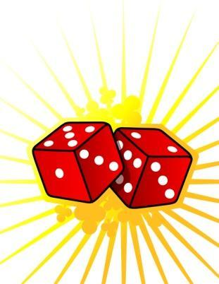

In this task, students will play a game to collect data concerning target numbers and sums. Students will then create a pictograph and bar graph to display results. Students will formulate questions that could be answered using the graphs.

**APPROXIMATE TIME:** 1 Day

**CONTENT STANDARDS**

**MGSE3.MD.3** Draw a scaled picture graph and a scaled bar graph to represent a data set with several categories. Solve one- and two-step “how many more” and “how many less” problems using information presented in scaled bar graphs. For example, draw a bar graph in which each square in the bar graph might represent 5 pets.

**MGSE3.NBT.2** Fluently add and subtract within 1000 using strategies and algorithms based on place value, properties of operations, and/or the relationship between addition and subtraction.

**STANDARDS FOR MATHEMATICAL PRACTICE**

1. Make sense of problems and persevere in solving them.

2. Reason abstractly and quantitatively.

3. Construct viable arguments and critique the reasoning of others.

4. Model with mathematics.

5. Use appropriate tools strategically.

6. Attend to precision.

**BACKGROUND KNOWLEDGE**

Students should have opportunities reading and solving problems using scaled graphs before being

asked to draw one. The standard requires students to be able to solve one and two step word problems using graphs. Providing students with the opportunity to create questions that can be answered using their created graphs in addition to answering teacher derived questions should be part of the tasks in this unit. Should students not include two step problems, the teacher needs to model how to develop grade level appropriate problem solving questions. Students should experience using different intervals to further develop their understanding of scale graphs and number facts. While exploring data concepts, students should **P**ose a question, **C**ollect data, **A**nalyze data, and **I**nterpret data (PCAI). Students should graph data that is relevant to their lives.

**COMMON MISCONCEPTIONS**

Students might misread the scale or fail to use the key when determining the amounts shown on the graph. Often, students count each square as one. To avoid this error, have students include tick marks between each interval. Students should begin each scale with 0. They should think of skip-counting when determining the value of a bar since the scale is not in single units.

Students may encounter confusion when determining the most appropriate graph to use to display data. Through increased exploration and use of these three types of graphs, students should construct an understanding of which graph is the most appropriate to use depending upon the question and data collected. These experiences should lend themselves to students understanding the differences and similarities among pictographs, bar graphs, and line plots.

**ESSENTIAL QUESTIONS**

* How can graphs be used to compare related data?
* How can data displayed in tables and graphs be used to inform?
* How can data displays be used to describe events?

**MATERIALS**

* Two Number Cubes
* Recording Sheet (below)
* Chart paper

**GROUPING**

3-4 players

**NUMBER TALKS**

By now number talks should be incorporated into the daily math routine. Continue utilizing the different strategies in number talks and revisiting them based on the needs of the students.

**TASK DESCRIPTION, DEVELOPMENT AND DISCUSSION (SMP 1, 2, 3, 4, 5 and 6)**

**PART I**

1. Each player needs to pick a sum between 2 and 12 and write it at the top of their recording sheet. (below) This is your “magic” number. No two students in the group should choose the same number.
2. Players will take turns rolling the pair of number cubes. A total of 20 rolls will happen.
3. After each roll, each player will record the sum of the two dice on the recording sheet.
4. Each time a player’s “magic number” is rolled, he or she gets a point. At the end of 20 turns, the player with the most points wins the game!
5. After the game, each group should complete the “After the Game” activities.

**PART II**

**After the Game**

1. On a piece of chart paper, create a bar graph for the results of the game as a group. *Consider the sum only.*
2. On a piece of chart paper, create a pictograph for the results of the game as a group. *Consider the sum only.*
3. Write 3 questions that can be answered from your graph.
4. Ask your questions of other groups and discuss!

**FORMATIVE ASSESSMENT QUESTIONS**

1. What strategies are you using to help you add quickly and accurately?
2. What plan will you use to create your bar graph?
3. What should you consider when creating your pictograph?
4. What types of questions should you create for your classmates?
5. Is there a way you could use your data to create a line plot graph? Why or Why not?

**DIFFERENTIATION**

**Extension**

* Have students repeat the activity and change the Magic Number. Explain why.
* Have students try to figure out a way to turn their graph into a line plot. Allow the students who were able to create line plots share their graph and strategies with their classmates.

**Intervention**

* Allow students to use dot dice instead of number cubes.
* Allow students to use number lines and manipulatives to help them add the numbers.
* Allow students to make graphs in small groups of with a partner.

**My “Magic Number” is:** \_\_\_\_\_\_\_\_\_\_\_\_\_\_\_\_\_\_\_\_\_\_\_\_\_\_\_\_\_\_

|  |  |  |  |  |
| --- | --- | --- | --- | --- |
| **Roll** | **Digit on First Die** | **Digit on Second Die** | **Sum** | **Points** |
| 1 |  |  |  |  |
| 2 |  |  |  |  |
| 3 |  |  |  |  |
| 4 |  |  |  |  |
| 5 |  |  |  |  |
| 6 |  |  |  |  |
| 7 |  |  |  |  |
| 8 |  |  |  |  |
| 9 |  |  |  |  |
| 10 |  |  |  |  |
| 11 |  |  |  |  |
| 12 |  |  |  |  |
| 13 |  |  |  |  |
| 14 |  |  |  |  |
| 15 |  |  |  |  |
| 16 |  |  |  |  |
| 17 |  |  |  |  |
| 18 |  |  |  |  |
| 19 |  |  |  |  |
| 20 |  |  |  |  |

**CONSTRUCTING TASK: IT’S IN THE DATA**

In this task, students will collect and display data using line plots and bar graphs. Students will answer teacher provided questions.

**APPROXIMATE TIME:** 2-3 Days

**CONTENT STANDARDS**

**MGSE3.MD.3** Draw a scaled picture graph and a scaled bar graph to represent a data set with several categories. Solve one- and two-step “how many more” and “how many less” problems using information presented in scaled bar graphs. For example, draw a bar graph in which each square in the bar graph might represent 5 pets.

**MGSE3.MD.4** Generate measurement data by measuring lengths using rulers marked with halves and fourths of an inch. Show the data by making a line plot, where the horizontal scale is marked off in appropriate units – whole numbers, halves, or quarters.

**STANDARDS FOR MATHEMATICAL PRACTICE**

1. Make sense of problems and persevere in solving them.

2. Reason abstractly and quantitatively.

3. Construct viable arguments and critique the reasoning of others.

4. Model with mathematics.

5. Use appropriate tools strategically.

6. Attend to precision.

7. Look for and make use of structure.

8. Look for and express regularity in repeated reasoning.

**BACKGROUND KNOWLEDGE**

***This is a two day task.*** Students will collect, record, and display data using tables, line plot graphs, and bar graphs.

This task could be introduced by reading *Lemonade for Sale* by Stuart J. Murphy, or a similar book that incorporates the use of bar graphs.

Students should have opportunities reading and solving problems using scaled graphs before being

asked to draw one. The standard requires students to be able to solve one and two step word problems using graphs. Providing students with the opportunity to create questions that can be answered using their created graphs in addition to answering teacher derived questions should be part of the tasks in this unit. Should students not include two step problems, the teacher needs to model how to develop grade level appropriate problem solving questions. Students should experience using different intervals to further develop their understanding of scale graphs and number facts. While exploring data concepts, students should **P**ose a question, **C**ollect data, **A**nalyze data, and **I**nterpret data (PCAI). Students should graph data that is relevant to their lives.

**COMMON MISCONCEPTIONS**

Students might misread the scale or fail to use the key when determining the amounts shown on the graph. Often, students count each square as one. To avoid this error, have students include tick marks between each interval. Students should begin each scale with 0. They should think of skip-counting when determining the value of a bar since the scale is not in single units.

Students may encounter confusion when determining the most appropriate graph to use to display data. Through increased exploration and use of these three types of graphs, students should construct an understanding of which graph is the most appropriate to use depending upon the question and data collected. These experiences should lend themselves to students understanding.

**ESSENTIAL QUESTIONS**

* How are tables, bar graphs, and line plot graphs useful ways to display data?
* How do I decide what increments to use for my scale?
* How can graphs be used to display data gathered from a survey?
* How can graphs be used to compare related data?

**MATERIALS**

* “It’s in the Data Part II” student recording sheet
* Plain paper
* Large container of small objects – buttons, blocks, marbles, or Unifix cubes, or similar object
* Chart Paper and Markers
* Ruler/tape measure
* Paper, markers, crayons, rulers and other supplies needed to create graphs
* *Lemonade for Sale* by Stuart J. Murphy, or a similar book

**GROUPING**

Small Group Task

**NUMBER TALKS**

By now number talks should be incorporated into the daily math routine. Continue utilizing the different strategies in number talks and revisiting them based on the needs of the students.

**TASK DESCRIPTION, DEVELOPMENT AND DISCUSSION (SMP 1, 2, 3, 4, 5, 6, 7, and 8)**

**Part I**

Line plot graphs (sometimes called dot plots) are an excellent way to display data in an easy and quick manner. Line plot graphs in third grade are used to record measurement data to the nearest ¼ inch.

Students should use the following questions to generate measurement data for a line plot graph:

* How tall are your classmates to the nearest ¼ inch?
* What is the arm span of your classmates to the nearest ¼ inch?
* How long are your classmates’ hands from the tip of their finger to their wrist to the nearest ¼ inch?

Once students have created their own line plot graph, they can discuss what the data tells them in their small groups and then a class discussion can be held where student groups are able to share their thinking.

**Part II**

Students will follow the directions below from the “How Many in a Handful?” student recording sheet.

If students have a difficult time determining a reasonable estimate, they can be shown how a group of five or ten of the items looks. Then students can think about how many groups of five or ten they think they could hold in a handful.

Look at the objects you will be using to find out “How Many in a Handful.”

1. Of the students in your group, who do you think can hold the most?
2. Of the students in your class, who do you think can hold the most?
3. Each student in your group should predict how many objects they can hold in one handful. Record the predictions in the table below.
4. Each student in your group should take a handful of objects. Count how many objects can be held in a handful. Record the results in the table above.
5. How close was your estimate to your actual handful? How do you know?
6. Whose estimate in your group was closest to the actual number of objects in a handful?
7. Using the data in the table above, create a bar graph to display the data. Be prepared to share your group data with the class.

**Create a Bar Graph -** Using the actual handful data collected, each student will create a bar graph to represent the data for their group. Groups should then be given the opportunity to talk about what their graphs show about the handfuls of the group members, and then share this information with the class. The bar graph (below, left) was created using Excel; alternatively, students can use the Create A Graph website (below, right). <http://nces.ed.gov/nceskids/createagraph/default.aspx?ID=3525a186ca2b4d3e8589a61cbefa47ac>.

**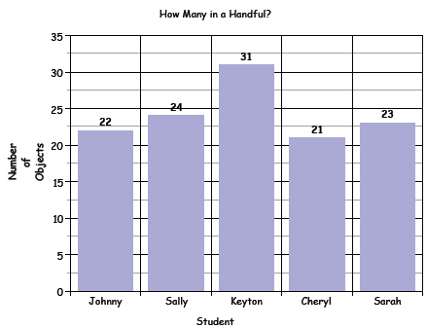**

|  |  |
| --- | --- |
|  |  |

**FORMATIVE ASSESSMENT QUESTIONS**

Creating a bar graph

* What information can you gather from your graphs?
* What decisions can you make from your data?
* How will you label the horizontal and vertical axes? How do you know?
* How will you label the scale on your vertical axis? How do you know?
* How did you choose the increments (1, 5, or 10) used to label the scale on the vertical axis? How would the graph be different if different increments were used?
* What does the graph show you about the data? What do you notice?

Creating a line plot graph

* What values need to be included on the number line? How do you know?
* Where is the data clumped? Where are the gaps in the data?
* What similarities do you see between a line plot and a bar graph?
* How is this line plot different from a bar graph?

**DIFFERENTIATION**

**Extension**

* Ask students to create a line plot graph for their group data. Have students to discuss similarities and differences between their line plot graph and the class line plot.
* What are the advantages/disadvantages of a line plot as opposed to a bar graph?

**Intervention**

* In a small group or individually, discuss with students the choices they can make regarding the increments used on the bar graph’s vertical axis. In most cases, bar graphs should start at zero. Ask students to think about how easy the data will be to read if the scale is labeled with increments of 1, 2, 5, or 10. Also, ask students to consider what will fit on the paper.

**TECHNOLOGY CONNECTION**

* <http://nces.ed.gov/nceskids/createagraph/default.aspx>

“Create A Graph” by the National Center for Education Statistics is a web-based program which allows students to create a bar graph.

* <http://www.amblesideprimary.com/ambleweb/mentalmaths/grapher.html>

This site is limited in its use but very simple to use – most labels can be renamed.

* <http://ellerbruch.nmu.edu/classes/cs255w03/cs255students/nsovey/P5/P5.html>

This site provides instructions to create a line plot graph as well as features to look for in a line plot graph.

Name \_\_\_\_\_\_\_\_\_\_\_\_\_\_\_\_\_\_\_\_\_\_\_\_\_\_\_\_ Date \_\_\_\_\_\_\_\_\_\_\_\_\_\_\_\_\_\_\_

It’s in the Data

Part 2

You will be finding handful data for a different object. Record the data for each student in your class in the table below.

|  |  |  |  |  |
| --- | --- | --- | --- | --- |
| **Student Name** | **Number of Objects in a Handful** |  | **Student Name** | **Number of Objects in a Handful** |
|  |  |  |  |  |
|  |  |  |  |  |
|  |  |  |  |  |
|  |  |  |  |  |
|  |  |  |  |  |
|  |  |  |  |  |
|  |  |  |  |  |
|  |  |  |  |  |
|  |  |  |  |  |
|  |  |  |  |  |
|  |  |  |  |  |

Use the data in the table above to create a line plot graph on a separate sheet of paper. Think about the following questions before you create your graph.

* What values will you use to label your number line? (What is the largest handful, what is the smallest handful?)
* How will you label your line plot graph? (Title, number line label)
* How will you be sure you record the data on the line plot graph accurately? (Be sure to include the data for each student in your class, use each piece of data only once.)

**MCAN00774_0000[1]****CULMINATING TASK: FIELD TRIP TO THE ZOO!**

While this task may serve as a summative assessment, it also may be used for teaching and learning. This task has three parts. In this task, students will use thinking and problem solving skills to plan a field trip to the zoo that includes a class picnic. For part 1, students must use elapsed time to plan the field trip schedule. While at the zoo (part 2), students will go on a “scavenger hunt” where they will determine the perimeter of the animals’ home, and how much mulch and grass it takes to cover certain living areas. At the picnic (part 3), students will determine how much food each student will get by weight and how much picnic punch each classmate will receive.

**APPROXIMATE TIME:** 3 days

**CONTENT STANDARDS**

**MGSE3.MD.1 Tell and write time to the nearest minute and measure elapsed time intervals in minutes. Solve word problems involving addition and subtraction of time intervals in minutes, e.g., by representing the problem on a number line diagram, drawing a pictorial representation on a clock face, etc.**

**MGSE3.MD.2** Measure and estimate liquid volumes and masses of objects using standard units of grams (g), kilograms (kg), and liters (l). Add, subtract, multiply, or divide to solve one-step word problems involving masses or volumes that are given in the same units, e.g., by using drawings (such as a beaker with a measurement scale) to represent the problem.

**MGSE3.MD.7** Relate area to the operations of multiplication and addition.

**MGSE3.MD.8** Solve real world and mathematical problems involving perimeters of polygons, including finding the perimeter given the side lengths, finding an unknown side length, and exhibiting rectangles with the same perimeter and different areas or with the same area and different perimeters.

**STANDARDS FOR MATHEMATICAL PRACTICE**

1. Make sense of problems and persevere in solving them.

2. Reason abstractly and quantitatively.

3. Construct viable arguments and critique the reasoning of others.

4. Model with mathematics.

5. Use appropriate tools strategically.

6. Attend to precision.

7. Look for and make use of structure.

8. Look for and express regularity in repeated reasoning.

**BACKGROUND KNOWLEDGE**

Students should understand and have had experience with elapsed time, area, perimeter, basic units of weight measurement (gram, kilogram), liquid volume (liters) and their relationships. Also, students should be able to solve problems in multiple ways and justify their thinking.

*NOTE: Keep in mind that students will not have to write everything out. However, they should give enough information to justify their answers.*

**ESSENTIAL QUESTIONS**

* How is elapsed time used in the world around me?
* What does it mean to determine time to the minute?
* How is perimeter measured?
* Why is it important to know how to figure out the area of a figure?
* How do we use weight measurement?
* Why is it important to be able to measure liquid volume?
* What strategies can I use to help determine elapsed time, area, perimeter, weight, and liquid volume?

**MATERIALS**

* “Field Trip to the Zoo” student recording sheet
* Blank Paper
* Model materials (if needed)
* Clocks (if needed)
* Geoboards, grid paper, area models (if needed)

**GROUPING**

Small Group/Partner Task

**NUMBER TALKS**

By now number talks should be incorporated into the daily math routine. Continue utilizing the different strategies in number talks and revisiting them based on the needs of the students.

**TASK DESCRIPTION, DEVELOPMENT AND DISCUSSION (SMP 1, 2, 3, 4, 5, 6, 7, and 8)**

It is important that all elements of the task be addressed throughout the learning process so that students understand what is expected of them. Uses for this task include but are not limited to:

* Peer Review
* Display for parent night
* Placement in student portfolio

Because the focus of this task is on measurement, it would be appropriate to allow students to use manipulatives and math tools for this task.

**Task Directions**

**Part I: Trip Schedule (Small Groups)**

Students follow the directions as stated on the “Field trip to the Zoo” recording sheet.

**Part II: Exploring the Zoo…a Scavenger Hunt! (Partner Groups)**

Students follow the directions as stated on the handout, “Exploring the Zoo...a Scavenger Hunt”

**Part III: The Class Picnic! (Small Groups)**

Students follow the directions as stated on the handout, “The Class Picnic.”

**FORMATIVE ASSESSMENT QUESTIONS**

* Why is understanding time to the minute and elapsed time important in completing this task? (part 1)
* What strategies are you using to organize your thinking about this task?
* How did you know when it is appropriate to determine perimeter?
* How do you know when it is appropriate to determine the area?
* What strategies are you using to figure out how much food and picnic punch each student gets?

**DIFFERENTIATION**

**Extension**

* Part 1: Have students create more than 1 schedule with different sets of activities on them.
* Part 2:
  + Have students create their own scavenger hunt.
  + Increase dimensions.
* Part 3:
  + Change the portion sizes and have students figure out new amounts.
  + Increase the class size (i.e. 35 students)

**Intervention**

* Part 1:
  + Give students clocks and number lines as aides.
  + Choose and fill in the activities for the students
  + Fill in other parts of the schedule
* Part 2:
  + Allow students to use geoboards, grid paper, or area models for help.
  + Decrease the dimensions.
  + Give students tactile models
* Part 3:
  + Use tactile models to help students.
  + Decrease the class size (i.e. 10 students)
  + Facilitate a teacher-guided group.

**TECHNOLOGY CONNECTION**

* <http://www.thefutureschannel.com/dockets/realworld/teaching_zoo/>

This FUTURES video is a great introduction to this task. Students see how important accurate measurements using both metric and standard weights are important in a zoo.

MCAN00774_0000[1] **Field Trip to the Zoo! Part I**

Name \_\_\_\_\_\_\_\_\_\_\_\_\_\_\_\_\_\_\_\_\_\_\_\_\_\_\_\_\_\_\_Date\_\_\_\_\_\_\_\_\_\_\_\_\_\_\_\_\_\_\_\_\_\_

Your class wants to take a trip to the zoo. Your teacher has agreed to take the class. However, your teacher insists that you must apply what you have learned in this math unit to your trip. For your trip, you must complete this task and answer the questions that follow. Good luck!

**Field Trip Schedule**

You must create a trip schedule for everyone to follow while on the trip. You may use the table below to help you with your plan. Here are the guidelines:

* Your schedule should begin at 8:00 AM
* Your schedule should end when your class returns to the school at 2:30 PM.
* Be sure to include 33 minutes of travel time to and from the zoo.
* Include time for a one hour picnic.
* You may select all other activities of your choice (visit reptile house, play at the petting zoo, watch the animal stunt show, meet the zookeepers, watch lions, souvenir shop, etc).

|  |  |  |  |
| --- | --- | --- | --- |
| **Name of Activity** | **Start Time** | **End Time** | **Elapsed Time** |
| Leave our school, ride to the zoo | 8:00 |  | 33 minutes |
|  |  |  |  |
|  |  |  |  |
|  |  |  |  |
|  |  |  |  |
|  |  |  |  |
| Leave the zoo, ride back to our school |  | 2:30 | 33 minutes |

**Questions for Reflection**

1. Which activity took the most time?
2. Which activity took the least amount of time?
3. Choose two activities and combine them. How much time do they take altogether?
4. How much time did the field trip take?
5. Why is understanding time to the minute and elapsed time important in completing this task?

###### MCAN03407_0000[1]Exploring the Zoo…The Scavenger Hunt!

**Part II**

Name \_\_\_\_\_\_\_\_\_\_\_\_\_\_\_\_\_\_\_\_\_\_\_\_\_\_\_\_\_\_\_\_Date \_\_\_\_\_\_\_\_\_\_\_\_\_\_\_\_\_\_\_\_\_

While at the zoo, your team will participate in a scavenger hunt! Your goal is stop by different habitats where the animals live. Your team will either determine the distance around the animals’ living space, or how much material (mulch, grass, woodchips) it takes to cover their zoo habitat. Use the models and clues below to help you.

**The Zoo of Georgia**

40 feet

30 feet

60 feet

10 feet

10 feet

10 feet

80 feet

36 feet

10 feet

6 feet

4 feet



**The Zoo of Georgia**

1. The zoo keeper needs to take fresh food and water to a herd of animals that live in a cage that has an area of 160 feet. Where should he take it?
2. The grounds crew needs to cover a certain animal pen with 100 square feet of fresh sod. Where should they go?
3. Take a visit to the animals that live in an area that is 180 feet around. Where will you go?
4. Certain animals like to graze in an area that’s covered with 800 square feet of grass. Where is this place?
5. A certain animal pen is 40 feet in perimeter. Where is this pen located?
6. Certain animals live in their habitat that has an area of 360 square feet. Which animals live in this habitat?
7. Can you find the habitat that’s enclosed in 92 feet of fencing?
8. What animals like to play in an enclosed space of 24 feet?

**MCAN03407_0000[1] The Class Picnic!**

**Part III**

Name \_\_\_\_\_\_\_\_\_\_\_\_\_\_\_\_\_\_\_\_\_\_\_\_\_\_\_\_\_\_\_\_\_\_ Date \_\_\_\_\_\_\_\_\_\_\_\_\_\_\_\_\_\_\_\_\_

Now, it’s time to take a break! Let’s have a class picnic! Our school cafeteria sent a big cooler with everything we need to have our picnic. **There are 20 students in our class.** We just need to decide how much of each food item and picnic punch each person gets. This is what Miss Sally, the lunch lady, packed for us:

* 10 kilograms of mini sub sandwiches
* 1,000 grams of Baked potato chips
* 2,000 grams of apples
* 400 grams of trail mix
* 10 liters of picnic punch

Using this information, your job is to determine how much of each item every student gets. Every student should get a complete lunch. Show how you figured it out with pictures, numbers, and words below.