

**Georgia**

**Standards of Excellence**

**Frameworks**

**Mathematics**

GSE Third Grade

Unit 5: Representing and Comparing Fractions



**TABLE OF CONTENTS**

Overview 3

Standards for Mathematical Practice 3

Content Standards 4

Big Ideas 5

Essential Questions 6

Concepts & Skills to Maintain 7

Strategies for Teaching and Learning 7

Selected Terms and Symbols 8

**Tasks**

* Exploring Fractions 13
* Candy Crush 18
* Comparing Fractions 23
* Strategies For Comparing Fractions 28
* Cupcake Party 33
* Using Fraction Strips to Explore the Number Line 40
* I Like to Move It! Move It!! 45
* Pattern Blocks Revisited-Exploring Fractions Further with Pattern Blocks 51
* Party Tray 56
* Make a Hexagon Game 64
* Pizzas Made to Order 69
* Graphing Fractions 74
* Inch by Inch 78
* Measuring to ½ and ¼ Inch 81
* Trash Can Basketball 87

**Culminating Task**

* The Fraction Story Game 91

***Please note that all changes made to the standards will appear in red bold type. Additional changes will appear in green.

**UNIT OVERVIEW**

**In this unit, students will:**

* Develop an understanding of fractions, beginning with unit fractions.
* View fractions in general as being built out of unit fractions, and they use fractions along with visual fraction models to represent parts of a whole.
* Understand that the size of a fractional part is relative to the size of the whole. For example, 1/2 of the paint in a small bucket could be less paint than 1/3 of the paint in a larger bucket, but 1/3 of a ribbon is longer than 1/5 of the same ribbon because when the ribbon is divided into 3 equal parts, the parts are longer than when the ribbon is divided into 5 equal parts. Students are able to use fractions to represent numbers equal to, less than, and greater than one.
* Solve problems that involve comparing fractions by using visual fraction models and strategies based on noticing equal numerators or denominators.
* Recognize that the numerator is the top number (term) of a fraction and that it represents the number of equal-sized parts of a set or whole; recognize that the denominator is the bottom number (term) of a fraction and that it represents the total number of equal-sized parts or the total number of objects of the set
* Explain the concept that the larger the denominator, the smaller the size of the piece
* Compare common fractions with like denominators and tell why one fraction is greater than, less than, or equal to the other
* Represent halves, thirds, fourths, sixths, and eighths using various fraction models.

# STANDARDS FOR MATHEMATICAL PRACTICE (SMP)

This section provides examples of learning experiences for this unit that support the development of the proficiencies described in the Standards for Mathematical Practice. The statements provided offer a few examples of connections between the Standards for Mathematical Practice and the content Standards of this unit. The list is not exhaustive and will hopefully prompt further reflection and discussion.

*Students are expected to:*

**1. Make sense of problems and persevere in solving them.** Students make sense of problems involving fractions.

**2. Reason abstractly and quantitatively.** Students demonstrate abstract reasoning by connecting fraction models of shapes with the written form of fractions.

**3. Construct viable arguments and critique the reasoning of others.** Students construct and critique arguments regarding fractions by creating or drawing fractional models to prove answers.

**4. Model with mathematics.** Students use fraction strips to find equivalent fractions.

**5. Use appropriate tools strategically.** Students use tiles and drawings to solve the value of a fraction of a set.

**6. Attend to precision.** Students use vocabulary such as numerator, denominator, and fractions with increasing precision to discuss their reasoning.

**7. Look for and make use of structure.** Students compare unit fraction models with various denominators to reason that as the denominator increases, the size of the unit fraction decreases.

**8. Look for and express regularity in repeated reasoning.** Students will manipulate tiles to find the value of a fraction of a set. This will lead to the relationship between fractions and division.

**\*\*\*Mathematical Practices 1 and 6 should be evident in EVERY lesson\*\*\***

**CONTENT STANDARDS**

**Develop understanding of fractions as numbers**

**MGSE3.NF.1 Understand a fraction $\frac{1}{b}$ as the quantity formed by 1 part when a whole is partitioned into *b* equal parts (unit fraction); understand a fraction as the quantity formed by *a* parts of size . *For example, means there are three parts, so = + + .***

**MGSE3.NF.2** Understand a fraction as a number on the number line; represent fractions on a number line diagram.

1. **Represent a fraction on a number line diagram by defining the interval from 0 to 1 as the whole and partitioning it into *b* equal parts. Recognize that each part has size . Recognize that a unit fraction is located whole unit from 0 on the number line.**
2. **Represent a non-unit fraction on a number line diagram by marking off *a* lengths of (unit fractions) from 0. Recognize that the resulting interval has size and that its endpoint locates the non-unit fraction on the number line.**

**MGSE3.NF.3 Explain equivalence of fractions through reasoning with visual fraction models. Compare fractions by reasoning about their size.**

1. **Understand two fractions as equivalent (equal) if they are the same size, or the same point on a number line.**
2. **Recognize and generate simple equivalent fractions with denominators of 2, 3, 4, 6, and 8, e.g., . Explain why the fractions are equivalent, e.g., by using a visual fraction model.**
3. **Express whole numbers as fractions, and recognize fractions that are equivalent to whole numbers. *Examples: Express 3 in the form 3 = (3 wholes is equal to six halves); recognize that = 3; locate and 1 at the same point of a number line diagram.***

d. Compare two fractions with the same numerator or the same denominator by reasoning

about their size. Recognize that comparisons are valid only when the two fractions refer

to the same whole. Record the results of comparisons with the symbols >, =, or <, and

justify the conclusions, e.g., by using a visual fraction model

**MGSE3.MD.3** Draw a scaled picture graph and a scaled bar graph to represent a data set with several categories. Solve one- and two-step “how many more” and “how many less” problems using information presented in scaled bar graphs. *For example, draw a bar graph in which each square in the bar graph might represent 5 pets.*

**MGSE3.MD.4** Generate measurement data by measuring lengths using rulers marked with halves and fourths of an inch. Show the data by making a line plot, where the horizontal scale is marked off in appropriate units— whole numbers, halves, or quarters.

For more detailed information about unpacking the content standards, unpacking a task, math routines and rituals, maintenance activities and more, please refer to the Grade Level Overview.

**BIG IDEAS**

In first grade and second grades, students discuss partitioning and equal shares. Students will have partitioned circles and rectangles into two, three, and four equal shares. This is the first time students are understanding/representing fractions through the use of a number line, and developing deep understanding of fractional parts, sizes, and relationships between fractions. This is a foundational building block of fractions, which will be extended in future grades. Students should have ample experiences using the words, *halves, thirds, fourths,* and *quarters*, and the phrases *half of, third of, fourth of,* and *quarter of*. Students should also work with the idea of the whole, which is composed of two halves, four fourths or four quarters, etc.

Example:

How can you and a friend share equally (partition) this piece of paper so that you both have the same amount of paper to paint a picture?

* Fractional parts are equal shares of a whole or a whole set.
* The more equal sized pieces that form a whole, the smaller the pieces of the whole become.
* When the numerator and denominator are the same number, the fraction equals one whole.
* When the wholes are the same size, the smaller the denominator, the larger the pieces.
* The fraction name (half, third, etc) indicates the number of equal parts in the whole.

**ESSENTIAL QUESTIONS**

* How are fractions used in problem-solving situations?
* How can I compare fractions?
* What are the important features of a unit fraction?
* What relationships can I discover about fractions?

**CONCEPTS/SKILLS TO MAINTAIN**

Third-grade students will have prior knowledge/experience related to the concepts and skills identified in this unit.

* In first grade, students are expected to partition circles and rectangles into two or four equal shares, and use the words, halves, half of, a fourth of, and quarter of.
* In second grade, students are expected to partition circles and rectangles into two, three, or four equal shares, and use the words, halves, thirds, half of, a third of, fourth of, quarter of.
* Students should also understand that decomposing into more equal shares equals smaller shares, and that equal shares of identical wholes need not have the same shape.

**Fluency**: Procedural fluency is defined as skill in carrying out procedures flexibly, accurately, efficiently, and appropriately. Fluent problem solving does not necessarily mean solving problems within a certain time limit, though there are reasonable limits on how long computation should take. Fluency is based on a deep understanding of quantity and number.

**Deep Understanding**: Teachers teach more than simply “how to get the answer” and instead support students’ ability to access concepts from a number of perspectives. Therefore students are able to see math as more than a set of mnemonics or discrete procedures. Students demonstrate deep conceptual understanding of foundational mathematics concepts by applying them to new situations, as well as writing and speaking about their understanding.

**Memorization**: The rapid recall of arithmetic facts or mathematical procedures. Memorization is often confused with fluency. Fluency implies a much richer kind of mathematical knowledge and experience.

**Number Sense:** Students consider the context of a problem, look at the numbers in a problem, make a decision about which strategy would be most efficient in each particular problem. Number sense is not a deep understanding of a single strategy, but rather the ability to think flexibly between a variety of strategies in context.

**Fluent students**:

* flexibly use a combination of deep understanding, number sense, and memorization.
* are fluent in the necessary baseline functions in mathematics so that they are able to spend their thinking and processing time unpacking problems and making meaning from them.
* are able to articulate their reasoning.
* find solutions through a number of different paths.

For more about fluency, see: <http://www.youcubed.org/wp-content/uploads/2015/03/FluencyWithoutFear-2015.pdf>  and: <http://joboaler.com/timed-tests-and-the-development-of-math-anxiety/>

**STRATEGIES FOR TEACHING AND LEARNING**

Students need many opportunities to discuss fractional parts using concrete models to develop familiarity and understanding of fractions. Expectations in this domain are limited to fractions with denominators 2, 3, 4, 6 and 8.

Understanding that a fraction is a quantity formed by part of a whole is essential to number sense with fractions. Fractional parts are the building blocks for all fraction concepts. Students need to relate dividing a shape into equal parts and representing this relationship on a number line, where the equal parts are between two whole numbers. Help students plot fractions on a number line, by using the meaning of the fraction. For example, to plot 4/5 on a number line, there are 5 equal parts with 4 copies of one of the 5 equal parts.

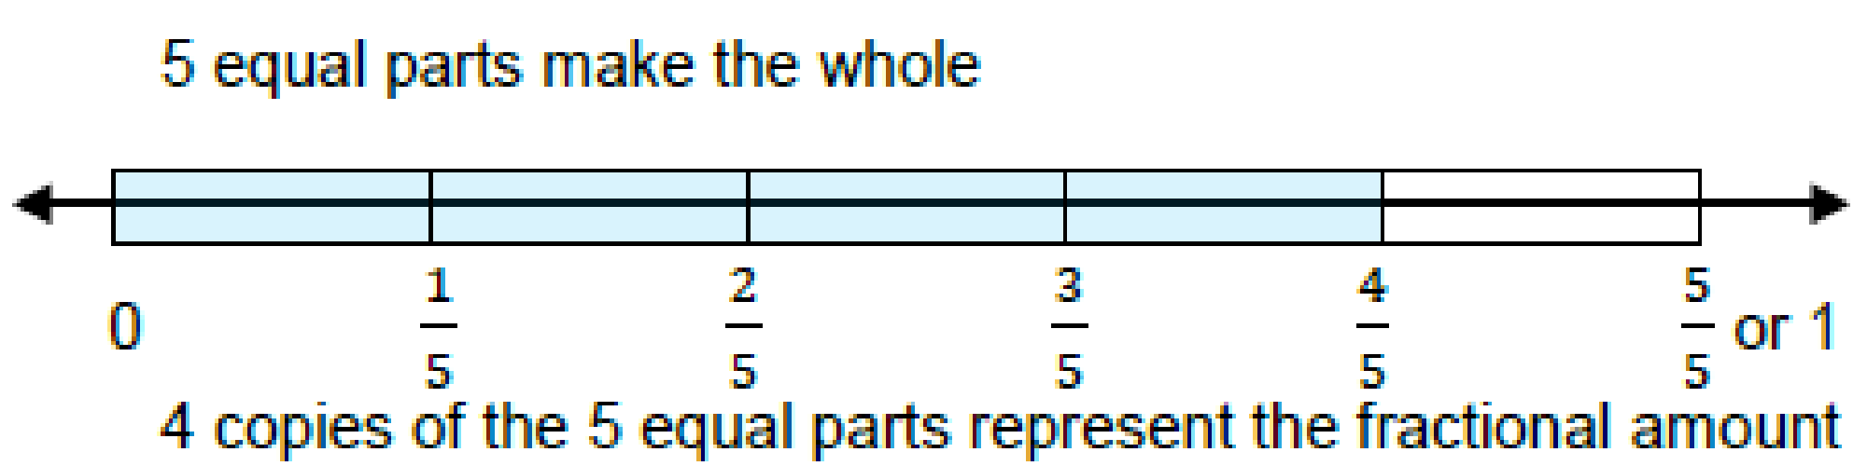

As students counted with whole numbers, they should also count with fractions. Counting equal-sized parts helps students determine the number of parts it takes to make a whole and recognize fractions that are equivalent to whole numbers.

Students need to know how big a particular fraction is and can easily recognize which of two fractions is larger. The fractions must refer to parts of the same whole. Benchmarks such as 1/2 and 1 are also useful in comparing fractions.

Equivalent fractions can be recognized and generated using fraction models. Students should use different models and decide when to use a particular model. Make transparencies to show how equivalent fractions measure up on the number line.

Venn diagrams are useful in helping students organize and compare fractions to determine the relative size of the fractions, such as more than 1/2, exactly 1/2 or less than 1/2. Fraction bars showing the same sized whole can also be used as models to compare fractions. Students are to write the results of the comparisons with the symbols >, =, or <, and justify the conclusions with a model.

*Should you need further support for this unit, please view the appropriate unit webinar at :*

[*https://www.georgiastandards.org/Pages/Math-PL-Sessions.aspx*](https://www.georgiastandards.org/Common-Core/Pages/Math-PL-Sessions.aspx)

**SELECTED TERMS AND SYMBOLS**

The following terms and symbols are often misunderstood. These concepts are not an inclusive list and should not be taught in isolation. However, due to evidence of frequent difficulty and misunderstanding associated with these concepts, instructors should pay particular attention to them and how their students are able to explain and apply them.

The terms below are **for teacher reference only** and are not to be memorized by the students. Teachers should present these concepts to students with models and real life examples. Students should understand the concepts involved and be able to recognize and/or demonstrate them with words, models, pictures, or numbers. [Mathematics Glossary](https://www.georgiastandards.org/Common-Core/Documents/CCGPS_Mathematics_Glossary.pdf)

* bar graph
* common fraction
* decimal fraction
* denominator
* equivalent fraction
* line plot graph
* numerator
* partition
* picture graph
* term
* unit fraction
* whole number
* set

**TASKS**

The following tasks represent the level of depth, rigor, and complexity expected of all third grade students. These tasks or a task of similar depth and rigor should be used to demonstrate evidence of learning. It is important that all standards of a task be addressed throughout the learning process so that students understand what is expected of them. While some tasks are identified as a performance task, they also may be used for teaching and learning (constructing task).

|  |  |
| --- | --- |
| **Scaffolding Task** | Tasks that build up to the learning task. |
| **Constructing Task** | Constructing understanding through deep/rich contextualized problem solving tasks. |
| **Practice Task** | Tasks that provide students opportunities to practice skills and concepts. |
| **Performance Task** | Tasks which may be a formative or summative assessment that checks for student understanding/misunderstanding and or progress toward the standard/learning goals at different points during a unit of instruction. |
| **Culminating Task** | Designed to require students to use several concepts learned during the unit to answer a new or unique situation. Allows students to give evidence of their own understanding toward the mastery of the standard and requires them to extend their chain of mathematical reasoning. |
| **Formative Assessment Lesson (FAL)** | Lessons that support teachers in formative assessment which both reveal and develop students’ understanding of key mathematical ideas and applications. These lessons enable teachers and students to monitor in more detail their progress towards the targets of the standards. |
| **CTE Classroom Tasks** | Designed to demonstrate how the Georgia Standards of Excellence and Career and Technical Education knowledge and skills can be integrated. The tasks provide teachers with realistic applications that combine mathematics and CTE content. |
| **3-Act Task** | A Three-Act Task is a whole-group mathematics task consisting of 3 distinct parts: an engaging and perplexing Act One, an information and solution seeking Act Two, and a solution discussion and solution revealing Act Three. More information along with guidelines for 3-Act Tasks may be found in the ***Guide to Three-Act Tasks*** on georgiastandards.org and the K-5 CCGPS Mathematics Wiki. |

|  |  |  |  |  |
| --- | --- | --- | --- | --- |
| **Task Name** | **Task Type**  ***Grouping Strategy*** | **Content Addressed** | **Standard(s)** | **Description** |
| Exploring Fractions | Scaffolding Task  *Individual/Small Group Task* | Naming fractional pieces, length model | MGSE3.NF.1 | In this lesson students will use strips of paper to create fraction bar models that they can refer back to and utilize throughout the unit |
| Candy Crush | Constructing Task  *Partner/Small Group Task* | Naming the value of a fraction of a set | MGSE3.NF.1 | In this lesson students will find the value of fractions of sets. |
| Comparing Fractions | Scaffolding Task  *Individual/Small Group Task* | Naming fractional pieces, exploring inequalities, length model | MGSE3.NF.3 | Students will create models of fractions that they can manipulate to find equivalent fractions. |
| Strategies for Comparing Fractions | Scaffolding Task  *Individual/Small Group Task* | Naming fractional pieces, exploring inequalities, length model | MGSE3.NF.3 | Students will use their fraction bars from the previous lesson to find inequalities and express those inequalities as number sentences. |
| Cupcake Party | 3-Act Task  *Whole Group* | Divide and label fractional parts | MGSE3.NF.1  MGSE3.NF.3 | In this task, students will watch a Vimeo and tell what they noticed. Next, they will be asked to discuss what they wonder about or are curious about. Students will then use mathematics to answer their own questions. |
| Using Fraction Strips to Explore the Number Line | Constructing Task  *Individual/Small Group Task* | Create a number line, explore fractions between 0 – 1, length model | MGSE3.NF.2 | Students create fraction number lines using strips of paper and use the number lines to find equalities and inequalities. |
| [Representing Fractions on a Number Line](http://ccgpsmathematicsk-5.wikispaces.com/file/view/Fractions%20on%20a%20Number%20Line%20Formative%20Assessment%20Lesson.pdf/437776398/Fractions%20on%20a%20Number%20Line%20Formative%20Assessment%20Lesson.pdf) | Formative Assessment Lesson | Representing fractions on a number line | MGSE.3.NF.1  MGSE.3.NF.2 | This formative assessment is designed to be implemented approximately two-thirds of the way through the instructional unit. |
| I Like to Move It! Move It!! | Constructing Task  *Partner/Small Group Task* | Placing fractions on number lines, iterating unit fractions | MGSE3.NF.1  MGSE3.NF.2  MGSE3.OA.3 | Students will count unit fraction on number lines. |
| Pattern Block Fractions Revisited | Constructing Task  *Partner/Small Group Task* | Apply skills in identifying fractional parts of a whole | MGSE3.NF.1 | Students will partition pattern blocks using various sized wholes. |
| Party Tray | 3-Act Task  *Whole Group* | Apply skills in identifying fractional parts of a whole  Practice using fractional parts to make a whole | MGSE3.NF.1 | In this task, students will look at a picture and tell what they noticed. Next, they will be asked to discuss what they wonder about or are curious about. Students will then use mathematics to answer their own questions. |
| Make a Hexagon Game | Practicing Task  *Partner/Small Group Task* | Practice using fractional parts to make a whole | MGSE3.NF.1 | Students will play a game where they create a fraction with dice and build their fraction on hexagons using pattern blocks. |
| Pizzas Made to Order | Practicing Task  *Individual Task* | Divide and label fractional parts | MGSE3.NF.1  MGSE3.NF.3 | Students will fill pizza orders by representing the ordered ingredients on the appropriate fractional parts of a pizza cut-out. |
| Graphing Fractions | Constructing Task  *Individual/Small Group Task* | Representing data as fractions, graphing data | MGSE3.MD.3  MGSE3.NF.1 | Students will create graphs and then identify the fractional representation of each bar of data and create questions that could be answered using the data in their graphs |
| Inch by Inch | Constructing Task  *Whole/Small Group Task* | Using nonstandard units of measurement to measure to the ¼ and ½ inch. | MGSE3.MD.4 | Students will create ruler using strips of paper and then create a line plot graph to collect and record the data of the objects they have measured to the nearest ¼ inch throughout the class. |
| Measuring to the ½ and ¼ Inch | Constructing Task  *Individual/Small Group Task* | Using a number line to measure and organize data | MGSE3.MD.4  MGSE3.NF.2  MGSE3.NF.3 | Students will measure objects to the nearest ½ and ¼ inch. Students will order their measurements from shortest to longest and will create a line-plot graph to represent their data. |
| Trash Can Basketball | Practice Task  *Partner/Small Group Task* | Representing data as fractions | MGSE3.NF.1  MGSE3.NF.2  MGSE3.NF.3 | Students will play a game where they write a fraction that represents the number of shots made and then create a poster that represents their results using an inequality. |
| The Fraction Story Game | Culminating Task  *Individual/Small Group Task* | Create a fraction game using story problems | MGSE3NF.1  MGSE3NF.2  MGSE3.NF.3 | Students create a game while reviewing all the different aspects of fractions they have studied. |

**FORMATIVE ASSESSMENT LESSONS (FALS)**

Formative Assessment Lessons are designed for teachers to use in order to target specific strengths and weaknesses in their students’ mathematical thinking in different areas. A Formative Assessment Lesson (FAL) includes a short task that is designed to target mathematical areas specific to a range of tasks from the unit. Teachers should give the task in advance of the delineated tasks and the teacher should use the information from the assessment task to differentiate the material to fit the needs of the students. The initial task should not be graded. It is to be used to guide instruction.

Teachers are to use the following Formative Assessment Lessons (FALS) Chart to help them determine the areas of strengths and weaknesses of their students in particular areas within the unit. The chart lists each FAL to use for a specific task or task along with the content addresses.

|  |  |  |
| --- | --- | --- |
| **Formative Assessments** | **Content Addressed** | **Pacing**  **(Use before and after this task)** |
| [ELEMENTARY FORMATIVE ASSESSMENT LESSONS](http://ccgpsmathematicsk-5.wikispaces.com/file/view/Fractions%20on%20a%20Number%20Line%20Formative%20Assessment%20Lesson.pdf/437776398/Fractions%20on%20a%20Number%20Line%20Formative%20Assessment%20Lesson.pdf) | Representing Fractions on a Number Line | I Like to Move It! Move It!! |

Although the units in this instructional framework emphasize key standards and big ideas at specific times of the year, routine topics such as estimation, mental computation, and basic computation facts should be addressed on an ongoing basis. Ideas related to the eight practice standards should be addressed constantly as well. This unit provides much needed content information and excellent learning activities. However, the intent of the framework is not to provide a comprehensive resource for the implementation of all standards in Unit 5. A variety of resources should be utilized to supplement this unit. The tasks in this unit framework illustrate the types of learning activities that should be utilized from a variety of sources. To assure that this unit is taught with the appropriate emphasis, depth, and rigor, it is important that the **“Strategies for Teaching and Learning”** and the tasks listed under **“Big Ideas”** be reviewed early in the planning process.

**SCAFFOLDING TASK:** **EXPLORING FRACTIONS**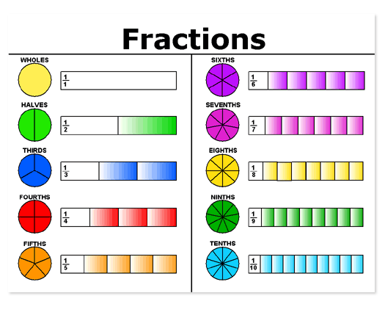

*Adapted from NCTM Illuminations*

**APPROXIMATE TIME:**2 class periods

In this lesson students will use strips of paper to create fraction bar models that they can refer back to and utilize throughout the unit.

**CONTENT STANDARDS**

**MGSE3.NF.1 Understand a fraction $\frac{1}{b}$ as the quantity formed by 1 part when a whole is partitioned into *b* equal parts (unit fraction); understand a fraction as the quantity formed by *a* parts of size . *For example, means there are three parts, so = + + .***

**STANDARDS FOR MATHEMATICAL PRACTICE**

1. Make sense of problems and persevere in solving them.

2. Reason abstractly and quantitatively.

3. Construct viable arguments and critique the reasoning of others.

4. Model with mathematics.

5. Use appropriate tools strategically.

6. Attend to precision.

7. Look for and make use of structure.

8. Look for and express regularity in repeated reasoning.

**BACKGROUND KNOWLEDGE**

Before the activity, be sure the children understand the concept of equal parts. Use pieces of different shaped paper (piece of construction paper, coffee filter, 8 ½ inch square cut from a piece of copy paper, 1/2 sheet of copy paper cut vertically, etc.) to demonstrate folding into equal-sized pieces. For some of the students to understand “equal-sized” you may have to cut and match the pieces, demonstrating that they are the same size. The use of different models, such as fraction bars and number lines, allows students to compare unit fractions and to reason about their sizes.

**COMMON MISCONCEPTIONS**

Students do not understand that when partitioning a whole shape, number line, or a set into unit fractions, the intervals must be equal. Students think all shapes can be divided the same way. To fix this misconception, students should have plenty of experiences with partitioning varying shapes and sets of shapes into equal parts.

**ESSENTIAL QUESTIONS**

* What is a fraction?
* How can I represent fractions of different sizes?
* What relationships can I discover about fractions?

**MATERIALS**

* Exploring Fractions task sheet
* 9” x 12” sheets of paper in six different colors (cut into 1” x 12” strips) Each child will need 6 strips, one of each color.
* Scissors
* File folder (1 for each child)
* Glue or tape

**GROUPING**

Individual/Partner Task

**NUMBER TALK**

By now number talks should be incorporated into the daily math routine. Continue utilizing the different strategies in number talks and revisiting them based on the needs of your students.

**TASK DESCRIPTION, DEVELOPMENT AND DISCUSSION**

**Part I (SMP 1, 3, 4, 5, 6, 7)**

To assess prior knowledge, ask students to create a list of ways they use fractions in their daily lives. Some examples may include dividing a snack in half (1/2), eating 3/8 of a pizza, using measuring cups or spoons while baking, money (half a dollar), time (quarter of an hour).

Read aloud and discuss, *Whole-y Cow!* by Taryn Souders (or another book about the concept of fractions).

To begin the lesson, give students six strips of paper in six different colors. Specify one color and have students hold up one strip of this color. Tell students that this strip will represent the whole. Have students write “one whole” on the fraction strip. The term **whole** is included in the labeling instead of 1 because it helps eliminate confusion between the numeral 1 in fractions such as ½.

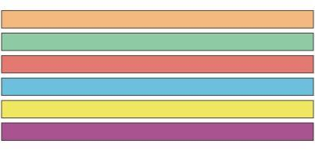

Next, ask students to pick a second strip and fold it into two equal pieces. Have students draw a line on the fold. Ask students what they think each of these strips should be called (one-half or ½). It is important, here, for students to understand how fractions are named. Discuss the names numerator and denominator with students. Have students label their strips accordingly using both the word and the fractional representation. Label both sides of the strip “1/2 one-half.”

Have students take out another strip, fold it in half twice, and divide it into four congruent pieces. Ask them what they think each of these strips should be called (one-fourth or ¼). Students should draw lines on the folds and label the strips using both the word and the fraction. Label all four sections of the strip “1/4 one-fourth”. Repeat the process of folding in half and naming eighths.

Students will take out another strip, fold it in thirds and divide it into three congruent pieces. Ask them what they think each of these strips should be called (one-third or 1/3). Have students draw lines on the folds and label the strips using both the word and the fraction. Label all three sections of the strip “1/3 one-third”. Repeat the process of folding in thirds and then in half to create sixths. Label each section “1/6 one-sixth.”

After folding and labeling strips of paper for the whole, halves, thirds, fourths, sixths, and eighths, ask students to glue or tape the strips on their file folder in order (largest fractional pieces to smallest fractional pieces). Make sure the students line up the strips evenly so that they begin to see equivalences. Suggestion: Secure the ½ strip first with the half mark on the crease in the file folder. Place every other paper strip in line with one-half.

**Part II (SMP 7)**

Arrange students in small groups of 2-3 students. Give them approximately ten minutes to write down their observations about the fraction strips. Have each group share some of their comments. Lead the groups to consider questions such as:

* How many halves does it take to make a whole strip?
* How many thirds does it take to equal one whole?
* How many fourths, sixths, eighths?

**Part III (SMP 1, 2, 3, 4, 5, 7, 8)**

Have students work in small groups to answer the questions below. The teacher should monitor the groups, asking questions, and encouraging students to explore the concept of fractions. Have groups (at least 2-3) share their solution to question number seven. Try to pick groups who presented different ways of dividing the sandwich.

**FORMATIVE ASSESSMENT QUESTIONS**

* Is your strip folded into equal parts? How do you know?
* What relationships did you discover about fractions?
* What does the numerator represent?
* What does the denominator represent?

**DIFFERENTIATION**

**Extension**

* Have students create additional fraction strips and write about relationships.

**Intervention**

* Use ready-made Fraction Tiles or Virtual Manipulatives.
* Use partitioning of shapes to link to this task. Show how the student is partitioning rectangles as they fold the strips.
* Class Fractions

Use a group of students as the whole – for example, six students if you want to work on 1/3s, 1/2s, and 1/6s. Ask students, “What fraction of our friends (are wearing tennis shoes, have brown hair, etc.)?” Change the number of people over time.

* Adapted fromElementary and Middle School Mathematics: Teaching Developmentally by John A. Van de Walle, Karen S. Karp, and Jennifer M. Bay-Williams, p. 290.

**TECHNOLOGY RESOURCES**

* <http://www.kidsnumbers.com/turkey-terminator-math-game.php>

This is a game site where students can practice concepts with fractions.

* <http://www.visualfractions.com/>

This site allows students to practice concepts with fractions using a variety of models.

* <http://nlvm.usu.edu/en/nav/frames_asid_103_g_1_t_1.html?from=topic_t_1.html>

The National Library of Virtual Manipulatives is a great site to visit when teaching fraction concepts.

Name: ___________________________ Date: _______________

**EXPLORING FRACTIONS**

(Adapted from a lesson by Angela Lacey Hester, Floyd County, GA)

1. Using complete sentences and math words, write 3 observations you and your group made about the Fraction Strips.

Use your Fraction Strips to answer the following questions.

2. How many thirds does it take to equal one whole?

3. How many sixths does it take to equal one whole?

4. What do you think three 1/8 strips might be called? How would you write that fraction?

5. If you made a 1/9 fraction strip, how many ninths would it take to make a whole?

Put on your thinking caps…

6. What would a 1/10 Fraction Strip look like? Sketch and label the Fraction Strip in the space below.

7. Pretend you are having a party for 6 people. For refreshments, you are serving a 12” sub sandwich. On the back of this paper, draw and label a 12” sub (just like your Fraction Strips). Show how you would equally divide the sandwich for 6 people. Use pictures, words, and numbers to explain your reasoning.

**CONSTRUCTING TASK: CANDY CRUSH!**

**APPROXIMATE TIME:** 1 Class period

In this lesson students will find the value of fractions of sets.

**CONTENT STANDARDS**

**MGSE3.NF.1 Understand a fraction $\frac{1}{b}$ as the quantity formed by 1 part when a whole is partitioned into *b* equal parts (unit fraction); understand a fraction as the quantity formed by *a* parts of size . *For example, means there are three parts, so = + + .***

**STANDARDS FOR MATHEMATICAL PRACTICE**

1. Make sense of problems and persevere in solving them.

2. Reason abstractly and quantitatively.

3. Construct viable arguments and critique the reasoning of others.

4. Model with mathematics.

5. Use appropriate tools strategically.

6. Attend to precision.

7. Look for and make use of structure.

**BACKGROUND KNOWLEDGE**

Students are introduced to fractions in 1st and 2nd grade by partitioning circles and rectangles into two, three, or four equal shares, describing the shares using the words halves, thirds, fourths, and quarters. This task will allow students to partition **sets** into fractional parts and will provide a foundation for exploring equivalent fractions in the next lessons of this unit. This task also links fractions with the concept of division which they have learned about in an earlier 3rd grade unit.

Understanding that parts of a whole must be partitioned into equal-sized shares across different models (shapes, number lines, **and sets**) is an important step in conceptualizing fractions and provides a foundation for exploring equivalence tasks, which are prerequisite to performing fraction operations (Cramer & Whitney, 2010)

**COMMON MISCONCEPTIONS**

Students plot points based on understanding fractions as whole numbers instead of fractional parts. For example: Students order fractions using the numerator or students order unit fractions by the denominator. Students also see the numbers in fractions as two unrelated whole numbers separated by a line.

**ESSENTIAL QUESTIONS**

* What represents the denominator in a set?
* What represents the numerator in a set?

**MATERIALS**

* counters

**GROUPING**

Partner/Small Group

**NUMBER TALKS**

By now number talks should be incorporated into the daily math routine. Continue utilizing the different strategies in number talks and revisiting them based on the needs of your students.

**TASK DESCRIPTION, DEVELOPMENT AND DISCUSSION (SMP 1, 2, 3, 4, 5, 6, 7)**

Begin by asking students to think about and discuss the meaning of the numerator and denominator in the fraction ½. It is essential that students have a clear understanding of the meaning of the digits in a fraction to complete this task. It may also be helpful to display the class-created definitions of numerator and denominator to refer to during the lesson.

In this task, students are rewarded for their good behavior! They get to choose the kind of candy they want based on their fractional calculations. To help guide students’ thinking as needed, refer them back to the meaning of the denominator and the numerator. Students will then answer the task questions.

**FORMATIVE ASSESSMENT QUESTIONS**

* What does the denominator represent in this problem?
* What does the numerator represent in this problem?
* Do fractions always represent the same amount? Why or why not?

**DIFFERENTIATION**

**Extension**

* Students can find other fractional parts of the available candy. If they are comfortable finding unit fractions, have them find fractions other than unit fractions. Examples: ⅔, ⅗ etc. Have these students explore what happens when the number in the set is not a multiple of the denominator. For example, what happens when you have 24 pieces of candy that you want to divide into fifths?

**Intervention**

* Provide struggling students with a sheet of paper that is divided into equal groups that is represented by the denominator in their problem. Have them count out the number of counters in the set in their problem and divide them evenly into the groups.

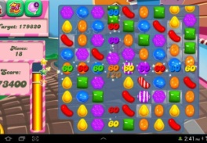**Name: ____________________________ Date: ____________________**

**Candy Crush!**

**Directions: You are being rewarded for your good classroom behavior! Use counters to help you solve and then draw a picture to justify each answer.**

**Jar #1 contains 24 pieces of Twizzlers. How many Twizzlers will you get if you can have ¼ of them?**

**Jar #2 contains 12 Hershey’s Kisses. How many Hershey’s Kisses can you get if you can have ½ of them?**

**Jar #3 contains 21 Gummie Bears. How many Gummie Bears can you get if you can have ⅓ of them?**

**Jar #4 contains 16 Skittles. How many Skittles can you get if you can have ½ of them?**

**Name: __________________________ Date: _____________________**

**Candy Crush! - Questions**

**1. Write a number sentence that represents how you solved each problem.**

**Jar #1 ________________________**

**Jar #2________________________**

**Jar #3________________________**

**Jar #4 ________________________**

**What operation is related to fractions? _________________**

**2. Does ½ always represent the same value? Explain your thinking.**

**3. Which candy will you choose? Explain your thinking.**

**4. Stanley chose 5 pieces of peppermints. If 5 pieces represents ¼ of all the peppermints, how many peppermints were there altogether?**

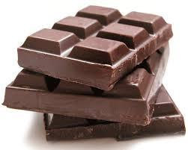**SCAFFOLDING TASK:** **COMPARING FRACTIONS**

*Adapted from NCTM Illuminations*

**APPROXIMATE TIME:**  2 class periods

Students will create models of fractions that they can manipulate to find equivalent fractions.

**CONTENT STANDARDS**

**MGSE3.NF.3 Explain equivalence of fractions through reasoning with visual fraction models. Compare fractions by reasoning about their size.**

1. **Understand two fractions as equivalent (equal) if they are the same size, or the same point on a number line.**
2. **Recognize and generate simple equivalent fractions with denominators of 2, 3, 4, 6, and 8, e.g., $\frac{1}{2} = \frac{2}{4}, \frac{4}{ 6} = \frac{2}{3}$. Explain why the fractions are equivalent, e.g., by using a visual fraction model.**

**STANDARDS FOR MATHEMATICAL PRACTICE**

1. Make sense of problems and persevere in solving them.

2. Reason abstractly and quantitatively.

3. Construct viable arguments and critique the reasoning of others.

4. Model with mathematics.

5. Use appropriate tools strategically.

6. Attend to precision.

7. Look for and make use of structure.

8. Look for and express regularity in repeated reasoning.

**BACKGROUND KNOWLEDGE**

Counting fractional parts is the groundwork for comparing and understanding the two parts of fractions. When developing this thinking, it is useful to display fraction pie pieces and count them together as a class. For example, using the fractions 1/4, 2/4, 3/4, 4/4, and 5/4, the class can discuss the relationship the fractions have with one whole. (Van De Walle, p. 138)

**COMMON MISCONCEPTIONS**

Students do not understand the importance of the whole of a fraction and identifying it. For example, students may use a fixed size of ¼ based on the manipulatives used or previous experience with a ruler.

**ESSENTIAL QUESTIONS**

* What relationships can I discover about fractions?
* How can I compare fractions?
* What equivalent groups of fractions can I discover using Fraction Strips?

**MATERIALS**

* Comparing Fractions task sheet
* 9” x 12” sheets of paper in six different colors (cut into 1” x 12” strips) Each child will need 6 strips, one of each color.
* Scissors

**GROUPING**

Partner/Small Group

**NUMBER TALKS**

By now number talks should be incorporated into the daily math routine. Continue utilizing the different strategies in number talks and revisiting them based on the needs of your students.

**TASK DESCRIPTION, DEVELOPMENT AND DISCUSSION**

**Part I (SMP 1, 4, 5, 6, 7)**

Give students six strips of paper in six different colors. Repeat the Fraction Strip folding and labeling activity from the Exploring Fractions Task. This time, ask students to separate the Fraction Strips by cutting on the folds giving them 2 - ½ strips, 3 – 1/3 strips, and so forth. Give each student a plastic sandwich bag or envelope to store the strips. (You can also use fraction bars)

Arrange students in small groups of 2-3 students. Give them approximately ten minutes to write down their observations about the separated Fraction Strips. Have each group share some of their comments. Lead the groups to consider questions such as:

* Do you see any special relationships among the different colored strips?
* Place a ½ strip on your desk. How many strips or combinations of strips are the same size as ½?
* When fractions are the same size, they are called *equivalent*. What other equivalent sets of fractions can you create?

Have students line up their fraction strips and find as many relationships as they can. For instance, they might notice that three of the 1/6 pieces are equal to four of the 1/8 pieces, or that two of the 1/3 pieces are equal to four of the 1/6 pieces. Have students record these relationships on paper. When they have finished, have them share the relationships they have discovered. Record the relationships on chart paper and discuss.

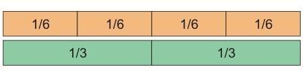

Students will notice that one whole is the same as 2/2, 4/4, 8/8, 3/3, or 6/6. Another example includes the relationship between ½, 2/4, 4/8, and 3/6. Tell students that when fraction strips are the same length, they represent equivalent fractions. Students may also notice that for each of these fractions, the numerator is ½ of the denominator.

**Part II (SMP 1, 2, 4, 5, 7, 8)**

Students will work in small groups to answer the questions in the activity sheet. The teacher should monitor the groups, asking questions, and encouraging students to explore the concept of fractions.

Have groups (at least 2-3) share their solution to question numbers 6 and 7. Try to pick groups who presented different ways of solving the problems. After this lesson, have students store their Fraction Strips in a plastic sandwich bag.

**Part III (SMP 1, 3, 4, 5, 6, 7)**

Students can practice comparing fractions using the following activity adapted fromElementary and Middle School Mathematics: Teaching Developmentally by John A. Van de Walle, Karen S. Karp, and Jennifer M. Bay-Williams, p. 290.

The friends below are playing red light-green light. Who is winning? Use your fraction strips to determine how far each friend has moved.

Mary – ¾ Harry – ½ Larry – 5/6

Sam – 5/8 Michael – 5/9 Angie – 2/3

**FORMATIVE ASSESSMENT QUESTIONS**

* What relationships did you discover about fractions?
* How can you compare fractions?
* What equivalent groups of fractions did you discover?

**DIFFERENTIATION**

**Extension**

* Students can use coffee filters, paper plates, or other objects to create different models to illustrate inequalities.

**Intervention**

* Use ready-made Fraction Tiles or Virtual Manipulatives.

**TECHNOLOGY RESOURCES**

* <http://www.mathplayground.com/Scale_Fractions.html>

This site provides games in which students can practice fraction concepts.

* <http://nlvm.usu.edu/en/nav/frames_asid_105_g_2_t_1.html?from=topic_t_1.html>

The National Library of Virtual Manipulatives is a great site for both teachers and students.

* <http://illuminations.nctm.org/ActivityDetail.aspx?ID=80>

This site by NCTM provides students to practice equivalent fractions.

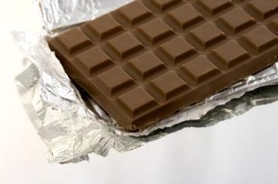Name: _______________________________ Date: _______________

**COMPARING FRACTIONS**

(Adapted from a Learning Task by Angela Lacey Hester, Floyd County, GA)

1. Using complete sentences and math words, write 3 observations you and your group made about the Fraction Strips.

Use your Fraction Strips to answer the following questions.

2. What fraction is equivalent to 2 of your 1/4 strips?

3. What fraction is equivalent to 3/6?

4. What fraction is equivalent to 6/8?

5. If you had made a fraction strip for 1/10s, how many tenths would it take to make to equal 1/2?

Put on your thinking caps….

6. In the space below, draw a Fraction Strip divided into fourths. Draw 2 additional shapes divided into fourths. Make one of your drawings a real-life example of something you might partition (divide) into fourths.

7. Pretend it is 7:30 a.m. Math Class begins at 8:00 a.m. Ashley says class starts in 30 minutes. Harrison says class starts in half an hour. Which child is correct? On the back of this page, draw a picture and write 2-3 sentences to explain your answer.

**SCAFFOLDING TASK:** **STRATEGIES FOR COMPARING FRACTIONS**

*Adapted from NCTM Illuminations*

**APPROXIMATE TIME:**2 class periods

Students will use their fraction bars from the previous lesson to find inequalities and express those inequalities as number sentences.

**CONTENT STANDARDS**

**MGSE3.NF.3 Explain equivalence of fractions through reasoning with visual fraction models. Compare fractions by reasoning about their size.**

1. **Understand two fractions as equivalent (equal) if they are the same size, or the same point on a number line.**
2. **Recognize and generate simple equivalent fractions with denominators of 2, 3, 4, 6, and 8, e.g., . Explain why the fractions are equivalent, e.g., by using a visual fraction model.**

d. Compare two fractions with the same numerator or the same denominator by reasoning about their size. Recognize that comparisons are valid only when the two fractions refer to the same whole. Record the results of comparisons with the symbols >, =, or <, and justify the conclusions, e.g., by using a visual fraction model.

**STANDARDS FOR MATHEMATICAL PRACTICE**

1. Make sense of problems and persevere in solving them.

2. Reason abstractly and quantitatively.

3. Construct viable arguments and critique the reasoning of others.

4. Model with mathematics.

5. Use appropriate tools strategically.

6. Attend to precision.

7. Look for and make use of structure.

8. Look for and express regularity in repeated reasoning.

**BACKGROUND KNOWLEDGE**

Counting fractional parts is the groundwork for comparing and understanding the two parts of fractions. When developing this thinking, it is useful to display fraction pie pieces and count them together as a class. For example, using the fractions 1/4, 2/4, 3/4, 4/4, and 5/4, the class can discuss the relationship the fractions have with one whole. (Van De Walle, p. 138)

**COMMON MISCONCEPTIONS**

Students do not understand the importance of the whole of a fraction and identifying it. For example, students may use a fixed size of ¼ based on the manipulatives used or previous experience with a ruler.

**ESSENTIAL QUESTIONS**

* How can I show that one fraction is greater (or less) than another using my Fraction Strips?
* How can I compare fractions when they have the same denominators?
* How can I compare fractions when they have the same numerators?

**MATERIALS**

* Strategies for Comparing Fractions task sheet
* Fraction strips from previous task

**GROUPING**

Partner/Small Group

**NUMBER TALKS**

By now number talks should be incorporated into the daily math routine. Continue utilizing the different strategies in number talks and revisiting them based on the needs of your students.

**TASK DESCRIPTION, DEVELOPMENT AND DISCUSSION**

Students will need their six strips of paper in six different colors from the previous task. Briefly review concepts covered in previous lessons.

**Part I (SMP 1 and 4)**

Guide students to compare fraction strips, this time encourage students to compare individual strips and explore which ones are longer and shorter. Arrange students in small groups of 2-3 students. Give them approximately ten minutes to write down their observations from comparing the Fraction Strips. Have each group share some of their comments. Lead the groups to consider questions such as:

* What special relationships do you notice among the different colored strips?
* Place a ½ strip on your desk. How many strips are less than ½?
* Place a 1/8 strip on your desk. How many strips are less than 1/8?

**Part II (SMP 1, 4, 5, 7)**

Instruct students to compare two fraction strips: ½ and ¼. Discuss which one is longer and which one is shorter. Have students discuss how they might write the inequality statements: ½ > ¼ and ¼ < ½. Guide them to the use of the symbols if they don’t do this independently. Repeat the activity with several additional fraction strips. Be sure to include equivalent fractions such as ½ = 2/4.

**Part III (SMP 1, 2, 3, 4, 5, 6, 7, 8)**

**Same Denominators/Different Numerator:**

Have students work in groups of 4. Ask them to arrange 3 groups of fractions in their work space. In row one, place 1 - 1/3 strip. In row two, place 2 – 1/3 strips. In row three, place 3 – 1/3 strips. On a sheet of paper, have the students write the names of the strips in order from shortest to longest (1/3, 2/3, 3/3). Encourage students to look for patterns. What do they observe about the denominators? (All are three.) What do they observe about the denominators? (They go in order getting larger each time.) How do the numerators relate to the size of the fraction strips? (The larger the numerator, the larger the strip of paper.) Why? (The larger the numerator, the more equal sized pieces you have.)

Ask students to repeat the above activity with their 1/4th strips. Discuss the students’ observations.

**Same Numerator/Different Denominator**:

Have students place one of each color Fraction Strip in their work space. At this time, do not include one whole. Ask students to arrange the strips from shortest to longest. Have the students write the names of the strips in order from shortest to longest (1/8, 1/6, ¼, 1/3, 1/2). Encourage students to look for patterns. What do they observe about the numerators? (All are one.) What do they observe about the denominators? (They go in order getting smaller each time.) How do the denominators relate to the size of the fraction strips? (The smaller the denominator, the larger the strip of paper.) Why? (The larger the denominator, the more pieces it takes to make the whole.)

Repeat this activity using 2 of each strip. Ask students to once again arrange the pairs of strips in order from smallest to largest (2/8, 2/6, 2/4, 2/3, 2/2). Discuss the students’ observations.

**Part IV (SMP 1, 2, 3, 4, 5, 6, 7, 8)**

Have students work in small groups to answer the questions in the task sheet. The teacher should monitor the groups, asking questions, and encouraging students to explore the concept of fractions.

At least two or three groups should share their solution to question number 6. Try to pick groups who presented different ways of solving the problems. After this lesson, have students store their Fraction Strips in their sandwich bag.

**FORMATIVE ASSESSMENT QUESTIONS**

* What relationships did you discover about fractions?
* How can you compare fractions with the same denominators?
* How can you compare fractions with the same numerators?

**DIFFERENTIATION**

**Extension**

* Have students write a set of guidelines and illustrations for comparing fractions and share with a peer.

**Intervention**

* Use ready-made Fraction Tiles or Virtual Manipulatives.
* Ordering Unit Fractions

List a set of unit fractions such as ½, 1/3, 1/8, 1/5. Ask children to put the fractions in order from least to greatest. Challenge students to defend the way they ordered fractions. Ask them to illustrate their idea using fraction strips or other models.

Repeat the activity using fractions with the same denominators

such as 3/5, 2/5, 5/5, 4/5, 1/5.

Adapted fromElementary and Middle School Mathematics: Teaching Developmentally

By John A. Van de Walle, Karen S. Karp, and Jennifer M. Bay-Williams, p. 300.

**TECHNOLOGY RESOURCES**

* <http://www.gamequarium.com/fractions.html>

This site provides games in which students came practice fraction concepts.

* <http://www.learningplanet.com/sam/ff/index.asp>

This site has both teacher and student activities .

Name: _______________________________ Date: _______________

**STRATEGIES FOR COMPARING FRACTIONS**

(Adapted from a Learning Task by Angela Lacey Hester, Floyd County, GA)

1. Using complete sentences and math words, write 3 observations you and your group made about fraction inequalities, comparing fractions with the same denominators, and comparing fractions with the same numerators.

Use your Fraction Strips to answer the following questions.

2. Write an inequality statement for the fractions .

3. Write two inequality statements using $\frac{1}{6}, \frac{1}{8}, \frac{1}{3}, \frac{1}{2}, and \frac{1}{4}.$

Put on your thinking caps….

4. Pretend you had fraction strips for $\frac{1}{5}$. Put the following fractions in order from smallest to largest: $\frac{1}{5}, \frac{5}{5}$, $\frac{3}{5}, \frac{4}{5}, and \frac{2}{5}.$ Draw a picture below to help explain your answer.

5. Using what you have learned about comparing fractions, put the following fractions in order from least to greatest: $\frac{3}{4}$, $\frac{3}{7}$, $\frac{3}{3}$, and $\frac{3}{8}$. Draw a picture below to help explain your answer. Stretch your brain- where would $\frac{3}{2}$ go? What might $\frac{3}{2}$ look like?

6. For the class party, Robin and Shawn each made a pan of brownies. Their pans were exactly the same size. Robin sliced her brownies into 9 pieces. Shawn sliced his into 12 pieces. Which student had the largest brownie pieces? On the back of this paper, make a sketch of Robin and Shawn’s brownies. Explain your reasoning using words, pictures, and numbers.

**3ACT TASK: CUPCAKE PARTY**

**APPROXIMATE TIME:** 1 class period

**CONTENT STANDARDS**

**MGSE3.NF.1 Understand a fraction $\frac{1}{b}$ as the quantity formed by 1 part when a whole is partitioned into *b* equal parts (unit fraction); understand a fraction as the quantity formed by *a* parts of size . *For example, means there are three parts, so = + + .***

**MGSE3.NF.3 Explain equivalence of fractions through reasoning with visual fraction models. Compare fractions by reasoning about their size.**

1. **Understand two fractions as equivalent (equal) if they are the same size, or the same point on a number line.**
2. **Recognize and generate simple equivalent fractions with denominators of 2, 3, 4, 6, and 8, e.g., . Explain why the fractions are equivalent, e.g., by using a visual fraction model.**
3. **Express whole numbers as fractions, and recognize fractions that are equivalent to whole numbers. *Examples: Express 3 in the form 3 = (3 wholes is equal to six halves); recognize that = 3; locate and 1 at the same point of a number line diagram.***
4. Compare two fractions with the same numerator or the same denominator by reasoning about their size. Recognize that comparisons are valid only when the two fractions refer to the same whole. Record the results of comparisons with the symbols >, =, or <, and justify the conclusions, e.g., by using a visual fraction model.

**STANDARDS FOR MATHEMATICAL PRACTICE**

1. **Make sense of problems and persevere in solving them.** Students must make sense of the problem by identifying what information they need to solve their question.
2. **Reason abstractly and quantitatively.** Students are asked to make an estimate (high and low).
3. **Construct viable arguments and critique the reasoning of others.** After writing down their own questions, students discuss their question with partners, creating the opportunity to construct the argument of why they chose their question, as well as critiquing the questions that others came up with.
4. **Model with mathematics.** Once given the information, the students use that information to develop a mathematical model to solve their question. Students should use model to justify their reasoning.
5. **Use appropriate tools strategically.** Students use number lines, drawings, or manipulatives to help them answer their main questions regarding fractions.
6. **Attend to precision.** Students use precise language when they discuss their reasoning with others.
7. **Look for and express regularity in repeated reasoning.** Students continually evaluate their work by asking themselves “Does this make sense?”

**ESSENTIAL QUESTIONS**

In order to maintain a student-inquiry-based approach to this task, it may be beneficial to wait until Act 2 to share the EQ’s with your students. By doing this, students will be allowed the opportunity to be very creative with their thinking in Act 1. By sharing the EQ’s in Act 2, you will be able to narrow the focus of inquiry so that the outcome results in student learning directly related to the content standards aligned with this task.

* What does it mean to partition a shape into parts?
* What are the important features of a unit fraction?

**MATERIALS**

* Act 1 video- <https://vimeo.com/94999740>
* Student recording sheet

**GROUPING**

Individual/Partner and or Small Group

**TASK DESCRIPTION, DEVELOPMENT AND DISCUSSION**

In this task, students will view the video and tell what they noticed. Next, they will be asked to discuss what they wonder about or are curious about. These questions will be recorded on a class chart or on the board and on the student recording sheet. Students will then use mathematics to answer their own questions. Students will be given information to solve the problem based on **need**. When they realize they don’t have the information they need, and ask for it, it will be given to them.

**Background Knowledge:**

This task follows the 3-Act Math Task format originally developed by Dan Meyer. More information on this type of task may be found at <http://blog.mrmeyer.com/category/3acts/>. A Three-Act Task is a whole-group mathematics task consisting of 3 distinct parts: an engaging and perplexing Act One, an information and solution seeking Act Two, and a solution discussion and solution revealing Act Three. More information along with guidelines for 3-Act Tasks may be found in the ***Guide to Three-Act Tasks*** on georgiastandards.org and the K-5 CCGPS Mathematics Wiki.

Up to this point, students have not worked with written fractions. They have partitioned circles and rectangles into equal shares using the words halves, thirds, half of, a third of, etc., but have not written fractions in fractional form ( ½ ).

Concepts about fractions are basic to mathematics but can pose challenges for students. In elementary schools, the most frequently used fraction models are the region and set models. This lesson exposes students to the region model and gives an opportunity for them to develop a thorough understanding of this model in multiple applications. As students work with a variety of fraction models in contexts that promote reasoning and problem solving, they develop a more thorough understanding of fractions and the relationships among them.

In this task, students may need scaffolds from the teacher. Students who struggle to see how to split the cupcakes evenly among 4 students will need prompts through questioning. When partitioning or sharing more than one object, one way to scaffold the activity for students is to ask, “How can you share 1 ______ (whatever the object is)?” In this particular task, it may be necessary to ask students how they would share 1 cupcake, and then have them apply that understanding to the 3 cupcakes. By requiring students to think about how to share 1 object, they are explicitly drawn to the unit fraction.

**Common Misconceptions:**

When partitioning a whole shape into parts, it is important to understand that the size of the parts must be equal, but the shape of the parts do not have to be the same. This task allows students to experience fractional parts that are not necessarily the same shape, but are the same size.

**Task Directions:**

**Act 1 – Whole Group** - Pose the conflict and introduce students to the scenario by showing Act I picture. **(Dan Meyer** <http://blog.mrmeyer.com/2011/the-three-acts-of-a-mathematical-story/>**)**

**“Introduce the central conflict of your story/task clearly, visually, viscerally, using as few words as possible.”**

* Show Act 1 video- <https://vimeo.com/94999740>
* Share and record students’ questions. The teacher may need to guide students so that the questions generated are math-related. Students may need to watch the video several times.

**Anticipated questions students may ask and wish to answer: (**\*Main question(s) to be investigated)

* *How can the students split the cupcakes equally?
* What fraction of a cupcake will each person get?
* Once students have their question, ask the students to estimate answers to their questions (think-pair-share). Students will write their best estimate, then write two more estimates – one that is too low and one that is too high so that they establish a range in which the solution should occur. Students should plot their three estimates on an empty number line. Note: As the facilitator, you may choose to allow the students to answer their own posed questions, one question that a fellow student posed, or a related question listed above. For students to be completely engaged in the inquiry-based problem solving process, it is important for them to experience ownership of the questions posed.

Important note: Although students will only investigate the main question(s) for this task, it is important for the teacher to not ignore student generated questions. Additional questions may be answered after they’ve found a solution to the main question, or as homework or extra projects.

**Act 2** – **Student Exploration** - Provide additional information as students work toward solutions to their questions. **(Dan Meyer** <http://blog.mrmeyer.com/2011/the-three-acts-of-a-mathematical-story/>**)**

**“The protagonist/student overcomes obstacles, looks for resources, and develops new tools.”**

* During Act 2, students decide on the facts, tools, and other information needed to answer the question(s) (from Act 1). When students decide what they need to solve the problem, they should ask for those things. It is pivotal to the problem solving process that students decide what is needed without being given the information up front.
* Required Information: (If students don’t get the information from the video)
  + 4 students
  + Only 3 cupcakes

* Some groups might need scaffolds to guide them. The teacher should question groups who seem to be moving in the wrong direction or might not know where to begin. Questioning is an effective strategy that can be used, with questions such as:
  + What is the problem you are trying to solve?
  + What do you think affects the situation?
  + Can you explain what you’ve done so far?
  + What strategies are you using?
  + What assumptions are you making?
  + What tools or models may help you?
  + Why is that true?
  + Does that make sense?

**Act 3 – Whole Group** – Share solutions and strategies.

* Students to present their solutions and strategies and compare them.
* Information for reveal:
  + Each person will get ¾ of a cupcake
* Lead discussion to compare these, asking questions such as:
  + How reasonable was your estimate?
  + Which strategy was most efficient?
  + Can you think of another method that might have worked?
  + What might you do differently next time?

**Act 4, The Sequel -** “The goals of the sequel task are to a) challenge students who finished quickly so b) I can help students who need my help. It can't feel like punishment for good work. It can't seem like drudgery. It has to entice and activate the imagination.” Dan Meyer <http://blog.mrmeyer.com/2013/teaching-with-three-act-tasks-act-three-sequel/>

For Act 4, share ideas below (see extensions) or reference other student-generated questions that could be used for additional classwork, projects or homework.

**FORMATIVE ASSESSMENT QUESTIONS**

* What organizational strategies did you use?
* How did you know what fraction you had?
* Is it possible to show each fraction in a different way? Show me your fraction in a different way.

**DIFFERENTIATION**

**Extension**

Students can create their own “cupcake party problems” where they can experiment with the number of people at the party and the number of cupcakes to be shared. Have students write a journal entry explaining their findings. Where there any problems that were easier to solve than others? Why?

**Intervention**

Allow students to first determine how the four students could share 1 cupcake. Once the student soles how to share 1 cupcake, allow them to expand on that knowledge to share the 3 cupcakes.

Task Title: ________________________ Name: ________________________

*Adapted from Andrew Stadel*

**ACT 1**

|  |
| --- |
| What did/do you notice? |
|  |
| What questions come to your mind? |
|  |

**Main Question**: ________________________________________________________________

|  |
| --- |
| What is your 1st estimate and why?  On an empty number line, record an estimate that is too low and an estimate that is too high. |

**ACT 2**

|  |
| --- |
| What information would you like to know or need to solve the MAIN question? |
|  |

Record the given information (measurements, materials, etc…)

**Act 2 (con’t)**

If possible, give a better estimation with this information: _______________________________

Use this area for your work, tables, calculations, sketches, and final solution.

**ACT 3**

|  |
| --- |
| What was the result? |
|  |

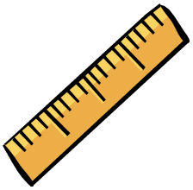**CONSTRUCTING TASK:** **USING FRACTION STRIPS TO EXPLORE THE NUMBER LINE**

*Adapted from a lesson by Michelle Clay, Floyd County, GA*

**APPROXIMATE TIME:** 2 class periods

Students create fraction number lines using strips of paper and use the number lines to find equalities and inequalities.

**CONTENT STANDARDS**

**MGSE3.NF.2** Understand a fraction as a number on the number line; represent fractions on a number line diagram.

1. **Represent a fraction on a number line diagram by defining the interval from 0 to 1 as the whole and partitioning it into *b* equal parts. Recognize that each part has size . Recognize that a unit fraction is located whole unit from 0 on the number line.**
2. **Represent a non-unit fraction on a number line diagram by marking off *a* lengths of (unit fractions) from 0. Recognize that the resulting interval has size $\frac{a}{b}$ and that its endpoint locates the non-unit fraction $\frac{a}{b}$ on the number line.**

**STANDARDS FOR MATHEMATICAL PRACTICE**

1. Make sense of problems and persevere in solving them.

2. Reason abstractly and quantitatively.

3. Construct viable arguments and critique the reasoning of others.

4. Model with mathematics.

5. Use appropriate tools strategically.

6. Attend to precision.

7. Look for and make use of structure.

8. Look for and express regularity in repeated reasoning.

**BACKGROUND KNOWLEDGE**

Children need to understand the meaning of fractions based on repeated hands-on activities. They need a general rule for explaining the numerator and denominator of a fraction. They need to understand that fractions are numbers that can be represented on a number line. Students need to understand that fractions between 0 – 1 can have denominators and numerators greater than one.

**COMMON MISCONCEPTIONS**

Students do not understand that when partitioning a whole shape, number line, or a set into unit fractions, the intervals must be equal. Students also do not count correctly on the number line. For example, students may count the hash mark at zero as the first unit fraction.

**ESSENTIAL QUESTIONS**

* What fractions are on the number line between 0 and 1?
* What relationships can I discover about fractions?
* How are tenths related to the whole?

**MATERIALS**

* Using Fraction Strips to Explore the Number Line Activity task sheet
* 9” x 12” sheets of paper in six different colors (cut into 1” x 12” strips) Each child will need one strip of paper in each color.
* Scissors
* File folder (1 for each child) or math journal
* Glue or tape

**GROUPING**

Individual/Partner Task

**NUMBER TALKS**

By now number talks should be incorporated into the daily math routine. Continue utilizing the different strategies in number talks and revisiting them based on the needs of your students.

**TASK DESCRIPTION, DEVELOPMENT AND DISCUSSION**

Students make and use a set of fraction strips to represent the interval between zero and one on the number line, discover fraction relationships, and work with equivalent fractions.

**Part I (SMP 4)**

To begin the lesson, give students six strips of paper in six different colors. Specify one color and have students hold up one strip of this color. Tell students that this strip will represent the number line from zero to one. Have students glue or tape the strip to the back of their file folder or math journal. The students will label folder above the left-hand side of the strip “0” and above the right-hand edge of the strip “1.”

Next, ask students to pick a second strip and fold it into two equal pieces. Have students label above this strip with the numerals 0, ½, 1.

Have students take out another strip, fold it twice, and divide it into four congruent pieces. Have students label the space above the strip using 0, ¼, 2/4, ¾, 1. Repeat this process of folding, cutting, and naming strips for thirds, and sixths. Have students use a ruler and label the last strip in 12ths by drawing a line at every inch. This particular number line will represent 1 foot. The inches are showing fractions of a foot. 1/12, 2/12, and so on.

**Part II (SMP 1, 4, 5, 6, 7)**

Arrange students in small groups of 2-3 students. Give them approximately ten minutes to write down their observations from comparing the Number Lines. Have each group share some of their comments. Lead the groups to consider questions such as:

* How are the Fraction Strips and Number Lines similar?
* How are they different?

Remind students that the fraction strip is equal to the length of a ruler which is one foot. Ask students to label ½ a foot with the letter A. Ask students to label 2/3 of a foot with B. Continue asking students to label fractional parts of a foot with letters.

**Part III (SMP 1, 2, 3, 4, 5, 6, 7, 8)**

Have students work in small groups to answer the questions below. The teacher should monitor the groups, asking questions, and encouraging students to explore the concept of fractions on the Number Line.

Have groups (at least 2-3) share their solution to question numbers 6 and 7. Try to pick groups who presented different ways of solving the problems. After this lesson, have students store their Fraction Strips in their sandwich bag.

**FORMATIVE ASSESSMENT QUESTIONS**

* What fractions are on the number line between 0-1?
* How did you determine the various fractions between 0-1?

**DIFFERENTIATION**

**Extension**

* Have students create additional strips representing fractions between 0 - 5 and write about relationships.

**Intervention**

* Use ready-made Fraction Tiles or Virtual Manipulatives.
* Line ‘Em Up

Select four or five fractions for students to put in order from least to greatest. Have them indicate approximately where each fraction belongs on the number line labeled only with the points 0 and 1. Adding machine paper can be used as a number line. Students can compare their lines with others and explain how they decided where to place the fractions.

Adapted fromElementary and Middle School Mathematics: Teaching Developmentally

By John A. Van de Walle, Karen S. Karp, and Jennifer M. Bay-Williams, p. 301.

**TECHNOLOGY RESOURCES**

* <http://www.mathsisfun.com/numbers/fraction-number-line.html>

This site is for both students and teachers and provides a visual for equivalent fractions using fraction bars.

Name: _______________________________ Date: _______________

**USING FRACTION STRIPS TO EXPLORE THE NUMBER LINE**

(Adapted from a Learning Task by Michelle Clay, Floyd County, GA)

1. Using complete sentences and math words, write 3 observations you and your group made about fractions between 0 and 1 on the Number Line.

Use your Number Lines to answer the following questions.

2. How many sixths are between 0 and 1?

3. How many 12ths are equivalent to 1 whole?

4. What fraction on the Number Line is equivalent to $\frac{2}{6}$?

Put on your thinking caps….

5. If is equivalent to the whole number 1, how many thirds are in the whole number 2?

6. What would the fraction $\frac{12}{4}$ represent? Draw a picture in the space below to explain your answer.

7. During a lesson on Measurement, students were asked to measure their feet using a ruler. Lexi’s foot measured 7 inches. Addie’s foot was $\frac{5}{6}$ of a foot. Robert’s foot was equal to ¾ of a foot. Andrew’s foot measured $\frac{2}{3}$ of a foot. Use your number line to help you arrange the students’ foot measurements in order from smallest to largest. On the back of this paper, sketch the Number Lines divided into thirds, fourths, sixths, and inches ($\frac{1}{12}$). Use pictures, numbers, and words to explain your solution.

**CONSTRUCTING TASK:** **I LIKE TO MOVE IT! MOVE IT!!**

**APPROXIMATE TIME:** 1-2 class periods

Students will count unit fraction on number lines.

**CONTENT STANDARDS**

**MGSE3.NF.1 Understand a fraction $\frac{1}{b}$ as the quantity formed by 1 part when a whole is partitioned into *b* equal parts (unit fraction); understand a fraction as the quantity formed by *a* parts of size . *For example, means there are three parts, so = + + .***

**MGSE3.NF.2** Understand a fraction as a number on the number line; represent fractions on a number line diagram.

1. **Represent a fraction on a number line diagram by defining the interval from 0 to 1 as the whole and partitioning it into *b* equal parts. Recognize that each part has size . Recognize that a unit fraction is located whole unit from 0 on the number line.**
2. **Represent a non-unit fraction on a number line diagram by marking off *a* lengths of (unit fractions) from 0. Recognize that the resulting interval has size $\frac{a}{b}$ and that its endpoint locates the non-unit fraction $\frac{a}{b}$ on the number line.**

**MGSE3.OA.3 Use multiplication and division within 100 to solve word problems in situations involving equal groups, arrays, and measurement quantities,e.g., by using drawings and equations with a symbol for the unknown number to represent the problem.[1]**

**See Glossary: *Multiplication and Division Within 100*.**

**STANDARDS FOR MATHEMATICAL PRACTICE**

1. Make sense of problems and persevere in solving them.

2. Reason abstractly and quantitatively.

3. Construct viable arguments and critique the reasoning of others.

4. Model with mathematics.

5. Use appropriate tools strategically.

6. Attend to precision.

7. Look for and make use of structure.

8. Look for and express regularity in repeated reasoning.

**BACKGROUND KNOWLEDGE**

Van de Walle stated that in whole-number learning, counting precedes and helps students compare the size of numbers and later to add and subtract. This is also true with fractions. Counting fractional parts, initially unit fractions, to see how multiple parts compare to the whole helps students understand the relationship between the parts (the numerator) and the whole (the denominator). (A unit fraction is a single fractional part. The fractions 1/3 and 1/8 are unit fractions). Students should come to think of counting fractional parts in much the same way as they; might count apples or other objects. If you know the kind of part you are counting (denominator), you can tell when you get to one whole, when you get to two wholes, and so on. Students should be able to answer the question, “How many fifths are in a whole?” us as they know how many ones are in a ten. However, in the 2008 National Assessment of Education Progress (NAEP) only 44 percent of fourth grade students answered that question correctly (Rampey, Dion, & Donahue, 2009).

The students will continue to be reinforced about their understanding of a unit fraction and the similarities and differences between it and units of 1 (whole numbers). Thus, in this task, the students will:

a. Develop an understanding of how, like units of 1, unit fractions are positioned on a number line in patterns of odd and even.

b. Adding unit fractions together can make wholes with extra “parts” as remainders.

c. “Explore” *b*’s relationship to division with remainders.

Throughout this unit, students have justified their understanding of how unit fractions make a whole. Just like counting whole numbers, the counting of unit fractions is called iterating. Like partitioning, iterating is an important part of being able to understand and use fractions. Understanding that ¾ can be thought of as a count of three parts called fourths is an important idea for students to develop (Van de Walle).

**COMMON MISCONCEPTIONS**

Many students do not see unit fractions as the basic building block of fractions, in the same sense that the number 1 is the basic building block of the whole numbers. Just as every whole number is obtained by combining sufficient number of 1s, every fraction is obtained by combining a sufficient number of unit fractions (Kentucky DOE FALs document).

**ESSENTIAL QUESTIONS**

* What is the relationship between a unit fraction and a unit of 1?
* How is the odd and even pattern with unit fractions on a number line similar to units of 1 on a number line?
* Why is the denominator important to the unit fractions?
* How does the numerator impact the denominator on the number line?

**MATERIALS**

* Sidewalk chalk

**GROUPING**

Partners/Small Group

**NUMBER TALKS**

By now number talks should be incorporated into the daily math routine. Continue utilizing the different strategies in number talks and revisiting them based on the needs of your students.

**TASK DESCRIPTION, DEVELOPMENT AND DISCUSSION**

**Part I**

It is imperative that the teacher conducts the following discussion using the below mentioned questions before the task since they will serve as a bridge for conceptual understanding.

On the board, the teacher will display the following number lines but have it continue to the whole number 5 with ⅓ and ⅔ being labeled between each whole unit and likewise with sixths . This will be done to reinforce how the denominator tells how many equal units it takes to make a whole and size relationship.

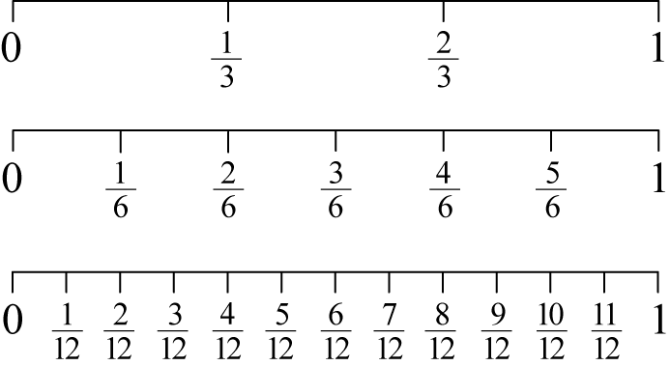

Questions:

a. How many units are represented between 0 and 1 on the first number line? second

number line?

b. What’s the major difference between the two number lines?

c. What do you think would happen if I had 5 thirds? Could it be placed on the number

line?

d. Are there fractions that are at the same point on the number line?

e. Why do you think that happened?

The teacher can then ask questions and have the students position the fractions on the number line. The Progressions document states that the words “proper” and “improper” fractions should NOT be introduced initially; instead 5/3 is the “quantity” you get by combining 5 parts together when the whole is divided into 3 equal parts. The **Progressions third grade** document also states that the goal is for students to see unit fractions as the basic building blocks of fractions, in the same sense that the number 1 is the basic building block of the whole numbers; just as every whole number is obtained by combining a sufficient number of 1s, every fraction is obtained by combining a sufficient number of unit fractions.

***The progressions’ document states that students need to see that unit fractions, the one with the larger denominator is smaller, by reasoning, for example, that in order for more (identical) pieces to make the same whole, the pieces must be smaller. From this they reason that for fractions that have the same numerator, the fraction with the smaller denominator is greater. For example, ⅖ >2/7, because 1/ 7 < ⅕, so 2 lengths of 1/7 is less than 2 lengths of ⅕ .***

**Part II (SMP 1, 2, 3, 4, 5, 6, 7, 8)**

The teacher will then take the students outside to the parking lot or sidewalk. She will have the students broken into groups of three. Each group will have been assigned a color which will match the sidewalk chalk number lines on the ground. Each group will have four number lines on the ground. The teacher will have this prepared with the number lines beginning at 0 and extending to 5. Their first task will be to partition each number line into halves, thirds, fourths, and sixths. Between each whole number should be 1/3, 2/3, or ¼, 2/4, ¾, etc. You never want the student to lose sight of whatever the denominator is, that’s how many parts it takes to make a whole. As for the number lines, be clear to say that each number line has its own fractions. Halves are on a line by themselves, thirds are on their own line and sixths are on their own line. They are NOT combined. ***Note for teacher: Creating unit fractions on a number line is actually more challenging than it sounds. The students will be developing their conceptual understanding of how halves should be drawn larger than thirds and so forth. Having a student serve as a “resident expert” once the fractions lines are completed will also reinforce the idea that the smaller the denominator the bigger the part and vice versa. The “expert” could also have a sheet with a sample to serve as a visual if need be.***

*Also, the students could partition the wholes into units without writing the fraction underneath. However, the students must know that between each whole number, the partitioning of units MUST remain the same****. 3rd grade progressions document, fractions, page 3***

The teacher should position the students in the parking lot or sidewalk side by side but with enough space so that the each group can work independently. This is important too so that when they begin the game, each team will have the same distance to run. The following gives an example of the way it could look.

**______No. Line Halves_______ _________No. Line Halves___________ _________No. Line Halves____**

**______No. Line Thirds________ _________No. Line Thirds___________ _________No. Line Thirds____**

**______No. Line Fourths_______ _________No. Line Fourths__________ _________No. Line Fourths____**

**______No. Line Sixths________ _________No. Line Sixths___________ _________No. Line Sixths____**

Once the number lines are partitioned into their correct fractional parts, the teams then go and stand at their starting line which should be about 8 to 10 feet directly behind their number lines and side by side with the other teams for fairness. The teacher will then call out a fraction. The first team member to run and stand on the correct position wins the point. They also must orally count aloud 1/3, 2/3, 3/3, 4/3, 5/3 so that ALL students gain an understanding of how unit fractions are counting numbers.

**FORMATIVE ASSESSMENT**

* What did you notice happening when the numerator was larger than the denominator?
* How is counting the number of parts related to creating whole numbers?
* How is that related to division?

**DIFFERENTIATION**

* **Extension #1-** Van de Walle Activity 12. 5, “How Far Did She Go?”, *Teaching Student Centered Mathematics, Second Edition*

Give students number lines partitioned such that only some of the partitions are showing. Meaning, between 0 and 1, give two partition fraction lines near zero, but leave the rest off to see if they can determine that there were six equal groupings. The other number line directly underneath could be eighths, but the partitioning lines could be near the number one. The scenario could be use a context such as walking to school. For each number line, ask, “How far has Nicole gone? How do you know? The teacher must have one of the partitioning lines circled on each graph and require the student to justify their responses to check for conceptual understanding. As an activity, the teacher can have the students create their own number lines with just a few partitioning lines displayed either near zero or one and have a classmate determine the location. Instead of it being just 0 to 1, it could be extended to whole numbers 5 or 10 depending on their readiness.

* **Extension #2-** This task could continue by doing similar activities from the previous day but the students must tell you the location in wholes and part. For example, if they are standing on 7/3 on the number line, then that’s 2 and 1/3. Note: This is NOT a third grade standard. However, it is an excellent opportunity to “expose” and justify how the parts of the denominator makes a whole and how the numerator factors in because the numerator partners with the denominator to possibly make wholes with parts left over. In fourth grade they call this a mixed number. This also shows a connection between division and fractions due to the divisor and denominator sharing the same role and the numerator is the dividend. This IS NOT meant for them to know, but to show relationships on the progression.

**Intervention**

* The students pull out their fractional self-created sets from the previous lesson or teacher provided fractional strips. The students will practice counting the fractional parts and drawing out different amounts. For example, they could count and display ½, 2/2, 3/2, 4/2, and 5/2. They would then draw the representation to look like a number line and label each part as typed above to show how you can count unit fractions like unit whole numbers.

***Just For Fun: The task is entitled “I like to move it! Move it!” When the students are using the sidewalk chalk to partition each number line into unit fractions, play the Madagascar song to get them moving since they will be running and moving throughout the game!***

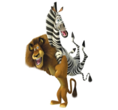

**CONSTRUCTING TASK:** **PATTERN BLOCK FRACTIONS REVISITED**

*Adapted from a Learning Task by Debra Childs, Floyd County, GA*

**[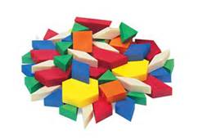](http://www.bing.com/images/search?q=pattern+blocks&qs=n&form=QBIR&pq=pattern+blocks&sc=8-14&sp=-1&sk=#view=detail&id=D43725A8A2361D93360524F7C49A143C69ADD720&selectedIndex=1)APPROXIMATE TIME:** 1 class period

Students will partition pattern blocks using various sized wholes.

**CONTENT STANDARDS**

**MGSE3.NF.1 Understand a fraction $\frac{1}{b}$ as the quantity formed by 1 part when a whole is partitioned into *b* equal parts (unit fraction); understand a fraction as the quantity formed by *a* parts of size . *For example, means there are three parts, so = + + .***

**STANDARDS FOR MATHEMATICAL PRACTICE**

1. Make sense of problems and persevere in solving them.

2. Reason abstractly and quantitatively.

3. Construct viable arguments and critique the reasoning of others.

4. Model with mathematics.

5. Use appropriate tools strategically.

6. Attend to precision.

7. Look for and make use of structure.

8. Look for and express regularity in repeated reasoning.

**BACKGROUND KNOWLEDGE**

A big idea for students to explore is that fractional parts are equal-sized parts of a whole unit. All the parts must be the same size. The unit can be a collection of things, and the unit is counted as one. The names for fractions tell how many parts of that size are needed to make the whole. In this activity, different wholes are designated in the same model. This discourages children from identifying a fractional part with a special shape or color, challenging them to see the relationship of each part to the designated whole. (Elementary and Middle School Mathematics: Teaching Developmentally, John A. Van de Walle, Karen S. Karp, and Jennifer M. Bay-Williams.)

**COMMON MISCONCEPTIONS**

Students do not understand that when partitioning a whole shape, number line, or a set into unit fractions, the intervals must be equal. Another misconception is that students do not understand the importance of the whole of a fraction and identifying it. For example, students may use a fixed size of ¼ based on the manipulatives used or previous experience with a ruler. Students also think all shapes can be divided the same way. These misconceptions will be addressed in this task.

**ESSENTIAL QUESTIONS**

* How can I use pattern blocks to name fractions?
* How does the size of the whole affect the size of the fractions?
* Is ¼ always the same size? How do you know?

**MATERIALS**

* Pattern Blocks
* Exploring Fractions Further With Pattern Blocks Activity Sheet

**GROUPING**

Partner/Small Group Task

**NUMBER TALKS**

By now number talks should be incorporated into the daily math routine. Continue utilizing the different strategies in number talks and revisiting them based on the needs of your students.

**TASK DESCRIPTION, DEVELOPMENT AND DISCUSSION**

**Part I (SMP 4)**

Begin this task by presenting the students with 2 different sized pieces of construction paper. (If you wish, you can name it a pan of brownies or pizza.) Pose the question: Is ¼ always the same size? With the students fold the larger piece of paper into fourths, then do the same with the smaller piece. Verify with the students that each piece was evenly folded into fourths. Ask the question, “Which ¼ of a pizza/pan of brownies would you like to have?” This will lead to a discussion around the size of the whole.

**Part II (SMP 1, 3, 4, 5, 7)**

Lead students in a discussion including questions such as:

* What if you use two yellow hexagon blocks to represent the whole?
* What fractional part of the whole will one yellow hexagon be?
* What block will represent ¼? What other relationships do you see?

Have students work together to complete the task sheet. Students should model each question with pattern blocks and make a sketch of the required blocks.

**FORMATIVE ASSESSMENT QUESTIONS**

* How did you determine ¼?
* How did the size of ½ change from the whole on page 1 to the whole on page 2?
* How does the size of the whole affect the size of the fractional piece?
* Can you find any equivalent fractions? How do you know?

**DIFFERENTIATION**

**Extension**

* Challenge students to explore additional variations of the whole such as three hexagons, four trapezoids, or eight triangles.

**Intervention**

* Finding Fair Shares - Give students other objects or models and ask them to find halves or fourths. Use familiar objects such as groups of cookies or pieces of candy. Vary the number of pieces in the whole. (Teaching Student-Centered Mathematics, Grades 3-5, John A. Van de Walle, Karen S. Karp, and Jennifer M. Bay-Williams, p. 136.

**[](http://www.bing.com/images/search?q=pattern+blocks&qs=n&form=QBIR&pq=pattern+blocks&sc=8-14&sp=-1&sk=#view=detail&id=D43725A8A2361D93360524F7C49A143C69ADD720&selectedIndex=1)PATTERN BLOCK FRACTIONS Revisited:**

**EXPLORING FRACTIONS FURTHER WITH PATTERN BLOCKS**

(Adapted from a Learning Task by Debra Childs, Floyd County, GA)

Name ____________________________________ Date _______________________

Task: Pattern Block Fractions

* Use the pattern blocks to solve

the riddles below.

* Draw the shape and label each fractional part.

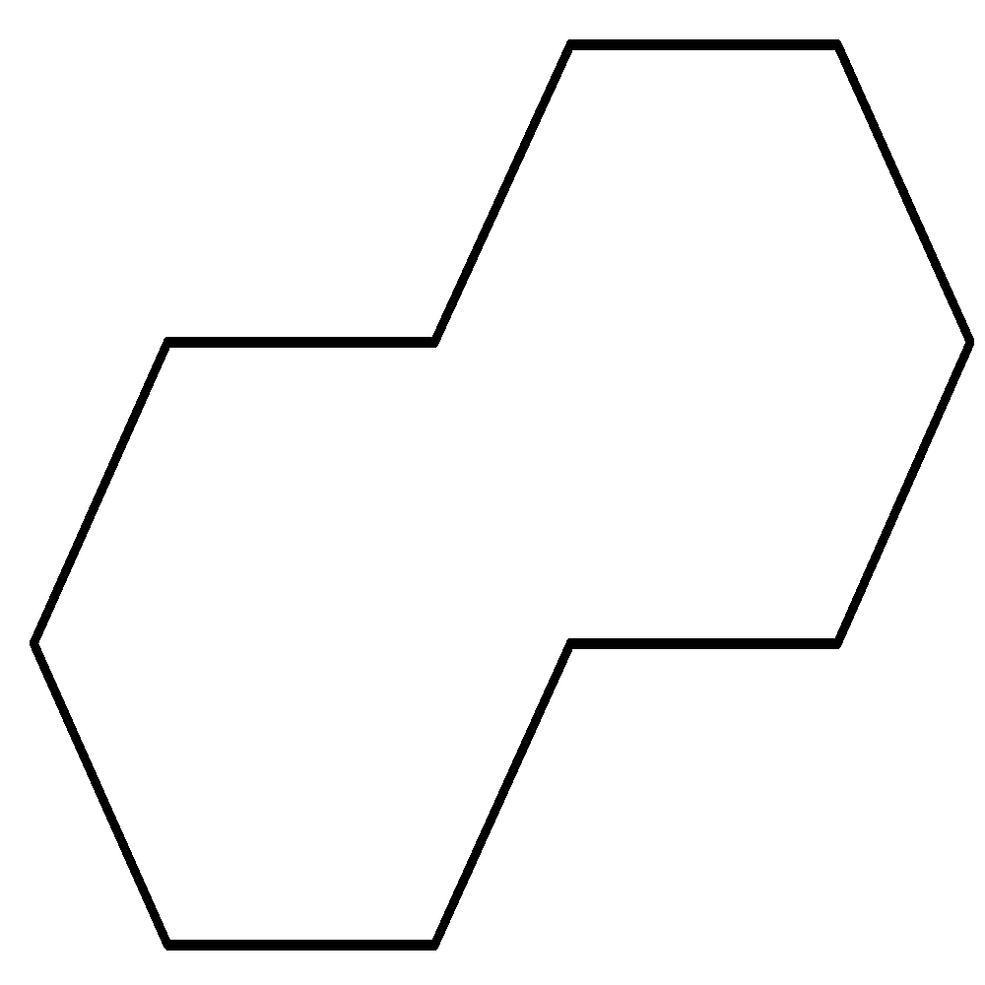

If this is one whole, what is $\frac{1}{2}$?

(Draw and label)



If this is one whole, what is $\frac{1}{4}$?

(Draw and label)



If this is one whole, what is $\frac{1}{6}$?

(Draw and label)

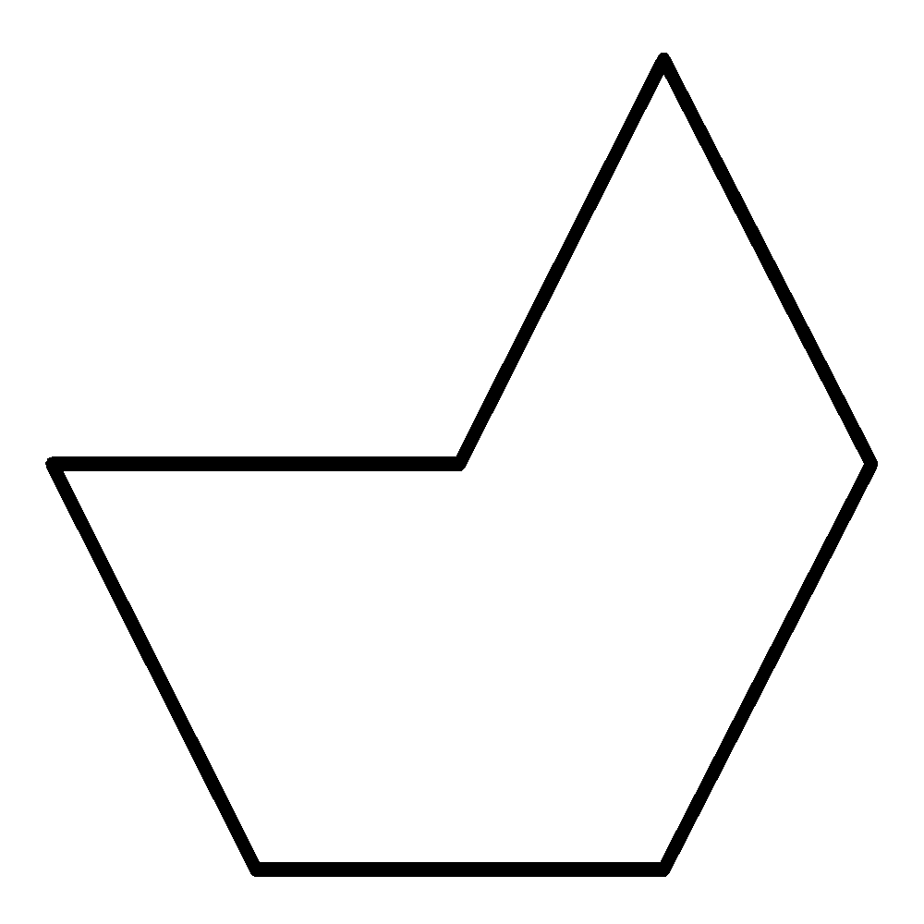

If this is one whole, what is $\frac{1}{2}$?

(Draw and label)



If this is one whole, what is $\frac{1}{4}$?

(Draw and label)



If this is one whole, show 1 $\frac{1}{2}$.

(Draw and label)

Use pictures, words, and numbers to summarize what you have learned from this task.

**3ACT TASK: PARTY TRAY** 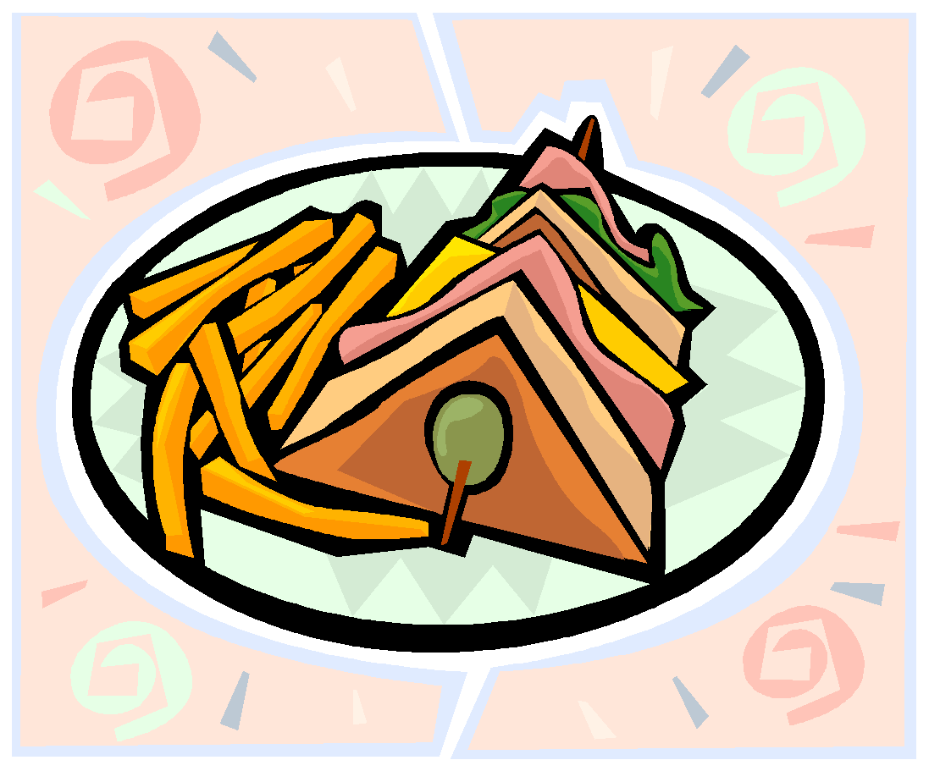

**APPROXIMATE TIME:** 1 class period

**CONTENT STANDARDS**

**MGSE3.NF.1 Understand a fraction $\frac{1}{b}$ as the quantity formed by 1 part when a whole is partitioned into *b* equal parts (unit fraction); understand a fraction as the quantity formed by *a* parts of size . *For example, means there are three $\frac{ 1 }{4}$ parts, so $\frac{3}{4}$ = $\frac{1}{4}$ + $\frac{1}{4}$ + $\frac{1}{4}$.***

**STANDARDS FOR MATHEMATICAL PRACTICE**

1. **Make sense of problems and persevere in solving them.** Students must make sense of the problem by identifying what information they need to solve their question.
2. **Reason abstractly and quantitatively.** Students are asked to make an estimate (high and low).
3. **Construct viable arguments and critique the reasoning of others.** After writing down their own questions, students discuss their question with partners, creating the opportunity to construct the argument of why they chose their question, as well as critiquing the questions that others came up with.
4. **Model with mathematics.** Once given the information, the students use that information to develop a mathematical model to solve their question. Students should use a model to justify their reasoning.
5. **Use appropriate tools strategically.** Students use number lines, drawings, or manipulatives to help them answer their main questions regarding fractions.
6. **Attend to precision.** Students use vocabulary such as numerator, denominator, and fractions with increasing precision to discuss their reasoning.
7. **Look for and express regularity in repeated reasoning.** Students continually evaluate their work by asking themselves “Does this make sense?”

**ESSENTIAL QUESTIONS**

In order to maintain a student-inquiry-based approach to this task, it may be beneficial to wait until Act 2 to share the EQ’s with your students. By doing this, students will be allowed the opportunity to be very creative with their thinking in Act 1. By sharing the EQ’s in Act 2, you will be able to narrow the focus of inquiry so that the outcome results in student learning directly related to the content standards aligned with this task.

* How are fractions used in problem-solving situations?
* How can I use fractions to name parts of a whole?
* What are the important features of a unit fraction?

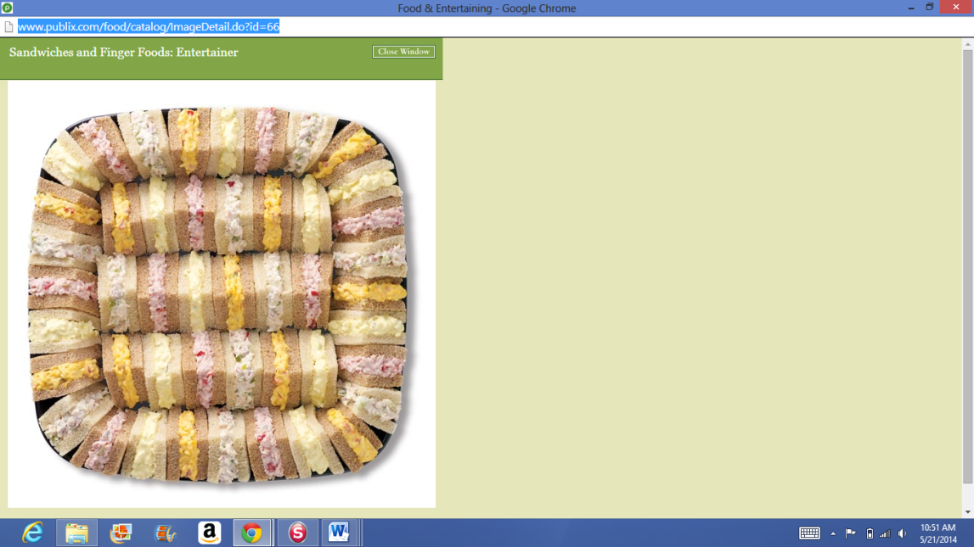**MATERIALS**

* Act 1 picture- Sandwich Tray
* Act 2 picture- Partitioned Sandwich
* Student recording sheet

**GROUPING**

Individual/Partner and or Small Group

**TASK DESCRIPTION, DEVELOPMENT AND DISCUSSION**

In this task, students will view the picture and tell what they noticed. Next, they will be asked to discuss what they wonder about or are curious about. These questions will be recorded on a class chart or on the board and on the student recording sheet. Students will then use mathematics to answer their own questions. Students will be given information to solve the problem based on **need**. When they realize they don’t have the information they need, and ask for it, it will be given to them.

**Background Knowledge:**

This task follows the 3-Act Math Task format originally developed by Dan Meyer. More information on this type of task may be found at <http://blog.mrmeyer.com/category/3acts/>. A Three-Act Task is a whole-group mathematics task consisting of 3 distinct parts: an engaging and perplexing Act One, an information and solution seeking Act Two, and a solution discussion and solution revealing Act Three. More information along with guidelines for 3-Act Tasks may be found in the ***Guide to Three-Act Tasks*** on georgiastandards.org and the K-5 CCGPS Mathematics Wiki.

Students are introduced to fractions in 1st and 2nd grade by partitioning circles and rectangles into two, three, or four equal shares, describing the shares using the words halves, thirds, fourths, and quarters.

Counting fractional parts is the groundwork for comparing and understanding the two parts of fractions. When developing this thinking, it is useful to display fraction pie pieces and count them together as a class. For example, using the fractions 1/4, 2/4, 3/4, 4/4, and 5/4, the class can discuss the relationship the fractions have with one whole. (Van De Walle, p. 138) This task will provide a foundation for exploring equivalent fractions in the next lessons of this unit. This task also links fractions with the concept of division which they have learned about in an earlier 3rd grade unit.

**Common Misconceptions:**

Students do not understand the importance of the whole of a fraction and identifying it. For example, students may use a fixed size of ¼ based on the manipulatives used or previous experience with a ruler.

**Task Directions:**

**Act 1 – Whole Group** - Pose the conflict and introduce students to the scenario by showing Act I picture. **(Dan Meyer** <http://blog.mrmeyer.com/2011/the-three-acts-of-a-mathematical-story/>**)**

**“Introduce the central conflict of your story/task clearly, visually, viscerally, using as few words as possible.”**

* Show Act 1 picture – Sandwich Tray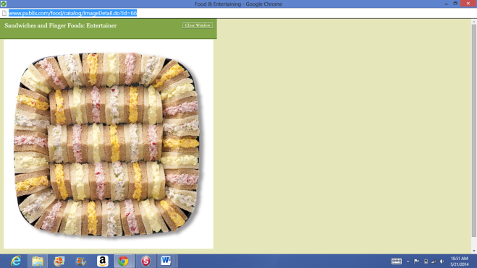
* Share and record students’ questions. The teacher may need to guide students so that the questions generated are math-related.

**Anticipated questions students may ask and wish to answer: (**\*Main question(s) to be investigated)

* What fraction of a sandwich is each piece?
* How many people can the tray feed?
* *How many whole sandwiches are on the tray?
* How many whole sandwiches are there of each type of sandwich?
* Once students have their question, ask the students to estimate answers to their questions (think-pair-share). Students will write their best estimate, then write two more estimates – one that is too low and one that is too high so that they establish a range in which the solution should occur. Students should plot their three estimates on an empty number line. Note: As the facilitator, you may choose to allow the students to answer their own posed questions, one question that a fellow student posed, or a related question listed above. For students to be completely engaged in the inquiry-based problem solving process, it is important for them to experience ownership of the questions posed.

Important note: Although students will only investigate the main question(s) for this task, it is important for the teacher to not ignore student generated questions. Additional questions may be answered after they’ve found a solution to the main question, or as homework or extra projects.

**Act 2** – **Student Exploration** - Provide additional information as students work toward solutions to their questions. **(Dan Meyer** <http://blog.mrmeyer.com/2011/the-three-acts-of-a-mathematical-story/>**)**

**“The protagonist/student overcomes obstacles, looks for resources, and develops new tools.”**

* During Act 2, students decide on the facts, tools, and other information needed to answer the question(s) (from Act 1). When students decide what they need to solve the problem, they should ask for those things. It is pivotal to the problem solving process that students decide what is needed without being given the information up front.
* Required Information: Act 2 Picture- Partitioned Sandwich

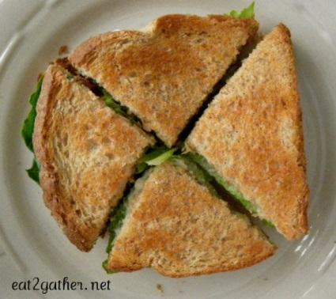

* Some groups might need scaffolds to guide them. The teacher should question groups who seem to be moving in the wrong direction or might not know where to begin. Questioning is an effective strategy that can be used, with questions such as:
  + What is the problem you are trying to solve?
  + What do you think affects the situation?
  + Can you explain what you’ve done so far?
  + What strategies are you using?
  + What assumptions are you making?
  + What tools or models may help you?
  + Why is that true?
  + Does that make sense?

**Act 3 – Whole Group** – Share solutions and strategies.

* Students present their solutions and strategies and compare them.
* Information for reveal:
  + 46 pieces that are ¼ in size
  + Total 11 ½ or 11 2/4 sandwiches
* As students share their solutions, this is a great opportunity to have the discussion of equivalent fractions. If a student gets the answer of 11 ½ sandwiches, but another gets 11 2/4 sandwiches, have students construct a viable argument for which student is correct or are both students correct. Once the students establish that both students are correct have the discussion of equivalence and what that means.
* Lead discussion to compare these, asking questions such as:
  + How reasonable was your estimate?
  + Which strategy was most efficient?
  + Can you think of another method that might have worked?
  + What might you do differently next time?

**Act 4, The Sequel -** “The goals of the sequel task are to a) challenge students who finished quickly so b) I can help students who need my help. It can't feel like punishment for good work. It can't seem like drudgery. It has to entice and activate the imagination.” Dan Meyer <http://blog.mrmeyer.com/2013/teaching-with-three-act-tasks-act-three-sequel/>

For Act 4, share ideas below (see extensions) or reference other student-generated questions that could be used for additional classwork, projects or homework.

**FORMATIVE ASSESSMENT QUESTIONS**

* What organizational strategies did you use?
* How is counting the number of parts related to creating whole numbers?

**DIFFERENTIATION**

**Extension**

* If each person ate 2/4 of a sandwich, how many people can the party tray feed?
* Pose similar problems to students. For example: If the tray contained 36 parts of a sandwich and each part was 1/3 of a sandwich in size, how many sandwiches are on the tray?
* If one person ate 1/3 of the sandwich pieces on the tray, how many pieces did they eat? How many whole sandwiches did they eat?

**Intervention**

* Provide students with manipulatives to act out forming sandwiches from the parts on the tray.

Act 1 Picture- Sandwich Tray

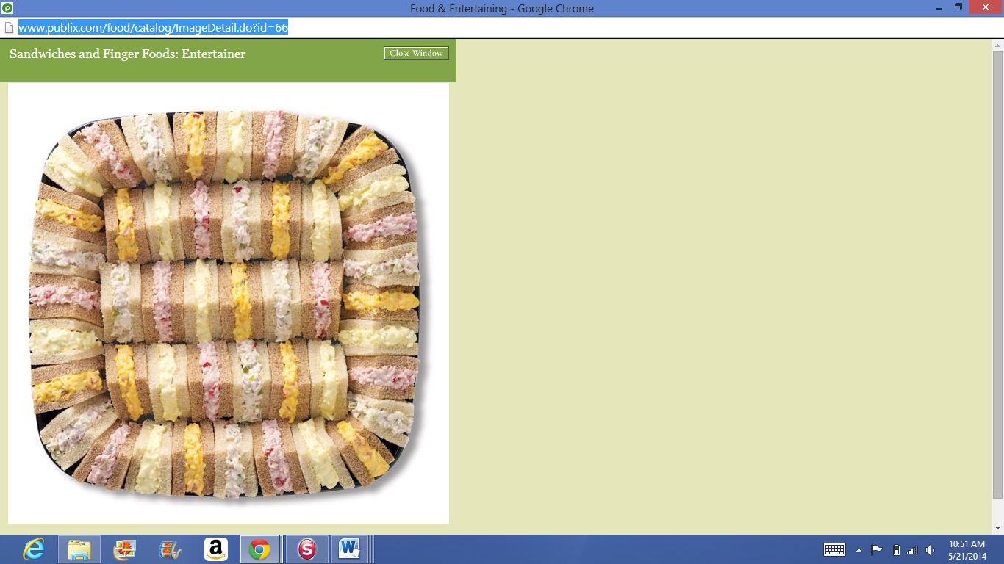

Act 2 Picture- Partitioned Sandwich



Task Title: ________________________ Name: ________________________

*Adapted from Andrew Stadel*

**ACT 1**

|  |
| --- |
| What did/do you notice? |
|  |
| What questions come to your mind? |
|  |

**Main Question**: ________________________________________________________________

|  |
| --- |
| What is your 1st estimate and why?  On an empty number line, record an estimate that is too low and an estimate that is too high. |

**ACT 2**

|  |
| --- |
| What information would you like to know or need to solve the MAIN question? |
|  |

Record the given information (measurements, materials, etc…)

**Act 2 (con’t)**

If possible, give a better estimation with this information: _______________________________

Use this area for your work, tables, calculations, sketches, and final solution.

**ACT 3**

|  |
| --- |
| What was the result? |
|  |

**C:\Users\Christy\AppData\Local\Microsoft\Windows\Temporary Internet Files\Content.IE5\02PBQILY\MC900048070[1].wmfPRACTICING TASK:** **MAKE A HEXAGON GAME**

*Adapted from a Learning Task from K-5 Math Teaching Resources*

**APPROXIMATE TIME:** 1 class period

Students will play a game where they create a fraction with dice and build their fraction on hexagons using pattern blocks.

**CONTENT STANDARDS**

**MGSE3.NF.1 Understand a fraction $\frac{1}{b}$ as the quantity formed by 1 part when a whole is partitioned into *b* equal parts (unit fraction); understand a fraction as the quantity formed by *a* parts of size . *For example, means there are three parts, so = + + .***

**STANDARDS FOR MATHEMATICAL PRACTICE**

1. Make sense of problems and persevere in solving them.

2. Reason abstractly and quantitatively.

3. Construct viable arguments and critique the reasoning of others.

4. Model with mathematics.

5. Use appropriate tools strategically.

6. Attend to precision.

7. Look for and make use of structure.

8. Look for and express regularity in repeated reasoning.

**BACKGROUND KNOWLEDGE**

The way we write fractions with a top and a bottom number with a bar between is simply an arbitrary agreement (convention) for how to represent fractions. It falls into the category of things you simply tell/show students. However, students do need to know the meaning of the numerator and denominator. The numerator tells how many shares or parts we have, how many have been counted, how many we are talking about. It counts the parts or shares. The denominator tells what is being counted. It tells what fractional part is being counted such as fourths or sixths.

(Elementary and Middle School Mathematics: Teaching Developmentally, John A. Van de Walle, Karen S. Karp, and Jennifer M. Bay-Williams.)

**COMMON MISCONCEPTIONS**

Students see the numbers in fractions as two unrelated whole numbers separated by a line.

**ESSENTIAL QUESTIONS**

* How can I use pattern blocks to name fractions?

**MATERIALS**

* Pattern Blocks: hexagon, triangles, trapezoid, blue rhombi
* Build a Hexagon Instructions and Game Board for each player
* Dice

**GROUPING**

Partner Task

**NUMBER TALKS**

By now number talks should be incorporated into the daily math routine. Continue utilizing the different strategies in number talks and revisiting them based on the needs of your students.

**TASK DESCRIPTION, DEVELOPMENT AND DISCUSSION (SMP 1, 2, 3, 4, and 5)**

Instruct students to work with a partner. For the game, students will take turns rolling two dice. The largest number rolled is the denominator and the smaller number is the numerator. Students build the fractional amount rolled on the game board using pattern blocks. Students may use equivalent fractions. If students roll a fraction they cannot build, they lose a turn. Play continues until one player has covered all the hexagons on his game board.

**FORMATIVE ASSESSMENT QUESTIONS**

* What does the top number (numerator) tell us?
* What does the bottom number (denominator) tell us?
* What happened in the game if you rolled the same number on both dice?
* Did you have to trade triangles for other shape blocks? What equal trades did you make?

**DIFFERENTIATION**

**Extension**

* Modify the game by changing the whole. Try using two hexagons for the whole or three trapezoids for the whole.

**Intervention**

* More, Less, or Equal to One Whole – Give students a collection of fractional parts (all the same type) and indicate the kind of fractional part they have. Parts can be drawn on a worksheet or physical models placed in plastic baggies with an identifying card. For example, if done with fraction strips, the collection might have seven strips with a card indicating “these are eighths.” The task is to decide if the collection is less than one whole, equal to a whole, or more than a whole. Students must draw pictures and/or use numbers to explain their answer. They can also tell how close the set is to a complete whole. (Teaching Student-Centered Mathematics, Grades 3-5, John A. Van de Walle, Karen S. Karp, and Jennifer M. Bay-Williams, p. 138.)

C:\Users\Christy\AppData\Local\Microsoft\Windows\Temporary Internet Files\Content.IE5\02PBQILY\MC900048070[1].wmfBuild a Hexagon

**Materials:** game board for each player, dice, pattern blocks (hexagon, triangles, trapezoids, blue rhombi)

Work with a partner. Take turns to roll two dice. The largest number you roll is the denominator and the smaller number is the numerator.

1. Use pattern blocks to build the fractional amount you rolled on the game board. You may use equivalent fractions.

2. If you roll a denominator that you can’t build, you lose a turn.

3. Keep going until one player has covered all the hexagons on his/her game board.

Build a Hexagon

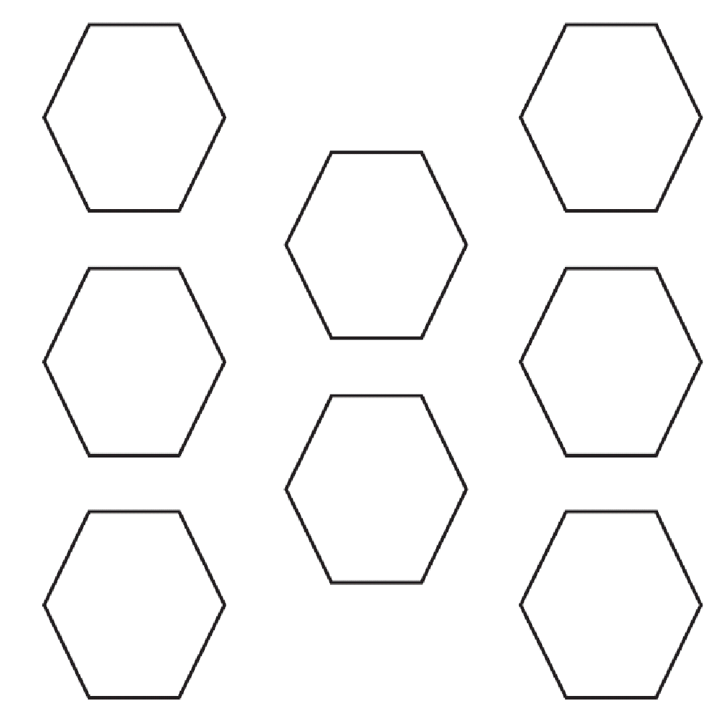

**CONSTRUCTING TASK:** **PIZZAS MADE TO ORDER**

*Adapted from a Learning Task by Cara Coker, Floyd County, GA*

**APPROXIMATE TIME:** 1-2 class periods

Students will fill pizza orders by representing the ordered ingredients on the appropriate fractional parts of a pizza cut-out.

**CONTENT STANDARDS**

**MGSE3.NF.1 Understand a fraction $\frac{1}{b}$ as the quantity formed by 1 part when a whole is partitioned into *b* equal parts (unit fraction); understand a fraction as the quantity formed by *a* parts of size . *For example, means there are three parts, so = + + .***

**MGSE3.NF.3 Explain equivalence of fractions through reasoning with visual fraction models. Compare fractions by reasoning about their size.**

1. **Understand two fractions as equivalent (equal) if they are the same size, or the same point on a number line.**
2. **Recognize and generate simple equivalent fractions with denominators of 2, 3, 4, 6, and 8, e.g., . Explain why the fractions are equivalent, e.g., by using a visual fraction model.**
3. **Express whole numbers as fractions, and recognize fractions that are equivalent to whole numbers. *Examples: Express 3 in the form 3 = (3 wholes is equal to six halves); recognize that = 3; locate and 1 at the same point of a number line diagram.***
4. Compare two fractions with the same numerator or the same denominator by reasoning about their size. Recognize that comparisons are valid only when the two fractions refer to the same whole. Record the results of comparisons with the symbols >, =, or <, and justify the conclusions, e.g., by using a visual fraction model.

**STANDARDS FOR MATHEMATICAL PRACTICE**

1. Make sense of problems and persevere in solving them.

2. Reason abstractly and quantitatively.

3. Construct viable arguments and critique the reasoning of others.

4. Model with mathematics.

5. Use appropriate tools strategically.

6. Attend to precision.

7. Look for and make use of structure.

8. Look for and express regularity in repeated reasoning.

**BACKGROUND KNOWLEDGE**

Before the activity, be sure the children understand the concept of equal parts. Practice with the student’s methods to divide various shapes into fractional pieces. Have students practice drawing lines to divide squares, rectangles, triangles, and circles into halves, fourths, eighths.

**COMMON MISCONCEPTIONS**

Students do not understand there are many fractions less than 1. Students do not understand fractions can be greater than 1.

**ESSENTIAL QUESTIONS**

* How can I represent fractions of different sizes?
* What relationships can I discover about fractions?
* What is a real-life example of using fractions?

**MATERIALS**

* Give Me Half! By Stuart J. Murphy (or another book about the concept of fractions).
* Scissors
* Glue or paste
* Crayons
* One large sheet of black paper
* One half sheet of brown paper
* Small pieces of various colored paper including red, white, green, yellow, black
* Pizza Order Directions – One per child

**GROUPING**

Individual Task

**NUMBER TALKS**

By now number talks should be incorporated into the daily math routine. Continue utilizing the different strategies in number talks and revisiting them based on the needs of your students.

**TASK DESCRIPTION, DEVELOPMENT AND DISCUSSION**

**Part I**

To assess prior knowledge, brainstorm with students about food that is divided into equal pieces. Possible suggestions may include a chocolate bar, apple pie, pizza, and an orange. Read aloud and discuss, *Give Me Half!* By Stuart J. Murphy (or another book about the concept of fractions).

**Part II (SMP 1, 2, 4, 5)**

To begin the lesson, give students a half sheet of brown paper. Instruct them to draw and cut out a circle from the brown paper. Then give each child a Pizza Order. Instruct the students to use their pencil to divide their circles into the fractional part used in the Pizza Order (fourths or eights). Then have the students trace over their pencil lines with a dark crayon. Next, give students small sheets of the colored paper (red, white, green, yellow, black). Instruct students to cut pieces of the colored paper to represent the pizza toppings. The toppings should be glued onto the appropriate number of pizza slices.

After the toppings have been successfully glued to the brown circle, give each student a sheet of black construction paper. Have the students glue their pizzas and Pizza Order Directions to the paper.

**FORMATIVE ASSESSMENT QUESTIONS**

* What fraction of your pizza is covered with peppers?
* What topping covers most of your pizza?
* Are black olives covering more or less than half your pizza?
* How did you divide your pizza into equal parts?
* How many equal parts did you need? How did you know?
* If your whole pizza was divided into fourths, how many slices did you cover with toppings? How would you write this as equivalent fractions? (4/4 = 1)
* If your pizza is covered with 1/8 mushrooms and 3/8 green peppers, does it have more mushrooms or green peppers? How do you know? (Encourage students to explain in terms of the pizza size and by comparing numerators in the fraction.)
* Some of you covered 4/8 of your pizzas with pepperoni. Can you name equivalent fractions for 4/8?
* Were any pizzas covered with ½ cheese? Why did your Pizza Order ask for 2/4 cheese?
* Do you see any other examples of equivalent fractions on the pizzas?

**DIFFERENTIATION**

**Extension**

* Have students create additional pizzas using more challenging fractional parts such as thirds, sixths, tenths. Increase the number of toppings. Have some sections contain more than one topping.

**Intervention**

* Provide ready-cut circles and if necessary, draw dotted lines for students to trace as they divide their pizzas into fractional parts. Have students complete Pizza Orders using fractions containing only common denominators.

**TECHNOLOGY RESOURCES**

<http://mrnussbaum.com/pizza_game/index.html>

<http://www.bgfl.org/bgfl/custom/resources_ftp/client_ftp/ks2/maths/fractions/index.htm>

<http://www.primarygames.com/fractions/2a.htm>

[**Student Work Sample**](http://www.primarygames.com/fractions/2a.htm)

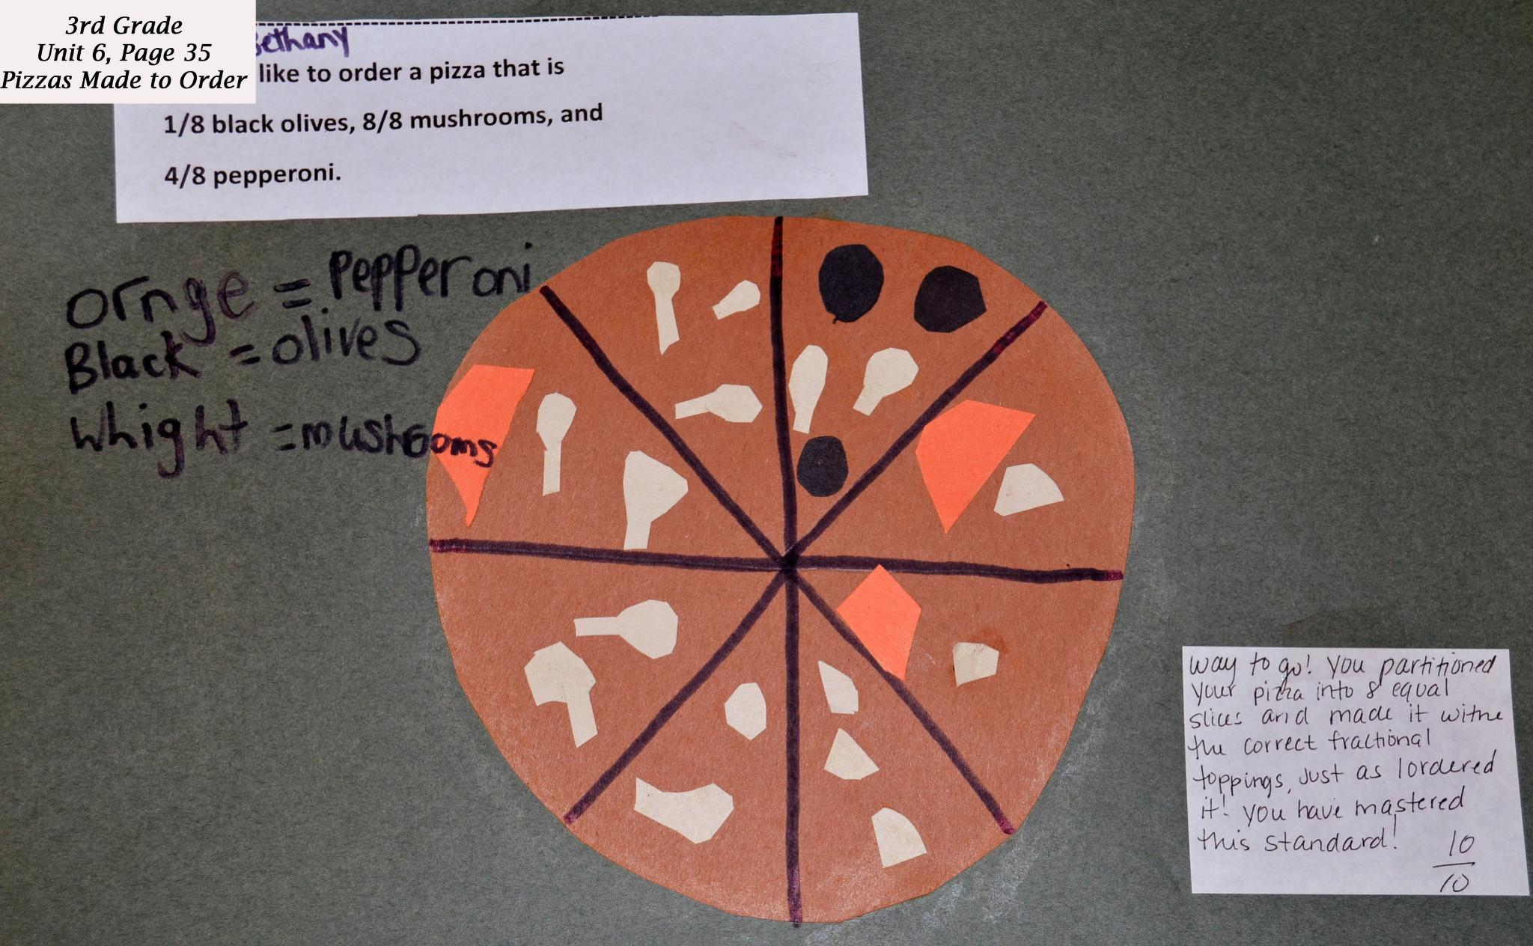

**PIZZAS MADE TO ORDER**: **PIZZA ORDER DIRECTIONS**

*Adapted from a lesson by Cara Coker, Floyd County, GA*

----------------------------------------------------------

I would like to order a pizza that is 1/8 green peppers,

8/8 pepperoni, and 3/8 mushrooms.

----------------------------------------------------------

I would like to order a pizza that is

¼ mushrooms, 2/4 cheese, and ¼ pepperoni.

----------------------------------------------------------

I would like to order a pizza that is

1/8 black olives, 8/8 mushrooms, and

4/8 pepperoni.

----------------------------------------------------------

I would like to order a pizza that is

¼ mushrooms, ¼ black olives, and

½ pepperoni.

----------------------------------------------------------

I would like to order a pizza that is

¼ cheese, ¼ black olives, ¼ pepperoni, and

¼ green peppers.

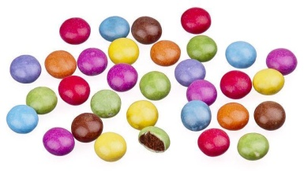**CONSTRUCTING TASK: GRAPHING FRACTIONS**

*From NCTM Illuminations*

**APPROXIMATE TIME:** 2 class periods

Students will draw a picture graph of their classmates’ favorite pets, a bar graph of their classmates’ favorite sports, and a graph of their choice of a bag of colored candies. Students will identify the fractional representation of each bar of data and create questions that could be answered using the data in their graphs.

**CONTENT STANDARDS**

**MGSE3.MD.3** Draw a scaled picture graph and a scaled bar graph to represent a data set with several categories. Solve one- and two-step “how many more” and “how many less” problems using information presented in scaled bar graphs. *For example, draw a bar graph in which each square in the bar graph might represent 5 pets.*

**MGSE3.NF.1 Understand a fraction $\frac{1}{b}$ as the quantity formed by 1 part when a whole is partitioned into *b* equal parts (unit fraction); understand a fraction as the quantity formed by *a* parts of size . *For example, means there are three parts, so = + + .***

**STANDARDS FOR MATHEMATICAL PRACTICE**

1. Make sense of problems and persevere in solving them.

2. Reason abstractly and quantitatively.

3. Construct viable arguments and critique the reasoning of others.

4. Model with mathematics.

5. Use appropriate tools strategically.

6. Attend to precision.

7. Look for and make use of structure.

8. Look for and express regularity in repeated reasoning.

**BACKGROUND KNOWLEDGE**

Children need to understand the meaning of fractions based on repeated hands-on activities. They need a general rule for explaining the numerator and denominator of a fraction. Students should be familiar with various types of graphs including bar graphs, and line plots. Students may not realize that data can be described and displayed using fractions.

**COMMON MISCONCEPTIONS**

Students may read the mark on a scale that is below a designated number on the scale as if it was the next number. For example, a mark that is one mark below 80 grams may be read as 81 grams. Students realize it is one away from 80, but do not think of it as 79 grams.

Although intervals on a bar graph are not in single units, students count each square as one. To avoid this error, have students include tick marks between each interval. Students should begin each scale with 0. They should think of skip-counting when determining the value of a bar since the scale is not in single units.

**ESSENTIAL QUESTIONS**

* How can I collect and organize data?
* How can I display fractional parts of data in a graph?

**MATERIALS**

Small individual bag of candy for each student

**GROUPING**

Individual/Partner Task

**NUMBER TALKS**

By now number talks should be incorporated into the daily math routine. Continue utilizing the different strategies in number talks and revisiting them based on the needs of your students.

**TASK DESCRIPTION, DEVELOPMENT, AND DISCUSSION**

**Part I (SMP 1, 2, 4, 5, 7)**

As a class, or in small groups create a picture graph of favorite pets. An example is shown below.

|  |  |
| --- | --- |
| **FAVORITE PETS** |  |
| Cat | C:\Users\Christy\AppData\Local\Microsoft\Windows\Temporary Internet Files\Content.IE5\P14HB8XW\MP900430957[1].jpgC:\Users\Christy\AppData\Local\Microsoft\Windows\Temporary Internet Files\Content.IE5\P14HB8XW\MP900430957[1].jpgC:\Users\Christy\AppData\Local\Microsoft\Windows\Temporary Internet Files\Content.IE5\P14HB8XW\MP900430957[1].jpgC:\Users\Christy\AppData\Local\Microsoft\Windows\Temporary Internet Files\Content.IE5\P14HB8XW\MP900430957[1].jpgC:\Users\Christy\AppData\Local\Microsoft\Windows\Temporary Internet Files\Content.IE5\P14HB8XW\MP900430957[1].jpg |
| Dog |  |
| Hamster | C:\Users\Christy\AppData\Local\Microsoft\Windows\Temporary Internet Files\Content.IE5\P14HB8XW\MP900430957[1].jpgC:\Users\Christy\AppData\Local\Microsoft\Windows\Temporary Internet Files\Content.IE5\P14HB8XW\MP900430957[1].jpgC:\Users\Christy\AppData\Local\Microsoft\Windows\Temporary Internet Files\Content.IE5\P14HB8XW\MP900430957[1].jpg |

Each 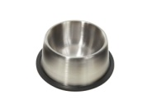stands for 2 votes.

Have students determine the fractional representation for pet. For example, in the graph shown above there are:

* 10 children out of 20 prefer cats (10/20),
* 4 children out of 20 prefer dogs (4/20),
* 6 children out of 20 prefer hamsters (6/20)

Discuss the graph. As a class, create problems that could be answered using the data. You may want to display the graph for other classes to analyze.

**Part II (SMP 1, 2, 3, 4, 5, ,6, 7)**

As a class, create a bar graph of students’ favorite sports. An example is shown below,

Once again, have students determine the fractional representation for favorite sports. For example, in the graph shown above there are:

* 9 children out of 22 prefer soccer (9/22)
* 4 children out of 22 prefer softball (4/22)
* 6 children out of 22 prefer basketball (6/22)
* 3 children out of 22 prefer other sports (3/22)

Discuss the graph, and create questions that can be answered using the data.

**Part III (SMP 1, 2, 4, 5, 6, 7)**

Working in small groups, students will examine the set model of fractions using colored candies. Give students an individual bag or pack of colored candies. Have students open their bag of candies and sort by color. Have students count the number of each color in their group and record the data in table on notebook paper. Have students record the fraction of each color represented in their group.

Have students log on to the [Create a Graph Tool](http://nces.ed.gov/nceskids/Graphing/) from the National Center for Education Statistics. Students should choose the type of graph they want to create by using the pull-down menu. Once students have created and printed their graph, they should label the data in fractional parts.

Have students work in groups to create story problems relating to their graphs. Examples of problems students might write:

* Which group had the most candies?
* How many candies did they have in their pack?
* What is the difference between the greatest and least number of candies in a pack?

**FORMATIVE ASSESSMENT QUESTIONS**

* Which type of graph did you create when you went to the Create a Graph Tool from the National Center for Educational Statistics?
* Why did you select this type of graph?

**DIFFERENTIATION**

**Extension**

* Have students create more than one graphical representational of the candy data. Discuss which display is most effective in presenting the data.

**Intervention**

* Have students graph fewer pieces of candy using sticky notes to represent elements of data in a student-created graph.

Adapted fromElementary and Middle School Mathematics: Teaching Developmentally

By John A. Van de Walle, Karen S. Karp, and Jennifer M. Bay-Williams, p. 443.

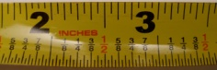**CONSTRUCTING TASK: INCH BY INCH**

**APPROXIMATE TIME:** Two class periods

Students will measure using strips of paper (non-standard units). Students will build a ruler beginning with inch units that they will glue to tagboard. Students will practice measuring with their ruler and compare it to a standard ruler. Students will create a line plot graph to collect and record the data of the objects they have measured to the nearest ¼ inch throughout the class.

**CONTENT STANDARDS**

**MGSE3.MD.4** Generate measurement data by measuring lengths using rulers marked with halves and fourths of an inch. Show the data by making a line plot, where the horizontal scale is marked off in appropriate units – whole numbers, halves, or quarters.

***(Refer to grade level overview for unpacked standards)***

**STANDARDS FOR MATHEMATICAL PRACTICE**

1. Make sense of problems and persevere in solving them.

2. Reason abstractly and quantitatively.

3. Construct viable arguments and critique the reasoning of others.

4. Model with mathematics.

5. Use appropriate tools strategically.

6. Attend to precision.

7. Look for and make use of structure.

8. Look for and express regularity in repeated reasoning.

**BACKGROUND KNOWLEDGE**

If students actually make simple measuring instruments using unit models with which they are familiar, it is more likely that they will understand how an instrument measures. A ruler is the most important measurement tool that primary students need to learn about. If students line up physical units, such as paper clips, along with a strip of tag board, and mark them off, they can see that it is the *spaces* on rulers, not the marks or numbers that are important. It is essential that the measurement with actual unit models be compared with measurement with using an instrument. The temptation is to carefully explain to students how to use these units to measure and then send them off to practice measuring. This approach will shift students’ attention to the procedure (following your instruction) and away from developing an understanding of measurement using units. (Van de Walle p.72-72)

**COMMON MISCONCEPTIONS**

Students plot points based on understanding fractions as whole numbers instead of fractional parts. For example: Students order fractions using the numerator or students order unit fractions by the denominator.

**ESSENTIAL QUESTIONS**

* What estimation strategies are used in measurement?
* How is the appropriate unit for measurement determined?
* How is the reasonableness of a measurement determined?
* Why are units important in measurement?
* How can I determine length to the nearest ¼ or ½?

**MATERIALS**

* tag board
* paper
* ruler

**GROUPING**

Whole group or small group

**NUMBER TALKS**

By now number talks should be incorporated into the daily math routine. Continue utilizing the different strategies in number talks and revisiting them based on the needs of your students.

**TASK DESCRIPTION, DEVELOPMENT AND DISCUSSION**

**Part I (SMP 4, 5, 6, 7)**

Cut strips of paper lengthwise (1-inch wide) from regular paper. Ask students what is a half and how could they find where a half is on the strip. Students will fold the strip in half. Have the students mark ½ on the folded line. Ask students: *if we needed to make this strip into 4 equal pieces/parts how could we do that?* Allow for exploration. Students will see that by folding a ½ in ½ it makes ¼.

*Discussion:* allow students to see that the strip is folded into 4 parts. Explain that the first fold is where 1 out of the four parts ends, have students label the next one 2/4 (two of 4 parts). Allow the conversation to take place that the second line is already labeled ½ and now it is going to be labeled 2 of 4 (2/4). What does that mean? Students will identify that they’re the same. Label the last fold 3 of 4 or ¾.

Have students measure objects all around the room to the nearest ¼ **strip** and record their findings in there journal. **The strip is a non-standard unit of measurement and should be recognized as such**. Have students measure things that are longer than one strip to count a whole strip plus part. Example: the width of the desk is 2 strips and ¼ of a strip long.

**Part II (SMP 1, 2, 4, 5, 6, 7)**

Give the students a 1x1 inch square and repeat the entire process from day one. Allow students time to measure using a single inch square. Students will recognize how tedious it is to measure with a single inch square, and in many cases inaccurate. Give students (12) 1x1 squares and mark them into fourths with a pencil (not folded).

Place the folded inch square on top of the blank inch squares as a template for marking and place a dash to identify ¼ , 2/4, (1/2), and 3/4. *Keep asking students what ½ and 2/4 have in common.* Give students a tag board strip that is 1 inch wide. Have students create an inch ruler by gluing the MARKED 1x1 inch squares side by side.

After each student has created the ruler, have them measure things around the class using their newly created inch ruler. After 10-15 minutes of exploring engage students in a discussion in regards to the difficulties they encountered using their ruler (not labeled correctly, always had to count what square it was, etc)

Introduce a ruler with inches. Discuss and compare the similarities between the created ruler and the actual 12’ ruler. Discuss how the actual ruler is more accurate and efficient. Have the student circulate the class measuring objects to the nearest ¼ of an inch using the actual ruler. Students create a line plot graph to collect and record the data of the objects they have measured throughout the class.

**FORMATIVE ASSESSMENT QUESTIONS**

* How did you determine ¼, ½, and ¾ on your strip of paper?
* Why is it important to have a standard unit of measurement?
* How does your “ruler” compare to the standard 12’ ruler?
* Looking at your line plot graph, which measurement seems to be the most common among the classroom?

**DIFFERENTIATION**

**Extension**

* Measure around the classroom to the nearest ¼, ½ and whole inch using a broken ruler.

**Intervention**

* Spend additional time with the original strip from part one.
* Have students create an additional strip that is a different size and determine the ¼, ½, and ¾ marks. Have students compare the two strips and lead a discussion of the importance of standard measuring tools.

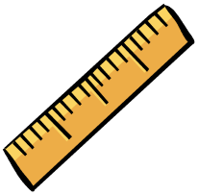**CONSTRUCTING TASK: MEASURING TO THE HALF AND QUARTER INCH**

*Adapted from a Learning Task from K-5 Math Teaching Resources*

**APPROXIMATE TIME:** 4 Class Periods

Students will measure objects to the nearest ½ and ¼ inch. Students will order their measurements from shortest to longest and will create a line-plot graph to represent their data.

**CONTENT STANDARDS**

**MGSE3.MD.4** Generate measurement data by measuring lengths using rulers marked with halves and fourths of an inch. Show the data by making a line plot, where the horizontal scale is marked off in appropriate units— whole numbers, halves, or quarters.

**MGSE3.NF.2** Understand a fraction as a number on the number line; represent fractions on a number line diagram.

**b. Represent a non-unit fraction $\frac{a}{b}$ on a number line diagram by marking off *a* lengths of $\frac{1}{b}$ (unit fractions) from 0. Recognize that the resulting interval has size and that its endpoint locates the non-unit fraction on the number line.**

**MGSE3.NF.3 Explain equivalence of fractions through reasoning with visual fraction models. Compare fractions by reasoning about their size.**

1. **Understand two fractions as equivalent (equal) if they are the same size, or the same point on a number line.**
2. **Recognize and generate simple equivalent fractions with denominators of 2, 3, 4, 6, and 8, e.g., . Explain why the fractions are equivalent, e.g., by using a visual fraction model.**

d. Compare two fractions with the same numerator or the same denominator by reasoning about their size. Recognize that comparisons are valid only when the two fractions refer to the same whole. Record the results of comparisons with the symbols >, =, or <, and justify the conclusions, e.g., by using a visual fraction model.

**STANDARDS FOR MATHEMATICAL PRACTICE**

1. Make sense of problems and persevere in solving them.

2. Reason abstractly and quantitatively.

3. Construct viable arguments and critique the reasoning of others.

4. Model with mathematics.

5. Use appropriate tools strategically.

6. Attend to precision.

7. Look for and make use of structure.

8. Look for and express regularity in repeated reasoning.

**BACKGROUND KNOWLEDGE**

Fractions and measurement can be very difficult concepts for children to understand. This task helps to combine fraction and measurement skills in a concrete and tangible activity geared toward learners of every type. By using fractions while measuring objects, children will be able to reason that fractions express a relationship between a part and a whole. Encourage students to consider the fact that a ruler is simply a number line used as a measuring tool. They will begin to see and apply fractions in their everyday lives as well as other areas of mathematics.

**COMMON MISCONCEPTIONS**

Students do not count correctly on the number line. For example, students may count the hash mark at zero as the first unit fraction. This can hinder their ability to read a ruler.

**ESSENTIAL QUESTIONS**

* How can I organize data measured to the half inch?
* How can I organize data measured to the quarter inch?

**MATERIALS**

* Half-Inch and Quarter-Inch Ruler Templates
* Unlined Paper

**GROUPING**

Individual/Partner Task

**NUMBER TALKS**

By now number talks should be incorporated into the daily math routine. Continue utilizing the different strategies in number talks and revisiting them based on the needs of your students.

**TASK DESCRIPTION, DEVELOPMENT, AND DISCUSSION**

**Part 1 (SMP 1, 2, 4, 5, and 6)**

To begin the lesson, give each child a half-inch ruler template. Instruct students to label their rulers to show all half-inch measurements. Working individually or in small groups, have students use the rulers to measure ten objects in the classroom to the nearest half-inch.

On a sheet of paper, students should sketch and label each object they measured. Then ask students to number the objects in order from shortest to longest. Discuss how students decided which objects were smaller and which objects were larger. Encourage discussion about comparing the physical size of each object as well as comparing the fractional measurements of each object.

**Part II (SMP 5)**

Students use their data to create a line plot where the horizontal scale is marked off whole numbers and halves. Completed line plots should be shared with small groups or entire class.

**Classroom Objects Measured to Nearest Half-Inch**

X

X X X

X X X X X X

______________________________________________________________________________

0 ½ 1 ½ 2 2 ½ 3 3 ½ 4 4 ½ 5 5 ½ 6

**Part III (SMP 1, 2, 4, 5, 6)**

Repeat the activity using quarter-inch measurement. Give each child a quarter-inch ruler template. Instruct students to label their rulers to show all quarter-inch measurements. Ask students to write both measures (ex. 2/4 and ½) for equivalent fractions on the ruler. Include discussion about equivalent fractions in measurement. Working individually or in small groups, have students use the rulers to measure ten objects in the classroom to the nearest quarter-inch.

On a sheet of paper, students should sketch and label each object they measured. Then ask students to number the objects in order from shortest to longest. Discuss how students decided which objects were smaller and which objects were larger. Encourage discussion about comparing the physical size of each object as well as comparing the fractional measurements of each object.

Students use their data to create a line plot where the horizontal scale is marked off with whole numbers, halves, and quarters. Completed line plots should be shared with small groups or entire class.

**FORMATIVE ASSESSMENT QUESTIONS**

* In what ways is your ruler similar to a number line?
* How did you label your number line to the half inch and quarter inch?
* Which measure is more exact?

**DIFERENTIATION**

**Extension**

* Measure around the classroom to the nearest ¼, ½, and whole inch using a broken ruler.

**Intervention**

* Spend additional time with the original strip from part one.
* Have students create an additional strip that is a different size and determine the ¼, ½, and ¾ marks. Have students compare the two strips and lead a discussion of the importance of standard measuring tools.

**Half-Inch and Quarter-Inch Ruler Templates**

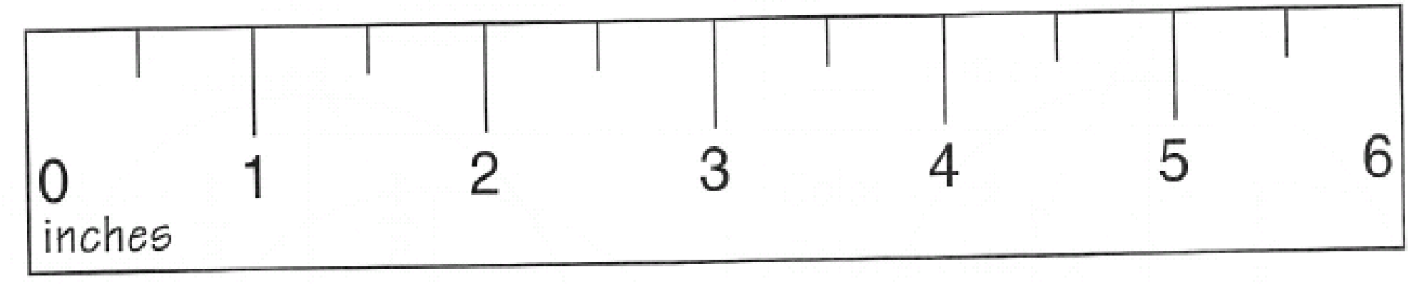











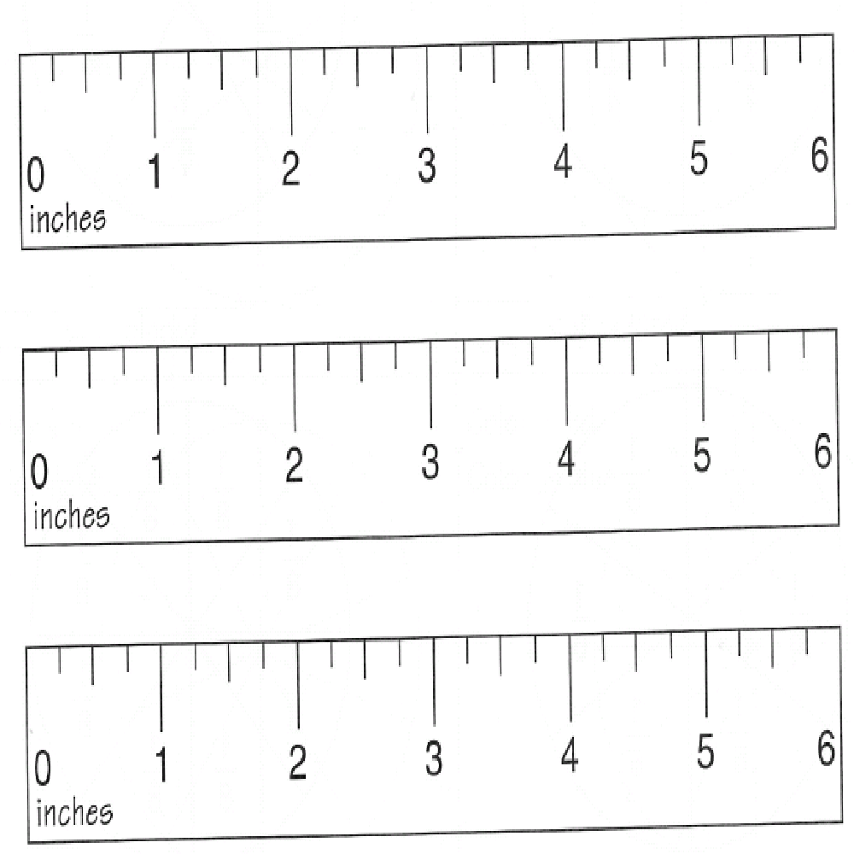

**PRACTICE TASK: TRASH CAN BASKETBALL**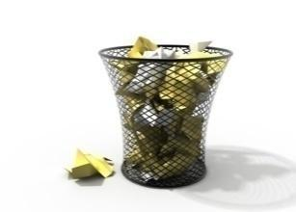

*Adapted from a 1st Grade GPS Frameworks Task*

**APPROXIMATE TIME:** 1 Class Period

Students will play a game where they record a tally mark each time they shoot a trash ball into a trashcan. Students will write a fraction that represents the number of shots made and then create a poster that represents their results using an inequality.

**CONTENT STANDARDS**

**MGSE3.NF.1 Understand a fraction $\frac{1}{b}$ as the quantity formed by 1 part when a whole is partitioned into *b* equal parts (unit fraction); understand a fraction as the quantity formed by *a* parts of size . *For example, means there are three parts, so = + + .***

**MGSE3.NF.2** Understand a fraction as a number on the number line; represent fractions on a number line diagram.

1. **Represent a fraction on a number line diagram by defining the interval from 0 to 1 as the whole and partitioning it into *b* equal parts. Recognize that each part has size . Recognize that a unit fraction is located whole unit from 0 on the number line.**
2. **Represent a non-unit fraction on a number line diagram by marking off *a* lengths of (unit fractions) from 0. Recognize that the resulting interval has size and that its endpoint locates the non-unit fraction on the number line.**

**MGSE3.NF.3 Explain equivalence of fractions through reasoning with visual fraction models. Compare fractions by reasoning about their size.**

1. **Understand two fractions as equivalent (equal) if they are the same size, or the same point on a number line.**
2. **Recognize and generate simple equivalent fractions with denominators of 2, 3, 4, 6, and 8, e.g., . Explain why the fractions are equivalent, e.g., by using a visual fraction model.**
3. **Express whole numbers as fractions, and recognize fractions that are equivalent to whole numbers. *Examples: Express 3 in the form 3 = (3 wholes is equal to six halves); recognize that = 3; locate and 1 at the same point of a number line diagram.***

d. Compare two fractions with the same numerator or the same denominator by reasoning

about their size. Recognize that comparisons are valid only when the two fractions refer

to the same whole. Record the results of comparisons with the symbols >, =, or <, and

justify the conclusions, e.g., by using a visual fraction model.

**STANDARDS FOR MATHEMATICAL PRACTICE**

1. Make sense of problems and persevere in solving them.

2. Reason abstractly and quantitatively.

3. Construct viable arguments and critique the reasoning of others.

4. Model with mathematics.

5. Use appropriate tools strategically.

6. Attend to precision.

7. Look for and make use of structure.

8. Look for and express regularity in repeated reasoning.

**BACKGROUND KNOWLEDGE**

Students have learned to write fractions as part of a whole and part of a group. They have also learned to compare fractions. This task allows students to practice their new knowledge in a game format.

**COMMON MISCONCEPTIONS**

Students do not understand the importance of the whole of a fraction and identifying it. For example, students may use a fixed size of ¼ based on the manipulatives used or previous experience with a ruler.

**ESSENTIAL QUESTIONS**

* How can I write a fraction to represent a part of a group?
* When we compare two fractions, how do we know which has a greater value?

**MATERIALS**

* “Trash Can Basketball” student recording sheet
* Each group will need 10 pieces of “trash” (paper balls).
* Box, tub, or trash can for a container
* Crayons or markers and construction paper for making a poster

**GROUPING**

Partner/Small Group Activity

**NUMBER TALKS**

By now number talks should be incorporated into the daily math routine. Continue utilizing the different strategies in number talks and revisiting them based on the needs of your students.

**TASK DESCRIPTION, DEVELOPMENT, AND DISCUSSION (SMP 1, 2, 4, 5, and 6)**

Students collect data from playing “Trash Can Basketball.” They use the data to write and compare fractions.

1. Students use scrap paper to make 10 paper balls per group. (Wad the paper balls up tightly so they are easier to aim.)
2. Place a trash can (or other large container) 5 feet away.
3. Students predict how many paper balls they will be able to get into the basket. Predictions should be written in the chart on the student recording sheet.
4. Students take turns with their partner(s) throwing the ten paper balls into the trash can. The partner will collect data using tally marks on the chart to show how many of the 10 paper balls went into the trash can.

The copy room is a good source of trash paper. Be sure the paper balls are tight. Loosely packed ones make it really difficult to throw accurately. Before beginning the throwing contest, as a class, decide on any rules regarding practice throws.

**FORMATIVE ASSESSMENT QUESTIONS**

* How did you determine your score? How many times did you throw the paper ball? How many times did you “make a basket”?
* How did you compare your fraction to your opponent’s?

**DIFFERENTIATION**

**Extension**

* Repeat the activity as time permits. (Try different types of paper balls, distances, types of shots, etc.)

**Intervention**

* Have the chart pre-made on the poster for student use and/or allow student to write his/her results on a computer, print, and attach to the poster.

**TECHNOLOGY RESOURCES**

* <http://www.mathsisfun.com/numbers/fractions-match-words-pizza.html>

This site allows students to practice fraction concepts using pizzas.

Name ______________________________ Date ___________________________

**TRASH CAN BASKETBALL**

This is your chance to demonstrate your basketball skills! You have been chosen to participate in a paper-ball throwing contest.

Directions:

1. Use the scrap paper to make 10 paper balls per group. (Wad the paper balls up tightly so they are easier to aim.)
2. Place a trash can (or other large container) 5 feet away.
3. Predict how many paper balls you will be able to get into the basket. Write your prediction in the chart below.
4. Take turns with your partner(s) throwing the ten paper balls into the trash can. Your partner will collect data using tally marks on the chart below to show how many of the 10 paper balls went into the trash can.

|  |  |  |  |  |
| --- | --- | --- | --- | --- |
| Player #1  _______________ | Number of Tosses | Prediction for Number of “Baskets” | Number of “Baskets”  (Use tallies) | Fraction of Baskets Made |
|  | 10 |  |  |  |
| Player #2  _______________ | Number of Tosses | Prediction for Number of “Baskets” | Number of “Baskets”  (Use tallies) | Fraction of Baskets Made |
|  | 10 |  |  |  |

1. On a sheet of unlined paper, create a poster to display your group’s results. Your poster should include the following. Write to explain the results of the contest. Be prepared to share your poster and results with the class. Represent the number of good throws for each partner as a fraction and express a comparison of fraction scores using a >, <, or = symbol. Make your poster colorful and informative!

Example:

Player #1 $\frac{6}{10}$

Player # 2 $\frac{7}{10}$

$\frac{6}{10}<\frac{7}{10}$

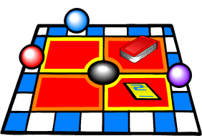**PERFORMANCE TASK: THE FRACTION STORY GAME**

**APPROXIMATE TIME:** 1-2 class periods

Students create a game while reviewing all the different aspects of fractions they have studied.

**CONTENT STANDARDS**

**MGSE3.NF.1 Understand a fraction $\frac{1}{b}$ as the quantity formed by 1 part when a whole is partitioned into *b* equal parts (unit fraction); understand a fraction as the quantity formed by *a* parts of size . *For example, means there are three parts, so = + + .***

**MGSE3.NF.2** Understand a fraction as a number on the number line; represent fractions on a number line diagram.

1. **Represent a fraction on a number line diagram by defining the interval from 0 to 1 as the whole and partitioning it into *b* equal parts. Recognize that each part has size . Recognize that a unit fraction is located whole unit from 0 on the number line.**
2. **Represent a non-unit fraction on a number line diagram by marking off *a* lengths of (unit fractions) from 0. Recognize that the resulting interval has size and that its endpoint locates the non-unit fraction on the number line.**

**MGSE3.NF.3 Explain equivalence of fractions through reasoning with visual fraction models. Compare fractions by reasoning about their size.**

1. **Understand two fractions as equivalent (equal) if they are the same size, or the same point on a number line.**
2. **Recognize and generate simple equivalent fractions with denominators of 2, 3, 4, 6, and 8, e.g., . Explain why the fractions are equivalent, e.g., by using a visual fraction model.**
3. **Express whole numbers as fractions, and recognize fractions that are equivalent to whole numbers. *Examples: Express 3 in the form 3 = (3 wholes is equal to six halves); recognize that = 3; locate and 1 at the same point of a number line diagram.***

d. Compare two fractions with the same numerator or the same denominator by reasoning

about their size. Recognize that comparisons are valid only when the two fractions refer

to the same whole. Record the results of comparisons with the symbols >, =, or <, and

justify the conclusions, e.g., by using a visual fraction model.

**STANDARDS FOR MATHEMATICAL PRACTICE**

1. Make sense of problems and persevere in solving them.

2. Reason abstractly and quantitatively.

3. Construct viable arguments and critique the reasoning of others.

4. Model with mathematics.

5. Use appropriate tools strategically.

6. Attend to precision.

7. Look for and make use of structure.

8. Look for and express regularity in repeated reasoning.

**BACKGROUND KNOWLEDGE**

While this task may serve as a summative assessment, it also may be used for teaching and learning. It is important that all elements of the task be addressed throughout the unit so that students understand what is expected of them.

**COMMON MISCONCEPTIONS**

Students do not understand that when partitioning a whole shape, number line, or a set into unit fractions, the intervals must be equal.

**ESSENTIAL QUESTION**

* How are fractions used in problem-solving situations?

**MATERIALS**

* Materials Required Per Group
* “The Fraction Story Game, Directions” student sheet
* “The Fraction Story Game, Game board” student sheet
* Colored pencils or crayons
* Index cards (about 60)
* Common classroom materials - Recycled items for game pieces (about 6)

**GROUPING**

Small Group Task

**NUMBER TALKS**

By now number talks should be incorporated into the daily math routine. Continue utilizing the different strategies in number talks and revisiting them based on the needs of your students.

**TASK DESCRIPTION, DEVELOPMENT, AND DISCUSSION**

Students create a game while reviewing all the different aspects of fractions they have studied.

**Comments**

Students may not understand what you mean by “common classroom materials.” While many classrooms have standard dice that can be used, give alternative examples such as a penny can be flipped to determine how many spaces the players get to move (heads = 2 spaces, tails =1 space). For game pieces, extra marker caps, plastic soda lids, manipulatives, or coins can be used.

**Part I (SMP 1, 2, and 6)**

Begin by having students review lessons or activities that have been done during the fraction unit. Record their thoughts on chart paper or the board. You may want to post a list of the elements of the standards covered during the unit and reflect on tasks and activities which addressed each element.

Students will write 20 – 30 word problems that assess the standards covered. You may want the children to work with a partner or in small groups to create enough questions.

This culminating task represents the level of depth, rigor, and complexity expected of all third grade students to demonstrate evidence of learning.

Additional Comments:

* + Students should have had multiple opportunities to write story problems by this time in the school year.
  + Questions should match a standard.
  + Index cards may be used for the problem cards. Insist that the students write legibly. All problem cards should have the solutions on the back
  + Solutions should be accompanied by an explanation/illustration.
  + Game boards, playing pieces, and cards can be stored in large Ziploc bags or manila folders.

The cards students create for their games can be used in a variety of ways. The problem cards can be used to create a Jeopardy type game which can be played as a review of the unit. Also the problem cards can be reproduced and used as a set of review question before the unit assessment.

Part II (SMP 1, 2, 3, 4, 5, 6, 7, and 8)

Students will follow the directions below from “The Fraction Story Game, Directions” student sheet.

Your task is to create a fraction story game using what you learned about fractions. Use the fraction game board on “The Fraction Story Game, Game Board” student sheet to create a game that other students will want to play.

Directions:

* Look at the list of the standard that you studied in class. The problem cards you create must match those standards.
* You will need to make approximately 30 problem cards for your game. Most of the cards should be written in story problem form.
* Be sure you have some problem cards for each of the standards addressed in this unit.
* Each problem card must have the correct answer on the back. Cover each problem card with a blank index card so players cannot see the problems before their turn. See sample below.
* Write the rules for your game.

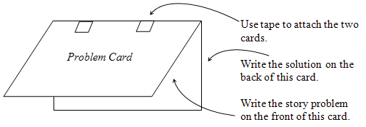

**Things to remember:**

* You can only use common classroom materials.
* You may decorate your game board in a way that makes the game interesting and fun to play.
* Be sure to play your game with a partner to be sure it works.

**FORMATIVE ASSESSMENT QUESTIONS**

* What are the skills you learned during this unit?
* What kind of problem can you create for ____ (one of the elements of the standard)?
* How do you know this is the correct solution for your problem?

**DIFFERENTIATION**

**Extension**

* Students can create their own game board format with penalties, rewards, and more complex rules.

**Intervention**

* Allow students to work in a small group so each student will need to make only one card per standard.
* For some of the parts of a standard, give the students the problem and require them to create the solution to the problem.

**Name ______________________________________ Date ___________**

**THE FRACTION STORY GAME**

Your task is to create a fraction story game using what you learned about common fractions and decimal fractions. Use the fraction game board on “The Fraction Story Game, Game Board” student sheet to create a game that other students will want to play.

**Directions:**

* Look at the list of the standards that you studied in class. The problem cards you create must match the standard.
* You will need to make approximately 30 problem cards for your game. Most of the cards should be written in story problem form.
* Be sure you have some problem cards for each of the standards addressed in this unit. Make sure you use both fractions in your problem cards.
* Each problem card must have the correct answer on the back. Cover each problem card with a blank index card so players cannot see the problems before their turn. See sample below.



* Write the rules for your game.

**Things to remember:**

* You can only use common classroom materials.
* You may decorate your game board in a way that makes the game interesting and fun to play.
* Be sure to play your game with a partner to be sure it works.

Name ______________________________________ Date __________________

The Fraction Story Game

Game Board

Start

Finish

Problem Cards

1. See glossary, Table 2.