**Georgia**

**Standards of Excellence**

**Frameworks**

**Mathematics**

GSE Third Grade

Unit 3: Patterns in Addition and Multiplication



**TABLE OF CONTENTS**

Overview 3

Standards for Mathematical Practice 4

Content Standards 5

Big Ideas 6

Essential Questions 6

Concepts and Skills to Maintain 8

Strategies for Teaching and Learning 9

Selected Terms and Symbols 10

**Tasks** 13

* Cover Me 14
* Fill Er’ Up 18
* The Same But Different 34
* Count Me In! 37
* Paper Cut 43
* Oops! I’m Decomposing 55
* Multiplication W/Base Ten Blocks 58
* Olympic Cola Display 64
* Array Challenge 74
* Skip Counting Patterns 83
* Take The Easy Way Out 89
* Read All About It 99
* It Takes Two 103
* Subject To Interpretation 108
* Measure and Plot 114
* Hooked on Solutions 119

**Culminating Task**

* Watch My Garden Grow! 127

***Please note that all changes made to the standards will appear in red bold type. Additional changes will appear in green.

**UNIT OVERVIEW**

In this unit, students will:

* Understand concepts of area and relate area to multiplication and addition.
* Find the area of a rectangle with whole- number side lengths by tiling it.
* Multiply side lengths to find areas of rectangles with whole-number side lengths in context of solving real world and mathematical problems.
* Construct and analyze area models with the same product.
* Describe and extend numeric patterns.
* Determine addition and multiplication patterns.
* Understand the commutative property’s relationship to area.
* Create arrays and area models to find different ways to decompose a product.
* Use arrays and area models to develop understanding of the distributive property.
* Solve problems involving one and two steps and represent these problems using equations with letters such as ***“n”*** or ***“x”*** representing the unknown quantity.
* Create and interpret pictographs and bar graphs.

The understanding of and ability to use multiplication and division is the basis for all further mathematics work and its importance cannot be overemphasized. As students move through upper elementary grades and middle school, the foundation laid here will empower them to work with fractions, decimals, and percents.

Area is a measure of the space inside a region or how much it takes to cover a region. As with other attributes, students must first understand the attribute of area before measuring.

The concept of multiplication can be related to the area of rectangles using arrays. Students need to discover that the length of one dimension of a rectangle tells how many squares are in each row of an array and the length of the other dimension of the rectangle tells how many squares are in each column.

Using this model, students should be able to create arrays to solve real-life problems involving multiplication and apply this concept with addition, subtraction, and division to solve equations involving two steps or more to find the solution.

Adapted from NC Dept of Public Instruction, Teaching Resources

# STANDARDS FOR MATHEMATICAL PRACTICE (SMP)

This section provides examples of learning experiences for this unit that support the development of the proficiencies described in the Standards for Mathematical Practice. The statements provided offer a few examples of connections between the Standards for Mathematical Practice and the content Standards of this unit. The list is not exhaustive and will hopefully prompt further reflection and discussion.

*Students are expected to:*

**1. Make sense of problems and persevere in solving them.** Students make sense of problems involving area.

**2. Reason abstractly and quantitatively.** Students demonstrate abstract reasoning by connecting area with multiplication and arrays.

**3. Construct viable arguments and critique the reasoning of others.** Students construct and critique arguments regarding area by creating or drawing arrays or area models to prove answers.

**4. Model with mathematics.** Students use arrays or area models to find area.

**5. Use appropriate tools strategically.** Students use tiles and drawings to solve area problems.

**6. Attend to precision.** Students use vocabulary such as area, array, area model, and dimensions with increasing precision to discuss their reasoning when solving area problems.

**7. Look for and make use of structure.** Students compare rectangles with the same area but different dimensions and look for patterns in the shapes of the rectangles.

**8. Look for and express regularity in repeated reasoning.** Students will notice that arrays and multiplication can be used to solve area problems.

**\*\*\*\*Mathematical Practices 1 and 6 should be evident in EVERY lesson. \*\*\***

**CONTENT STANDARDS**

**Solve problems involving the four operations, and identify and explain patterns in arithmetic.**

**MGSE3.OA.8. Solve two-step word problems using the four operations. Represent these problems using equations with a letter standing for the unknown quantity. Assess the**

**reasonableness of answers using mental computation and estimation strategies including rounding.[1]**

**‡ See Glossary, Table 2**

**MGSE3.OA.9. Identify arithmetic patterns (including patterns in the addition table or multiplication table), and explain them using properties of operations.[2] *For example,* *observe that 4 times a number is always even, and explain why 4 times a number can* *be decomposed into two equal addends.***

**‡ See Glossary, Table 3**

**Represent and interpret data.**

**MGSE3.MD.3.** Draw a scaled picture graph and a scaled bar graph to represent a data set with several categories. Solve one- and two-step “how many more” and “how many less” problems using information presented in scaled bar graphs. *For example, draw a bar graph in which each square in the bar graph might represent 5 pets.*

**MGSE3.MD.4.** Generate measurement data by measuring lengths using rulers marked with halves and fourths of an inch. Show the data by making a line plot, where the horizontal scale is marked off in appropriate units— whole numbers, halves, or quarters.

**Geometric Measurement: understand concepts of area and relate area to multiplication and to addition.**

**MGSE3.MD.5.** Recognize area as an attribute of plane figures and understand concepts of area measurement.

1. A square with side length 1 unit, called “a unit square,” is said to have “one square unit” of area, and can be used to measure area.
2. A plane figure which can be covered without gaps or overlaps by n unit squares is said to have an area of *n* square units.

**MGSE3.MD.6.** Measure areas by counting unit squares (square cm, square m, square in, square ft, and improvised units).

**MGSE3.MD.7.** Relate area to the operations of multiplication and addition.

1. Find the area of a rectangle with whole-number side lengths by tiling it, and show that the area is the same as would be found by multiplying the side lengths.
2. Multiply side lengths to find areas of rectangles with whole number side lengths in the context of solving real world and mathematical problems, and represent whole-number products as rectangular areas in mathematical reasoning.
3. Use tiling to show, in a concrete case, that the area of a rectangle with whole-number side lengths *a* and *b + c* is the sum of *a × b* and *a × c*. Use area models to represent the distributive property in mathematical reasoning.
4. **~~Recognize area as additive. Find areas of rectilinear figures by decomposing them into non-overlapping rectangles and adding the areas of the non-overlapping parts, applying this technique to solve real world problems.~~**

For more detailed information about unpacking the content standards, unpacking a task, math routines and rituals, maintenance activities and more, please refer to the Grade Level Overview.

**BIG IDEAS**

* Area models are related to addition and multiplication.
* Area covers a certain amount of space using square units.
* When finding the area of a rectangle, the dimensions represent the factors in a multiplication problem.
* Multiplication can be used to find the area of rectangles with whole numbers.
* Area models of rectangles and squares are directly related to the commutative property of multiplication.
* Rearranging an area such as 24 sq. units based on its dimensions or factors does NOT change the amount of area being covered (Van de Walle, pg 234). Ex. A 3 x 8 is the same area as a 4 x 6, 2 x12, and a 1 x 24.
* A product can have more than two factors.
* Area in measurement is equivalent to the product in multiplication.
* Area models can be used as a strategy for solving multiplication problems.
* Some word problems may require two or more operations to find the solution.

**ESSENTIAL QUESTIONS**

* How can area be determined without counting each square?
* How can the knowledge of area be used to solve real world problems?
* How can the same area measure produce rectangles with different dimensions? (Ex. 24 square units can produce a rectangle that is a 3 x 8, 4 x 6, 1 x 24, 2 x 12)
* How does understanding the distributive property help us multiply large numbers?

**CONCEPTS/SKILLS TO MAINTAIN**

It is expected that students will have prior knowledge/experience related to the concepts and skills identified below. It may be necessary to pre-assess in order to determine if time needs to be spent on conceptual activities that help students develop a deeper understanding of these ideas.

* Addition, Subtraction, Multiplication, Division
* Skip counting
* Relationship between addition and multiplication
* Two-dimensional plane figures
* Understanding of arrays
* Solving one-step word problems
* Factors of products
* Commutative Property of Multiplication
* Distributive Property of Multiplication

**Fluency**: Procedural fluency is defined as skill in carrying out procedures flexibly, accurately, efficiently, and appropriately. Fluent problem solving does not necessarily mean solving problems within a certain time limit, though there are reasonable limits on how long computation should take. Fluency is based on a deep understanding of quantity and number.

**Deep Understanding**: Teachers teach more than simply “how to get the answer” and instead support students’ ability to access concepts from a number of perspectives. Therefore students are able to see math as more than a set of mnemonics or discrete procedures. Students demonstrate deep conceptual understanding of foundational mathematics concepts by applying them to new situations, as well as writing and speaking about their understanding.

**Memorization**: The rapid recall of arithmetic facts or mathematical procedures. Memorization is often confused with fluency. Fluency implies a much richer kind of mathematical knowledge and experience.

**Number Sense:** Students consider the context of a problem, look at the numbers in a problem, make a decision about which strategy would be most efficient in each particular problem. Number sense is not a deep understanding of a single strategy, but rather the ability to think flexibly between a variety of strategies in context.

**Fluent students**:

* flexibly use a combination of deep understanding, number sense, and memorization.
* are fluent in the necessary baseline functions in mathematics so that they are able to spend their thinking and processing time unpacking problems and making meaning from them.
* are able to articulate their reasoning.
* find solutions through a number of different paths.

For more about fluency, see: <http://www.youcubed.org/wp-content/uploads/2015/03/FluencyWithoutFear-2015.pdf>  and: <http://joboaler.com/timed-tests-and-the-development-of-math-anxiety/>

**STRATEGIES FOR TEACHING AND LEARNING**

*Adapted from North Carolina Dept. of Public Instruction Teaching Resources*

**Solve problems involving the four operations, and identify and explain patterns in arithmetic.**

Students gain a full understanding of which operation to use in any given situation through contextual problems. Number skills and concepts are developed as students solve problems. Problems should be presented on a regular basis as students work with numbers and computations.

Researchers and mathematics educators advise against providing “key words” for students to look for in problem situations because they can be misleading. Students should use various strategies to solve problems. Students should analyze the structure of the problem to make sense of it. They should think through the problem and the meaning of the answer before attempting to solve it.

Encourage students to represent the problem situation in a drawing or using manipulatives such as counters, tiles, and blocks. Students should determine the reasonableness of the solution to all problems using mental computations and estimation strategies.

Students can use base–ten blocks on centimeter grid paper to construct rectangular arrays to represent problems involving area.

Students are to identify arithmetic patterns and explain these patterns using properties of operations. They can explore patterns by determining likenesses, differences and changes. Use patterns in addition and multiplication tables.

**Represent and interpret data.**

Representation of a data set is extended from picture graphs and bar graphs with single-unit scales to scaled picture graphs and scaled bar graphs. Intervals for the graphs should relate to multiplication and division within 100 (product is 100 or less and numbers used in division are 100 or less). In picture graphs, use multiplication fact values, with which students are having difficulty, as the icons. For example, one picture represents 7 people. If there are three pictures, students should use known facts to determine that the three pictures represent 21 people. The intervals on the vertical scale in bar graphs should not exceed 100.

Students are to draw picture graphs in which a symbol or picture represents more than one object. Bar graphs are drawn with intervals greater than one. Ask questions that require students to compare quantities and use mathematical concepts and skills. Use symbols on picture graphs that students can easily represent half of, or know how many half of the symbol represents.

Students are to measure lengths using rulers marked with halves and fourths of an inch and record the data on a line plot. The horizontal scale of the line plot is marked off in whole numbers, halves or fourths. Students can create rulers with appropriate markings and use the ruler to create the line plots

**Geometric measurement– understand concepts of area and relate area to multiplication and to addition.**

Students can cover rectangular shapes with tiles and count the number of units (tiles) to begin developing the idea that area is a measure of covering. Area describes the size of an object that is two-dimensional. **The formulas should not be introduced before students discover the meaning of area.**

The area of a rectangle can be determined by having students lay out unit squares and count how many square units it takes to completely cover the rectangle completely without overlaps or gaps. Students need to develop the meaning for computing the area of a rectangle. A connection needs to be made between the number of squares it takes to cover the rectangle and the dimensions of the rectangle. Ask questions such as:

* What does the length of a rectangle describe about the squares covering it?
* What does the width of a rectangle describe about the squares covering it?

The concept of multiplication can be related to the area of rectangles using arrays. Students need to discover that the length of one dimension of a rectangle tells how many squares are in each row of an array and the length of the other dimension of the rectangle tells how many squares are in each column. Ask questions about the dimensions if students do not make these discoveries. For example:

* + - How do the squares covering a rectangle compare to an array?
    - How is multiplication used to count the number of objects in an array?

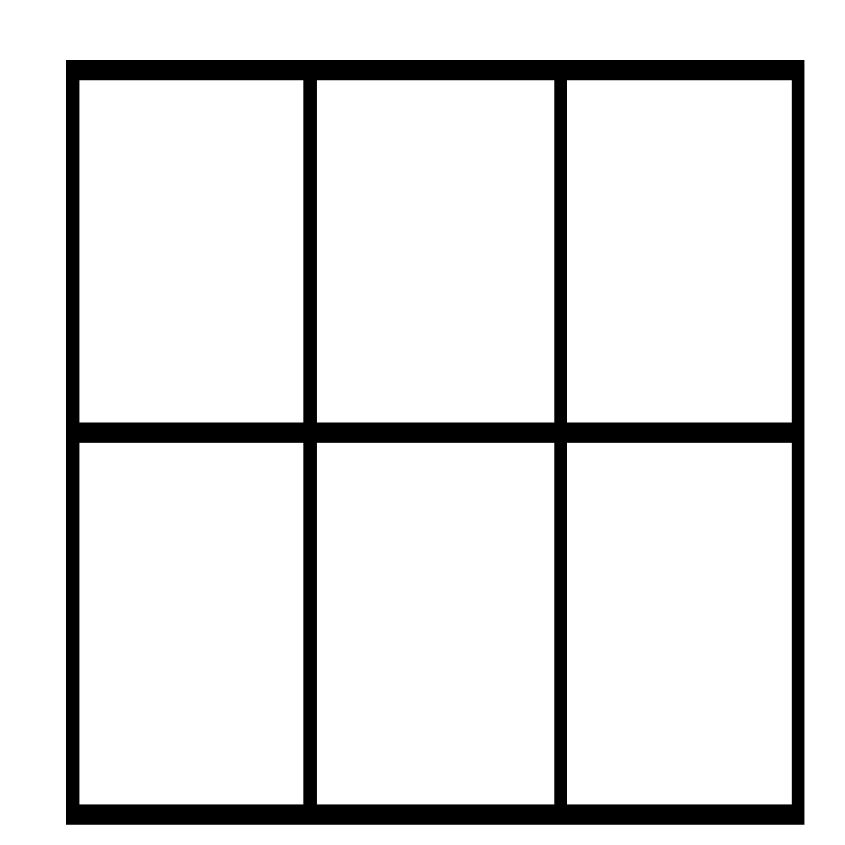

Students should also make the connection of the area of a rectangle to the area model used to represent multiplication. This connection justifies the formula for the area of a rectangle.

Provide students with the area of a rectangle (i.e., 42 square inches) and have them determine possible lengths and widths of the rectangle. Expect different lengths and widths such as 6 inches by 7 inches, or 3 inches by 14 inches.

**For additional assistance see the [Unit Webinar](https://www.georgiastandards.org/Common-Core/Pages/Math.aspx) at Georgiastandards.org.

**SELECTED TERMS AND SYMBOLS**

The following terms and symbols are often misunderstood. These concepts are not an inclusive list and should not be taught in isolation. However, due to evidence of frequent difficulty and misunderstanding associated with these concepts, instructors should pay particular attention to them and how their students are able to explain and apply them.

The terms below are **for teacher reference only** and are not to be memorized by the students. Teachers should present these concepts to students with models and real life examples. Students should understand the concepts involved and be able to recognize and/or demonstrate them with words, models, pictures, or numbers. [Mathematics Glossary](http://www.georgiastandards.org/)

* addend
* addition
* area
* area model
* array
* attribute
* bar graph
* centimeter
* commutative property of multiplication
* decomposing
* difference
* dimensions
* distributive property of multiplication
* divide
* equation
* estimation
* expression
* factor
* gap
* inch
* line plot
* mental computation
* multiply
* non-standard units
* operation
* plane figure
* product
* quotient
* rounding
* scale
* side length
* square unit
* subtract
* sum tiling
* tiling
* unknown/variable

**TASKS**

The following tasks represent the level of depth, rigor, and complexity expected of all third grade students. These tasks or a task of similar depth and rigor should be used to demonstrate evidence of learning. It is important that all elements of a task be addressed throughout the learning process so that students understand what is expected of them. The following is a description of the types of tasks you will see in this unit and their purpose.

|  |  |
| --- | --- |
| **Scaffolding Task** | Tasks that build up to the learning task. |
| **Constructing Task** | Constructing understanding through deep/rich contextualized problem solving tasks. |
| **Practice Task** | Tasks that provide students opportunities to practice skills and concepts. |
| **Performance Task** | Tasks which may be a formative or summative assessment that checks for student understanding/misunderstanding and or progress toward the standard/learning goals at different points during a unit of instruction. |
| **Culminating Task** | Designed to require students to use several concepts learned during the unit to answer a new or unique situation. Allows students to give evidence of their own understanding toward the mastery of the standard and requires them to extend their chain of mathematical reasoning. |
| **Formative Assessment Lesson (FAL)** | Lessons that support teachers in formative assessment which both reveal and develop students’ understanding of key mathematical ideas and applications. These lessons enable teachers and students to monitor in more detail their progress towards the targets of the standards. |
| **CTE Classroom Tasks** | Designed to demonstrate how the Common Core and Career and Technical Education knowledge and skills can be integrated. The tasks provide teachers with realistic applications that combine mathematics and CTE content. |
| **3-Act Task** | A Three-Act Task is a whole-group mathematics task consisting of 3 distinct parts: an engaging and perplexing Act One, an information and solution seeking Act Two, and a solution discussion and solution revealing Act Three. More information along with guidelines for 3-Act Tasks may be found in the ***Guide to Three-Act Tasks*** on georgiastandards.org and the K-5 CCGPS Mathematics Wiki. |

Although the units in this instructional framework emphasize key standards and big ideas at specific times of the year, routine topics such as estimation, mental computation, and basic computation facts should be addressed on an ongoing basis. Ideas related to the eight practice standards should be addressed constantly as well. This unit provides much needed content information and excellent learning activities. However, the intent of the framework is not to provide a comprehensive resource for the implementation of all standards. A variety of resources should be utilized to supplement this unit. The tasks in this unit framework illustrate the types of learning activities that should be utilized from a variety of sources. To assure that this unit is taught with the appropriate emphasis, depth, and rigor, it is important that the **“Strategies for Teaching and Learning”** be reviewed early in the planning process.

|  |  |  |  |  |
| --- | --- | --- | --- | --- |
| **Task Name** | **Task Type**  *Grouping Strategy* | **Skills** | **Standards** | **Description** |
| Cover Me | **Scaffolding Task**  *Partner/Small Group Task* | Analyze the concept of area | MGSE3.MD.5 | In this task, students investigate area using tangrams. |
| Fill Er’ Up | **Constructing Task**  *Partner/Small Group Task* | Estimating area | MGSE3.MD.5  MGSE3.MD.6 | In this task, students practice estimating and filling the area of three different figures. |
| Same But Different | **Constructing Task**  *Partner/Small Group Task* | Same area, different dimensions | MGSE3.MD.5  MGSE3.MD.6 | In this task, students will create different area models for a given product. |
| Count Me In | **Constructing Task**  *Partner/Small Group* | Area Dimensions | MGSE3.MD.5  MGSE3.MD.6  MGSE3.MD.7 | In this task, students create area models and label them with appropriate dimensions. |
| Paper Cut | **3-Act Task**  *Whole Group* | Area Dimensions | MGSE3.MD.5  MGSE3.MD.6  MGSE3.MD.7 | In this task, students will watch a Vimeo and tell what they noticed. Next, they will be asked to discuss what they wonder about or are curious about. Students will then use mathematics to answer their own questions. |
| [Multiplication](http://ccgpsmathematicsk-5.wikispaces.com/file/view/Multiplication%20Formative%20Assessment%20Lesson.pdf/437801992/Multiplication%20Formative%20Assessment%20Lesson.pdf) | **Formative Assessment Lesson**  *Individual/Small Group* | Interpret various multiplication strategies | MGSE3.OA.1  MGSE3.OA.8  MGSE3.OA.9 | This formative assessment is designed to be implemented approximately two-thirds of the way through the instructional unit. |
| Oops! I’m Decomposing! | **Constructing Task**  *Partner/Small Group Task* | Distributive Property of Multiplication | MGSE3.MD.7 | In this task, students will work through problems using area models to understand that numbers can be decomposed into “nice” numbers for multiplication and addition. |
| Multiplication W/ Base-Ten Blocks | **Practice Task**  *Individual/Partner Task* | One-digit by 2-digit multiplication | MGSE3.MD.7 | In this task, students will model multiplication of 2-digit numbers using base-ten blocks to create partial products. |
| Olympic Cola Display | **3-Act Task**  *Whole Group* | Distributive property of multiplication | MGSE3.MD.7 | In this task, students will use their understanding of area models to represent the distributive property to solve problems associated with an Olympic cola display. |
| Array Challenge | **Practice Task**  *Partner/Small Group Task* | Practicing multiplication facts using area models | MGSE3.MD.6  MGSE3.MD.7 | In this task, students will apply multiplication problems to the matching area model/array |
| Skip Counting Patterns | **Constructing Task**  *Partner/Small Group* | Analyze patterns formed when skip-counting on the 1-100 chart | MGSE3.OA.9 | In this task, students look for number patterns relationship to multiplication. |
| Take The Easy Way Out! | **Practice Task**  *Partner/Small Group* | Discovering patterns using a multiplication chart | MGSE3.OA.9 | In this task, students will identify patterns and their relationship to multiplication and division*.* |
| Read All About It | **Constructing Task**  *Small group/Partner* | Applying area and problem solving | MGSE3.OA.8 | This task provides students with experiences solving multistep real world problems. |
| It Takes Two! | **Constructing Task**  *Individual/Partner* | Write multiplication story problems | MGSE3.OA.8 | In this two part task, students will first work in groups to solve two-step word problems. Student groups will then create their own two-step word problems to present to the class to solve. |
| Subject To Interpretation | **Constructing Task**  *Partner/Small Group* | Creating and interpreting pictographs and bar graphs | MGSE3.MD.3 | In the following task, students will organize data given to create a picture graph. Students will use the graph to answer word problems. |
| Measure And Plot! | **Constructing Task**  *Individual Task* | Creating a line plot | MGSE3.MD.4 | In this task, students measure their sitting height to nearest whole inch and then use collected class results to create a line plot graph. |
| Hooked On Solutions! | **Constructing Task**  *Individual Task* | Writing two-step word problems | MGSE3.OA.8 | In this task, students will create word problems to match given equations. |
| Watch My Garden Grow | **Culminating Task**  *Individual Task* | Area, multiplication, problem solving, bar graphs | MGSE3.OA.8  MGSE3.MD.3  MGSE3.MD.5  MGSE3.MD.6  MGSE3.MD.7 | Students will create a flower garden representing 100 square units. The garden is composed of five rectangular regions, each with a different flower plant. A graph will be completed to represent the number of plants used in the garden. Student will compose word problems that can be answered by analyzing the data in the graph. |

**FORMATIVE ASSESSMENT LESSONS (FALS)**

Formative Assessment Lessons are designed for teachers to use in order to target specific strengths and weaknesses in their students’ mathematical thinking in different areas. A Formative Assessment Lesson (FAL) includes a short task that is designed to target mathematical areas specific to a range of tasks from the unit. Teachers should give the task in advance of the delineated tasks and the teacher should use the information from the assessment task to differentiate the material to fit the needs of the students. The initial task should not be graded. It is to be used to guide instruction.

Teachers are to use the following Formative Assessment Lessons (FALS) Chart to help them determine the areas of strengths and weaknesses of their students in particular areas within the unit.

|  |  |  |
| --- | --- | --- |
| **Formative Assessments** | **Content Addressed** | **Pacing**  **(Use before and after this task)** |
| [**ELEMENTARY FORMATIVE ASSESSMENT LESSONS**](http://ccgpsmathematicsk-5.wikispaces.com/file/view/Multiplication%20Formative%20Assessment%20Lesson.pdf/437801992/Multiplication%20Formative%20Assessment%20Lesson.pdf) | **Interpret various multiplication strategies** | **Count Me In** |

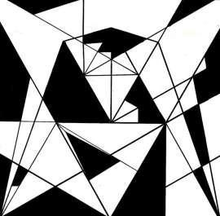**SCAFFOLDING TASK**: **COVER ME**!

In this task, students investigate area using tangrams.

*Adapted from Teaching Student Centered Mathematics, by John A. Van de Walle, 2006, pg. 235*

**APPROXIMATE TIME:** 1 class session

**CONTENT STANDARDS**

**MGSE3.MD.5** Recognize area as an attribute of plane figures and understand concepts of area measurement.

**STANDARDS FOR MATHEMATICAL PRACTICE**

1. Make sense of problems and persevere in solving them.

2. Reason abstractly and quantitatively.

3. Construct viable arguments and critique the reasoning of others.

4. Model with mathematics.

5. Use appropriate tools strategically.

6. Attend to precision.

**BACKGROUND KNOWLEDGE**

Students should know that a rectangle is a two-dimensional plane figure. Students have measured length to the nearest quarter inch but have not had any experience with using square units or measuring area.

“Area is an amount of two-dimensional surface that is contained within a plane figure. Area measurement assumes that congruent figures enclose equal areas, and that area is additive, i.e., the area of the union of two regions that overlap only at their boundaries is the sum of their areas. Area is measured by tiling a region with a two-dimensional unit (such as a square) and parts of the unit, without gaps or overlaps. Understanding how to spatially structure a two-dimensional region is an important aspect of the progression in learning about area” (from *Progressions for Common Core State Standards,* 2012, p. 4).

Van de Walle states that area is a measure of the space inside a region or how much it takes to cover a region. As with other attributes, students must first understand the attribute of area before measuring.

“One purpose of comparison activities with areas is to help students distinguish between size (or area) and shape, length, and other dimensions. Activities in which one area is rearranged (conservation of area) are suggested. Cutting a shape into two parts and reassembling it in a different shape can show that the before and after shapes have the same area, even though they are different shapes” (*Teaching Student Centered Mathematics*, *Volume II*, Van de Walle, p. 324).

**COMMON MISCONCEPTIONS**

Students may think that different shapes made with the same units have different areas as well. This is due to lack of experience in developing conservation on area. (Math Misconceptions: From Misunderstanding to Deep Understanding (2010), Bamberger, Oberdorf, and Shultz-Ferrel. Using activities such as the one presented in the lesson with tangrams and arrays will provide the needed spatial experience for students to develop this understanding.

**ESSENTIAL QUESTION**

* What is area?

**MATERIALS**

* tangrams (a blackline master can be found on pg 18)
* math journal/learning log,
* *Grandfather Tang’s Story* by Ann Tompert,
* video clip, <http://www.youtube.com/watch?v=AVUy058_JNE>, What is a Tangram?

**GROUPING**

Students may be grouped in partner pairs or in small groups at the teacher’s discretion.

**NUMBER TALKS**

By now number talks should be incorporated into the daily math routine. Continue utilizing the different strategies in number talks and revisiting them based on the needs of the students.

**TASK DESCRIPTION, DEVELOPMENT, AND DISCUSSION (SMP 1, 2, 3, 4, 5, and 6)**

In this task, students investigate the concept of area using a set of tangrams. Students create a variety of pictures using tangrams. Students discover that one set of tangrams can create different shapes but all shapes have the same area since the same seven pieces are used to create all pictures.

Read the book, ***Grandfather Tang’s Story****.* Show the following short video clip to introduce tangrams.: <http://www.youtube.com/watch?v=AVUy058_JNE>

Use the following questions to lead a discussion about tangrams:

* What are tangrams? *(puzzle)*
* What makes the puzzle unique? (*rectangle formed by 7 shapes)*
* After reading the book and looking at the video, what do you think is the puzzle’s relationship to math?

Provide a set of tangrams for each student. Allow time for exploration. Students can create their own set of tangrams if needed using directions available at:

<http://www.beaconlearningcenter.com/documents/2795_01.pdf>

<http://www.heckscher.org/downloads/ED08_KidsCor_ActivityPages_Tangram.pdf>

Have students create a variety of pictures using all seven tangram pieces. Students must use all seven pieces and be certain that pieces form a picture in which there are no gaps or overlaps of pieces. Provide paper for students to trace one of their pictures. Students then trade pictures with a partner. Students should try to make the same picture as the partner’s picture. Students should be able to see that although the pictures are different each picture is formed from the same seven pieces therefore each picture covers the same amount of space.

Once completed, lead students in a discussion using the following questions:

* Were all the pictures the same?
* What did all of the pictures have in common? Lead students to understanding that although each picture is different, the same 7 pieces were used to create each picture.
* Are the tangrams covering the same amount of space? How do you know?

Introduce the term area as the amount of space inside a two-dimensional figure. Ask: How does the term area relate to the tangram lesson?

**FORMATIVE ASSESSMENT QUESTION**

* How can two different pictures formed with the same pieces have the same area?
* How does the term area relate to the tangram lesson?

**DIFFERENTIATION**

**Extension**

* Provide students with a variety of plane figures such as pentagons, hexagons, trapezoids, etc. and have them create their own tangram puzzles. Students create a new picture with puzzle pieces and exchange new pictures and puzzle pieces with one another student to solve.

**Intervention**

* Provide students with outlined shapes to cover with tangram pieces. Students can also work in small groups and/or with teacher.

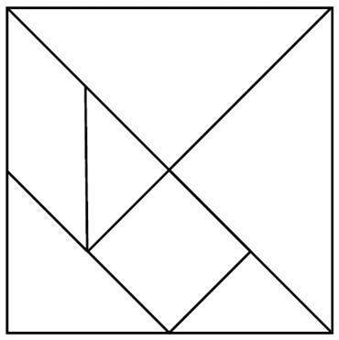

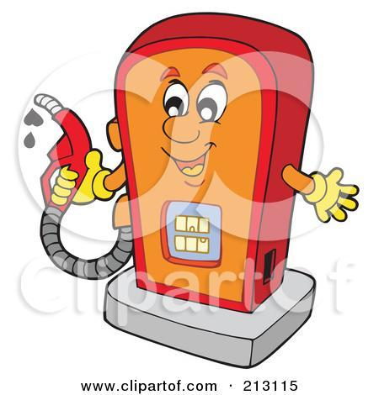

**CONSTRUCTING TASK:** **FILL ‘ER UP!**

*Adapted from Teaching Student Centered Mathematics, by John A. Van de Walle pg. 324*

In this task, students practice estimating and filling the area of three different figures.

**APPROXIMATE TIME:** One class session

**CONTENT STANDARDS**

**MGSE3.MD.5.** Recognize area as an attribute of plane figures and understand concepts of area measurement.

1. A square with side length 1 unit, called “a unit square,” is said to have “one square unit” of area, and can be used to measure area.
2. A plane figure which can be covered without gaps or overlaps by n unit squares is said to have an area of *n* square units.

**MGSE3.MD.6.** Measure areas by counting unit squares (square cm, square m, square in, square ft, and improvised units).

**STANDARDS FOR MATHEMATICAL PRACTICE**

1. Make sense of problems and persevere in solving them.

2. Reason abstractly and quantitatively.

3. Construct viable arguments and critique the reasoning of others.

5. Use appropriate tools strategically.

6. Attend to precision.

8. Look for and express regularity in repeated reasoning.

**BACKGROUND KNOWLEDGE**

Students should know that a rectangle is a two-dimensional plane figure. Students have measured length to the nearest quarter inch but have not had any experience with using square units or measuring area.

“Area is an amount of two-dimensional surface that is contained within a plane figure. Area measurement assumes that congruent figures enclose equal areas, and that area is additive, i.e., the area of the union of two regions that overlap only at their boundaries is the sum of their areas. Area is measured by tiling a region with a two-dimensional unit (such as a square) and parts of the unit, without gaps or overlaps. Understanding how to spatially structure a two-dimensional region is an important aspect of the progression in learning about area” (from *Progressions for Common Core State Standards,* 2012, p. 4).

Van de Walle states that area is a measure of the space inside a region or how much it takes to cover a region. As with other attributes, students must first understand the attribute of area before measuring the area of a figure.

“One purpose of comparison activities with areas is to help students distinguish between size (or area) and shape, length, and other dimensions. Activities in which one area is rearranged (conservation of area) are suggested. Cutting a shape into two parts and reassembling it in a different shape can show that the before and after shapes have the same area, even though they are different shapes” (*Teaching Student Centered Mathematics*, *Volume II*, Van de Walle, p. 324).

In these first tasks, students are developing the idea that area is a two-dimensional figure’s attribute and is measured by covering an entire figure with no overlaps or gaps. **Formulas are not introduced at this point.**  Conceptual development and understanding of area is. During this conceptual stage, “it is important to understand that filling regions with units and counting does little to help students develop multiplicative formulas. Even when rectangles are filled with a grid of squares, students are more likely to count the squares than to relate the number of squares to the dimensions of the rectangles” (Van de Walle, page 236-237).

**COMMON MISCONCEPTIONS**

Students may think that different shapes made with the same units have different areas as well. This is due to lack of experience in developing conservation on area. (Math Misconceptions: From Misunderstanding to Deep Understanding (2010), Bamberger, Oberdorf, and Shultz-Ferrel.) Using activities such as the one presented in the task will provide the needed spatial experience for students to develop this understanding.

**ESSENTIAL QUESTIONS**

* What is area?
* What is tiling?
* Why is it important to not have gaps or overlaps when determining the area of a figure?

**MATERIALS**

* variety of outlined shapes for student partners to fill
* color tiles
* math journal/learning logs

**GROUPING**

Students may be grouped in partner pairs or in small groups at the teacher’s discretion.

**NUMBER TALKS**

By now number talks should be incorporated into the daily math routine. Continue utilizing the different strategies in number talks and revisiting them based on the needs of the students.

**TASK DESCRIPTION, DEVELOPMENT, AND DISCUSSION (SMP 1, 2, 3, 5, 6, and 8)**

In this task, students will practice estimating and filling in the area of three different figures. They will relate area to real-life situations such as the area formed by the boundary lines on a football field, covering a basement floor with tile, or the amount of space on a banquet table. Students need to understand that area represents the amount needed to cover or fill a space with no gaps or overlaps.

The teacher will draw two rectangles and a curved-closed figure on paper for each partner group. Make the figures so that the three areas are not the same, but with no figure that is clearly the largest or smallest. Students first estimate which of the shapes has the smallest area and which has the largest area. After recording estimates, students use color tiles to cover each of the figures. Students then count the number of tiles used in each figure and compare the actual area of each figure to their estimates. Explain that this act is referred to as tiling, or covering, the space inside the shape. Be certain students are not overlapping tiles and have no gaps in coverage.

Have students share findings. Ask students what they did when they needed to cover a gap but a color tile was too large to fill the space. Following the discussion, students should be able to explain what they now understand about area.

**FORMATIVE ASSESSMENT QUESTIONS**

* How did you compare the areas of the shapes?
* Why is it important to not have gaps or overlaps when finding the area of a figure?
* What can be used to measure area?
* How is area used in real-world situations?

**DIFFERENTIATION**

**Extension**

* Students can determine how to measure the area of a large space such as the classroom floor using at least two different units of measure. Students might use cardboard squares, newspaper sheets, or the flats of base ten blocks..

**Intervention**

* Using this task as a direct instruction strategy in small groups will provide support for students who struggle with these concepts and will enable them to develop the ability to describe their thinking.
* Use only rectangular shapes drawn on grid paper.

**TECHNOLOGY CONNECTION**

* <http://illuminations.nctm.org/ActivityDetail.aspx?id=46>

This website provides actives for measuring the area of rectangles.

* <http://www.mathplayground.com/area_perimeter.html>

This website provides practice with measuring the area and perimeter of rectangles.

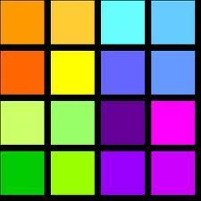**CONSTRUCTING TASK:** **THE SAME BUT DIFFERENT**

In this task, students will create different area models for a given product.

**APPROXIMATE TIME:** 1 class session

**CONTENT STANDARDS**

**MGSE3.MD.5.** Recognize area as an attribute of plane figures and understand concepts of area measurement.

1. A square with side length 1 unit, called “a unit square,” is said to have “one square unit” of area, and can be used to measure area.
2. A plane figure which can be covered without gaps or overlaps by n unit squares is said to have an area of *n* square units.

**MGSE3.MD.6** Measure areas by counting unit squares (square cm, square m, square in, square ft, and improvised units).

**STANDARDS FOR MATHEMATICAL PRACTICE**

1. Make sense of problems and persevere in solving them.

2. Reason abstractly and quantitatively.

3. Construct viable arguments and critique the reasoning of others.

4. Model with mathematics.

5. Use appropriate tools strategically.

6. Attend to precision.

7. Look for and make use of structure.

8. Look for and express regularity in repeated reasoning.

**BACKGROUND KNOWLEDGE AND MISCONCEPTIONS**

“As the teacher, your objective in the beginning is to develop the idea that area is a measure of covering. Do not introduce formulas. Simply have the students fill the shapes and count the units. Be sure to include estimation before measuring (this is significantly more difficult than for length), use approximate language, and relate precision to the size of the units in the same manner as with length” (Van de Walle, page 237).

In these first few tasks, students are beginning to develop the idea that area is a two-dimensional figure’ attribute and is measured by covering an entire figure with no overlaps or gaps. **Formulas are not introduced at this point.**  Conceptual development and understanding of area is. During this conceptual stage, “it is important to understand that filling regions with units and counting does little to help students develop multiplicative formulas. Even when rectangles are filled with a grid of squares, students are more likely to count the squares than to relate the number of squares to the dimensions of the rectangles” (Van de Walle, page 236-237).

**COMMON MISCONCEPTION**

Students may think that different shapes made with the same units have different areas as well. This is due to lack of experience in developing conservation on area. (Math Misconceptions: From Misunderstanding to Deep Understanding (2010), Bamberger, Oberdorf, and Shultz-Ferrel. Using activities such as the one presented in the lesson with tangrams and arrays will provide the needed spatial experience for students to develop this understanding.

**ESSENTIAL QUESTIONS**

* What is area?
* How does knowing the area of a square or rectangle relate to knowing different multiplication facts?
* How can the same area measure produce rectangles with different dimensions? (Ex. 24 sq. units can produce a rectangle that is a 3 x 8, 4 x 6, 1 x 24, 2 x 12)
* How can area be determined without counting each square?

**MATERIALS**

* Post-it notes (square), color tiles, or construction paper squares
* math journal/learning logs

**GROUPING**

Students may be grouped in partner pairs or in small groups at the teacher’s discretion.

**NUMBER TALKS**

By now number talks should be incorporated into the daily math routine. Continue utilizing the different strategies in number talks and revisiting them based on the needs of the students.

**TASK DESCRIPTION, DEVELOPMENT, AND DISCUSSION (1, 2, 3, 4, 5, 6, 7, and 8)**

Have students recall what they have learned about area. Have students suggest examples of squares and rectangles as seen in the classroom (ceiling, walls, table tops, floor, etc.) whose area could be measured. Ask: What could be used to measure the space inside these figures? Lead students to understanding that square units are used to measure area. Also, the teacher could ask why they think squares are used instead of hexagons, trapezoids, or circles when building.

Group students in pairs and give each pair a container of tiles, construction paper squares, or square post-its. Teacher provides a target number using a number (product) that can be made from more than two factors.. This is so a variety of rectangles can be formed. For example, using 12 as a target number yields several different rectangles, 1x12, 2x6, and 3x4. Pairs use this number of tiles or post-its and create a rectangle. Remind students that there can be no gaps or overlapping when forming rectangles.

Once completed, have students take a gallery walk around the room to observe each other’s rectangles. Tell students to find another pair of students who have a rectangle that looks different from the one they created. Have the two partner pairs compare and contrast the two figures. Allow time for partner pairs to share their observations. Observations should include the number of squares in each row and each column as seen in the two different figures. This should lead students to observing that arrays are being formed when making rectangles with square units.

Teacher provides additional target numbers for partner practice having partner pairs note the differences and similarities of figures. As a closing, have students reconvene as a class and lead students in a discussion that provides the opportunity for students to connect finding the area of a figure to making arrays. This connection is critical in helping students relate how multiplication can be used to determine the area of a rectangle; that is, one number (the product) can have multiple dimensions (factors).

**FORMATIVE ASSESSMENT QUESTION**

* How was the figure your pair created the same as another partner pair?
* How was the figure your pair created different from another partner pair?
* Explain how a rectangle with the area of 10 can be shown using two different arrays such as 1 x 10 and a 2 x 5.
* How can you relate what you learned in the tangram task (first task in this unit) to today’s task?

**DIFFERENTIATION**

**Extension**

* Have students explain why square units are expressed in square units of measure rather than measures of length only.

**Intervention**

* Using this task as a direct instruction strategy in small groups will provide support for students who struggle with these concepts and will enable them to develop the ability to describe their thinking.

**CONSTRUCTING TASK:** **COUNT ME IN!**

In this task, students create area models and label them with appropriate dimensions.

**APPROXIMATE TIME** – One class session

**CONTENT STANDARDS**

**MGSE3.MD.5.** Recognize area as an attribute of plane figures and understand concepts of area measurement.

1. A square with side length 1 unit, called “a unit square,” is said to have “one square unit” of area, and can be used to measure area.
2. A plane figure which can be covered without gaps or overlaps by n unit squares is said to have an area of *n* square units.

**MGSE3.MD.6.** Measure areas by counting unit squares (square cm, square m, square in, square ft, and improvised units).

**MGSE3.MD.7.** Relate area to the operations of multiplication and addition.

1. Find the area of whole number side lengths by tiling it, and show that the area is the same as would be found by multiplying the side lengths.

**STANDARDS FOR MATHEMATICAL PRACTICE**

1. Make sense of problems and persevere in solving them.

2. Reason abstractly and quantitatively.

3. Construct viable arguments and critique the reasoning of others.

4. Model with mathematics.

5. Use appropriate tools strategically.

6. Attend to precision.

7. Look for and make use of structure.

8. Look for and express regularity in repeated reasoning.

**BACKGROUND KNOWLEDGE**

The students should understand that a plane figure is a two-dimensional figure that consists of length and width. Students should understand skip-counting and how skip-counting represents repeated addition. Students should also be familiar with the term sum.

**COMMON MISCONCEPTION**

Students may think that different shapes made with the same units have different areas as well. This is due to lack of experience in developing conservation on area. (Math Misconceptions: From Misunderstanding to Deep Understanding (2010), Bamberger, Oberdorf, and Shultz-Ferrel. Using activities such as the one presented in the lesson with tangrams and arrays will provide the needed spatial experience for students to develop this understanding.

**ESSENTIAL QUESTIONS**

* How does knowing the dimensions of a rectangle relate to area?
* How does knowing the area of a square or rectangle relate to knowing multiplication facts?
* What is the relationship between dimensions and factors?
* What is the connection between area models and skip counting?

**MATERIALS**

* grid paper
* Post-it notes (square), color tiles, or construction paper squares
* math journal/learning log

**GROUPING**

Students may be grouped in partner pairs or in small groups at the teacher’s discretion.

**NUMBER TALKS**

By now, number talks should be incorporated into the daily math routine. Continue utilizing the different strategies in number talks and revisiting them based on the needs of the students.

**TASK DESCRIPTION, DEVELOPMENT, & DISCUSSION (SMP 1, 2, 3, 4, 5, 6, 7 and 8)**

In this task, students will create area models and label them with appropriate dimensions.

**Part I**

Students use color tiles, post-its, or colored squares of paper to create a rectangle representing an area of 24. Have students share all the different dimensions that could be used to create rectangles. (1x24, 2x12, 3x8, or 4x6)

As a class, lead a discussion using the questions below to assist students in understanding the relationship between addition and multiplication when using arrays.

* While your figure may look different from someone else’s figure, how do both figures show the same area? (This relates back to the Cover Me scaffolding task.)
* Write the following dimensions on the board representing the variety of arrays made by students: 1 by 24; 2 by 12; 3 by 8; and 4 by 6. (Be certain not to use the multiplication symbol, ***x***)
* What math could be used to quickly determine the area of each figure? This question should lead the students to saying that they could use skip counting or some may respond that they would multiply the number of columns and number of rows.
* Have students use both repeated addition and multiplication to show how the area of the figure could be found. Record students responses for all to see.
* Provide student pairs with grid paper and a product. Use products that yield more than one set of dimensions/factors.
* Student pairs draw all the ways their product can be shown using rectangles and square units such as color tiles, square post-its, or colored paper squares.
* Pairs record equations for each figure using repeated addition and multiplication.

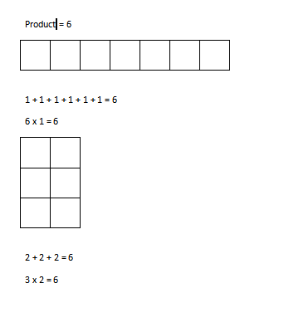**Example:**

**BIG IDEAS**

* Area is related to addition in that the square units can be counted two ways: based on columns or length along with width or rows. This can be done using skip counting which is a form of addition.
* The most efficient way to determine a figure’s area is to multiply the number of squares in one column by the number of squares in one row..
* Consider the product 12. The commutative property of multiplication can be seen by turning the figures to represent 3 groups of 4 or 4 groups of 3. Both yield the same area but the figure has different lengths and width depending on the figure’s orientation. This will make the connection to the commutative property of multiplication.

For example:

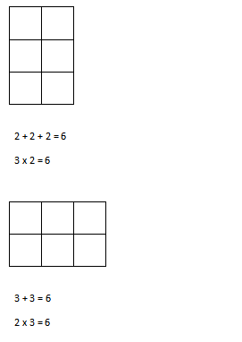

**Part II**

Students complete the “Count Me In” task using recording form. Have students share the different rectangles created and how they are similar/different.

**FORMATIVE ASSESSMENT QUESTIONS**

* What is the connection between skip-counting/addition and multiplication?
* Which one is better to use and why?
* Can the same areas look different? Why or why not?
* What is the commutative property of multiplication and how does it relate to area?
* What is the relationship between a product and a sum?
* Can an area measurement have the same area but different factors? How does that relate back to the tangram task?
* What would happen if we took some of the post-its or blocks away? Would we still have an accurate area measurement of the plane figure? Explain.

**DIFFERENTIATION**

**Extension**

* Provide students with 1cm grid paper. Given a two different number products, (one prime number product such as 7 and one composite product such as 15) have students create all the arrays possible for each product. Have students use drawings to illustrate the difference between prime and composite number.

**Intervention**

* <http://www.brainpopjr.com/math/measurement/area/grownups.weml>

Have students view the short video clip and discuss as needed.

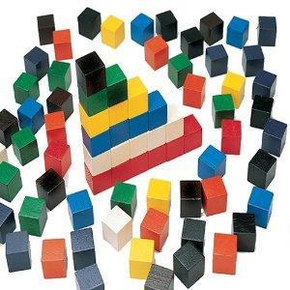

Count Me In!

|  |  |
| --- | --- |
| Create a rectangle with the area of 16 square units. What is a multiplication sentence that could describe your rectangle?  Find a different way to show an area of 16 square units. | Create a rectangle with the area of 30 square units. What is a multiplication sentence that could describe your rectangle?  Find a different way to show an area of 30 square units. |
| Draw a rectangle with the area of 36 square units. What is a multiplication sentence that could describe your rectangle?  Find a different way to show an area of 36 square units. | Draw a rectangle with the area of 48 square units. What is a multiplication sentence that could describe your rectangle?  Find a different way to show an area of 48 square units. |

**3 ACT TASK:** **Paper Cut**

Task Adapted From [www.gfletchy.wordpress.com](http://www.gfletchy.wordpress.com)

**APPROXIMATE TIME:** 1 class period

**CONTENT STANDARDS**

**MGSE3.MD.5** Recognize area as an attribute of plane figures and understand concepts of area measurement.

a. A square with side length 1 unit, called “a unit square,” is said to have “one square

unit” of area, and can be used to measure area.

b. A plane figure which can be covered without gaps or overlaps by n unit squares is said

to have an area of n square units.

**MGSE3.MD.6** Measure areas by counting unit squares (square cm, square m, square in, square ft, and improvised units).

**MGSE3.MD.7.** Relate area to the operations of multiplication and addition.

a. Find the area of a rectangle with whole-number side lengths by tiling it, and show that

the area is the same as would be found by multiplying the side lengths.

b. Multiply side lengths to find areas of rectangles with whole number side lengths in the

context of solving real world and mathematical problems, and represent whole-number

products as rectangular areas in mathematical reasoning.

c. Use tiling to show, in a concrete case, that the area of a rectangle with whole-number

side lengths a and b + c is the sum of a × b and a × c. Use area models to represent the

distributive property in mathematical reasoning.

d. ~~Recognize area as additive. Find areas of rectilinear figures by decomposing them into~~

~~non-overlapping rectangles and adding the areas of the non-overlapping parts, applying~~

~~this technique to solve real world problems.~~

**STANDARDS FOR MATHEMATICAL PRACTICE**

1. **Make sense of problems and persevere in solving them.** Students must make sense of the problem by identifying what information they need to solve it.
2. **Reason abstractly and quantitatively.** Students are asked to make an estimate (high and low).
3. **Construct viable arguments and critique the reasoning of others.** After writing down their own questions, students discuss their question with partners, creating the opportunity to construct the argument of why they chose their question, as well as critiquing the questions that others came up with.
4. **Model with mathematics.** Once given the information, the students use that information to develop a mathematical model to solve their question.
5. **Use appropriate tools strategically.** Students write their best estimate and two more estimates – one that is too low and one that is too high to establish a range in which the solution would occur.
6. **Attend to precision.** Students use clear and precise language when discussing their strategies and sharing their own reasoning with others.
7. **Look for and make sense of structure.** Students develop their understanding of area specifically making sense that different shapes may share the same area.

**ESSENTIAL QUESTIONS**

In order to maintain a student-inquiry-based approach to this task, it may be beneficial to wait until Act 2 to share the EQ’s with your students. By doing this, students will be allowed the opportunity to be very creative with their thinking in Act 1. By sharing the EQ’s in Act 2, you will be able to narrow the focus of inquiry so that the outcome results in student learning directly related to the content standards aligned with this task.

* How can the knowledge of area be used to solve real world problems?
* How do different dimensions resulting in the same area cover the same amount of space?

**MATERIALS**

* Act 1 video- <https://vimeo.com/86924977>
* Act 2- Original Piece Picture
* Act 2- The Middle Cut Picture
* Act 2- The Paper Cut visual representation (only use if necessary)
* Act 3 video- <https://vimeo.com/86924978>
* Student recording sheet

**GROUPING**

Individual/Partner and or Small Group

**TASK DESCRIPTION, DEVELOPMENT AND DISCUSSION**

In this task, students will view the video (<https://vimeo.com/86924977> ) and tell what they noticed. Next, they will be asked to discuss what they wonder about or are curious about. These questions will be recorded on a class chart or on the board and on the student recording sheet. Students will then use mathematics to answer their own questions. Students will be given information to solve the problem based on **need**. When they realize they don’t have the information they need, and ask for it, it will be given to them.

**Background Knowledge:**

This task follows the 3-Act Math Task format originally developed by Dan Meyer. More information on this type of task may be found at <http://blog.mrmeyer.com/category/3acts/>. A Three-Act Task is a whole-group mathematics task consisting of 3 distinct parts: an engaging and perplexing Act One, an information and solution seeking Act Two, and a solution discussion and solution revealing Act Three. More information along with guidelines for 3-Act Tasks may be found in the ***Guide to Three-Act Tasks*** on georgiastandards.org and the K-5 CCGPS Mathematics Wiki.

“Area is an amount of two-dimensional surface that is contained within a plane figure. Area

measurement assumes that congruent figures enclose equal areas, and that area is additive, i.e.,

the area of the union of two regions that overlap only at their boundaries is the sum of their areas.

Area is measured by tiling a region with a two-dimensional unit (such as a square) and parts of

the unit, without gaps or overlaps. Understanding how to spatially structure a two-dimensional

region is an important aspect of the progression in learning about area” (from Progressions for

Common Core State Standards, 2012, p. 4).

Van de Walle states that area is a measure of the space inside a region or how much it takes to

cover a region. As with other attributes, students must first understand the attribute of area

before measuring.

“One purpose of comparison activities with areas is to help students distinguish between size (or

area) and shape, length, and other dimensions. Activities in which one area is rearranged

(conservation of area) are suggested. Cutting a shape into two parts and reassembling it in a

different shape can show that the before and after shapes have the same area, even though they

are different shapes” (Teaching Student Centered Mathematics, Volume II, Van de Walle, p.

324).

**Common Misconceptions:**

Students may think that different shapes made with the same units have different areas as well.

This is due to lack of experience in developing conservation on area. (Math Misconceptions:

From Misunderstanding to Deep Understanding (2010), Bamberger, Oberdorf, and Shultz-Ferrel.

Using activities such as the one presented in the lesson with tangrams and arrays will provide the

needed spatial experience for students to develop this understanding.

**Task Directions:**

**Act 1 – Whole Group** - Pose the conflict and introduce students to the scenario by showing Act I video. **(Dan Meyer** <http://blog.mrmeyer.com/2011/the-three-acts-of-a-mathematical-story/>**)**

**“Introduce the central conflict of your story/task clearly, visually, viscerally, using as few words as possible.”**

* Show Act 1 video (<https://vimeo.com/86924977>) to students.
* Ask students what they noticed in the video, what they wonder about, and what questions they have about what they saw in the video. Do a think-pair-share so that students have an opportunity to talk with each other before sharing questions with the whole group. Students may need to watch the video several times.
* Share and record students’ questions. The teacher may need to guide students so that the questions generated are math-related.

**Anticipated questions students may ask and wish to answer: (**\*Main question(s) to be investigated)

* + *Which piece of paper has a greater area?
  + What is the total area of the original piece of paper?
  + What is the area of the middle piece of paper?
* Once students have their question, ask the students to estimate answers to their questions (think-pair-share). Students will write their best estimate, then write two more estimates – one that is too low and one that is too high so that they establish a range in which the solution should occur. Students should plot their three estimates on an empty number line. Note: As the facilitator, you may choose to allow the students to answer their own posed questions, one question that a fellow student posed, or a related question listed above. For students to be completely engaged in the inquiry-based problem solving process, it is important for them to experience ownership of the questions posed.

Important note: Although students will only investigate the main question(s) for this task, it is important for the teacher to not ignore student generated questions. Additional questions may be answered after they’ve found a solution to the main question, or as homework or extra projects.

**Act 2** – **Student Exploration** - Provide additional information as students work toward solutions to their questions. **(Dan Meyer** <http://blog.mrmeyer.com/2011/the-three-acts-of-a-mathematical-story/>**)**

**“The protagonist/student overcomes obstacles, looks for resources, and develops new tools.”**

* During Act 2, students decide on the facts, tools, and other information needed to answer the question(s)(from Act 1). When students decide what they need to solve the problem, they should ask for those things. It is pivotal to the problem solving process that students decide what is needed without being given the information up front. Some groups might need scaffolds to guide them. The teacher should question groups who seem to be moving in the wrong direction or might not know where to begin.
* Required Information:

1. The Original Piece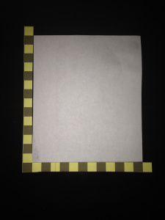

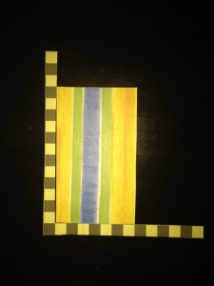

2. The Middle Cut

3. Paper Cut Visual Representation- Use these images only to scaffold students learning. Don’t use if you don’t have too!

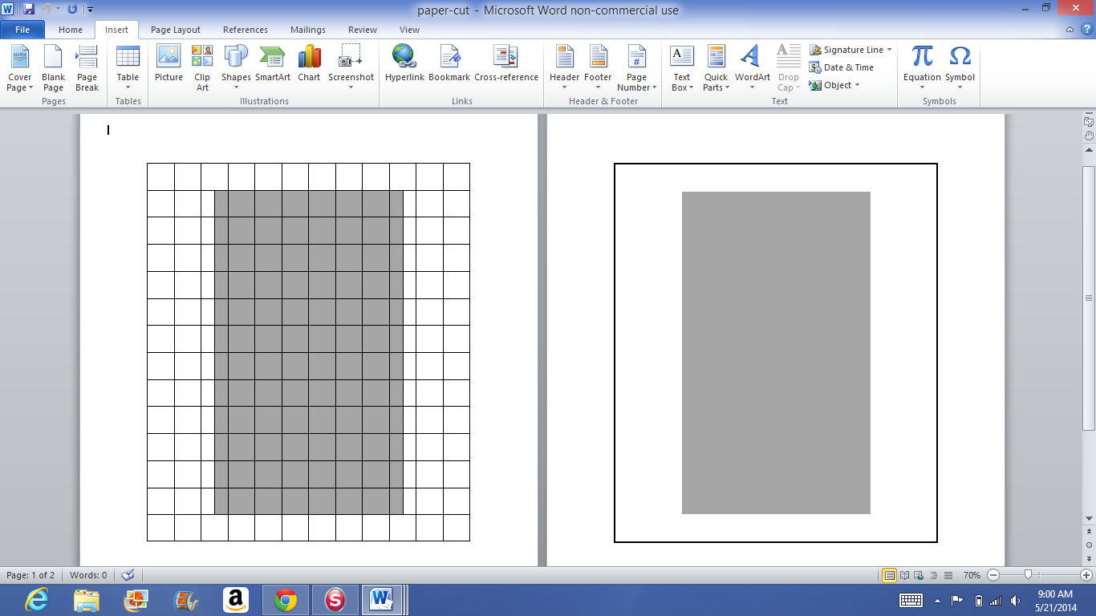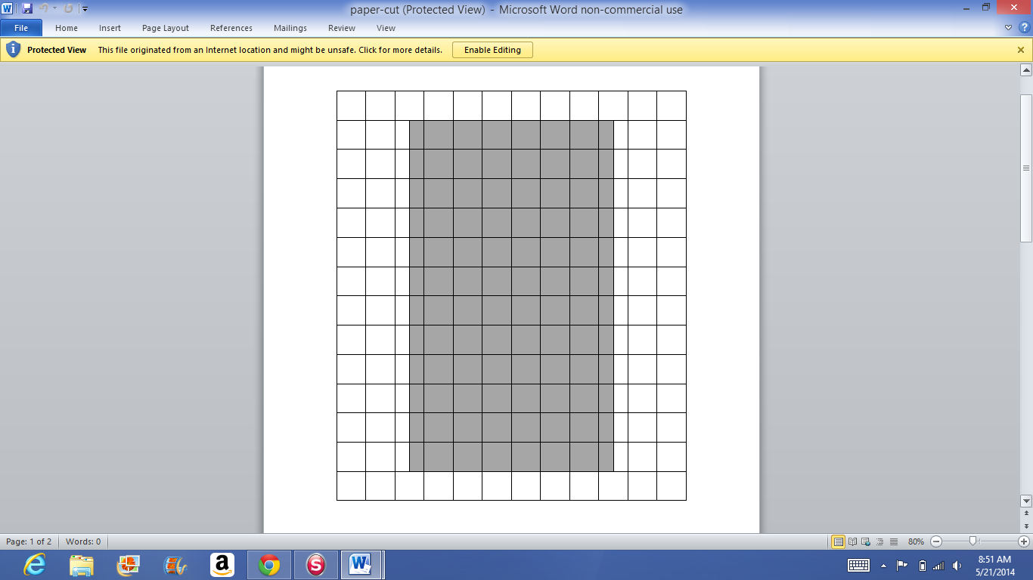

* The teacher provides guidance as needed during this phase. Some groups might need scaffolds to guide them. The teacher should question groups who seem to be moving in the wrong direction or might not know where to begin. Questioning is an effective strategy that can be used, with questions such as:
  + What is the problem you are trying to solve?
  + What do you think affects the situation?
  + Can you explain what you’ve done so far?
  + What strategies are you using?
  + What assumptions are you making?
  + What tools or models may help you?
  + Why is that true?
  + Does that make sense?

**Act 3 – Whole Group** – Share solutions and strategies.

* Students to present their solutions and strategies and compare them.
* Reveal the solution in Act 3 video (<https://vimeo.com/86924978>).
* Lead discussion to compare these, asking questions such as:
  + How reasonable was your estimate?
  + Which strategy was most efficient?
  + Can you think of another method that might have worked?
  + What might you do differently next time?

**Act 4, The Sequel -** “The goals of the sequel task are to a) challenge students who finished quickly so b) I can help students who need my help. It can't feel like punishment for good work. It can't seem like drudgery. It has to entice and activate the imagination.” Dan Meyer <http://blog.mrmeyer.com/2013/teaching-with-three-act-tasks-act-three-sequel/>

For Act 4, share ideas below or reference other student-generated questions that could be used for additional classwork, projects or homework.

Examples:

* Is there more than one way to cut the paper where the areas of the two pieces would still be equal?
* How can you cut the paper so that the area of the middle piece is half the area of the original piece?

**FORMATIVE ASSESSMENT QUESTIONS**

* What models did you create?
* What organizational strategies did you use?

**DIFFERENTIATION**

**Extension**

* Provide students a different size original piece of paper to make a paper cut where the middle piece would equal the same area. Is there more than one way to cut the paper where the two pieces will be equal in area?

**Intervention**

* Allow students to use the paper cut attachment (Paper Cut Visual Representation) .

Act 2 Original Picture:



Act 2 Middle Picture:



3. Paper Cut Visual Representation



Task Title: ________________________ Name: ________________________

*Adapted from Andrew Stadel*

**ACT 1**

|  |
| --- |
| What did/do you notice? |
|  |
| What questions come to your mind? |
|  |

**Main Question**: ________________________________________________________________

|  |
| --- |
| What is your 1st estimate and why?  On an empty number line, record an estimate that is too low and an estimate that is too high. |

**ACT 2**

|  |
| --- |
| What information would you like to know or need to solve the MAIN question? |
|  |

Record the given information (measurements, materials, etc…)

If possible, give a better estimation with this information: _______________________________

**Act 2 (con’t)**

Use this area for your work, tables, calculations, sketches, and final solution.

**ACT 3**

|  |
| --- |
| What was the result? |
|  |

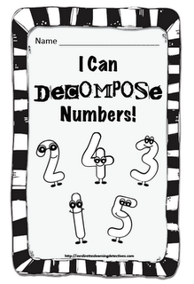**CONSTRUCTING TASK**- **“OOPS! I’M DECOMPOSING!”**

In this task, students will work through problems using area models to understand that numbers can be decomposed into “nice” numbers for multiplication and addition.

**APPROXIMATE TIME:** One class session

**CONTENT STANDARDS**

**MGSE3.MD.7** Relate area to the operation of multiplication and addition.

c. Use tiling to show in a concrete case that the area of a rectangle with whole-number side

lengths ***a*** and ***b*** + ***c*** is the sum of ***a*** x ***b*** and ***a*** x ***c***. Use area models to represent the

distributive property in mathematical reasoning.

**STANDARDS FOR MATHEMATICAL PRACTICE**

1. Make sense of problems and persevere in solving them.

2. Reason abstractly and quantitatively.

3. Construct viable arguments and critique the reasoning of others.

4. Model with mathematics.

5. Use appropriate tools strategically.

6. Attend to precision.

7. Look for and make use of structure.

8. Look for and express regularity in repeated reasoning.

**BACKGROUND KNOWLEDGE AND MISCONCEPTIONS**

“The distributive property of multiplication over addition refers to the idea that either of the two factors in a product can be split (decomposed) into two or more parts and each part is multiplied separately and then added (Teaching Student Centered Mathematics Volume 2, pp. 119, 2014). Students will discover that this will result in the same product as multiplying the two numbers. Using an area model is a great way for students to develop this understanding.

**ESSENTIAL QUESTIONS**

* What does it mean to decompose a number?
* How is the decomposition of a factor in an equation related to the distributive property of multiplication?

**MATERIALS**

* Centimeter grid paper (see task description for preparation instructions)
* Crayons
* Learning log/math journal
* <http://mrsrenz.net/mathsites.htm#area-perim>
* Base Ten Blocks (if possible alternate colors yellow/blue)

**GROUPING**

Partner

**NUMBER TALKS**

By now, number talks should be incorporated into the daily math routine. Continue utilizing the different strategies in number talks and revisiting them based on the needs of the students.

**TASK DESCRIPTION, DEVELOPMENT & DISCUSSION (SMP’s 1, 2, 3, 4, 5, 7, 8)**

In this task, students will work through an array that is less than 10 x 10. The purpose is for the student to understand that numbers can be decomposed into “nice” numbers for multiplication and addition.

Each student/pair of students will be given cm grid paper (this will need to be prepared ahead of time) with rectangles drawn on them that are less than 10 x 10. Before the students attempt the area, discuss the dimensions of the rectangle. The example rectangle below is 11x8. The students will be given base ten blocks to determine the area. The decomposing of the numbers will be easier to see if the students have both the blue and yellow base ten blocks. For example blue rods and yellow units or something similar. It is important that the students are not instructed to use any particular base ten blocks. They may struggle but, will eventually figure out that it will be easier to tile with the rods than the units. When students have tiled the rectangle, ask them to respond to the following questions:

* What do you notice about the array?
* How did you determine the area?
* Were you able to see two or more rectangles in the larger one?
* Could you write a multiplication number sentence to identify the two rectangles?
* How does knowing the area of the two smaller rectangles help you to determine the number of the larger one?

Have students share their strategies with the class. Below is an example of a grid with possible solutions.

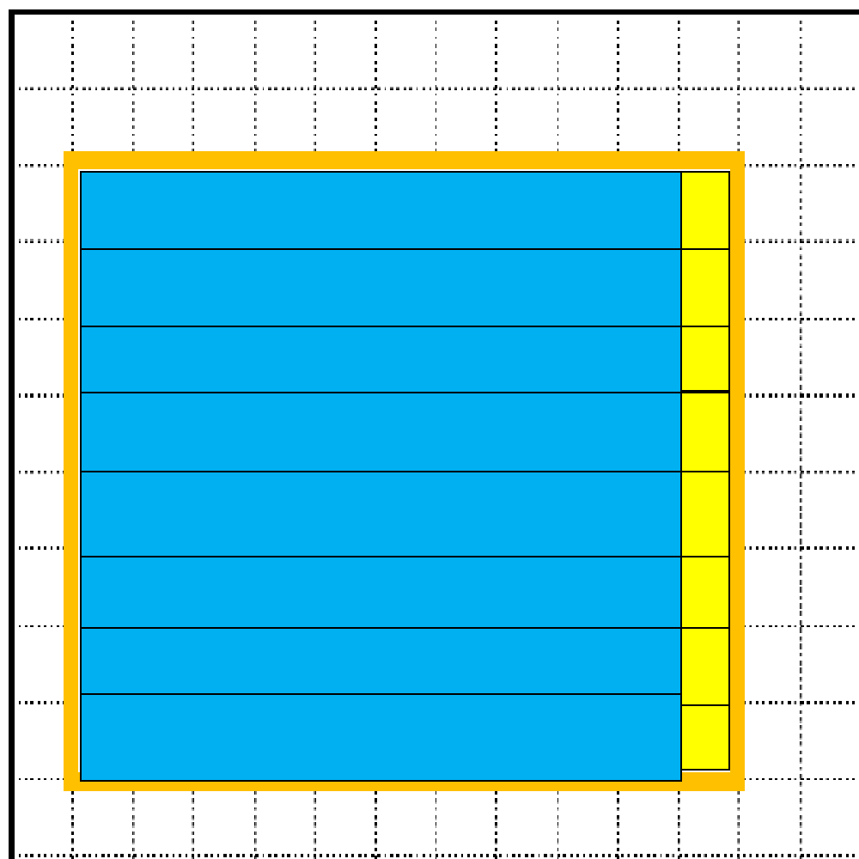

Students could see this as 10 x 8 and 1 x 8. Some may even see it as 8 tens is eighty, plus 8 ones. All solutions will give them an area of 88. In closing, you can talk about the relationship this has to the distributive property discussed in unit 3.

**FORMATIVE ASSESSMENT QUESTIONS**

* Were you able to see any additional arrays in the rectangle?
* How did you determine the area of the rectangle?
* Was your strategy the most efficient?
* What’s the relationship between the distributive equation and the original multiplication sentence?

**DIFFERENTIATION**

**Extension**

* For early finishers, the teacher could give them equations reflecting the distributive property of multiplication BUT have them figure out the original multiplication problem.

**Intervention**

* The teacher could do this lesson with small groups allowing them to use rectangles that are smaller in size (less than 100).

**PRACTICE TASK: MULTIPLICATION WITH BASE TEN BLOCKS**

A*dapted from GPS frameworks*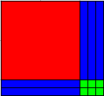

In this lesson, students will model multiplication of 2-digit numbers using base-

ten blocks to create partial products.

**APPROXIMATE TIME:** One class session

**CONTENT STANDARDS**

**MGSE3.MD.7.** Relate area to the operations of multiplication and addition.

c. Use tiling to show in a concrete case that the area of a rectangle with whole-number side

lengths a and b + c is the sum of a x b and a x c. Use area models to represent the

distributive property in mathematical reasoning.

**STANDARDS FOR MATHEMATICAL PRACTICE**

1. Make sense of problems and persevere in solving them.

2. Reason abstractly and quantitatively.

3. Construct viable arguments and critique the reasoning of others.

4. Model with mathematics.

5. Use appropriate tools strategically.

6. Attend to precision.

7. Look for and make use of structure.

8. Look for and express regularity in repeated reasoning.

**BACKGROUND KNOWLEDGE**

Students need **multiple** experiences with base-ten blocks and how to represent ones, tens, and hundreds with them. Students should also understand how to trade pieces for equal values. For example, ten rods (of 10) can be traded for one flat (100).

Students need to have a good understanding of basic multiplication facts. They should also understand the various ways that multiplication number sentences can be written using an x, a dot, or parenthesis.

**COMMON MISCONCEPTIONS**

A common misconception is that students should learn their multiplication tables 0-12 in order. Van de Walle states that students need to see multiplication as patterns and use different strategies in determining the product of factors such as the base-ten model.

**ESSENTIAL QUESTIONS**

* How can base-ten blocks help us understand how to multiply a two-digit number?
* How does understanding the distributive property help us multiply large numbers?

**MATERIALS**

* Base-ten manipulatives for **each student**
* “Multiplication with Base-Ten Blocks” recording sheet

**GROUPING**

Individual/Partner Task

**TASK DESCRIPTION, DEVELOPMENT AND DISCUSSION (All SMP’s apply!)**

In this task, students will model multiplication of 2-digit numbers using base-ten blocks to create partial products.

**Comments**

Students need to know more than one way to denote multiplication. The “x” may become confusing for some students when they begin using variables, so they should also recognize that a dot and parentheses are also symbols indicating multiplication.

Students need many experiences with arrays and base-ten blocks to be successful with this task.

Detailed examples follow below. Two colors are used to emphasize the placement of the base-ten blocks.

**2 • 13** means there are two groups of 13. Using the base-ten blocks, ask students to build two rows of thirteen.

Have students make the row of 13 with one rod and three units joined together.

10 + 3 = 13

|  |  |  |  |  |  |  |  |  |  |  |  |  |
| --- | --- | --- | --- | --- | --- | --- | --- | --- | --- | --- | --- | --- |
|  |  |  |  |  |  |  |  |  |  |  |  |  |

|  |  |  |  |  |  |  |  |  |  |  |  |  |
| --- | --- | --- | --- | --- | --- | --- | --- | --- | --- | --- | --- | --- |
|  |  |  |  |  |  |  |  |  |  |  |  |  |

Repeat.

Place the two rows of thirteen in an array. The diagram below shows **2 x 13** as two groups of 13 combined: two rods joined together, making two rows of ten, and six units joined together, forming two rows of three.

|  |  |  |  |  |  |  |  |  |  |  |  |  |
| --- | --- | --- | --- | --- | --- | --- | --- | --- | --- | --- | --- | --- |
|  |  |  |  |  |  |  |  |  |  |  |  |  |
|  |  |  |  |  |  |  |  |  |  |  |  |  |

Students should see how to visually group the two rods to make twenty and the two rows of three units to make six, totaling 26.

In the next example, 5(15) is five groups of fifteen. Have students build one row of fifteen with one rod and five units joined together.

|  |  |  |  |  |  |  |  |  |  |  |  |  |  |  |
| --- | --- | --- | --- | --- | --- | --- | --- | --- | --- | --- | --- | --- | --- | --- |
|  |  |  |  |  |  |  |  |  |  |  |  |  |  |  |

Repeat four more times until they have five rows of 15. Join them together to form an array of five groups of fifteen.

Some students will quickly discover they can multiply the tens first, 5 x 10 = 50, because the rods in the model are easy to see as groups of ten. Then they may see the units as an array, 5 x 5 = 25. Finally, they can add the two partial products, 50 + 25, to reach the total of 75.

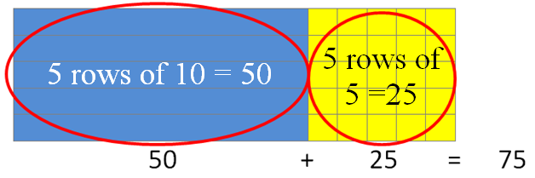

As students practice while you model these examples, they often become quickly adept with this method. After sufficient practice with actual base 10 blocks, have them draw and label the arrays. Some will begin to do partial calculations in their heads and add them to get the totals much more quickly than they would with the traditional algorithm. This joining together of arrays clearly models the distributive property of multiplication.

Another way to think about the array is to describe it in terms of its dimensions of length and width. For example, the same array can be shown as follows:

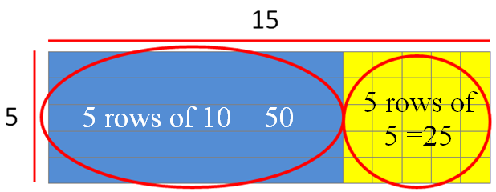

The 5 and 15 are shown as dimensions of the array, and can be described as “5 by 15.” The area of the array is visibly shown as 50 + 25, or 75. This method of building arrays using dimensions reinforces the idea of the product shown as an area model and the dimensions as factors in the multiplication problem.

As students become more comfortable with this model, some will be able to move to using basic sketches to illustrate the model shown above. Rather than using grid paper or drawing each row, their sketches may evolve to look like the sketch shown below:

10 + 5

|  |  |
| --- | --- |
| 5 x 10 = 50 | 5 x 5 = 25 |

5

50 + 25 = 75

**Task Directions**

Students will follow the directions below from the “Multiplication with Base-Ten Blocks” recording sheet.

Model each expression with a drawing of base 10 blocks. Show how you use the model to find the product. Label the dimensions of each array. Write number sentences to help explain your drawings.

**Comments**

Students need the opportunity to work with manipulatives on their own or with a partner in order to develop the understanding of 2-digit multiplication. From the manipulatives, students will be able to move to pictorial representations of the blocks, then more abstract representations of the blocks (see the sketch above), and finally to abstract representation of multiplication using numbers. It is important to remember that this progression begins with concrete representations using manipulatives.

**FORMATIVE ASSESSMENT QUESTIONS**

* How did you know which pieces and how many to use for your array model?
* What partial products did you create?
* How does the arrangement of the base-ten pieces help you see partial products?
* What are the dimensions of your array?
* What product/area does your model represent?

**DIFFERENTIATION**

**Extension**

* Give students a base-ten block array or a drawing of an array and have them determine the product and its factors.
* Have students decide on a number, build it with base 10 blocks, and then trade seats with a neighbor to determine the factors and find the product.
* Have students use an array to write/solve division problems.

**Intervention**

* Begin with much smaller arrays, such as 2 x 3, 3 x 4, and 2 x 6. Have students describe the dimensions and area of each array. Then connect dimensions and area to the actual multiplication sentence.
* Use grid paper and allow students to place the base-ten blocks onto the grid paper first and then to count the grid squares as part of their calculations.
* If necessary, allow students to use a times table chart or other cueing device if full mastery of the basic multiplication facts has not yet been attained.

Name __________________________________ Date _______________________

**Multiplication with Base-Ten Blocks**

Model each expression with a drawing of base 10 blocks. Show how you use the model to find the product. Label the dimensions of each array. Write number sentences to explain your drawings.

|  |  |
| --- | --- |
| 4 x 14 | 12 • 7 |
| 5(15) | (13)(6) |



**3 ACT TASK: Olympic Cola Display**

Task adapted from: <http://mikewiernicki3act.wordpress.com/olympic-display/>

In this task, students will use their understanding of area models to represent the distributive property to solve problems associated with an Olympic cola display.

**APPROXIMATE TIME:** One class session

**CONTENT STANDARDS**

**MGSE3.MD.7.** Relate area to the operations of multiplication and addition.

c. Use tiling to show in a concrete case that the area of a rectangle with whole-number

side lengths a and b + c is the sum of a x b and a x c. Use area models to represent the

distributive property in mathematical reasoning.

**STANDARDS FOR MATHEMATICAL PRACTICE**

1. **Make sense of problems and persevere in solving them.** Students must make sense of the problem by identifying what information they need to solve it.
2. **Reason abstractly and quantitatively.** Students are asked to make an estimate (high and low).
3. **Construct viable arguments and critique the reasoning of others.** After writing down their own questions, students discuss their question with partners, creating the opportunity to construct the argument of why they chose their question, as well as critiquing the questions that others came up with.
4. **Model with mathematics.** Once given the information, the students use that information to develop a mathematical model to solve their question.
5. **Use appropriate tools strategically.** Students write their best estimate and two more estimates – one that is too low and one that is too high to establish a range in which the solution would occur.
6. **Attend to precision.** Students use clear and precise language when discussing their strategies and sharing their own reasoning with others.
7. **Look for and make sense of structure.** Students use their understanding of properties of operations and area models to make sense of the distributive property.

**ESSENTIAL QUESTIONS**

In order to maintain a student-inquiry-based approach to this task, it may be beneficial to wait until Act 2 to share the EQ’s with your students. By doing this, students will be allowed the opportunity to be very creative with their thinking in Act 1. By sharing the EQ’s in Act 2, you will be able to narrow the focus of inquiry so that the outcome results in student learning directly related to the content standards aligned with this task.

* Which strategies do we have that can help us understand how to multiply a two-digit number?
* How does understanding partial products (using the distributive property) help us multiply larger numbers?

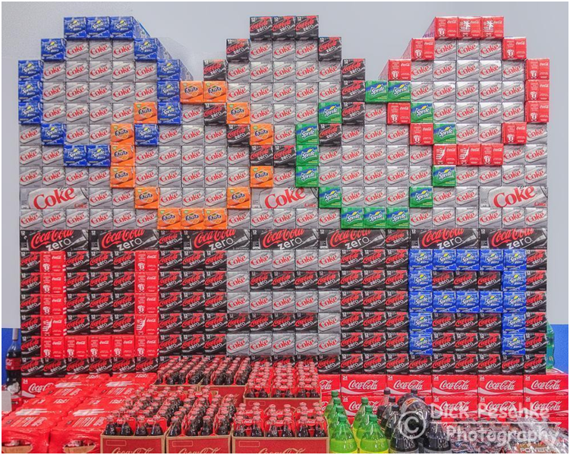

**MATERIALS**

* Act 1 picture -Olympic Cola Display
* Pictorial representations of the display
* Student recording sheet

**GROUPING**

Individual/Partner and or Small Group

**TASK DESCRIPTION, DEVELOPMENT AND DISCUSSION**

In this task, students will view the picture and tell what they noticed. Next, they will be asked to discuss what they wonder about or are curious about. These questions will be recorded on a class chart or on the board and on the student recording sheet. Students will then use mathematics to answer their own questions. Students will be given information to solve the problem based on **need**. When they realize they don’t have the information they need, and ask for it, it will be given to them.

In this task, students should build upon what they already know about arrays and area models to answer their questions. Specifically, in finding the total number of 12-packs in the display, students should construct strategies for decomposing the display into smaller areas (the distributive property). Note: Students should not be expected to find the total number of 12-packs by multiplying 14 x 23.

**Background Knowledge:**

This task follows the 3-Act Math Task format originally developed by Dan Meyer. More information on this type of task may be found at <http://blog.mrmeyer.com/category/3acts/>. A Three-Act Task is a whole-group mathematics task consisting of 3 distinct parts: an engaging and perplexing Act One, an information and solution seeking Act Two, and a solution discussion and solution revealing Act Three. More information along with guidelines for 3-Act Tasks may be found in the ***Guide to Three-Act Tasks*** on georgiastandards.org and the K-5 CCGPS Mathematics Wiki.

Students need **multiple** experiences arrays to build their understanding of multiplication. Students should also understand how arrays and multiplication are connected to the concept of area, and how their flexibility with number can help them develop strategies for solving complex problems such as the one in this task.

Students need to have a good understanding of basic multiplication facts. They should also understand the various ways that multiplication number sentences can be written using an x, a dot, or parenthesis.

**COMMON MISCONCEPTIONS:**

A common misconception is that students should learn their multiplication tables 0-12 in order. Van de Walle states that students need to see multiplication as patterns and use different strategies in determining the product of factors such as the base-ten model and partial products.

**Task Directions:**

**Act 1 – Whole Group** - Pose the conflict and introduce students to the scenario by showing Act I picture.. **(Dan Meyer** <http://blog.mrmeyer.com/2011/the-three-acts-of-a-mathematical-story/>**)**

**“Introduce the central conflict of your story/task clearly, visually, viscerally, using as few words as possible.”**



* Show Act 1 picture to students.
* Ask students what they noticed in the picture, what they wonder about, and what questions they have about what they saw in the picture. Do a think-pair-share so that students have an opportunity to talk with each other before sharing questions with the whole group.
* Share and record students’ questions. The teacher may need to guide students so that the questions generated are math-related.

**Anticipated questions students may ask and wish to answer: (**\*Main question(s) to be investigated)

* + How many 12 packs of Coke are there?
  + *How many 12 packs are there in the display?
  + *How many cans of soda is that?
  + How tall is it?
  + How wide is it?
  + What is the area of the front of the display?
  + How much time did it take to make that display?
  + Where is it?
  + How many cans of each kind of soda are in the display?
  + What are the dimensions of the display?
* Once students have their question, ask the students to estimate answers to their questions (think-pair-share). Students will write their best estimate, then write two more estimates – one that is too low and one that is too high so that they establish a range in which the solution should occur. Students should plot their three estimates on an empty number line. Note: As the facilitator, you may choose to allow the students to answer their own posed questions, one question that a fellow student posed, or a related question listed above. For students to be completely engaged in the inquiry-based problem solving process, it is important for them to experience ownership of the questions posed.

Important note: Although students will only investigate the main question(s) for this task, it is important for the teacher to not ignore student generated questions. Additional questions may be answered after they’ve found a solution to the main question, or as homework or extra projects.

**Act 2** – **Student Exploration** - Provide additional information as students work toward solutions to their questions. **(Dan Meyer** <http://blog.mrmeyer.com/2011/the-three-acts-of-a-mathematical-story/>**)**

**“The protagonist/student overcomes obstacles, looks for resources, and develops new tools.”**

* During Act 2, students decide on the facts, tools, and other information needed to answer the question(s) (from Act1). When students decide what they need to solve the problem, they should ask for those things. It is pivotal to the problem solving process that students decide what is needed without being given the information up front.
* Students need the opportunity to work with manipulatives on their own or with a partner in order to develop the understanding of multiplication. From the manipulatives, students will be able to move to pictorial representations of the display (attached), then more abstract representations (such as sketches), and finally to abstract representation of multiplication using numbers. It is important to remember that this progression begins with concrete representations using manipulatives.
* The teacher provides guidance as needed during this phase. Some groups might need scaffolds to guide them. The teacher should question groups who seem to be moving in the wrong direction or might not know where to begin. Questioning is an effective strategy that can be used, with questions such as:
  + What is the problem you are trying to solve?
  + What do you think affects the situation?
  + Can you explain what you’ve done so far?
  + What strategies are you using?
  + What assumptions are you making?
  + What tools or models may help you?
  + Why is that true?
  + Does that make sense?

Additional Information for Act 2

* It is during Act 2 that you may provide the students with the pictorial representation of the display that is attached.

**Act 3 – Whole Group** – Share solutions and strategies.

* Students to present their solutions and strategies and compare them.
* Lead discussion to compare these, asking questions such as:
  + How reasonable was your estimate?
  + Which strategy was most efficient?
  + Can you think of another method that might have worked?
  + What might you do differently next time?

**Act 4, The Sequel -** “The goals of the sequel task are to a) challenge students who finished quickly so b) I can help students who need my help. It can't feel like punishment for good work. It can't seem like drudgery. It has to entice and activate the imagination.” Dan Meyer <http://blog.mrmeyer.com/2013/teaching-with-three-act-tasks-act-three-sequel/>

For Act 4, share ideas (see extensions) or reference other student-generated questions that could be used for additional classwork, projects or homework.

**FORMATIVE ASSESSMENT QUESTIONS**

* What partial products did you create?
* What organizational strategies did you use?
* What are the dimensions of your array(s)?
* What product/area does your model represent?

**DIFFERENTIATION**

**Extension**

* Give students a base-ten block array or a drawing of an array and have them determine the product and its factors.
* Have students create their own display, build it with base 10 blocks or connecting cubes, and then trade seats with a neighbor to determine the factors and find the product.
* Have students use an array to write/solve division problems.

**Intervention**

* Begin with much smaller arrays, such as 2 x 3, 3 x 4, and 2 x 6. Have students describe the dimensions and area of each array. Then connect dimensions and area to the actual multiplication sentence.
* Use grid paper and allow students to place the base-ten blocks onto the grid paper first and then to count the grid squares as part of their calculations.
* If necessary, allow students to use a times table chart or other cueing device if full mastery of the basic multiplication facts has not yet been attained.

Act 1 Picture: 

Pictorial Representation of the Display:

|  |  |  |  |  |  |  |  |  |  |  |  |  |  |  |  |  |  |  |  |  |  |  |
| --- | --- | --- | --- | --- | --- | --- | --- | --- | --- | --- | --- | --- | --- | --- | --- | --- | --- | --- | --- | --- | --- | --- |
|  |  |  |  |  |  |  |  |  |  |  |  |  |  |  |  |  |  |  |  |  |  |  |
|  |  |  |  |  |  |  |  |  |  |  |  |  |  |  |  |  |  |  |  |  |  |  |
|  |  |  |  |  |  |  |  |  |  |  |  |  |  |  |  |  |  |  |  |  |  |  |
|  |  |  |  |  |  |  |  |  |  |  |  |  |  |  |  |  |  |  |  |  |  |  |
|  |  |  |  |  |  |  |  |  |  |  |  |  |  |  |  |  |  |  |  |  |  |  |
|  |  |  |  |  |  |  |  |  |  |  |  |  |  |  |  |  |  |  |  |  |  |  |
|  |  |  |  |  |  |  |  |  |  |  |  |  |  |  |  |  |  |  |  |  |  |  |
|  |  |  |  |  |  |  |  |  |  |  |  |  |  |  |  |  |  |  |  |  |  |  |
|  |  |  |  |  |  |  |  |  |  |  |  |  |  |  |  |  |  |  |  |  |  |  |
|  |  |  |  |  |  |  |  |  |  |  |  |  |  |  |  |  |  |  |  |  |  |  |
|  |  |  |  |  |  |  |  |  |  |  |  |  |  |  |  |  |  |  |  |  |  |  |
|  |  |  |  |  |  |  |  |  |  |  |  |  |  |  |  |  |  |  |  |  |  |  |
|  |  |  |  |  |  |  |  |  |  |  |  |  |  |  |  |  |  |  |  |  |  |  |
|  |  |  |  |  |  |  |  |  |  |  |  |  |  |  |  |  |  |  |  |  |  |  |
|  |  |  |  |  |  |  |  |  |  |  |  |  |  |  |  |  |  |  |  |  |  |  |
|  |  |  |  |  |  |  |  |  |  |  |  |  |  |  |  |  |  |  |  |  |  |  |
|  |  |  |  |  |  |  |  |  |  |  |  |  |  |  |  |  |  |  |  |  |  |  |

Task Title: ________________________ Name: ________________________

*Adapted from Andrew Stadel*

**ACT 1**

|  |
| --- |
| What did/do you notice? |
|  |
| What questions come to your mind? |
|  |

**Main Question**: ________________________________________________________________

|  |
| --- |
| What is your 1st estimate and why?  On an empty number line, record an estimate that is too low and an estimate that is too high. |

**ACT 2**

|  |
| --- |
| What information would you like to know or need to solve the MAIN question? |
|  |

Record the given information (measurements, materials, etc…)

If possible, give a better estimation with this information: _______________________________

**Act 2 (con’t)**

Use this area for your work, tables, calculations, sketches, and final solution.

**ACT 3**

|  |
| --- |
| What was the result? |
|  |

**PRACTICE TASK: 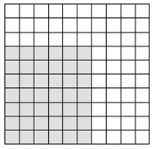ARRAY CHALLENGE**

In this task, students will apply multiplication problems to the matching area model/array.

**APPROXIMATE TIME:** One class session

**CONTENT STANDARDS**

**MGSE3.MD.6** Measure areas by counting unit squares (square cm, square m, square in, square ft, and improvised units).

**MGSE3.MD.7.** Relate area to the operations of multiplication and addition.

a. Find the area of a rectangle with whole-number side lengths by tiling it, and show that the

area is the same as would be found by multiplying the side lengths.

b. Multiply side lengths to find areas of rectangles with whole number side lengths in the

context of solving real world and mathematical problems, and represent whole-number

products as rectangular areas in mathematical reasoning.

**STANDARDS FOR MATHEMATICAL PRACTICE**

1. Make sense of problems and persevere in solving them.

2. Reason abstractly and quantitatively.

3. Construct viable arguments and critique the reasoning of others.

4. Model with mathematics.

5. Use appropriate tools strategically.

6. Attend to precision.

7. Look for and make use of structure.

8. Look for and express regularity in repeated reasoning.

**BACKGROUND KNOWLEDGE AND MISCONCEPTIONS**

The students should know that area covers a certain amount of space. The students should know that the numbers that are multiplied to find a product are called factors.

It is important to understand that filling regions with units and counting does little to help students develop multiplicative formulas. Even when rectangles are filled with a grid of squares, students are more likely to count the squares than to relate the number of squares to the dimensions of the rectangles (Van de Walle, page 236-237).

**ESSENTIAL QUESTIONS**

* Can the same area measurement produce different size rectangles? (Ex. 24 sq.units can produce a rectangle that is a 3 X 8, 4 X 6, 1 X24, 2 X 12)
* How does the length and width (factors) impact the area of the rectangle?
* Do different factors with the same area cover the same amount of space? (Ex. Is a 3 X8 the same area as a 1 X 24?)

**MATERIALS**

* “Shaded Array Cards” copied on card stock and cut out
* “Array Challenge” game directions and recording sheet

**GROUPING**

Partner/Small Group

**NUMBER TALKS**

By now, number talks should be incorporated into the daily math routine. Continue utilizing the different strategies in number talks and revisiting them based on the needs of the students.

**TASK DESCRIPTION, DEVELOPMENT AND DISCUSSION (SMP’s 1, 2, 3, 4, 6, 7, 8)**

In this task, students work in small groups to play a game in which array cards are used to represent area models for multiplication facts. Students have opportunities to display their cards and respond with the multiplication fact(s) that apply to the array.

**Comments**

The Shaded Array Cards provide an excellent opportunity for students to make visual connections between multiplication facts and the corresponding area models. Students are able to relate the commutative property of multiplication to the model quickly because it represents a fact and its related fact. For example, the area model for 6 x 7 is the same as 7 x 6 with a different orientation. Also, familiarity with array models for multiplication facts builds number sense as students understand that a smaller array represents a smaller product of two facts.

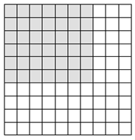6 rows of 7or 6 x 7 = 42

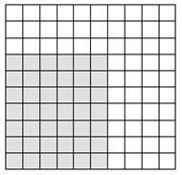

7 rows of 6 or 7 x 6 = 42

**Task Directions:**

Have students follow the directions below:

1. Place the Array Cards face down in a stack.
2. For each round, each player should draw one card from the stack and, using the commutative property, record both multiplication facts that apply to the card. (If the array is a square, there will be only one multiplication fact for the array.)
3. At the end of each round, the player with the largest product collects the cards from the other players.
4. Play continues until all cards have been played.

NOTE: The rules can be changed so that the player with the smallest product collects all the cards.

**FORMATIVE ASSESSMENT QUESTIONS**

* How can you use your Array Card to show the commutative property for multiplication?
* How does the size of the array change as the factors get larger? Smaller?
* How are the dimensions of the array and the number of shaded squares related?
* How does an array model show repeated addition?

**DIFFERENTIATION**

**Extension**

* Make additional Array Cards that model higher levels of multiplication facts.
* Play Double Challenge where students draw two cards at a time and add the products.
* Have students use the Array Cards to explain the division facts that are related to a given array and write the corresponding fact family for multiplication and division.

**Intervention**

* Make Array Cards with lower level multiplication facts, or with other math facts and concepts that students need to review.
* Use this game in small group instruction to informally assess a student’s level of multiplication fact mastery and to pinpoint specific areas to target instruction.

**TECHNOLOGY CONNECTIONS**

<http://real.doe.k12.ga.us/content/math/destination_math/msc2/msc2/msc2/msc2/msc2/module2/unit2/session3/lesson.html>

Name ___________________________________________ Date ________________________



Array Challenge

Game Directions

Array Challenge is a game for 2 – 4 players.

Materials:

One deck of Array Challenge cards

Array Challenge recording sheet

Directions:

1. Place the Array Cards face down in a stack.
2. For each round, each player should draw one card from the stack and, using the commutative property, describe both multiplication facts that apply to the card. (If the array is a square, there will be only one multiplication fact for the array.)
3. At the end of each round, the player with the largest product collects the cards from the other players.
4. Play continues until all cards have been played.

NOTE: The rules can be changed so that the player with the smallest product collects all the cards.

Record the multiplication facts for your array cards in the table on the back of this sheet.

*Example: : If you drew a 6 x 7 array card, two number sentences can be written.*

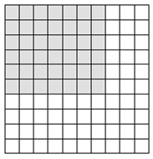

6 rows of 7

or

6 x 7 = 42 7 rows of 6

or

7 x 6 = 42

Name **_____________________________** Date ________________

Array Challenge

Recording Sheet

Record the number sentences for each array card in the table below.

|  |  |  |  |
| --- | --- | --- | --- |
| **Round** | **Number Sentence** | **Number Sentence** | **Highest Product?** |
| *Example* | 6 x 7 = 42 | 7 x 6 = 42 | ✓ ✗  or |
| 1 |  |  |  |
| 2 |  |  |  |
| 3 |  |  |  |
| 4 |  |  |  |
| 5 |  |  |  |
| 6 |  |  |  |
| 7 |  |  |  |
| 8 |  |  |  |
| 9 |  |  |  |
| 10 |  |  |  |
| 11 |  |  |  |
| 12 |  |  |  |

**Shaded Array Cards**

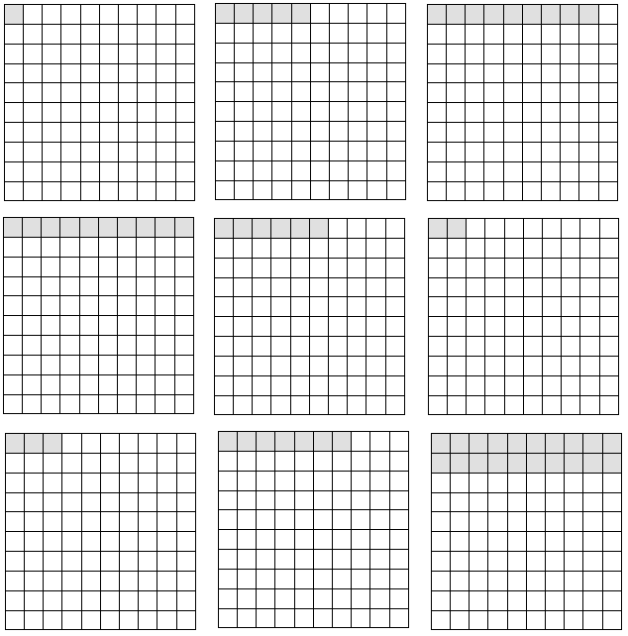

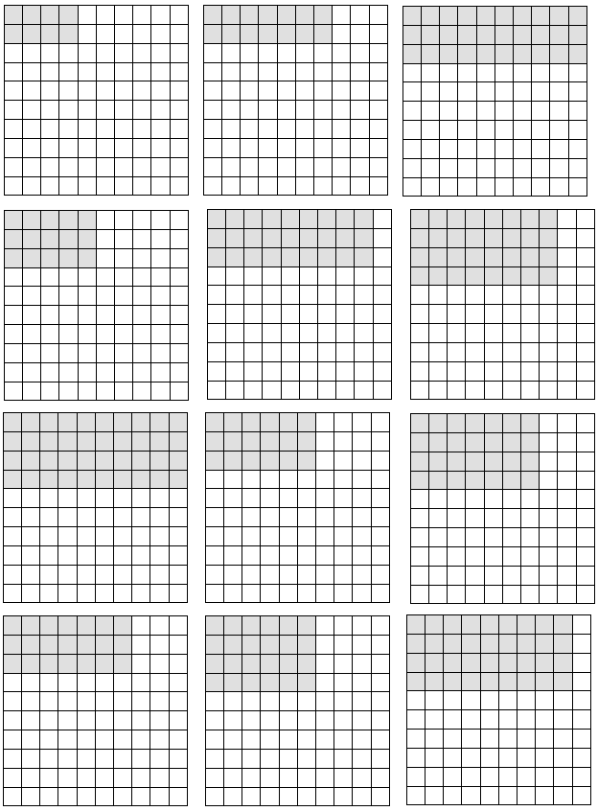

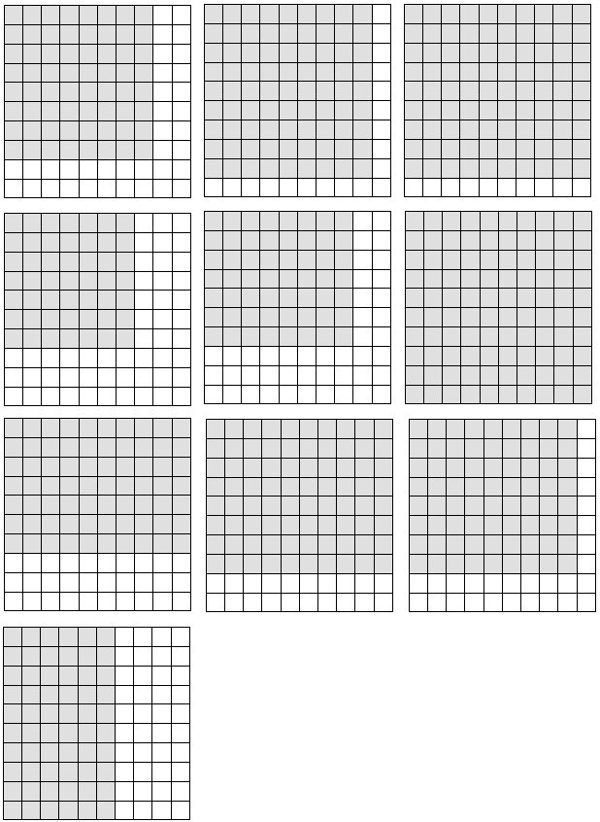

**CONSTRUCTING TASK:** **SKIP-COUNTING PATTERNS**

*I*n this task, students look for number patterns relationship to multiplication.

**APPROXIMATE TIME:** One or two class sessions

**CONTENT STANDARDS**

**MGSE3.OA.9 Identify arithmetic patterns (including patterns in the addition table or**

**multiplication table), and explain them using properties of operations.*For example, observe that 4 times a number is always even, and explain why 4 times a number can be decomposed into two equal addends.***

**STANDARDS FOR MATHEMATICAL PRACTICE**

1. Make sense of problems and persevere in solving them.

2. Reason abstractly and quantitatively.

3. Construct viable arguments and critique the reasoning of others.

4. Model with mathematics.

5. Use appropriate tools strategically.

6. Attend to precision.

7. Look for and make use of structure.

8. Look for and express regularity in repeated reasoning.

**BACKGROUND KNOWLEDGE**

Multiplication facts should be mastered by relating them to existing knowledge. It is essential for students to understand the commutative property. For example, 2 x 7 is related to the fact double seven. However, the same relationship applies to 7 x 2 that most think about as 2+2+2+2+2+2+2. Many of the facts are easier to master in one order, but should always be learned with its turn around. Van de Walle identifies the following patterns; doubles, fives facts, zeros and ones, and nifty nines. These rules cover 75 of the 100 facts. (Teaching Student Centered Mathematics, Van de Walle, John, A., p.88-89)

This activity provides opportunities for the students to make sense of the many patterns in our base-ten system and how it is full of patterns. It helps with multiplication and division as well as providing time to search for patterns.

**COMMON MISCONCEPTIONS**

There are many misconceptions about how students should learn their multiplication facts. Most think that multiplication facts should be taught in numerical order starting with 0 and 1, then facts less than 5, and from there on out in order, facts 6 through 12. They also believe that multiplication should be taught in isolation with no connection to addition. A third misconception is that multiplication should be taught separately from division. (Wallace & Gurganus, 2005). Many times these misconceptions are based on a teacher’s or parent’s personal learning experience. Fortunately, we now know from the research of Van de Walle, Fosnot et. al., Heibert, and others that there are more effective strategies for teaching and learning the multiplication facts. Several of these strategies are outlined in Teaching Student Centered Mathematics, by John A. Van de Walle.

**ESSENTIAL QUESTIONS**

* How can multiplication products be displayed on a 1-100 chart?
* How can you describe various patterns, (i.e. with words, as a visual pattern on a 1-100 chart, or using mathematical notations)?

**MATERIALS**

* “Skip-Counting Patterns, Directions” student sheet
* “Skip-Counting Patterns, 1-100 Chart” student sheet (Students can cut apart the 1-100 charts to create a small booklet.)
* A large 1-100 chart that can be used for class discussion
* Highlighters, crayons, colored pencils, or markers for each student

**GROUPING**

Individual Task

**NUMBER TALKS**

By now, number talks should be incorporated into the daily math routine. Continue utilizing the different strategies in number talks and revisiting them based on the needs of the students.

**TASK DESCRIPTION, DEVELOPMENT AND DISCUSSION (All SMP’s present!)**

In this task, students create patterns on a1-100 chart by skip counting with each number 2 through 10. Students do this by coloring in each number on which they land. Afterwards, students look for patterns on their charts and discuss how the patterns identified inform their understanding of our base-ten system.

**Comments**

Show students five or six numbers from a number pattern. Have them extend the pattern for several more numbers and to explain the rule for generating the pattern. The difficulty of the task depends on the number pattern and the familiarity of students with searching for patterns (Teaching Student-Centered Mathematics 3-5, volume 2, ed. 1, pg. 299).

**Examples:**

1, 2, 2, 3, 3, 3, …

2, 4, 6, 8, 10, …

1, 2, 4, 8, 16, ...

1, 2, 4, 7, 11, 16, …

0, 1, 5, 14, 30, …

Introduce this task is by asking students to identify patterns on the 1-100 chart. Examples of student observations may include:

* All of the numbers in the first column end in a 1 (also noticing the other columns and the observation that the last digits remain the same.)
* All of the numbers in the last column are the ones we say when we count by 10s.
* When you start in the top left corner and go down diagonally the one’s digit goes up by 1 and so does the tens digit.

During this task, students will highlight or mark all numbers they land on when skip-counting by 2s, 3s, 4s, 5s, 6s, 7s, 8s, 9s, and 10s. Students will use a clean 1-100 chart for each number and start on the number by which they are counting (e.g. when counting by 2s, they will start on 2). Once they finish highlighting a 1-100 chart, students should discuss with a partner or partners any patterns they notice. Once students have completed skip-counting by the numbers 2-10, initiate a class discussion about the patterns students observed. Create a class list of student observations. As an example, student observations of patterns when counting by 2s on the 1-100 chart could include:

* Only the even numbers are highlighted.
* All of the shaded numbers are in the ‘even’ columns.

Encourage students to check their work as they go with other students, a calculator, or by referring to a teacher-created sample so that students don’t get frustrated. Obviously, one error on the 1-100 chart will result in all of the subsequent numbers being incorrect as well.

**Part 1: Task Directions**

Students will follow directions below from the “Skip-Counting, Directions” student sheet.

You will be skip-counting by 2, 3, 4, 5, 6, 7, 8, 9, and 10.

1. Highlight or mark all numbers counting by 2s starting with 2 (i.e., skip counting by twos). Discuss with your partner(s) what you notice about the highlighted numbers.
2. Using a new hundred chart, highlight or mark all numbers counting by 3s starting with 3. Discuss with your partner(s) what you notice about the highlighted numbers.
3. Continue with a new hundred chart for each number 4 through 10, highlighting the numbers you land on as you skip count by each number. After completing each chart, discuss with your partner(s) what you notice about the highlighted numbers.
4. Be prepared to share your observations about patterns on your 1-100 charts with the class.

**Part 2: Task Directions**

Students will do a similar activity. However, in this task, students will create the patterns on the same sheet to see the relationship between pattern skips. Using an 8 count of crayons, the students could shade all skips of 2 green, skips of 3 red, of 4 yellow, etc. The students will be instructed to shade a partial part of the box since the number could be included in other patterns. The teacher could ask how it is possible that more than one color is shaded for a box, and how that is connected to multiplication. A free hundreds chart is available at: <http://www.superteacherworksheets.com/hundredschart/hundreds-chart-filled_WNRTB.pdf>

**FORMATIVE ASSESSMENT QUESTIONS**

* How do you know you skip-counted correctly?
* What do you notice about the numbers that are highlighted?
* How can you describe the geometric pattern that is formed with the highlighted numbers?
* What’s the connection to multiplication? division?

**DIFFERENTIATION**

**Extension**

* Ask students to compare the two 1-100 charts they created. For example, compare the 2’s and 4’s chart and ask the students to describe what they notice about these two charts and more importantly why this is happening. One way students could organize their thinking is by recording the highlighted numbers in a Venn Diagram and then writing about what they notice and why their observations make sense based on our base-ten number system.
* Ask students to make predictions before they compare the various charts, such as, “Will the 6’s and 9’s have anything highlighted in common? Why or why not? ” Or “How do you know?”

**Intervention**

* Encourage students to use a calculator (or another tool) to determine the highlighted numbers. Being off by one number can be very frustrating and the main objective of this task is not to generate the numbers when skip-counting but to analyze the numbers found.
* For most students, it is easier to see the patterns from one step to the next. When you have a chart constructed, the differences from one step to the next can be written next to or below it. Create charts on one page like the one listed below and have the students draw circles beneath each step in groups so they can see the relationship to the pattern.

***The completed example is found in Teaching Student-Centered Mathematics 3-5, edition 1, page 295. This book should already be in your school sent by the DOE.***

Name ___________________________________ Date _________________________



**Skip-Counting Patterns**

Directions

You will be skip-counting by 2, 3, 4, 5, 6, 7, 8, 9, and 10.

1. Highlight or mark all numbers counting by 2s starting with 2 (i.e., skip counting by twos). Discuss with your partner(s) what you notice about the highlighted numbers.
2. Using a new hundred chart, highlight or mark all numbers counting by 3s starting with 3. Discuss with your partner(s) what you notice about the highlighted numbers.
3. Continue with a new hundred chart for each number 4 through 10, highlighting the numbers you land on as you skip count by each number. After completing each chart, discuss with your partner(s) what you notice about the highlighted numbers.
4. Be prepared to share your observations about patterns on your 1-100 charts with the class.

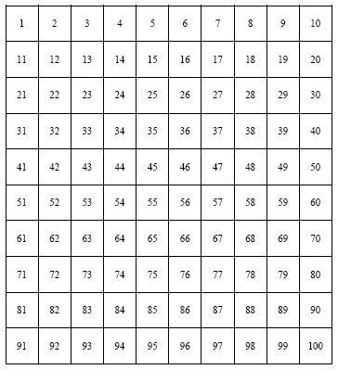

Skip-Counting by _____



Skip-Counting by _____

Name _______________________________ Date______________________

Skip-Counting Patterns

1 – 100 Charts



Skip-Counting by _____



Skip-Counting by _____



Skip-Counting by _____



Skip-Counting by _____

**PRACTICE TASK:** **TAKE THE EASY WAY OUT**! *Portions of this lesson were adapted from Bright Hub.*

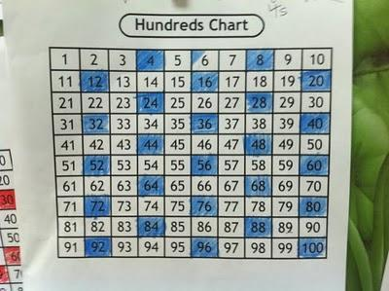In this task, students will identify patterns and their relationship to

multiplication and division*.*

**APPROXIMATE TIME:** One class session

**CONTENT STANDARDS:**

**MGSE3.OA.9 Identify arithmetic patterns (including patterns in the addition table or multiplication table), and explain them using properties of operations.‡ *For example,* *observe that 4 times a number is always even, and explain why 4 times a number can be decomposed into two equal addends.***

**‡ See Glossary, Table 3**

**STANDARDS FOR MATHEMATICAL PRACTICE**

1. Make sense of problems and persevere in solving them.

2. Reason abstractly and quantitatively.

3. Construct viable arguments and critique the reasoning of others.

4. Model with mathematics.

5. Use appropriate tools strategically.

6. Attend to precision.

7. Look for and make use of structure.

8. Look for and express regularity in repeated reasoning.

**BACKGROUND KNOWLEDGE AND MISCONCEPTIONS**

Learning multiplication facts does not seem as daunting when you tell your students they will only have to memorize a total of 10 facts! How is this possible, they might ask? The answer is multiplication patterns.

From very early on, children have been taught to identify patterns - in reading, in spelling, in art, in music and of course, in mathematics. The Multiplication Table is no exception. It is made almost entirely of repeating patterns. Once these patterns are identified and understood, it can be noted that there are only 10 remaining multiplication facts that do not fit a specific pattern. For these problems, the only available learning tool is memorization. Still...the thought of having to memorize 10 problems is much less overwhelming than the thought of memorizing an entire table!

***Misconceptions***

There are many misconceptions about how students should learn their multiplication facts. Most think that multiplication facts should be taught in numerical order starting with 0 and 1, then facts less than 5, and from there on out in order, facts 6 through 12. They also believe that multiplication should be taught in isolation with no connection to addition. A third misconception is that multiplication should be taught separately from division. (Wallace & Gurganus, 2005).

Many times these misconceptions are based on a teacher’s or parent’s personal learning experience. Fortunately, we now know from the research of Van de Walle, Fosnot et. al., Heibert, and others, that there are more effective strategies for teaching and learning the multiplication facts. Several of these strategies are outlined in Teaching Student Centered Mathematics, by John A. Van de Walle. Further resources on fluency development can be found in the grade level overview and on the K-5 Math wiki.

**ESSENTIAL QUESTIONS**

* What is a pattern?
* How are patterns related to multiplication?
* How can an addition table help you explain the Commutative Property of Multiplication?

**MATERIALS**

* Construction paper and writing paper
* Hundreds charts
* [Amanda Bean's Amazing Dream (A mathematical story) - Cindy Neuschwander](http://www.bookdepository.co.uk/book/9780590300124/Amanda-Beans-Amazing-Dream)
* [The Mathemagician's Apprentice -Brian Boyd](http://www.amazon.com/Mathemagicians-Apprentice-Maths-adventures/dp/190280404X/ref=sr_1_fkmr2_1?ie=UTF8&qid=1289466399&sr=1-1-fkmr2)
* [The Best of Times - Greg Tang](http://www.amazon.com/gp/product/0439210445?ie=UTF8&tag=livingmath-20&linkCode=as2&camp=1789&creative=9325&creativeASIN=0439210445)
* [Grapes of Math - Greg Tang](http://www.bookdepository.co.uk/book/9780439598408/Grapes-of-Math)
* Math journal/learning log
* Printable Task Games

**GROUPING**

Individual/Partner

**NUMBER TALKS**

By now, number talks should be incorporated into the daily math routine. Continue utilizing the different strategies in number talks and revisiting them based on the needs of the students.

**TASK DESCRIPTION, DEVELOPMENT, AND DISCUSSION (SMP’s 1, 2, 3, 4, 6, &7)**

In this task, students will explore patterns in multiplication. They will also create a book of multiplication rules to learn relationships that exist within the multiplication family and apply the concepts to a hundreds chart.

By showing your students how to use multiplication patterns, you will demonstrate that it is really only necessary to memorize 10 multiplication facts. The lesson could open with one of the above multiplication books. Each book is about patterns in multiplication. However, the ability levels are different. Select the book that best fits the level of your class. Following the reading of the book, engage the students in the following task:

Tell students they are going to create their own multiplication book. Provide each student with two pieces of construction paper and eight sheets of manuscript paper. This will serve as the basis for your book. The title of the book will be My Multiplication Book. The first page of the book should define the word “multiplication”:

**What is multiplication?**

After eliciting responses from your students, you should (together) construct a definition that reads something like this:

* **Multiplication is a way to add groups of equal size.** **3 x 4 = 12 (How many groups x How many in each group = How many all together?)**

Have your students write the agreed upon definition on the first page of their multiplication book.

The next step is to have students explain the Commutative Property of Multiplication, and determine a definition:

When two numbers are multiplied together, the product is the same regardless of the order of the factors. For example 3 x 2 = 2 x 3.

By understanding this principle, students see that many problems can be overlooked because they are actually duplicates. Have them write the agreed upon definition on the second page of their book.

The following pages of the book will cover the fact families that show definitive patterns, the associated rules, the numerical sentences that make up the fact family and a pictorial representation of the Commutative Property of Multiplication. Below you will find examples of each of these pages.

**My Multiplication Book**

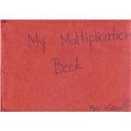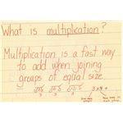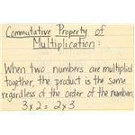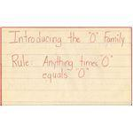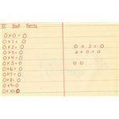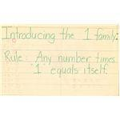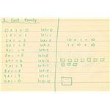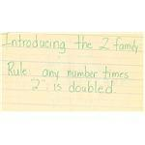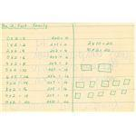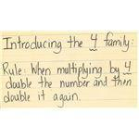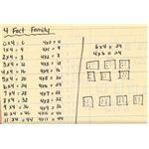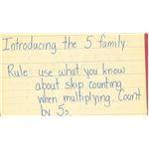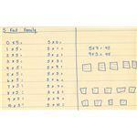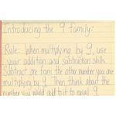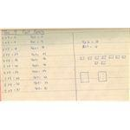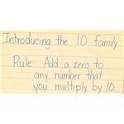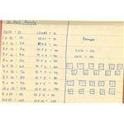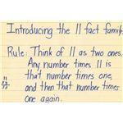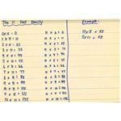

**Using a Multiplication Table as a Visual Aid**

An effective way to manage the lessons is to introduce one Rule/Family each day. Using a large multiplication table can be a terrific visual aid. As you learn each fact family, cross them off on the multiplication table. That way, your students can actually see the progress they are making in learning the multiplication facts:

**Multiplication Table after the 1’s Family is studied**

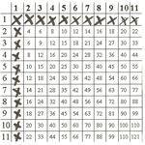

**Only 10 Problems Left!**

The last page of your Multiplication Book will include the 10 multiplication problems that are not covered by the fact family patterns studied:

3x3, 3x6, 3x7, 3x8, 6x6, 6x7, 6x8, 7x7, 7x8 & 8x8

*(Remember…due to the Commutative Property of Multiplication, there are only 10 problems instead of 20.)*

This is how the multiplication table you are using for demonstration will look when you have completed teaching multiplication facts. (The circled problems are the 10 that must be learned through an alternative strategy).

**Multiplication Table at Completion**

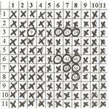

**Task Directions:** After teaching the 2’s and 4’s pattern, have the students do the following task:

**2’s Rule!**- Have the students work in groups of two and supply them with the attached sheet called 2’s Rule! This is a game. The students will cut out the cards and place them face down in a pile. They will take turns flipping over a card 1 at a time. However, the first person to give the correct answer wins the card. The person with the most cards wins the game. Since the 2’s rule is double the number and add, some of the cards will simply have an even number. The students must then tell what number was doubled and say the 2’s multiplication sentence that correlates with it. **Van de Walle states that division should be taught in connection with multiplication.**

**4 Score 4 Sure!-**  ***This task can be completed as a 4 man game, which will be intense fun! Or, it can be a cut and paste activity with a partner****.* Break students into teams of 4. Give them the attached reproducible page and have them cut out the numbers. Once completed, revisit the rule of 4. Then, have the groups move to separate locations around the room. Rules: The teacher will say a number. Let’s say it’s 3. She can say, “I need to see this number’s double, and then its double.” Thus, working cooperatively, the students must send up two people from the team holding up the number 6 and 12. For an extra point, the teacher can have them give the 4’s multiplication sentence that corresponds with 3 which would be 4 times 3.

To advance the game, the teacher could make them think backward. She could only give the product and they would have to send up two people with half the product and then half of that. This would once again, as Van de Walle states, show connections to division while still reinforcing multiplication and teaching pattern relationships. Of course, the same procedure for the extra point would apply. The team with the most points wins. **(Suggestion**: The numbers for the games can be written on large index cards or construction paper so they are visible to all learners during the game.)

**FORMATIVE ASSESSMENT QUESTIONS**

* How does learning patterns aid mastery in multiplication?
* How does the commutative property of multiplication aid mastery of multiplication facts as well?

**DIFFERENTIATION**

**Extension**

* The lessons could be extended by creating similar tasks or games using different factors and products.

**Intervention**

* Having the students work in small groups will provide support for students who struggle with this concept and will enable them to develop the ability to describe their thinking.

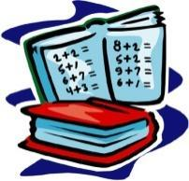*Math Book Synopsis* 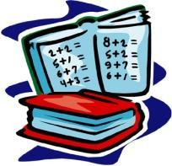

[**Amanda Bean's Amazing Dream (A mathematical story) - Cindy Neuschwander**](http://www.bookdepository.co.uk/book/9780590300124/Amanda-Beans-Amazing-Dream)

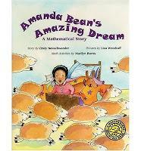 Amanda Bean happily counts "anything and everything" by ones, twos, fives, and tens. Although her teacher tells her that learning multiplication is important, Amanda remains unconvinced until a strange dream presents her with arithmetic challenges that overwhelm her counting skills. She awakens to learn to multiply "anything and everything." Recommended for 6-8 yrs but another fun introduction.

The Mathemagician's Apprentice -Brian Boyd

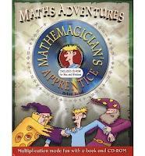  
  
 Oz, the mathemagician's apprentice, needs help with his final test. Teaching times tables whilst you help Oz.  Packed on each page with an activity to do, the book also includes a CD.  Princess really enjoyed working with this, and needed Michelangelo's help.

[The Best of Times - Greg Tang](http://www.amazon.com/gp/product/0439210445?ie=UTF8&tag=livingmath-20&linkCode=as2&camp=1789&creative=9325&creativeASIN=0439210445)  
  
Greg Tang uses rhymes and commonsense tricks to walk through the multiplication tables from zero to 10. For example, if you know how to multiply by two ("Two is very fast and fun, quickly double and you're done. What's that you say, be more precise? Okay then, just add it twice!"), then fours ("... please just always double twice!") and eights. This book does not promote the memorization of multiplication facts, but teaches the reader to problem solve and use different approaches and strategies. Does move fast but we found it excellent! 5 Star.

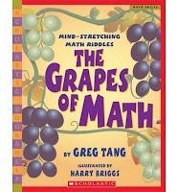

[Grapes of Math - Greg Tang](http://www.bookdepository.co.uk/book/9780439598408/Grapes-of-Math)  
  
Tang shows readers creative ways to use patterns and combinations of numbers to solve math puzzles quickly and effectively. Rather than laboriously counting 24 mushroom slices on a pizza, Tang suggests: "Let me give you some advice, / Just do half and count twice." And in adding the number of dots on a fan: "Instead of seeing groups of threes, / Count by fives and it's a breeze!"  
Each riddle offers a clue, the "Answers" section at the back of the book, offers an explanation of each problem and shows how to group objects together and look for patterns. Recommended for 8-10 years. An easier introduction than 'The Best of Times.' Excellent!

**2’s Rule!**

|  |  |  |
| --- | --- | --- |
| 2 X 0 | 2 X 8 | 10 |
| 2 X 1 | 2 X 9 | 12 |
| 2 X 2 | 2 X 10 | 14 |
| 2 X 3 | 0 | 16 |
| 2 X 4 | 2 | 18 |
| 2 X 5 | 4 | 20 |
| 2 X 6 | 6 |  |
| 2 X 7 | 8 |  |

**4’s The Score!**

|  |  |  |  |
| --- | --- | --- | --- |
| 1 | 12 | 7 | 36 |
| 2 | 16 | 14 | 10 |
| 4 | 5 | 28 | 20 |
| 8 | 10 | 32 | 40 |
| 3 | 20 | 9 |  |
| 6 | 24 | 18 |  |

**CONSTRUCTING TASK:** **READ ALL ABOUT IT**

This task provides students with experiences solving multistep real world problems.

**APPROXIMATE TIME:** One class session

**CONTENT STANDARDS**

**MGSE3.OA.8 Solve two-step word problems using the four operations. Represent these problems using equations with a letter standing for the unknown quantity. Assess the reasonableness of answers using mental computation and estimation strategies including rounding.**

**‡ See Glossary, Table 2**

**MGSE3.MD.6.** Measure areas by counting unit squares (square cm, square m, square in, square ft, and improvised units).

**MGSE3.MD.7** Relate area to the operations of multiplication and addition.

1. Find the area of a rectangle with whole-number side lengths by tiling it, and show that the area is the same as would be found by multiplying the side lengths.
2. Multiply side lengths to find areas of rectangles with whole number side lengths in the context of solving real world and mathematical problems, and represent whole-number products as rectangular areas in mathematical reasoning.
3. Use tiling to show in a concrete case that the area of a rectangle with whole-number side lengths *a* and *b* + *c* is the sum of *a* × *b* and *a* × *c*. Use area models to represent the distributive property in mathematical reasoning.
4. **~~Recognize area as additive. Find areas of rectilinear figures by decomposing them into non-overlapping rectangles and adding the areas of the non-overlapping parts, applying this technique to solve real world problems~~**.

**STANDARDS FOR MATHEMATCAL PRACTICE**

1. Make sense of problems and persevere in solving them.

2. Reason abstractly and quantitatively.

3. Construct viable arguments and critique the reasoning of others.

4. Model with mathematics.

5. Use appropriate tools strategically.

6. Attend to precision.

7. Look for and make use of structure.

8. Look for and express regularity in repeated reasoning.

**BACKGROUND KNOWLEDGE**

“Problem solving focuses students’ attention on ideas and sense making. It allows students to make sense of mathematics, while providing an ongoing assessment for the teacher. It is important that students explain and defend their solutions. The information gained from this will allow teachers to clear up misconceptions and plan for future instruction. A good problem solving task allows for multiple paths to a solution.” (Van de Walle, Teaching Student-Centered Mathematics, p. 15)

**MISCONCEPTIONS**

The single most important principle for improving the teaching of mathematics is to allow the subject of mathematics to be problematic for students. That is, students solve problems not to apply mathematics but also to learn new mathematics. When students engage in well-chosen problem-based tasks and focus on the solution methods, what results is a new understanding of the mathematics embedded in the task. When students are actively looking for relationships, analyzing patterns, finding out which methods work and which don’t, justifying results, or evaluating and challenging the thoughts of others, they are necessarily and optimally engaging in reflective thought about the ideas involved (Van de walle, Teaching Student Centered mathematics).

**Essential Questions**

* How can we use patterns to solve problems?
* How do estimation, multiplication, and division help us solve problems in everyday life?
* How do rectangle dimensions impact the area of the rectangle?

**Materials**

* “Read All About it” task sheet
* 1 inch color tiles
* 8 ½ x 11 inch paper

**Grouping**

Small group/partner

**NUMBER TALKS**

By now, number talks should be incorporated into the daily math routine. Continue utilizing the different strategies in number talks and revisiting them based on the needs of the students.

**TASK DESCRIPTION, DEVELOPMENT AND DISCUSSION (All SMP’s are included.)**

The teacher will present the students with the following problem solving task:

The 3rd grade class at Georgia Elementary School wanted to go on a field trip to a soda factory. The trip will cost $100. The students decided to write a class newspaper and sell it to the kids at their school. Each of the 20 students will be given a 16 inch square for his/her article in the newspaper. How many pages long will the newspaper be if they used paper that was 8 ½ x 11 inches? Will there be enough room for additional graphics on the pages once the articles have been written? How did you determine this?

Students should be allowed to use 1 inch color tiles as well as sheets of paper to complete the task. They should show their solution using pictures, numbers and words.

**FORMATIVE ASSESSMENT QUESTIONS**

* How did you determine the number of pages needed?
* Is there another way you could have solved this?
* Did you find a pattern when you were solving this?
* How does your knowledge of area help you solve this problem?

**DIFFERENTIATION**

**Extension**

* The students could determine the cost of producing the paper, and how many copies should be sold and at what price, in order to reach their goal.

**Intervention**

* Decrease the number of students that are writing articles.
* Use this task in a guided small group.

**Name_________________________Date ____________**

**READ ALL ABOUT IT**

The 3rd grade class at Georgia Elementary School wanted to go on a field trip to a soda factory. The trip will cost $100. The students decided to write a class newspaper and sell it to the kids at their school. Each of the 20 students will be given a 16 inch square for his/her article in the newspaper. How many pages will the newspaper be if they used paper that was 8 ½ x 11 inches? Will there be enough room for additional graphics on the pages once the articles have been written? How did you determine this? Use pictures, numbers, and words to show your solution and your mathematical thinking.

**C:\Users\Sarah\AppData\Local\Microsoft\Windows\Temporary Internet Files\Content.IE5\2RKR7POZ\MC900441890[1].wmf**

**CONSTRUCTING TASK:** **IT TAKES TWO!**

In this two part task, students will first work in groups to solve two-step word problems. Student groups will then create their own two-step word problems to present to the class to solve.

**APPROXIMATE TIME:** 2 class periods

**STANDARDS FOR MATHEMATICAL CONTENT**

**MGSE3.OA.8** **Solve two-step word problems using the four operations. Represent these problems using equations with a letter standing for the unknown quantity. Assess the**

**reasonableness of answers using mental computation and estimation strategies including rounding. ‡**[3]

**‡ See Glossary, Table 2**

**STANDARDS FOR MATHEMATICAL PRACTICE**

1. Make sense of problems and persevere in solving them.

2. Reason abstractly and quantitatively.

3. Construct viable arguments and critique the reasoning of others.

4. Model with mathematics.

5. Use appropriate tools strategically.

6. Attend to precision.

7. Look for and make use of structure.

8. Look for and express regularity in repeated reasoning.

**BACKGROUND KNOWLEDGE**

Students have had experience in solving one step and limited multi-step word problems. Students need a solid understanding of the components of a number sentence, the use of a symbol to represent unknown quantities, and how to translate words into mathematical symbols.

**COMMON MISCONCEPTIONS**

Students often have difficulty with multi-step problems. This can be due to lack of understanding the structure of a one-step problem and how to find the solution. Remind students of successful strategies they have used in the past to solve word problems before proceeding to two-step problems. Strategies such as working a simpler problem, drawing a picture, working backwards, finding a pattern, making a table, guess and check, or make a list can assist students in finding the solution.

“Researchers and mathematics educator have long cautioned against the strategy of teaching students ‘key words’ since they are often misleading” or have different meanings at different grade levels (Clement & Bernhard, 2005; Kenney, Hancewicz, Heuer, Metsisto, & Tuttle, 2005 as listed in *Teaching Student-Centered Mathematics*, Van de Walle, 2014, page 122.)

**ESSENTIAL QUESTIONS**

* How do two-step word problems differ from one-step word problems?
* What strategies can be used to solve word problems?
* What symbols can be used to represent an unknown amount?

**MATERIALS**

* chart paper and markers
* copies of two-step word problem from It TAkes Two to distribute to small groups

**GROUPING**

Whole group and small group work

**NUMBER TALKS**

By now, number talks should be incorporated into the daily math routine. Continue utilizing the different strategies in number talks and revisiting them based on the needs of the students.

**TASK DESCRIPTION, DEVELOPMENT AND DISCUSSION (SMP 1, 2, 3, 4, 5, 6, 7, and 8)**

In this task, students write and solve two-step word problems using facts about animals studied in class. Students should record number sentences to show the steps involved in finding the solution.. Students include symbol(s) in their number sentences unknown quantities. Animals are usually highly motivating subjects for third graders to study. Have students note how science and mathematics are connected as they study Georgia animals and habitats throughout the school year.

Model example word problems from “Taking WHAT I KNOW to find out WHAT I NEED TO KNOW” section (see below). Then student groups solve problems included in “It Takes Two”. Students record solutions, using numbers, pictures, and words, on chart paper to share with the class prior to the end of the class period.

**Taking WHAT I KNOW to find out WHAT I NEED TO KNOW**

**Solving Multi-Step Word Problems**

* Word problems are simply math mysteries waiting for you to solve!
* Use the information given (what you know) to find the answer (what you want to find out) to each of the math mysteries.

Use the two examples below to model how to solve word problems using numbers, pictures and/or words. Be sure to include a number sentence, using a symbol for the unknown.

**Example 1:** Kai has 28 goldfish. He wants to place 4 goldfish in each fish bowl. How many fish bowls does he need?

28 goldfish divided equally among 4 fish bowls.

28 ÷ 4 = ?

“I think about how 28 can be shared equally among 4. I remember that multiplication and division are related and can be used to find out an unknown amount. I know that 4 x 7 = 28, so there must be 7 fish in each of the 4 fish bowls.”

* Ask students how they might draw a picture to show how the answer can be found.
* Ask students for additional ideas of how they might find the solution to this problem.
* Ask students if the example above is a one-step word or two-step word problem to reinforce “steps” as the number of computational steps used to find the solution.

**Example 2:** Kai has 28 goldfish. He donates 12 to the school aquarium. He wants to place the remaining goldfish in 4 fishbowls. How many fish bowls will he need for the remaining goldfish?

Step 1: 28 goldfish less 12 donated to the school aquarium.

28 – 12 = ?

? = 16

Step 2: 16 goldfish divided equally among 4 fishbowls.

16 ÷ 4 = ?

? = 4 because I know that 4 x 4 = 16 so the missing factor is 4.

* Ask students how they might draw a picture to show how the answer can be found.
* Ask students for additional ideas of how they might find the solution to this problem.
* Ask students if the example above is a one-step word or two-step word problem to reinforce “steps” as the number of computational steps used to find the solution.

Give a word problem from the IT TAKES TWO to each small group. Students are to use numbers, pictures and words to show how each problem can be solved. Each group will record their shared thinking on chart paper and present solutions to class at the end of the class period.

**IT TAKES TWO**

**Problem #1**

The school media center is selling paperbacks as a fund-raiser to purchase new books for the media center. Ms. Kilburn’s third grade students bought 17 adventure books and 14 mystery books. If 19 of the books were used paperbacks, how many new paperback books did her class purchase?

**Problem #2**

While on vacation, Brad took seventy-six pictures of his family on Tybee Island and fifty-nine pictures while his family explored the Okefenokee Swamp. Later he deleted all but forty-eight pictures. How many pictures did he delete?

**Problem #3**

Jessica bought five new chairs and three new tables for her restaurant. It takes her six minutes to put together each chair and nine minutes to put together each table. How long will it take her to finish putting all of the furniture together?

**Problem #4**

Braylen made $465 dollars mowing lawns over the summer. If he spent $78 on new mower blades and $21 for new spark plugs, how much money does he have left?

**Problem #5**

While at Wild Kingdom, Jaide counted 49 zebra, 34 monkeys, and some giraffes. If the total number of zebras, monkeys, and giraffes is 92 how many giraffes are there?

**FORMATIVE ASSESSMENT QUESTIONS**

* What data did you use for your word problem?
* How did you decide what to include in your number sentences?
* Is there more than one correct way to write your number sentence? How do you know?
* How did you use a symbol in your number sentence? What does it represent?
* What does each part of the multiplication sentence represent in your story?
* How does multiplication help us represent ideas about the sizes of armadillos?

**DIFFERENTIATION**

**Extension**

* Encourage students to experiment with writing two step word problems using the information found in Armadillo stories.

Armadillos are native Georgia animals and are they ever strange! Use the following facts about armadillos to create at 2 two-step word problems for your classmates to solve. Record your word problems on the paper provided by your teacher.

* Armadillos live an average of 12 to 15 years.
* An armadillo can be as long as 59 inches.
* An armadillo’s tail is about 15 inches long.
* An armadillo can jump nearly 5 feet straight into the air.
* The largest armadillos weigh 120 pounds.
* An armadillo mother has 4 identical armadillo babies every time she gives birth.

**Intervention**

* Provide manipulatives for student use in solving word problems.



**CONSTRUCTING TASK:** **SUBJECT TO INTERPRETATION!**

Students will organize data given to create a picture graph. Students will use the graph to answer word problems. In Part III student pairs will create their own survey question, collect, represent, and interpret data using a pictograph

**APPROXIMATE TIME** - **2- 3 CLASS SESSIONS**

**CONTENT STANDARDS**

**MGSE3.MD.3.** Draw a scaled picture graph and a scaled bar graph to represent a data set with several categories. Solve one- and two-step “how many more” and “how many less” problems using information presented in scaled bar graphs. *For example, draw a bar graph in which each square in the bar graph might represent 5 pets.*

**STANDARDS FOR MATHEMATICAL PRACTICE**

1. Make sense of problems and persevere in solving them.

2. Reason abstractly and quantitatively.

3. Construct viable arguments and critique the reasoning of others.

4. Model with mathematics.

5. Use appropriate tools strategically.

6. Attend to precision.

7. Look for and make use of structure.

8. Look for and express regularity in repeated reasoning.

**BACKGROUND KNOWLEDGE**

Students should have had opportunities reading and solving problems using scaled graphs before being asked to draw one. While exploring data concepts, students should **P**ose a question, **C**ollect data, **A**nalyze data, and **I**nterpret data (PCAI). Students have worked with picture graphs, bar graphs, and line plots in previous grades and in previous units in third grade.

**How Should We Teach Data Analysis?** (Van de Walle, 2007)

• Don't rely on textbook questions - students are not interested in questions that have no relevance to their own lives. Allow opportunities for students to generate questions, decide on the appropriate data needed to answer the question, and how to analyze the data.

• In the primary grades, students are engaged when learning about themselves and their class. Questions around favorites, numbers, and measures are useful for the primary grades. Each student can contribute one piece of data (favorite color, number of siblings, foot length). In the upper elementary grades, students can answer questions outside of the classroom. At these grade levels, data collection and analysis can be used in science and social studies (collecting leaf samples, U.S. Census).

• Students learn how to sort, categorize or classify in order to organize the data. Classiﬁying items is accomplished by identifying the objects’ attribute that can then be used to sort items in groups. (color, height, gender, etc.). Sorting is a skill students began in kindergarten and have continued to use throughout primary grades.

• Once data is organized, it can be represented in a graphical representation such **a** **picture graph, a bar graph**, or **a line plot.**

• Students should construct their own graphs so that they are connected to the data and they learn how a graph conveys information about the data. These graphs provide a visual representation that allows students to look at information about the data as the “big picture” and see how the data is spread out, instead of just a collection of numbers.

• It is possible for one set of data to be used to answer multiple questions about the population depending on the depth of the data collection.

• The shape of the data as represented in graphs allows the student to see how the data is spread out or distributed, what characteristics of the data can be seen, and what it says about the data's population.

**COMMON MISCONCEPTIONS**

Students “don’t recognize the specific purpose and varying qualities among graphs.” (Math Misconceptions: From Misunderstanding to Deep Understanding, p. 142, Bamberger, Oberdorf, and Shultz-Ferrell)

“Some students make inaccurate assumptions when comparing data displays based on visual differences such as a change in scale or a truncated (shortened) axis.” (Math Misconceptions: From Misunderstanding to Deep Understanding, p. 142, Bamberger, Oberdorf, and Shultz-Ferrell)

**ESSENTIAL QUESTIONS**

* Why is a graph a more efficient way to view the data collected than a paragraph written describing the results?
* How can multiplication used when reading a pictograph?

**MATERIALS**

* Math journals/learning logs
* clipboards
* chart paper
* markers
* <http://illuminations.nctm.org/ActivityDetail.aspx?ID=204>

**GROUPING**

Whole group for modeling and then work individually to complete picture graphs and answer word problems using the graph. Student pairs will work together on the final task.

**NUMBER TALKS**

By now, number talks should be incorporated into the daily math routine. Continue utilizing the different strategies in number talks and revisiting them based on the needs of the students.

**TASK DESCRIPTION, DEVELOPMENT AND DISCUSSION (SMP 1, 2, 3, 4, 5 , 6, 7, and 8)**

In the following tasks, students will organize data given to create a picture graph. Students will use the graph to answer word problems. In Part III student pairs will create their own survey question, collect, represent, and interpret data using a pictograph.

**Part I:** Pose the question: I need to order math team t-shirts for 40 students. What are some possible strategies I could use to collect the information? How can I best share the information collected?

Scaled pictographs include symbols that represent multiple units. Review the purpose of posing, collecting, and organizing data. Model how to represent data on a pictograph using the t-shirts question. Ask: What should be included on a pictograph in order to represent the data collected? (title, categories, category label, key, and data.)

|  |  |
| --- | --- |
| T-Shirt Colors |  |
| Striped T-shirts |  |
| Blue T-shirts |  |
| Yellow T-shirts |  |
| White T-shirts |  |

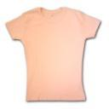= 5 T-Shirts

Have students suggest questions that could be answered from the pictograph? Possible student responses:

* Which t-shirt did they like most?
* Which did they like least?
* How many more people liked white than yellow?
* Which t-shirt was liked more than striped but less than blue?
* What is the value of one t-shirt symbol?
* What are the benefits of using a pictograph?
* How can multiplication be used to determine the most liked choice?
* Why is a graph a more efficient way to view data collected than a paragraph describing the results?

**Part II**

Student pairs use **GIRL SCOUT COOKIE** information and recording sheet to create a pictograph and answer questions based on the data in the graph..

**Part III**

Student pairs pose a survey question, collect results, choose to represent data on either a bar, picture or line plot.. Pairs record three mathematical observations concerning the data as presented on their graph. Pairs are to also explain why they chose to display data using a bar, picture or line plot.

**FORMATIVE ASSESSMENT QUESTIONS**

* How can a pictograph be used to solve word problems?
* Picture graphs use a symbol to represent a specific amount. What’s the relationship between the symbol’s value and patterns found in multiplication?
* Explain how a picture graph is a more effective way to share survey results than a paragraph written to share results.

**DIFFERENTIATION**

**Extension**

* The teacher could increase the value of the scale intervals to numbers beyond 10 to challenge students who are fluent with their multiplication facts.
* Students import their data into an online pictograph generator using the following website:

<http://illuminations.nctm.org/ActivityDetail.aspx?ID=204>

**Intervention**

* A variety of survey questions can be offered to students to use for Part III.
* For students with spatial challenges, offer graph or grid paper to make graphs.

Name ______________________________________ Date _____________

Girl Scout Cookie Pictograph

Four Girl Scouts sold cookies for one month. The list below shows how many boxes were sold by each Girl Scout.

Jamiya - 60 boxes

Lauren - 40 boxes

Zoey - 25 boxes

Macy - 15 boxes

Use the information from the list to complete a pictograph. Use your pictograph to answer the questions.

|  |  |
| --- | --- |
| Name | Cookie Sales |
| Macy |  |
| Lauren |  |
| Jamiya |  |
| Zoey |  |
| = 5 boxes |  |

1. How many boxes of cookies did the girls sell in all? _____________________

2. How many more boxes of cookies did Jamiya sell than Macy?_____________________

3. Which two girls sold a total of 65 boxes of cookies?

4. Half of the cookies sold by Lauren were Thin Mints. How many boxes of Thin Mints did Grace sell?__________________________

5. How many more cookies did Zoey and Macy need to sell in order to equal Jamiya?_______



**Pictograph Data Collection Sheet**

**DIRECTIONS:**

* You and a partner are to pose a question and interview your classmates to collect data.
* Record student responses on the tally chart below.
* Use collected data to create either a picture or bar graph.
* Write three mathematical observations that can be seen using your graph.
* Write an explanation of why you chose to use the graph selected. (bar, picture or line plot)

***Title of Graph***

|  |  |  |
| --- | --- | --- |
| ***Survey Responses*** | ***Tally Marks*** | ***Total*** |
|  |  |  |
|  |  |  |
|  |  |  |
|  |  |  |
|  |  |  |

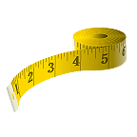**CONSTRUCTING TASK**- **MEASURE AND PLOT!**

In this task, students measure their sitting height to nearest whole inch and then use collected class results to create a line plot graph.

**APPROXIMATE TIME -** 2 class sessions

**CONTENT STANDARDS**

**MGSE3.MD.4.** Generate measurement data by measuring lengths using rulers marked with halves and fourths of an inch. Show the data by making a line plot, where the horizontal scale is marked off in appropriate units— whole numbers, halves, or quarters.

**STANDARDS FOR MATHEMATICAL PRACTICE**

1. Make sense of problems and persevere in solving them.

2. Reason abstractly and quantitatively.

4. Model with mathematics.

5. Use appropriate tools strategically.

6. Attend to precision.

7. Look for and make use of structure.

8. Look for and express regularity in repeated reasoning.

**BACKGROUND KNOWLEDGE**

Bar graphs and picture graphs are useful for illustrating categorical data. A line plot is used for counts of things along a numerical scale. It is essentially a number line with an X placed above the corresponding data. The advantage to a line plot graphs is that all data is displayed. Line plots were introduced in 2nd grade.

**COMMON MISCONCEPTIONS**

Students “don’t recognize the specific purpose and varying qualities of bar graphs, line graphs, and line plots.” (Math Misconceptions: From Misunderstanding to Deep Understanding, p. 142, Bamberger, Oberdorf, and Shultz-Ferrell)

“Some students make inaccurate assumptions when comparing data displays based on visual differences such as a change in scale or a truncated (shortened) axis.” (Math Misconceptions: From Misunderstanding to Deep Understanding, p. 142, Bamberger, Oberdorf, and Shultz-Ferrell)

Students may confuse line plots with line graphs. Review real-world examples and the features of each type. Examples:

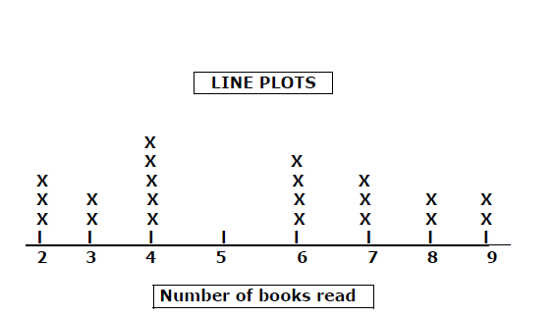

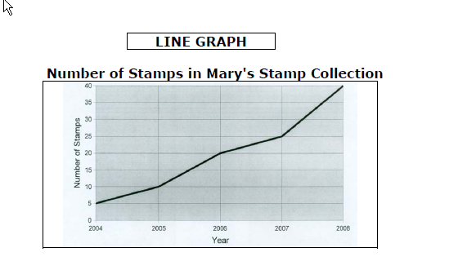

**ESSENTIAL QUESTIONS**

* How is a line plot similar to a bar graph? How do they differ?
* What does a line plot show about the data represented?
* What are the features of a line plot?

**MATERIALS**

* measuring tools such as rulers, tape measures, yardsticks
* chart paper or board for open number line
* Measure and Plot recording sheet for each student
* post-it for each student
* 3 index cards for each students

**GROUPING**

Students work in partner pairs for the purpose of measuring and then small groups to construct line plots after class data has been shared.

**TASK DESCRIPTION, DEVELOPMENT & DISCUSSION (SMP 1, 2, 4, 5, 6, 7 and 8)**

In this task, students measure their sitting height to nearest whole inch and then use collected class results to create a line plot graph.

**Part I**

Students have worked with bar graphs and picture graphs in grades 1 and 2. Students have also worked with and created line plots in 2nd grade. Review features and differences of graphs as needed with the class prior to having students complete the task.

Show either of the following short video clips with students to review how to create and use a line plot: <http://www.schooltube.com/video/27ad1fffb73701b8ead9/> or <http://www.youtube.com/watch?v=L-spnWWAWbo>

**\*Remember: ALWAYS preview any video prior to showing to students to determine appropriateness for your students.**

Display the following data as grades from a math test from last year’s class. As a class, create a line plot guiding students in including all features needed for a line plot.

**(85, 90, 75, 100, 100, 80, 60, 100, 90, 90, 100, 65, 60, 85, 90, 75, 85, 65, 100, 90)**

After completion of modeled line plot, ask students questions that can be answered by using the line plot. Consider questions such as:

* How many student took the math test?
* Why was it important to include the number 95 although no students scored a 95?
* Is there a score that represents what the majority of students’ scored?
* Why is ordering the numbers chronologically important when making a line plot?
* Is it necessary to order the data from greatest to least or could data be ordered from least to greatest? Why or why not?
* What tool could be used to organize the data prior to creating the line plot? (tally chart)
* Why might using this tool be important to use?

**Part II**

Draw an open number line on chart paper or board. Explain that this will be used by all students to post their sitting height. Review the task as outline on **Measure and Plot.** Students work in pairs to measure their sitting height to the nearest inch. Students record their sitting height on their task recording sheet and a post-it note. Each student places his/her post-it on the open number line. In doing so, students should recognize they are in essence creating a line plot. Student pairs use the organized data to create a class line plot.

Using the completed line plot, pair students to record three questions that could be answered from using the line plot. Pairs trade questions with another pair to answer questions. Pairs share and check results.

**FORMATIVE ASSESSMENT QUESTIONS**

* What makes a bar graph different from a line plot?
* Give examples and explain when would be the most appropriate time to use each and why.
* Do you think that it was wise for the custodians to use the third grade to determine the swing height? Explain your answer.

**DIFFERENTIATION**

**Extension**

* Students can collect data from a fifth grade classroom to create a line plot for analysis and comparison to their results.

**Intervention**

* Students may struggle with measuring. Provide assistance. Using a tape measure may be easier than a ruler or yardstick.
* <http://www.youtube.com/watch?v=s2gSY1F5kQI> Provides excellent review of how to collect, organize, and represent data to make a line plot based upon student results of rolling dice.

Name __________________________________ Date_____________________

Measure and Plot

The custodians will be adjusting the height of the swings on the playground. They have decided to use measurement data from the third grade classes. The custodians need to know the sitting height of a majority of the third grade students. They will use this data to adjust the height of the swings.

1. With a partner, measure each other’s sitting height to the nearest inch. Record height below and on a post-it. My sitting height is __________________.

2. Place your post-it along the number line provided by the teacher.

3. After all students have posted results, you and your partner are to create a line plot below.

**Record three questions that could be answered from using the line plot on index cards. Trade your three questions with another pair. Answer the other pair’s questions and then check your answers with the student pair.**

**PRACTICE TASK:** **HOOKED ON SOLUTIONS!**

In this task, students will create word problems to match given equations.

**CONTENT STANDARDS**

**MGSE3.OA.8** **Solve two-step word problems using the four operations. Represent these problems using equations with a letter standing for the unknown quantity. Assess the**

**reasonableness of answers using mental computation and estimation strategies including rounding. ‡**[4]

**‡ See Glossary, Table 2**

**STANDARDS FOR MATHEMATICAL PRACTICE**

1. Make sense of problems and persevere in solving them.

2. Reason abstractly and quantitatively.

3. Construct viable arguments and critique the reasoning of others.

4. Model with mathematics.

5. Use appropriate tools strategically.

6. Attend to precision.

7. Look for and make use of structure.

8. Look for and express regularity in repeated reasoning.

**BACKGROUND KNOWLEDGE**

Students should understand math concepts addition and subtraction and multiplications relationship to addition.

**ESSENTIAL QUESTIONS**

* How can multiple math operations be used to solve real world problems?
* How can we use patterns to solve problems?
* Why is it important to understand that more than one math operation may be needed to solve a problem?

**MATERIALS**

* Unifix cubes, or any counting manipulative
* Bingo cards
* Dry-erase boards
* Index cards

**GROUPING**

Individual, partner

**TASK DESCRIPTION, DEVELOPMENT, & DISCUSSION**

The teacher will begin by **scaffolding the lesson** using a Bingo game. Distribute a card to each student. There are 6 different versions of the card. Thus, you should have multiple winners at once. The teacher will call out each product on the 3 X 3 card in the form of a story problem to further build the student’s understanding of multiplication with real life. She will reinforce to them that multiplication is repeated addition. If they get stuck, use this strategy to figure out the product. The nine factors on the cards are: 36, 20, 18, 28, 35, 16, 21, 24, and 30.

The teacher will call out problems for the above products as follows. A task sheet is included.

*There are 5 cars.*

*Each car has 4 tires.*

*How many tires do they have in all?*

The teacher will create a story problem for each product until a winner has been established. While playing, the teacher will use this time to have open discussions about how answers were derived and what strategies they used.

The teacher will then give each student some type of counting manipulative. She will have them create on their desk arrays to compliment the story problems she calls out which will be similar to the aforementioned problems used in the game. However, she will add another sentence which will involve another math operation.

***Ex.1***

*There are 5 cars.*

*Each car has 4 tires.*

*3 of the tires are flat.*

*How many tires are not flat?*

**Question:**

What type of math is being presented now? How would that equation be written? **(*5 x 4) - 3= X***

The teacher would have the students create arrays and subtract or add manipulatives to solve the equation. Along with that, the students would write the equation for the story problem on a dry erase board and hold the board in the air when the teacher instructs them to do so. This will be done so the teacher can check understanding and all students are engaged. The teacher would give the students more practice problems to build their contextual understanding.

**Student Task:**

The teacher will break the students into groups of two. The students will be given five index cards. Each index card will have a different equation similar to the ones they had practiced. However, this time, they must work with a partner and create a story problem to match each equation. The teacher should prepare the equations to include an unknown (variable) in different parts of the equation. For example, ***a*** x 12 = 36. After completion of the work, the teacher will collect the index cards and redistribute them to other students and have them solve their classmates’ problems. The more opportunities students are given, the more effective the lesson.

**FORMATIVE ASSESSMENT QUESTIONS**

* Why is it important to not see math as a single operation?
* What is the relationship between word problems and equations?
* What happens if the equations are not solved in the correct order?

**DIFFERENTIATION**

**Extension**

* This lesson can be extended by allowing students to model, using arrays, similar problems with two-digit numbers.

**Intervention**

* This lesson could be taught in small groups so that more hands-on instruction can be given as needed. Also, during the task, the students could continue to use manipulatives to help create the word problems or even draw a picture.

***HOOKED ON SOLUTIONS Bingo Cards!***

|  |  |  |
| --- | --- | --- |
| 20 | 28 | 18 |
| 30 | *Free*  *Space* | 36 |
| 16 | 24 | 35 |

|  |  |  |
| --- | --- | --- |
| 36 | 24 | 20 |
| 30 | *Free*  *Space* | 35 |
| 18 | 16 | 28 |

|  |  |  |
| --- | --- | --- |
| 30 | 20 | 24 |
| 16 | *Free*  *Space* | 18 |
| 28 | 36 | 35 |

|  |  |  |
| --- | --- | --- |
| 24 | 35 | 18 |
| 36 | *Free*  *Space* | 28 |
| 30 | 16 | 20 |

|  |  |  |
| --- | --- | --- |
| 28 | 35 | 30 |
| 20 | *Free*  *Space* | 36 |
| 16 | 18 | 24 |

|  |  |  |
| --- | --- | --- |
| 30 | 36 | 28 |
| 18 | *Free*  *Space* | 24 |
| 35 | 16 | 20 |

Word Problem Suggestions for use During Instruction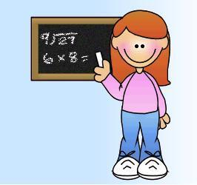

|  |
| --- |
| 36-There are four kids. Each kid has 9 marbles. How many marbles is that? |
| 20-The gardener has 4 gardens. Each garden has 5 rose bushes. How many rose bushes are there? |
| 18- Six police officers were patrolling the city. Each one captured 3 bad guys. How many bad guys did they capture? |
| 28- Seven kids were buying ice cream. They each have four quarters. How many quarters do they have? |
| 35-There were 5 doctors. Each doctor had 7 patients. How many patients is that? |
| 16- The pet shop had eight dogs. Each dog has 2 puppies. How many puppies will they have to sell? |
| 21- There were three teachers. Each teacher had 7 boys each in their class. How many boys were in all three classes? |
| 24- Three buckets were under an apple tree. Each one could hold 8 apples. What is the largest number of apples that the buckets can hold? |

2-Step Word Problem Suggestions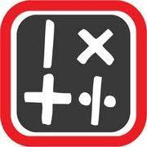

|  |
| --- |
| There were 5 parents at the park. Each parent had 3 kids. 6 of the kids were boys. How many were girls? |
| The coach had 6 baskets. Each basket contained 7 balls. 12 of them were footballs. How many were not footballs? |
| Mary, Luke, Mark, and Isaiah went fishing. They each caught 8 fish. When they got home, their mom had purchased 10 from the local supermarket. How many fish do they have? |
| There are 7 fire stations in the city. Each fire station has 5 firemen. During the week, the city hired 8 more. How many firemen do they have in all? |
| There were nine students and they each have a pencil box. 7 pencils are inside each one. 28 of the pencils are sharpened. How many are not sharpened? |

**CULMINATING TASK:** **WATCH MY GARDEN GROW!**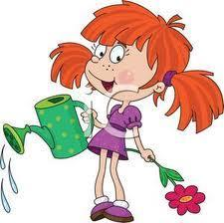

Students will create a flower garden representing 100 square units. The garden is composed of five rectangular regions, each with a different flower plant. A graph will be completed to represent the number of plants used in the garden. Student will compose word problems that can be answered by analyzing the data in the graph.

**APPROXIMATE TIME:** 2-3 class sessions

**CONTENT STANDARDS:**

**Solve problems involving the four operations, and identify and explain patterns in arithmetic.**

**MGSE3.OA.8.** **Solve two-step word problems using the four operations. Represent these problems using equations with a letter standing for the unknown quantity. Assess the reasonableness of answers using mental computation and estimation strategies including rounding.**

**Represent and interpret data.**

**MGSE3.MD.3.** Draw a scaled picture graph and a scaled bar graph to represent a data set with several categories. Solve one- and two-step “how many more” and “how many less” problems using information presented in scaled bar graphs. *For example, draw a bar graph in which each square in the bar graph might represent 5 pets.*

**MGSE3.MD.5.** Recognize area as an attribute of plane figures and understand concepts of area measurement.

1. A square with side length 1 unit, called “a unit square,” is said to have “one square unit” of area, and can be used to measure area.
2. A plane figure which can be covered without gaps or overlaps by n unit squares is said to have an area of *n* square units.

**MGSE3.MD.6.** Measure areas by counting unit squares (square cm, square m, square in, square ft, and improvised units).

**MGSE3.MD.7.** Relate area to the operations of multiplication and addition.

1. Find the area of a rectangle with whole-number side lengths by tiling it, and show that the area is the same as would be found by multiplying the side lengths.
2. Multiply side lengths to find areas of rectangles with whole number side lengths in the context of solving real world and mathematical problems, and represent whole-number products as rectangular areas in mathematical reasoning.
3. Use tiling to show, in a concrete case, that the area of a rectangle with whole-number side lengths *a* and *b + c* is the sum of *a × b* and *a × c*. Use area models to represent the distributive property in mathematical reasoning.
4. ~~Recognize area as additive. Find areas of rectilinear figures by decomposing them into non-overlapping rectangles and adding the areas of the non-overlapping parts, applying this technique to solve real world problems.~~

**STANDARDS FOR MATHEMATICAL PRACTICE**

1. Make sense of problems and persevere in solving them.

2. Reason abstractly and quantitatively.

3. Construct viable arguments and critique the reasoning of others.

4. Model with mathematics.

5. Use appropriate tools strategically.

6. Attend to precision.

7. Look for and make use of structure.

8. Look for and express regularity in repeated reasoning.

**COMMON MISCONCEPTIONS**

Refer previous tasks for common misconceptions for the standards listed above.

**ESSENTIAL QUESTION**

* How can the knowledge of area be used to solve real world problems?
* How can graphs be used to solve real world problems?

**MATERIAL**

* Inch/centimeter grid paper
* “Watching My Garden Grow” task sheet

**GROUPING**

Individual task

**TASK DESCRIPTION, DEVELOPMENT AND DISCUSSION (SMP 1, 2, 3, 4, 5, 6, 7, and 8)**

In this culminating task each student will design a garden measuring 100 square units. The student garden must include five different rectangular regions, each containing a different type of flower. The area of each region is to be recorded as a multiplication number sentence representing the dimensions of the region.

Once the student garden design is completed, students use flower data represented in the garden to show results using a bar or pictograph. (One square unit represents one flower plant) Students will then create word problems (one step and two step) that can be answered by analyzing the graph.

**Possible student response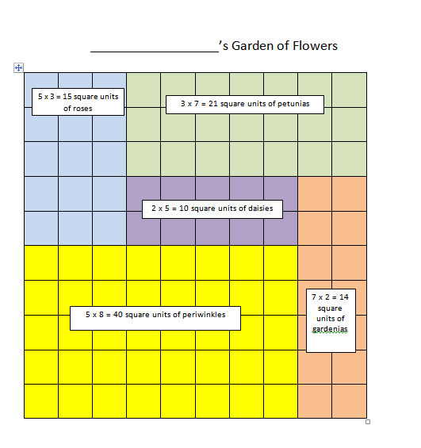 to prompt:**

**FORMATIVE ASSESSMENT QUESTIONS**

* How did you decide upon the design for your garden?
* If you could change one aspect of your design, what change would you make and why?
* How does your graph represent your design?
* Using another student’s design, compare and contrast your design to convince your teacher to use your design.

**DIFFERENTIATION**

**Extension**

* Increase the size of the garden to 154 square units. Students utilize the distributive property to record dimensions of 3-5 regions.

**Intervention**

* Students use manipulatives and grid paper to design their garden and then draw the design on the same grid paper.



**Name__________________________Date______________________**

**WATCH MY GARDEN GROW**

You want to surprise your mom by planting a flower garden for the Spring. You have measured an area of land in the backyard equal to 100 square feet. You want to plant five of your mom’s favorite flowers, one type of plant in each of the five regions. Each of the five flower regions should be rectangular and labeled with the flower’s name, the dimensions of the region and the number of square units (the area) for the region.

Once your garden design is complete, graph the number of flower plants you have chosen to include in your garden design. One square unit represents one flower plant.

Create word problems (one and two step that can be answered by analyzing the graph.

1. See Glossary, Table 2
2. See Glossary, Table 3
3. This standard is limited to problems posed with whole numbers and having whole-number answers; students should know how to perform operations in the conventional order where there are no parentheses to specify a particular order (Order of Operations).
4. This standard is limited to problems posed with whole numbers and having whole-number answers; students should know how to perform operations in the conventional order where there are no parentheses to specify a particular order (Order of Operations).