**Georgia**

**Standards of Excellence**

**Frameworks**

**Mathematics**

GSE First Grade

Unit 4: Sorting, Comparing, and Ordering



**Unit Four: Sorting, Comparing and Ordering**

**TABLE OF CONTENTS**

Overview 3

Standards for Mathematical Practice 5

Standards for Mathematical Content 5

Big Ideas 6

Essential Questions 6

Concepts and Skills to Maintain 7

Strategies for Teaching and Learning 7

Selected Terms and Symbols 10

FAL 11

Sample Unit Assessments 11

Number Talks 11

Writing in Math 12

Page Citations 12

Tasks 14

1. [How Long is Your Name?](#How_long_isyour_name) 16
2. [Breaking and Making a Ruler](#making_and_breakingruler) 21

[FAL](#FAL_measurement) 27

1. [How Big Is a Foot?](#how_big_isa_foot) 28
2. [Lil’ Sisters and Me](#lil_sisters_andme) 32
3. [Groundhog’s Garden](#groundhogs_garden) 43
4. [What Shape Are You?](#what_shape_are_you) 48
5. [It’s Time: Part I-Using a Number Line](#its_time_part1) 52
6. [It’s Time, Part II](#its_time_part2) 58
7. [It’s Time, Part III](#its_time_part3) 63
8. [Time for Bed](#timeforbed) 71
9. [Measurement Olympics](#measurement_olympics) 79

Please note that all changes made to standards will appear in red bold type. Additional changes will appear in green.

**OVERVIEW**

In this unit students will:

* Develop an understanding of linear measurement.
* Measure lengths as iterating length units.
* Tell and write time to the hour and half hour.
* Represent and interpret data.

The measure of an attribute is a count of how many units are needed to fill, cover, or match the attribute of the object being measured. Students need to understand what a unit of measure is and how it is used to find a measurement. They need to predict the measurement, find the measurement, and then discuss the estimates, errors, and the measuring process. It is important for students to measure the same object with differently sized units.

Students need to make their own measuring tools. For instance, they can place inch cubes end to end along a piece of cardboard, make marks at the endpoints of the clips and color in the spaces. Students can now see that the spaces represent the unit of measure, not the marks or numbers on a ruler. Eventually they write numbers in the center of the spaces. Students should know that the numbers on the ruler represent units of measurement. Learning to use a ruler accurately and with understanding requires becoming comfortable with the meaning of the units on the ruler. Compare and discuss two measurements of the same distance, one found by using a ruler and one found by aligning the actual units end to end, as in a chain of inch cubes. Students should also measure lengths that are longer than a ruler. The units of measure used, such as paper clips, should correspond with a standard unit of measure (Ex. Each paper clip is 1 inch long) and this correspondence should be stated to the students explicitly by the teacher.

Further info: **Investigating Measurement Knowledge,** Jenni K. McCool and Carol Holland

May 2012, Volume 18, Issue 9, Page 542 See more at: <http://www.nctm.org/publications/article.aspx?id=33156#sthash.o6B8Bisy.dpuf>

Have students use reasoning to compare measurements indirectly. To order the lengths of Objects A, B and C, examine, then compare the lengths of Object A and Object B and the lengths of Object B and Object C. The results of these two comparisons allow students to use reasoning to determine how the length of Object A compares to the length of Object C. For example, to order three objects by their lengths, reason that if Object A is smaller than Object B and Object B is smaller than Object C, then Object A has to be smaller than Object C. The order of objects by their length, from smallest to largest, would be Object A - Object B - Object C.

Although the units in this instructional framework emphasize key standards and big ideas at specific times of the year, routine topics such as counting, time, money, positional words, patterns, and tally marks should be addressed on an ongoing basis through the use of calendars, centers, and games. Calendar instruction should be a part of daily mathematics instruction. Students should be able to determine the day before and after the current day, as well as identify the day after a particular passage of time.

Students are likely to experience some difficulties learning about time. On an analog clock, the shorter hand indicates approximate time to the nearest hour and the focus is on where it is pointing. The longer hand shows minutes before and after an hour and the focus is on distance that it has gone around the clock or the distance yet to go for the hand to get back to the top or the number 12. It is easier for students to read times on digital clocks, but these do not relate progression of time very well.

Students need to experience a progression of activities for learning how to tell time. Begin by using a one-handed clock (hour handed) to tell times in hour and half-hour intervals. Then discuss what is happening to the unseen minute hand. Next, use two clocks, one with the minute hand removed, and compare the hands on the clocks. Students can predict the position of the missing minute hand to the nearest hour or half-hour and check their prediction using the two-handed clock. They can also predict the display on a digital clock given a time on a one- or two-handed analog clock and vice-versa.

Have students tell the time for events in their everyday lives to the nearest hour or half hour. Make a variety of models for analog clocks. One model uses a strip of paper marked in half hours. Connect the ends with tape to form the strip into a circle.

For more detailed information about unpacking the content standards, unpacking a task, math routines and rituals, maintenance activities and more, please refer to the Grade Level Overview.

**MEASUREMENT TRAJECTORY**

|  |
| --- |
| ***Important Understanding of Measurement:*** *Students progress through the underlying concepts of the measurement trajectory with the use of non-standard units and standard units of measurement interchangeably (inch cubes, inch tiles, feet, hands, paperclips, etc.). The emphasis in the early stages of the trajectory is related to quantitative and spatial reasoning and comparison; not on procedural use of measurement tools.* |

|  |  |  |  |  |  |  |  |
| --- | --- | --- | --- | --- | --- | --- | --- |
| **Progression** | **Length Quantity Recognizer** | **Length Direct Comparer** | **Indirect Length Comparer** | **End-to-end Length Measurer** | **Length Unit Relater and Iterator** | **Length Measurer** | **Conceptual Ruler Measurer** |
| Description | Become aware of the physical attributes of objects in order to clearly identify what is to be measured.  At the earliest level, children can identify length as an attribute. For example, they might say, “I’m tall, see?” | Compare the attributes of two or more objects to establish, for example, which is longer, heavier or holds more. When comparing three or more objects they can be ordered. For example, they can stand two sticks up next to each other on a table and say, “This one’s bigger.” | Can use a third object to compare the length of two objects.  Students can use a piece of string to measure the width of the door and then hold the piece of string against a table to see if it will fit through the door. | Expects that length is quantifiable as a composition of shorter lengths. Compares an end-to-end train of countable objects to the linear extent of an object. For example steps or hands can be used to measure length, and cups measure volume. Anything used to measure in this way can be described as a unit. | Is able to iterate a unit along an object to find length\*\*\* | Can compose and partition length units. Can think of the length of a bent path as the sum of its parts. Mentally iterates a unit and sub units (internalized ruler). | Operates mentally with units and composite units. Can mentally project a known length along an object to measure or partition an unknown length. |
| Look *Fors* | Length as an attribute  • Detects differences in length  • May view length as a non-comparative property possessed by objects based on  shape  • May not know the need to align objects when comparing them based on their  length | Need to physically align objects to compare  • Guided ruler use (help with alignment and how to read measure) may help  children abstract length and understand measurement | Represents the length of objects by another  • Assigns a number to length | Lays units end-to-end along object to measure its length  • Measurement as the covering of distance (no gaps or overlaps in the placement  of units)  • May not understand the need for equal units | Relates the size and the number of units  • Operates on length as represented by a number (additivity of length)  • May understand the need for equal units and universal units  • Iterates a single unit to measure | Flexible understanding of the relationship between the whole, units, and units of  units  • Connected mental representations of length | Equal facility in iterating and partitioning a given length, both physically and  mentally |

*\*\*\*Unit iteration is the repetition of a single unit. If you are measuring the length of a desk with straws, it is easy enough to lay out straws across the desk and then count them. But if only one straw is available, then you must iterate (repeat) the unit (straw). You first have to visualize the total length in terms of the single unit and then reposition the unit repeatedly.*

**STANDARDS FOR MATHEMATICAL PRACTICE**

The Standards for Mathematical Practice describe varieties of expertise that mathematics educators at all levels should seek to develop in their students. These practices rest on important “processes and proficiencies” with longstanding importance in mathematics education.

***Students are expected to:***

1. Make sense of problems and persevere in solving them.

2. Reason abstractly and quantitatively.

3. Construct viable arguments and critique the reasoning of others.

4. Model with mathematics.

5. Use appropriate tools strategically.

6. Attend to precision.

7. Look for and make use of structure.

8. Look for and express regularity in repeated reasoning.

**\*\*\*Mathematical Practices 1 and 6 should be evident in EVERY lesson\*\*\***

**STANDARDS FOR MATHEMATICAL CONTENT**

**MGSE1.MD.1** Order three objects by length; compare the lengths of two objects indirectly by using a third object.

**MGSE1.MD.2** **Express the length of an object as a whole number of length units, by laying multiple copies of a shorter object (the length unit) end to end; understand that the length measurement of an object is the number of same-size length units that span it with no gaps or overlaps. (Iteration)**

**MGSE1.MD.3** Tell and write time in hours and half-hours using analog and digital clocks.

**MGSE1.MD.4** Organize, represent, and interpret data with up to three categories; ask and answer questions about the total number of data points, how many in each category, and howmany more or less are in one category than in another.

**BIG IDEAS**

* Telling time to the hour and half hour using analog and digital clocks.
* Objects may be compared according to length.
* Objects may be used to determine length, but must correspond with a standard unit of measurement.
* Tools may be created to measure length.
* Organize and represent data collected from measurement.
* Ask and answer questions related to measurement data.

**ESSENTIAL QUESTIONS**

* How can we measure the length of an object?
* What can we use to measure objects?
* How can we tell which of two objects is longer than the other?
* How can we order a group of objects by their length?
* How does using an object help us when measuring another object?
* Why are the measurements of classmates different?
* Why would an estimate be helpful when measuring?
* When is an estimate good enough? When should I measure instead of using an estimate?
* How can we compare the length of a set of objects?
* How are objects used to measure other objects?
* How are measuring units selected?
* How do measurements help compare objects?
* Why is telling time important?
* How do you use time in your daily life?
* How can we measure time?
* What does the hour hand on a clock tell us?
* Why is it important to know the difference between the two hands?
* Why do we need to be able to tell time?
* How do we show our thinking with pictures and words?
* How does time impact my day?
* What does the minute hand on a clock tell us?
* What do I know about time?
* Why do people collect data?
* Are there different ways to display data?
* What can we learn from our data?

**CONCEPTS/SKILLS TO MAINTAIN**

* Counting to 100
* Sorting
* Write and represent numbers through 20
* Comparing sets of objects (equal to, longer than, shorter than)
* One to one correspondence
* Equivalence
* Basic geometric shapes
* Modeling addition and subtraction
* Estimating using 5 and 10 as a benchmark
* Measurement: comparing and ordering two or more objects

**STRATEGIES FOR TEACHING AND LEARNING**

**Developing understanding of linear measurement and measuring lengths as iterating length units**.

**MGSE1.MD.1** Order three objects by length; compare the lengths of two objects indirectly by using a third object.

**Instructional Strategies**

This standard calls for students to indirectly measure objects by comparing the length of two objects by using a third object as a measuring tool. This concept is referred to as transitivity.

Example:

Which is longer: the height of the bookshelf or the height of a desk?

|  |  |  |
| --- | --- | --- |
| **Student 1:**  I used inch cubes to measure the height of the bookshelf and it was 36 cubes long. I used the same pencil to measure the height of the desk and the desk was 24 inch cubes long. Therefore, the bookshelf is taller than the desk. |  | **Student 2:**  I used a 1 foot piece of string to measure the bookshelf and it was 3 strings long. I used the same string to measure the height of the desk and it was 2 strings long. Therefore, the bookshelf is taller than the desk. |

It is beneficial to use informal units for beginning measurement activities at all grade levels because they allow students to focus on the attributes being measured. The units need to correspond to standard units of measurement and this relationship should always be expressed by the teacher.

**MGSE1.MD.2** **Express the length of an object as a whole number of length units, by laying multiple copies of a shorter object (the length unit) end to end; understand that the length measurement of an object is the number of same-size length units that span it with no gaps or overlaps. (Iteration)**

**Instructional Strategies**

This standard asks students to use multiple copies of one object to measure a larger object. This concept is referred to as iteration. Through numerous experiences and careful questioning by the teacher, students will recognize the importance of making sure that there are not any gaps or overlaps in order to get an accurate measurement. This concept is a foundational building block for the concept of area in 3rd Grade.

Example:

How long is the paper in terms of 1 inch paper clips?

Measurement units share the attribute being measured. Students need to use as many copies of the length unit as necessary to match the length being measured. For instance, use large footprints with the same size as length units. Place the footprints end to end, without gaps or overlaps, to measure the length of a room to the nearest whole footprint. Use language that reflects the approximate nature of measurement, such as the length of the room is about 19 footprints. Students need to also measure the lengths of curves and other distances that are not straight lines.

**Tell and write time**

**MGSE1.MD.3** Tell and write time in hours and half-hours using analog and digital clocks.

**Instructional Strategies**

This standard calls for students to read both analog and digital clocks and then orally tell and write the time. Times should be limited to the hour and the half-hour. Students need experiences exploring the idea that when the time is at the half-hour the hour hand is between numbers and not on a number. Further, the hour is the number before where the hour hand is. For example, in the clock below, the time is 8:30. The hour hand is between the 8 and 9, but the hour is 8 since it is not yet on the 9.



**Represent and interpret data**

**MGSE1.MD.4** Organize, represent, and interpret data with up to three categories; ask and answer questions about the total number of data points, how many in each category, and how many more or less are in one category than in another.

**Instructional Strategies**

This standard calls for students to work with categorical data by organizing, representing and interpreting data. Students should have experiences posing a question with 3 possible responses and then work with the data that they collect. For example:

Students pose a question and the 3 possible responses: *Which is your favorite flavor of ice cream? Chocolate, vanilla, or strawberry?* Students collect their data by using tallies or another way of keeping track. Students organize their data by totaling each category in a chart or table. Picture and bar graphs are introduced in 2nd Grade.

|  |  |
| --- | --- |
| **What is your favorite flavor of ice cream?** | |
| Chocolate | 12 |
| Vanilla | 5 |
| Strawberry | 6 |

Students interpret the data by comparing categories.

Examples of comparisons:

* What does the data tell us? Does it answer our question?
* More people like chocolate than the other two flavors.
* Only 5 people liked vanilla.
* Six people liked Strawberry.
* 7 more people liked Chocolate than Vanilla.
* The number of people that liked Vanilla was 1 less than the number of people who liked Strawberry.
* The number of people who liked either Vanilla or Strawberry was 1 less than the number of people who liked chocolate.

For more detailed information about unpacking the content standards, unpacking a task, math routines and rituals, maintenance activities and more, please refer to the Grade Level Overview.

**Fluency**: Procedural fluency is defined as skill in carrying out procedures flexibly, accurately, efficiently, and appropriately. Fluent problem solving does not necessarily mean solving problems within a certain time limit, though there are reasonable limits on how long computation should take. Fluency is based on a deep understanding of quantity and number.

**Deep Understanding**: Teachers teach more than simply “how to get the answer” and instead support students’ ability to access concepts from a number of perspectives. Therefore students are able to see math as more than a set of mnemonics or discrete procedures. Students demonstrate deep conceptual understanding of foundational mathematics concepts by applying them to new situations, as well as writing and speaking about their understanding.

**Memorization**: The rapid recall of arithmetic facts or mathematical procedures. Memorization is often confused with fluency. Fluency implies a much richer kind of mathematical knowledge and experience.

**Number Sense:**

Students consider the context of a problem, look at the numbers in a problem, make a decision about which strategy would be most efficient in each particular problem. Number sense is not a deep understanding of a single strategy, but rather the ability to think flexibly between a variety of strategies in context.

**Fluent students**:

* flexibly use a combination of deep understanding, number sense, and memorization.
* are fluent in the necessary baseline functions in mathematics so that they are able to spend their thinking and processing time unpacking problems and making meaning from them.
* are able to articulate their reasoning.
* find solutions through a number of different paths.

For more about fluency, see:

<http://www.youcubed.org/wp-content/uploads/2015/03/FluencyWithoutFear-2015.pdf>

and:

<http://joboaler.com/timed-tests-and-the-development-of-math-anxiety/>

**SELECTED TERMS AND SYMBOLS**

The following terms and symbols are often misunderstood. These concepts are not an inclusive list and should not be taught in isolation. However, due to evidence of frequent difficulty and misunderstanding associated with these concepts, teachers should pay particular attention to them and how their students are able to explain and apply them.

The terms below are for **teacher reference only and are not to be memorized by students**. Teachers should present these concepts to students using models and real life examples. Students should understand the concepts involved and be able to recognize and/or demonstrate them with words, models, pictures, or numbers.

* **Analog**
* **Compare**
* **Data**
* **Digital**
* **Estimate**
* **Graph**
* **Hands (clock)**
* **Hour**
* **Length**
* **Minute**
* **Sorting rule**

<http://www.corestandards.org/Math/Content/mathematics-glossary/glossary>

**FALS**

The linked Formative Assessment lesson is designed to be part of an instructional unit. This assessment should be implemented approximately two-thirds of the way through this instructional unit and is noted in the unit task table. This assessment can be used at the beginning of the unit to ascertain student needs. The results of this task should give you pertinent information regarding your students learning and help to drive your instruction for the remainder of the unit.

[**SAMPLE UNIT ASSESSMENTS**](http://ccgpsmathematicsk-5.wikispaces.com/K-5+Formative+Assessment+Lessons+%28FALs%29)

Math Unit Summative Assessments were written by the First Grade Mathematics Assessment and Curriculum Team, Jackson County, Georgia. The team is comprised of first grade teachers and administrators whose focus is to provide assessments that address depth of knowledge and higher order thinking skills. These assessments are provided as a courtesy from the Jackson County School System as samples that may be used as is or as a guide to create common assessments.

**NUMBER TALKS**

In order to be mathematically proficient, today’s students must be able to compute accurately, efficiently, and flexibly. Daily classroom number talks provide a powerful avenue for developing “efficient, flexible, and accurate computation strategies that build upon the key foundational ideas of mathematics.” (Parrish, 2010) Number talks involve classroom conversations and discussions centered upon purposefully planned computation problems.

In Sherry Parrish’s book, Number Talks: Helping Children Build Mental Math and Computation Strategies, teachers will find a wealth of information about Number Talks, including:

* Key components of Number Talks
* Establishing procedures
* Setting expectations
* Designing purposeful Number Talks
* Developing specific strategies through Number Talks

There are four overarching goals upon which K-2 teachers should focus during Number Talks. These goals are:

1. Developing number sense
2. Developing fluency with small numbers
3. Subitizing
4. Making Tens

The teacher should continue with the Number Talks suggested in Unit 3. Suggested Number Talks for Unit 3 are fluency with 6, 7, 8, 9, and 10; and counting all and counting on using dot images, ten-frames, Rekenreks, double ten-frames, and number sentences. When students are ready, inclue Number Talks for addition, including doubles/near doubles and making tens.Specifics on these Number Talks can be found on pages 74-117 of Number Talks: Helping Children Build Mental Math and Computation Strategies.

**WRITING IN MATH**

The Standards for Mathematical Practice, which are integrated throughout effective mathematics content instruction, require students to explain their thinking when making sense of a problem (SMP 1). Additionally, students are required to construct viable arguments and critique the reasoning of others (SMP 2). Therefore, the ability to express their thinking and record their strategies in written form is critical for today’s learners. According to Marilyn Burns, “Writing in math class supports learning because it requires students to organize, clarify, and reflect on their ideas--all useful processes for making sense of mathematics. In addition, when students write, their papers provide a window into their understandings, their misconceptions, and their feelings about the content.” (Writing in Math. Educational Leadership. Oct. 2004 (30).) The use of math journals is an effective means for integrating writing into the math curriculum.

Math journals can be used for a variety of purposes. Recording problem solving strategies and solutions, reflecting upon learning, and explaining and justifying thinking are all uses for math journals. Additionally, math journals can provide a chronological record of student math thinking throughout the year, as well as a means for assessment than can inform future instruction.

The following website provides a wealth of information and grade specific activities for math journaling: <http://www.k-5mathteachingresources.com/math-journals.html>. Though this is not a free site, there are some free resources that are accessible.

**PAGE CITATIONS**

Teaching Student-Centered Mathematics written by Van de Walle, Lovin, Karp, and Bay-Williams, has been recently revised. Page citation numbers may vary due to this change.

**TASK DESCRIPTIONS**

|  |  |
| --- | --- |
| **Scaffolding Task** | Tasks that build up to the learning task. |
| **Constructing Task** | Constructing understanding through deep/rich contextualized problem solving tasks. |
| **Practice Task** | Tasks that provide students opportunities to practice skills and concepts. |
| **Culminating Task** | Designed to require students to use several concepts learned during the unit to answer a new or unique situation. Allows students to give evidence of their own understanding toward the mastery of the standard and requires them to extend their chain of mathematical reasoning. |
| **Formative Assessment Lesson (FAL)** | Lessons that support teachers in formative assessment which both reveal and develop students’ understanding of key mathematical ideas and applications. These lessons enable teachers and students to monitor in more detail their progress towards the targets of the standards. |
| **3-Act Task** | A Three-Act Task is a whole-group mathematics task consisting of 3 distinct parts: an engaging and perplexing Act One, an information and solution seeking Act Two, and a solution discussion and solution revealing Act Three. More information along with guidelines for 3-Act Tasks may be found in the ***Guide to Three-Act Tasks*** on georgiastandards.org and the K-5 CCGPS Mathematics Wiki. |

|  |  |  |  |  |
| --- | --- | --- | --- | --- |
| **Task Name** | **Task Type/**  ***Grouping Strategy*** | **Content Standards** | **Content Addressed** | **Brief Description** |
| [Task 1:](#How_long_isyour_name)  [How Long is Your Name?](#How_long_isyour_name) | Scaffolding Task  *Whole and small group* | MGSE1.MD.1  MGSE1.MD.4 | Measuring Length; Represent and interpret data | Students will compare the length of their name with others. |
| [Task 2:](#making_and_breakingruler)  [Breaking and Making a Ruler](#making_and_breakingruler) | Constructing Task  *Whole Group/Partners* | MGSE1.MD.1  MGSE1.MD.2 | Measuring length | Students will be introduced to ruler and inch measurements. |
| [FAL](#FAL_measurement) | Performance Assessment | MGSE1.MD.1  MGSE1.MD.2 | FAL: Measurement | Students will measure lengths indirectly and by iterating length units. |
| [Task 3:](#how_big_isa_foot)  [How Big is a Foot?](#how_big_isa_foot) | Constructing Task  *Large group* | MGSE1.MD.1  MGSE1.MD.2  MGSE1.MD.4 | Measuring length | Students will practice estimating and measuring. |
| [Task 4: Lil’ Sisters and Me!](#lil_sisters_andme) | 3 Act Task  *Large group, Individual* | MGSE1.MD.1  MGSE1.MD.2 | Measuring length, ordering and comparing | Students will practice comparing height while doing a problem solving lesson. |
| [Task 5:](#groundhogs_garden)  [Groundhog’s Garden](#groundhogs_garden) | Practice Task  *Whole Group/Individual* | MGSE1.MD.1  MGSE1.MD.2 | Measuring length, ordering and comparing | Students will practice measuring with non-standard units. |
| [Task 6:](#what_shape_are_you)  [What Shape Are You?](#what_shape_are_you) | Practice Task  *Whole Group/Partner* | MGSE1.MD.1  MGSE1.MD.2  MGSE1.MD.4 | Measuring length  Represent and interpret data | Students will measure height and arm reach with yarn then determine their own shape in this lesson. |
| [Task 7:](#its_time_part1)  [It’s Time – Part I: Using a Number Line](#its_time_part1) | Scaffolding Task  *Whole group* | MGSE1.MD.3 | Time as linear measurement, AM and PM | Students will build a number line clock to begin discussion on time. |

|  |  |  |  |  |
| --- | --- | --- | --- | --- |
| [Task 8:](#its_time_part2)  [It’s Time, Part II](#its_time_part2) | Constructing Task  *Large or small group* | MGSE1.MD.3 | Movement of clock hands | Students will practice telling time using digital and analog clocks. |
| [Task 9:](#its_time_part3)  [It’s Time, Part III](#its_time_part3) | Constructing Task  *Whole Group* | MGSE1.MD.3 | Telling time (hour and minute hand) | Students will practice telling time using the hour and minute hand. |
| [Task 10:](#timeforbed)  [Time for Bed](#timeforbed) | Performance Task | MGSE1.MD.3 | Data, graphing, telling time to hour/half hour | Students will graph class information about bed time and wake up time and report their findings. |
| **[Task 11:](#measurement_olympics)**  **[Culminating Task:](#measurement_olympics)**  [Measurement Olympics](#measurement_olympics) | **Culminating Task**  *Individual/Small Group* | MGSE1.MD.1  MGSE1.MD.2  MGSE1.MD.4 | Measuring Length and Time  Represent and interpret data | Review of measurement lessons in the framework unit. |

**Task 1**

**SCAFFOLDING TASK: How Long is Your Name?**

*Approximately 2 days**Adapted from Name Trains by Vicki Bachman*

**STANDARDS FOR MATHEMATICAL CONTENT**

**MGSE1.MD.1** Order three objects by length; compare the lengths of two objects indirectly by using a third object.

**MGSE1.MD.4** Organize, represent, and interpret data with up to three categories; ask and answer questions about the total number of data points, how many in each category, and how many more or less are in one category than in another.

**STANDARDS FOR MATHEMATICAL PRACTICE**

1. Make sense of problems and persevere in solving them.

2. Reason abstractly and quantitatively.

3. Construct viable arguments and critique the reasoning of others.

4. Model with mathematics. *Students model their names with linking cubes.*

5. Use appropriate tools strategically.

6. Attend to precision.

7. Look for and make use of structure.

8. Look for and express regularity in repeated reasoning*. Students observe the length of the names corresponding to the number of letters in the name.*

**BACKGROUND KNOWLEDGE/COMMON MISCONCEPTIONS**

Students should have had many practice opportunities in kindergarten to compare two objects and use describing words to identify which of the two objects is longer or shorter than the other. For this activity, they should apply that knowledge of how to compare two objects on a larger scale by comparing their name to a group and then to a larger set, their class.

**ESSENTIAL QUESTIONS**

* How can we measure the length of an object?
* How does using an object help us when measuring other objects?
* How can we tell which of two objects is longer than the other?

**MATERIALS**

* Linking cubes, enough for each letter of each student’s first name
* Dot stickers, enough for each letter of each student’s first name
* “How Long is My Name?” Recording Sheet
* *Chrysanthemum,* by Kevin Henkes (or a similar book about names)

**GROUPING**

Whole Group/ Small Groups

**TASK DESCRIPTION, DEVELOPMENT, AND DISCUSSION**

**Part I**

Begin the lesson by discussing with students the ways in which we measure objects each day in our own lives. Make a list together. After brainstorming objects that can be measured, read a book similar to *Chrysanthemum,* by Kevin Henkes. Ask students, “Have you ever thought of measuring a name? How might we measure our own names?” Allow for student responses and then show them how to create name chain using your name. Print the letters of your name on dot stickers and attach each sticker to a linking cube. Link all of the cubes together and show students that you have created a name chain. Have students think about whether or not their name will be longer, shorter, or the same length as yours. Have students record their thinking in their math journal and tell them that they will refer to their predictions later in the lesson.

**Part II**

Assign students to groups of three. Review and post the following directions:

1. With cubes, make a name chain that shows your name.
2. Compare your name chain with the members of your group. Decide whose name is shorter, longer, or the same length.
3. Complete the recording sheet.

As groups are working, circulate the room and ask questions of members of each group such as:

* *What is the length of your name?*
* *Are there any of you with same-length names?*
* *Do any of you have the same length of name as I do? Shorter or longer?*
* *How does your name compare with the names of the other members in the group?*

**Part III**

Once all groups have compared their names to the other students’ names within the group, have them return to a common area with their recording sheets. Make a table on the board that lists the possible number of letters in a name, starting from the fewest number of letters to the maximum number of letters in a student’s name in the class. For each category, have students raise their hand to indicate the number of letters in their name. See example below:

|  |  |  |  |  |
| --- | --- | --- | --- | --- |
| **3 letters** | **5 letters** | **6 letters** | **7 letters** | **11 letters** |
| Ava | Layla  Nelly  Caden  Kayla | Lauren  Preston  Travis  Radeta  Olivia | Madison  William  Jillian | Christopher |

Once all names have been listed within the chart, have students complete the second recording sheet. As students are working, ask questions such as:

* *Does anyone have a name that is as the same length as mine?*
* *Who has the longest name?*
* *Is it longer than mine? How much longer?*
* *Who has the shortest name in the class?*
* *What is the most common length in the class?*

As students finish the recording sheet, have students write a comparison sentence using the class data on the back of their recording sheet or in their math journal to be shared during the closing of the activity.

**Part IV**

Once all students have completed the second recording sheet, have them gather again in a common area for a class discussion of the data. Lead students to discuss the information they discovered about the names in the class through this task and allow them to share the comparison sentences they developed on the back of their sheet or in their math journal.

**FORMATIVE ASSESSMENT QUESTIONS**

* Who has the longest name?
* Who has the fewest number of letters in their name in the class?
* What is the length of your name?
* What is the most common length name in the class?

**DIFFERENTIATION**

**Extension**

* Have students compare the lengths of their first and last name.

**Intervention**

* For students who have difficulty with organization, have them cut out the letters of their name

and glue to their recording sheet along with the names of their group members to compare.

* For students that need smaller words, use preselected sight words.

**Name:\_\_\_\_\_\_\_\_\_\_\_\_\_\_\_\_\_\_\_ Date:\_\_\_\_\_\_\_\_\_\_\_\_\_\_\_**

**How Long is My Name?**

**After making your name chain, write each letter of your name and your partner’s names in each box.**

|  |  |  |  |  |  |  |  |  |  |  |  |
| --- | --- | --- | --- | --- | --- | --- | --- | --- | --- | --- | --- |
| **Partner 1** |  |  |  |  |  |  |  |  |  |  |  |
| **Partner 2** |  |  |  |  |  |  |  |  |  |  |  |
| **Partner 3** |  |  |  |  |  |  |  |  |  |  |  |

**Order the names from fewest number of letters to greatest number of letters:**

1.\_\_\_\_\_\_\_\_\_\_\_\_\_\_\_\_\_\_\_\_\_\_\_\_\_\_\_\_

2. \_\_\_\_\_\_\_\_\_\_\_\_\_\_\_\_\_\_\_\_\_\_\_\_\_\_\_

3. \_\_\_\_\_\_\_\_\_\_\_\_\_\_\_\_\_\_\_\_\_\_\_\_\_\_\_

**Write a comparison sentence using one of the following phrases: longer than, shorter than, or equal to.**

\_\_\_\_\_\_\_\_\_\_\_\_\_\_\_\_\_\_\_\_\_\_\_\_\_\_\_\_\_\_\_\_\_\_\_\_\_\_\_\_\_\_\_\_\_\_\_\_\_\_\_\_\_\_\_\_\_\_\_\_\_\_\_\_\_\_\_\_\_\_\_\_\_\_\_\_\_\_\_\_\_\_\_\_\_\_\_\_\_\_\_\_\_\_\_\_\_\_\_\_\_\_\_\_\_\_\_\_\_\_\_\_\_\_\_\_\_\_\_\_\_\_\_\_\_\_\_\_\_\_\_\_\_\_\_\_\_\_\_\_\_\_\_\_\_\_\_\_\_\_\_\_\_\_\_\_\_\_\_\_\_\_\_\_\_\_\_\_\_\_\_\_\_\_\_\_\_\_\_\_\_\_\_

**Name:\_\_\_\_\_\_\_\_\_\_\_\_\_\_\_\_\_\_\_ Date:\_\_\_\_\_\_\_\_\_\_\_\_\_\_\_**

**Comparing Names**

My name is \_\_\_\_\_\_\_\_\_\_\_\_\_\_\_\_\_.

There are \_\_\_\_\_\_\_\_ letters in my name.

|  |  |  |  |  |  |  |  |  |  |  |  |  |  |  |  |  |  |  |  |  |  |  |  |  |  |  |  |  |  |  |  |  |  |  |  |
| --- | --- | --- | --- | --- | --- | --- | --- | --- | --- | --- | --- | --- | --- | --- | --- | --- | --- | --- | --- | --- | --- | --- | --- | --- | --- | --- | --- | --- | --- | --- | --- | --- | --- | --- | --- |
| **Shorter**   |  |  |  |  |  | | --- | --- | --- | --- | --- | |  |  |  |  |  |  |  |  |  | | --- | --- | --- | |  |  |  | | **Equal**   |  |  |  |  |  | | --- | --- | --- | --- | --- | |  |  |  |  |  |  |  |  |  |  |  | | --- | --- | --- | --- | --- | |  |  |  |  |  | | **Longer**   |  |  |  |  |  | | --- | --- | --- | --- | --- | |  |  |  |  |  |  |  |  |  |  |  |  |  |  |  |  | | --- | --- | --- | --- | --- | --- | --- | --- | --- | --- | |  |  |  |  |  |  |  |  |  |  | |
| Write the names of students whose name is shorter than yours. | Write the names of students whose name is the same length as yours. | Write the names of students whose name is longer than yours. |

Which student in the class has the longest name?\_\_\_\_\_\_\_\_\_\_\_\_\_\_\_\_

Which student in the class has the shortest name?\_\_\_\_\_\_\_\_\_\_\_\_\_\_\_

How many students have a name that is the same length as your name?\_\_\_\_\_\_\_

**Task 2**

**CONSTRUCTING TASK: Breaking and Making a Ruler**

*Approximately 2-3 days*

**STANDARDS FOR MATHEMATICAL CONTENT**

**MGSE1.MD.1** Order three objects by length; compare the lengths of two objects indirectly by using a third object.

**MGSE1.MD.2** **Express the length of an object as a whole number of length units, by laying multiple copies of a shorter object (the length unit) end to end; understand that the length measurement of an object is the number of same-size length units that span it with no gaps or overlaps. (Iteration)**

**STANDARDS FOR MATHEMATICAL PRACTICE**

1. Make sense of problems and persevere in solving them.

2. Reason abstractly and quantitatively.

3. Construct viable arguments and critique the reasoning of others.

4. Model with mathematics. *Students use inch pieces of a ruler to construct a model of a ruler to use in measuring.*

5. Use appropriate tools strategically*. Students use inch sized pieces of a ruler to measure.*

6. Attend to precision.

7. Look for and make use of structure.

8. Look for and express regularity in repeated reasoning.

**BACKGROUND KNOWLEDGE/COMMON MISCONCEPTIONS**

Students should be familiar with using measuring tools. They should be able to measure an object correctly by placing the tool at the base or end of an object. When using multiple objects, each object should be placed end to end without overlapping or gaps.

**ESSENTIAL QUESTIONS**

* How can we measure the length of an object?
* How can we tell which of two objects is longer than the other?
* How can we order a group of objects by their length?

**MATERIALS**

* *Paper Ruler for each student (or see links just below for other printable rulers)*
  + <http://printable-ruler.net/images/stories/rulers/ruler-12in-30cm-USLetter-transparent.pdf>
  + <https://www.teachervision.com/tv/printables/scottforesman/Math_2_TTM_28.pdf>
* *Sentence strips or strips of tag board*
* *Crayons or markers*
* *Scissors*
* *“Breaking a Ruler” recording sheet*
* *“Making a Ruler” recording sheet*

**GROUPING**

Whole Group/Partners/Individual

**TASK DESCRIPTION, DEVELOPMENT, AND DISCUSSION**

**Part I**

Show the students a ruler. What is this? What do we do with it? What do the numbers on the ruler mean? Discuss that between each set of numbers on the ruler is one inch. Give each student the paper ruler page. Have them cut out the ruler. Instruct them to cut along the number lines so they have 12 one inch pieces. Give each student a strip of tag board or a sentence strip. Place one of the inch pieces at the edge of the strip. Make a mark at the end of the inch piece across the strip. Color in this inch piece of the strip. Put the inch piece against the line made and make a new mark at the end of the inch piece. Color in the 2nd inch. Have the students continue this pattern until they have 12 inches colored on their strip. In the center of each inch, write in the number of the corresponding inch 1 – 12.

**Part II**

Have the students work in pairs using the inch pieces to measure the objects on the “Breaking a Ruler” recording sheet. They will record how many inch pieces they used to measure each object. Remind the students to align the inch pieces with the edge of the object and to not overlap or leave spaces between each inch piece.

**Part III**

Have the students complete the “Making a Ruler” recording sheet. They should glue 2 inch pieces, 4 inch pieces, and 6 inch pieces end to end in the appropriate row. Remind them to not overlap or leave space between the inch pieces.

**FORMATIVE ASSESSMENT QUESTIONS**

* Which object on “Breaking a Ruler” was the longest?
* Which object was the shortest?
* How do you know which object is the longest or the shortest?
* What is the order of the rulers made on the “Making a Ruler” page from shortest to longest?
* Why is it important to not overlap your inch pieces when you measure with them?

**DIFFERENTIATION**

**Extension**

* On the “Making a Ruler” page, have the students draw a line to show their estimate of the measurement before they glue their inch pieces. Then have them compare whether they estimated longer, shorter, or equal to the actual measurement.

**Intervention**

* The students will be given a line to glue their inch pieces on to keep them from overlapping or gapping.

****

**BREAKING A RULER**

**Name\_\_\_\_\_\_\_\_\_\_\_\_\_\_\_\_\_\_\_\_\_\_\_\_\_\_\_\_\_\_\_\_\_\_ Date\_\_\_\_\_\_\_\_\_\_\_\_\_\_\_\_\_\_\_\_\_\_\_\_\_\_**

**Use the inch pieces in a row end to end to see how many inch pieces long each object below is. Remember not to overlap or leave gaps when you use your inch pieces.**

**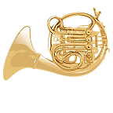**

**I used \_\_\_\_\_\_\_\_\_\_\_\_\_ inch pieces.**

**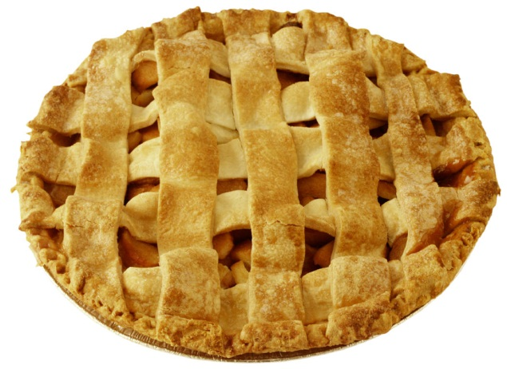**

**I used \_\_\_\_\_\_\_\_\_\_\_\_\_\_inch pieces.**

**MAKING A RULER**

**Name\_\_\_\_\_\_\_\_\_\_\_\_\_\_\_\_\_\_\_\_\_\_\_\_\_\_\_\_\_ Date\_\_\_\_\_\_\_\_\_\_\_\_\_\_\_\_\_\_\_\_\_\_\_\_\_\_\_\_\_\_\_**

**Glue 4 inch pieces together in this box. Do not overlap or leave gaps.**

**Glue 2 inch pieces together in this box. Do not overlap or leave gaps.**

**Glue 6 inch pieces together in this box. Do not overlap or leave gaps.**

**Color the longest group of inch pieces blue. Color the shortest group of inch pieces yellow.**

**FAL Assessment: Measurement**

See link below to access this assessment:

[Georgia Mathematics Educator Forum: Grades K-5 - K-5 Formative Assessment Lessons (FAL)](http://ccgpsmathematicsk-5.wikispaces.com/K-5+Formative+Assessment+Lessons+%28FALs%29)

**Task 3**

**CONSTRUCTING TASK: How Big is a Foot?**

*Approximately 2 days*

**STANDARDS FOR MATHEMATICAL CONTENT**

**MGSE1.MD.1** Order three objects by length; compare the lengths of two objects indirectly by using a third object.

**MGSE1.MD.2** **Express the length of an object as a whole number of length units, by laying multiple copies of a shorter object (the length unit) end to end; understand that the length measurement of an object is the number of same-size length units that span it with no gaps or overlaps. (Iteration)**

**MGSE1.MD.4.** Organize, represent, and interpret data with up to three categories; ask and answer questions about the total number of data points, how many in each category, and how many more or less are in one category than in another.

**STANDARDS FOR MATHEMATICAL PRACTICE**

1. Make sense of problems and persevere in solving them.

2. Reason abstractly and quantitatively.

3. Construct viable arguments and critique the reasoning of others. *Students discuss the drawbacks of using a singular measurement unit.*

4. Model with mathematics.

5. Use appropriate tools strategically.

6. Attend to precision.

7. Look for and make use of structure. *Students discover the benefits from a common unit of measure.*

8. Look for and express regularity in repeated reasoning.

**BACKGROUND KNOWLEDGE**

Students should be familiar with using measuring tools. They should be able to measuring an object correctly by placing the non-standard tool at the base or end of an object. When using multiple nonstandard objects, each object should be placed end to end without overlapping or gaps. There should be a common understanding that while students may each use a common unit, for example their own foot, they may find that their results differ.

**COMMON MISCONCEPTIONS**

Students often overlap or leave spaces when using multiple objects. Students sometimes do not realize they are measuring a unit of space.

**ESSENTIAL QUESTIONS**

* How can we measure the length of an object?
* How can we tell which of two objects is longer than the other?
* How can we order a group of objects by their length?

**MATERIALS**

* Reproducible foot cut-outs (all one foot long)
* *How Big Is a Foot?* by Rolf Myller or similar book
* “How Big is Foot” Student Task Sheet (copied twice, back to back, per student)
* Sentence strips or strips of tag board

**GROUPING**

Whole group/Individual

**TASK DESCRIPTION, DEVELOPMENT AND DISCUSSION**

**Part I**

Read the book, *How Big Is a Foot?,* by Rolf Myller (or similar book.). If the feet need to be cut out, have the students do so at this time. Have students work with partner to lay their feet cut-outs end to end. This will allow students to see why it is important to use the measurement tool back to back and not leave big gaps when measuring. You can also have students practice walking the rug, or the length of tables by walking heel to toe, heel to toe, to help them see this.

Allow students time to measure several distances with their “feet”.

**Part II**

Next, students should choose 5 items from the classroom to measure. They must estimate the number of “feet” first; measure the item next, and then record the actual measurement on the recording sheet. Also, have the students place the items they measured in order from longest to shortest or vice-versa. This could be recorded on their student task sheet. While students are measuring, ask the following questions about their findings:

* *Which of the two objects is longer than the other?*
* *Show me how to put these in order.*
* *What will you do for objects longer than your feet?*
* *Is it important to put the “feet” end to end? Why?*

After all groups have completed their recording sheet, take time to share results with the entire class. Be sure to ask each group of students if they measured using the length or the width of their foot. Encourage them to give reasons to support one way over the other but do not discourage them from choosing a particular way. However, make sure to discuss how this might affect their results.

**Part III**

Review Parts I and II of this lesson with the students. Ask them to share what they remember about using multiple feet versus only one unit of measure (a single footprint). Ask, *“What are the drawbacks to using only one unit of measure to determine the length of an object?”, “How might using only one unit affect your findings?”* Ultimately, you want students to discover that using only one single unit is not efficient. Have them create a measurement tool using their “feet” by using multiple copies to create a measurement tool of “5 feet”. Students could glue their footprints to sentence strips or tape each footprint, toe-to-heel, in groups of five to create a measurement tool. Once each student has created a tool, have them re-measure the same objects and record their findings on the second recording sheet.

Once students have completed the task with their measurement tool, have them answer the following question in their math journals:

* *What is an efficient method of measuring an object? Why?*

**FORMATIVE ASSESSMENT QUESTIONS**

* What will/did you do when the item was longer or further than the number of “feet” you had, what did you do to figure out an answer?
* Which do you prefer to use to measure, a single footprint or your measurement tool of “5 feet”? Why?
* How are you able to determine which the objects you have measured are longer than the other?

**DIFFERENTIATION**

**Extension**

* Have the students measure objects that are longer than the tool they created with the 5 feet. Have them explain how they dealt with this situation.

**Intervention**

* Have the students make a tool that is 3 feet long rather than 5 feet. Provide them with a precut strip of tag board upon which they will glue the feet.
* **Name \_\_\_\_\_\_\_\_\_\_\_\_\_\_\_\_\_\_\_\_\_\_\_\_ Date:\_\_\_\_\_\_\_\_\_\_\_\_\_\_\_\_\_\_\_**

[Description: http://tbn0.google.com/images?q=tbn:fQpQpHEnUi4PpM:http://www.donorbrick.com/images/clipart/foot.gifDescription: http://tbn0.google.com/images?q=tbn:fQpQpHEnUi4PpM:http://www.donorbrick.com/images/clipart/foot.gifDescription: http://tbn0.google.com/images?q=tbn:fQpQpHEnUi4PpM:http://www.donorbrick.com/images/clipart/foot.gifDescription: http://tbn0.google.com/images?q=tbn:fQpQpHEnUi4PpM:http://www.donorbrick.com/images/clipart/foot.gifDescription: http://tbn0.google.com/images?q=tbn:fQpQpHEnUi4PpM:http://www.donorbrick.com/images/clipart/foot.gifDescription: http://tbn0.google.com/images?q=tbn:fQpQpHEnUi4PpM:http://www.donorbrick.com/images/clipart/foot.gif](http://images.google.com/imgres?imgurl=http://www.donorbrick.com/images/clipart/foot.gif&imgrefurl=http://www.donorbrick.com/clipart.htm&h=63&w=35&sz=1&hl=en&start=8&tbnid=fQpQpHEnUi4PpM:&tbnh=63&tbnw=35&prev=/images?q=foot+clipart&gbv=2&hl=en)**How Big Is a Foot?**

|  |  |  |  |  |
| --- | --- | --- | --- | --- |
| **Object to be Measured** | **My Foot Estimate** | **My Foot Measurement** | **Was my estimate close?**  **Put an x in the box**  **Yes No** | |
|  |  |  |  |  |
|  |  |  |  |  |
|  |  |  |  |  |
|  |  |  |  |  |
|  |  |  |  |  |

**Task 4**

**3-Act Task: Lil’ Sisters and Me!**

*Adapted from:* [*http://gfletchy3act.wordpress.com/lil-sister/*](http://gfletchy3act.wordpress.com/lil-sister/)

**APPROXIMATE TIME: One class session**

**STANDARDS FOR MATHEMATICAL CONTENT**

**MGSE1.MD.1** Order three objects by length; compare the lengths of two objects indirectly by using a third object.

**MGSE1.MD.2** **Express the length of an object as a whole number of length units, by laying multiple copies of a shorter object (the length unit) end to end; understand that the length measurement of an object is the number of same-size length units that span it with no gaps or overlaps. (Iteration)**

**STANDARDS FOR MATHEMATICAL PRACTICE**

1. Make sense of problems and persevere in solving them*. Students are required to figure out a question to work through, the information they need to solve the problem, and then persevere until solving it.*

2. Reason abstractly and quantitatively. *Students are asked to make an estimate both high and low.*

3. Construct viable arguments and critique the reasoning of others*. Students will discuss the questions they have with partners, creating the opportunity to construct the argument of why they chose their question, as well as critiquing the questions that others came up with.*

4. Model with mathematics*. In first grade, students experiment with representing problem situations in multiple ways including numbers, pictures, and using objects.*

5. Use appropriate tools strategically. *First grade students will consider the available tools and decide which tools will be helpful for problem solving.*

6. Attend to precision. *Students will use clear and precise language when discussing their strategies and sharing their solutions with others.*

**ESSENTIAL QUESTIONS**

In order to maintain a student-inquiry-based approach to this task, it may be beneficial to wait until Act 2 to share the EQ’s with your students. By doing this, students will be allowed the opportunity to be very creative with their thinking in Act 1. By sharing the EQ’s in Act 2, you will be able to narrow the focus of inquiry so that the outcome results in student learning directly related to the content standards aligned with this task.

* How can we measure the length of an object?
* How can we compare the length of a set of objects?
* How can we order a group of objects by length?
* How do measurements help compare objects?

**MATERIALS**

* Act 1 Photo: 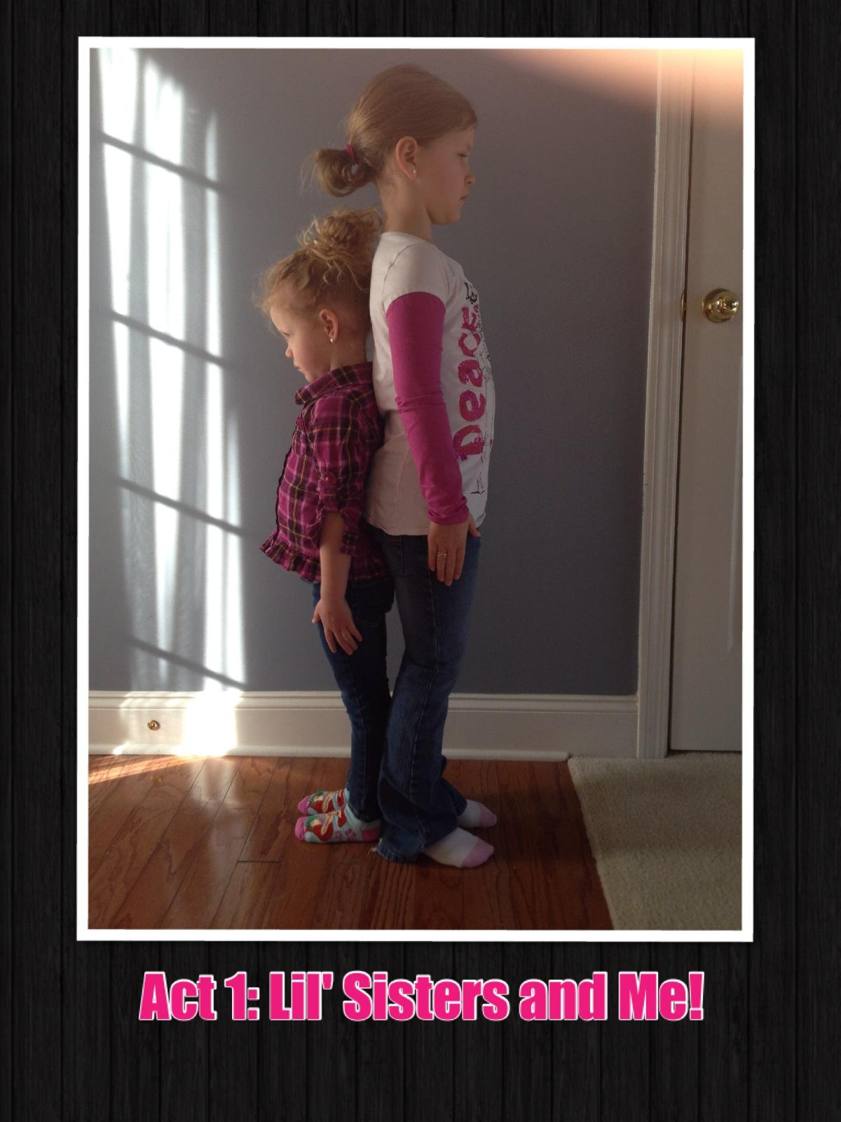
* Act 2 Photo: 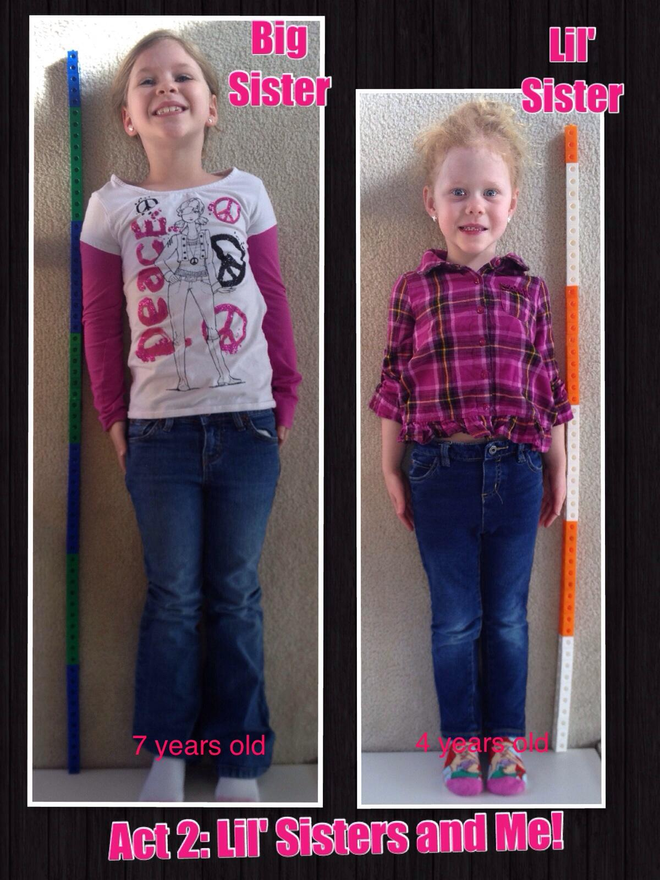
* Act 3 Photo: 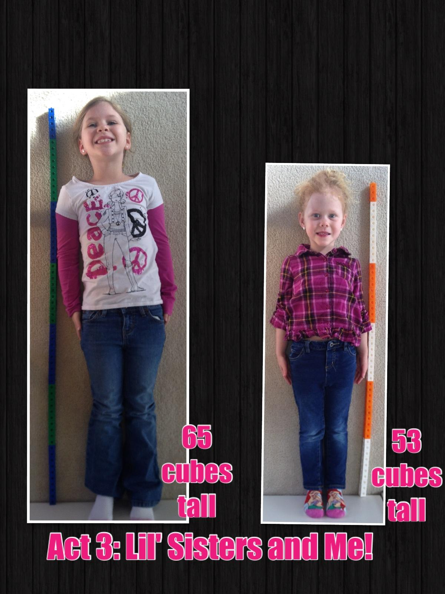
* Snap cubes or unifix cubes
* 3 Act Recording Sheet

**GROUPING**

Individual/Partner Task

**TASK DESCRIPTION, DEVELOPMENT AND DISCUSSION**

In this task, students will view the photo and tell what they noticed. Next, they will be asked to discuss what they wonder about or are curious about. These questions will be recorded on a class chart or on the board. Students will then use mathematics to answer their own questions. Students will be given information to solve the problem based on need. When they realize they don’t have the information they need, and ask for it, it will be given to them.

Students will begin the task by viewing a photo of two girls standing side by side. Then, the students will estimate the difference of their height compared to each of the girls. Students should actually measure themselves to determine their own height so that they can accurately compare their height to that of each girl. Though the height of each girl (in nonstandard units) is revealed in the Act 2 photo (attached), students may want to recreate the girls’ height using unifix cubes so that they can compare the all three measurements. Finally, students will analyze the information to then write comparative statements that describe their own height compared to each of the girls.

**Background Knowledge**

This task follows the 3-Act Math Task format originally developed by Dan Meyer. More information on this type of task may be found at <http://blog.mrmeyer.com/category/3acts/>. A Three-Act Task is a whole-group mathematics task consisting of 3 distinct parts: an engaging and perplexing Act One, an information and solution seeking Act Two, and a solution discussion and solution revealing Act Three. More information along with guidelines for 3-Act Tasks may be found in the ***Guide to Three-Act Tasks*** on georgiastandards.org and the K-5 CCGPS Mathematics Wiki.

Prior to this task, students should have an understanding of units of measurement and have multiple experiences measuring objects using direct comparison and various measurement tools.

**Task Directions:**

**Part I**

**Act 1 – Whole Group** - Pose the conflict and introduce students to the scenario by showing Act I picture. **(Dan Meyer**<http://blog.mrmeyer.com/2011/the-three-acts-of-a-mathematical-story/>**)**

**“Introduce the central conflict of your story/task clearly, visually, viscerally, using as few words as possible.”**

1. Show Act 1 photo to students. 
2. Ask students what they noticed in the photo, what they wonder about, and what questions they have about what they saw in the picture. Consider doing a think-pair-share so that students have an opportunity to talk with each other before sharing questions with the whole group.
3. Share and record students’ questions. The teacher may need to guide students so that the questions generated are math-related.
4. Ask students to estimate answers to their questions (think-pair-share). For the question “How does your height compare with the height of the girls?”, students write down an estimate on the recording sheet, then write down two more estimates – one that is too low and one that is too high. This is an excellent time to informally assess a student’s understanding of quantity sizes, making comparisons, and nonstandard units of measure. Next, students discuss the questions and determine the information they need.

**Anticipated questions students may ask and wish to answer:**

* How tall are the girls?
* How tall am I?
* What much taller am I than the oldest girl? the youngest girl?
* Who is the tallest? The shortest?

**Act 2** – **Student Exploration** - Provide additional information as students work toward solutions to their questions. **(Dan Meyer**<http://blog.mrmeyer.com/2011/the-three-acts-of-a-mathematical-story/>**)**

**“The protagonist/student overcomes obstacles, looks for resources, and develops new tools.”**

* During Act 2, students review the main question(s) from Act 1 and decide on the facts, tools, and other information needed to answer the question(s). When students decide what they need to solve the problem, they should ask for those things. It is pivotal to the problem solving process that students decide what is needed without being given the information up front.
* The teacher provides guidance during this phase. Some groups might need scaffolds to guide them. The teacher should question groups who seem to be moving in the wrong direction or might not know where to begin. Questioning is an effective strategy that can be used, with questions such as:
  + What is the problem you are trying to solve?
  + What do you think affects the situation?
  + Can you explain what you’ve done so far?
  + What strategies are you using?
  + What assumptions are you making?
  + What tools or models may help you?
  + Why is that true?
  + Does that make sense?

Additional Act 2 Information:



Important note: Although students will only investigate the main question(s) for this task, it is important for the teacher to not ignore student generated questions. Additional questions may be answered after they’ve found a solution to the main question, or as homework or extra projects.

**Act 3 – Whole Group** – Share solutions and strategies.

1. Students to present their solutions and strategies and compare them.
2. Reveal the solution in the Act 3 picture. 
3. Lead discussion to compare these, asking questions such as:
4. How reasonable was your estimate?
5. Which strategy was most efficient?
6. Can you think of another method that might have worked?
7. What might you do differently next time?

**Act 4, The Sequel -** “The goals of the sequel task are to a) challenge students who finished quickly so b) I can help students who need my help. It can't feel like punishment for good work. It can't seem like drudgery. It has to entice and activate the imagination.” Dan Meyer <http://blog.mrmeyer.com/2013/teaching-with-three-act-tasks-act-three-sequel/>

For Act 4, reference other student-generated questions that could be used for additional class work, projects or homework.

**FORMATIVE ASSESSMENT QUESTIONS**

● What strategies did you use to determine how tall the girls are?

* Which strategies worked most efficiently for you? Why?
* Describe how you determined how tall you are.
* Describe the strategies you used to determine how your height compares to that of each of the girls.

**Part II**

**Journal Writing:** Have students reflect on the task and write (or blog) about what they perceived to challenging about the task and enjoyable about the task.

**DIFFERENTIATION**

**Extension**

*If you had to order you and the girls in a way that makes sense to you, how would you do it?* Share your mathematical thinking in your journal or blog.

**Intervention**

Have the student build cube towers that represent the height of each of the girls, as well as, their own height. Have them use the models to help them compare their own height to that of the girls in the photo.

Act 1:



**Act 2:**



**Act 3:**



Name:\_\_\_\_\_\_\_\_\_\_\_\_\_\_\_\_\_\_\_\_\_\_\_\_\_\_\_\_

Task: Lil’ Sisters and Me!

Act 1:

What information do you already have?

|  |  |  |
| --- | --- | --- |
| **Estimate how tall you are compared to:**  Big Sister: \_\_\_\_\_\_\_ taller  Lil’ Sister: \_\_\_\_\_\_\_ taller | **Write an estimate that is too high:**  Big Sister:\_\_\_\_\_\_\_\_ taller  Lil’ Sister: \_\_\_\_\_\_\_ taller | **Write an estimate that is too low:**  Big Sister:\_\_\_\_\_\_\_\_ taller  Lil’ Sister: \_\_\_\_\_\_\_ taller |

I know that \_\_\_\_\_\_\_\_\_\_\_\_\_\_\_\_\_\_\_\_\_\_\_\_\_\_\_\_\_\_\_\_\_\_\_\_\_\_\_\_\_\_\_\_\_\_\_\_\_\_\_\_\_\_\_\_\_\_\_\_

\_\_\_\_\_\_\_\_\_\_\_\_\_\_\_\_\_\_\_\_\_\_\_\_\_\_\_\_\_\_\_\_\_\_\_\_\_\_\_\_\_\_\_\_\_\_\_\_\_\_\_\_\_\_\_\_\_\_\_\_

\_\_\_\_\_\_\_\_\_\_\_\_\_\_\_\_\_\_\_\_\_\_\_\_\_\_\_\_\_\_\_\_\_\_\_\_\_\_\_\_\_\_\_\_\_\_\_\_\_\_\_\_\_\_\_\_\_\_\_\_

Or, draw a picture of what you know:

|  |
| --- |
|  |

Act 2: What information do you need to find out?

I need to know \_\_\_\_\_\_\_\_\_\_\_\_\_\_\_\_\_\_\_\_\_\_\_\_\_\_\_\_\_\_\_\_\_\_\_\_\_\_\_\_\_\_\_\_\_\_\_\_\_\_\_\_\_\_\_\_\_\_\_\_

\_\_\_\_\_\_\_\_\_\_\_\_\_\_\_\_\_\_\_\_\_\_\_\_\_\_\_\_\_\_\_\_\_\_\_\_\_\_\_\_\_\_\_\_\_\_\_\_\_\_\_\_\_\_\_\_\_\_\_\_

\_\_\_\_\_\_\_\_\_\_\_\_\_\_\_\_\_\_\_\_\_\_\_\_\_\_\_\_\_\_\_\_\_\_\_\_\_\_\_\_\_\_\_\_\_\_\_\_\_\_\_\_\_\_\_\_\_\_\_

I will find this information out by \_\_\_\_\_\_\_\_\_\_\_\_\_\_\_\_\_\_\_\_\_\_\_\_\_\_\_\_\_\_\_\_\_\_\_\_\_

\_\_\_\_\_\_\_\_\_\_\_\_\_\_\_\_\_\_\_\_\_\_\_\_\_\_\_\_\_\_\_\_\_\_\_\_\_\_\_\_\_\_\_\_\_\_\_\_\_\_\_\_\_\_\_\_\_\_\_\_

Act 3:

I can use an open number line to show the difference in my height and the big sister, like this:

open_number_line.png

I can use an open number line to show the difference in my height and the lil’ sister, like this:

open_number_line.png

Write two comparative sentences telling how your height compares with each of the girls. Be sure to use phrases like, “shorter than”, “taller than”, “more than”, “less than”, or “equal to” when communicating your mathematical thinking.

\_\_\_\_\_\_\_\_\_\_\_\_\_\_\_\_\_\_\_\_\_\_\_\_\_\_\_\_\_\_\_\_\_\_\_\_\_\_\_\_\_\_\_\_\_\_\_\_\_\_\_\_\_\_\_\_\_\_\_\_

\_\_\_\_\_\_\_\_\_\_\_\_\_\_\_\_\_\_\_\_\_\_\_\_\_\_\_\_\_\_\_\_\_\_\_\_\_\_\_\_\_\_\_\_\_\_\_\_\_\_\_\_\_\_\_\_\_\_\_\_

\_\_\_\_\_\_\_\_\_\_\_\_\_\_\_\_\_\_\_\_\_\_\_\_\_\_\_\_\_\_\_\_\_\_\_\_\_\_\_\_\_\_\_\_\_\_\_\_\_\_\_\_\_\_\_\_\_\_\_\_

\_\_\_\_\_\_\_\_\_\_\_\_\_\_\_\_\_\_\_\_\_\_\_\_\_\_\_\_\_\_\_\_\_\_\_\_\_\_\_\_\_\_\_\_\_\_\_\_\_\_\_\_\_\_\_\_\_\_\_\_

**Task 5**

**PRACTICE TASK: Groundhog’s Garden**

*Approximately 2 days*

**STANDARDS FOR MATHEMATICAL CONTENT**

**MGSE1.MD.1** Order three objects by length; compare the lengths of two objects indirectly by using a third object.

**MGSE1.MD.2** **Express the length of an object as a whole number of length units, by laying multiple copies of a shorter object (the length unit) end to end; understand that the length measurement of an object is the number of same-size length units that span it with no gaps or overlaps. (Iteration)**

**STANDARDS FOR MATHEMATICAL PRACTICE**

1. Make sense of problems and persevere in solving them.

2. Reason abstractly and quantitatively. *Students represent the entire length of each flower with a numeral.*

3. Construct viable arguments and critique the reasoning of others.

4. Model with mathematics.

5. Use appropriate tools strategically. *Students utilize measurement tools to determine the length of flowers and make comparisons.*

6. Attend to precision.

7. Look for and make use of structure.

8. Look for and express regularity in repeated reasoning.

**BACKGROUND KNOWLEDGE/COMMON MISCONCEPTIONS**

Students should have an understanding of units of measurement and have multiple experiences measuring objects using direct comparison and various measurement tools.

**ESSENTIAL QUESTIONS**

* How can we measure the length of an object?
* How can we compare the length of a set of objects?
* How can we order a group of objects by length?

**MATERIALS**

* One copy of flower sheet per student
* Worms or ladybugs measuring tool sheet (each sheet has tools for two students)
* *How Groundhog’s Garden Grew,* by Lynne Cherry, or similar text
* “Groundhog’s Garden” Recording Sheet

**GROUPING**

Individual

**TASK DESCRIPTION, DEVELOPMENT, AND DISCUSSION**

**Part I**

Begin the lesson by reading, *How Groundhog’s Garden Grew*, by Lynne Cherry (or similar story.) Discuss the different plants in the story, and how you might go about measuring them. How could you measure flowers if Groundhog planted a flower garden?

Next, have students cut out the single ladybug and the single worm on the task sheet. Have students practice measuring each flower using each object. The teacher should note that the ladybugs measure to 1 centimeter and the worms measure to 1 inch. After students have had time to measure each one using each single unit, lead them in a discussion about how much easier it is to use a measuring tool, rather than a single unit. Ask them to compare the previous tasks and the level of success they felt they had using the tools they created versus the frustrations they may have had using the single units (single footprint). Once students recognize the need for a measurement tool, move on to part II.

**Part II**

**Task Directions**

Each student will have a bag of flowers and a measuring tool - either worms or ladybugs.

1. The student will choose 5 flowers to measure.

2. They will record an estimate first before measuring with their ladybugs or worms.

3. Have the students measure the length of the flower card.

4. Record measurements on the recording sheet.

5. The student will paste the flowers in an order that makes sense to them onto the back of their

recording sheet.

6. The student will explain what they discovered while measuring flowers and describe how the

flowers were ordered.

**Part III**

To extend students’ experiences using measurement tools and to emphasize the need for using a measurement tool, have students engage in the activity, “*Estimate and Measure*”. (Van de Walle, Activity 15.12, page 283) Make a list of things in the room to measure. Have students make a row or chain of exactly ten units (allow them to choose from a set of materials) to use in helping measure the object. First, have them estimate the length of the object to be measured and then lay the measuring tool against the object to record an actual measurement. Once all students have completed the activity, have them share their measuring tool and explain why they chose the units they selected. *How did their measurements compare to those other students determined? What factors may have caused their results to differ?*

**FORMATIVE ASSESSMENT QUESTIONS**

* How did you order the flowers and why did you choose to do it in that way?
* (When measuring the flowers) Show me where you are putting your measuring tool.
* What do you think your measurements would have been if you chose the other measuring tool? Why?

**DIFFERENTIATION**

**Extension**

* “Crooked Paths” (Van de Walle, page 297) Make several lines of masking tape on the floor for students to measure distances. Be sure to include distances that are curved and crooked, in addition to straight lines. Require students to estimate the measurement of each, predict which distance will be longer (or shorter) and then take an actual measurement using the tool of their choice.

**Intervention**

* Draw a line from the base of the flower to the top for students to use as a guide when measuring.
* “Guess and Measure” (Van de Walle, Actvity 15.12, page 283). **Flowers for Groundhog’s Garden**

**Flower 1 Flower 2 Flower3 Flower 4 Flower 5 Flower 6**

********





Cut out each measuring tool. Measure your flowers and record your results on the recording sheet.



**Name \_\_\_\_\_\_\_\_\_\_\_\_\_\_\_\_\_\_\_\_\_\_ Date:\_\_\_\_\_\_\_\_\_\_\_\_\_\_\_\_**

**Flower Measurement Recording Sheet**

**Directions: Estimate the length of each flower below. Then measure and record the length of each flower below.**

|  |  |  |  |  |
| --- | --- | --- | --- | --- |
| **Flower Number** | **Estimate** | | **Actual Measure** | |
| **Ladybug** | **Worm** | **Ladybug** | **Worm** |
| **1** |  |  |  |  |
| **2** |  |  |  |  |
| **3** |  |  |  |  |
| **4** |  |  |  |  |
| **5** |  |  |  |  |
| **6** |  |  |  |  |

After recording the measurements for each flower, glue the flowers onto the back of this sheet in an order that make sense to you. Explain how the flowers are ordered:

\_\_\_\_\_\_\_\_\_\_\_\_\_\_\_\_\_\_\_\_\_\_\_\_\_\_\_\_\_\_\_\_\_\_\_\_\_\_\_\_\_\_\_\_\_\_\_\_\_\_\_\_\_\_\_\_\_\_\_\_\_\_\_\_\_\_\_\_\_\_\_\_\_\_\_\_\_\_\_\_\_\_\_\_\_\_\_\_\_\_\_\_\_\_\_\_\_\_\_\_\_\_\_\_\_\_\_\_\_\_\_\_\_\_\_\_\_\_\_\_\_\_\_\_\_\_\_\_\_\_\_\_\_\_\_\_\_\_\_\_\_\_\_\_\_\_\_\_\_\_\_\_\_\_\_\_\_\_\_\_\_\_\_\_\_\_\_\_\_\_\_\_\_\_\_\_\_\_\_\_\_\_\_\_\_\_\_\_\_\_\_\_\_\_\_

**Task 6**

**CONSTRUCTING TASK: What Shape Are You?**

*\*Adapted from Are You a Square? By Marilyn Burns*

*Approximately 1 day*

**STANDARDS FOR MATHEMATICAL CONTENT**

**MGSE1.MD.1** Order three objects by length; compare the lengths of two objects indirectly by using a third object.

**MGSE1.MD.2** **Express the length of an object as a whole number of length units, by laying multiple copies of a shorter object (the length unit) end to end; understand that the length measurement of an object is the number of same-size length units that span it with no gaps or overlaps. (Iteration)**

**MGSE1.MD.4** Organize, represent, and interpret data with up to three categories; ask and answer questions about the total number of data points, how many in each category, and how many more or less are in one category than in another.

**STANDARDS FOR MATHEMATICAL PRACTICE**

1. Make sense of problems and persevere in solving them.

2. Reason abstractly and quantitatively. *Students compare the measured height and length of themselves.*

3. Construct viable arguments and critique the reasoning of others.

4. Model with mathematics.

5. Use appropriate tools strategically.

6. Attend to precision. *Students use explicit language in discussion of measured height and length,* *comparing those measurements, graphing class results, and interpreting data collected.*

7. Look for and make use of structure.

8. Look for and express regularity in repeated reasoning.

**BACKGROUND KNOWLEDGE/COMMON MISCONCEPTIONS**

Students should have some understanding of appropriate units of measure in relationship to the size of the object being measured. Ex: It would not be efficient to measure the length of the white board using inch long paper clips. More appropriate tools would include: outline of foot from previous task, inchworm ruler, and ladybug ruler.

**ESSENTIAL QUESTIONS**

* How are single units used to measure objects?
* How are measuring units selected?
* How do measurements help compare objects?

**MATERIALS**

* Yarn (enough for each student)
* Various units of measure for students to choose from (various small and large tools for discussion in Part I)
* Sticky notes (enough for each student to have 1)
* Chart paper (1-2 sheets, see diagram in Part II)
* “What Shape Are You?” recording sheet (1 per pair of students)

**GROUPING**

Whole group/Partners

**TASK DESCRIPTION, DEVELOPMENT, AND DISCUSSION**

**Part I**

Students will work in pairs for this activity. They will measure each other's height and length of reach by using a piece of yarn. The teacher will need to model these measurements so that all the students are clear on the procedure. Then, they will decide on a measuring tool (from a set) to determine the number of units long their height and length of reach are. Once they have determined their "measurements" they will then decide which category they belong in (square, tall or wide rectangle) and place their sticky note on the chart.

**Part II**

Once everyone in the class has posted their findings, allow students to share their results. Then, graph the results and have a class discussion. Possible questions to pose include:

* *Which does our class have the most of? Tall or wide rectangles?*
* *How many squares does our class have?*
* *Do we have an equal amount of any shapes?*

Discuss the various measurement tools students chose to use. Ask students to explain why they chose the tool they used and ask students if they would be able to determine, based on the data they collected, who is the tallest (or shortest) in the class? Why or why not?

**DIFFERENTIATION**

**Extension**

* Use Van de Walle, Activity 15.13, “Changing Units,” page 284 to give students opportunities to estimate the length of their height using a different unit of measure than they used in the task.

**Intervention**

* You may want to provide a large standard unit of measurement for the student to use when measuring his or her height or length of reach, so that organization is less of an issue.
* *Who is taller than \_\_\_\_\_\_\_\_\_\_?*  Students will stand back-to-back with the other students and determine if they are taller than, the same as, or shorter than each classmate. As they identify which of those they are in relation to each student, they will record the information on a task sheet. After all data is collected, the student will answer questions about the data, such as: *Are you taller or shorter than most students in the class? How many students are the same height as you?*

**What Shape Are You? Recording Sheet**

[](http://www.clker.com/cliparts/9/5/f/c/11949954201129417153ungroup.svg.med.png)

**Partner 1: \_\_\_\_\_\_\_\_\_\_\_\_\_\_\_\_\_\_\_\_\_**

Unit of measurement used: \_\_\_\_\_\_\_\_\_\_\_\_\_\_\_\_

Length of reach (left fingertip to right fingertip):\_\_\_\_\_\_\_\_\_\_\_\_\_\_\_

Length of height (top of head to bottom of feet):\_\_\_\_\_\_\_\_\_\_\_\_\_\_\_

**Partner 2: \_\_\_\_\_\_\_\_\_\_\_\_\_\_\_\_\_\_\_\_\_**

Unit of measurement used: \_\_\_\_\_\_\_\_\_\_\_\_\_\_\_\_

Length of reach (left fingertip to right fingertip):\_\_\_\_\_\_\_\_\_\_\_\_\_\_\_

Length of height (top of head to bottom of feet):\_\_\_\_\_\_\_\_\_\_\_\_\_\_\_

[](http://www.clker.com/cliparts/9/5/f/c/11949954201129417153ungroup.svg.med.png)

**What Shape Are You? Recording Sheet**

**Partner 1: \_\_\_\_\_\_\_\_\_\_\_\_\_\_\_\_\_\_\_\_\_**

Unit of measurement used: \_\_\_\_\_\_\_\_\_\_\_\_\_\_\_\_

Length of reach (left fingertip to right fingertip):\_\_\_\_\_\_\_\_\_\_\_\_\_\_\_\_

Length of height (top of head to bottom of feet):\_\_\_\_\_\_\_\_\_\_\_\_\_\_\_\_

**Partner 2: \_\_\_\_\_\_\_\_\_\_\_\_\_\_\_\_\_\_\_\_\_**

Unit of measurement used: \_\_\_\_\_\_\_\_\_\_\_\_\_\_\_\_

Length of reach (left fingertip to right fingertip):\_\_\_\_\_\_\_\_\_\_\_\_\_\_\_\_

Length of height (top of head to bottom of feet):\_\_\_\_\_\_\_\_\_\_\_\_\_\_\_\_

**Task 7**

**SCAFFOLDING TASK: It’s Time, Part I: Using a Number Line**

*Approximately 3-4 days*

**STANDARDS FOR MATHEMATICAL CONTENT**

**MGSE1.MD.3** Tell and write time in hours and half-hoursusing analog and digital clocks.

**STANDARDS FOR MATHEMATICAL PRACTICE**

1. Make sense of problems and persevere in solving them. *Students create a personalized timeline and verifying their sequence of activities.*

2. Reason abstractly and quantitatively.

3. Construct viable arguments and critique the reasoning of others.

4. Model with mathematics.

5. Use appropriate tools strategically.

6. Attend to precision*. Students communicate about students’ timelines and discuss their reasoning for their choice of placement.*

7. Look for and make use of structure.

8. Look for and express regularity in repeated reasoning.

**BACKGROUND INFORMATION**

Another variation on teaching students how to tell time on the clock is by using the number line. The number line is a useful way to help students understand the movement of the hands of the clock. Also, connecting the number line and the clock is helpful in developing student’s number sense.

It is important to note that *am* and *pm* are discussed within this task. It is not part of the first grade standards for students to master this concept and they are not officially introduced to the concept of am and pm until 2nd grade. However, some discussion of *am* and *pm* is needed to build student understanding of the concept of time.

**ESSENTIAL QUESTIONS**

* What does the hour hand on a clock tell us?
* Why do we need to be able to tell time?

**MATERIALS**

* *It’s Time: Part I* task sheet
* 12 sheets of cardstock or construction paper
* Brass fasteners (13)
* Markers
* 1 ruler
* Masking tape
* 1 piece of construction paper, cut into a triangle to tape to the tip of the ruler.

**GROUPING**

Whole Group/Individual

**TASK DESCRIPTION, DEVELOPMENT, AND DISCUSSION**

**Part I**

Gather students in a common area and discuss prior knowledge of a number line. Ask, “Do you know of any connections between a number line and telling time?” Introduce the important term, “Clockwise” and allow students to see the connection between the term and the direction of the moving hands on a clock.

Lead students in a discussion about am and pm. Encourage students to make the connection of each by explaining that the hands on a clock travel completely around the clock, twice, to make a full day (24 hours). The am hours represent one trip around the clock and the pm hours represent the second trip around the clock. Lead students to brainstorm activities that occur during these time periods by asking questions such as, “What are you doing at 3 am?” “What might your family be doing at 5 pm?”

Prepare to create two clocks by assigning each student an hour of the day and have the student illustrate an appropriate activity that might occur during that hour. If you have less than 24 students, you may need to assign some students more than one hour.

**Part II**

Once the illustrations are complete for each hour, ask the students to lay their hours in order. Ask them to take their illustration to the floor and place them, as a group, in an order that makes sense to them. The teacher should not influence where the students place their hours. More than likely, they will place their hours with like numbers. If this occurs, use this scenario to show the separation of am and pm. Ask the students to make a number line, using their illustrations. Discuss with the students that even though they are individual hours, they are all connected and complete a full rotation around a clock. Tell them that they are going to make two number lines to represent the hour hand traveling twice around the clock to complete a full day. Punch the lower left hand corner of each sheet and connect the hours with brass fasteners as you have this discussion.



As students are working together to create a number line that reflects hours in a day, listen to the conversations they have with each other. There may be some students who insist that the numeral 1 come first on the number line and others who insist that the 12 comes first. How are they able to justify their reasoning? The students may request that you help them settle the mathematical dispute, but try to encourage them to share what they know to teach each other. If this situation occurs, use questioning to help them explain their rationale for placing the 1 or 12 at the start of the number line.

Suggested questions include:

* *What do you know about the hours in a day that help you determine what number should go first?*
* *What do you know about a number line that helps you decide what number should go first or last?*
* *What experiences with time have helped you with this task?*

Once students are satisfied with the number lines they have created, allow each group to share their number line and explain to the other group how they determined the placement of each hour. Discuss the differences in each, if there are any, and clear up any misconceptions. Lead a class discussion using the following suggested questions:

* *Does this number line remind you of anything?*
* *Where should 12 be in this progression of numbers?*
* *What number comes after twelve on a number line?*
* *What number comes before one??*
* *What if I take these cards and rearrange them, and instead of putting them in a line, put them in a circle? What would this look like?*
* *Does this number line remind you of anything we have in our room or that you have seen on the wall?*

Once both groups have had the opportunity to share and you have lead a meaningful discussion of the number line as it relates to time, allow students to write in the math journal about their experience. Have them answer the following questions and allow them to share after they have all had time to reflect on the task:

* *Are there any differences between a traditional number line and a number line that represents time? If so, what are they?*
* *What is something new you learned today that you did not know before? Anything that surprised you?*
* *Is there anything that is unclear to you or that you would like more practice with?*

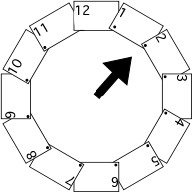Next, connect and fasten the 12th and the 1st hour by arranging the cards in a circle. Connect a triangle to the tip of the ruler using masking tape. Explain to students that this will represent the hour hand for the clock.

**Part III**

Using the large class made clocks, give students several practice opportunities to make time. Line half of the class up at each clock. Explain to students that one student at a time, from each group, will make time to the hour on the clock. (Ex. Heather is standing in line at one clock and Natisha is standing in line at the other clock. The teacher calls out “4:00”. Each student makes the time on the clock using the hour hand. All students check to see if they are correct by showing thumbs up if they agree with the time made, or thumbs down if they disagree.). Continue giving practice opportunities until it seems that all students have developed proficiency making time to the hour.

**Part IV**

Once student demonstrate proficiency making time on a clock to the hour, call out an activity and allow students to determine the approximate time it would occur. Students should show the time on student geared clocks (Judy clocks or similar clocks). Have the students show the time on their clock. Call on students to justify their answers. Suggestions:

* Eat dinner
* Get dressed for school
* Attend baseball practice
* Sleep
* Dream
* Take a bath
* Read a book
* Have recess
* Eat lunch
* Write a story

**Part V**

Have students return to their seat to create a number line of their own, using time to the hour. Give each student the *It’s Time Part I* task sheet and have them demonstrate their understanding of time as linear measurement and their ability to identify time to the hour on an analog and digital clock. Students will choose 5 things they love to do throughout the day and write the time on the analog clock and digital clock along with a short description of the event. They will then cut out each strip and glue them in order to create a number line. Allow students to share these with the whole group once all students have sequenced the events of their choosing.

**FORMATIVE ASSESSMENT QUESTIONS**

* How are a clock and a number line related?
* What differences are there in a regular number line and one that measures time?
* What types of activities would occur during the am hours? The pm hours?

**DIFFERENTIATION**

**Extension**

* Make several cards that have time to the hour in the form of an analog clock and a digital clock. On a long sheet of construction paper, draw an empty number line. Have students place the cards correctly on the number line to reflect time. You could also include a short task sheet that requires them to answer questions about their number line, such as: *What hour comes before \_\_\_\_\_ ? After \_\_\_\_\_? “I started with \_\_\_\_ o’clock because I know that…”* Or have students write questions of their own for other students to answer.

**Intervention**

* Help the student create a “My Day Timeline” whereby s/he lists the events of his or her day, hour by hour, to attach meaning to the concept of time. This activity provides a good scaffold if the class is experiencing difficulty with the task.

|  |  |  |
| --- | --- | --- |
| http://www.videomathtutor.com/E-Store/Printshop/Printshop/page3_files/stacks_image_1876_1.png | http://www.videomathtutor.com/E-Store/Printshop/Printshop/page3_files/stacks_image_1876_1.png | Explain why the event could happen  at this time.  \_\_\_\_\_\_\_\_\_\_\_\_\_\_\_\_  \_\_\_\_\_\_\_\_\_\_\_\_\_\_\_\_  \_\_\_\_\_\_\_\_\_\_\_\_\_\_\_\_  \_\_\_\_\_\_\_\_\_\_\_\_\_\_\_\_ |
| http://www.videomathtutor.com/E-Store/Printshop/Printshop/page3_files/stacks_image_1876_1.png | http://www.videomathtutor.com/E-Store/Printshop/Printshop/page3_files/stacks_image_1876_1.png | Explain why the event could happen  at this time.  \_\_\_\_\_\_\_\_\_\_\_\_\_\_\_\_  \_\_\_\_\_\_\_\_\_\_\_\_\_\_\_\_  \_\_\_\_\_\_\_\_\_\_\_\_\_\_\_\_  \_\_\_\_\_\_\_\_\_\_\_\_\_\_\_\_ |
| http://www.videomathtutor.com/E-Store/Printshop/Printshop/page3_files/stacks_image_1876_1.png | http://www.videomathtutor.com/E-Store/Printshop/Printshop/page3_files/stacks_image_1876_1.png | Explain why the event could happen  at this time.  \_\_\_\_\_\_\_\_\_\_\_\_\_\_\_\_  \_\_\_\_\_\_\_\_\_\_\_\_\_\_\_\_  \_\_\_\_\_\_\_\_\_\_\_\_\_\_\_\_  \_\_\_\_\_\_\_\_\_\_\_\_\_\_\_\_ |
| http://www.videomathtutor.com/E-Store/Printshop/Printshop/page3_files/stacks_image_1876_1.png | http://www.videomathtutor.com/E-Store/Printshop/Printshop/page3_files/stacks_image_1876_1.png | Explain why the event could happen at this time.  \_\_\_\_\_\_\_\_\_\_\_\_\_\_\_\_  \_\_\_\_\_\_\_\_\_\_\_\_\_\_\_\_  \_\_\_\_\_\_\_\_\_\_\_\_\_\_\_\_  \_\_\_\_\_\_\_\_\_\_\_\_\_\_\_\_ |
| http://www.videomathtutor.com/E-Store/Printshop/Printshop/page3_files/stacks_image_1876_1.png | http://www.videomathtutor.com/E-Store/Printshop/Printshop/page3_files/stacks_image_1876_1.png | Explain why the event could happen at this time.  \_\_\_\_\_\_\_\_\_\_\_\_\_\_\_\_  \_\_\_\_\_\_\_\_\_\_\_\_\_\_\_\_  \_\_\_\_\_\_\_\_\_\_\_\_\_\_\_\_  \_\_\_\_\_\_\_\_\_\_\_\_\_\_\_\_ |

**Task 8**

**CONSTRUCTING TASK: It’s Time – Part II**

*Approximately 3-4 days*

**STANDARDS FOR MATHEMATICAL CONTENT**

**MGSE1.MD.3** Tell and write time in hours and half-hoursusing analog and digital clocks.

**STANDARDS FOR MATHEMATICAL PRACTICE**

1. Make sense of problems and persevere in solving them.

2. Reason abstractly and quantitatively. *Students link the numerals on the digital and analog clocks to a quantity of time.*

3. Construct viable arguments and critique the reasoning of others.

4. Model with mathematics.

5. Use appropriate tools strategically.

6. Attend to precision. *Students use explicit language discussing progression of time in the task.*

7. Look for and make use of structure.

8. Look for and express regularity in repeated reasoning.

**BACKGROUND KNOWLEDGE/COMMON MISCONCEPTIONS**

Children at this stage are usually shown the time set exactly to the hour or half hour. Be sure to show children that when the time is shown to the half-hour, that the hour hand is actually between the current hour and the next hour (for example: if the time is 4:30, the hour hand is set between the 4th and 5th hour.). This will help students understand the functions of the two hands on a clock. The little hand indicates an approximate time (nearest hour), and the big hand indicates time (minutes) before or after an hour. When we look at the hour hand, we focus on where it is pointing. With the minute hand, the focus is on the distance that it has gone around the clock or the distance yet to go for the hand to get back to the top (Van de Walle & Lovin 2006).

**ESSENTIAL QUESTIONS**

* What does the hour hand on a clock tell us?
* Why do we need to be able to tell time?
* What do the two hands on the clock tell us?

**MATERIALS**

* “It’s Time!” Student clock sheet, one per student printed on cardstock
* “It’s Time!” Student recording sheet (copy only 1 sheet per pair of students and cut in half)
* Brass fasteners (one per student)
* *The Grouchy Lady Bug* by Eric Carle, or similar book
* Flip book (one for each child), each page stamped with an analog clock face

**GROUPING**

Large or small group

**TASK DESCRIPTION, DEVELOPMENT, AND DISCUSSION**

**Part I**

Prior to the lesson, set out a digital clock and an analog clock for display. Review with students the similarities and differences among each of the two clocks and ways in which we use them. Allow students to share where they have seen each of the two different types of clocks.

Tell students that you are going to make a clock much like an analog clock. Distribute the “It’s Time!” task sheet and help each student make their own clock (Rather than giving them a clock with numbers already printed, allow students to write the numbers in the correct positions.) and attach the hour hand **only** with a brass fastener. Using approximate language, give students several opportunities to make the time to the hour on their clock (ex: “It’s about 7 o’clock.” “It’s a little past 9 o’clock.”). Ask these sample questions as you give students this practice opportunity:

* *What hour are we in now?*
* *How do you know we are still in the \_\_\_\_\_\_\_\_\_ hour?*

**Part II**

After practicing with clocks, read *The Grouchy Ladybug* and have students move the hand of their clocks to match the time in the story. Make sure to have the students notice and talk about how the display of time is different when the ladybug meets the whale (it shows time in 15 minute increments instead of hour increments, but students may not be aware of this.). Students may mention that the other hand, or minute hand, has moved. If the discussion does not naturally lend itself to discussion of the minute hand, use these questions as a guide:

* How did the movement of the clock hands change in this part of the story?
* What do you notice about the hands at each hour? What is the minute hand doing? What is the hour hand doing?
* What can happen during the duration of an hour or in one minute?

Give students “It’s Time!” recording sheet with clock faces and an analog clock. Students should draw the hour hand on the clock faces and write the digital time to match the event described above each ladybug. Again, stress that the hour hand is the shorter hand and does not normally touch the numbers on the face of the clock that mark the hours.

**Part III**

Students will make a flipbook. In the flipbook they will write a time story similar to *The Grouchy Lady Bug*. Show students an example of a flipbook to give them an idea for their own time story. On the front will be the title, your name and an illustration (ex: The Busy Bee). Inside, students will draw/stamp a clock and draw the hands of the clock. The student will write a sequenced story like the one from *The Grouchy Ladybug.* In your example, be sure to continue to use approximate language (example: At about 6:00, the Busy Bee…), so that students will not always show the hour hand exactly on the hour, but in between hours as well.

**FORMATIVE ASSESSMENT QUESTIONS**

* *If the time was about \_\_\_\_ o’clock. Where would the hour hand be?*
* *I see that you started your story with \_\_\_\_ o’clock. What time will it be three hours in to your story?*
* *Since your story starts at \_\_\_ o’clock, what time of day does it start? What time of day will it end?*

**DIFFERENTIATION**

**Extension**

* Make a list of times that reflect a normal school day. Example: At 8:00, we listen to the morning announcements. At 9:00, we read together. Use these ideas to create a class book about time.

**Intervention**

* Have times and events recorded on index cards that the student can use as a guide when making their flipbook. Have the student put these in order according to the story.
* **“Favorite Time of the Day”** This could be done independently or in a center. Students will identify their favorite time, record that time on a printout of an analog and digital clock, and write to tell why that is their favorite time of day. You could also put these times in order and make a class book.
* **To help students see the connection between an analog clock and a digital clock, allow them to go to** [**http://nlvm.usu.edu/en/nav/grade\_g\_1.html**](http://nlvm.usu.edu/en/nav/grade_g_1.html)

**It’s Time! (Part II)**

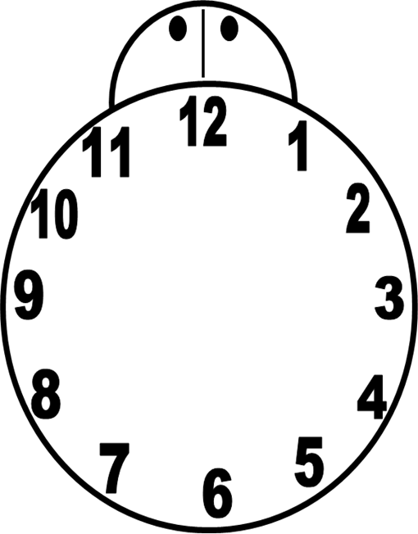

Name:\_\_\_\_\_\_\_\_\_\_\_\_\_\_\_\_\_\_\_\_\_\_\_ Date:\_\_\_\_\_\_\_\_\_\_\_\_\_\_\_\_\_\_\_\_\_\_\_\_\_

**It’s Time! Part II**

Breakfast Lunch Dinner

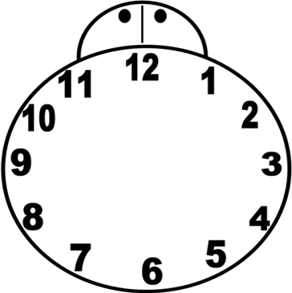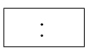

Name:\_\_\_\_\_\_\_\_\_\_\_\_\_\_\_\_\_\_\_\_\_\_\_ Date:\_\_\_\_\_\_\_\_\_\_\_\_\_\_\_\_\_\_\_\_\_\_\_\_\_

**It’s Time! Part II**

Breakfast Lunch Dinner



**Task 9**

**CONSTRUCTING/PERFORMANCE TASK: It’s Time – Part III**

*Approximately 4-5 days*

**STANDARDS FOR MATHEMATICAL CONTENT**

**MGSE1.MD.3** Tell and write time in hours and half-hoursusing analog and digital clocks.

**STANDARDS FOR MATHEMATICAL PRACTICE**

1. Make sense of problems and persevere in solving them.

2. Reason abstractly and quantitatively.

3. Construct viable arguments and critique the reasoning of others.

4. Model with mathematics.

5. Use appropriate tools strategically.

6. Attend to precision.

7. Look for and make use of structure. *Students recognize an hour is composed of 12 consecutive benchmarks. Students also understand that the hour only changes once the minute hand has made a full rotation around the clock and the hour hand reaches the next hour numeral.*

8. Look for and express regularity in repeated reasoning.

**BACKGROUND INFORMATION**

Students should have an understanding of 5 as a benchmark number and have had experience with number patterns for this activity. They will also need to have a strong understanding of the role of the hour hand in order to develop an understanding of its relationship to the minute hand for this task. Duration of time is discussed within in this task, but it is not required by the standard for mastery. However, it is concept that will naturally be included in your conversations as you communicate the concept of a half-hour in relation to a whole hour.

**ESSENTIAL QUESTIONS**

* What does the hour hand on a clock tell us?
* What does the minute hand on a clock tell us?
* Why is it important to know the difference between the two hands?
* Why do we need to be able to tell time?

**MATERIALS**

* It’s Time, Part III: Foldable Clock Templates
* Analog and Digital Clock Recording Sheet, 2 per student
* One paper plate, per student
* Markers
* Minute and hour hand for student clocks
* Brass fasteners (one for each student)
* *The Clock Struck One: A Time-telling Tale,* by Trudy Harris
* **GROUPING**

Large or small group

**TASK DESCRIPTION, DEVELOPMENT, AND DISCUSSION**

**Part I**

Begin the lesson by gathering students in a common place. Read *The Clock Struck One: A Time-telling Tale,* by Trudy Harris (or similar time story.) Discuss the progression of the story over a 12 hour period.

**Part II**

Lead the students in a discussion of using 5 as a benchmark number. How does it make it easier to count using 5? What experiences have they had using groups of 5? Allow them to share their experiences, and then as a group count by 5’s.

**Part III**

Review the number line that was created in *It’s Time: Part I*. Refer to student examples from the previous task and discuss each. Next, review with students how many minutes are in an hour and then have students predict how many minutes are in half of an hour. Explain, if needed, that 30 is half of 60.

Make another number line using time to the hour, but leave an extra space in between each hour to include time to the half hour. Once the number line is displayed, ask students to predict what time they think will go in between each hour and to explain their reasoning. Lead students to an understanding that, at the midpoint between each hour, a half hour has passed. Write several examples of time to the half hour, in digital form, on an index card. Have student volunteers place the time card on the number line. As students are placing the time cards on the number line, emphasize that the time they are posting is halfway between the two hours. The discussion of the concept of time to the half hour needs to occur during this activity and not afterwards, so be sure to monitor students closely as they place the times, to address any misconceptions as they occur.

Give students the opportunity to demonstrate their understanding of the concept of a half hour being between two hours, by having them create a number line as they did in *It’s Time: Part I.* Students will select events to display on a number line and assign a time that they would participate in each. They will write the time on the analog and digital clocks and write an explanation of the event. You can choose to have students select ten separate events or leave it open ended for those students who may have an understanding of duration of time to display one event starting at a half-hour and ending at the following half-hour or continuing across a few hours [For example, Elliott’s game is scheduled for 9:30 and lasts an hour. She will display her number line to reflect her basketball game starting at 9:30 and continuing at 10:00, and ending at 10:30. OR, you may have some students who display two events within one hour (ex: Eating lunch from 11:00-11:30 and Recess from 11:30-12:00), going to a movie at 5:00 that ends at 7:00, etc.].

There are multiple ways students could display their understanding of time for this activity, so only limit the number of events students could choose for the children who may be overwhelmed with the task of selecting appropriate events.

**Part IV**

Review the understanding of minutes, as units of 5, from the previous activity. Show students the foldable clock and explain that they will make one to practice time to the hour and half hour. Students will begin by making the clock face with dotted lines to represent the hours on the face of a clock. Each student will write the hour, starting with 1, in between the dotted lines (see pictures for clarification). Cut the tabs on the dotted lines. Next, they will write the minutes, in units of 5, in between the solid lines on the second clock face. Students should not cut the solid lines on the minute clock. Place the clocks with the hours on top of the clock face with the minutes (see example below).

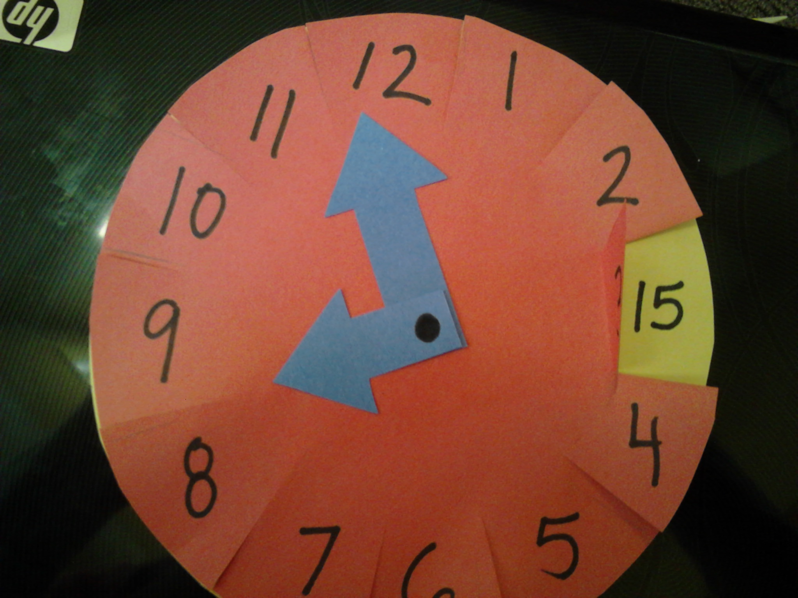

**Part V**

To help with understanding the relationship between the minute and hour hands show students a paper plate clock constructed as follows:



The teacher will give all students one paper plate. Students will write the numbers for the minute hand on the ribbed edge of the plate and the numbers for the hour within the flat circular space in the middle of the plate. Have students cut out and attach the hour and minute hands with a brass fastener.

* Have the students skip count by fives at least up to sixty.
* Allow students to move the minute hand as they skip count by fives. Allow them time to practice moving both the hour and minute hands as they skip count. (Students should understand that the reason they are doing this is because there are five minutes between consecutive integers on the clock face.)
* After students understand that there are sixty minutes in an hour, it is a good time for them to recognize the relationship between the hour hand’s movement and the movement of the minute hand. This is a good time to reinforce on a demonstration clock that one full circle of the minute hand will cause the hour hand to move from one hour to the next.

**Part VI**

Allow time for students write in their math journal about number relationships and patterns they noticed during the lesson. After students have had a sufficient amount of time to record their thoughts, allow them to share their thinking with a partner and then with the class.

**FORMATIVE ASSESSMENT QUESTIONS**

* How do the minute and hour hands help us tell time?
* Does it matter which hand we read first?
* Why do we need to be able to tell time?

**DIFFERENTIATION**

**Extension**

* Have the children make time cards using index cards. Create one card with an analog clock on it and then create a corresponding card with a digital clock. Make several examples like this and allow the children to play “Time Memory.” All of the cards with the times on them, both analog and digital clock cards, will be mixed up and turned face down. They take turns turning 2 cards over at a time and try to find a match. For example, the analog clock will read 2:00 and the digital clock will say 2:00. If they get a match they get to keep the cards and go again. If they do not find a match, they turn the cards back over and their turn ends.
* Have students play Time Match and What Time Will it Be on http://nlvm.usu.edu/en/nav/grade\_g\_1.html

**Intervention**

* For students who seem overwhelmed with the task of selecting events to add to their timeline, give them a set of 10 pictures representing daily activities and have them assign a time for each and place on a number line.
* In addition to giving students pictures to use as prompts, also make time cards for them to match to the pictures and then place on a number line.

**It’s Time-Part III (Clock Hands)**

|  |  |  |
| --- | --- | --- |
| http://www.videomathtutor.com/E-Store/Printshop/Printshop/page3_files/stacks_image_1876_1.png | http://www.videomathtutor.com/E-Store/Printshop/Printshop/page3_files/stacks_image_1876_1.png | Explain why the event could happen at this time.  \_\_\_\_\_\_\_\_\_\_\_\_\_\_\_\_\_\_\_\_\_\_\_\_\_\_\_\_\_\_  \_\_\_\_\_\_\_\_\_\_\_\_\_\_\_\_\_\_\_\_\_\_\_\_\_\_\_\_\_\_  \_\_\_\_\_\_\_\_\_\_\_\_\_\_\_\_  \_\_\_\_\_\_\_\_\_\_\_\_\_\_\_\_ |
| http://www.videomathtutor.com/E-Store/Printshop/Printshop/page3_files/stacks_image_1876_1.png | http://www.videomathtutor.com/E-Store/Printshop/Printshop/page3_files/stacks_image_1876_1.png | Explain why the event could happen at this time.  \_\_\_\_\_\_\_\_\_\_\_\_\_\_\_\_\_\_\_\_\_\_\_\_\_\_\_\_\_\_  \_\_\_\_\_\_\_\_\_\_\_\_\_\_\_\_\_\_\_\_\_\_\_\_\_\_\_\_\_\_  \_\_\_\_\_\_\_\_\_\_\_\_\_\_\_\_  \_\_\_\_\_\_\_\_\_\_\_\_\_\_\_\_ |
| http://www.videomathtutor.com/E-Store/Printshop/Printshop/page3_files/stacks_image_1876_1.png | http://www.videomathtutor.com/E-Store/Printshop/Printshop/page3_files/stacks_image_1876_1.png | Explain why the event could happen at this time.  \_\_\_\_\_\_\_\_\_\_\_\_\_\_\_\_\_\_\_\_\_\_\_\_\_\_\_\_\_\_\_\_\_\_\_\_\_\_\_\_\_\_\_\_\_  \_\_\_\_\_\_\_\_\_\_\_\_\_\_\_\_\_\_\_\_\_\_\_\_\_\_\_\_\_\_  \_\_\_\_\_\_\_\_\_\_\_\_\_\_\_\_  \_\_\_\_\_\_\_\_\_\_\_\_\_\_\_\_ |
| http://www.videomathtutor.com/E-Store/Printshop/Printshop/page3_files/stacks_image_1876_1.png | http://www.videomathtutor.com/E-Store/Printshop/Printshop/page3_files/stacks_image_1876_1.png | Explain why the event could happen at this time.  \_\_\_\_\_\_\_\_\_\_\_\_\_\_\_\_\_\_\_\_\_\_\_\_\_\_\_\_\_\_  \_\_\_\_\_\_\_\_\_\_\_\_\_\_\_\_\_\_\_\_\_\_\_\_\_\_\_\_\_\_  \_\_\_\_\_\_\_\_\_\_\_\_\_\_\_\_  \_\_\_\_\_\_\_\_\_\_\_\_\_\_\_\_ |
| http://www.videomathtutor.com/E-Store/Printshop/Printshop/page3_files/stacks_image_1876_1.png | http://www.videomathtutor.com/E-Store/Printshop/Printshop/page3_files/stacks_image_1876_1.png | Explain why the event could happen at this time.  \_\_\_\_\_\_\_\_\_\_\_\_\_\_\_\_  \_\_\_\_\_\_\_\_\_\_\_\_\_\_\_\_  \_\_\_\_\_\_\_\_\_\_\_\_\_\_\_\_  \_\_\_\_\_\_\_\_\_\_\_\_\_\_\_\_  \_\_\_\_\_\_\_\_\_\_\_\_\_\_\_\_ |

**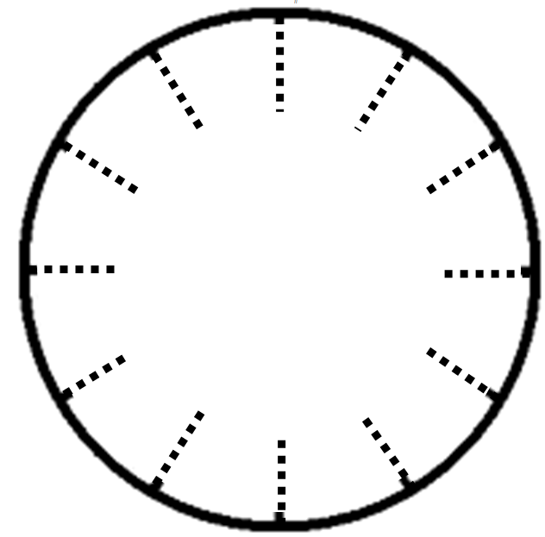**

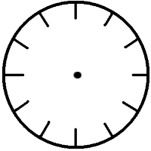

**Task 10**

**PERFORMANCE TASK: Time for Bed**

*Approximately 1-2 days*

**STANDARDS FOR MATHEMATICAL CONTENT**

**MGSE1.MD.3** Tell and write time in hours and half-hoursusing analog and digital clocks.

**STANDARDS FOR MATHEMATICAL PRACTICE**

1. Make sense of problems and persevere in solving them.

2. Reason abstractly and quantitatively.

3. Construct viable arguments and critique the reasoning of others.

4. Model with mathematics. *Students create a chart to collect and analyze data gathered in this task.*

5. Use appropriate tools strategically.

6. Attend to precision. *Students discuss accurate times students go to bed/awake and analyze data gathered.*

7. Look for and make use of structure.

8. Look for and express regularity in repeated reasoning.

**BACKGROUND KNOWLEDGE/COMMON MISCONCEPTIONS**

Prior to this to this task, students should take home the “Time Survey” to complete for homework. All students will need to have this completed in order to have a sufficient amount of class data.

Although *am* and *pm* are mentioned in this task, this concept is not a standard for mastery until 2nd grade. However, it is an important concept to discuss when learning about time and necessary for building a strong understanding.

**ESSENTIAL QUESTIONS**

* Why do people collect data?
* Are there different ways to display data?
* What can we learn from our data?

**MATERIALS**

* “Time Survey” homework page
* **“**Time for Bed” and “Wake Time” census sheets (one for each student, copied front to back)
* *What Time is it Mr. Crocodile?,* by Judy Sierra or other similar time story

**GROUPING**

Large group, Individual

**TASK DESCRIPTION, DEVELOPMENT AND DISCUSSION**

**Part I**

Begin lesson by reading *What Time is it Mr. Crocodile?* by Judy Sierra (or similar time story.) As you read the story, have students make the times from the story using their clocks or draw the times on the board.

**Part II**

Have students sit in a common area and review the differences between AM and PM. Tell students that they are going to collect data on bed times and wake times of each student in the class. They will need to go to each student’s seat and record on their census sheets each student’s wake time and bed time.

Distribute the “Time Survey” page to each student. Ask them to place the sheet on their desk so that it is visible to other students as they collect data. Distribute census sheets for both wake time and bed time and allow students to collect and record the data.

**Part III**

Once students have collected their data, allow them time to analyze and organize their data on to their tally charts. Once they have completed the tally charts for bed time and wake time, allow them time to answer the questions related to their data. Once each student is finished, lead the class in a discussion of their findings.

**FORMATIVE ASSESSMENT QUESTIONS**

* What do you notice about your graph?
* What information do your charts give you?
* How can we use this information?

**DIFFERENTIATION**

**Extension**

* Students proficient in interpreting data could create their own questions for the data and have a partner respond.
* “Using Data to Answer a Question,” Van de Walle, page 351 – This expanded lesson can be used as an extension or intervention. Differentiation suggestions are embedded in the lesson.

**Intervention**

* Provide students with completed graph and have them respond to the questions.
* “Using Data to Answer a Question,” Van de Walle, page 351 – This expanded lesson can be used as an extension or intervention. Differentiation suggestions are embedded in the lesson.

**Time Survey**

Child’s Name \_\_\_\_\_\_\_\_\_\_\_\_\_\_\_\_\_\_\_\_\_\_\_\_\_\_\_\_\_\_\_\_\_

Please circle one time for each:

My child’s bedtime is: **7:30, 8:00, 8:30**, or **9:00**

My child wakes up at: **5:30, 6:00, 6:30**, or **7:00**

**Time Survey**

Child’s Name \_\_\_\_\_\_\_\_\_\_\_\_\_\_\_\_\_\_\_\_\_\_\_\_\_\_\_\_\_\_\_\_\_

Please circle one time for each:

My child’s bedtime is: **7:30, 8:00, 8:30**, or **9:00**

My child wakes up at: **5:30, 6:00, 6:30**, or **7:00**

**Time Survey**

Child’s Name \_\_\_\_\_\_\_\_\_\_\_\_\_\_\_\_\_\_\_\_\_\_\_\_\_\_\_\_\_\_\_\_\_

Please circle one time for each:

My child’s bedtime is: **7:30, 8:00, 8:30**, or **9:00**

My child wakes up at: **5:30, 6:00, 6:30**, or **7:00**



[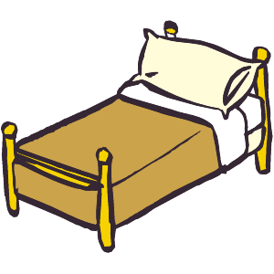](http://cliparts101.com/files/759/1EFE339670AFFCCB8485097535B25379/lrg_Bed_01.png)

[](http://cliparts101.com/files/759/1EFE339670AFFCCB8485097535B25379/lrg_Bed_01.png)

[](http://cliparts101.com/files/759/1EFE339670AFFCCB8485097535B25379/lrg_Bed_01.png)

**Name:\_\_\_\_\_\_\_\_\_\_\_\_\_\_\_\_\_\_\_\_\_ Date:\_\_\_\_\_\_\_\_\_\_\_\_\_\_\_\_\_\_\_\_\_\_\_\_\_**

**Time For Bed**

|  |  |  |  |
| --- | --- | --- | --- |
|  |  |  |  |
|  |  |  |  |
|  |  |  |  |
|  |  |  |  |
|  |  |  |  |
|  |  |  |  |
|  |  |  |  |
|  |  |  |  |
|  |  |  |  |
|  |  |  |  |
|  |  |  |  |
|  |  |  |  |
|  |  |  |  |
|  |  |  |  |
|  |  |  |  |
|  |  |  |  |
|  |  |  |  |
|  |  |  |  |
|  |  |  |  |
|  |  |  |  |
| **7:30 pm** | **8:00 pm** | **8:30 pm** | **9:00 pm** |

**Time to Wake Up**

|  |  |  |  |
| --- | --- | --- | --- |
|  |  |  |  |
|  |  |  |  |
|  |  |  |  |
|  |  |  |  |
|  |  |  |  |
|  |  |  |  |
|  |  |  |  |
|  |  |  |  |
|  |  |  |  |
|  |  |  |  |
|  |  |  |  |
|  |  |  |  |
|  |  |  |  |
|  |  |  |  |
|  |  |  |  |
|  |  |  |  |
|  |  |  |  |
|  |  |  |  |
|  |  |  |  |
|  |  |  |  |
| **5:30 am** | **6:00 am** | **6:30 am** | **7:00 am** |

**Name:\_\_\_\_\_\_\_\_\_\_\_\_\_\_\_\_\_\_\_\_\_\_\_\_\_ Date:\_\_\_\_\_\_\_\_\_\_\_\_\_\_\_\_\_\_\_\_\_\_**

**Tally Chart**

|  |  |
| --- | --- |
| **Bed Time** | **Number of Students** |
| **7:30** |  |
| **8:00** |  |
| **8:30** |  |
| **9:00** |  |

1. **How many people go to bed at 8:00 or 8:30? \_\_\_\_\_\_\_\_\_\_\_\_\_\_**
2. **What time do most of your classmates go to bed? \_\_\_\_\_\_\_\_\_\_\_\_\_\_\_\_\_**
3. **What time do the least amount of your classmates go to bed?\_\_\_\_\_\_\_\_\_\_\_**
4. **How many more students go to bed at 8:00 than at 9:00?\_\_\_\_\_\_\_\_\_\_**

**Name:\_\_\_\_\_\_\_\_\_\_\_\_\_\_\_\_\_\_\_\_\_\_\_\_\_ Date:\_\_\_\_\_\_\_\_\_\_\_\_\_\_\_\_\_\_\_\_\_\_**

**Tally Chart**

|  |  |
| --- | --- |
| **Wake Time** | **Number of Students** |
| **5:30** |  |
| **6:00** |  |
| **6:30** |  |
| **7:00** |  |

1. **How many people wake up at 6:00 or 6:30? \_\_\_\_\_\_\_\_\_\_\_\_\_\_**
2. **What time do most of your classmates wake up? \_\_\_\_\_\_\_\_\_\_\_\_\_\_\_\_\_**
3. **What time do the least amount of your classmates wake up?\_\_\_\_\_\_\_\_\_\_\_**
4. **Why do you think fewer people wake up at \_\_\_\_\_\_\_\_\_\_\_?**

**\_\_\_\_\_\_\_\_\_\_\_\_\_\_\_\_\_\_\_\_\_\_\_\_\_\_\_\_\_\_\_\_\_\_\_\_\_\_\_\_\_\_\_\_\_\_\_\_\_\_\_\_\_\_\_\_\_**

**\_\_\_\_\_\_\_\_\_\_\_\_\_\_\_\_\_\_\_\_\_\_\_\_\_\_\_\_\_\_\_\_\_\_\_\_\_\_\_\_\_\_\_\_\_\_\_\_\_\_\_\_\_\_\_\_\_**

**Task 11**

**PERFORMANCE TASK: Measurement Olympics**

*Approximately 2 days*

**STANDARDS FOR MATHEMATICAL CONTENT**

**MGSE1.MD.1** Order three objects by length; compare the lengths of two objects indirectly by using a third object.

**MGSE1.MD.2** **Express the length of an object as a whole number of length units, by laying multiple copies of a shorter object (the length unit) end to end; understand that the length measurement of an object is the number of same-size length units that span it with no gaps or overlaps. (Iteration)**

**MGSE1.MD.4** Organize, represent, and interpret data with up to three categories; ask and answer questions about the total number of data points, how many in each category, and how many more or less are in one category than in another.

**STANDARDS FOR MATHEMATICAL PRACTICE**

1. Make sense of problems and persevere in solving them.

2. Reason abstractly and quantitatively. *Students analyze data on charts to make comparisons.*

3. Construct viable arguments and critique the reasoning of others.

4. Model with mathematics.

5. Use appropriate tools strategically. *Students use tools to measure activities in this task.*

6. Attend to precision. *Students participate in a class discussion about the data collected in this task.*

7. Look for and make use of structure.

8. Look for and express regularity in repeated reasoning.

**BACKGROUND KNOWLEDGE/COMMON MISCONCEPTIONS**

Students should have a variety of experiences with measuring objects with units prior to this activity. Remind students that when using objects, each object should be placed end to end without overlapping or gaps.

**ESSENTIAL QUESTIONS**

* How are units used to measure objects?
* How are measuring units selected?
* How is estimation helpful in measurement?
* How do measurements help compare objects?

**MATERIALS**

* Olympic Event Recording sheet
* Olympic Event Graph Sheet
* Olympic Event Task Cards
* Cotton Balls
* Paper worms
* Student created, non-standard measuring tools from previous lessons
* Mini Flipbooks (4 pages each, per student)
* Clock stamps
* *Length,* by Henry Pluckrose, or similar text

**GROUPING**

Individual

**TASK DESCRIPTION, DEVELOPMENT, AND DISCUSSION**

**Part I**

Begin lesson by reading *Length,* by Henry Pluckrose (or similar measurement story.) As you read, discuss the questions and have students partner share how they would measure each object.

Review with the students the importance of using appropriate tools to measure objects. Review with students the various measuring tools they made or used during previous lessons (footprint strips, ladybug strip, worm strip, broken rulers, and any other tool that may have been created during other tasks). Lead a discussion that prepares students to make a decision about which measuring tool they will use for each event.

Each of the “Olympic Events” will allow the students to demonstrate their mastery of the measurement standards. The tasks and activities will be grouped as “Events.” Students will rotate to all four of the Olympic events. Have students record their data on the Olympic Event recording sheets.

**Part II**

The teacher should arrange the events with enough room for students to complete the event with safety and accuracy. The teacher should model each event so that students are aware of the expectation of each event. The events could be implemented using small group rotations. Olympic Event Descriptions:

**Event #1 – Wiggle Worms**

The students will measure the length of their desk using inch worms.

**Event #2 – Feather Blow**

The students will blow a feather and measure the distance the feather travels, with the broken ruler tool.

**Event #3– Long Jump**

The students will measure their longest jump using the footprint tool.

**Event #4 – Cotton Ball Throw**

The students will measure the distance they can throw a cotton ball using the ladybug centimeter ruler.

**Event #5 Events of the Day**

The students will sequence a series of events, and assign a time of day which makes sense to them, to each event. They will justify their reasoning by writing an explanation for each time and selected event.

**Part III**

The teacher will post 4 pieces of chart paper at the front of the room for students to record their results. *(Sample charts below)* Students will record their Olympic Event data on a class charts at the front of the room.

*Cotton Ball Throw*

Boys Girls

*Long Jump*

Boys Girls

*Feather Blow*

Student Name # units

*Wiggle Worms*

Student Name # of Worms

**Part IV**

Gather students to a common area. The teacher will lead a discussion about each event. Allow students to compare results within each event.

**FORMATIVE ASSESSMENT QUESTIONS**

* What do you notice about the results from each event?

*Looking at the long jump results, I noticed that the boys jumped longer than the girls.*

* How do you know that your measurements are accurate?’
* Is there anything that you would change about the way you measured the objects?
* Would you have selected a different measuring tool at any of the events? Why?
* What do the events all have in common?
* Which event do you think our class would do best in at the real Olympics?

**Name \_\_\_\_\_\_\_\_\_\_\_\_\_\_\_\_\_\_\_\_\_\_\_\_\_ Date:\_\_\_\_\_\_\_\_\_\_\_\_\_\_\_\_\_\_\_\_\_\_\_**



**Olympic Event Recording Sheet**

|  |  |  |
| --- | --- | --- |
| ***Event Name*** | ***Measurement Estimate*** | ***Actual Measurement*** |
| **Wiggle Worms** |  |  |
| **Feather Blow** |  |  |
| **Long Jump** |  |  |
| **Cotton Ball Throw** |  |  |
| **Shoelace** |  |  |

**Measurement tool used:\_\_\_\_\_\_\_\_\_\_\_\_\_\_\_\_\_\_\_\_\_\_\_\_\_\_**

**Which event was your best event? Why?\_\_\_\_\_\_\_\_\_\_\_\_\_\_\_\_\_\_\_\_\_\_\_\_\_\_\_\_\_\_\_\_**

**\_\_\_\_\_\_\_\_\_\_\_\_\_\_\_\_\_\_\_\_\_\_\_\_\_\_\_\_\_\_\_\_\_\_\_\_\_\_\_\_\_\_\_\_\_\_\_\_\_\_\_\_\_\_\_\_\_\_\_\_\_\_\_\_\_**

**\_\_\_\_\_\_\_\_\_\_\_\_\_\_\_\_\_\_\_\_\_\_\_\_\_\_\_\_\_\_\_\_\_\_\_\_\_\_\_\_\_\_\_\_\_\_\_\_\_\_\_\_\_\_\_\_\_\_\_\_\_\_\_\_\_**

**Which event was your worst event? Why?\_\_\_\_\_\_\_\_\_\_\_\_\_\_\_\_\_\_\_\_\_\_\_\_\_\_\_\_\_\_\_**

**\_\_\_\_\_\_\_\_\_\_\_\_\_\_\_\_\_\_\_\_\_\_\_\_\_\_\_\_\_\_\_\_\_\_\_\_\_\_\_\_\_\_\_\_\_\_\_\_\_\_\_\_\_\_\_\_\_\_\_\_\_\_\_\_\_**

**\_\_\_\_\_\_\_\_\_\_\_\_\_\_\_\_\_\_\_\_\_\_\_\_\_\_\_\_\_\_\_\_\_\_\_\_\_\_\_\_\_\_\_\_\_\_\_\_\_\_\_\_\_\_\_\_\_\_\_\_\_\_\_\_\_**

**Event 1: Wiggle Worms**

MC900090999[1]

-Estimate how many inchworms it will take

to measure your desk across the top.

Record your estimate on the sheet.

-Lay the inchworms in a straight line across

your desk. Count the number of inchworms

you used and record on your sheet.

**Event 2: Feather Blow**

-Estimate how many units it will take

to measure your desk across the top.

Record your estimate on the worksheet.

-Put a feather at the edge of a table. Use

this as the starting line. Blow the feather as far as you can.

-Mark the distance where the feather lands. Then measure the distance between the edge of the table and where your feather landed using unused units on the broken ruler. Record on your sheet.

[](http://www.clker.com/cliparts/A/0/U/Y/m/j/feather-blue-black-hi.png)

**Event 3: Long Jump**

-Estimate how many footprints it will take to

measure as far you can jump.

Record your estimate on the sheet.

- Use a piece of tape as a starting line. Stand

with heels on tape. Jump the longest jump

possible.

-Using the footprint tool, measure your jump and record the results.

**Event 4: Cotton Ball Throw** MC900215105[1]

- Estimate how many centimeter ladybugs it will take to measure how far you can throw a cotton ball. Record your estimate on the recording sheet.

-Stand at the tape line on the floor. With one hand throw the cotton ball as far as you can.-Using the centimeter ladybug tool, measure the distance that the cotton ball traveled. Record the results.

MC900232599[1]

**Event 5: Events of the Day**

**C:\Program Files\Microsoft Office\MEDIA\CAGCAT10\j0234131.wmf**

-Cut out each of the pictures and glue them to the task sheet under a clock.

-Write the time on an analog clock and a digital clock that you would participate in the activity during the day, for each event.

-Write an explanation that justifies your reasoning for assigning the time you chose for the each activity.

|  |  |  |  |  |  |  |  |  |
| --- | --- | --- | --- | --- | --- | --- | --- | --- |
| http://www.videomathtutor.com/E-Store/Printshop/Printshop/page3_files/stacks_image_1876_1.png | | | http://www.videomathtutor.com/E-Store/Printshop/Printshop/page3_files/stacks_image_1876_1.png |  | | \_\_\_\_\_\_\_\_\_\_\_\_\_\_\_  \_\_\_\_\_\_\_\_\_\_\_\_\_\_\_  \_\_\_\_\_\_\_\_\_\_\_\_\_\_\_  \_\_\_\_\_\_\_\_\_\_\_\_\_\_\_ | | |
| http://www.videomathtutor.com/E-Store/Printshop/Printshop/page3_files/stacks_image_1876_1.png | | | http://www.videomathtutor.com/E-Store/Printshop/Printshop/page3_files/stacks_image_1876_1.png |  | | \_\_\_\_\_\_\_\_\_\_\_\_\_\_\_\_  \_\_\_\_\_\_\_\_\_\_\_\_\_\_\_\_  \_\_\_\_\_\_\_\_\_\_\_\_\_\_\_\_  \_\_\_\_\_\_\_\_\_\_\_\_\_\_\_\_ | | |
| http://www.videomathtutor.com/E-Store/Printshop/Printshop/page3_files/stacks_image_1876_1.png | | | http://www.videomathtutor.com/E-Store/Printshop/Printshop/page3_files/stacks_image_1876_1.png |  | | \_\_\_\_\_\_\_\_\_\_\_\_\_\_\_  \_\_\_\_\_\_\_\_\_\_\_\_\_\_\_  \_\_\_\_\_\_\_\_\_\_\_\_\_\_\_  \_\_\_\_\_\_\_\_\_\_\_\_\_\_\_ | | |
| http://www.videomathtutor.com/E-Store/Printshop/Printshop/page3_files/stacks_image_1876_1.png | | | http://www.videomathtutor.com/E-Store/Printshop/Printshop/page3_files/stacks_image_1876_1.png |  | | \_\_\_\_\_\_\_\_\_\_\_\_\_\_\_  \_\_\_\_\_\_\_\_\_\_\_\_\_\_\_  \_\_\_\_\_\_\_\_\_\_\_\_\_\_\_  \_\_\_\_\_\_\_\_\_\_\_\_\_\_\_ | | |
| http://www.videomathtutor.com/E-Store/Printshop/Printshop/page3_files/stacks_image_1876_1.png | | | http://www.videomathtutor.com/E-Store/Printshop/Printshop/page3_files/stacks_image_1876_1.png |  | | \_\_\_\_\_\_\_\_\_\_\_\_\_\_\_\_  \_\_\_\_\_\_\_\_\_\_\_\_\_\_\_\_  \_\_\_\_\_\_\_\_\_\_\_\_\_\_\_\_  \_\_\_\_\_\_\_\_\_\_\_\_\_\_\_\_ | | |
| http://teethwhitens.com/wp-content/uploads/2011/10/tooth-brush1.png | http://teethwhitens.com/wp-content/uploads/2011/10/tooth-brush1.png | | | http://teethwhitens.com/wp-content/uploads/2011/10/tooth-brush1.png | | http://teethwhitens.com/wp-content/uploads/2011/10/tooth-brush1.png |
| http://www.clker.com/cliparts/4/f/1/7/11970884651605706367Gerald_G_Fast_Food_Lunch_Dinner_(FF_Menu)_1.svg.hi.png | http://www.clker.com/cliparts/4/f/1/7/11970884651605706367Gerald_G_Fast_Food_Lunch_Dinner_(FF_Menu)_1.svg.hi.png | | | http://www.clker.com/cliparts/4/f/1/7/11970884651605706367Gerald_G_Fast_Food_Lunch_Dinner_(FF_Menu)_1.svg.hi.png | | http://www.clker.com/cliparts/4/f/1/7/11970884651605706367Gerald_G_Fast_Food_Lunch_Dinner_(FF_Menu)_1.svg.hi.png |
| http://www.clipartpal.com/_thumbs/pd/school_bus_bright_T.png | http://www.clipartpal.com/_thumbs/pd/school_bus_bright_T.png | | | http://www.clipartpal.com/_thumbs/pd/school_bus_bright_T.png | | http://www.clipartpal.com/_thumbs/pd/school_bus_bright_T.png |
| american flag clipart | american flag clipart | | | american flag clipart | | american flag clipart |
| http://cdn2.fotosearch.com/bthumb/ARP/ARP123/playset.jpg | http://cdn2.fotosearch.com/bthumb/ARP/ARP123/playset.jpg | | | http://cdn2.fotosearch.com/bthumb/ARP/ARP123/playset.jpg | | http://cdn2.fotosearch.com/bthumb/ARP/ARP123/playset.jpg |