**Georgia**

**Standards of Excellence**

**Frameworks**

**Mathematics**

GSE First Grade

Unit 2: Developing Base Ten Number Sense



**Unit 2: Developing Base Ten Number Sense**

**TABLE OF CONTENTS** (\* indicates new task, \*\* indicates modified task)

Overview 3

Standards for Mathematical Practice 4

Standards for Mathematical Content 5

Big Ideas 5

Essential Questions 6

Concepts and Skills to Maintain 6

Strategies for Teaching and Learning 7

Selected Terms and Symbols 9

FAL 9

Sample Unit Assessments 10

Number Talks 10

Writing in Math 10

Page Citations 12

Tasks 13

* [Button, Button!](#Button_Button) 15
* [Count it, Graph it](#Countit_Graphit) 19
* [House of Gum](#House_of_Gum) 25
* [One Minute Challenge](#One_Minute_Challenge) 35
* [More or Less Revisited](#More_or_Less_Revisited) 42
* [Close, Far and in Between](#Close_Far_Inbetween) 45
* [Finding Neighbors](#Finding_Neighbors) 49
* \*\*[Make it Straight](#Make_it_Straight) 54
* [Number Hotel](#Number_Hotel) 62
* [FAL](#FAL_PlaceValue)  68
* [Mystery Number](#Mystery_Number) 69
* [Tens and Some More](#Ten_and_SomeMore) 71
* [Dropping Tens](#Dropping_Tens) 76
* [Riddle Me This](#Riddle_me_This) …81
* [Drop it, Web it, Graph it](#Dropit_Webit_Graphit) 84

\*\*\*Please note that all changes made to standards will appear in red bold type. Additional changes will appear in green.

**OVERVIEW**

The Overview is designed to bring focus to the standards so that educators can build curriculum and guide instruction. For more detailed information about unpacking the content standards, unpacking a task, math routines and rituals, maintenance activities and more, please refer to the Grade Level Overview.

*Many of the skills and concepts in this unit are readdressed from Unit 1. Even though they are revisited, it is important to note that they are not necessarily presented in the same way as in Unit 1.*

In this unit, students will:

* rote count forward to 120 by counting on from any number less than 120.
* represent a quantity using numerals.
* locate 0-100 on a number line.
* use the strategies of counting on and counting back to understand number relationships.
* explore with the 99 chart to see patterns between numbers, such as, all of the numbers in a column on the hundreds chart have the same digit in the ones place, and all of the numbers in a row have the same digit in the tens place.
* read, write and represent a number of objects with a written numeral (number form or standard form).
* build an understanding of how the numbers in the counting sequence are related—each number is one more, ten more (or one less, ten less) than the number before (or after).
* work with categorical data by organizing, representing and interpreting data using charts and tables.
* pose questions with 3 possible responses and then work with the data that they collect.
* begin working with dimes and understand a dime is worth ten cents.
* explore counting by tens with dimes.

All mathematical tasks and activities should be meaningful and interesting to students. Posing relevant questions, collecting data related to those questions, and analyzing the data creates a real world connection to counting. The meaning students attach to counting is the key conceptual idea on which all other number concepts are developed. Students begin thinking of counting as a string of words, but then they make a gradual transition to using counting as a tool for describing their world. They must construct the idea of counting using manipulatives and have opportunities to see numbers visually (dot cards, tens frames, number lines, 0-99 chart, hundreds charts, arithmetic rack- ex: small frame abacus and physical groups of tens and ones). To count successfully, students must remember the rote counting sequence, assign one counting number to each object counted, and at the same time have a strategy for keeping track of what has already been counted and what still needs to be counted. Only the counting sequence is a rote procedure. Most students can count forward in sequence. Counting on and counting back are difficult skills for many students. Students will develop successful and meaningful counting strategies as they practice counting and as they listen to and watch others count. They should begin using strategies of skip counting by 2’s, 5’s, and 10’s. As students practice counting by tens they should also think in terms of dimes and the relationship of a dime’s worth being ten cents.

The use of a 99 chart is an extremely useful tool to help students identify number relationships and patterns. Listed below are several reasons that support use of a 99 chart:

* A 0-99 chart begins with zero where a hundred chart begins with 1. We need to include zero because it is one of the ten digits and just as important as 1-9.
* A 100 chart puts the decade numerals (10, 20, 30, etc.) in a different row than its corresponding numerals. For instance, on a hundred chart, 20 appears at the end of the teens row. The number 20 is the beginning of the 20’s decade.
* A 0-99 chart ends with the last two-digit number, 99, whereas a hundred chart ends in 100. 100 could begin a new chart because it is the first three-digit number.

|  |  |  |  |  |  |  |  |  |  |
| --- | --- | --- | --- | --- | --- | --- | --- | --- | --- |
| 0 | 1 | 2 | 3 | 4 | 5 | 6 | 7 | 8 | 9 |
| 10 | 11 | 12 | 13 | 14 | 15 | 16 | 17 | 18 | 19 |
| 20 | 21 | 22 | 23 | 24 | 25 | 26 | 27 | 28 | 29 |
| 30 | 31 | 32 | 33 | 34 | 35 | 36 | 37 | 38 | 39 |
| 40 | 41 | 42 | 43 | 44 | 45 | 46 | 47 | 48 | 49 |
| 50 | 51 | 52 | 53 | 54 | 55 | 56 | 57 | 58 | 59 |
| 60 | 61 | 62 | 63 | 64 | 65 | 66 | 67 | 68 | 69 |
| 70 | 71 | 72 | 73 | 74 | 75 | 76 | 77 | 78 | 79 |
| 80 | 81 | 82 | 83 | 84 | 85 | 86 | 87 | 88 | 89 |
| 90 | 91 | 92 | 93 | 94 | 95 | 96 | 97 | 98 | 99 |

As students in first grade begin to count larger amounts, they should group concrete materials into tens and ones to keep track of what they have counted. This is an introduction to the concept of place value. Students must learn that digits have different values depending on their position in numbers. Students in first grade could also group pennies and dimes together to see the relationship between a penny being worth one cent and a dime being worth ten cents.

Although the units in this instructional framework emphasize key standards and big ideas at specific times of the year, routine topics such as counting, time, money, positional words, patterns, and tallying should be addressed on an ongoing basis through the use of routines, centers, and games. Understanding the concept of a coin’s name and its value should be practiced throughout the year. Although the standard includes dimes and pennies, teachers may also use nickels, as they naturally relate to counting by fives. This first unit should establish these routines, allowing students to gradually understand the concept of number and time.

Students in first grade are only asked to construct tables and charts. Picture graphs and bar graphs are not introduced until 2nd grade. In first grade students can use money as a manipulative for patterns, skip counting and any counting additional counting activities.

[**STANDARDS FOR MATHEMATICAL PRACTICE**](https://www.georgiastandards.org/Common-Core/Documents/CCGPS-GrK-5-Math-Teaching-Guide.pdf)

The Standards for Mathematical Practice describe varieties of expertise that mathematics educators at all levels should seek to develop in their students. These practices rest on important “processes and proficiencies” with longstanding importance in mathematics education.

***Students are expected to:***

1. Make sense of problems and persevere in solving them.

2. Reason abstractly and quantitatively.

3. Construct viable arguments and critique the reasoning of others.

4. Model with mathematics.

5. Use appropriate tools strategically.

6. Attend to precision.

7. Look for and make use of structure.

8. Look for and express regularity in repeated reasoning.

**\*\*\*Mathematical Practices 1 and 6 should be evident in EVERY lesson\*\*\***

[**STANDARDS FOR MATHEMATICAL CONTENT**](https://www.georgiastandards.org/Common-Core/Documents/CCGPS-GrK-5-Math-Standards.pdf)

**Extend the counting sequence.**

**MGSE1.NBT.1** Count to 120, starting at any number less than 120. In this range, read and write numerals and represent a number of objects with a written numeral..

**Represent and interpret data.**

**MGSE1.MD.4** Organize, represent, and interpret data with up to three categories; ask and answer questions about the total number of data points, how many in each category, and how many more or less are in one category than in another.

**MGSE1.NBT.7** **Identify dimes, and understand ten pennies can be thought of as a dime. (Use dimes as manipulatives in multiple mathematical contexts.)**

**Big Ideas**

* Students can count on starting at any number less than 120.
* Read, write, and represent a number of objects with a written numeral.
* Quantities can be compared using matching sets and words.
* Recognize and understand patterns on a 99 chart.
* A number line can represent the order of numbers.
* Problems can be solved in different ways.
* Important information can be found in representations of data such as tallies, tables, and charts.
* Tables and charts can help make solving problems easier.
* Questions can be solved by collecting and interpreting data.
* A dime is worth 10 cents, and its value is equivalent to ten pennies.
* Represent and count quantities up to 120 in multiple ways, pictures, and numerals.
* Use counters and pictures to represent numbers in terms of tens and ones
* Interpret tables and charts

*Coins are now explicitly taught, beginning with the penny in Kindergarten and the dime in first grade. The connections to patterns and skip counting should be made using coins. Coins can be used as manipulatives for patterns, skip counting and counting*. *Note that skip counting is not formally addressed until grade 2, but as students develop an understanding of number and the relationships between numbers, they may naturally work with this concept. While the standard references dimes and pennies, teachers are encouraged to include nickels, as they fall naturally in the progression of coin use/recognition.*

**ESSENTIAL QUESTIONS**

* How can patterns help us understand numbers?
* How can we organize and display the data we collected into three categories to create a graph?
* How can we represent a number with tens and ones?
* How can we use counting to compare objects in a set?
* How can we use tally marks to help represent data in a table or chart?
* How do we know if a set has more or less?
* How do we know where a number lies on a number line?
* How does a graph help us better understand the data collected?
* What do the numerals represent in a two or three digit number?
* What is an effective way of counting a large quantity of objects?
* What patterns can be found on the 0-99 chart?
* What strategies can be used to find a missing number?
* What strategy can we use to efficiently count a large quantity of objects?
* What is estimating and when can you use it?
* What do a 0-99 chart and number line have in common?
* What is the value of a dime? What is the value of a penny?

**CONCEPTS/SKILLS TO MAINTAIN**

* Comparing two sets of objects (equal to, more than, or less than)
* Count forward from a given number
* Counting to 100 by ones and tens
* Equivalence
* Number words
* One to one correspondence
* Sorting
* Subitizing
* Unitizing tens
* Writing and representing numbers through 100

**Fluency**: Procedural fluency is defined as skill in carrying out procedures flexibly, accurately, efficiently, and appropriately. Fluent problem solving does not necessarily mean solving problems within a certain time limit, though there are reasonable limits on how long computation should take. Fluency is based on a deep understanding of quantity and number.

**Deep Understanding**: Teachers teach more than simply “how to get the answer” and instead support students’ ability to access concepts from a number of perspectives. Therefore students are able to see math as more than a set of mnemonics or discrete procedures. Students demonstrate deep conceptual understanding of foundational mathematics concepts by applying them to new situations, as well as writing and speaking about their understanding.

**Memorization**: The rapid recall of arithmetic facts or mathematical procedures. Memorization is often confused with fluency. Fluency implies a much richer kind of mathematical knowledge and experience.

**Number Sense:** Students consider the context of a problem, look at the numbers in a problem, make a decision about which strategy would be most efficient in each particular problem. Number sense is not a deep understanding of a single strategy, but rather the ability to think flexibly between a variety of strategies in context.

**Fluent students**:

* flexibly use a combination of deep understanding, number sense, and memorization.
* are fluent in the necessary baseline functions in mathematics so that they are able to spend their thinking and processing time unpacking problems and making meaning from them.
* are able to articulate their reasoning.
* find solutions through a number of different paths.

For more about fluency, see:

<http://www.youcubed.org/wp-content/uploads/2015/03/FluencyWithoutFear-2015.pdf>

and:

<http://joboaler.com/timed-tests-and-the-development-of-math-anxiety/>

**STRATEGIES FOR TEACHING AND LEARNING**

**Extend the counting sequence.**

**MGSE1.NBT.1** Count to 120, starting at any number less than 120. In this range, read and write numerals and represent a number of objects with a written numeral.

**MGSE1.NBT.7** **Identify dimes, and understand ten pennies can be thought of as a dime. (Use dimes as manipulatives in multiple mathematical contexts.)**

**Instructional Strategies**

In first grade, students build on their counting to 100 by ones and tens beginning with numbers other than 1 as they learned in Kindergarten. Students can start counting at any number less than 120 and continue to 120. Although not required by the standards, it is important for students to also count backwards from a variety of numbers. It is important for students to connect different representations for the same quantity or number. Students use materials to count by ones and tens to build models that represent a number. They connect these models to the number word they represent as a written numerals. Students learn to use numerals to represent numbers by relating their place-value notation to their models.

They build on their experiences with numbers 0 to 20 in Kindergarten to create models for 21 to 120 with groupable (examples: dried beans and a small cup for 10 beans, linking cubes, plastic chain links) and grouped materials (examples: base-ten blocks, dried beans and beans sticks (10 beans glued on a craft stick), strips (ten connected squares) and squares (singles), ten-frame, place-value mat with ten-frames, and number chart). Students represent the quantities shown in the models by placing numerals in labeled hundreds, tens and ones columns. They eventually move to representing the numbers in standard form, where the group of hundreds, tens, then singles shown in the model matches the left-to-right order of digits in numbers. Listen as students orally count to 120 and focus on their transitions between decades and the century number. These transitions will be signaled by a 9 and require new rules to be used to generate the next set of numbers. Students need to listen to their rhythm and pattern as they orally count so they can develop a strong number word list. Extend counting charts by attaching a blank chart and writing the numbers 120. Students can use these charts to connect the number symbols with their count words for numbers 0 to 120. Teachers may post the number words in the classroom to help students read and write them, demonstrating another way to represent a numeral for students. Time should also be spent on the dime and its value of 10 pennies. Make connections to tens and the dime and also when skip counting on a 99 chart or hundreds chart. Use Number Talks as a way to reinforce the dime and understanding it being the same as ten pennies. Time is now spent on the penny in Kindergarten and understanding it being worth one. Teachers are encouraged to also include the nickel and its value of 5 pennies in the same manner.

**Represent and interpret data.**

**MGSE1.MD.4** Organize, represent, and interpret data with up to three categories; ask and answer questions about the total number of data points, how many in each category, and how many more or less are in one category than in another.

**Instructional Strategies**

In first grade, the students will sort a collection of items up to three categories. They will pose questions about the number of items in each category, the total number of items, and compare the number of items in categories. The total number of items to be sorted should be less than or equal to 100 to allow for sums and differences less than or equal to 100. This standard lends itself to the integration of first grade geometry concepts. For example, provide categories for students to sort identical collections of different geometric shapes. After the shapes have been sorted, pose these questions: How many triangles are in the collection? How many rectangles are there? How many triangles and rectangles are there? Which category has the most items? How many more? Which category has the least? How many less? Students can create a Venn diagram after they have had multiple experiences with sorting objects according to given categories. The teacher should model a Venn diagram several times before students make their own. A Venn diagram in Grade 1 has two or three labeled loops or regions (categories). Students place items inside the regions that represent a category that they chose. Items that do not fit in a category are placed outside of the loops or regions. Students can place items in a region that overlaps the categories if they see a connection between categories. Ask questions that compare the number of items in each category and the total number of items inside and outside of the regions.

[**SELECTED TERMS AND SYMBOLS**](https://www.georgiastandards.org/Common-Core/Documents/CCGPS_Mathematics_Glossary.pdf)

The following terms and symbols are often misunderstood. These concepts are not an inclusive list and should not be taught in isolation. However, due to evidence of frequent difficulty and misunderstanding associated with these concepts, instructors should pay particular attention to them and how their students are able to explain and apply them.

The terms below are for **teacher reference only** and are not to be memorized by the students. Teachers should present these concepts to students with models and real life examples. Students should understand the concepts involved and be able to recognize and/or demonstrate them with words, models, pictures, or numbers.

* **chart**
* **compare**
* **counting on**
* **data**
* **equal to**
* **less than**
* **more than**
* **number line**
* **number patterns**
* **number relationships**
* **same**
* **table**
* **tally mark**
* **ten frame**
* **unitizing**
* **dime**

**FAL**

The linked Formative Assessment lesson is designed to be part of an instructional unit. This assessment should be implemented approximately two-thirds of the way through this instructional unit and is noted in the unit task table. This assessment can be used at the beginning of the unit to ascertain student needs. The results of this task should give you pertinent information regarding your students learning and help to drive your instruction for the remainder of the unit.

[**SAMPLE UNIT ASSESSMENTS**](http://ccgpsmathematicsk-5.wikispaces.com/K-5+Formative+Assessment+Lessons+%28FALs%29)(linked here)

Math Unit Summative Assessments were written by the First Grade Mathematics Assessment and Curriculum Team, Jackson County, Georgia. The team is comprised of first grade teachers and administrators whose focus is to provide assessments that address depth of knowledge and higher order thinking skills. These assessments are provided as a courtesy from the Jackson County School System as samples that may be used as is or as a guide to create common assessments.

**NUMBER TALKS**

In order to be mathematically proficient, today’s students must be able to compute accurately, efficiently, and flexibly. Daily classroom number talks provide a powerful avenue for developing “efficient, flexible, and accurate computation strategies that build upon the key foundational ideas of mathematics.” (Parrish, 2010) Number talks involve classroom conversations and discussions centered upon purposefully planned computation problems.

In Sherry Parrish’s book, Number Talks: Helping Children Build Mental Math and Computation Strategies, teachers will find a wealth of information about Number Talks, including:

* Key components of Number Talks
* Establishing procedures
* Setting expectations
* Designing purposeful Number Talks
* Developing specific strategies through Number Talks

There are four overarching goals upon which K-2 teachers should focus during Number Talks. These goals are:

1. Developing number sense
2. Developing fluency with small numbers
3. Subitizing
4. Making Tens

Suggested Number Talks for Unit 2 are fluency with 6, 7, 8, 9, and 10; and counting all and counting on using dot images, ten-frames, and Rekenreks, double ten frames and number sentences. Specifics on these Number Talks can be found on pages 74-106 of Number Talks: Helping Children Build Mental Math and Computation Strategies.

**WRITING IN MATH**

The Standards for Mathematical Practice, which are integrated throughout effective mathematics content instruction, require students to explain their thinking when making sense of a problem (SMP 1). Additionally, students are required to construct viable arguments and critique the reasoning of others (SMP 2). Therefore, the ability to express their thinking and record their strategies in written form is critical for today’s learners. According to Marilyn Burns, “Writing in math class supports learning because it requires students to organize, clarify, and reflect on their ideas--all useful processes for making sense of mathematics. In addition, when students write, their papers provide a window into their understandings, their misconceptions, and their feelings about the content.” (Writing in Math. Educational Leadership. Oct. 2004 (30).) The use of math journals is an effective means for integrating writing into the math curriculum.

Math journals can be used for a variety of purposes. Recording problem solving strategies and solutions, reflecting upon learning, and explaining and justifying thinking are all uses for math journals. Additionally, math journals can provide a chronological record of student math thinking throughout the year, as well as a means for assessment than can inform future instruction.

The following website provides a wealth of information and grade specific activities for math journaling: <http://www.k-5mathteachingresources.com/math-journals.html>. Though this is not a free site, there are some free resources that are accessible.

**PAGE CITATIONS**

The text, Teaching Student-Centered Mathematics written by Van de Walle, Lovin, Karp, and Bay-Williams, has been recently revised. Page numbers/citations in this unit may vary due to this change.

**TASK DESCRIPTIONS**

|  |  |
| --- | --- |
| **Scaffolding Task** | Tasks that build up to the learning task. |
| **Constructing Task** | Constructing understanding through deep/rich contextualized problem solving tasks. |
| **Practice Task** | Tasks that provide students opportunities to practice skills and concepts. |
| **Culminating Task** | Designed to require students to use several concepts learned during the unit to answer a new or unique situation. Allows students to give evidence of their own understanding toward the mastery of the standard and requires them to extend their chain of mathematical reasoning. |
| **Formative Assessment Lesson (FAL)** | Lessons that support teachers in formative assessment which both reveal and develop students’ understanding of key mathematical ideas and applications. These lessons enable teachers and students to monitor in more detail their progress towards the targets of the standards. |
| **3-Act Task** | A Three-Act Task is a whole-group mathematics task consisting of 3 distinct parts: an engaging and perplexing Act One, an information and solution seeking Act Two, and a solution discussion and solution revealing Act Three. More information along with guidelines for 3-Act Tasks may be found in the ***Guide to Three-Act Tasks*** on georgiastandards.org and the K-5 CCGPS Mathematics Wiki. |

|  |  |  |  |  |
| --- | --- | --- | --- | --- |
| **Task Name** | **Task Type/**  ***Grouping Strategy*** | **Content**  **Standard** | **Content Addressed** | **Brief Description** |
| [Task 1: Button, Button!](#Button_Button) | Constructing Task  *Large Group, Individual* | **MGSE1.NBT.1**  **MGSE1.MD.4** | Count, read and write numerals  Organize, represent and interpret data | Students will collect data to solve a problem. |
| [Task 2: Count it, Graph it!](#Countit_Graphit) | Constructing Task  *Large Group, Individual* | **MGSE1.NBT.1**  **MGSE1.MD.4** | Count, read and write numerals  Organize, represent and interpret data | Students will practice counting sets of objects by grouping into tens. |
| [Task 3: House of Gum](#House_of_Gum) | 3 Act Task  Large Group, Individual | **MGSE1.NBT.1**  **MGSE1.G.1** | Count, read, and write numerals | 3 Act Task asking students to estimate and count objects. |
| [Task 4: One Minute Challenge](#One_Minute_Challenge) | Constructing Task  *Large Group, Partners* | **MGSE1.NBT.1**  **MGSE1.MD.4** | Count, read and write numerals  Organize, represent and interpret data | Students will practice counting objects and efficient counting by playing a game. |
| [Task 5: More or Less Revisited](#More_or_Less_Revisited) | Practice Task  *Individual, Partners* | **MGSE1.NBT.1** | Count, read and write numerals | Students will practice more or less on a 99 chart. |
| [Task 6: Close, Far and In Between](#Close_Far_Inbetween) | Scaffolding Task  *Large Group, Partners* | **MGSE1.NBT.1** | Count, read and write numerals | Students will practice putting numbers in order and estimating closer to 50 or 100. |
| [Task 7: Finding Neighbors](#Finding_Neighbors) | Constructing Task  *Large Group, Partners* | **MGSE1.NBT.1**  **MGSE1.MD.4** | Count, read and write numerals | Students will practice building numbers with tens and ones. |
| [Task 8: Make it Straight](#Make_it_Straight) | Constructing Task  *Large Group, Small Group* | **MGSE1.NBT.1**  **MGSE1.NBT.7**  **MGSE1.MD.4** | Reading and locating numbers | Students will practice working on 99 chart with numbers in addition to practice with dimes and pennies. |
| [Task 9: Number Hotel](#Number_Hotel) | Constructing Task  Large Group, Partner | **MGSE1.NBT.1**  **MGSE1.MD.4** | Reading and locating numbers | Students will practice understanding of 10 more, 10 less, 1 more, 1 less while playing a game. |
| [**FAL**](#FAL_PlaceValue) | **Performance Assessment** | **MGSE1.NBT.1**  **MGSE1.MD.4** | **FAL: Place Value** | Students show their understanding of place value in a formative assessment lesson |
| [Task 10: Mystery Number](#Mystery_Number) | Practice Task  *Large Group, Partners* | **MGSE1.NBT.1** | Count, read and write numerals | Students will use 0-100 number line drawn on board to practice guessing missing number. |
| [Task 11: Ten and Some More](#Ten_and_SomeMore) | Constructing Task  *Partners* | **MGSE1.NBT.1** | Count, read and write numerals  Represent numbers | Students will practice understanding of digits in a number and their value. |
| [Task 12: Dropping Tens](#Dropping_Tens) | Constructing Task  *Large Group, Individual, Partners* | **MGSE1.NBT.1** | Count, read and write numerals  Represent numbers | Students will play a game practicing creating groups of tens and ones. |
| [Task 13: Riddle Me This](#Riddle_me_This) | Practice Task  *Large Group, Small Group, Partners* | **MGSE1.NBT.1** | Count, read and write numerals  Represent numbers | Students will play game with tens and ones riddles. |
| [Task 14: Drop It, Web It, Graph It!](#Dropit_Webit_Graphit) | Culminating Task  *Individual* | **MGSE1.NBT.1**  **MGSE1.MD.4** | Count, read and write numerals  Represent numbers  Organize, represent and interpret data | Students will create a data chart of information recorded about dropped tens/ones sticks. |

**Task 1**

**CONSTRUCTING TASK****: Button! Button!**

*Approximately 2 days*

*Adapted from The Pocket Problem task, First-Grade Math by Vicki Bachman,*

**STANDARDS FOR MATHEMATICAL CONTENT**

**MGSE1.NBT.1** Count to 120, starting at any number less than 120. In this range, read and write numerals and represent a number of objects with a written numeral.

**MGSE1.MD.4** Organize, represent, and interpret data with up to three categories; ask and answer questions about the total number of data points, how many in each category, and how many more or less are in one category than in another.

**STANDARDS FOR MATHEMATICAL PRACTICE**

1. Make sense of problems and persevere in solving them.

2. Reason abstractly and quantitatively.

3. Construct viable arguments and critique the reasoning of others.

**4.** Model with mathematics. *Students decide what representation tool they will use to model the buttons in the word problem.*

5. Use appropriate tools strategically.

6. Attend to precision.

7. Look for and make use of structure.

8. Look for and express regularity in repeated reasoning.

**BACKGROUND KNOWLEDGE/COMMON MISCONCEPTIONS**

This task is centered on number relations and counting, as well as collecting, organizing and representing data. Remember that students must experiment with showing amounts in groups of like size and you cannot arbitrarily impose grouping by 10 on students. Letting the students express and agree on the idea that grouping objects by 10 is an effective way of allowing the students to count a quantity in a meaningful way. (Van de Walle, p. 129)

**ESSENTIAL QUESTIONS**

* What strategy can we use to efficiently count a large quantity of objects?
* How can we organize and display the data we collected to create a graph?
* Why do we need to be able to count objects?
* How does a graph help us better understand the data collected?
* How can we use tally marks to help represent data in a table or chart?

**MATERIALS**

* *Corduroy*, by Don Freeman or similar book
* Button, Button! Recording sheet

**GROUPING**

Large Group/Individual

**TASK DESCRIPTION, DEVELOPMENT AND DISCUSSION**

**Part I**

Gather students together to read *Corduroy*, by Don Freeman or another story featuring buttons. During the story, ask the students if they, too, are wearing buttons.

**Part II**

After reading the story, continue the class discussion with this story problem: The students in Mrs. Fletcher’s class just won a competition for eating the most cake of any first grade class in the world! Mrs. Fletcher’s class ate so much cake that every button in the class popped off everyone’s clothes. Mrs. Fletcher has to get to the store before the end of class, buy buttons and sew them back on. How many buttons does Mrs. Fletcher need to buy to replace every button in her class?

Now, pretend you are Mrs. Fletcher’s class. How many buttons would your teacher need to buy to replace all the buttons in your class?

Before collecting data, have the students determine how they are going to collect, organize and display their data.

**FORMATIVE ASSESSMENT QUESTIONS**

* What strategy did you use to count the missing buttons?
* What makes counting the objects easier?
* Who had the most buttons? How many did they have?
* Who had the least amount of buttons? How many did they have?
* How did you organize your data?
* How did you display your data?

**DIFFERENTIATION**

**Extension**

* Read *A Pocket For Corduroy* by Don Freeman. Have the students determine the total number of pockets the students are wearing on a certain day.
* After determining the total number of buttons in the class, ask the students how many buttons each student would have if each student had the same amount of buttons.
* Students can formulate three observations about data collected (using terms more than, less than, and same).

**Intervention**

* Have students the students complete the activity by counting only pant buttons from the class.
* Help the students make a tally mark for each button counted or collect a counter for each button as it counted.
* Illustrate a small set of children on the board, giving the visual learners a point of reference.

MC900199257[1]Name: \_\_\_\_\_\_\_\_\_\_\_\_\_\_\_\_\_\_

Button, Button!

Pretend you are in Mrs. Fletcher’s class. How many buttons would your teacher need to buy to replace all the buttons in your class?

**Task 2**

**CONSTRUCTING TASK:** **Count it! Graph it!**

*Approximately 2 days (adapted from VDW activity 5.2)*

**STANDARDS FOR MATHEMATICAL CONTENT**

MGSE1.NBT.1 Count to 120, starting at any number less than 120. In this range, read and write numerals and represent a number of objects with a written numeral.

MGSE1.MD.4 Organize, represent, and interpret data with up to three categories; ask and answer questions about the total number of data points, how many in each category, and how many more or less are in one category than in another.

**STANDARDS FOR MATHEMATICAL PRACTICE**

1. Make sense of problems and persevere in solving them. *Students explain their approach to count each set.*

2. Reason abstractly and quantitatively. *Students assign a number to represent the quantity of each set.*

3. Construct viable arguments and critique the reasoning of others.

4. Model with mathematics.

5. Use appropriate tools strategically.

6. Attend to precision.

7. Look for and make use of structure.

8. Look for and express regularity in repeated reasoning*. Students identify multiples (2’s, 5’s, 10’s) and implement them to count each set.*

**BACKGROUND KNOWLEDGE/COMMON MISCONCEPTIONS**

Students must understand that making groups of ten is the most efficient way of counting large quantities. This activity allows students to explore counting using a variation of group sizes as it relates to quantity. Note that some students will count by ones, twos and or fives before realizing that counting by tens is the most efficient way of counting the objects.

**ESSENTIAL QUESTIONS**

* What strategies can we use to efficiently count a large quantity of objects?
* How can we organize and display the data we collected into three categories to create a graph?
* How can we use counting to compare objects in a set?
* How can we represent a number with tens and ones?
* How do we know if a set has more or less?
* What do the numerals represent in a two or three digit number?
* Why do we need to be able to count objects?

**MATERIALS**

* 10 sets of objects with various amounts ranging between 1 and 120 (buttons, toothpicks, beans, connecting cubes, craft sticks, counters, counting bears, Legos, washers, pennies)
* Count it! Station recording sheet
* Graph it! Recording sheet

**GROUPING**

Large Group and individual

**TASK DESCRIPTION, DEVELOPMENT AND DISCUSSIO**N

**Part I**

Gather students together to discuss the ten different stations prepared for them, explaining that each station has a different quantity of objects. Allow students to work through stations and count the various quantities of objects. As students are counting, begin conferencing with the students requiring them to explain and verify the quantity of objects counted. After students have had the opportunity to explore the stations, bring the students back to the carpet. Brainstorm with the students different strategies that could be used to count a large number of objects efficiently. Then, discuss what those strategies might look like on a number line. Ask, *Would you write all numbers on the number line or just the ones you say when skip counting, counting on, etc.?* Demonstrate or have a student demonstrate how to show a counting strategy on a number line. (For example, a student makes 3 groups of ten Legos and has 4 single Legos left over. On a number line, the student would show large hops from 0 to10, 20 to 30 and 4 single hops showing 31, 32, 33, and 34.) Guide the discussion to help students realize that grouping objects by ten is the most efficient way of counting a large number of objects. DO NOT tell the students the answer, but allow them to realize the concept after their initial exploration of the stations. Note that some students will count by ones, twos and or fives before realizing that counting by tens is the most efficient way of counting the objects.

**Part II**

Give the students the Graph it! station recording sheet. Have them return to the stations and record the quantity of objects using the strategy discovered in part I.

**Part III**

Now that students have efficiently counted and recorded the quantity of objects at each station, discuss with the students that they are going to use the data they have collected to create a graph. The graph will be organized into three categories: objects with the quantities of 0-49, objects with the quantities of 50-99 and those objects with the quantities of a 100 or more. After students have created a graph, have them write three statements about what the information found in their graph tells them about their data.

Part IV

Have students reflect about the task and the strategies they used for counting the objects. Students should record their reflections in their math journal or blog, taking time to describe which of the counting strategies they used were efficient and those that were not. Also, have students describe the use of the number line and how they perceive it to help them mathematically (counting, visualization, mental computation, etc.)

**FORMATIVE ASSESSMENT QUESTIONS**

* How many objects did you count?
* What makes counting the objects easier?
* How does this help?
* Which station had the most objects?
* Which station had the least objects?
* How did we organize the objects into three groups?

**DIFFERENTIATION**

**Extension**

* Have the students independently organize the data into three different categories and create a graph. How did the graph change?

**Intervention**

* To help students monitor their counting, provide the students with a sheet of paper divided in half. Place the objects on one side of the paper, and as the students count each object, they should move them to the other side of the paper.
* Have students complete the task with a teacher-selected partner for effective peer tutoring.
* Use a ten frame to assist learners in grouping their sets.

Name:\_\_\_\_\_\_\_\_\_\_\_\_\_\_\_\_\_\_\_\_\_\_\_\_\_\_\_\_\_\_\_\_\_\_\_\_\_ **Count It!**

Count the objects at each station. Write the sets of ten and amount of ones in the column and write the numeral to name the quantity. Then, show how you counted the objects on the open number line.

|  |  |  |
| --- | --- | --- |
| Station Name | Quantity | Numeral |
| Station 1: | Tens:  Ones: |  |
| **open_number_line.png** | | |
| Station 2: | Tens:  Ones: |  |
| **open_number_line.png** | | |
| Station 3: | Tens:  Ones: |  |
| **open_number_line.png** | | |
| Station 4: | Tens:  Ones: |  |
| **open_number_line.png** | | |
| Station 5: | Tens:  Ones: |  |
| **open_number_line.png** | | |
| Station 6: | Tens:  Ones: |  |
| **open_number_line.png** | | |
| Station 7: | Tens:  Ones: |  |
| **open_number_line.png** | | |
| Station 8: | Tens:  Ones: |  |
| **open_number_line.png** | | |
| Station 9: | Tens:  Ones: |  |
| **open_number_line.png** | | |
| Station 10: | Tens:  Ones: |  |
| **open_number_line.png** | | |

Name\_\_\_\_\_\_\_\_\_\_\_\_\_\_\_\_\_\_\_\_\_ 

**Graph It!**

|  |  |  |
| --- | --- | --- |
|  |  |  |
|  |  |  |
|  |  |  |
|  |  |  |
|  |  |  |
|  |  |  |
|  |  |  |
|  |  |  |
|  |  |  |
|  |  |  |
| 0-49 | 50-99 | 100 or more |

**Task 3**

**3 ACT TASK:** **House of Gum**

APPROXIMATE TIME: 1 Class Session

**STANDARDS FOR MATHEMATICAL CONTENT**

Extend the counting sequence.

MGSE1.NBT.1 Count to 120, starting at any number less than 120. In this range, read and write numerals and represent a number of objects with a written numeral.

MCC1.G.1 Distinguish between defining attributes (e.g., triangles are closed and three-sided)

versus non-defining attributes (e.g., color, orientation, overall size); build and draw shapes to

possess defining attributes.

**STANDARDS FOR MATHEMATICAL PRACTICE**

1. Make sense of problems and persevere in solving them. *Students are required to figure out a question to work through, the information they need to solve the problem, and then persevere until solving it.*

2. Reason abstractly and quantitatively*. Students are asked to make an estimate both high and low.*

3. Construct viable arguments and critique the reasoning of others. *Students will discuss the questions they have with partners, creating the opportunity to construct the argument of why they chose their question, as well as critiquing the questions that others came up with.*

4. Model with mathematics*. In early grades, students experiment with representing problem situations in multiple ways including numbers, pictures, and creating equations.*

6. Attend to precision. *Students will use clear and precise language when discussing their strategies and sharing their solutions with others*.

8. Look for and express regularity in repeated reasoning. *In the early grades, students notice repetitive actions in counting and computations.*

**COMMON MISCONCEPTIONS**

Students must understand that making groups of ten is the most efficient way of counting large

quantities. This activity allows students to explore counting as it relates to quantity. Note that some students will count by ones, twos and or fives before realizing that counting by tens is the most efficient way of counting the objects.

Shape attributes and three dimensional shapes are not formally introduced until a later unit. However, this task provides a great opportunity for students to explore cubes and have a discussion about three dimensional shapes.

**ESSENTIAL QUESTIONS**

In order to maintain a student-inquiry-based approach to this task, it may be beneficial to wait until Act 2 to share the EQ’s with your students. By doing this, students will be allowed the opportunity to be very creative with their thinking in Act 1. By sharing the EQ’s in Act 2, you will be able to narrow the focus of inquiry so that the outcome results in student learning directly related to the content standards aligned with this task

* What strategies can we use to efficiently count a large quantity of objects?
* How can we represent a number with tens and ones?
* Why do we need to be able to count objects?
* How can you describe shapes?

· **MATERIALS**

* Act 1 Photo: 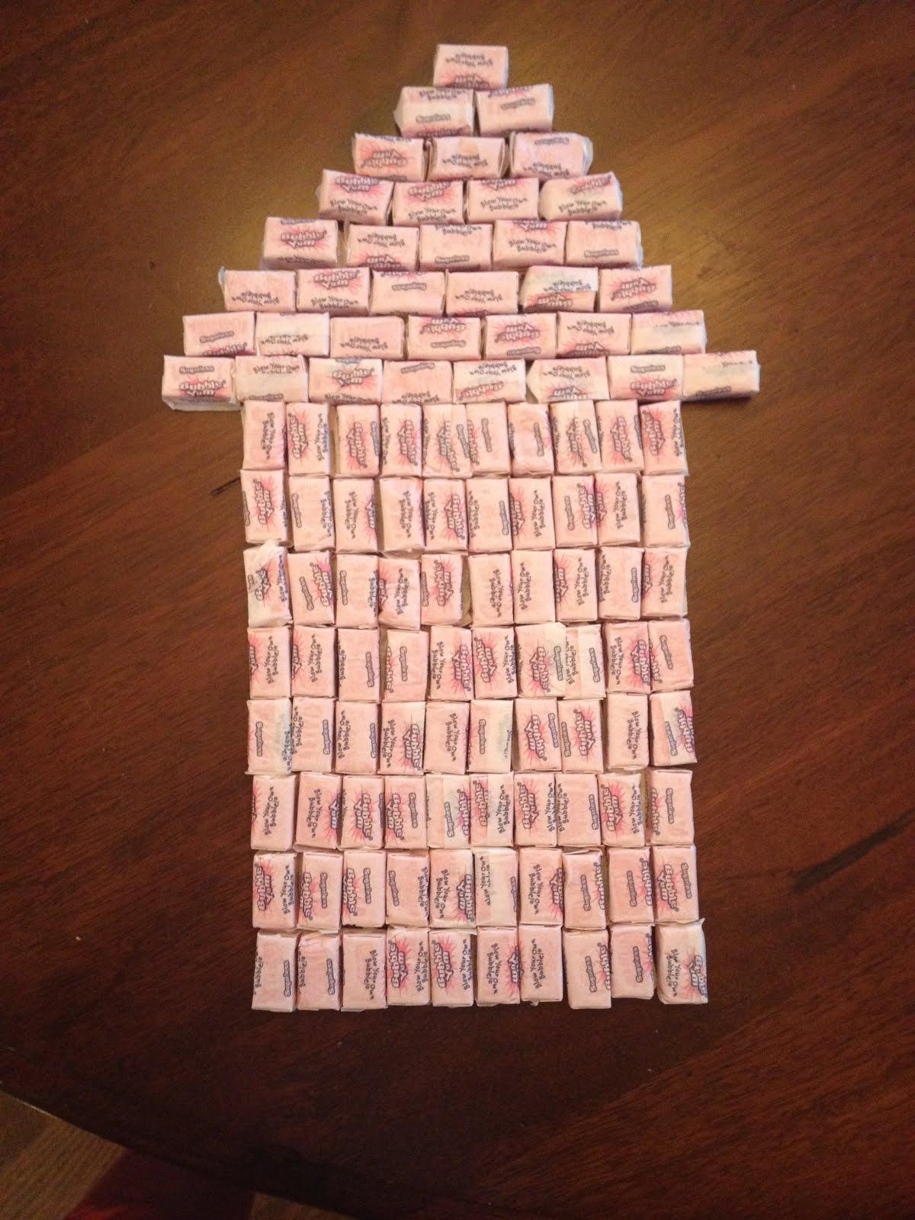
* Act 2 House of Gum Infographic: 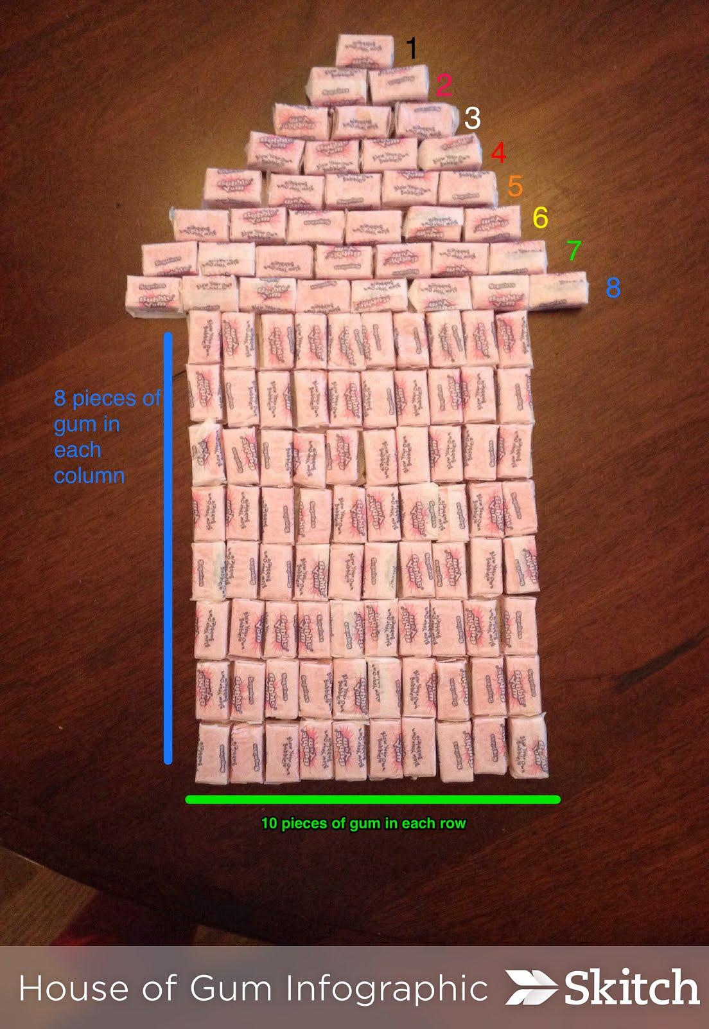
* Act 3 Photo: 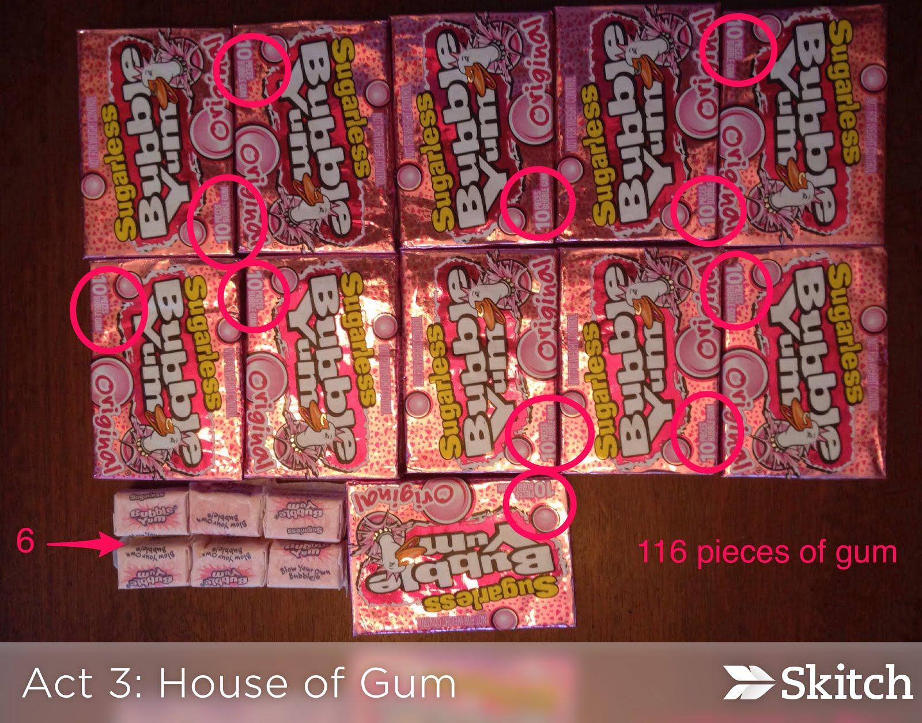
* 3 Act Recording Sheet

**GROUPING**

Whole group/student pairs/ individual task

**TASK DESCRIPTION, DEVELOPMENT AND DISCUSSION**

In this task, students will view the picture and tell what they notice. Next, they will be asked to discuss what they wonder about or are curious about. These questions will be recorded on a class chart or on the board and on the student recording sheet. Students will then use mathematics to answer their own questions. Students will be given information to solve the problem based on need. When they realize they don’t have the information they need, and ask for it, it will be given to them.

**Background Knowledge:**

This task follows the 3-Act Math Task format originally developed by Dan Meyer. More information on this type of task may be found at <http://blog.mrmeyer.com/category/3acts/>. A Three-Act Task is a whole-group mathematics task consisting of 3 distinct parts: an engaging and perplexing Act One, an information and solution seeking Act Two, and a solution discussion and solution revealing Act Three. More information along with guidelines for 3-Act Tasks may be found in the ***Guide to Three-Act Tasks*** on georgiastandards.org and the K-5 CCGPS Mathematics Wiki.

This task should help develop student “intellectual need” for using efficient strategies for counting. Some students may find the total number of gum pieces used by counting by 1’s or skip counting. Students with advanced counting strategies may even identify an array in the photo as well.

**Part I**

**Act 1 – Whole Group** - Pose the conflict and introduce students to the scenario by showing Act I video or picture. **(Dan Meyer**<http://blog.mrmeyer.com/2011/the-three-acts-of-a-mathematical-story/>**)**

**“Introduce the central conflict of your story/task clearly, visually, viscerally, using as few words as possible.”**

1. Show Act 1 photo to students. 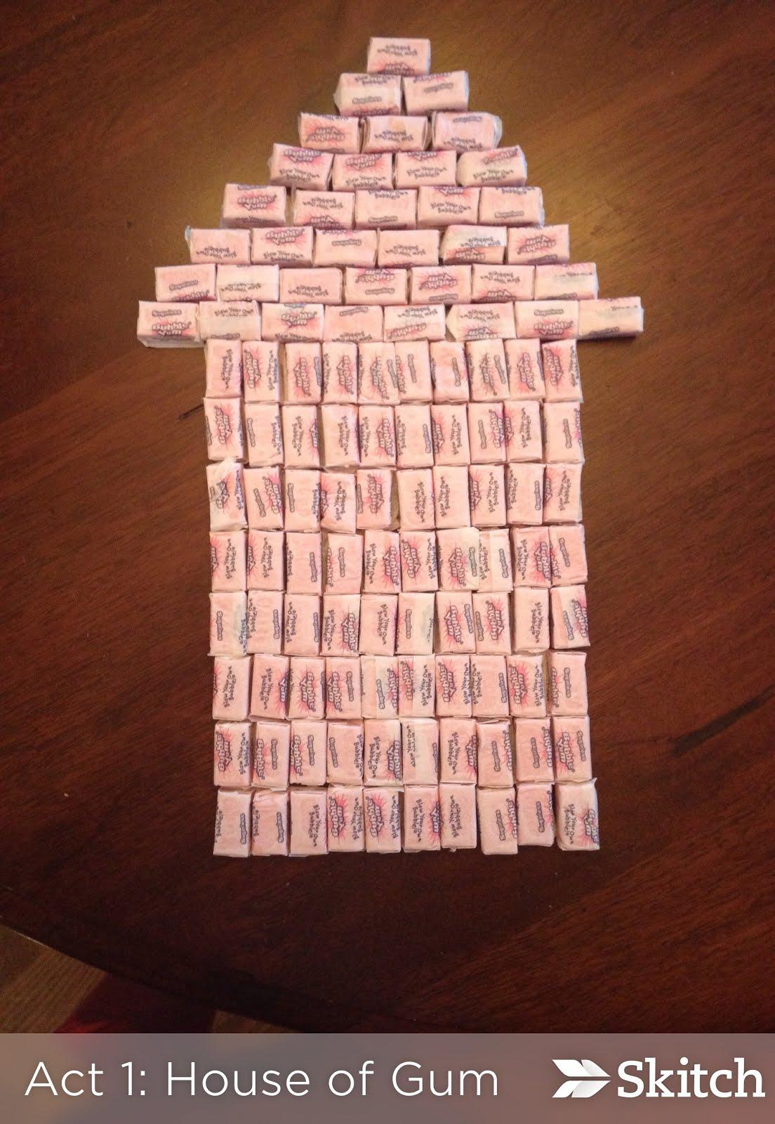
2. Ask students what they noticed in the picture, what they wonder about, and what questions they have about what they saw in the picture. Consider doing a think-pair-share so that students have an opportunity to talk with each other before sharing questions with the whole group. Students may need to see the photo several times.
3. Share and record students’ questions. The teacher may need to guide students so that the questions generated are math-related.
4. Ask students to estimate answers to their questions (think-pair-share). For the question “How many pieces of bubblegum were used to build the house?”, students write down an estimate on the task sheet then write down two more estimates – one that is too low and one that is too high. This is an excellent time to informally assess a student’s understanding of quantity sizes, in addition to practicing writing numbers. Next, students discuss the questions and determine the information they need.

**Anticipated questions students may ask and wish to answer:**

* How many pieces of gum are in each row?
* Are there the same amounts of gum pieces in each row?
* How many pieces of gum are on the top of the square?
* How many packs of gum did they use to build this house?

**Act 2** – **Student Exploration** - Provide additional information as students work toward solutions to their questions. **(Dan Meyer**<http://blog.mrmeyer.com/2011/the-three-acts-of-a-mathematical-story/>**)**

**“The protagonist/student overcomes obstacles, looks for resources, and develops new tools.”**

* During Act 2, students review the main question(s) from Act 1 and decide on the facts, tools, and other information needed to answer the question(s). When students decide what they need to solve the problem, they should ask for those things. It is pivotal to the problem solving process that students decide what is needed without being given the information up front. Some groups might need scaffolds to guide them.
* The teacher provides guidance as needed during this phase. Some groups might need scaffolds to guide them. The teacher should question groups who seem to be moving in the wrong direction or might not know where to begin. Questioning is an effective strategy that can be used, with questions such as:
* What is the problem you are trying to solve?
* What do you think affects the situation?
* Can you explain what you’ve done so far?
* What strategies are you using?
* What assumptions are you making?
* What tools or models may help you?
* Why is that true?
* Does that make sense?
* What number comes before\_\_\_\_\_\_\_\_\_\_? After?
* What is another efficient strategy you could use for counting the pieces of gum?

Important note: Although students will only investigate the main question(s) for this task, it is important for the teacher to not ignore student generated questions. Additional questions may be answered after they’ve found a solution to the main question, or as homework or extra projects.

Additional Act 2 Information: 

**Act 3 – Whole Group** – Share solutions and strategies.

1. Students to present their solutions and strategies and compare them.
2. Reveal the solution in Act 3 picture. 
3. Lead discussion to compare these, asking questions such as:
   1. o How reasonable was your estimate?
   2. o Which strategy was most efficient?
   3. o Can you think of another method that might have worked?
   4. o What might you do differently next time?

**FORMATIVE ASSESSMENT QUESTIONS**

● What organizational strategies did you use?

* Can you describe the patterns that you see?

● What counting strategies did you use?

* Which was most efficient? Why?

**Part II**

**Journal Writing:** Have students reflect on the task and write (or blog) about what they perceived to be challenging about the task and what they found enjoyable about the task. Pose questions like, *Which strategies helped you successfully identify the number of pieces of gum used? What strategies did you try that didn’t work? Why? Can you show your counting strategies on an open number line?* Encourage students to use mathematical language and make connections to the task.

**DIFFERENTIATION**

**Extension**

*Can you write a number sentence that matches how you counted the objects? What other connections can you make?* Students may need to go back and view the photo for Act 1 for this task. Students may make connections such as identifying repeated addition, 2-D shapes (triangle and square) and their attributes, and counting backwards or forwards by 1’s (to form the triangle).

**Intervention**

Students may need a copy (digital or hard copy) of the photo so they can physically touch the objects for counting. They may also prefer to circle groups of objects to demonstrate the strategies they use.

**Act 1 Photo**



**Act 2 Infographic**



**Act 3 Reveal**



Name:\_\_\_\_\_\_\_\_\_\_\_\_\_\_\_\_\_\_\_\_\_\_\_\_\_\_\_\_\_\_\_ Date:\_\_\_\_\_\_\_\_\_\_\_\_\_\_\_\_\_\_\_\_

**House of Gum**

|  |
| --- |
| **What problem are you trying to figure out?** |
| **What information do you already know?** |
| **What information do you need to solve the problem?** |
| |  |  |  | | --- | --- | --- | | **Make an estimate:** | **Write an estimate that is too high.** | **Write an estimate that is too low.** | |
| **Show your estimates on a number line:**  open_number_line.png |
| **Show your mathematical thinking using pictures, numbers, or words.** |
| **Describe the counting strategies you used.** |
| **What is your conclusion?** |

**Task 4**

**CONSTRUCTING TASK:** **The One Minute Challenge**

*Approximately 1 day, then repeated (Adapted from NCTM’s TCM 2011)*

**STANDARDS FOR MATHEMATICAL CONTENT**

**MGSE1.NBT.1** Count to 120, starting at any number less than 120. In this range, read and write numerals and represent a number of objects with a written numeral.

**MGSE1.MD.4** Organize, represent, and interpret data with up to three categories; ask and answer questions about the total number of data points, how many in each category, and how many more or less are in one category than in another.

**STANDARDS FOR MATHEMATICAL PRACTICE**

1. Make sense of problems and persevere in solving them.

2. Reason abstractly and quantitatively. *Students assign a number to represent each counter set.*

3. Construct viable arguments and critique the reasoning of others.

4. Model with mathematics*. Students create a graph to display the class’ results*.

5. Use appropriate tools strategically.

6. Attend to precision. *Students discuss their reasoning for placement of the number line, using the terms tens and ones.*

7. Look for and make use of structure.

8. Look for and express regularity in repeated reasoning. *Students determine a number benchmark to count their counters.*

**BACKGROUND KNOWLEDGE**

Subitizing is a skill that allows students to recognize the size of a collection without counting. This skill can aid in counting on or learning combinations of numbers. (Van de Walle, p. 43).

**COMMON MISCONCEPTIONS**

Van de Walle states that producing an estimate is a very difficult concept for students to understand. Using the terms “*estimate”* and *“about”* interchangeably throughout the lesson will help students understand the concept of estimating without having to randomly select numbers (p.59). Refer to the Number Talks section in this unit.

**ESSENTIAL QUESTIONS**

* What is an effective way of counting a large quantity of objects?
* Why do we need to be able to count objects?
* What is estimating and when can you use it?

**MATERIALS**

* A timer (to keep track of one minute)
* 1 bag of counters
* 1 number cube per pair (standard six-sided)
* 2 sticky notes per student (of the same color to record estimates)
* 1 different colored sticky note per student (to record the actual number of counters)

**GROUPING**

Large Group/partners

**TASK DESCRIPTION, DEVELOPMENT AND DISCUSSION**

**Part I**

Gather students in a circle and ask two volunteers to come into the middle to demonstrate the game to the class. Give the pair one standard six-sided number cube and a bag of about 100 counters. Model and explain *One Minute Challenge*:

**Roll and Gather**

Tell the pair that they will be trying to accumulate as many counters as they can in one minute. To start, place all of the counters in a pile. When the timer starts, one student will toss the number cube repeatedly and call out each result. The other student will quickly remove the called number of counters from the start pile and place them in a separate pile. (Example: Player 1 rolls the dice and calls out the number “4”. Player 2 gathers 4 counters and places them in a NEW separate pile). As the action is quickly repeated again and again, the pile of counters will grow larger and larger. Player 1 cannot roll again until the counters have been placed in the separate pile. This continues for one minute. At the end of one minute, students stop rolling and adding counters to their pile.

Comment: First grade students have cumbersome ways of counting. It is important to probe students as they explore different ways of counting efficiently. It is often the case that students do not subitize although they are capable of doing so. Here is a possible list of questions to ask students and to informally assess:

* Can you think of a more efficient way to count?
* Is counting by ones the most efficient way to count?
* What is quicker to count, the dice or the counters? Why?
* Why are the dice quicker to count? Could you use the same strategy with the counters?

So much potential exists for classroom teachers to assess as students engage in this task. Here is a possible list of things to observe:

* How quickly do young children subitize the numbers on the number cube or subitize a collection of counters without needing to count them one by one?
* How reasonable are the students’ estimates? How do they go about estimating?
* When counting the actual counters, do students group in ten or simply count one by one?
* Do they have trouble with reversals when writing numerals, such as 46 and 64?

**Estimate and count**

For one minute, bother partners will roll their dice and move their counters to one combined pile. Once a minute has elapsed, both players stop rolling and neither player can touch the counters. Each player gets a sticky note (of the same color). On separate sticky notes, each player will record their estimate of how many counters have been set aside in the new pile. Be sure players do not touch or count the counters at this time and are just focusing on making an accurate and meaningful estimation. Both players record their estimates and explain their strategy for their estimate. *Many times students will say a number with no purpose other than to be different. Students must justify their reasoning. In addition, students usually underestimate quantity at this stage.*

Both students count the counters to find the actual total earned in the round. Typical scores at this demonstration stage seem to vary from about 30–50 counters in first grade. The volunteer pair is asked to record the actual number in large digits on a different colored sticky. Students compare both estimated sticky notes with the actual number and keep the estimation sticky that was closest to the actual count. Students must share the strategy they used for determining which estimate was closer. The sticky note with the number which was farther away is discarded.

**Part II**

Students are invited to find a partner and a quiet spot on the floor or at a table. Each pair receives a number cube, a bag of counters, 2 sticky notes that are the same color and one different color sticky note. Students decide who will roll and who will count and practice rolling and counting for a few minutes. When everyone is ready, the start signal is given and the timer starts.

After one minute, when told to stop, students carefully set aside the collection of counters they have separated from the original pile. Both students make an estimate and record the estimate on the same colored sticky. Players then count the actual number of counters collected in a minute and record on the different colored sticky. Students then use the open number line recording sheet to compare their estimates. Whose estimate was closer to the actual amount of counters in the pile? Once students compare the difference in estimates, they keep the closest estimate and discard the one that is furthest away to use during Part III.

**Line ‘Em Up**

The student that had the closest estimate keeps that sticky note and the other student keeps the sticky with the actual count of counters on it. Have students stand shoulder to shoulder at the front of the class. Ask them to get in order from the least to greatest number based on the numbered sticky they are holding.

Special Note: *During this time, allow students to order themselves without your guidance. Observe the conversations taking place and the roles students play in organizing one another. This can be extremely beneficial with the future grouping of students.*

When students are satisfied with their number order, record the order of the students on the board. Ask students to review the order posted and ask if they would like to reconsider their decision on some or all of the numbers in the order. Again, allow the students to problem solve without your guidance. If there are duplicate numbers, have the students decide how to manage the problem.

**Graphing the Data**

After the correct numbered order has been identified and agreed upon, have each student place their post-it on their desk. Using the *One Minute Challenge* data recording sheet, students record the data and graph their class’ results. Once all students have graphed the results, lead a discussion that allows students to share information they’ve learned from the data they collected.

**FORMATIVE ASSESSMENT QUESTIONS**

* Did you use a counting strategy for counting your counters? If so, what was it?
* Why did you estimate that number?
* Whose estimation was more accurate? How do you know?

**DIFFERENTIATION**

**Extension**

* Graph can be modified so that each square represents 2 players’ numbers.
* Students can identify the actual difference between the estimate sticky note and the actual sticky note, and also between both estimates.

**Intervention**

* Allow students to use a number line to place sticky notes in order.
* Post the numbers on the sticky notes on the board and have students record them in order in their math journal.

**One Minute Challenge**

Partner One:\_\_\_\_\_\_\_\_\_\_\_\_\_\_\_\_\_\_\_ Partner Two:\_\_\_\_\_\_\_\_\_\_\_\_\_\_\_\_\_\_\_\_\_\_

|  |  |
| --- | --- |
| **Partner One’s Estimate** | **Partner Two’s Estimate** |
|  |  |
| Actual Amount of Counters in the Pile: | |
| Partner One: Show the difference between your estimate and the actual amount of counters.  **open_number_line.png**  Difference:\_\_\_\_\_\_\_\_\_\_\_\_ | |
| Partner Two: Show the difference between your estimate and the actual amount of counters.  **open_number_line.png**  Difference:\_\_\_\_\_\_\_\_\_\_\_ | |

One Minute Challenge Name\_\_\_\_\_\_\_\_\_\_\_\_\_\_\_\_

|  |  |
| --- | --- |
| **Numbers of Counters** | **Number of Students** |
| 0-9 |  |
| 10-19 |  |
| 20-29 |  |
| 30-39 |  |
| 40-49 |  |
| 50-59 |  |
| 60-69 |  |
| 70-79 |  |
| 80-89 |  |
| 90-99 |  |
| 100-109 |  |
| 110-119 |  |

Name:\_\_\_\_\_\_\_\_\_\_\_\_\_\_\_\_\_ **One Minute Challenge**

|  |  |  |  |
| --- | --- | --- | --- |
| 15 |  |  |  |
| 14 |  |  |  |
| 13 |  |  |  |
| 12 |  |  |  |
| 11 |  |  |  |
| 10 |  |  |  |
| 9 |  |  |  |
| 8 |  |  |  |
| 7 |  |  |  |
| 6 |  |  |  |
| 5 |  |  |  |
| 4 |  |  |  |
| 3 |  |  |  |
| 2 |  |  |  |
| 1 |  |  |  |
| **0-19** | **20-49** | **50 and some more** | |

**Task 5**

**PRACTICE TASK****: More or Less Revisited**

*Approximately 1 day (Adapted from Stuart Murphy’s More or Less activity)*

**STANDARDS FOR MATHEMATICAL CONTENT**

**MGSE1.NBT.1** Count to 120, starting at any number less than 120. In this range, read and write numerals and represent a number of objects with a written numeral.

**STANDARDS FOR MATHEMATICAL PRACTICE**

1. Make sense of problems and persevere in solving them.

2. Reason abstractly and quantitatively.

3. Construct viable arguments and critique the reasoning of others. *Students discuss how to guess the number*

4. Model with mathematics. *Students use a number chart to locate their number.*

5. Use appropriate tools strategically.

6. Attend to precision.

7. Look for and make use of structure.

8. Look for and express regularity in repeated reasoning.

**BACKGROUND KNOWLEDGE/COMMON MISCONCEPTIONS**

This task is centered on number relations and counting. Students need to expand their basic ideas of place value understanding which include base-ten grouping, oral names, and written names, to relative magnitude. Students should be able to relate a number’s relationship to another number as: much larger, much smaller, close to, or about the same. (Van de Walle, p. 142)

**ESSENTIAL QUESTIONS**

* Why do we need to be able to count objects?
* How can we use counting to compare objects in a set?
* How do we know if a set has more or less?

**MATERIALS**

* *More or Less,* by Stuart J Murphy or similar text
* 0-99 chart
* 0-99 chart (student)
* Counters

**GROUPING**

Large Group/Partner

**TASK DESCRIPTION, DEVELOPMENT AND DISCUSSION**

**Part I**

Gather students in a common area and read *More or Less,* by Stuart Murphy, or a similar book*.* During the story, chart the guesses the students gave and identify them on the 0-99 chart. Then, have a class discussion about how the children guessed the principal’s age. Play the same type of game by having students guess your principal’s age. Students will begin guessing the principal’s age; once the number is given, have the students locate it on the 0-99 chart. Only give the students clues by telling them that the number is more or less.

**Part II**

Partner the students to play a version of *More or Less*. Player One will write a number on a sticky note and cover it. Player Two will then try to guess the covered number as Player One guides them to an answer by saying, *more or less*. Every number that is guessed is then covered on the 0-99 chart with a counter. Once the number is revealed or correctly guessed, the players switch roles and play again.

**FORMATIVE ASSESSMENT QUESTIONS**

* What was the number?
* How many guesses did you need to find the number?
* Was the number more or less than what you thought?
* What was the hardest number to guess? Why?
* Was your guess close to the number? How close?
* Was your guess far from the number? How far?

**DIFFERENTIATION**

**Extension**

* Have the students use higher numbers.

**Intervention**

* Have students use lower numbers they are more familiar with.
* Cover up half of the 99 chart so the students see only the numbers 0-49 as they play.
* Give students a range of numbers they can use.

0-99 Chart

|  |  |  |  |  |  |  |  |  |  |
| --- | --- | --- | --- | --- | --- | --- | --- | --- | --- |
| 0 | 1 | 2 | 3 | 4 | 5 | 6 | 7 | 8 | 9 |
| 10 | 11 | 12 | 13 | 14 | 15 | 16 | 17 | 18 | 19 |
| 20 | 21 | 22 | 23 | 24 | 25 | 26 | 27 | 28 | 29 |
| 30 | 31 | 32 | 33 | 34 | 35 | 36 | 37 | 38 | 39 |
| 40 | 41 | 42 | 43 | 44 | 45 | 46 | 47 | 48 | 49 |
| 50 | 51 | 52 | 53 | 54 | 55 | 56 | 57 | 58 | 59 |
| 60 | 61 | 62 | 63 | 64 | 65 | 66 | 67 | 68 | 69 |
| 70 | 71 | 72 | 73 | 74 | 75 | 76 | 77 | 78 | 79 |
| 80 | 81 | 82 | 83 | 84 | 85 | 86 | 87 | 88 | 89 |
| 90 | 91 | 92 | 93 | 94 | 95 | 96 | 97 | 98 | 99 |

**Task 6**

**SCAFFOLDING TASK:** **Close, Far, and In Between**

*Approximately 1 day*

*(Adapted from Van de Walle activities 5.12 and 5.19)*

**STANDARDS FOR MATHEMATICAL CONTENT**

**MGSE1.NBT.1** Count to 120, starting at any number less than 120. In this range, read and write numerals and represent a number of objects with a written numeral.

**STANDARDS FOR MATHEMATICAL PRACTICE**

1. Make sense of problems and persevere in solving them.

2. Reason abstractly and quantitatively.

3. Construct viable arguments and critique the reasoning of others*. Students validate why they chose the order of their numbers.*

4. Model with mathematics.

5. Use appropriate tools strategically.

6. Attend to precision. *Students identify how to compare numbers based on shared tens or ones.*

7. Look for and make use of structure.

8. Look for and express regularity in repeated reasoning.

**BACKGROUND KNOWLEDGE/COMMON MISCONCEPTIONS**

This task is centered on number relations and counting. Students need to expand their basic ideas of place value understanding, which includes base-ten grouping, oral names, and written names, to relative magnitude. Students should refer one number to the size relationship of another number much larger, much smaller, close to or about the same. (Van de Walle, p. 142)

**ESSENTIAL QUESTIONS**

* What patterns can be found on the 0-99 chart?
* How can patterns help us understand number?
* What do the numerals represent in a two or three-digit number?
* What are math tools and how can they help me make sense of numbers and counting?

**MATERIALS**

* 0-99 chart
* *Close, Far, and In Between* recording sheet
* A set of four cards with three numerals on each. (the numerals should be from the same row or column found on the 0-99 chart, but should not exceed 120) \*see additional note about recording sheet.

**GROUPING**

Large Group/Partner

**TASK DESCRIPTION, DEVELOPMENT AND DISCUSSION**

Prior to the lesson, write three numbers on the board for students to analyze, along with the questions listed below to lead a class discussion. The three numbers should be from the same row or columns found on the 0-99 chart, but should not exceed 120 (Example: 62, 67, 69).

* How are the numbers alike? How are they different?
* Which two are closest? Why?
* Which is closest to 50? To 100?
* Have the students name a number between two of the numbers you have chosen.
* Name a number that is more than all of the numbers chosen.
* Name a number that is less than all of these numbers chosen.

**Part I**

Gather students in a common area for a class discussion about the three numbers provided on the board. The students should use the 0-99 chart as a reference when comparing these numbers.

Continue the class discussion with three new numbers for the students to explore and express their mathematical reasoning.

**Part II**

In partners, students should go to each of the four stations and record the numerals found and answer the same questions found on the class discussion chart.

After the students have rotated through each of the stations, have the class come back together to share their findings and express their mathematical reasoning about their answers and the numerals they have explored.

**FORMATIVE ASSESSMENT QUESTIONS**

* What numerals did you explore?
* Did you find any patterns in the numerals you explored? Which ones?
* Explain why the numbers with a five in the ones place are in the same column. Why are the numbers with a five in the tens place in the same column?

**DIFFERENTIATION**

**Extension**

* Give students numbers with a greater value to compare. Have them choose two numbers and write at least five things they know about each number through pictures and words.

**Intervention**

* Give students numbers with a lesser value to work with.
* Allow students to work with a student copy of the 0-99 chart, having the students circle the numbers that are being compared. Cover up half of the 99 chart so students see only the numbers 0-49 as they play. This also helps the students to better see the numbers and their relationships.
* Have students complete the task in a small group to closely monitor the student’s work.

**Close, Far and in Between**

**0 120**

|  |  |  |  |  |  |
| --- | --- | --- | --- | --- | --- |
| **My 3 Numbers** | **Closest 2 Numbers** | **Farthest from** | | **Greatest Number** | **Least Number** |
| \_\_\_\_**, \_\_\_\_, \_\_\_\_**  **Put numbers in order** | **\_\_\_\_, \_\_\_\_** | **50** | **100** | **\_\_\_\_** | **\_\_\_\_** |
| **\_\_\_\_** | **\_\_\_\_** |
| **\_\_\_\_, \_\_\_\_, \_\_\_\_**  **Put numbers in order** | **\_\_\_\_, \_\_\_\_** | **50** | **100** | **\_\_\_\_** | **\_\_\_\_** |
| **\_\_\_\_** | **\_\_\_\_** |
| **\_\_\_\_, \_\_\_\_, \_\_\_\_**  **Put numbers in order** | **\_\_\_\_, \_\_\_\_** | **50** | **100** | **\_\_\_\_** | **\_\_\_\_** |
| **\_\_\_\_** | **\_\_\_\_** |

**Task 7**

**CONSTRUCTING TASK:** **Finding Neighbors**

*Approximately 1 day (Adapted from VDW Activity 5.11)*

**STANDARDS FOR MATHEMATICAL CONTENT**

MGSE1.NBT.1 Count to 120, starting at any number less than 120. In this range, read and write numerals and represent a number of objects with a written numeral.

MGSE1.MD.4 Organize, represent, and interpret data with up to three categories; ask and answer questions about the total number of data points, how many in each category, and how many more or less are in one category than in another.

**STANDARDS FOR MATHEMATICAL PRACTICE**

1. Make sense of problems and persevere in solving them.

2. Reason abstractly and quantitatively.

3. Construct viable arguments and critique the reasoning of others.

4. Model with mathematics.

5. Use appropriate tools strategically.

6. Attend to precision.

7. Look for and make use of structure. *Students discover patterns in the rows and columns of the number chart.*

8. Look for and express regularity in repeated reasoning.

**BACKGROUND KNOWLEDGE/COMMON MISCONCEPTIONS**

The hundreds chart is an important tool that can help in the development of place value concepts. Here students are exploring patterns in the hundreds chart and are developing the structure of the written numbers in our place-value system when they fill in the missing numbers on the chart. (Van De Walle, p. 137)

**ESSENTIAL QUESTIONS**

* How can we find the missing numbers on the 0-99 chart?
* What patterns can be found on the 0-99 chart?
* How can patterns help us understand number?

**MATERIALS**

* 0-99 chart
* Base ten blocks
* Finding neighbors recording sheet

**GROUPING**

Large Group/partners

**TASK DESCRIPTION, DEVELOPMENT AND DISCUSSION**

Before gathering the students together, create a 0-99 chart with missing numerals similar to the student’s recording sheet. During the whole group session, review how to create numbers using base ten blocks and how to use the spinners. A spinner board can be made with a paper clip and a pencil. Then, have students work in pairs to complete the Finding Neighbors task.

To play: Each pair of students should have two *Finding Neighbors Recording Sheets* and one spinner board. While holding the paper clip in place with the pencil, player 1 spins the spinner on each spin board to determine the amount of tens and ones required to build the number. The first number spun represents the amount of tens in the number, while the second number spun represents the amount of ones in the number. The student then builds the number using base ten blocks and locates it on the recording sheet. Player 1 then records the numbers that are neighbors to the number created. (Example: if the student spun 3 tens and 4 ones they would build 34 with the base-ten blocks and identify/ record the numeral on the 0-99 chart. Player one must then fill the squares for the numbers that are 1 more, 1 less, 10 more and 10 less. Subsequently, the numbers 33, 35, 44 and 24 must be filled in.)

If a number has already been filled in, the square is left alone.

After each player has had ten plays, the player with the greatest amount of numbers on their chart wins.

**FORMATIVE ASSESSMENT QUESTIONS**

* What numerals did you spin to build your number?
* How did you represent your number with the base ten blocks?
* What did you notice about the neighbor numbers when you filled them in?
* Did you notice any patterns in the 0-99 chart? Which ones?
* (As the board is filled) What numerals do you need to spin to help complete your chart?

**DIFFERENTIATION**

**Extension**

* Have the students complete the 0-99 chart by using the strategies and patterns they have discovered while playing the game.

**Intervention**

* Allow the students to complete the activity in a small group.
* Allow students access to a completed 0-99 chart to use as a reference when completing their task.

**Finding Neighbors**

|  |  |  |  |  |  |  |  |  |  |
| --- | --- | --- | --- | --- | --- | --- | --- | --- | --- |
| **0** |  |  |  |  |  |  |  |  |  |
|  |  |  |  |  |  |  | **17** |  |  |
|  |  |  |  |  |  |  |  |  |  |
|  |  |  | **33** |  |  |  |  |  |  |
|  |  |  |  |  |  |  |  |  |  |
|  |  |  |  |  | **55** |  |  |  |  |
|  | **61** |  |  |  |  |  |  | **68** |  |
|  |  |  |  |  |  |  |  |  |  |
|  |  |  |  |  |  |  |  |  |  |
|  |  |  |  |  |  |  |  | **98** |  |

0-9 Spinners

Provide a paper clip or transparent spinner to use with the templates below. Place a pencil point inside one end of the paper clip and hold with one hand. Use the other hand to flick the paperclip and it will spin. Students will need to have practice with this prior to this activity.

**Number of Tens Number of Ones**



**zero**

**one**

**two**

**three**

**four**

**five**

**six**

**seven**

**eight**

**nine**



**0**

**1**

**2**

**3**

**4**

**5**

**6**

**7**

**8**

**9**

**Task 8**

**\*CONSTRUCTING TASK****: Make It Straight!**

*Approximately 2 days*

**STANDARDS FOR MATHEMATICAL CONTENT**

**MGSE1.NBT.1** Count to 120, starting at any number less than 120. In this range, read and write numerals and represent a number of objects with a written numeral.

**MGSE1.NBT.7** **Identify dimes, and understand ten pennies can be thought of as a dime. (Use dimes as manipulatives in multiple mathematical contexts.)**

**MGSE1.MD.4** Organize, represent, and interpret data with up to three categories; ask and answer questions about the total number of data points, how many in each category, and how many more or less are in one category than in another.

**STANDARDS FOR MATHEMATICAL PRACTICE**

1. Make sense of problems and persevere in solving them.

2. Reason abstractly and quantitatively.

3. Construct viable arguments and critique the reasoning of others.

4. Model with mathematics.

5. Use appropriate tools strategically*. Students create a number line to add and subtract numbers.*

6. Attend to precision.

7. Look for and make use of structure. *Students see numbers with a common tens place.*

8. Look for and express regularity in repeated reasoning.

**BACKGROUND KNOWLEDGE/COMMON MISCONCEPTONS**

Although the 0-99 chart is a critical tool to develop students understanding, students must also realize that the 0-99 chart is a folded number line. This task is developed to help students make the connection between a 0-99 chart and number line. A number line measures distance from zero to any number the same way a ruler does. In the early grades, students focus on the dots or numerals on a number line instead of the spaces, which is incorrect (Van de Walle, page 73).

With the addition of the standard for counting dimes and understanding a dime is worth 10 pennies, conversation should be made about the dime being like a group of ten and the penny being like a one. For example, 21 is 2 tens and one, we could also say 2 dimes and 1 penny. The standard MGSE1.NBT.7. indicates that students should understand a dime is worth ten and the correlation to place value is a good place to do this. The concept of a dime and its worth will be revisited again in Unit 5 of the frameworks. For additional support see interventions listed for this task.

**ESSENTIAL QUESTIONS**

* What is an effective way of counting a large quantity of objects?
* How can we represent a number with tens and ones?
* What are math tools and how can they help me make sense of numbers and counting?
* What do a 0-99 chart and a number line have in common?
* How can dimes and pennies be used to count by tens and ones?

**MATERIALS**

* *Centipede’s One Hundred Shoes,*  by Tony Ross or similar book about tally marks
* 0-99 chart printed on tag board
* Tape or glue
* 2 different colored counters
* spinner (1 more, 1 less, 10 more, 10 less)
* spinner labeled with 10 and 1
* spinner labeled dimes and pennies

**GROUPING**

Large group/small group/partner

**TASK DESCRIPTION, DEVELOPMENT AND DISCUSSION**

**Part I**

By this time in the year, students should be familiar with a 0-99 chart. Assess prior knowledge and record what they know and how can use they chart as a tool.

Give each student a 0-99 chart and have them color each row of ten a different color. Ask the students what the benefits will be of coloring each row of ten a different color. After each student has colored their chart, have them cut their 99 chart into strips (0-9, 10-19, 20-29, etc.). Observe which students immediately start lining strips in order. Praise this concept and ask all students to do the same thing. After each student has put their number line in order, connect them together.

*This is a teacher preference: some teachers like to glue strips together using the extra flap on the end and some teachers cut the flap off and put a piece of tape on the back to connect. Either way is fine, however, keep in mind the number lines will be reused through the unit and year so they will need to be folded up.*

**Part II**

**Race to 99 (2 players)**

Each player should place their counter on zero. Players will take turns using the spinner and moving the corresponding number of spaces on the number line. (Example: if player 1 is on zero, and spins 10 less, they stay on zero. If player 1 spins 1 more, they move their counter to 1 on the number line. If player 2 is on 23 and spins 10 more they move their counter to 33.) The first player to reach the number 99 or beyond that number wins the game.

**Part III**

**Tug-A-War (2 players)**

Place the counter at the number 50 on the number line. Player 1 wants the counter to reach 0 on the number line and player 2 wants the counter to reach 99. 1 counter is shared between players and each player takes turn pulling the counter towards their designated side of the number line.

Player 1 uses the spinner and moves the counter the correspoding number of spaces towards zero on the number line. (If the chip is on fifty and player 1 spins 10, they move the chip 10 spaces towards the zero) Player one must identify and say the location of the chip on the number line. If player 1 is unable to` identify the correct location of the chip, it moves back to the previous location.

Player 2 spins and moves the counter that many spaces towards 99. (If the chip is on 40 and player 2 spins 1, they move the counter to 41) If player 2 is unable to correctly identify the location of the chip, it moves back to the previous location.

If the chip reaches zero on the number line, player 1 wins. If the chip reaches 99 on the number line, player 2 wins.

**Part IV**

Tug-A-War with dimes and pennies (2 players)

In this game similar to the one above the students will now play pretending the 99 chart is cents.

Place the counter at the number 50, or 50 cents, on the number line. Player 1 wants the counter to reach 0 on the number line and player 2 wants the counter to reach 99 cents. 1 counter is shared between players and each player takes turn pulling the counter towards their designated side of the number line.

Player 1 uses the dime and penny spinner and moves the counter the correspoding number of spaces towards zero on the number line. (If the chip is on fifty and player 1 spins dime, they move the chip 10 spaces towards the zero) Player one must identify and say the location of the chip on the number line. If player 1 is unable to identify the correct location of the chip, it moves back to the previous location.

Player 2 spins and moves the counter that many spaces towards 99 cents. (If the chip is on 40 cents and player 2 spins a penny, they move the counter to 41 cents) If player 2 is unable to correctly identify the location of the chip, it moves back to the previous location.

If the chip reaches zero on the number line, player 1 wins. If the chip reaches 99 cents on the number line, player 2 wins.

**FORMATIVE ASSESSMENT QUESTIONS**

* What do a 0-99 chart and a number line have in common?
* Can you recognize any patterns on the number line?
* How are a dime and penny similar to counting by ones and tens?
* What strategy are you using to move forward or backwards by 10 or 1?

**DIFFERENTIATION**

**Extension**

* Have students extend their number line to 120 and play *Race to 99* and *Tug-O-War.*
* Have students use a ten-sided die instead of using spinners with ones and tens.

**Intervention**

* Have students play Tug-O-War from the Kindergarten Frameworks with numbers 0-20.
* Use the lesson in Kindergarten Frameworks, Make a 10 and Carry On, which uses pennies and dimes.
* Play the game Race to 100 Pennies from Kindergarten Frameworks Unit 3.
* Modify *Race to 99* and *Tug-O-War* to only use a section of the number line.
* Utilized enlarged copies of number chart or number line.

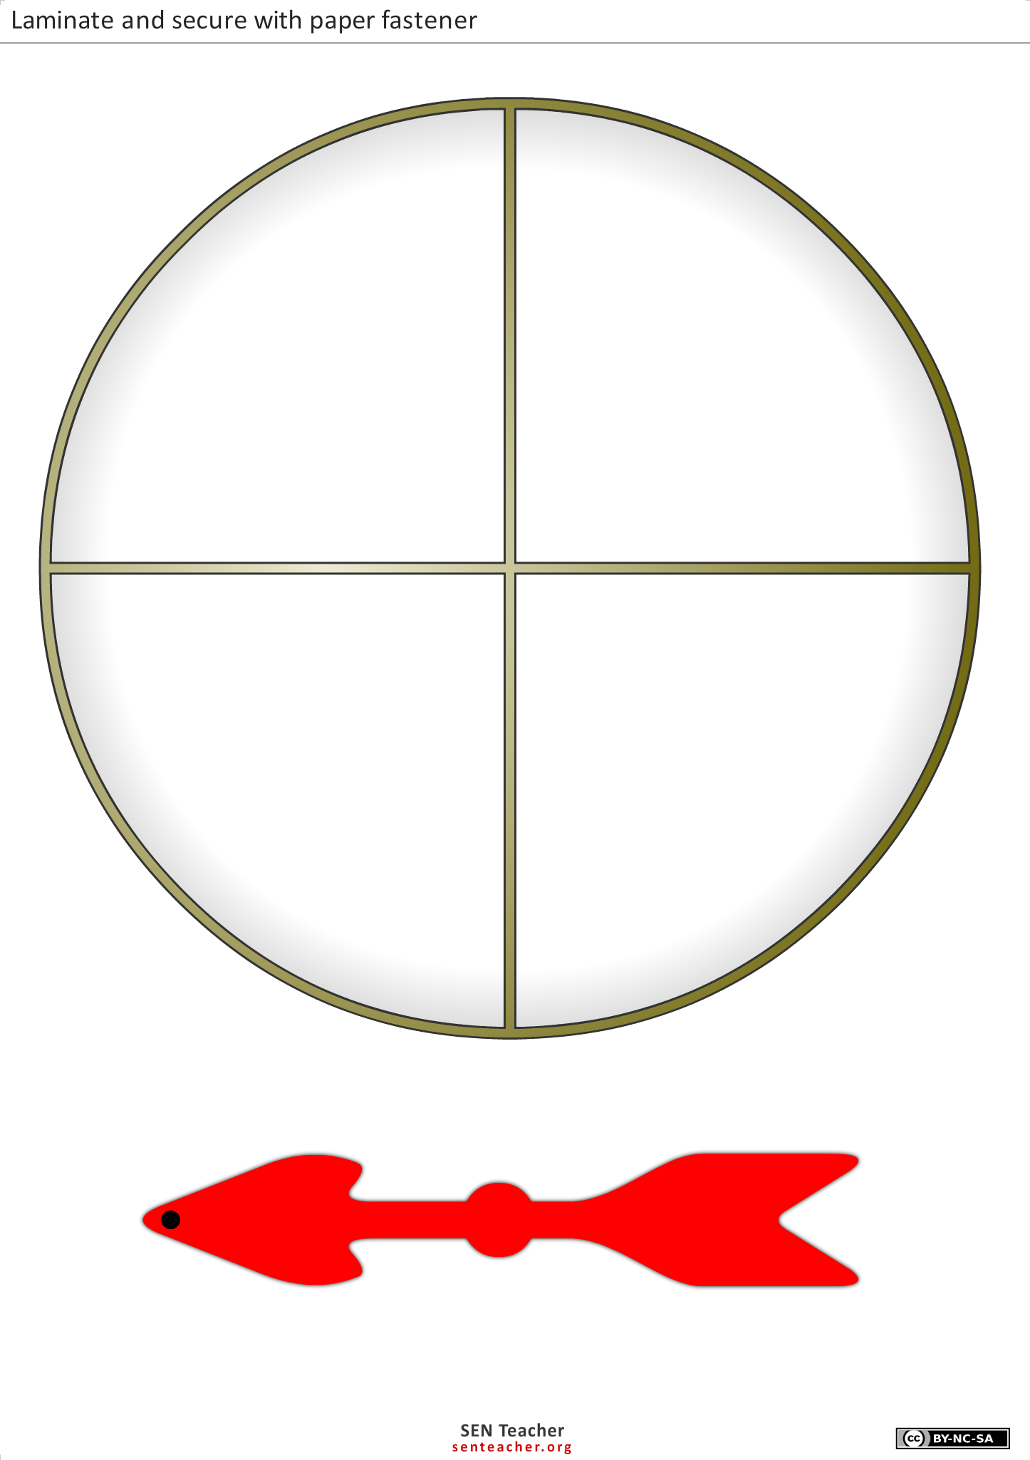

10 more

1 less

10 less

1 more

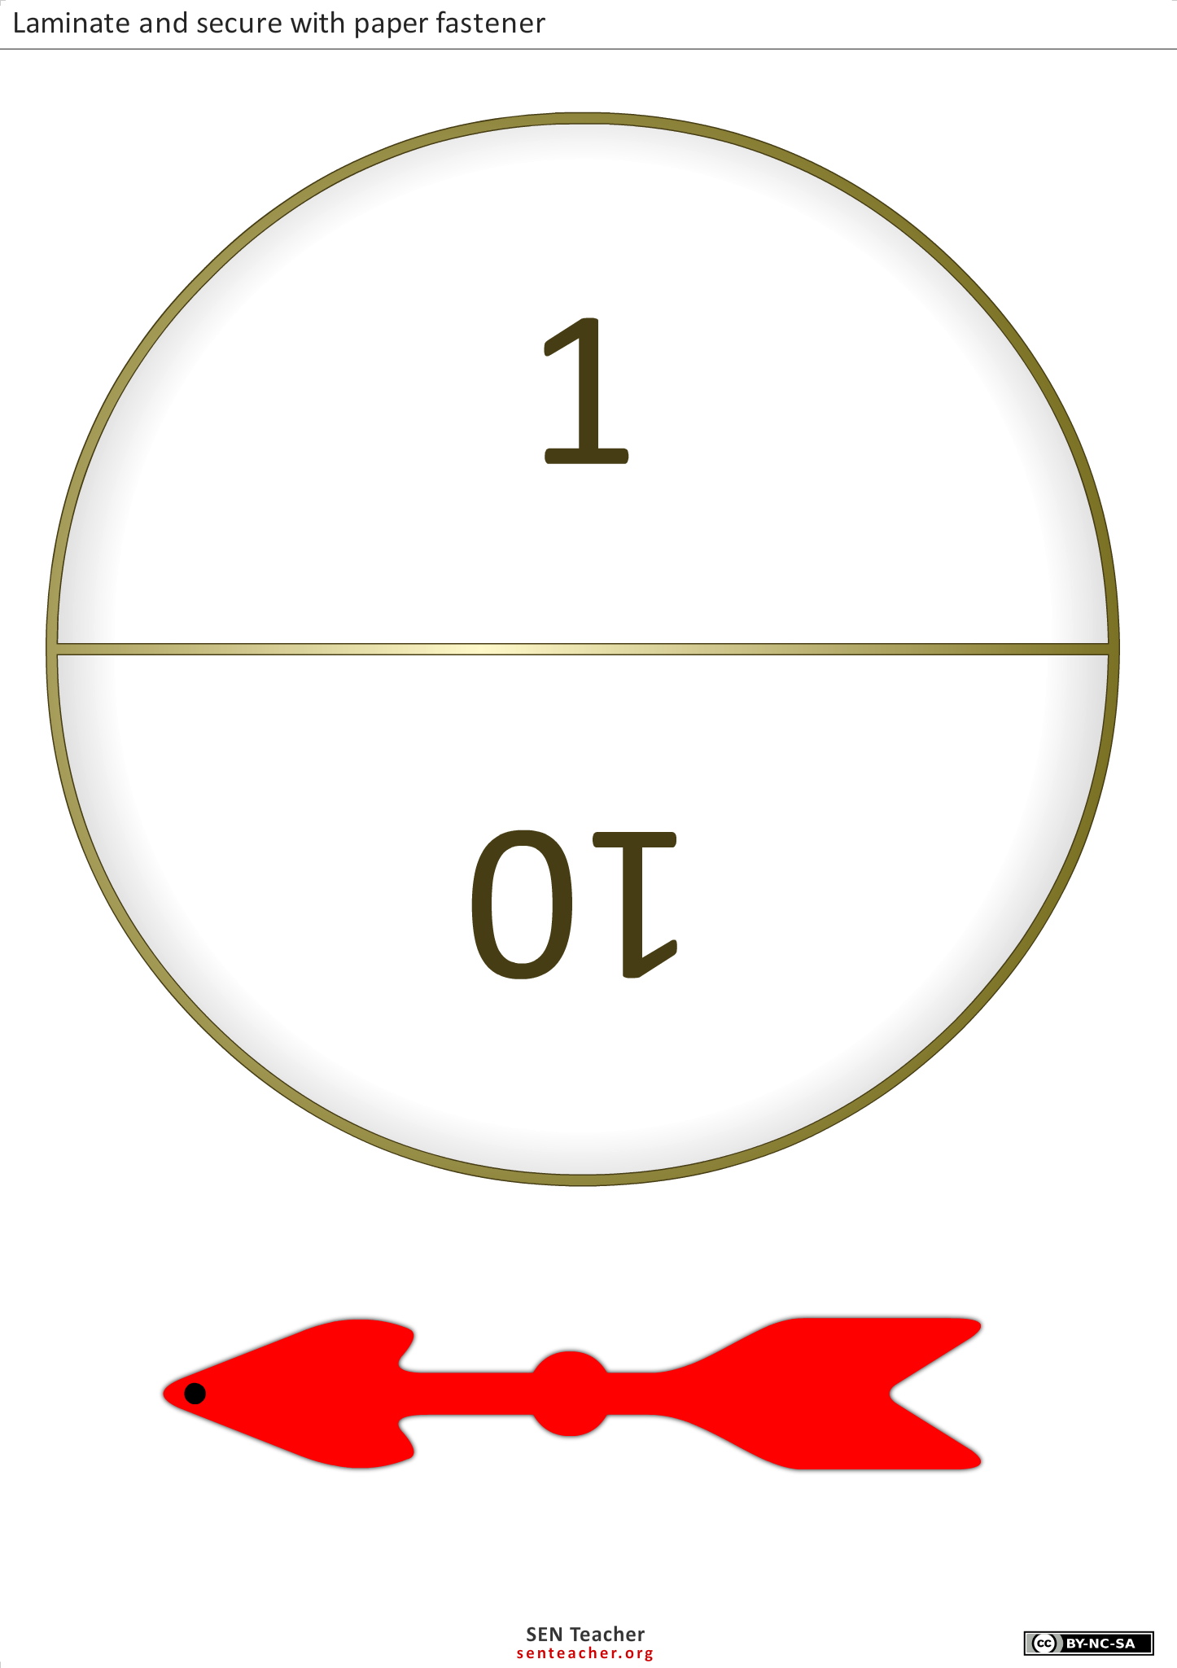**0-99 Chart**

|  |  |  |  |  |  |  |  |  |  |
| --- | --- | --- | --- | --- | --- | --- | --- | --- | --- |
| **0** | **1** | **2** | **3** | **4** | **5** | **6** | **7** | **8** | **9** |
| **10** | **11** | **12** | **13** | **14** | **15** | **16** | **17** | **18** | **19** |
| **20** | **21** | **22** | **23** | **24** | **25** | **26** | **27** | **28** | **29** |
| **30** | **31** | **32** | **33** | **34** | **35** | **36** | **37** | **38** | **39** |
| **40** | **41** | **42** | **43** | **44** | **45** | **46** | **47** | **48** | **49** |
| **50** | **51** | **52** | **53** | **54** | **55** | **56** | **57** | **58** | **59** |
| **60** | **61** | **62** | **63** | **64** | **65** | **66** | **67** | **68** | **69** |
| **70** | **71** | **72** | **73** | **74** | **75** | **76** | **77** | **78** | **79** |
| **80** | **81** | **82** | **83** | **84** | **85** | **86** | **87** | **88** | **89** |
| **90** | **91** | **92** | **93** | **94** | **95** | **96** | **97** | **98** | **99** |

**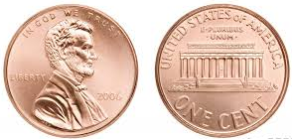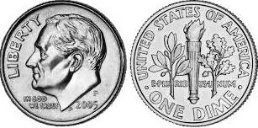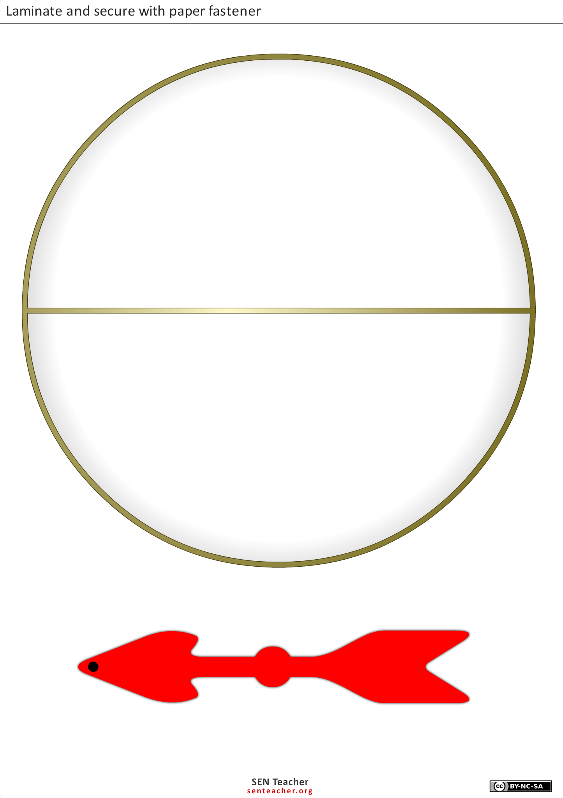**

Penny

Dime

**Task 9**

**CONSTRUCTING TASK:** **Number Hotel**

*Approximately 2 days Adapted from* [*www.thinkmath.edc.org*](http://www.thinkmath.edc.org)

**STANDARDS FOR MATHEMATICAL CONTENT**

**MGSE1.NBT.1** Count to 120, starting at any number less than 120. In this range, read and write numerals and represent a number of objects with a written numeral.

**MGSE1.MD.4** Organize, represent, and interpret data with up to three categories; ask and answer questions about the total number of data points, how many in each category, and how many more or less are in one category than in another.

**STANDARDS FOR MATHEMATICAL PRACTICE**

1. Make sense of problems and persevere in solving them.

2. Reason abstractly and quantitatively.

3. Construct viable arguments and critique the reasoning of others.

4. Model with mathematics.

5. Use appropriate tools strategically*. Students explore the numbers charts between numbers 0 and 119.*

6. Attend to precision.

7. Look for and make use of structure.

8. Look for and express regularity in repeated reasoning.

**BACKGROUND KNOWLEDGE/COMMON MISCONCEPTIONS**

On a conventional 0-99 and hundred chart, each row below the previous is greater than the one above. It can be conceptually hard for many children to understand that when you move down, the numbers actually increase in value. Using the *Number Hotel* will allow students to make the connection that as the height of the hotel increases so do the numbers in general.

**ESSENTIAL QUESTIONS**

* What are math tools and how can they help me make sense of numbers and counting?
* What do the numerals represent in a two or three digit number?
* What is an effective way of counting a large quantity of objects?
* What patterns can be found on the 0-99 chart?

**MATERIALS**

* Number Hotel game board
* Arrow cards
* Counters to use on the game board

**GROUPING**

Large Group

**TASK DESCRIPTION, DEVELOPMENT AND DISCUSSION**

**Part I**

Gather the students together to compare and analyze the Number Hotel and the 0-99 Chart. Have the students participate in a class discussion which includes reviewing and finding new patterns. Ask questions, rather than pointing out the differences, to prompt students to explain their discoveries of the Number Hotel, such as:

* *What differences do you notice between the Number Hotel and the 0-99 Chart?*
* *In what ways are they the same?*
* *What strategies might you need to know in order to use the Number Hotel?*

**Part II**

Pair the students into partner groups to play *Let Me Out* using the Number Hotel game board.

To Play: There are two exits out of the Number Hotel. The students must exit the hotel through the 0 door or the 119 door. Each player will place a counter on numeral 60 on their own game board. Using the stack of arrow cards, players will turn over five arrow cards each. The arrow cards can be arranged in any order for the player to find the quickest way to get out of the building. Each arrow represents one move on the Number Hotel game board. Players may move up, down, left or right. Once the players have moved five spaces, they may turn over five more arrow cards. Play stops and the player closest to their door wins.

**Part III**

Revisit the task, *Exploring the 99 Chart,* from the previous unit and incorporate some of the activities mentioned in the task. In particular, *Special Numbers* and *What’s My Picture?*

For *Special Numbers,* have the students pair up and cover three numbers special to them (ex.: birthday, address, numbers in their phone number) and have their partner guess the player’s numbers.

For *What’s My Picture*, have students pair up and cover numbers to create a picture using counters. Player one then calls out the numbers to a partner. The partner uses those numbers to recreate the picture made by player one. Then the players’ roles are reversed, giving each player a chance to recreate a picture.

**Part IV**

Gather the students together for a class discussion about what was learned from the *Number Hotel*. Have the students reflect on any connections they have made between the 0-99 chart and the Number Hotel. Have the students record what they learned in their math journals.

**FORMATIVE ASSESSMENT QUESTIONS**

* How is the Number Hotel different from the 0-99 chart?
* How is the Number Hotel the same as the 0-99 chart?
* What new patterns did you find in the Number Hotel?
* Does the order of the arrows change where you would end up?
* What strategy did you use to make it as close as you could to the door?
* What would you do differently if you could play again?
* What special numbers did you cover up? Why?
* What picture did you make with your counters?
* Was it difficult to recreate a picture from you partner? Why or why not?

**DIFFERENTIATION**

**Extension**

* Have the students continue playing *Let Me Out* until they have reached the exit.
* Instead of recording arrows at the bottom of the recording sheet, have the students record the numerical representation of what they need to do to exit the building.  (Example: if the counter is at 77 they would need to move +10, +10, +1, +1. Or, if the counter was at 22, they would need to record -10, -10, -1, -1.

**Intervention**

* Have the students use the 0-99 chart to play *Let Me Out*.
* In *What’s My Picture*, give the students an outline of a picture such as a flower to replicate.

Number Hotel

|  |  |  |  |  |  |  |  |  |  |
| --- | --- | --- | --- | --- | --- | --- | --- | --- | --- |
| ●  MC900352099[1]  110 | ●  111 | ●  112 | ●  113 | ●  114 | ●  115 | ●  116 | ●  117 | ●  118 | ●  119 |
| ●  100 | ●  101 | ●  102 | ●  103 | ●  104 | ●  105 | ●  106 | ●  107 | ●  108 | ●  109 |
| ●  90 | ●  91 | ●  92 | ●  93 | ●  94 | ●  95 | ●  96 | ●  97 | ●  98 | ●  99 |
| ●  80 | ●  81 | ●  82 | ●  83 | ●  84 | ●  85 | ●  86 | ●  87 | ●  88 | ●  89 |
| ●  70 | ●  71 | ●  72 | ●  73 | ●  74 | ●  75 | ●  76 | ●  77 | ●  78 | ●  79 |
| ●  60 | ●  61 | ●  62 | ●  63 | ●  64 | ●  65 | ●  66 | ●  67 | ●  68 | ●  69 |
| ●  50 | ●  51 | ●  52 | ●  53 | ●  54 | ●  55 | ●  56 | ●  57 | ●  58 | ●  59 |
| ●  40 | ●  41 | ●  42 | ●  43 | ●  44 | ●  45 | ●  46 | ●  47 | ●  48 | ●  49 |
| ●  30 | ●  31 | ●  32 | ●  33 | ●  34 | ●  35 | ●  36 | ●  37 | ●  38 | ●  39 |
| ●  20 | ●  21 | ●  22 | ●  23 | ●  24 | ●  25 | ●  26 | ●  27 | ●  28 | ●  29 |
| ●  10 | ●  11 | ●  12 | ●  13 | ●  14 | ●  15 | ●  16 | ●  17 | ●  18 | ●  19 |
| ●  0 | ●  1 | ●  2 | ●  3 | ●  4 | ●  5 | ●  6 | ●  7 | ●  8 | ●  9 |

**Number Hotel Playing Cards**

|  |  |  |  |
| --- | --- | --- | --- |
| Number Hotel | Number Hotel | Number Hotel | Number Hotel |
| Number Hotel | Number Hotel | Number Hotel | Number Hotel |
| Number Hotel | Number Hotel | Number Hotel | Number Hotel |
| Number Hotel | Number Hotel | Number Hotel | Number Hotel |
| Number Hotel | Number Hotel | Number Hotel | Number Hotel |

**Number Hotel** Name:\_\_\_\_\_\_\_\_\_\_\_\_\_\_\_\_\_\_\_\_\_\_\_\_

Each player places a counter on the numeral 50. Player 1 takes the top five arrow cards from the pile and records the moves they made. Players keep track of their moves on the task sheet by recording where they moved to after each card and the move they had to make to get there. After both players have had 2 turns taking the top five arrow cards, they identify which arrows they still need to get out of the hotel.

Description: C:\Documents and Settings\gfletcher.HES-L-1MT2FN1\Local Settings\Temporary Internet Files\Content.IE5\RV4OMV1I\MC900352099[2].wmf

|  |  |  |  |  |
| --- | --- | --- | --- | --- |
| **Direction**  **+1, -1, +10, -10** | **Room Number** |  | **Direction**  **+1, -1, +10, -10** | **Room Number** |
| Start | 50 |  | Start | 50 |
|  |  | 1 |  |  |
|  |  | 2 |  |  |
|  |  | 3 |  |  |
|  |  | 4 |  |  |
|  |  | 5 |  |  |
|  |  | 6 |  |  |
|  |  | 7 |  |  |
|  |  | 8 |  |  |
|  |  | 9 |  |  |
|  |  | 10 |  |  |

Draw the arrows you need to get out Draw the arrows you need to get out

|  |  |  |  |  |  |  |  |  |  |  |
| --- | --- | --- | --- | --- | --- | --- | --- | --- | --- | --- |
|  |  |  |  |  |  |  |  |  |  |  |

**FAL Assessment:** **Place Value**

See link below to access this assessment:

[Georgia Mathematics Educator Forum: Grades K-5 - K-5 Formative Assessment Lessons (FAL)](http://ccgpsmathematicsk-5.wikispaces.com/K-5+Formative+Assessment+Lessons+%28FALs%29)

**Task 10**

**PRACTICE TASK:** **Mystery Number!**

*Approximately 1 day Adapted from Van de Walle activity 5.17*

**STANDARDS FOR MATHEMATICAL CONTENT**

MGSE1.NBT.1 Count to 120, starting at any number less than 120. In this range, read and write numerals and represent a number of objects with a written numeral.

**STANDARDS FOR MATHEMATICAL PRACTICE**

1. Make sense of problems and persevere in solving them*. Students use rationale why they selected their number, as it relates to the number line.*

2. Reason abstractly and quantitatively.

3. Construct viable arguments and critique the reasoning of others. *Students use rationale and discuss why they selected their number, as it relates to the number line.*

4. Model with mathematics.

5. Use appropriate tools strategically.

6. Attend to precision. *Students use mathematic language to discuss if the mystery number more than or less than.*

7. Look for and make use of structure.

8. Look for and express regularity in repeated reasoning.

**BACKGROUND KNOWLEDGE/COMMON MISCONCEPTIONS**

This task is centered on number relations and counting. Students need to expand their basic ideas of place value understanding which include, base-ten grouping, oral names and written names to relative magnitude. Students should refer one number to the size relationship of another number much larger, much smaller, close or about the same. Using number lines allows students to see how one number is related to another. (Van de Walle, p. 142)

**ESSENTIAL QUESTIONS**

* What are math tools and how can they help me make sense of numbers and counting?
* How do we know where a number lies on a number line?
* What strategies can be used to find a missing number?

**MATERIALS**

* 0-99 chart
* Student dry erase boards or paper and pencil

**GROUPING**

Large Group/Partner

**TASK DESCRIPTION, DEVELOPMENT AND DISCUSSION**

**Part I**

Draw a number line labeled with only a 0 and 100 on the board. The number line should be labeled 0 at one end and 100 at the other. Gather students together to have a class discussion about the number line provided on the board. Select a mystery number. Draw an arrow to a spot on the number line and have students guess the mystery number. With each student’s guess, have the students identify why they chose that particular number and what their strategy was. Write that number on the number line as it relates to the mystery number. As students guess the mystery number have a volunteer also identify that number on the 0-99 chart, so students can make the connection between the number line and 0-99 chart. Continue to record the student guesses until the mystery number has been revealed. Be sure that students explain why they are choosing a particular number.

**Part II**

Have the students play the mystery number game with a partner using dry erase boards or paper and pencil. Let each student have a chance creating a mystery number, as well as guessing a mystery number.

**FORMATIVE ASSESSMENT QUESTIONS**

* What was the mystery number?
* How many guesses did you need to find the mystery number?
* What strategy did you use to correctly identify the mystery number?
* What was the hardest number to guess? Why?

**DIFFERENTIATION**

**Extension**

* Have the students extend their number lines to try 200, 300 or 400.

**Intervention**

* Have students complete the task in a small group to closely monitor the student’s work. Students can also hold a 0-99 chart in their hand to help suggest what the mystery number could be.

**Task 11**

**CONSTRUCTING TASK:** **Ten and Some More**

*Approximately 1 day (Adapted from Stuart J. Murphy’s 1, 2, 3 Sassafras activity)*

**STANDARDS FOR MATHEMATICAL CONTENT**

**MGSE1.NBT.1** Count to 120, starting at any number less than 120. In this range, read and write numerals and represent a number of objects with a written numeral.

**STANDARDS FOR MATHEMATICAL PRACTICE**

1. Make sense of problems and persevere in solving them. *Students discuss with partners which numbers created are larger.*

2. Reason abstractly and quantitatively. *Students recognize and compare the value represented by the numeral.*

3. Construct viable arguments and critique the reasoning of others.

4. Model with mathematics.

5. Use appropriate tools strategically.

6. Attend to precision. *Students discuss different numbers created and compare values.*

7. Look for and make use of structure.

8. Look for and express regularity in repeated reasoning.

**BACKGROUND KNOWLEDGE/COMMON MISCONCEPTIONS**

Two digit numbers must also be connected with the grouping-by-tens concept. This counting method provides a connection between the numeral and the set. Therefore students begin to understand that 19 is one ten and nine. (Van de Walle, p. 126)

**ESSENTIAL QUESTIONS**

* What do the numerals represent in a two or three digit number?
* How can patterns help us understand number?
* What are math tools and how can they help me make sense of numbers and counting?

**MATERIALS**

* *1, 2, 3 Sassafras,* by Stuart J. Murphy, or similar text
* 0-99 Chart
* Base Ten Blocks
* Number Cards(1 set per person)
* Recording Sheet

**GROUPING**

Large Group/Partner

**TASK DESCRIPTION, DEVELOPMENT AND DISCUSSION**

**Part I**

Gather the students together to read *1, 2, 3 Sassafras,* by Stuart J. Murphy or similar text. Have a class discussion about the different ways the family could be arranged in the picture. Discuss the different ways numbers could be arranged. For example: 19 could be rearranged 91. Discuss how different these numbers are when built with base ten blocks. Reinforce that the positions of digits in numbers determine what they represent (which size group they count.) This is a major principle of place-value numeration (Van de Walle, page 122).

**Part II**

In partners, students should take turns picking up two numbers from their pile. The players then build the largest number possible. The student records both numbers made on the recording sheet. The students then build their number using base ten blocks. The player with the largest number takes all four cards. Play continues until all cards have been played. The student with the largest amount of cards wins. Students then must place the numbers created in order from least to greatest on their recording sheet.

**Part III**

Students identify the largest number made during the game and must build that number using a various combinations of base ten blocks. (Example: 91 can be decomposed as 9 tens and 1 one, 8 tens and 11 ones, 7 tens and 21 ones, etc.)

**FORMATIVE ASSESSMENT QUESTIONS**

* What strategy did you use to arrange your numbers?
* What was the highest number made?
* What was the lowest number made?
* What are the differences between the numbers you made?
* When building your number with base ten blocks, did you notice any patterns?

**DIFFERENTIATION**

**Extension**

* Have the students use three cards instead of two, when building three digit numbers.
* Have students record all ten numbers from greatest to least.

**Intervention**

* Allow students to work with a student copy of the 0-99 chart, having the students circle the numbers being made.
* Reduce the amount of cards to 0-5.

Number Cards

|  |  |
| --- | --- |
| 0 | 1 |
| 2 | 3 |
| 4 | 5 |
| 6 | 7 |
| 8 | 9 |

Ten and Some More



|  |  |  |
| --- | --- | --- |
|  | **Player 1**  **Name:\_\_\_\_\_\_\_\_\_\_\_\_\_** | **Player 2**  **Name :\_\_\_\_\_\_\_\_\_\_\_\_\_** |
|  | **Greatest Number** | **Greatest Number** |
| **1st** |  |  |
| **2nd** |  |  |
| **3rd** |  |  |
| **4th** |  |  |
| **5th** |  |  |

**Choose the winning players numbers and place them in order from least to greatest.**

**\_\_\_\_\_ \_\_\_\_\_ \_\_\_\_\_ \_\_\_\_\_ \_\_\_\_\_**

How many ways could you build your largest number using base ten blocks?

**Task 12**

**CONSTRUCTING TASK****: Dropping Tens**

*Approximately 3-4 days (Adapted from Van de Walle activity 5.1)*

**STANDARDS FOR MATHEMATICAL CONTENT**

**MGSE1.NBT.1**  Count to 120, starting at any number less than 120. In this range, read and write numerals and represent a number of objects with a written numeral.

**STANDARDS FOR MATHEMATICAL PRACTICE**

1. Make sense of problems and persevere in solving them.

2. Reason abstractly and quantitatively. *Students compare two sets and determining which set is larger.*

3. Construct viable arguments and critique the reasoning of others. *Students create charts to record numbers constructed.*

4. Model with mathematics. *Students create charts to record numbers constructed.*

5. Use appropriate tools strategically.

6. Attend to precision. *Students identify which set is greater than.*

7. Look for and make use of structure.

8. Look for and express regularity in repeated reasoning.

**BACKGROUND KNOWLEDGE/COMMON MISCONCEPTIONS**

Place-value requires the understanding of grouping by tens and how groups are recorded in our place-value system, how numbers are written, and how they are spoken. We want children to recognize that making groupings of tens and left-overs is a way of counting the same quantity by ones. (Van de Walle, p. 124)

**ESSENTIAL QUESTIONS**

* What is an effective way of counting a large quantity of objects?
* How can we represent a number with tens and ones?
* What are math tools and how can they help me make sense of numbers and counting?
* How do we know if a set has more or less?
* How can we use counting to compare objects in a set?

**MATERIALS**

* 25-100 piece collection of dried beans
* Tongue depressors
* School glue
* Dot sticks (craft sticks/popsicle sticks)

**GROUPING**

Large Group/Individual/Partner

**TASK DESCRIPTION, DEVELOPMENT AND DISCUSSION**

**Part I**

Gather the students together for a class discussion on ways to represent a number. Dump the collection of beans (Teacher Tip: use stickers or other items in place of beans) on the floor, and ask the students to count the beans. Have students share their method of counting the beans. Note: *Having the students group items in groups of ten is the most efficient means to count the items. However, this strategy needs to be found by the students and not prompted by the teacher*. Continue the discussion after the number of items on the floor is determined. Ask the students how this number could be represented. (Example: How can we represent the number 54?) Chart the students’ responses and ideas. Continue the class discussion until the students understand that when representing the number 54, there are five sets of ten and 4 ones left over. Note: Some students may say 4 sets of ten and 14 ones.

**Part II**

Show students how to make base-ten models by gluing ten beans on each tongue depressor to represent one group of ten. Have them work independently, to make the base-ten models until all the possible groups of ten beans are used.

Comment: Bean sticks are an excellent way to connect unitizing to base-ten blocks and should be used interchangeably. Physical models for base-ten concepts helps students to develop the idea of “a ten” as both a single entity and as a set of 10 units. (Van de Walle, p. 127)

**Part III**

Comment: Prior to this activity, the teacher should make dot sticks to represent the base-ten model. To make dot sticks, place a set of ten dots on one side of the stick and one dot on the reverse side of the stick. This will allow students to represent both tens and ones.

Gather students in a common area to introduce the dot sticks and to play Dropping Tens. Students will be given ten dot sticks each. The students will drop the ten sticks to see what combination of tens and ones are created. The students will then record the number created on their recording sheet. Please refer to the key at the bottom of the recording sheet to explain to students how to record their number.

**Part IV**

Gather the students in a common area to explain the *Who Has More?* game. With students in pairs, player one drops their group of ten sticks and records their number on the game board. Then, player two drops their group of ten sticks and records their number on the game board. The player with the most circles their number. Play continues until each player has gone 5 times. The player with the most groups circled wins. If there is a tie, students must count up all the ones recorded to determine the winner.

**FORMATIVE ASSESSMENT QUESTIONS**

* How many beans were counted? How many tens? How many ones?
* How can a set of ten be represented?
* How can ones be represented?
* What is the number with the least value that could have been made with your dot sticks?
* What is the greatest number that could have been made with your dot sticks?

**DIFFERENTIATION**

**Extension**

* Have students model their number with base-ten blocks.
* Have students place the numbers they created in order from least to greatest.

**Intervention**

* Have the students use fewer sticks to play Dropping Tens.
* Have students model their number dropped with the bean sticks.

**Dropping Tens Name:**\_\_\_\_\_\_\_\_\_\_\_\_\_\_\_\_\_\_\_\_\_\_\_\_\_\_\_\_

|  |  |
| --- | --- |
| **Sticks of 10 and some more** | **Numeral** |
| **I I I I I I I**●●● | 73 |
|  |  |
|  |  |
|  |  |
|  |  |
|  |  |
|  |  |
|  |  |
|  |  |

|  |
| --- |
| **Key**  **I** -is equal to 10 beans ● is equal to 1 bean |

**Who Has More?**

|  |  |  |  |  |
| --- | --- | --- | --- | --- |
| http://etc.usf.edu/clipart/73300/73373/73373_balance_lg.gif**Player 1**  **Name:** | |  | **Player 2**  **Name:** | |
| **Sticks of 10 and some more** | **Numeral** |  | **Sticks of 10 and some more** | **Numeral** |
| **I I I I I I I**●●● | 73 |  | **I I I I**●●●●●● | 46 |
|  |  |  |  |  |
|  |  |  |  |  |
|  |  |  |  |  |
|  |  |  |  |  |
|  |  |  |  |  |

|  |
| --- |
| **Key**  **I** -is equal to 10 beans ● is equal to 1 bean |

**Task 13**

**PRACTICE TASK:** **Riddle Me This**

*Approximately 1 day , then repeated (Adapted from VdW Activity 5.6)*

**STANDARDS FOR MATHEMATICAL CONTENT**

**MGSE1.NBT.1** Count to 120, starting at any number less than 120. In this range, read and write numerals and represent a number of objects with a written numeral.

**STANDARDS FOR MATHEMATICAL PRACTICE**

1. Make sense of problems and persevere in solving them*. Students develop strategies to find the answer to a given riddle.*

2. Reason abstractly and quantitatively.

3. Construct viable arguments and critique the reasoning of others. *Students discuss how they solved the riddle.*

4. Model with mathematics. *Students decide how to represent the clues in each riddle to solve.*

5. Use appropriate tools strategically. *Students choose manipulatives to assist in solving riddles.*

*6. Attend to precision.*

7. Look for and make use of structure.

8. Look for and express regularity in repeated reasoning.

**BACKGROUND KNOWLEDGE/COMMON MISCONCEPTIONS**

An important variation of the grouping activities is aimed at the equivalent representations of numbers. Students need to be able to think flexibly about numbers. Many students have a difficult time understanding that 10 is actually a unitization of 10 ones. For example: most students will see 21 as 2 groups of ten and 1 one, which is correct, however they must also begin to see that 21 is also 1 ten and 11 ones. This flexible view of number supports strategy development later. See the Number Talks section of this unit.

**ESSENTIAL QUESTIONS**

* What is an effective way of counting a large quantity of objects?
* How can we represent a number with tens and ones?
* How can we use counting to compare objects in a set?

**MATERIALS**

* 0-99 Chart
* Base-ten blocks, ben sticks, dot sticks
* Folder (to hide riddle)

**GROUPING**

Partner, small group, whole group

**TASK DESCRIPTION, DEVELOPMENT AND DISCUSSION**

Gather students in a common area and present several riddles to them. Allow student access to base ten blocks, ten frames, bean sticks, dot sticks, or any other manipulative that allows them to see numbers and quantities as tens and ones. Create several base ten riddles for students to solve using the manipulatives.

Sample riddles:

* I have 2 tens and 1 one. What number am I?
* I have 6 ones and 3 tens. What number am I?
* I have 3 tens and 11 ones. What number am I?

Have students share how they solved the mystery riddle. Once students are comfortable with the concept, have them work in pairs to solve the riddles.

Once students are familiar with concept and have solved various teacher prepared riddles, have them create a riddle of their own using the base ten blocks, bean sticks, or dot sticks. They can do this with a partner. One partner will create a riddle and hide it from the view of their partner. He or she will then describe what their number looks like (example: I have 3 tens and 4 ones). The other partner tries to solve the mystery riddle. If they are correct, they switch roles.

This task should be continued throughout the unit and revisited throughout the year. To meet the needs of all students, the complexity of the riddles should increase, in addition to the quantity of the mystery number. Examples of how to increase the complexity of riddles:

* I am 32. I have 12 ones. How many tens do I have?
* I have 22 ones. I am between 80 and 90. How many tens do I have?

Student-created riddles can be placed in a center to allow other classmates to solve them.

**FORMATIVE ASSESSMENT QUESTIONS**

* How many ones make up the mystery number?
* How many groups of ten make up the mystery number?
* What strategy did you use to solve the mystery riddle?

**DIFFERENTIATION**

**Extension**

* The complexity of the riddles and how they are presented to students can easily extend this lesson. Allowing students to create riddles that do not list numbers as only tens and ones gives great insight into the students’ understanding of numbers and how they can represent numbers in multiple ways.

**Intervention**

* There is a similar task in the kindergarten frameworks, *Riddle Me This,* during which students create riddles using a number line from 0-20.
* Students can use a 0-99 chart, or the number line from the *Make It Straight* task, to help them solve the riddles.

**Task 14**

**Culminating TASK:** **Drop It, Web It, Graph It!**

*Approximately 2 day (Adapted from Van de Walle activity 5.1)*

**STANDARDS FOR MATHEMATICAL CONTENT**

**MGSE1.NBT.1** Count to 120, starting at any number less than 120. In this range, read and write numerals and represent a number of objects with a written numeral.

**MGSE1.MD.4** Organize, represent, and interpret data with up to three categories; ask and answer questions about the total number of data points, how many in each category, and how many more or less are in one category than in another.

**STANDARDS FOR MATHEMATICAL PRACTICE**

1. Make sense of problems and persevere in solving them.

2. Reason abstractly and quantitatively.

3. Construct viable arguments and critique the reasoning of others.

4. Model with mathematics. *Students model numbers through drawings, writing the numerals, marking the amount of tens and ones.*

5. Use appropriate tools strategically.

6. Attend to precision.

7. Look for and make use of structure.

8. Look for and express regularity in repeated reasoning. *Students add multiples of tens and ones as well creating number webs to check their answer.*

**BACKGROUND KNOWLEDGE/COMMON MISCONCEPTIONS**

Place value requires the understanding of grouping by tens, and how groups are recorded in our place-value system, how numbers are written, and how they are spoken. We want children to recognize that making groupings of tens and left-overs is a way of counting the same quantity by ones. (Van de Walle, p. 124) This activity is designed to assess the previous concepts taught throughout the unit. This task revisits Dropping Tens and One Minute Challenge concepts and procedures.

**ESSENTIAL QUESTIONS**

* What is an effective way of counting a large quantity of objects?
* How can we represent a number with tens and ones?
* How does a graph help us better understand the data collected?
* How can we use tally marks to help represent data in a table or chart?

**MATERIALS**

* Dropping Tens Dot Sticks
* Web It recording sheet
* Data recoding sheet
* Graph It recording sheet

**GROUPING**

Individual

**TASK DESCRIPTION, DEVELOPMENT AND DISCUSSION**

**Part I**

Gather the students together to review Dropping Tens directions. Model with the students how to fill in the Recording Web after the number is determined. Also, review the gathering data process from the One Minute Challenge.

**Part II**

Give each student a varied amount of dot sticks ranging between 7 and 12 and a recording web to complete. Have the student complete two number webs.

Note: Be aware that students with 11 or 12 dot sticks can potentially have all ones showing. Be prepared to engage students in questions to help determine how many tens and ones they have dropped.

**Part III**

Have each student choose one number to put on a sticky note to complete the graphing recording sheet.

**FORMATIVE ASSESSMENT QUESTIONS**

* How many sticks did you drop? How many were tens? How many were ones?
* How can a set of ten be represented?
* How can ones be represented?
* What is the smallest number that could have been made with your dot sticks?
* What is the largest number that could have been made with your dot sticks?
* Which range of numbers was created the most often in the class?
* Which range of numbers was created the least often in the class?

**DIFFERENTIATION**

**Extension**

* Have students model and represent the web numbers in multiple representations. (Example: 34 can be represent as 3 tens and 4 ones or 1 ten and 24 ones)

**Intervention**

* Have the students use fewer sticks to play Dropping Tens.
* Allow students to use bean sticks to represent their number.
* Create a work mat to organize the tens and ones sticks that dropped.

**Drop It, Web It, Graph It!** Name: \_\_\_\_\_\_\_\_\_\_\_\_\_\_\_\_\_

**10 less than the number**

**1 more than the number**

**10 more than the number**

**\_\_\_\_\_\_ tens**

**\_\_\_\_\_\_ ones**

**1 less than the number**

**Numeral**

**Draw a**

**representation**

**Drop It, Web It, Graph It**! Name: \_\_\_\_\_\_\_\_\_\_\_\_\_\_\_\_\_

|  |  |
| --- | --- |
| Numbers of Counters | Number of Students |
| 0-9 |  |
| 10-19 |  |
| 20-29 |  |
| 30-39 |  |
| 40-49 |  |
| 50-59 |  |
| 60-69 |  |
| 70-79 |  |
| 80-89 |  |
| 90-99 |  |
| 100-109 |  |
| 110-119 |  |

**Drop It, Web It, Graph It!** Name: \_\_\_\_\_\_\_\_\_\_\_\_\_\_\_\_\_

|  |  |  |  |
| --- | --- | --- | --- |
| 15 |  |  |  |
| 14 |  |  |  |
| 13 |  |  |  |
| 12 |  |  |  |
| 11 |  |  |  |
| 10 |  |  |  |
| 9 |  |  |  |
| 8 |  |  |  |
| 7 |  |  |  |
| 6 |  |  |  |
| 5 |  |  |  |
| 4 |  |  |  |
| 3 |  |  |  |
| 2 |  |  |  |
| 1 |  |  |  |
| 0-39 | 40-79 | 80 and some more | |